Romeo and Juliet
Wider Reading Booklet

An introduction to Shakespearean Tragedy
Daughters in Shakespeare: dreams, duty and defiance
Character analysis: Romeo and Juliet in Act 2, Scene 2 – Part 1
Character analysis: Romeo and Juliet in Act 2, Scene 2 – Part 2
The violence of Romeo and Juliet
Juliet's eloquence
Romeo + Juliet at 20: Baz Luhrmann's adaptation refuses to age
Key moments from Romeo and Juliet

All extracts taken from the British Library, Guardian and RSC websites
https://www.bl.uk/works/macbeth
https://www.theguardian.com/uk
https://www.rsc.org.uk/

Extracts from An introduction to Shakespearean Tragedy
Source: https://www.bl.uk/shakespeare/articles/an-introduction-to-shakespearean-tragedy

So what is it that stamps a play as the kind of tragedy that merits the term ‘Shakespearean’? The key point should become clear if we turn to one of Shakespeare’s earliest tragedies, Romeo and Juliet. Shakespeare’s immortal couple have become a global byword for lovers driven unjustly to their doom because they belong to warring factions that refuse to tolerate their love. During the last four centuries the play has inspired countless adaptations and offshoots on stage and screen, as well as operas, symphonies, fiction, poetry and paintings. But Romeo and Juliet couldn’t have acquired its enduring resonance, if the significance and value of the tragedy were trapped in the time when Shakespeare wrote it. If the play made sense and mattered only in terms of that time, it wouldn’t be able to reach across the centuries and speak with such urgency to so many different cultures now. That Romeo and Juliet is rooted in the age of Shakespeare, and can’t be fully understood without some knowledge of the world it sprang from, hardly needs demonstrating. But no critical account or production can do justice to Romeo and Juliet, if it’s not alert to the ways in which it was far ahead of Shakespeare’s time and is still far ahead of ours too.

What makes the fate of Romeo and Juliet tragic, and what makes the play a Shakespearean tragedy, is the fact that they live at a time when a boundless love like theirs cannot be sustained and cannot survive, because it belongs to a future men and women are still struggling to create. Romeo and Juliet turn out to have been citizens of truly civilized centuries to come, who reveal the potential to lead more fulfilling lives than those they have been forced to lose by the barbaric age in which they are marooned.

Extracts from Daughters in Shakespeare: dreams, duty and defiance
Source: https://www.bl.uk/shakespeare/articles/daughters-in-shakespeare-dreams-duty-and-defiance

Romeo and Juliet may be a love story, but a daughter/father relationship lies at the heart of the play’s events. Juliet is not yet 14 when the young nobleman Paris approaches her father Capulet for permission to woo his daughter. At first, Capulet seems protective of Juliet, his only surviving child, and proposes that ‘two more summers’ should pass before ‘we may think her ripe to be a bride’. But Paris is a good prospect, a relative of the Prince of Verona, so Capulet agrees to Paris’s request, inviting him to a family feast that very evening which Juliet will be attending.

In Shakespeare’s time, daughters of respectable families, like Juliet, could expect their fathers to have a significant involvement in choosing their future husband. This reflected the subordinate position of women in a patriarchal society, and particularly the traditional view that daughters were a commodity and could be used in marriage to forge useful alliances. Paternal involvement in husband selection provided fertile material for Shakespeare in many of his plays, and he makes considerable dramatic use of the resulting family clashes. Initially, Capulet is seemingly kinder than many fathers in allowing Juliet some say over her future husband: ‘But woo her, gentle Paris, get her heart, / My will to her consent is but a part…’

Later in the play, however, when the family is in shock after their kinsman Tybalt has been murdered, Capulet leaps ahead and sets an early date for the wedding without consulting his daughter first. ‘I think she will be rul’d / In all respects by me’ (3.4.13–14) he comments, clearly expecting Juliet to be compliant.

It’s part of Juliet’s tragedy that she’s unable to tell her authoritarian father about her marriage to Romeo, even though she could express her love with an eloquence that could overcome anger and hatred. Capulet is determined to ‘give’ her to Paris (a father’s prerogative, even enshrined in the marriage ceremony) and she feels she has little option but to agree to Friar Laurence’s drastic plan to fake her own death in order to extricate herself from this situation – a plan that is doomed to go horribly wrong.

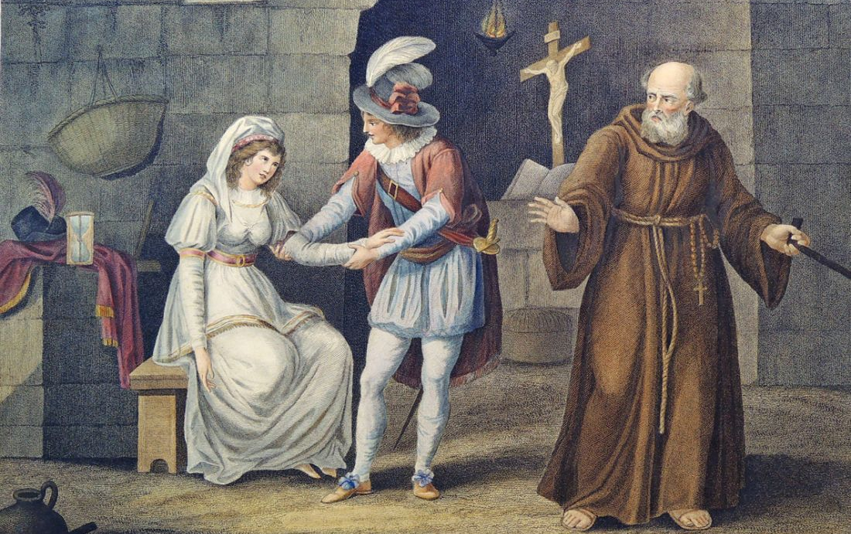
Extracts from Character analysis: Romeo and Juliet in Act 2, Scene 2 – Part 1
Source: https://www.bl.uk/shakespeare/articles/character-analysis-romeo-and-juliet

Famously referred to as the ‘balcony scene’, Act 2, Scene 2 of Romeo and Juliet begins with Juliet standing on her bedroom balcony, talking to herself. She muses on how unfair it is that the striking gentleman she kissed moments ago is in fact Romeo Montague – a young man from the family her Capulet kin are warring with. Romeo, who has crept into the Capulet grounds in order to find Juliet, overhears her words. Stepping out of the shadows, Romeo presents himself to Juliet and the two embark on an impassioned conversation in which they try to define their feelings and profess their love for one another. Their declarations are cut short both by the fear that Romeo will be discovered and by Juliet’s Nurse insistently calling her to come back into her bedroom. Before Romeo finally leaves, Juliet steals away from the Nurse and returns to the balcony. She issues Romeo with instructions about covertly communicating with her the following day in order for them to make plans to marry.

Juliet’s portrayal in this scene feverishly wavers between different positions, reminding the audience how inexperienced and emotionally unsteady she is. Firstly, her speech – seemingly delivered in private – offers the audience access to the thinking of a young girl on the cusp of independent womanhood. In her wrestling with the thorny issue of Romeo’s identity, she repeatedly asks questions: ‘What’s Montague? … What’s in a name?’ These disgruntled interrogatives about the inefficiencies of language and labels – a linguistic probing which connects with Romeo’s later promise to ‘tear the word’ – are also assaults on social rigidity and received wisdom. These are not the words of a submissive child content to follow rules as she has been instructed. They are challenges posed by an individual developing a singular, personal way of looking at the world. They are the utterances of someone dissatisfied with the way things are.

This boldness continues throughout this almost-soliloquy, reaching its greatest intensity at the end of the speech when Juliet offers her ‘self’ to Romeo in exchange for him shedding his ‘name’. This imagined or proposed transaction is radical as it undoes all sorts of patriarchal assumptions. One of these is the idea that after marriage it was women who should lose their names. Secondly, in determinedly stating how she envisages her future, her vow here contradicts the Elizabethan expectation that fathers should ‘pilot’ the destinies of their young daughters rather than the daughters directing themselves.

However, the surprising arrival of Romeo makes Juliet momentarily retreat into a more conventional role: that of the frightened, modest female. She becomes consumed with anxiety that her ‘kinsmen’ may discover and ‘murder’ Romeo. Though concealed by the darkness of night, she claims that her cheeks ‘blush’ at the idea that Romeo heard her earlier, emotional outpouring. Equally, she is desperate for assurances about Romeo’s feelings towards her. However, this submissiveness is short-lived, and Juliet soon regains a sense of stridency. As the scene progresses and Romeo begins to offer Juliet oaths as a way of demonstrating his affection, Juliet controls his smooth talking. Like a much more worldly and experienced woman, one tired of hackneyed ‘chat up lines’, she interrupts and edits his words.

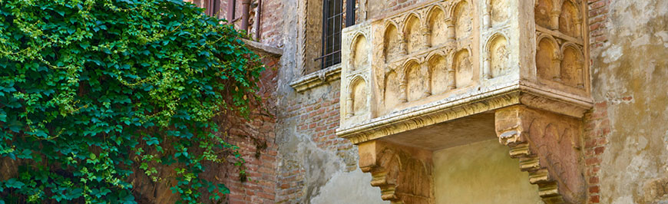
Extracts from Character analysis: Romeo and Juliet in Act 2, Scene 2 – Part 2
Source: https://www.bl.uk/shakespeare/articles/character-analysis-romeo-and-juliet

Romeo’s impulsive nature is in full evidence in this exchange. The very fact of his location – Romeo has brazenly crept behind enemy lines – and his bragging that he has no fear if the Capulets ‘find him’ in their midst clearly demonstrate to the audience how Romeo’s ego is dangerously inflated by the power of love. As soon as he engages in conversation with Juliet, and in order to win her over, he immediately and without real thought about the consequences denies his lineage and heritage, instantly claiming his Montague background is now ‘hateful’. Equally, in response to Juliet’s tender attempts to understand how he has trespassed into her family’s grounds, his hyperbolic declaratives and ornate comparisons are dazzlingly quick and unequivocal.

He figures his pursuit of Juliet in the language of perilous expedition, where he must adventurously scale ‘stony limits’ and traverse the ‘farthest sea’ in order to reach his love. But, movingly, the grandness of his self-presentation is eventually reduced by the power Juliet has over him. By the end of the scene, rather than as a heroic, questing figure, Romeo describes himself as Juliet’s pet ‘bird’: a tiny toy of a thing controlled by her every whim.

This scene compares and contrasts with the beginning of Act 3, Scene 5, which contains another anguished parting between the two lovers. As in Act 2, Scene 2, in the later scene there is a sense of negotiation, exchange and gentle conflict between Romeo and Juliet as they sleepily argue about whether or not it is daylight and if Romeo must leave Juliet’s bedroom before he is caught. In the earlier scene both characters seem to agree that linguistic signs – names, in particular – are problematic. In the famous aubade – a song between lovers marking the dawn – of Act 3, Scene 5, the meaning of other kinds of signs – nightingales, larks and what these might symbolise – troubles the lovers.

In Act 3, Scene 5, the pretence both lovers uphold – at different times – that it is not yet daylight adds a note of childishness to the scene. By seemingly lying to themselves and to each other, these characters reveal themselves to be unwilling or ill-equipped to deal with the adult realities of their situation, and so escape into a fantastical realm where they can control the passage of time and prolong the secrecy of night. This youthful element neatly matches with Romeo’s impetuousness and Juliet’s greenness explored earlier.

Identity emerges as one of the key ideas in Act 2, Scene 2. As well as the discussion of naming, the shifting characterisations of the two lovers prompt audiences to ponder who we become when influenced by love, what we might sacrifice in order to love and how we change ourselves in the presence of one we love.

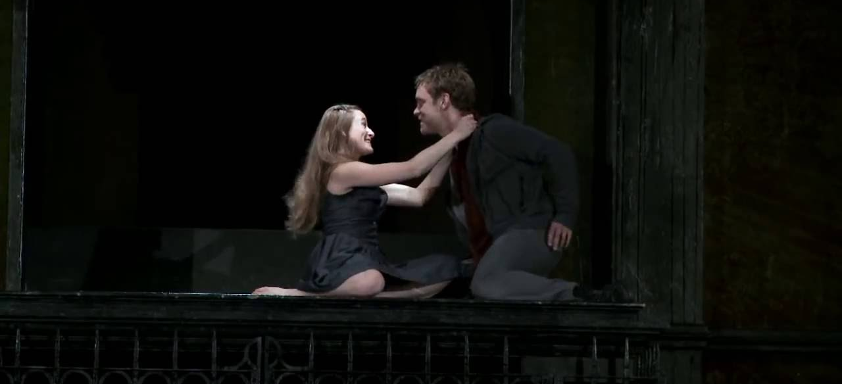
Extracts from The violence of Romeo and Juliet
Source: https://www.bl.uk/shakespeare/articles/new-mutiny-the-violence-of-romeo-and-juliet

All Shakespeare’s plays contain themes that feel universal – the father who breaks disastrously from his children, the marriage that collapses under the pressure of a husband’s jealousy. But the ingredients that make up Romeo and Juliet are perhaps more universal than most: young love, bitter hate, feuding communities, tragic and undeserved death. Shakespeare drew his story of a pair of star-crossed Veronese lovers from the lumbering narrative poem Tragicall Historye of Romeus and Juliet by the Elizabethan writer Arthur Brooke, but in reality the idea could have come from almost anywhere. The story is surely as old as love itself.

It is not hard to see why. Following Brooke, the play is set in Verona, but – as so often with Shakespeare – the streets we hear described on stage are also those of the bustling, overcrowded, pestilent, noisy and noisome city in which he lived and worked. London was a young city in the 1590s, and the crowds who took their chances with prostitutes and pickpockets in the entertainment districts were even younger; contemporary reports suggest audiences at the open-air theatres were predominantly male, and (unlike ‘private’ indoor playhouses, where admission cost at least six times as much) were drawn from all ranks of society. For this youthful, restless crowd – some of whom were bunking off work to attend – the violent skirmishes between the Capulets and Montagues that dominate the action must have been a major part of the attraction, and the swordfighting skills displayed by Shakespeare’s colleagues will have been watched with a keen eye. It is an amusing thought that for at least some of these artisans and apprentices, the lovers and their all-consuming passion might have seemed almost incidental.

For greyer heads in the audience, the image of young men on the prowl and a city slipping into mayhem would have been only too familiar. In summer 1595, two years before that first quarto was printed and perhaps in the same year Shakespeare was writing the play, a series of riots in London over rocketing inflation caused the authorities to panic. On 29 June, a 1,000-strong army of apprentices and disaffected soldiers marched on Tower Hill; on 4 July, martial law was imposed. In the legal action that followed, the rioters were accused of intending to ‘robbe, steale, pill and spoile the wealthy … and to take the sworde of auchthorytye from the magistrats and governours lawfully aucthorised’. Five were hanged, drawn and quartered. Ever-attentive to the world around him, Shakespeare responded to this atmosphere of what Benvolio calls ‘the mad blood stirring’ by putting a version of it on stage:

Gregory Draw thy tool. Here comes the House of Montagues.
Samson My naked weapon is out. Quarrel, I will back thee.

Audiences at early performances must have watched these exchanges with a nervous shiver, and wondered whether the couple in the play’s title would be the only ones caught up in the tragedy.

Extracts from Juliet's eloquence
Source: https://www.bl.uk/shakespeare/articles/juliets-eloquence

Juliet is the youngest leading female character in a Shakespeare play – she is just about to turn 14. Juliet is also the third-longest female role in Shakespeare; only the much more adult Cleopatra and Rosalind have more lines. A young girl who, in the course of the play, takes life-changing decisions and tells the audience about them, in poetry of extraordinary eloquence. What was Shakespeare up to in presenting such a paradoxical figure?

The play’s source material, Arthur Brooke’s narrative poem Romeus and Juliet (1562), was in most respects followed closely by Shakespeare, but not in the matter of Juliet’s age. Brooke’s Juliet is nearly 16; Shakespeare’s is so young that her parents’ attempts to control her life are strong drivers of the play’s narrative. Her father threatens to whip her if she disobeys him. She still has as a confidante the Nurse who breast-fed her. Yet her mother, her father and her suitor Paris emphasise that she is ready for an arranged marriage. ‘By my count, / I was your mother much upon these years’, says Lady Capulet. Juliet has a mere seven lines in her first scene; it is the Nurse who is talkative, emphasising for the audience exactly how young Juliet is.

But when she next appears, at the Capulets’ feast, an unexpected side of Juliet is revealed. When Romeo, admiring her beauty, approaches her in courtly mode (‘If I profane with my unworthiest hand …’), rather than being coy and quiet, she matches him line for line and wit for wit in a formal sonnet. In this way they jointly – and equally – declare their attraction to each other. Juliet shows herself to be a natural poet, able to play the linguistic games of which the self-consciously poetical Romeo has so far been the sole performer.

In the play’s later acts, where the action turns inexorably to tragedy, Juliet is even more expressive. If the plot’s turning point is the violent deaths of Mercutio and Tybalt in Act 3, Scene 1, the play’s more astonishing central moment is Juliet’s 116 lines in Act 3, Scene 2 as she prepares for her wedding night and deals with the dreadful irony that these deaths involve her new husband. ‘Gallop apace’ is a speech of extraordinary imaginative daring: it is full of explicit physical imagery – this young virgin is no naïve innocent – and joyous sexual energy, from the beginning to the end of its astonishing 30 lines. Is it the adrenalin of the dangerously secret marriage, the experience of sexual fulfilment, or the excitement of discovering her own intellectual and imaginative powers that fuels the rapid development of the child into the woman that we see in the second half of the play? In allowing herself to both think and speak as a poet, Juliet may be seen to be claiming a masculine role.

‘My dismal scene I needs must act alone’, Juliet says as she begins this last act of her story. In employing one of his favourite images – that ‘All the world’s a stage’ – Shakespeare here reminds the audience that they are at a play, in the theatre, where nothing is really as it seems. Perhaps at this point the first audiences were subconsciously reminded of the paradox that this girl who defies her parents – and talks about it – could actually be played only by a teenage boy. And perhaps this is the clue to Shakespeare’s daring in writing this eloquent role: he cannot represent the real 16th-century world on his stage because of strong religious opposition and the misogyny enshrined in English law, but he can present an alternative world, in which young women can express themselves freely and eloquently – though it does not guarantee them a happy ending.

Extracts from Romeo + Juliet at 20: Baz Luhrmann's adaptation refuses to age
Source: https://www.theguardian.com/film/2016/nov/01/romeo-juliet-baz-lurhmann-leonardo-dicaprio-claire-danes-20th-anniversary

Two decades on, stray sounds and images from Luhrmann’s film remain entirely vivid, if not entirely undated. But what of the film itself? Does it hold up as more than a whirling mood board of generationally evocative iconography? Did it ever? I’m almost afraid to revisit it, but minutes into Luhrmann’s headlong, tricked-out dive into the decayed bohemia of fair Verona Beach – where he and justly Oscar-nominated art director Catherine Martin don’t so much lay their scene as paint-blast it – the surprisingly elegant, elemental pull of its storytelling takes hold.

It’s de rigueur for purists to complain about contemporary Shakespeare adaptations stripping back his language to the nub, but the kinetic visual translations the film makes for the missing text remain quite startling. We tend to remember the hyperactivity of any Luhrmann film foremost, yet so much narrative here is articulated through faces and gazes: I can’t think of any Romeo and Juliet production I’ve seen, on stage or screen, in which the attraction between its eponymous lovers is so viscerally, obsessively instant. Franco Zeffirelli’s 1968 version may have caused something of a youthquake with its ravishing adolescent casting, but it’s cautiously carnal at best: here, 17-year-old Claire Danes’ and 21-year-old DiCaprio’s eyes meet in an electric blue thunderbolt of sheer, woozy want.

Neither actor delivers the most mellifluous iambic pentameter you’ve ever heard, and nor should they: the lines roll eagerly, earnestly, blushingly off their tongues, like eighth-graders reading and writing poetry for the first time. (Compare it to the misbegotten Douglas Booth-Hailee Steinfeld update that Julian Fellowes attempted three years ago: that film’s leads sound like they’re being made to read the play aloud in class with surly reluctance.) The flushed sugar rush of Luhrmann’s film-making – not that we’d have believed it then, but a positively restrained dry run for the ecstatic excess of 2001’s marvelous Moulin Rouge! – worked to conjure the same air of reckless, uncalculated feeling. To look at its peach-skinned lovefools’ recent work – DiCaprio grimly chomping raw bison liver in Alaskan purgatory, Danes determinedly gurning away on TV’s Homeland – is to know that William Shakespeare’s Romeo + Juliet is indeed 20 years old. Like its doomed, bullet-bound lovers, however, the film refuses to age with us.

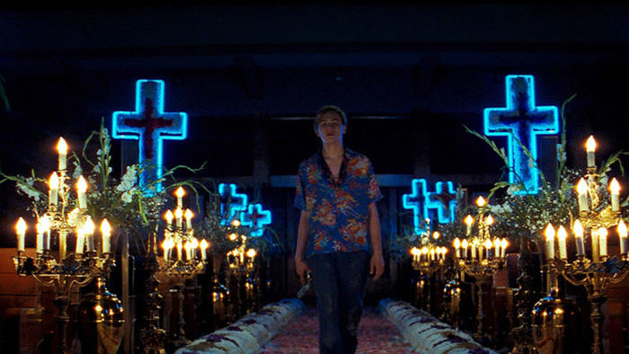
Extracts from Key moments from Romeo and Juliet
Source: https://www.rsc.org.uk/romeo-and-juliet/about-the-play/key-moments-and-facts

The lovers meet for the first time (A1S4)
Romeo is persuaded to attend a masked party at the Capulet household. Not knowing who she is, he falls in love with Juliet the moment he sees her, and she, equally ignorant that he is a Montague, falls just as instantly for him.

Romeo risks death to meet Juliet again (A2S1)
When everyone has left the party, Romeo creeps into the Capulet garden and sees Juliet on her balcony. They reveal their mutual love and Romeo leaves, promising to arrange a secret marriage and let Juliet's messenger, her old Nurse, have the details the following morning.

Romeo angrily kills Juliet's cousin, Tybalt (A3S1)
Romeo meets Tybalt in the street, and is challenged by him to a duel. Romeo refuses to fight and his friend Mercutio is so disgusted by this 'cowardice' that the takes up the challenge instead. As Romeo tries to break up the fight, Tybalt kills Mercutio and, enraged, Romeo then kills Tybalt. The Prince arrives and banishes Romeo.

The unhappy couple are parted (A3S5)
Arranged by the Friar and the Nurse, Romeo and Juliet have spent their wedding night together. They are immediately parted though, as Romeo must leave for banishment in Mantua or die if he is found in Verona. Believing her grief to be for the death of her cousin, Juliet's father tries to cheer Juliet by arranging her immediate marriage to Paris. He threatens to disown her when she asks for the marriage to be at least postponed, and she runs to the Friar for advice.

The Friar suggests a dangerous solution (A4S1)
Juliet arrives at the Friar's to be met by Paris, who is busy discussing their wedding plans. She is so desperate that she threatens suicide, and the Friar instead suggests that she takes a potion that will make her appear to be dead. He promises to send a message to Romeo, asking him to return secretly and be with Juliet when she wakes, once her 'body' has been taken to the family crypt.

Juliet is found 'dead' (A4S4)
The Nurse discovers Juliet 's 'body' dead' when she goes to wake her for her marriage Paris. Friar Laurence is called, counsels the family to accept their grief, and arranges for Juliet to be 'buried' immediately.

Romeo learns of the tragedy and plans suicide (A5S1)
Romeo's servant, Balthasar, reaches Mantua before the Friar's messenger and tells Romeo that Juliet is dead. Romeo buys poison and leaves for Verona, planning to die alongside Juliet's body.

The tragic conclusion (A5S3)
Romeo kills Paris and reaches Juliet's body. He drinks the poison, kisses his wife for the last time, and dies. Having learned that Romeo never received his message, the Friar comes to the crypt to be with Juliet when she wakes. He finds Paris's body and reaches Juliet just as she revives. He cannot persuade her to leave her dead husband and runs away in fear. Juliet realises what has happened, takes Romeo's knife and stabs herself to death with it. The watchmen discover the gruesome sight and call the Prince, to whom the Friar confesses everything. Having heard the full story, the Montagues and Capulets are reconciled. Peace has been achieved, but the price has been the lives of two innocent young lovers.

