War of Words: Soldier-Poets of the Somme

The 1916 Battle of the Somme remains the most famous battle of World War I, remembered for its bloodshed and its limited territorial gains. What is often overlooked, however, is the literary importance of the Somme: more writers and poets fought in it than in any other battle in history. Narrated by Michael Sheen, this film details the experiences of the poets and writers who served in the battle. The work of Siegfried Sassoon, Robert Graves, David Jones, Isaac Rosenberg and JRR Tolkien (who arrived at the Western Front with ambitions to be a poet) was informed and transformed by the battle. Taken together, their experiences allow us to see this dreadful historical event through multiple points of view.
Source: BBC (documentary originally shown in 2014)

List of Poems and Big Questions

- Absolution, by Siegfried Sassoon (1915)
‘Sassoon was older, but less worldly’ – How is Sassoon’s inexperience of war reflected in the poem Absolution?
- Before Action, by William Hodgson (1916)
‘They were in a peculiarly dangerous spot’ – What do we learn from Before Action about how Hodgson prepared himself for battle?
- A Dead Boche, by Robert Graves (1916)
‘He wanted to focus on the details of the horrors he saw’ – What horrors of war does the poem A Dead Boche convey?
- Died of Wounds, by Siegfried Sassoon (1917)
‘The poem is beautifully done because there is compassion’ – How does the poem show the sadness and futility of war?
- Lord of the Rings: The Two Towers, by J. R. R. Tolkien (1954) – Prose
It was a horrifying, searing experience’ – How are the horrors of war reflected in ‘The Dead Marshes’ extract from Lord of the Rings?
- Louse Hunting, by Isaac Rosenberg (1917)
‘This bizarre ritual was turned into poetry’ – How does Rosenberg reflect the ‘bizarreness’ of the louse hunting ritual?

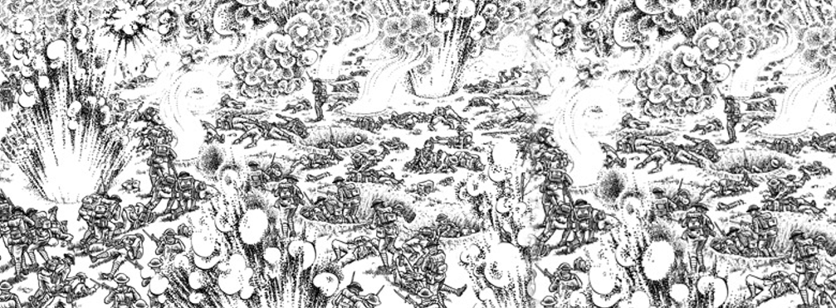
Absolution, by Siegfried Sassoon (1915)

The anguish of the earth absolves our eyes
Till beauty shines in all that we can see.
War is our scourge; yet war has made us wise,
And, fighting for our freedom, we are free.

5 Horror of wounds and anger at the foe,
And loss of things desired; all these must pass.
We are the happy legion, for we know
Time’s but a golden wind that shakes the grass.

There was an hour when we were loth to part
10 From life we longed to share no less than others.
Now, having claimed this heritage of heart,
What need we more, my comrades and my brothers?

7 minutes

Before Action, by William Hodgson (1916)

By all the glories of the day
And the cool evening’s benison
By that last sunset touch that lay
Upon the hills when day was done,
5 By beauty lavishly outpoured
And blessings carelessly received,
By all the days that I have lived
Make me a soldier, Lord.

By all of all man’s hopes and fears
10 And all the wonders poets sing,
The laughter of unclouded years,
And every sad and lovely thing;
By the romantic ages stored
With high endeavour that was his,
15 By all his mad catastrophes
Make me a man, O Lord.

I, that on my familiar hill
Saw with uncomprehending eyes
A hundred of thy sunsets spill
20 Their fresh and sanguine sacrifice,
Ere the sun swings his noonday sword
Must say good-bye to all of this; –
By all delights that I shall miss,
Help me to die, O Lord?

25 minutes
A Dead Boche, by Robert Graves (1916)

To you who’d read my songs of War
And only hear of blood and fame,
I’ll say (you’ve heard it said before)
‘War’s Hell!’ and if you doubt the same,
5 Today I found in Mametz Wood
A certain cure for lust of blood:

Where, propped against a shattered trunk,
In a great mess of things unclean,
Sat a dead Boche; he scowled and stunk
10 With clothes and face a sodden green,
Big-bellied, spectacled, crop-haired,
Dribbling black blood from nose and beard.

48 minutes

Died of Wounds, by Siegfried Sassoon (1917)

His wet white face and miserable eyes
Brought nurses to him more than groans and sighs:
But hoarse and low and rapid rose and fell
His troubled voice: he did the business well.

5 The ward grew dark; but he was still complaining
And calling out for ‘Dickie’. ‘Curse the Wood!
‘It’s time to go. O Christ, and what’s the good?
‘We’ll never take it, and it’s always raining.’

I wondered where he’d been; then heard him shout,
10 ‘They snipe like hell! O Dickie, don’t go out...
I fell asleep… Next morning he was dead;
And some Slight Wound lay smiling on the bed..

57 minutes

Lord of the Rings: The Two Towers, by J. R. R. Tolkien (1954)

The hobbits soon found that what had looked like one vast fen was really an endless network of pools, and soft mires, and winding half-strangled water-courses… It was dreary and wearisome. Cold clammy winter still held sway in this forsaken country. The only green was the scum of livid weed on the dark greasy surfaces of the sullen waters. Dead grasses and rotting reeds loomed up in the mists like ragged 5 shadows of long-forgotten summers. There was a faint hiss, a noisome smell went up, the lights flickered and danced and swirled. For a moment, the water below him looked like some window, glazed with grimy glass, through which he was peering. Wrenching his hands out of the bog, he sprang back with a cry. ‘There are dead things, dead faces in the water,’ he said with horror. ‘Dead faces!’

Gollum laughed. ‘The Dead Marshes, yes, yes: that is their names,’ he cackled. ‘You should not look in 10 when the candles are lit.’

‘Who are they? What are they?’ asked Sam shuddering, turning to Frodo, who was now behind him.

‘I don’t know,’ said Frodo in a dreamlike voice. ‘But I have seen them too. In the pools when the candles were lit. They lie in all the pools, pale faces, deep, deep under the dark water. I saw them: grim faces and evil, and noble faces and sad. Many faces proud and fair, and weeds in their silver hair. But all foul, all 15 rotting, all dead. A fell light is in them.’ Frodo hid his eyes in his hands. ‘I know not who they are; but I thought I saw there Men and Elves, and Orcs beside them.’

‘Yes, yes,’ said Gollum. ‘All dead, all rotten. Elves and Men and Orcs. The Dead Marshes. There was a great battle long ago, yes, so they told him when Sméagol was young, when I was young before the Precious came. It was a great battle. Tall Men with long swords, and terrible Elves, and Orcses shrieking. 20 They fought on the plain for days and months at the Black Gates. But the Marshes have grown since then, swallowed up the graves; always creeping, creeping.’

115 minutes

Louse Hunting, by Isaac Rosenberg (1917)

Nudes, stark and glistening,
Yelling in lurid glee. Grinning faces
And raging limbs
Whirl over the floor one fire;
5 For a shirt verminously busy
Yon soldier tore from his throat with oaths
Godhead might shrink at, but not the lice,
And soon the shirt was aflare
Over the candle he’d lit while we lay.

10 Then we all sprang up and stript
To hunt the verminous brood.
Soon like a demons’ pantomime
This plunge was raging.
See the silhouettes agape,
15 See the gibbering shadows
Mixed with the baffled arms on the wall.

See Gargantuan hooked fingers
Pluck in supreme flesh
To smutch supreme littleness.
20 See the merry limbs in that Highland fling
Because some wizard vermin willed
To charm from the quiet this revel
When our ears were half lulled
By the dark music
25 Blown from Sleep’s trumpet.
117 minutes

