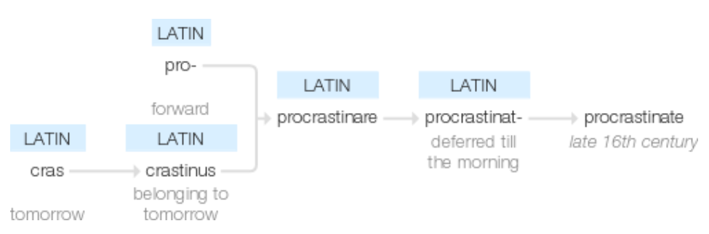

- What is procrastination?

- What does the research say?

- Is there anything else I need to know?

- What’s the best advice out there for dealing with procrastination?

- Discussion: Why do men aged between 35-44 typically delay getting help with their healthcare?

Mr Wise
8th February
AA1
What is Procrastination?

- ‘To put off acting on one’s intentions’
Trait Procrastination and the Big-Five Factors of Personality, by Henri Schouwenburg and Clarry Lay (1995)
- ‘Purposive delay in starting or completing tasks’
Prevalence of procrastination in the United States, UK and Australia, by Joseph Ferrari et al. (2005)
- ‘A prevalent and pernicious form of self-regulatory failure that is not entirely understood’
The Nature of Procrastination, by Piers Steel (2007)
- ‘The gap between intention and action’
Escape Artists, by Steven Kotler (2009)

What Does the Research Say?

- From a study with 660 college students: 46% reported that they ‘always’ or ‘nearly always’ procrastinate on writing a paper and 30% reported procrastinating on studying for exams or on reading for weekly assignments; 60% indicated that they would like to reduce their procrastination.
Academic Procrastination: Frequency and Co Cognitive-Behavioural Correlates, by Laura Solomon and Esther Rothblum (1984)
- From a study with 147 college students: Procrastinators can be highly motivated students and yet still be ‘vulnerable to temptations’
Procrastination, Temptations and Incentives, by Siegfried DeWitte and Henri Schouwenburg (2002)
- From a study with 660 adults: There is ‘virtually no variance’ in the procrastination tendencies between men and women.
Prevalence of procrastination in the United States, UK and Australia, by Joseph Ferrari et al. (2005)
- From a study with 120 college students: Procrastinators are more likely to see tasks as ‘difficult’ and ‘not enjoyable’, and are more likely to claim that they ‘lack clarity’ in how to complete them
Procrastination as a predictor of task perceptions, by Joseph Ferrari et al. (2006)
- From a study with 498 college students: ‘No matter how important students consider their courses to be for achieving their future life goals, they are still likely to procrastinate if they are not genuinely interested in the course material.’
Self-regulation and Academic Procrastination, by Caroline Senécal and Richard Koestner (1995)
- From a study of students from different academic disciplines at four German universities: The strongest effect of academic procrastination is ‘on using fraudulent excuses’, but it also increases the probability of other forms of misconduct like plagiarism and fabrication or falsification of data.
Investigating the Effect of Academic Procrastination on the Frequency and Variety of Academic Misconduct, by Justine Patrzek (2014)

Anything Else?

- A fear of fear of failure ‘is either of only secondary importance or practically absent’ as reason for procrastination
Procrastinators and Fear of Failure: An Exploration of Reasons for Procrastination, by Henri Schouwenberg (1992)
- ‘Distractibility’ is one of the top reasons for procrastination’
The Cognitive Mediation of Procrastination, by Laurel Haycock (1993)
- ‘95% of procrastinators wish to reduce it’
The Nature of Procrastination, by Piers Steel (2007)
- ‘Impulsiveness’ is strongly connected to procrastination’
The Procrastination Equation, by Piers Steel (2010)

Any Advice?

- Conceptualise the costs of procrastination. For example, consider the potential effects of not handing in an essay by the deadline or of choosing not to revise for your mock exams (and so on). The negative emotions that you might feel later will probably outweigh the discomfort of short-term effortful engagement.

- Conceptualise the benefits of making a start. This time, focus on the positive effects of overcoming your reluctance to engage with your to-do list and remember that making the smallest of starts is better than making no start at all. And you might just find it wasn’t so bad after all.

- Remove distractions from your workspace. If your phone is within easy reach, you’ll almost certainly check it. And even if you don’t, you’ll think about checking it and that itself will harm your ability to concentrate. If you’re working on your computer, apps like StayFocused can limit the amount of time you’re able to spend browsing.

- Don’t assume good planning will prevent procrastination. Chances are, you’ll be just as distractable and you won’t necessarily have any more or less intrinsic motivation to complete the tasks ahead of you. Beware, too, about the planning process itself becoming a form of procrastination.

- Be mindful that delaying a task isn’t always a bad thing. For example, periods of reflection are important and can help you to make productive decisions. However, remember that there is a difference between strategic delay (positive outcome) and procrastination (negative outcome).

- Publicly commit to getting a task done. We’re social creatures and, even though were sometimes reluctant to admit it, we do care about what other people think of us. As such, to avoid reputational harm, we’re more likely to get a task done if we say we’re going to do it beforehand. So, state your intentions to those around you.

- Be clear on how to start a task. Without that clarity, the task itself will probably seem more daunting than it really is and that will make you less likely to get on with it. For example, if you know that you need to create a plan before you start writing an essay, get cracking with it and you’ll be more inclined to carry on.

- Beware of the planning fallacy. We routinely underestimate how long it will take to complete a task, and this often leads to us leaving things to the last minute. In part, this is because it’s hard for us to predict complicating factors that might arise, but we’re also bad at accurately recalling how long similar tasks have taken in the past.

