**The Central Message of The Play**

By reminding the audience about the inequalities and limitations of life for ‘millions and millions’ of people in 1912, and by hinting at the devastating conflicts to come, **Priestley emphasises the importance of working together for greater social change**. In this sense, the **central message** of the play is both a warning and a call for further action: a *warning* about the consequences of selfishness and a *call* to continue campaigning for a fairer and more socially responsible society. Remember that the Labour Party was elected in 1945 and the leader, Clement Attlee, made a pledge to provide welfare to all British citizens who needed it. In this this sense – despite the grizzly events that unfold on stage – the play is actually very **optimistic**.

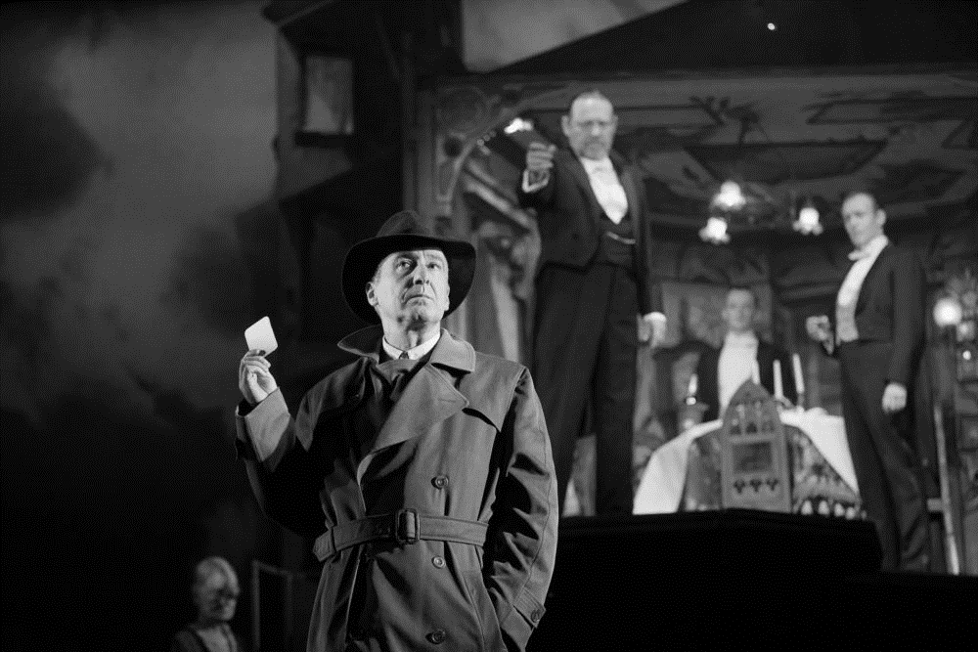

**A Reminder of Inequalities and Limitations in 1912**

1. Why is the role of Edna important?
2. Why are the names Eva Smith and Daisy Renton significant?
3. Why is the suicide of Eva Smith described (twice) in such graphic detail?
4. Why is it significant that Eva Smith is unable to find employment immediately after getting fired?
5. Why is the character of Alderman Meggarty significant?
6. What ‘capital’ do the Birlings possess other than financial wealth?
7. What is Birling’s immediate concern after the Inspector leaves?

**A Call for Further Action in 1946**

1. Why does the stage lighting change when the Inspector enters?
2. Why is the name Inspector Goole significant?
3. How does Priestley emphasise that the Inspector is a credible character (i.e. not a ‘crank’)?
4. What does the Inspector mean when he says ‘we are members of one body’?
5. What is the meaning of the reference the Inspector makes to ‘fire and blood and anguish’?
6. Does it matter if the Inspector is a ‘fake’?
7. What does it mean when people describe the Inspector as ‘Priestley’s mouthpiece’?