Study Booklet

An Inspector Calls

Contents

3 | Knowledge Organiser
4 | BQ: ‘The four Birlings and Gerald are seated at the table’ – What do we learn about the main characters from the opening pages?
5 | BQ: ‘It’s one of the happiest nights of my life’ – Why is Birling so happy that Sheila (his daughter) is getting married to Gerald?
6 | BQ: ‘And we’re in for a time of steadily increasing prosperity’ – Why is it significant that Birling’s predictions are clearly incorrect?
7 | BQ: ‘I don’t like the tone’ – How is Birling implicated in the suicide of Eva and how does he react to the Inspector’s questions?
8 | BQ: ‘Why shouldn’t they try for higher wages?’ – How do Eric and Sheila initially react to the news of the suicide?
9 | BQ: ‘And if I could help her now, I would’ – How does Sheila’s reaction to her role in the suicide differ to Birling’s earlier reaction?
10 | Review Questions on Act One
11 | BQ: ‘You seem to have made a great impression on this child’ – How has Sheila changed since the beginning of the play?
12 | BQ: ‘You were the wonderful Fairy Prince’ – To what extent is Gerald presented as a manipulative and deceitful character?
13 | BQ: ‘You’re not telling me the truth’ – Why is Mrs Birling so reluctant to openly answer the Inspector’s questions?
14 | BQ: ‘I think she only had herself to blame’ – What does Mrs Birling’s interrogation reveal about the lives of working-class women?
15 | Review Questions on Act Two
16 | BQ: ‘I was in that state when a chap turns easily nasty’ – What makes Eric’s behaviour towards Eva so deplorable?
17 | BQ: ‘We are members of one body’ – What messages does the Inspector convey to the Birlings and how do they respond?
18 | BQ: ‘The point is, you don’t seem to have learnt anything’ – Is Sheila’s criticism of her parents fair?
19 | BQ: ‘So nothing really happened’ – Does it matter if the Birling family and Gerald have been hoaxed?
20 | Review Questions on Act Three
21 | Common Misconceptions
22 | The Knowledge
23 | Final Five

Acts
Act 1 | The Birling family and Gerald celebrate the engagement; the stage lighting is ‘pink and intimate’ until the Inspector arrives.
 | The Inspector arrives and questions Birling; he is unremorseful about firing Eva; Sheila is ashamed that she used her social influence to get Eva sacked.
 | The Inspector reveals that Eva Smith changed her name to Daisy Renton; Gerald is ‘startled’ to hear her name mentioned.
Act 2 | Gerald admits that he had an affair with Daisy; Sheila hands the engagement ring back to him.
 | The Inspector questions Mrs Birling; Sheila forcefully encourages her mother to be honest and open; Mrs Birling does not feel that did anything wrong.
 | Mrs Birling eventually realises that Eric was the father of Eva’s unborn child.
Act 3 | Eric recounts the details of his relationship with Eva; he admits stealing money from his father.
 | The Inspector reminds the Birling family and Gerald that they ‘do not live alone’ and then leaves.
 | Gerald believes that he and the Birling family have been ‘had’ and the Inspector is swiftly dismissed as a hoaxer; the phone rings and Birling answers…
Key Characters |  | Key Themes |  | Historical Context
Mr and Mrs Birling | - Arrogant  - Unremorseful  - Selfish | Responsibility | - Priestley was a socialist  - See: Birling’s speech on ‘bees in a hive’  - See: Inspector Goole’s final speech | The play was first performed at the end of World War II, which was a time of remarkable social and political change. Clement Attlee was elected as Prime Minister in 1945 by a significant majority. The Labour campaign was based on the slogan ‘Let Us Face the Future’.  By contrast, the play is set in 1912, which was a time of rigid social divisions. Women were still unable to vote and the tensions that eventually lead to the Russian Revolution were becoming increasingly visible.
Sheila and  Eric | - Impulsive  - Regretful  - Distraught | Class | - Gerald and Mrs Birling are from the aristocracy  - Birling hopes to be awarded with a knighthood  - Eva and Edna represent the working classes
Gerald | - Agreeable  - Influential  - Apologetic | Gender | - Birling uses Eva as ‘cheap labour’  - Gerald and Eric are predatory  - Mrs Birling fails to empathise with Eva
Inspector  Goole | - Forceful  - Resolute  - Confident | Age | - There is a clear divide between the generations  - Mrs and Mrs Birling do not change  - Eric and Sheila offer hope for the future
Eva Smith | - Vulnerable  - Capable  - Victimised | Hypocrisy | - Brumley is a place of class divisions and hypocrisy  - See: Alderman Meggarty  - See: Mrs Birling’s naivety

Big Question

‘The four Birlings and Gerald are seated at the table’ – What do we learn about the main characters from the opening pages?

Pages: 161-2

Vocabulary

Wealth | Celebration | Relationships
Class | Engagement | Symbolism
Comfort | Mood | Stage

Literacy

An Inspector calls was first performed just after the end of World War Two. it was a time of grate change in Britain and many

writer’s were concerned with the wellfare of the poor. Priestly wanted to address this issue. This is why social responsibality is a

key theme of the play.

Source: BBC Bitesize

Retrieval

- The Birling family are celebrating

- The Birling family are wealthy

- Sheila is in an excitable mood

- Gerald is handsome

- Eric does not seem particularly confident

Key Image

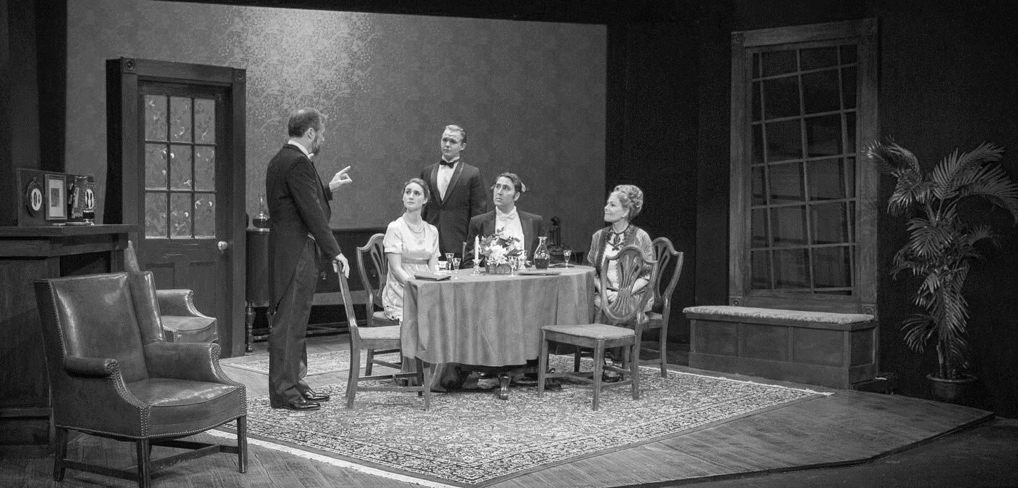

Recap Task

Write down five adjectives to describe the Birling family (or individual members of the family).

Big Question

‘It’s one of the happiest nights of my life’ – Why is Birling so happy that Sheila (his daughter) is getting married to Gerald?

Pages: 162-5

Vocabulary

Capitalism | Exploitation | Inequality
Greed | Confidence | Divide

Literacy

An Inspector Calls is Priestleys most performed play. Its set in the household of a prosperous northern manufacturer, arthur

Birling. It’s 1912 and the Birling family are celebrating the engagement of daughter Sheila, when a strangar, who introduces

himself as Inspector Goole, shows up at their door

Source: British Library

Retrieval

- Edna leaves the dining-room

- Sheila teases Gerald about being absent for the whole of last summer

- Eric laughs loudly and awkwardly

- Birling declares that he is very happy

- Birling expresses hope that Birling and Company and Crofts Limited will work together in the future

- Gerald presents Sheila with an engagement ring

Key Quotations

Mr B: ‘I’m going to tell you frankly, without any pretences, that your engagement to Sheila means a tremendous lot to me’ (163)

Mr B: ‘You’re just the kind of son-in-law I always wanted’ (163)

Mr B: ‘Crofts Limited are both older and bigger than Birling and Company’ (164)

Gerald: ‘Hear, hear!’ (164)

Recap Task

Explain in 50 words or fewer why Birling is so pleased that Gerald will become his son-in-law.

Big Question

‘And we’re in for a time of steadily increasing prosperity’ – Why is it significant that Birling’s predictions are clearly incorrect?

Pages: 165-8

Vocabulary

Dramatic Irony | Tone | Audience
Labour | 1912 | 1946

Literacy

Just as the Birlings come face-to-face with there future at the end of the play, the present-day Audience are faced with the

mistakes of their past and can also choose to act differently to create a farer, safer world

Source: British Library

Retrieval

- Eric asks if there will be a war in Europe

- Birling dismisses Eric’s question and confidently predicts that there will not be a war

- Birling says that the Titanic is unsinkable

- Birling says that in the future, by 1940, there will be no prospect of war

- Birling hints to Gerald that he knows Lady Croft (Gerald’s mother) disapproves of the engagement

- Birling suggests that he will receive a knighthood

- The front doorbell rings

Key Contextual Information

Society in 1912 was divided: there was a large gap between the rich and the poor. Roughly 10% of the population controlled 90% of the wealth.

Gerald and Mrs Birling are part of the aristocracy, which is to say that they are both from families that have been wealthy for many generations. Birling is slightly different. He is part of the emerging upper-middle class because he has made his money relatively recently. Think back to his conversation with Gerald about Crofts Limited being both ‘older and bigger than Birling and Company’. Birling has ‘new’ money, whilst his wife and Gerald have ‘old’ money.

Society in 1946 was different. The two World Wars resulted in significant financial losses for families like the Birlings. On top of this, the Wars forced people from different backgrounds to mix. In short, society was becoming more equal and workers had far more rights than they did in 1912.

As a socialist – someone who believed in social equality – Priestley wanted to remind his audience about how bad things were in 1912 as a way of encouraging them to continue pushing for changes that would result in more freedom and fairness. Always remember as you’re reading the play that Priestley uses dramatic irony: the audience (and us!) will always know more than the characters on stage. We know when they make mistakes and we know when they have behaving badly.
Recap Task

Provide three examples of dramatic irony in the play so far.

Big Question

‘I don’t like the tone’ – How is Birling implicated in the suicide of Eva Smith and how does he react to the Inspector’s questions?

Pages: 168-74

Vocabulary

Lighting | Strike | Reluctance
Mood | Responsibility | Duty
Suicide | Irritation | Influence

Literacy

At the start of the play the unsuspecting birling family are visited by the misterious Inspector Gool. He informs them that a girl

caled Eva Smith has taken her own life by drinking disinfectant. The family are initialy confused as to why the Inspector has caled

to see them.

Source: BBC Bitesize

Retrieval

- The Inspector announces that he has come to investigate the suicide of a young working-class girl

- Birling initially struggles to remember Eva Smith

- Birling says that he cannot accept any responsibility for the suicide

- Birling attempts to deter Inspector Goole from asking him further questions

Key Image

Recap Task

Which of the following words accurately describe Birling: Remorseful | Irritable | Uncaring | Helpful | Charming | Greedy | Fair

Big Question

‘Why shouldn’t they try for higher wages?’ – How do Eric and Sheila initially react to the news of the suicide?

Pages: 174-79

Vocabulary

Contrast | Shock | Empathy
Naivety | Disagreement

Literacy

Social responsibility is the idea that a societys porer members should be helped by those who have more than them. Priestly

was a socialist and his political beleifs are woven through his work

Source: British Library

Retrieval

- Eric questions why it was unacceptable for Eva to ask for higher wages

- Sheila enters the room asks what is happening

- Sheila says that it was ‘mean’ for her father to sack Eva

- Sheila reflects on the limited opportunities that working-class girls like Eva had available to them

- The Inspector reveals that Eva was able to find a new job at Milwards

- The Inspector shows Sheila a picture of Eva Smith

Key Images

Recap Task

Look closely at the opening stage directions. How is the lighting meant to change when the Inspector enters?

Big Question

‘And if I could help her now, I would’ – How does Sheila’s reaction to her role in the suicide differ to Birling’s earlier reaction?

Pages: 179-82

Vocabulary

Jealousy | Power | Remorse
Insecurity | Status | Distress
Complaint | Wealth | Regret

Literacy

Although the Birling’s have wealth and social standing, they are not loving to one another or compassionate to other’s. the seting

of the play in a single roome refleckts their self-absorption and disconnectedness from the wider world

Source: British Library

Retrieval

- Sheila admits that she petulantly complained about Eva Smith

- Sheila implies that she was jealous of Eva

- Sheila expresses regret at her actions

- The Inspector reveals that Eva changed her name to Daisy Renton

- Gerald reveals that he knew Daisy

- Gerald pleads with Sheila not to tell the Inspector

Key Statements for Discussion

- Sheila understands Eva’s death is not entirely her fault

- Sheila is willing to be open and honest with the Inspector

- Sheila’s immaturity is shown by her emotional reaction to the news

- Sheila seems to genuinely regret her actions

- Sheila understands that her actions were spiteful and petulant

- Sheila is upset that engagement party has been ruined by the Inspector

- Sheila is embarrassed

- Sheila understands that she must change her outlook and her future behaviour

- Sheila is worried that she will no longer be allowed to shop in Milwards

- Sheila would not act in the same way again

Review of Act One

- In which year is the play set?

- How should the stage be lit prior to the arrival of the Inspector?

- How is Gerald described in the stage directions?

- What have the Birling family and Gerald had to drink, and what are they about to drink?

- Which character says, ‘Arthur, you’re not supposed to say such things’?

- Why are Lord and Lady Croft absent from the celebration?

- Which character says, ‘You can drink to me’?

- Birling says, ‘We’ve passed the worst of it’ – what is he alluding to?

- In which year did Birling serve as Lord Mayor?

- Is it Lord Croft or Lady Croft who feels that Gerald ‘might have done better’ for himself ‘socially’?

- How should the lighting change when the Inspector enters?

- How should the Inspector be dressed?

- How does the Inspector say that Eva died?

- In which year did Birling fire Eva Smith from his factory?

- Which character says, ‘Look – there’s nothing mysterious – or scandalous – about this business’?

- How much did Eva and the workforce want to earn?

- What is the name of the Chief Constable who Birling plays golf with?

- Which character says, ‘They’d all be broke – if I know them’?

- How old was Eva Smith before she died?

- What is the name of the shop that Eva found work in after she was fired by Birling?

- How long was it before she was taken on?

- Why was she considered to be ‘lucky’?

- Which character claims to have a headache and says, ‘I think I’d better turn in’?

- What did Eva Smith change her name to?

- How does Gerald react when he hears the name announced by the Inspector?

Recap Task

Look closely at the opening stage directions. How is the lighting meant to change when the Inspector enters?

Big Question

‘You seem to have made a great impression on this child, Inspector’ – How has Sheila changed since the beginning of the play?

Pages: 183-88

Vocabulary

Contrast | Excitable | Distressed
Develop | Playful | Defiant

Literacy

The Inspector reveels that eva used to work in Mr Birlings factory and he had her sacked for going on strike. He than reveals that

Sheila complaned about Eva and got her sacked. Shelia is deaply ashamed and feels responsable for the girls death.

Source: BBC Bitesize

Retrieval

- Gerald attempts to get Sheila to leave the room

- The Inspector states that Sheila should stay

- Mrs Birling enters the room and greets the Inspector

- Mrs Birling suggests that Sheila should go to bed

- Mrs Birling refuses to believe that Eric drinks too much

Key Starting Points

- Sheila is presented as a cheerful and optimistic character who appears to be genuinely in love with Gerald

- Sheila’s delight at being presented with the engagement ring is shown through the stage directions – ‘smiling’

- Sheila’s immaturity is shown through the language she uses to address her parents – ‘Mummy’ and ‘Daddy’

- Gerald’s dominance in his relationship with Sheila is shown through this control over the choice of engagement ring

Recap Task

Write down five adjectives to describe the Sheila at the beginning of the first act and then five to describe her at the end.

Big Question

‘You were the wonderful Fairy Prince’ – To what extent is Gerald presented as a manipulative and deceitful character?

Pages: 188-93

Vocabulary

Reputation | Charming | Relationship
Appearance | Aristocratic | Betrayal
Attractive | Caring | Honesty

Literacy

At the begining of the play, gerald is portrayed as a confident and charmming ‘man-about-town’. However, this changes after his afair with Eva smith is reveled. Gereld initially gives himself away when he hears that Eva changed her name to Daisy Rentan.

Source: BBC Bitesize

Retrieval

- Gerald admits that he met Daisy Renton in the bar at the Palace Variety Theatre

- Gerald claims that he first saw Daisy when she was receiving unwanted attention from Alderman Meggarty

- Gerald recalls buying Daisy a drink

- Gerald says that he embarked on an affair with Daisy

- Gerald concedes to Sheila that he enjoyed receiving attention and adulation from Daisy

Key Starting Points

- The Palace Variety Theatre is a ‘favourite haunt of women of the town’

- Gerald admits to drinking there, despite hating ‘those hard-eyed dough-faced women’

- Joe Meggarty, an Alderman (an important member of the local council), was also there on the same night

- Gerald offers Daisy the opportunity of temporarily living at his friend’s empty house

- Gerald concedes that he ‘didn’t feel about her as she felt about me’

Recap Task

What excuse did Gerald give Sheila to justify not seeing her (whilst he was having an affair with Daisy)? Find the quotation.

Big Question

‘You’re not telling me the truth’ – Why is Mrs Birling so reluctant to openly answer the Inspector’s questions?

Pages: 193-96

Vocabulary

Defensive | Dismissive | Indifferent

Literacy

An Inspector calls gives voice to Priestleys strong socialist principles and carrys a clear morale message that stresses the

importance of social responsability.

Source: British Library

Retrieval

- Sheila returns her engagement ring to Gerald

- Gerald leaves the room

- The Inspector shows Mrs Birling the photograph

- Birling demands an apology from the Inspector

- Sheila angrily says that the Inspector has no need to apologise

- Mrs Birling tries to evade the Inspector’s questions

- Eric’s absence is noted by Mr and Mrs Birling

Key Image

Recap Task

Fill in the gaps: ‘His wife is about __________, a rather __________ woman and her husband’s __________ superior.’

Big Question

‘But I think she only had herself to blame’ – What does Mrs Birling’s interrogation reveal about the lives of working-class women?

Pages: 196-201

Vocabulary

Charity | Empathy | Despair
Vulnerable | Support | Blame
Helpless | Power | Responsibility

Literacy

mrs Birling’s cold, uncaring nature leeds to her down fall as the Inspector forces her to unknowingly condemn her own son

Source: BBC Bitesize

Retrieval

- The Inspector reveals that Eva asked Mrs Birling and the members of the BWCO for financial help

- Mrs Birling says that Eva introduced herself as ‘Mrs Birling’

- Mrs Birling recalls how she unsuccessfully questioned Eva

- Mrs Birling says that she told Eva to seek support from the father

- The Inspector asks Mrs Birling is she accepts any blame for what happened to Eva

- Mrs Birling states that the father should share some of the blame

- Mrs Birling finally realises that Eric was the father of the unborn child

Key Perspectives

- Edna is a compliant character who reminds the audience of the Birling family’s wealth and social status

- The rigid social conventions of Edwardian England are highlighted when Birling for wanting to compliment Edna

- Birling treats his workers as ‘cheap labour’ and believes that it is his duty to keep ‘labour costs down’

- Eric highlights the limited opportunities that working women had in 1912

- Eric exposes a double standard by asking why workers like Eva shouldn’t campaign for higher wages

- Gerald condescendingly implies that Eva and other working-class women are reckless with their (limited) wages

- The Inspector highlights the precarious nature of Eva’s life – ‘few friends, lonely, half-starved’

- Eva Smith is a character who represents all working-class women – ‘there are a lot of young women’

Review of Act Two

- Which character speaks first at the start of act two?

- Which character says, ‘He means I’m getting hysterical now’?

- How does Priestley describe Mrs Birling’s movement as she enters the scene?

- How is her tone of voice initially described?

- Which character says, ‘You’re looking tired, dear’?

- Which word, used by Mrs Birling, does Sheila believe is ‘silly’?

- Which character is ‘still a magistrate’?

- Which character has Mr Birling been persuading to go to bed?

- Sheila says that she doesn’t ‘want to get poor Eric into trouble’ – what does she reveal?

- In which month did Eva leave Milwards?

- What is the name of the theatre where Gerald meets Daisy Renton?

- How does Gerald describe the appearance of the ‘women of the town’?

- By contrast, how does he describe the appearance of Daisy?

- Which character says, ‘You were the wonderful Fairy Prince?

- What is the name of the alderman who had ‘wedged’ Daisy ‘into a corner’?

- What is the name of Gerald’s friend who gives him the key to ‘a nice little set of rooms’?

- Which character says, ‘Were you in love with her?’

- Sheila says to Gerald, ‘You must have adored it, Gerald’ – what is she referring to?

- In which month did Gerald end the affair?

- Which character says, ‘I don’t understand you, Inspector’?

- What is the name of Mrs Birling’s charity organisation?

- What name did Eva use when she appealed to the charity for help?

- On what grounds was Eva turned down by Mrs Birling?

- Which character says, ‘Mother – stop – stop!’?

- Which character is implicated in the suicide just before the act ends?

Recap Task

Write down five adjectives to describe the Eric at the beginning of the play.

Big Question

‘I was in that state when a chap turns easily nasty’ – What makes Eric’s behaviour towards Eva so deplorable?

Pages: 201-06

Vocabulary

Coercion | Violence | Status
Assault | Power | Consequences

Literacy

eric had an affair with eva smith and that she became pregnant with his baby. Eric stole money from his fathers business to help

her.
Source: BBC Bitesize

Retrieval

- Mrs Birling says that Eric is not the type to get drunk

- Eric pours himself a drink

- Eric recalls meeting Eva in the bar of the Palace Variety Theatre

- Eric says that he coerced Eva into letting him into her lodgings

- Eric says that he was told by Eva that he’s the father of her child

- Eric admits to stealing money from Birling and Company

- Birling reacts angrily

- Eric says that Eva refused to accept the money

Key Images

Recap Task

Retrieve three stage directions that indicate how an actor should deliver the Inspector’s lines.

Big Question

‘We are members of one body’ – What messages does the Inspector convey to the Birlings and how do they respond?

Pages: 206-7

Vocabulary

Responsibility | Wealth | Violence
Socialism | Poverty | Revolution

Literacy

The Birling’s and Gerald may not have kiled Eva Smith, but threw action – and inaction – they all played a role in the events that

led to her death. Arthur dismmised her from her job at his mill, sheila contrived to have her fired from her new post in a

department store, both gerald and Eric embarked on relationships with her, and sybil denied her charitey when she came to her

in desperation.

Source: British Library

Retrieval

- The Inspector demands that the Birling family stop squabbling

- The Inspector delivers his final speech

- The Inspector leaves

Key Quotations

Birling: ‘The way some of these cranks talk right and write now, you’d think we’re all mixed up together like bees in a hive’ (168)

Birling: ‘A man has to mind his own business and look after himself and his own’ (168)

Goole: ‘There are millions and millions and millions of Eva Smiths and John Smiths still left with us’ (207)

Goole: ‘We don’t live alone’ (207)

Goole: ‘We are members of one body’ (207)

Goole: ‘If men will not learn that lesson, then they will be taught it fire and blood and anguish’ (207)

Recap Task

‘But don’t forget I’m ashamed of you as well – yes, both of you’ – Who said it?

Big Question

‘The point is, you don’t seem to have learnt anything’ – Is Sheila’s criticism of her parents fair?

Pages: 207-13

Vocabulary

Shame | Frustration | Anger
Insecurity | Embarrassment | Blame

Literacy

We learn that eric had an afair with Eva Smith and that she was pregnent with his baby when she commited suicide. Eric stole

money from his fathers bussines to help her. In the final act, Eric makes an emotional attack on his parents and there values and

shows that he can be asertive.

Source: BBC Bitesize

Retrieval

- Birling states his knighthood will be in jeopardy

- Eric and Sheila say that they are ashamed of their parents

- Sheila wonders whether the Inspector was real and Eric agrees with her

- Gerald returns to the room

- Gerald argues that the Inspector is a fake

Key Image

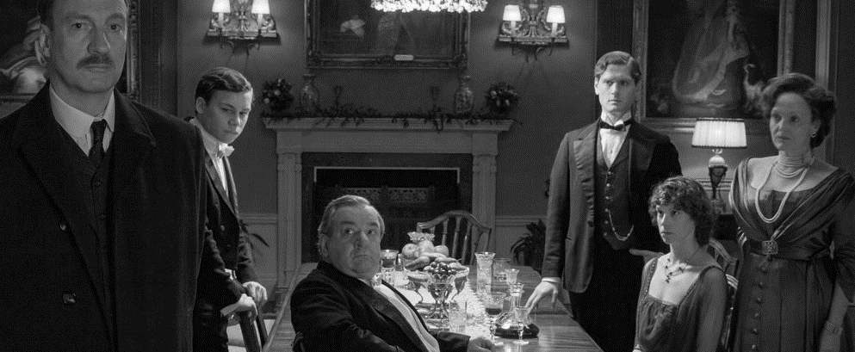
Recap Task

Write down five adjectives to describe each member of the Birling family, Gerald and the Inspector.

Big Question

‘So nothing really happened’ – Does it matter if the Birling family and Gerald have been hoaxed?

Pages: 213-220

Vocabulary

Change | Challenge | Growth
Equality | Warning | Responsibility
Hope | Decline | Generation
Divide | Unite | Progress

Literacy

After Gool departs, Birling becomes suspicious and calls the cheif constable. He discovers that there is no Inspector Goole and

there have been no recent suicides. birling and his wife see this as cause for celebration, but their children are more chastened by

the nights events. The ending twists things further, concluding with a phone call to the Birling’s teling them that the police are on

their way to talk to them about the deth of a young women in a suspected case of suicide.

Source: British Library

Retrieval

- Birling phones Colonel Roberts

- Birling confirms his belief that the family have been hoaxed

- Eric states that the hoax changes nothing

- Gerald argues that the Inspector showed the family different photographs

- Gerald phones the Infirmary

- Gerald confirms that the Infirmary have no record of a girl’s death

- The phone rings

Key Starting Points

- There is a clear generational divide.

- Gerald seems genuinely upset about his role in Eva’s suicide, but ultimately sides with the older Birlings.

- Birling’s speech about ‘man’ having to ‘look after himself’ contrasts with the Inspector’s final speech.

- Birling’s excitement and relief at the Inspector being a ‘fake’ reveals that he has learnt nothing.

- The Inspector’s real identity is, in some ways, unimportant: it’s the reaction of the different characters that counts.

- Through Eric and Sheila, Priestley offers hope for the future

Review of Act Three

- Which character speaks first at the start of act three?

- Which character says, ‘Besides, you’re not that type – you don’t get drunk’?

- What does Eric drink before engaging with the Inspector’s questions?

- In which month did Eric meet Eva?

- How much money did Eric give Eva?

- Which character says, ‘Your trouble is – you’ve been spoilt’?

- Which character speaks with ‘calm authority’?

- Which character is ‘nearly at breaking point’?

- How much money does Birling say he would give to Eva if he had the chance?

- How many ‘Eva Smiths and John Smiths’ does the Inspector say there are?

- Which character says, ‘there’ll be a public scandal’?

- Which character is the first to suspect that the Inspector might not be entirely ‘ordinary’?

- Which character says, ‘Probably a Socialist or some sort of crank’?

- Edna has a single line in act three – what is it?

- Which character declares that Inspector Goole ‘wasn’t a police officer’?

- Who does Birling call to verify that the Inspector is a ‘fake’?

- Which character says, ‘I suppose we’re all nice people now’?

- On what page does Sheila say her parents ‘don’t seem to understand’?

- On what page does Sheila say ‘won’t bring Eva Smith back to life’?

- What evidence does Gerald have for suggesting that Eva Smith might actually be ‘four or five different girls’?

- Why doesn’t Eric think it matters if this is the case or not?

- Who does Gerald call to check if ‘there’s a dead girl’?

- Which character says, ‘The whole story’s just a lot of moonshine’?

- Which character recalls the Inspector’s reference to ‘Fire and blood and anguish’?

- Which character says, ‘And a police inspector is on his way here – to ask some – questions’?

Common Misconceptions

- Gerald did nothing wrong

The Inspector says that Gerald ‘at least had some affection’ for Eva (Daisy). However, the uncomfortable truth remains that his behaviour was predatory. He took advantage of Eva’s desperate circumstances and embarked on a relationship with her knowing that it couldn’t possibly last. He’s no ‘Fairy Prince’, despite what he might like to think.

- Birling is stupid

Birling’s incorrect predictions about the future don’t necessarily show that he’s stupid. Limited, perhaps, but not stupid. However, they do highlight his arrogance. He speaks with a misplaced confidence and won’t entertain Eric’s (reasonable) attempts to challenge him – ‘You’ve a lot to learn yet.’

- Birling did nothing wrong

In a legal sense, Birling did nothing wrong. He acted within his rights as an employer. However, his dismissal of Eva for causing ‘trouble’ is morally questionable. As Eric points out, his father could’ve ‘kept her on instead of throwing her out’ – particularly because, by his own admission, she was a ‘good worker’.

- Sheila is naive

Sheila might appear to have very little understanding of the wider world around her and, to an extent, this is very much the case. However, she does possess more knowledge that it initially seems. For example, she’s suspicious of the reasons behind Gerald’s absence and she is fully aware of the double-lives lived by men like Alderman Meggarty.

- Socialism is communism

Socialism is about the inequalities that arise within capitalist societies; the aim of socialists is to reduce those inequalities. In a communist country, there are no private businesses and no private property. The Inspector might be a ‘crank’, accounting to Birling at least, but he is not a communist.

- Edna is unimportant

Edna is unimportant in the sense that she has few lines in the play and only appears a handful of times on stage. However, her understated presence at the beginning of the play – ‘just clearing the table’ – signifies the Birling family’s wealth and acts as a reminder of the rigid social hierarchy of Edwardian England.

- Eric’s drunkenness excuses his behaviour

Eric was ‘in that state when a chap easily turns nasty’. However, his drunkenness in no way excuses what he did. The issue is around consent: he pressurises her into having sex by threatening ‘to make a row’. The Inspector calls it out when he says that Eric used her ‘as if she was an animal, a thing, not a person.’

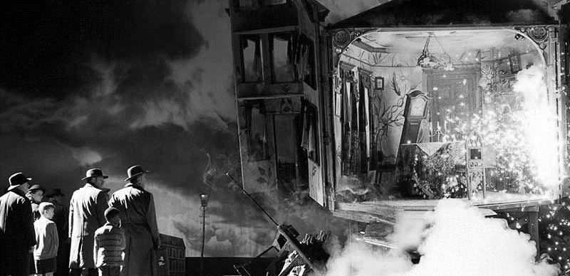
The Knowledge

- The Birling family live in a ‘fairly large suburban house’ and, at rise of curtain, they are ‘pleased with themselves’.
- Birling remarks awkwardly that ‘it’s a pity Sir George and – er – Lady Croft can’t be with us’.
- Gerland presents Sheila with an engagement ring and she exlaims, ‘Oh – it’s wonderful!’
- Birling makes predictions about the future; he says, ‘we’re in for a time of steadily increasing prosperity’.
- Birling is unrepentant about his role in the suicide of Eva Smith, remarking that ‘it’s a free country’.
- Eric disagrees by saying that ‘it isn’t if you can’t go and work somewhere else’.
- Eva does manage to find another job because ‘Milwards suddenly found themselves short-handed’.
- Sheila feels deeply guilty about using her influence to get Eva sacked; she says that ‘if I could help her now, I would – ’.
- The Inspector reveals that Eva changed her name to Daisy Renton, which prompts Gerald to ask ‘[startled] what?’
- Gerald asks Sheila not to tell the Inspector about his relationship with Daisy; he says, ‘we can keep it from him’.

Celebration | Wealth | Class | Entrepreneur | Prediction
Engagement | Provincial | Hierarchy | Labour | Strike

- Gerald tries to deter Sheila from staying to witness the questions and answers that are ‘bound to be unpleasant’.
- Mrs Birling notes Eric’s absence and remarks that he ‘seems to be in an excitable silly mood’.
- Gerald conceeds to the Inspector that he met the ‘quite different’ and ‘pretty‘ Daisy in the disreputable Palace Bar.
- Gerald says that he ‘broke it off’ with her before he went away for ‘several weeks’ on business.
- The Inspector reveals Daisy kept a diary, in which she wrote that ‘she felt there’d never be anything as good again for her’.
- Obviously upset, Gerald excuses himself and leaves; however, he says, ‘I’m coming back’.
- Mrs Birling claims that she ‘did nothing I’m ashamed of or that won’t bear investigation’.
- She refused Eva charity money, stating that it is the father’s ‘responsibility’ to support her.
- Mrs Birling defiantly says, ‘I blame the young man who was the father of the child she was going to have’.
- When it is implied that Eric is the father, Mrs Birling becomes agitated and says, ‘I won’t believe it’.

Responsibility | Absence | Relationship | Investigation | Impudence
Interrogation | Deceit | Support | Charity | Confession

- Eric says bitterly to his mother that ‘you haven’t made it any easier for me’.
- Eric admits that he was ‘a bit squiffy’ when he met Eva and ‘was in that state when a chap easily turns nasty’.
- He saw Eva again; he ‘liked’ her, but ‘wasn’t in love with her or anything’.
- Eric tells the Inspector that Eva ‘didn’t want me to marry her’.
- Eric admits to taking money from his father; Birling reacts angrily and says that Eric has been ‘spoilt’.
- As the Inspector prepares to leave, he highlights to the Birlings and Gerald that each of them ‘helped to kill’ Eva.
- He asks them to remember that ‘there are millions and millions and millions of Eva Smiths and John Smiths still left with us’.
- The Inspector leaves and Birling says he is ‘absolutely ashamed’ of Eric; Eric says that he is ‘ashamed’ of his father ‘as well’.
- Birling believes that he and the rest of the family were ‘bluffed’; he later concludes that the Inspector was a ‘fake!’
- The play ends with Birling reporting that ‘a police inspector is on his way here – to ask some – questions’.

Guilt | Dispute | Commitment | Shame | Relief
Resentment | Anger | Dishonesty | Dread | Dismay
Final Five

Five things to remember…

- Sheila isn’t naive

She knows about Eric’s drinking; she knows Gerald wasn’t working all summer; she knows about Joe Meggarty.

- The lighting matters

‘Pink and intimate’ prior to the Inspector’s arrival; ‘brighter and harder’ afterwards.

- The stage directions matter

Compare the beginning of the play (‘gaily’, ‘positively’, ‘smiling’) with the middle (‘severely’, ‘bitterly’, ‘distressed’).

- Joe Meggarty is predatory and lecherous

His treatment of Eva is in no way dissimilar to Gerald and Eric’s treatment of her.

- Much of what the Birlings and Gerald say about Eva is positive

Birling concedes that she was a good worker; Sheila admits to being jealous of her; Eric highlights her morality.

