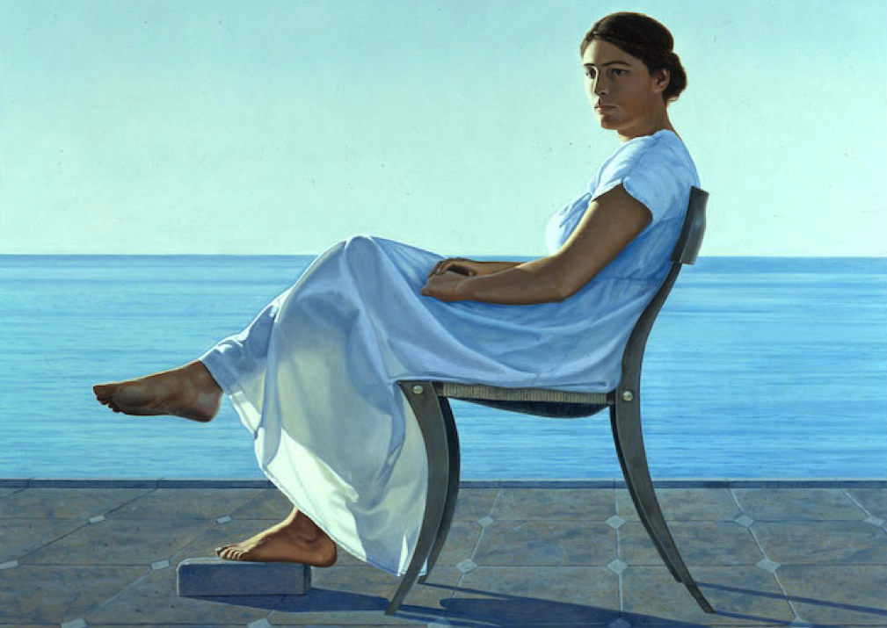

Who + Detail + What
Penelope, her face turned away from the glare of the sun, looked towards the shore.
- Describe the shore (e.g. fishermen or cliffs or birds or distant groups of people)

Description + More Detail
It was calm today, with only a light breeze skimming over waves that broke gently on the sand.
- Describe an action (e.g. Penelope stands-up or she walks over to the sea or she kicks away the stone)

Flashback
When she was younger, she’d always dreamt of escaping from her father’s palace and starting a new life.
- Provide more detail (e.g. Penelope’s father is controlling or she yearns for adventure or she feels frustrated)

Narrator’s Voice + Background
She knew that she was braver and more capable than her siblings, so she saw the journey in front of her as a challenge
- Provide more detail (e.g. the journey is long or she has to travel in disguise or she needs help along the way)

Feeling + Other Character
She would miss her mother – that was beyond doubt – but she remembered the parting words they had exchanged.
- Develop the character (e.g. Penelope’s mother is like her and she advises her to be brave and she gives her blessing)
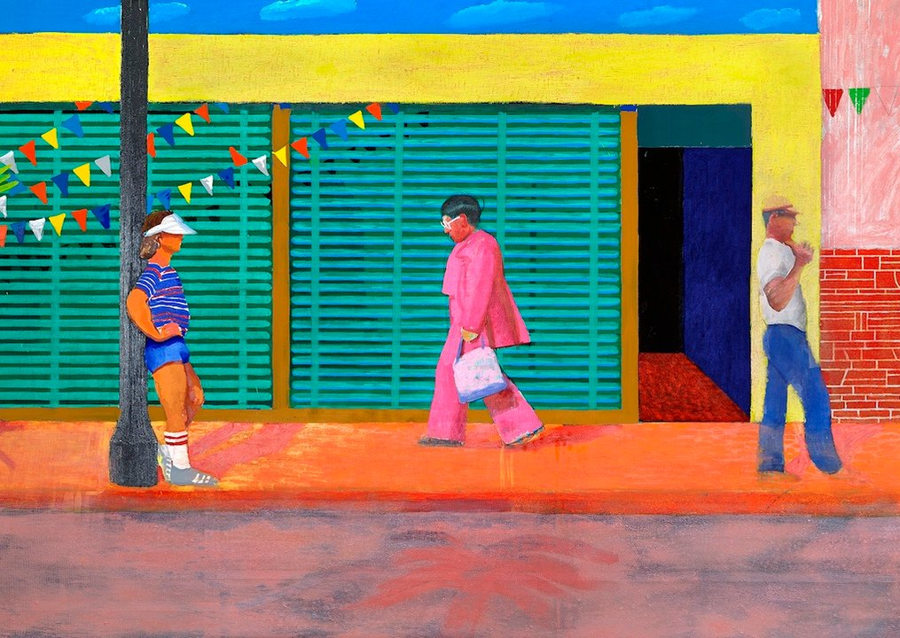

Who + Detail + What
Penelope, her face turned away from the glare of the sun, looked towards the shore.
- Describe the shore (e.g. fishermen or cliffs or birds or distant groups of people)

Description + More Detail
It was calm today, with only a light breeze skimming over waves that broke gently on the sand.
- Describe an action (e.g. Penelope stands-up or she walks over to the sea or she kicks away the stone)

Flashback
When she was younger, she’d always dreamt of escaping from her father’s palace and starting a new life.
- Provide more detail (e.g. Penelope’s father is controlling or she yearns for adventure or she feels frustrated)

Narrator’s Voice + Background
She knew that she was braver and more capable than her siblings, so she saw the journey in front of her as a challenge
- Provide more detail (e.g. the journey is long or she has to travel in disguise or she needs help along the way)

Feeling + Other Character

