Sentence Crafting

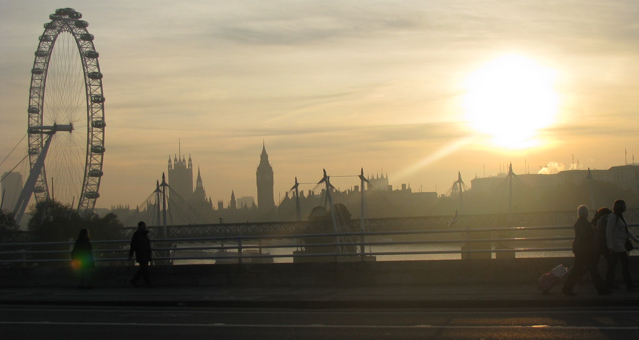

- Provide Further Explanation (Colon)
The early morning sun shone over the river as I walked across the bridge: it was surely a sign of better things to come.

- Start with an Action (Verb Phrase)
Running as fast as I could, I realised about halfway across the bridge that I wouldn’t make in time.

- Describe the Mood or Manner (Adverb)
Cautiously, I looked up and saw the silhouette of the building where I knew she would be waiting.

- Convey a ‘Measured’ Inner-Thought (Brackets)
The bridge was almost deserted (remarkably, not a single commuter or tourist in sight) and I finally felt free.

- Convey a ‘Spontaneous’ Inner-Thought (Dashes)
She said she would be there – she had been absolutely clear – so perhaps it was unfair of me of start having doubts.

- Qualify a Statement (Subordinate Clause)
Although the sun had now broken through the early morning fog, I still felt the chill of the wind coming from the river.

- Change Direction (Subordinate Clause)
The light on the river was clear and bright, but my future remained cloudy.

- Ask a Question (Rhetorical Question)
Why wasn’t anyone taking the time to appreciate the beautiful morning light?

- Repeat an Image (Repetition)
The light on the river was golden. My future was golden. Everything had worked out exactly as I had planned.

