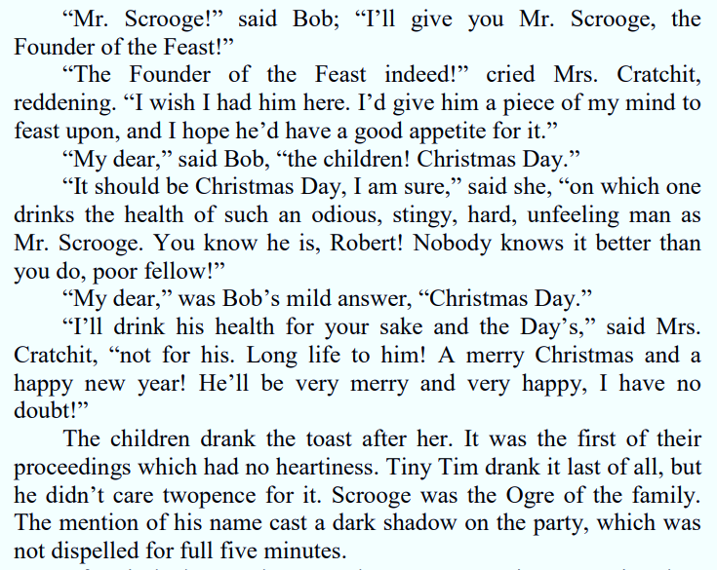

Sentence Fragments | 1 | 2 | 3
calls Scrooge an ‘odious, stingy, hard, unfeeling man’ | furthermore | because | before
exclaims that ‘nobody knows it better’ than Bob | despite | indeed | after
presents Scrooge as | above all | as revealed by | whereas

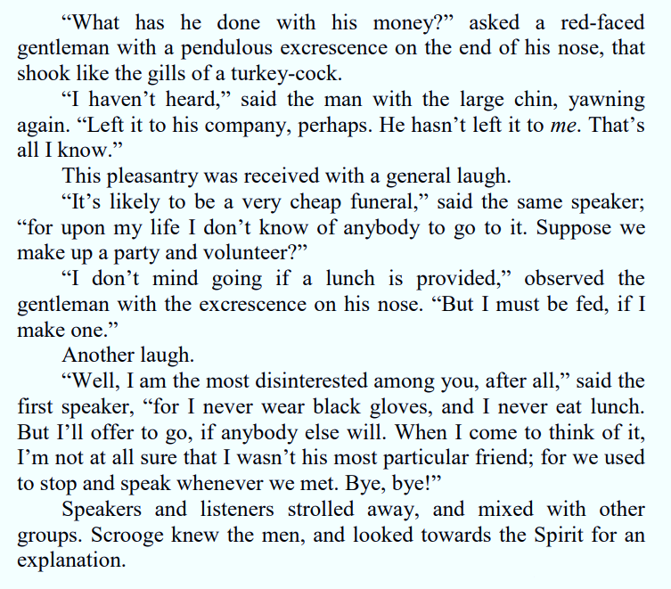

Sentence Fragments | 1 |  | 2 |  | 3
the ‘general laugh’ |  | furthermore |  | in particular |  | in contrast
the appearance of the gentlemen |  | because |  | although |  | for example
the verb ‘strolled’ |  | after |  | despite |  | significantly
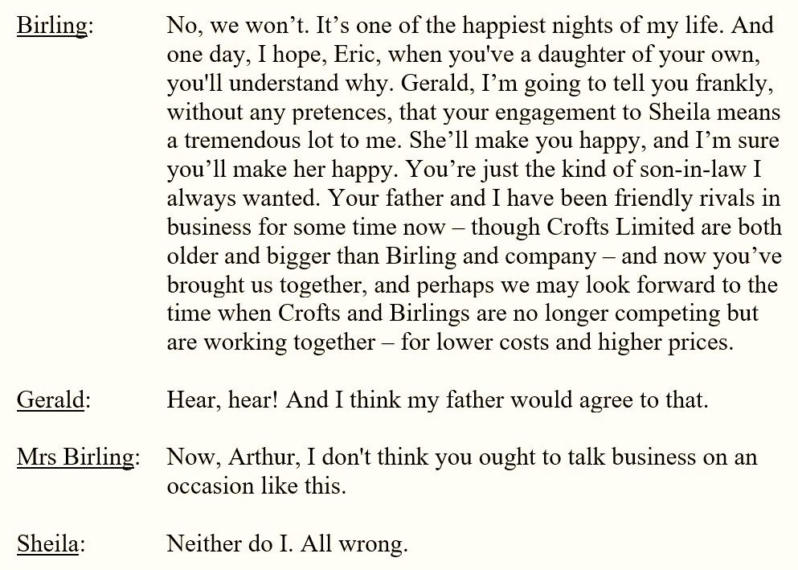

Sentence Fragments | 1 |  | 2 |  | 3
states that it’s ‘one of the happiest nights’ of his life |  | because |  | before |  | first
agrees with |  | furthermore |  | after |  | above all
expresses disagreement |  | Also |  | however |  | In contrast

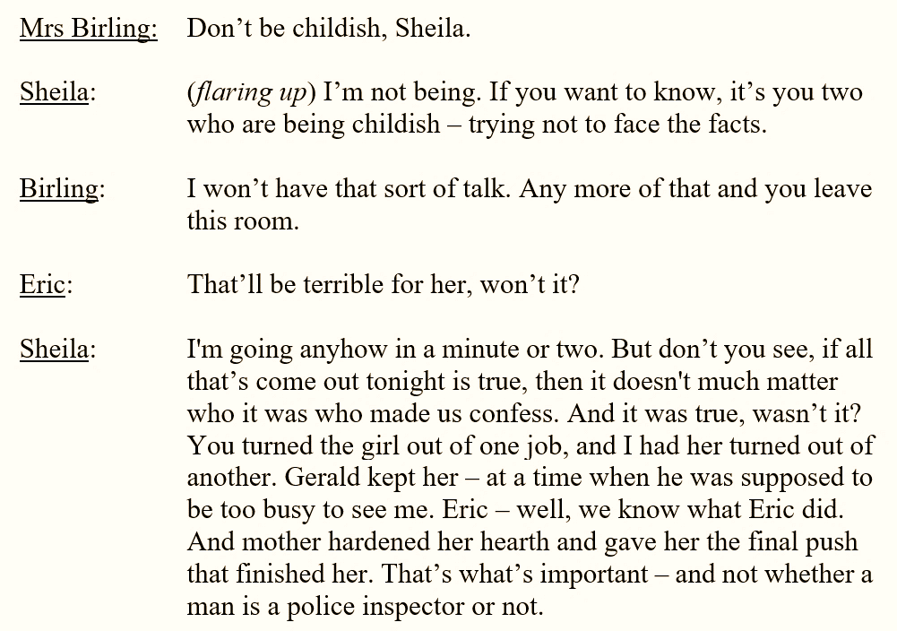

Sentence Fragments | 1 |  | 2 |  | 3
‘childish’ |  | because |  | despite |  | for example
‘terrible’ |  | after |  | however |  | above all
‘important’ |  | finally |  | although |  | In contrast

