Study Booklet

Romeo and Juliet

3 | Knowledge organiser
4 | The Prologue
5 | Act 1, Scene 1 – Extract 1
6 | Act 1, Scene 1 – Extract 2
7 | Act 1, Scene 1 – Extract 3
8 | Act 1, Scene 2
9 | Act 1, Scene 3
10 | Act 1, Scene 4
11 | Act 1, Scene 5 – Extract 1
12 | Act 1, Scene 2 – Extract 2
13 | Review of Act 1 and Assessment
14 | Act 2, Scene 2 – Extract 1
15 | Act 2, Scene 2 – Extract 2
16 | Act 2, Scene 3
17 | Act 2, Scene 4
18 | Act 2, Scene 5
19 | Act 2, Scene 6
20 | Review of Act 2 and Assessment
21 | Act 3, Scene 1 – Extract 1
22 | Act 3, Scene 1 – Extract 2
23 | Act 3, Scene 2
24 | Act 3, Scene 3
25 | Act 3, Scene 5
26 | Review of Act 3 and Assessment
27 | Act 4, Scene 1
28 | Act 4, Scene 4
29 | Act 4, Scene 5
30 | Review of Act 4
31 | Act 5, Scene 3 – Extract 1
32 | Act 5, Scene 3 – Extract 2
33 | Review of Act 5
34 | Final Assessment
35 | Wider Reading

Key Scenes
Act 1 | Fighting breaks out between the Montagues and Capulets; marriage between Juliet and Paris is proposed; Romeo and Juliet fall in love.
 | ‘My only love sprung from my only hate!
Act 2 | Romeo is teased about his former love for Rosaline; Romeo learns of Tybalt’s challenge; Romeo and Juliet plan their marriage; Friar Lawrence performs the ceremony.
 | ‘Wisely and slow, they stumble that run fast’
Act 3 | Tybalt kills Mercutio; Romeo kills Tybalt and is banished from Verona; Capulet makes plans for Juliet to marry Paris.
 | ‘O, I am fortune’s fool.’
Act 4 | Juliet takes Friar Lawrence’s potion; the Capulets prepare for the wedding of Paris and Juliet; Juliet cannot be woken and the Capulets believe she has died.
 | ‘Romeo, Romeo, Romeo! Here’s drink – I drink to thee.’
Act 5 | Romeo believes that Juliet has died and visits her tomb; Romeo encounters Paris and kills him; Romeo kills himself; Juliet awakes and then swiftly kills herself.
 | ‘O, happy dagger’
Key Characters |  | Key Themes |  | Key Words
Romeo | - ‘Loved’ Rosaline; loves Juliet  - Kills Tybalt  - Banished from Verona | Fate | - Romeo and Juliet are ‘star-crossed lovers’  - Romeo attempts to deny fate: ‘I defy you, stars!’  - Romeo has bad dreams; Juliet foresees bad things | - Shakespeare  - Tragedy  - Comedy  - Prologue  - Chorus  - Blank verse  - Iambic pentameter  - Dramatic irony  - Verona  - Mantua  - Friendship  - Status  - Loyalty  - Appearance  - Deception  - Light  - Darkness
Juliet | - Loves Romeo; does not want to marry Paris  - Takes Friar Lawrence’s potion  - Fails to wake in time. | Family | - The Montagues and Capulets are in conflict  - Juliet defies her mother and father  - Capulet and Lady Capulet are enraged by Juliet
Friar Lawrence | - Has the very best of intentions  - Agrees to marry Romeo and Juliet  - Supplies Juliet with a sleeping potion | Love | - Juliet does not love Paris  - Romeo and Juliet love ‘springs’ from hate  - Love is always overshadowed by death
Mercutio | - Lively, devoted friend to Romeo  - Provokes Tybalt  - Killed by Tybalt. | Violence | - The male characters fight to the death  - Extreme emotions are ‘violent delights’  - The play finishes with ‘violent ends’
Tybalt | - Juliet’s cousin  - Proud and protective  - Killed by Romeo. | Conflict | - An ‘ancient grudge’ frames the events of the play  - Perceived dishonour leads to conflict  - Both Romeo and Juliet experience inner conflict

The Prologue

Notes

Enter Chorus
Two households, both alike in dignity,
In fair Verona, where we lay our scene,
From ancient grudge break to new mutiny,
Where civil blood makes civil hands unclean.
From forth the fatal loins of these two foes 5
A pair of star-cross’d lovers take their life;
Whose misadventur’d piteous overthrows
Do with their death bury their parents’ strife.
The fearful passage of their death-mark’d love,
And the continuance of their parents’ rage, 10
Which, but their children’s end, nought could remove,
Is now the two hours’ traffic of our stage;
The which if you with patient ears attend,
What here shall miss, our toil shall strive to mend.

households Families
civil Related to citizens and society
star-cross’d Ill-fated
death-mark’d Doomed to die
two-hours’ traffic The play will last for two hours

Questions

- What do we learn about the plot?

- Which quotations link to the images below?

- What themes (i.e. big ideas) emerge?

Act 1, Scene 1 – Extract 1

Notes

Prince Escales
Rebellious subjects, enemies to peace, 75
Profaners of this neighbour-stained steel –
Will they not hear? What, ho! you men, you beasts,
That quench the fire of your pernicious rage
With purple fountains issuing from your veins,
On pain of torture, from those bloody hands 80
Throw your mistemper’d weapons to the ground,
And hear the sentence of your moved prince.
Three civil brawls, bred of an airy word,
By thee, old Capulet, and Montague,
Have thrice disturb’d the quiet of our streets, 85
And made Verona’s ancient citizens
Cast by their grave beseeming ornaments,
To wield old partisans, in hands as old,
Canker’d with peace, to part your canker’d hate:
If ever you disturb our streets again, 90
Your lives shall pay the forfeit of the peace.
For this time, all the rest depart away:
You Capulet; shall go along with me:
And, Montague, come you this afternoon,
To know our further pleasure in this case, 95
To old Free-town, our common judgment-place.
Once more, on pain of death, all men depart.

Questions

- What punishment does the Prince threaten the families with if violence breaks out again?

- Why does he call the men ‘beasts’?

- What connotations do the metaphors of ‘fire’ and ‘fountains convey?

Act 1, Scene 1 – Extract 2

Notes

Montague
Many a morning hath he there been seen, 125
With tears augmenting the fresh morning dew.
Adding to clouds more clouds with his deep sighs;
But all so soon as the all-cheering sun
Should in the furthest east begin to draw
The shady curtains from Aurora’s bed, 130
Away from the light steals home my heavy son,
And private in his chamber pens himself,
Shuts up his windows, locks far daylight out
And makes himself an artificial night:
Black and portentous must this humour prove, 135
Unless good counsel may the cause remove.
Benvolio
My noble uncle, do you know the cause?

augmenting Supplementing
Aurora’s bed The Greek goddess of dawn; sunrise
heavy Sad
humour Mood

Questions

- What does Montague reveal about how Romeo is feeling?

- Which quotations link to the images below?

- What themes (i.e. big ideas) emerge from the conversation between Benvolio and Montague?

- To what extent does Romeo appear to conform to the archetype of a courtly lover?

Act 1, Scene 1 – Extract 3

Notes

Romeo
A right good mark-man! And she’s fair I love.
Benvolio
A right fair mark, fair coz, is soonest hit. 200
Romeo
Well, in that hit you miss: she’ll not be hit
With Cupid’s arrow; she hath Dian’s wit;
And, in strong proof of chastity well arm’d,
From love’s weak childish bow she lives unharm’d. 205
She will not stay the siege of loving terms,
Nor bide the encounter of assailing eyes,
Nor ope her lap to saint-seducing gold:
O, she is rich in beauty, only poor,
That when she dies with beauty dies her store. 210
Benvolio
Then she hath sworn that she will still live chaste?

mark Target
Cupid’s arrow Cupid is traditionally depicted as a young, winged boy who shoots arrows of love
Dian Diana; the Greek goddess of chastity
chastity Sexual restraint
proof Armour
saint-seducing gold Gold that would seduce even a saint

Questions

- What does Romeo mean when he says of Rosaline, ‘From love’s weak childish bow she lives unharm’d’?

- Which of the following adjectives most precisely describes Romeo? Sad | Melancholy | Frustrated | Hopeful | Desperate

- What is it about Rosaline that Romeo seems to particularly love?

- How does this extract develop our understanding of Romeo’s character?

Act 1, Scene 2

Notes

Capulet
But saying o’er what I have said before:
My child is yet a stranger in the world;
She hath not seen the change of fourteen years,
Let two more summers wither in their pride, 10
Ere we may think her ripe to be a bride.
Paris
Younger than she are happy mothers made.
Capulet
And too soon marr’d are those so early made.
The earth hath swallow’d all my hopes but she,
She is the hopeful lady of my earth: 15
But woo her, gentle Paris, get her heart,
My will to her consent is but a part;
An she agree, within her scope of choice
Lies my consent and fair according voice.

ripe ready
marr’d Spoiled (particularly relating to appearance)
swallow’d all my hopes Juliet is Capulet’s only child
her scope of choice Capulet’s consent is contingent on who Juliet chooses to marry
get her heart Make Juliet fall in love
consent Agreement

Questions

- What evidence is there to suggests that Capulet is protective of his daughter?

- What do you learn about Paris in this extract from his single line?

- To what extent is Capulet’s attitude towards marriage typical of Elizabethan times?

- To what extent does Romeo appear to conform to the archetype of a courtly lover?

Act 1, Scene 3

Notes

Lady Capulet
Well, think of marriage now; younger than you, 70
Here in Verona, ladies of esteem,
Are made already mothers: by my count,
I was your mother much upon these years
That you are now a maid. Thus then in brief:
The valiant Paris seeks you for his love. 75
Nurse
A man, young lady! lady, such a man
As all the world – why, he’s a man of wax.
Lady Capulet
Verona’s summer hath not such a flower.
Nurse
Nay, he’s a flower; in faith, a very flower.
Lady Capulet
What say you? Can you love the gentleman? 80

ladies of esteem Women of nobility
valiant Brave and courageous
man of wax A perfect model (man)

Questions

- Which quotations link to the images below?

- What is the Nurse’s view of Paris?

- How do you know that the Nurse’s view of Paris is like the view held by Lady Capulet?

- Which of the following adjectives most precisely describes Paris? Handsome | Charming | Respectable | Sensitive | Kind

Act 1, Scene 4

Notes

Mercutio
O, then, I see Queen Mab hath been with you.
She is the fairies’ midwife, and she comes
In shape no bigger than an agate-stone 55
On the fore-finger of an alderman,
Drawn with a team of little atomies
Over men’s noses as they lie asleep;
Her chariot is an empty hazel-nut,
Made by the joiner squirrel or old grub, 60
Time a’mind the fairies’ coachmakers:
Her wagon-spokes made of long spiders’ legs,
The cover of the wings of grasshoppers,
The traces of the smallest spider’s web,
Her collars of the moonshine’s watery beams, 65
Her whip of cricket’s bone, the lash of film,
Her wagoner a small grey-coated gnat,
Not so big as a round little worm
Prick’d from the lazy finger of a maid.
And in this state she gallops night by night 70
Through lovers’ brains, and then they dream of love

Queen Mab A fairy
agate A gemstone
little atomies Creatures as tiny as atoms
Time a’mind Eternity

Questions

- What impression do we get of Mercutio from the passage above?

- Which of the following adjectives most precisely describes Mercutio? Stern | Imaginative | Wild | Dangerous | Playful

Act 1, Scene 5 – Extract 1

Notes

Romeo
Beauty too rich for use, for earth too dear!
So shows a snowy dove trooping with crows,
As yonder lady o’er her fellows shows.
The measure done, I’ll watch her place of stand,
And, touching hers, make blessed my rude hand. 50
Did my heart love till now? Forswear it, sight!
For I ne’er saw true beauty till this night.
Tybalt
This, by his voice, should be a Montague.
Fetch me my rapier, boy. What dares the slave
Come hither, cover’d with an antic face, 55
To fleer and scorn at our solemnity?
Now, by the stock and honour of my kin,
To strike him dead, I hold it not a sin.

rude Rough
Foreswear Deny
rapier A thin, light sword
antic face A comical mask
solemnity Ceremony
kin Family

Questions

- What does Romeo mean when he says of Juliet, ‘So shows a snowy dove trooping with crows’?

- Which line indicates that Romeo did not love Rosaline?

- What does Romeo mean when he says, ‘For I ne’er saw true beauty till this night’?

- Why is Tybalt so angered by Romeo’s presence?

- Why does Tybalt believe it is ‘not a sin’ to kill Romeo?

Act 1, Scene 5 – Extract 2

Notes

Juliet
Go ask his name: if he be married.
My grave is like to be my wedding bed.
Nurse
His name is Romeo, and a Montague; 135
The only son of your great enemy.
Juliet
My only love sprung from my only hate!
Too early seen unknown, and known too late!
Prodigious birth of love it is to me,
That I must love a loathed enemy. 140
Nurse
What’s this? What’s this?
Juliet
A rhyme I learn’d even now
Of one I danced withal.
One calls within ‘Juliet.’
Nurse
Anon, anon!
Come, let’s away; the strangers all are gone.

Prodigious A bad sign
loathed Intense hatred
Anon I’m coming

Questions

- What does Juliet mean when she says, ‘My grave is like to be my wedding bed?

- What evidence is there in the passage above to suggest that Juliet feels conflicted?

Review of Act 1

Big Questions
- How are the themes of love and conflict developed as the act progresses?

- How are Montagues and the Capulets presented?

- In what ways are Benvolio and Mercutio different?

- In what ways are Capulet and Tybalt different?

Assessment
- Starting with this conversation, explore how Shakespeare presents aggressive male behaviour in Romeo and Juliet?
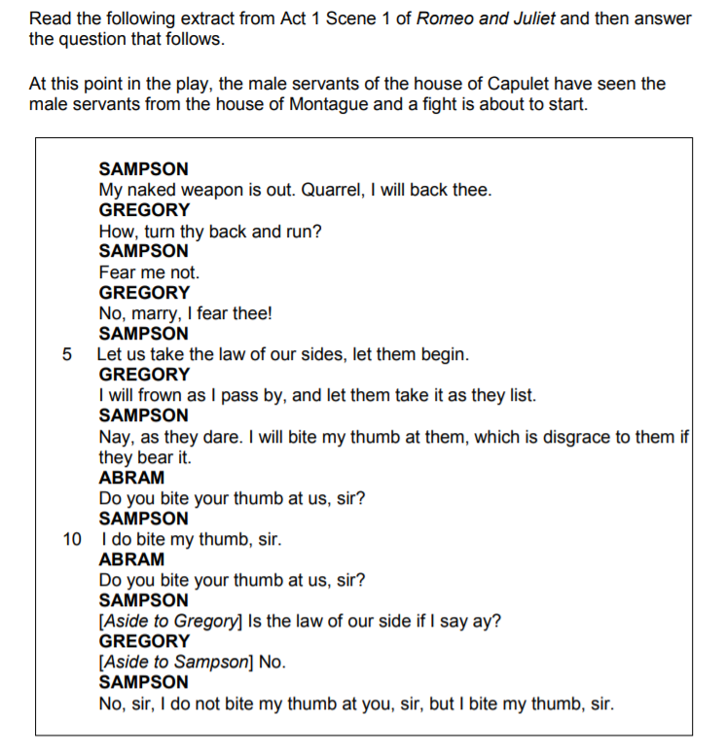
Source: AQA GCSE English Literature Exam Paper (2017)

Act 2, Scene 2 – Extract 1

Notes

Romeo
He jests at scars that never felt a wound.
Juliet appears above at a window.
But, soft! what light through yonder window breaks?
It is the east, and Juliet is the sun.
Arise, fair sun, and kill the envious moon,
Who is already sick and pale with grief, 5
That thou her maid art far more fair than she:
Be not her maid, since she is envious;
Her vestal livery is but sick and green
And none but fools do wear it; cast it off.
It is my lady, O, it is my love! 10
O, that she knew she were!
She speaks yet she says nothing: what of that?
Her eye discourses; I will answer it.
I am too bold, ‘tis not to me she speaks:
Two of the fairest stars in all the heaven, 15
Having some business, do entreat her eyes
To twinkle in their spheres till they return.
What if her eyes were there, they in her head?
The brightness of her cheek would shame those stars,
As daylight doth a lamp; her eyes in heaven 20
Would through the airy region stream so bright
That birds would sing and think it were not night.
See, how she leans her cheek upon her hand!

Questions

- How is Romeo presented in the passage above?

- What images are particularly striking?

Act 2, Scene 2 – Extract 2

Notes

Juliet
Thou know’st the mask of night is on my face, 85
Else would a maiden blush bepaint my cheek
For that which thou hast heard me speak to-night
Fain would I dwell on form, fain, fain deny
What I have spoke: but farewell compliment!
Dost thou love me? I know thou wilt say ‘Ay,’ 90
And I will take thy word: yet if thou swear’st,
Thou mayst prove false; at lovers’ perjuries
Then say, Jove laughs. O gentle Romeo,
If thou dost love, pronounce it faithfully:
Or if thou think’st I am too quickly won, 95
I’ll frown and be perverse an say thee nay,
So thou wilt woo; but else, not for the world.
In truth, fair Montague, I am too fond,
And therefore thou mayst think my behaviour light:
But trust me, gentleman, I’ll prove more true 100
Than those that have more cunning to be strange.
I should have been more strange, I must confess,
But that thou overheard’st, ere I was ware,
My true love’s passion: therefore pardon me,
And not impute this yielding to light love, 105
Which the dark night hath so discovered.

Perjuries Broken vows

Questions

- What concern is Juliet expressing when she says, ‘Or if thou think’st I am too quickly won’?

- How is romantic love presented in the passage above?

Act 2, Scene 3

Notes

Friar Lawrence
Holy Saint Francis, what a change is here! 65
Is Rosaline, whom thou didst love so dear,
So soon forsaken? Young men’s love then lies
Not truly in their hearts, but in their eyes.
Jesu Maria, what a deal of brine
Hath wash’d thy sallow cheeks for Rosaline! 70
How much salt water thrown away in waste,
To season love, that of it doth not taste!
The sun not yet thy sighs from heaven clears,
Thy old groans ring yet in my ancient ears;
Lo, here upon thy cheek the stain doth sit 75
Of an old tear that is not wash’d off yet:
If e’er thou wast thyself and these woes thine,
Thou and these woes were all for Rosaline:
And art thou changed? Pronounce this sentence then,
Women may fall, when there’s no strength in men. 80
Romeo
Thou chid’st me oft for loving Rosaline.

Jesu Maria Jesus and Mary
sallow Sickly
wast thyself were sincere

Questions

- What does Friar Lawrence appear to be particularly surprised about?

- How does he describe Romeo’s behaviour when has was infatuated by Rosaline?

- What does Friar Lawrence mean when he says, ‘there’s no strength in men’?

Act 2, Scene 4

Notes

Mercutio
Alas poor Romeo! he is already dead; stabbed with a
white wench’s black eye; shot through the ear with a
love-song; the very pin of his heart cleft with the 15
blind bow-boy’s butt-shaft: and is he a man to
encounter Tybalt?
Benvolio
Why, what is Tybalt?
Mercutio
More than prince of cats, I can tell you. O, he is
the courageous captain of compliments. He fights as 20
you sing prick-song, keeps time, distance, and
proportion; rests me his minim rest, one, two, and
the third in your bosom: the very butcher of a silk
button, a duellist, a duellist; a gentleman of the
very first house, of the first and second cause: 25
ah, the immortal ‘passado’! The ‘punto reverso’! the
‘hay’!

blind bow-boy Cupid
passado […] hay A duelling move

Questions

- Which quotations link to the images below?

- Who is the better fighter: Romeo or Tybalt?

- What does Mercutio mean when he says of Tybalt that he is ‘the very butcher of a silk button’?

- Which of the following adjectives most precisely describes Tybalt? Dangerous | Timid | Aggressive | Skilful | Brave

Act 2, Scene 5

Notes

Juliet
How art thou out of breath, when thou hast breath
To say to me that thou art out of breath?
The excuse that thou dost make in this delay
Is longer than the tale thou dost excuse.
Is thy news good, or bad? answer to that; 35
Say either, and I’ll stay the circumstance:
Let me be satisfied, is’t good or bad?
Nurse
Well, you have made a simple choice; you know not
how to choose a man: Romeo! no, not he; though his
face be better than any man’s, yet his leg excels 40
all men’s; and for a hand, and a foot, and a body,
though they be not to be talked on, yet they are
past compare: he is not the flower of courtesy,
but, I’ll warrant him, as gentle as a lamb. Go thy
ways, wench; serve God. What, have you dined at home? 45
Juliet
No, no: but all this did I know before.
What says he of our marriage? what of that?

simple Foolish
flower A prime example; a model

Questions

- How do we know that the Nurse is teasing Juliet?

- How do we know that Juliet is desperate to hear news about Romeo?

- How does the Nurse describe Romeo?

- In terms of the structure of the play, why might this scene be important?

Act 2, Scene 6

Notes

Friar Lawrence
These violent delights have violent ends
And in their triumph die, like fire and powder, 10
Which as they kiss consume: the sweetest honey
Is loathsome in his own deliciousness
And in the taste confounds the appetite:
Therefore love moderately; long love doth so;
Too swift arrives as tardy as too slow. 15
Enter Juliet.
Here comes the lady: O, so light a foot
Will ne’er wear out the everlasting flint:
A lover may bestride the gossamer
That idles in the wanton summer air,
And yet not fall; so light is vanity. 20
Juliet
Good even to my ghostly confessor?
Friar Lawrence
Romeo shall thank thee, daughter, for us both.
Juliet
As much to him, else is his thanks too much.
Friar Lawrence
Romeo shall thank thee, daughter, for us both.
Juliet returns his kiss.

wanton Playful

Questions

- What does Friar Lawrence mean when he says, ‘These violent delights have violent ends’?

- How does Friar Lawrence describe Juliet?

Review of Act 2

Big Questions
- How has the relationship between Romeo and Juliet developed since Act One?

- What further indications are we given that Romeo and Juliet are ‘star-cross’d’?

- What are the similarities in the views held by Friar Lawrence and the Nurse about Romeo and Juliet’s relationship?

- What imagery is particularly prevalent in Act Two?

Assessment
- Starting with this conversation, explore how Shakespeare presents Romeo’s attitude to love in Romeo and Juliet?
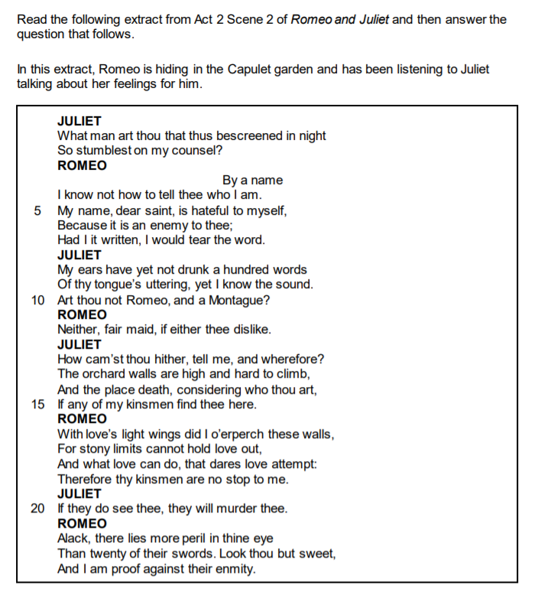
Source: AQA GCSE English Literature Specimen Assessment Materials 3

Act 3, Scene 1 – Extract 1

Notes

Tybalt
Well, peace be with you, sir: here comes my man.
Mercutio
But I’ll be hanged, sir, if he wear your livery:
Marry, go before to field, he’ll be your follower; 55
Your worship in that sense may call him ‘man.’
Tybalt
Romeo, the hate I bear thee can afford
No better term than this – thou art a villain.
Romeo
Tybalt, the reason that I have to love thee
Doth much excuse the appertaining rage 60
To such a greeting: villain am I none;
Therefore farewell; I see thou know’st me not.
Tybalt
Boy, this shall not excuse the injuries
That thou hast done me; therefore turn and draw.
Romeo
I do protest, I never injured thee, 65
But love thee better than thou canst devise,
Till thou shalt know the reason of my love:
And so, good Capulet – which name I tender
As dearly as my own – be satisfied.

Questions

- To ‘go before the field’ means to enter the duelling-ground – what is Mercutio suggesting that Romeo will do?

- What evidence can you find that indicates Romeo does not want to fight Tybalt?

- What is Tybalt alluding to when refers to ‘injuries’ committed by Romeo?

- What do Tybalt’s actions reveal about codes of honour in the play?

Act 3, Scene 1 – Extract 2

Notes

Romeo
Again, in triumph, and Mercutio slain?
Away to heaven, respective lenity,
And fire-eyed fury be my conduct now! 120
Re-enter Tybalt.
Now, Tybalt, take the villain back again,
That late thou gavest me; for Mercutio’s soul
Is but a little way above our heads,
Staying for thine to keep him company:
Either thou, or I, or both, must go with him. 125
Tybalt
Thou, wretched boy, that didst consort him here,
Shalt with him hence.
Romeo
This shall determine that.
They fight; Tybalt falls.
Benvolio
Romeo, away, be gone!
The citizens are up, and Tybalt slain.
Stand not amazed: the prince will doom thee death, 130
If thou art taken: hence, be gone, away!

lenity Mercy

Questions

- Which quotations link to the images below?

- Before Romeo flees, he exclaims, ‘O, I am fortune’s fool’ – what does he mean?

Act 3, Scene 2

Notes

Juliet
Shall I speak ill of him that is my husband?
Ah, poor my lord, what tongue shall smooth thy name,
When I, thy three-hours wife, have mangled it?
But, wherefore, villain, didst thou kill my cousin? 100
That villain cousin would have kill’d my husband:
Back, foolish tears, back to your native spring;
Your tributary drops belong to woe,
Which you, mistaking, offer up to joy.
My husband lives, that Tybalt would have slain; 105
And Tybalt’s dead, that would have slain my husband:
All this is comfort; wherefore weep I then?
Some word there was, worser than Tybalt’s death,
That murder’d me: I would forget it fain;
But, O, it presses to my memory, 110
Like damned guilty deeds to sinners’ minds:
‘Tybalt is dead, and Romeo – banished;’
That ‘banished,’ that one word ‘banished,’
Hath slain ten thousand Tybalts.

native spring Eyes
tributary drops Tears
fain Gladly

Questions

- Who is Juliet’s ‘villain cousin’?

- How does Juliet’s mood and language here contrast to her mood at language at the beginning of the scene?

- Which of the following adjectives most precisely describes Juliet? Angry | Resentful | Wretched | Sad | Confused | Irate

- Why does Juliet say the word ‘banished’ has killed ‘ten thousand Tybalts’?

Act 3, Scene 3

Notes

Romeo
Spakest thou of Juliet? how is it with her?
Doth she not think me an old murderer,
Now I have stain’d the childhood of our joy 95
With blood removed but little from her own?
Where is she? and how doth she? and what says
My conceal’d lady to our cancell’d love?
Nurse
O, she says nothing, sir, but weeps and weeps;
And now falls on her bed; and then starts up, 100
And Tybalt calls; and then on Romeo cries,
And then down falls again.
Romeo
As if that name,
Shot from the deadly level of a gun,
Did murder her; as that name’s cursed hand
Murder’d her kinsman. O, tell me, friar, tell me, 105
In what vile part of this anatomy
Doth my name lodge? Tell me, that I may sack
The hateful mansion.
He offers to stab himself, and the Nurse snatches the dagger away.

My conceal’d lady My secret wife
level Aim

Questions

- What evidence can you find to suggest Romeo is in a desperate state?

- What does the Nurse reveal about Juliet?

Act 3, Scene 5

Notes

Juliet
Wilt thou be gone? it is not yet near day:
It was the nightingale, and not the lark,
That pierced the fearful hollow of thine ear;
Nightly she sings on yon pomegranate-tree:
Believe me, love, it was the nightingale. 5
Romeo
It was the lark, the herald of the morn,
No nightingale: look, love, what envious streaks
Do lace the severing clouds in yonder east:
Night’s candles are burnt out, and jocund day
Stands tiptoe on the misty mountain tops. 10
I must be gone and live or stay and die.
Juliet
Yon light is not day-light, I know it, I:
It is some meteor that the sun exhales,
To be to thee this night a torch-bearer,
And light thee on thy way to Mantua: 15
Therefore stay yet; thou need’st not to be gone.

lark A bird that sings early in morning
nightingale A bird that sings throughout the night
Night’s candles Stars

Questions

- How is the relationship between Romeo and Juliet presented in the passage above?

- Why is Juliet so keen to reassure Romeo that ‘it was the nightingale’ he heard singing?

- Which of the following adjectives most precisely describes Juliet? Hopeful | Stoical | Impatient | Forlorn | Delusional

- Why does Romeo mean when he says, ‘I must be gone and live or stay and die’?

Review of Act 3

Big Questions
- In what ways does Act 3 contrast to Act 2?

- How does Shakespeare convey a sense of anguish and desperation?

- How have Romeo and Juliet developed as characters since Act 1?

- How is the concept of justice presented?

Assessment
- Starting with this moment, explore how Shakespeare presents relationships between adults and young people in Romeo and Juliet?
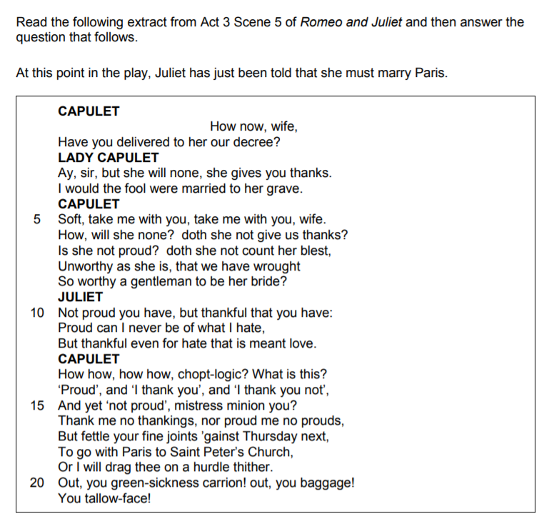
Source: AQA GCSE English Literature Exam Paper (2018)

Act 4, Scene 1

Notes

Friar Lawrence
Hold, daughter: I do spy a kind of hope,
Which craves as desperate an execution.
As that is desperate which we would prevent. 70
If, rather than to marry County Paris,
Thou hast the strength of will to slay thyself,
Then is it likely thou wilt undertake
A thing like death to chide away this shame,
That copest with death himself to scape from it: 75
And, if thou darest, I’ll give thee remedy.
Juliet
O, bid me leap, rather than marry Paris,
From off the battlements of yonder tower;
Or walk in thievish ways; or bid me lurk
Where serpents are; chain me with roaring bears; 80
Or shut me nightly in a charnel-house,
O’er-cover’d quite with dead men’s rattling bones,
With reeky shanks and yellow chapless skulls;
Or bid me go into a new-made grave
And hide me with a dead man in his shroud;
Things that, to hear them told, have made me tremble;
And I will do it without fear or doubt,
To live an unstain’d wife to my sweet love.

charnel-house A building used to store bones dug up in a graveyard

Questions

- What does Juliet say that she’d rather do than marry Paris?

- Juliet says that she wants to be an ‘unstain’d wife’ to Romeo – what does she mean?

Act 4, Scene 4

Notes

Juliet
Farewell! God knows when we shall meet again.
I have a faint cold fear thrills through my veins, 15
That almost freezes up the heat of life:
I’ll call them back again to comfort me:
Nurse! What should she do here?
My dismal scene I needs must act alone.
Come, vial. 20
What if this mixture do not work at all?
Shall I be married then tomorrow morning?
No, no: this shall forbid it: lie thou there.
Laying down her dagger.
What if it be a poison, which the friar
Subtly hath minister’d to have me dead, 25
Lest in this marriage he should be dishonour’d,
Because he married me before to Romeo?
I fear it is: and yet, methinks, it should not,
For he hath still been tried a holy man.
How if, when I am laid into the tomb, 30
I wake before the time that Romeo
Come to redeem me? there’s a fearful point!

thrills Shivers
vial A small glass container (usually cylindrical)
minister’d Prescribed

Questions

- What is Juliet fearful about?

- How do we know that Juliet is fearful?

Act 4, Scene 5

Notes

Capulet
Ha! let me see her: out, alas! she’s cold: 25
Her blood is settled, and her joints are stiff;
Life and these lips have long been separated:
Death lies on her like an untimely frost
Upon the sweetest flower of all the field.
Nurse
O lamentable day! 30
Lady Capulet
O woeful time!
Capulet
Death, that hath ta’en her hence to make me wail,
Ties up my tongue, and will not let me speak.
Enter Friar Lawrence and Paris with Musicians.
Friar Lawrence
Come, is the bride ready to go to church?
Capulet
Ready to go, but never to return.
O son! the night before thy wedding-day 35
Hath Death lain with thy wife. There she lies,
Flower as she was, deflowered by him.
Death is my son-in-law, Death is my heir;
My daughter he hath wedded: I will die,
And leave him all; life, living, all is Death’s. 40

Questions

- Why does Friar Lawrence say, ‘Come, is the bride ready to go to church?’?

- What does Capulet mean when he says, ‘Death is my son-in-law, Death is my heir’?

Review of Act 4

Big Questions
- What repeated images can identify in Act 4?

- What juxtapositions are there in Act 4 and what effect might they have on an audience?

- What examples of dramatic irony are there in Act 4 and what effect might they have on an audience?

- How is the theme of love presented?

Act 5, Scene 3 – Extract 1

Notes

Romeo
A grave? O no! A lantern, slaughter’d youth,
For here lies Juliet, and her beauty makes 85
This vault a feasting presence full of light.
Death, lie thou there, by a dead man interr’d.
Laying PARIS in the tomb
How oft when men are at the point of death
Have they been merry! which their keepers call
A lightning before death: O, how may I 90
Call this a lightning? O my love! My wife!
Death, that hath suck’d the honey of thy breath,
Hath had no power yet upon thy beauty:
Thou art not conquer’d; beauty’s ensign yet
Is crimson in thy lips and in thy cheeks, 95
And death’s pale flag is not advanced there.

Death The dead body of Paris
ensign A signal (i.e. Juliet’s red lips)
pale flag Juliet’s body would have turned pale white in colour if she had been dead for a long time

Questions

- Which quotations link to the images below?

- Which of the following adjectives most precisely describes Romeo? Optimistic | Distraught | Uncertain | Irritable | Sad

- What has happened to Paris?

- Why does Romeo speak largely in exclamation?

- How does Romeo describe Juliet?

- How is Romeo’s presentation in this passage different from his presentation in Act One?

Act 5, Scene 3 – Extract 2

Notes

Juliet
O comfortable friar! where is my lord?
I do remember well where I should be,
And there I am. Where is my Romeo? 150
Friar Lawrence
I hear some noise. Lady, come from that nest
Of death, contagion, and unnatural sleep:
A greater power than we can contradict
Hath thwarted our intents. Come, come away.
Thy husband in thy bosom there lies dead; 155
And Paris too. Come, I'll dispose of thee
Among a sisterhood of holy nuns:
Stay not to question, for the watch is coming;
Come, go, good Juliet,
I dare no longer stay.
Juliet
Go, get thee hence, for I will not away. 160
What's here? A cup, closed in my true love's hand?
Poison, I see, hath been his timeless end:
O churl! Drunk all, and left no friendly drop
To help me after? I will kiss thy lips;
Haply some poison yet doth hang on them, 165
To make die with a restorative.
Thy lips are warm.

Questions

- How does Juliet react to the news that Romeo is dead?

- What does Juliet mean when she says that Romeo has ‘left no friendly drop’ of poison for her?

Review of Act 5

Big Questions
- How is the theme of death presented in Act Five?

- How has the character of Romeo changed since Act One?

- How has the character of Juliet changed since Act One?

- What imagery is particularly prevalent in Act Five?

Final Assessment

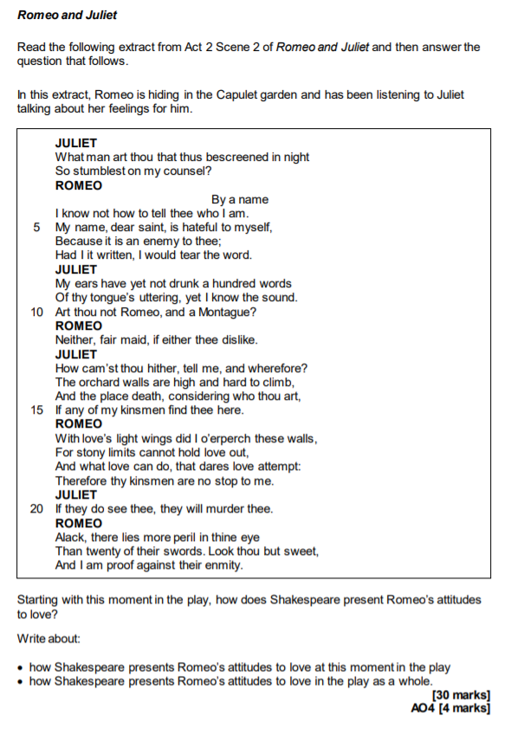

Extracts from An introduction to Shakespearean Tragedy
Source: https://www.bl.uk/shakespeare/articles/an-introduction-to-shakespearean-tragedy

So what is it that stamps a play as the kind of tragedy that merits the term ‘Shakespearean’? The key point should become clear if we turn to one of Shakespeare’s earliest tragedies, Romeo and Juliet. Shakespeare’s immortal couple have become a global byword for lovers driven unjustly to their doom because they belong to warring factions that refuse to tolerate their love. During the last four centuries the play has inspired countless adaptations and offshoots on stage and screen, as well as operas, symphonies, fiction, poetry and paintings. But Romeo and Juliet couldn’t have acquired its enduring resonance, if the significance and value of the tragedy were trapped in the time when Shakespeare wrote it. If the play made sense and mattered only in terms of that time, it wouldn’t be able to reach across the centuries and speak with such urgency to so many different cultures now. That Romeo and Juliet is rooted in the age of Shakespeare, and can’t be fully understood without some knowledge of the world it sprang from, hardly needs demonstrating. But no critical account or production can do justice to Romeo and Juliet, if it’s not alert to the ways in which it was far ahead of Shakespeare’s time and is still far ahead of ours too.

What makes the fate of Romeo and Juliet tragic, and what makes the play a Shakespearean tragedy, is the fact that they live at a time when a boundless love like theirs cannot be sustained and cannot survive, because it belongs to a future men and women are still struggling to create. Romeo and Juliet turn out to have been citizens of truly civilized centuries to come, who reveal the potential to lead more fulfilling lives than those they have been forced to lose by the barbaric age in which they are marooned.

Extracts from Daughters in Shakespeare: dreams, duty and defiance
Source: https://www.bl.uk/shakespeare/articles/daughters-in-shakespeare-dreams-duty-and-defiance

Romeo and Juliet may be a love story, but a daughter/father relationship lies at the heart of the play’s events. Juliet is not yet 14 when the young nobleman Paris approaches her father Capulet for permission to woo his daughter. At first, Capulet seems protective of Juliet, his only surviving child, and proposes that ‘two more summers’ should pass before ‘we may think her ripe to be a bride’. But Paris is a good prospect, a relative of the Prince of Verona, so Capulet agrees to Paris’s request, inviting him to a family feast that very evening which Juliet will be attending.

In Shakespeare’s time, daughters of respectable families, like Juliet, could expect their fathers to have a significant involvement in choosing their future husband. This reflected the subordinate position of women in a patriarchal society, and particularly the traditional view that daughters were a commodity and could be used in marriage to forge useful alliances. Paternal involvement in husband selection provided fertile material for Shakespeare in many of his plays, and he makes considerable dramatic use of the resulting family clashes. Initially, Capulet is seemingly kinder than many fathers in allowing Juliet some say over her future husband: ‘But woo her, gentle Paris, get her heart, / My will to her consent is but a part…’

Later in the play, however, when the family is in shock after their kinsman Tybalt has been murdered, Capulet leaps ahead and sets an early date for the wedding without consulting his daughter first. ‘I think she will be rul’d / In all respects by me’ (3.4.13–14) he comments, clearly expecting Juliet to be compliant.

It’s part of Juliet’s tragedy that she’s unable to tell her authoritarian father about her marriage to Romeo, even though she could express her love with an eloquence that could overcome anger and hatred. Capulet is determined to ‘give’ her to Paris (a father’s prerogative, even enshrined in the marriage ceremony) and she feels she has little option but to agree to Friar Laurence’s drastic plan to fake her own death in order to extricate herself from this situation – a plan that is doomed to go horribly wrong.

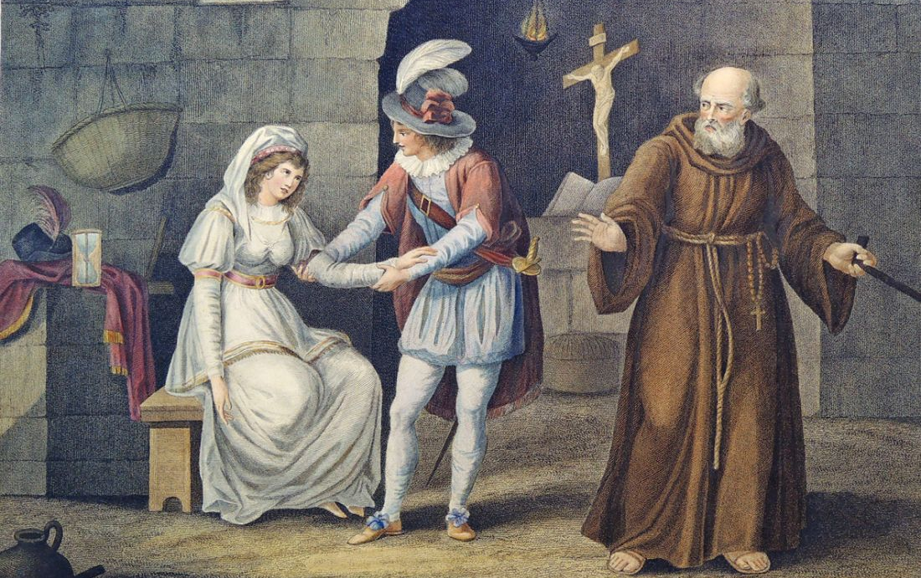
Extracts from Character analysis: Romeo and Juliet in Act 2, Scene 2 – Part 1
Source: https://www.bl.uk/shakespeare/articles/character-analysis-romeo-and-juliet

Famously referred to as the ‘balcony scene’, Act 2, Scene 2 of Romeo and Juliet begins with Juliet standing on her bedroom balcony, talking to herself. She muses on how unfair it is that the striking gentleman she kissed moments ago is in fact Romeo Montague – a young man from the family her Capulet kin are warring with. Romeo, who has crept into the Capulet grounds in order to find Juliet, overhears her words. Stepping out of the shadows, Romeo presents himself to Juliet and the two embark on an impassioned conversation in which they try to define their feelings and profess their love for one another. Their declarations are cut short both by the fear that Romeo will be discovered and by Juliet’s Nurse insistently calling her to come back into her bedroom. Before Romeo finally leaves, Juliet steals away from the Nurse and returns to the balcony. She issues Romeo with instructions about covertly communicating with her the following day in order for them to make plans to marry.

Juliet’s portrayal in this scene feverishly wavers between different positions, reminding the audience how inexperienced and emotionally unsteady she is. Firstly, her speech – seemingly delivered in private – offers the audience access to the thinking of a young girl on the cusp of independent womanhood. In her wrestling with the thorny issue of Romeo’s identity, she repeatedly asks questions: ‘What’s Montague? … What’s in a name?’ These disgruntled interrogatives about the inefficiencies of language and labels – a linguistic probing which connects with Romeo’s later promise to ‘tear the word’ – are also assaults on social rigidity and received wisdom. These are not the words of a submissive child content to follow rules as she has been instructed. They are challenges posed by an individual developing a singular, personal way of looking at the world. They are the utterances of someone dissatisfied with the way things are.

This boldness continues throughout this almost-soliloquy, reaching its greatest intensity at the end of the speech when Juliet offers her ‘self’ to Romeo in exchange for him shedding his ‘name’. This imagined or proposed transaction is radical as it undoes all sorts of patriarchal assumptions. One of these is the idea that after marriage it was women who should lose their names. Secondly, in determinedly stating how she envisages her future, her vow here contradicts the Elizabethan expectation that fathers should ‘pilot’ the destinies of their young daughters rather than the daughters directing themselves.

However, the surprising arrival of Romeo makes Juliet momentarily retreat into a more conventional role: that of the frightened, modest female. She becomes consumed with anxiety that her ‘kinsmen’ may discover and ‘murder’ Romeo. Though concealed by the darkness of night, she claims that her cheeks ‘blush’ at the idea that Romeo heard her earlier, emotional outpouring. Equally, she is desperate for assurances about Romeo’s feelings towards her. However, this submissiveness is short-lived, and Juliet soon regains a sense of stridency. As the scene progresses and Romeo begins to offer Juliet oaths as a way of demonstrating his affection, Juliet controls his smooth talking. Like a much more worldly and experienced woman, one tired of hackneyed ‘chat up lines’, she interrupts and edits his words.

Extracts from Character analysis: Romeo and Juliet in Act 2, Scene 2 – Part 2
Source: https://www.bl.uk/shakespeare/articles/character-analysis-romeo-and-juliet

Romeo’s impulsive nature is in full evidence in this exchange. The very fact of his location – Romeo has brazenly crept behind enemy lines – and his bragging that he has no fear if the Capulets ‘find him’ in their midst clearly demonstrate to the audience how Romeo’s ego is dangerously inflated by the power of love. As soon as he engages in conversation with Juliet, and in order to win her over, he immediately and without real thought about the consequences denies his lineage and heritage, instantly claiming his Montague background is now ‘hateful’. Equally, in response to Juliet’s tender attempts to understand how he has trespassed into her family’s grounds, his hyperbolic declaratives and ornate comparisons are dazzlingly quick and unequivocal.

He figures his pursuit of Juliet in the language of perilous expedition, where he must adventurously scale ‘stony limits’ and traverse the ‘farthest sea’ in order to reach his love. But, movingly, the grandness of his self-presentation is eventually reduced by the power Juliet has over him. By the end of the scene, rather than as a heroic, questing figure, Romeo describes himself as Juliet’s pet ‘bird’: a tiny toy of a thing controlled by her every whim.

This scene compares and contrasts with the beginning of Act 3, Scene 5, which contains another anguished parting between the two lovers. As in Act 2, Scene 2, in the later scene there is a sense of negotiation, exchange and gentle conflict between Romeo and Juliet as they sleepily argue about whether or not it is daylight and if Romeo must leave Juliet’s bedroom before he is caught. In the earlier scene both characters seem to agree that linguistic signs – names, in particular – are problematic. In the famous aubade – a song between lovers marking the dawn – of Act 3, Scene 5, the meaning of other kinds of signs – nightingales, larks and what these might symbolise – troubles the lovers.

In Act 3, Scene 5, the pretence both lovers uphold – at different times – that it is not yet daylight adds a note of childishness to the scene. By seemingly lying to themselves and to each other, these characters reveal themselves to be unwilling or ill-equipped to deal with the adult realities of their situation, and so escape into a fantastical realm where they can control the passage of time and prolong the secrecy of night. This youthful element neatly matches with Romeo’s impetuousness and Juliet’s greenness explored earlier.

Identity emerges as one of the key ideas in Act 2, Scene 2. As well as the discussion of naming, the shifting characterisations of the two lovers prompt audiences to ponder who we become when influenced by love, what we might sacrifice in order to love and how we change ourselves in the presence of one we love.

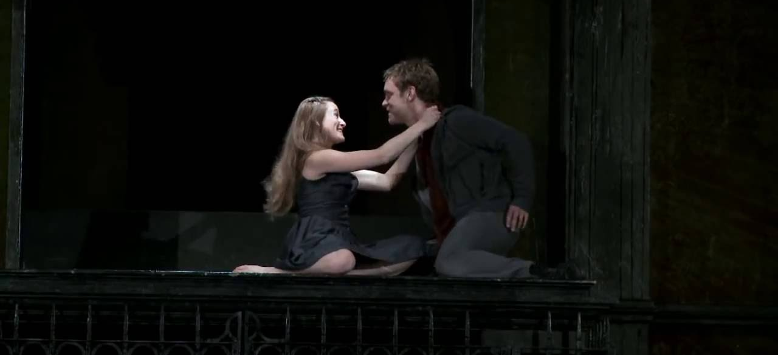
Extracts from The violence of Romeo and Juliet
Source: https://www.bl.uk/shakespeare/articles/new-mutiny-the-violence-of-romeo-and-juliet

All Shakespeare’s plays contain themes that feel universal – the father who breaks disastrously from his children, the marriage that collapses under the pressure of a husband’s jealousy. But the ingredients that make up Romeo and Juliet are perhaps more universal than most: young love, bitter hate, feuding communities, tragic and undeserved death. Shakespeare drew his story of a pair of star-crossed Veronese lovers from the lumbering narrative poem Tragicall Historye of Romeus and Juliet by the Elizabethan writer Arthur Brooke, but in reality the idea could have come from almost anywhere. The story is surely as old as love itself.

It is not hard to see why. Following Brooke, the play is set in Verona, but – as so often with Shakespeare – the streets we hear described on stage are also those of the bustling, overcrowded, pestilent, noisy and noisome city in which he lived and worked. London was a young city in the 1590s, and the crowds who took their chances with prostitutes and pickpockets in the entertainment districts were even younger; contemporary reports suggest audiences at the open-air theatres were predominantly male, and (unlike ‘private’ indoor playhouses, where admission cost at least six times as much) were drawn from all ranks of society. For this youthful, restless crowd – some of whom were bunking off work to attend – the violent skirmishes between the Capulets and Montagues that dominate the action must have been a major part of the attraction, and the swordfighting skills displayed by Shakespeare’s colleagues will have been watched with a keen eye. It is an amusing thought that for at least some of these artisans and apprentices, the lovers and their all-consuming passion might have seemed almost incidental.

For greyer heads in the audience, the image of young men on the prowl and a city slipping into mayhem would have been only too familiar. In summer 1595, two years before that first quarto was printed and perhaps in the same year Shakespeare was writing the play, a series of riots in London over rocketing inflation caused the authorities to panic. On 29 June, a 1,000-strong army of apprentices and disaffected soldiers marched on Tower Hill; on 4 July, martial law was imposed. In the legal action that followed, the rioters were accused of intending to ‘robbe, steale, pill and spoile the wealthy … and to take the sworde of auchthorytye from the magistrats and governours lawfully aucthorised’. Five were hanged, drawn and quartered. Ever-attentive to the world around him, Shakespeare responded to this atmosphere of what Benvolio calls ‘the mad blood stirring’ by putting a version of it on stage:

Gregory Draw thy tool. Here comes the House of Montagues.
Samson My naked weapon is out. Quarrel, I will back thee.

Audiences at early performances must have watched these exchanges with a nervous shiver, and wondered whether the couple in the play’s title would be the only ones caught up in the tragedy.

Extracts from Juliet's eloquence
Source: https://www.bl.uk/shakespeare/articles/juliets-eloquence

Juliet is the youngest leading female character in a Shakespeare play – she is just about to turn 14. Juliet is also the third-longest female role in Shakespeare; only the much more adult Cleopatra and Rosalind have more lines. A young girl who, in the course of the play, takes life-changing decisions and tells the audience about them, in poetry of extraordinary eloquence. What was Shakespeare up to in presenting such a paradoxical figure?

The play’s source material, Arthur Brooke’s narrative poem Romeus and Juliet (1562), was in most respects followed closely by Shakespeare, but not in the matter of Juliet’s age. Brooke’s Juliet is nearly 16; Shakespeare’s is so young that her parents’ attempts to control her life are strong drivers of the play’s narrative. Her father threatens to whip her if she disobeys him. She still has as a confidante the Nurse who breast-fed her. Yet her mother, her father and her suitor Paris emphasise that she is ready for an arranged marriage. ‘By my count, / I was your mother much upon these years’, says Lady Capulet. Juliet has a mere seven lines in her first scene; it is the Nurse who is talkative, emphasising for the audience exactly how young Juliet is.

But when she next appears, at the Capulets’ feast, an unexpected side of Juliet is revealed. When Romeo, admiring her beauty, approaches her in courtly mode (‘If I profane with my unworthiest hand …’), rather than being coy and quiet, she matches him line for line and wit for wit in a formal sonnet. In this way they jointly – and equally – declare their attraction to each other. Juliet shows herself to be a natural poet, able to play the linguistic games of which the self-consciously poetical Romeo has so far been the sole performer.

In the play’s later acts, where the action turns inexorably to tragedy, Juliet is even more expressive. If the plot’s turning point is the violent deaths of Mercutio and Tybalt in Act 3, Scene 1, the play’s more astonishing central moment is Juliet’s 116 lines in Act 3, Scene 2 as she prepares for her wedding night and deals with the dreadful irony that these deaths involve her new husband. ‘Gallop apace’ is a speech of extraordinary imaginative daring: it is full of explicit physical imagery – this young virgin is no naïve innocent – and joyous sexual energy, from the beginning to the end of its astonishing 30 lines. Is it the adrenalin of the dangerously secret marriage, the experience of sexual fulfilment, or the excitement of discovering her own intellectual and imaginative powers that fuels the rapid development of the child into the woman that we see in the second half of the play? In allowing herself to both think and speak as a poet, Juliet may be seen to be claiming a masculine role.

‘My dismal scene I needs must act alone’, Juliet says as she begins this last act of her story. In employing one of his favourite images – that ‘All the world’s a stage’ – Shakespeare here reminds the audience that they are at a play, in the theatre, where nothing is really as it seems. Perhaps at this point the first audiences were subconsciously reminded of the paradox that this girl who defies her parents – and talks about it – could actually be played only by a teenage boy. And perhaps this is the clue to Shakespeare’s daring in writing this eloquent role: he cannot represent the real 16th-century world on his stage because of strong religious opposition and the misogyny enshrined in English law, but he can present an alternative world, in which young women can express themselves freely and eloquently – though it does not guarantee them a happy ending.

Extracts from Romeo + Juliet at 20: Baz Luhrmann's adaptation refuses to age
Source: https://www.theguardian.com/film/2016/nov/01/romeo-juliet-baz-lurhmann-leonardo-dicaprio-claire-danes-20th-anniversary

Two decades on, stray sounds and images from Luhrmann’s film remain entirely vivid, if not entirely undated. But what of the film itself? Does it hold up as more than a whirling mood board of generationally evocative iconography? Did it ever? I’m almost afraid to revisit it, but minutes into Luhrmann’s headlong, tricked-out dive into the decayed bohemia of fair Verona Beach – where he and justly Oscar-nominated art director Catherine Martin don’t so much lay their scene as paint-blast it – the surprisingly elegant, elemental pull of its storytelling takes hold.

It’s de rigueur for purists to complain about contemporary Shakespeare adaptations stripping back his language to the nub, but the kinetic visual translations the film makes for the missing text remain quite startling. We tend to remember the hyperactivity of any Luhrmann film foremost, yet so much narrative here is articulated through faces and gazes: I can’t think of any Romeo and Juliet production I’ve seen, on stage or screen, in which the attraction between its eponymous lovers is so viscerally, obsessively instant. Franco Zeffirelli’s 1968 version may have caused something of a youthquake with its ravishing adolescent casting, but it’s cautiously carnal at best: here, 17-year-old Claire Danes’ and 21-year-old DiCaprio’s eyes meet in an electric blue thunderbolt of sheer, woozy want.

Neither actor delivers the most mellifluous iambic pentameter you’ve ever heard, and nor should they: the lines roll eagerly, earnestly, blushingly off their tongues, like eighth-graders reading and writing poetry for the first time. (Compare it to the misbegotten Douglas Booth-Hailee Steinfeld update that Julian Fellowes attempted three years ago: that film’s leads sound like they’re being made to read the play aloud in class with surly reluctance.) The flushed sugar rush of Luhrmann’s film-making – not that we’d have believed it then, but a positively restrained dry run for the ecstatic excess of 2001’s marvelous Moulin Rouge! – worked to conjure the same air of reckless, uncalculated feeling. To look at its peach-skinned lovefools’ recent work – DiCaprio grimly chomping raw bison liver in Alaskan purgatory, Danes determinedly gurning away on TV’s Homeland – is to know that William Shakespeare’s Romeo + Juliet is indeed 20 years old. Like its doomed, bullet-bound lovers, however, the film refuses to age with us.

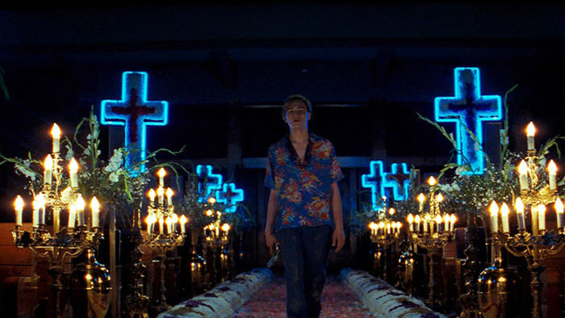
Extracts from Key moments from Romeo and Juliet
Source: https://www.rsc.org.uk/romeo-and-juliet/about-the-play/key-moments-and-facts

The lovers meet for the first time (A1S4)
Romeo is persuaded to attend a masked party at the Capulet household. Not knowing who she is, he falls in love with Juliet the moment he sees her, and she, equally ignorant that he is a Montague, falls just as instantly for him.

Romeo risks death to meet Juliet again (A2S1)
When everyone has left the party, Romeo creeps into the Capulet garden and sees Juliet on her balcony. They reveal their mutual love and Romeo leaves, promising to arrange a secret marriage and let Juliet's messenger, her old Nurse, have the details the following morning.

Romeo angrily kills Juliet's cousin, Tybalt (A3S1)
Romeo meets Tybalt in the street, and is challenged by him to a duel. Romeo refuses to fight and his friend Mercutio is so disgusted by this 'cowardice' that the takes up the challenge instead. As Romeo tries to break up the fight, Tybalt kills Mercutio and, enraged, Romeo then kills Tybalt. The Prince arrives and banishes Romeo.

The unhappy couple are parted (A3S5)
Arranged by the Friar and the Nurse, Romeo and Juliet have spent their wedding night together. They are immediately parted though, as Romeo must leave for banishment in Mantua or die if he is found in Verona. Believing her grief to be for the death of her cousin, Juliet's father tries to cheer Juliet by arranging her immediate marriage to Paris. He threatens to disown her when she asks for the marriage to be at least postponed, and she runs to the Friar for advice.

The Friar suggests a dangerous solution (A4S1)
Juliet arrives at the Friar's to be met by Paris, who is busy discussing their wedding plans. She is so desperate that she threatens suicide, and the Friar instead suggests that she takes a potion that will make her appear to be dead. He promises to send a message to Romeo, asking him to return secretly and be with Juliet when she wakes, once her 'body' has been taken to the family crypt.

Juliet is found 'dead' (A4S4)
The Nurse discovers Juliet 's 'body' dead' when she goes to wake her for her marriage Paris. Friar Laurence is called, counsels the family to accept their grief, and arranges for Juliet to be 'buried' immediately.

Romeo learns of the tragedy and plans suicide (A5S1)
Romeo's servant, Balthasar, reaches Mantua before the Friar's messenger and tells Romeo that Juliet is dead. Romeo buys poison and leaves for Verona, planning to die alongside Juliet's body.

The tragic conclusion (A5S3)
Romeo kills Paris and reaches Juliet's body. He drinks the poison, kisses his wife for the last time, and dies. Having learned that Romeo never received his message, the Friar comes to the crypt to be with Juliet when she wakes. He finds Paris's body and reaches Juliet just as she revives. He cannot persuade her to leave her dead husband and runs away in fear. Juliet realises what has happened, takes Romeo's knife and stabs herself to death with it. The watchmen discover the gruesome sight and call the Prince, to whom the Friar confesses everything. Having heard the full story, the Montagues and Capulets are reconciled. Peace has been achieved, but the price has been the lives of two innocent young lovers.

