Complete the Quotations

- ‘A pair of __________ lovers take their life’ – Prologue
- ‘Once more, on pain of __________, all men depart’ – A1-S1
- ‘Away from the __________ steals home my __________ son’ – A1-S1
- ‘But woo her, gentle _________, get her __________’ – A1-S2
- ‘For I ne’er saw true ___________ till this night’ – A1-S5
- ‘To strike him __________, I hold it not a ___________’ – A1-S5
- ‘It is the __________, and ___________ is the __________’ – A2-S2
- ‘Thou chid’st me oft for loving __________’ – A2-S3
- ‘These violent ___________ have violent ___________’ – A2-S6
- ‘No better term than this – thou art a ___________’ – A3-S1
- ‘And __________ dead, that would have slain my ___________’ – A3-S2
- ‘It was the __________, and not the __________’ – A3-S5
- ‘Hold, daughter: I do spy a kind of ___________’ – A4-S1
- ‘__________ lies on her like an untimely ___________’ – A4-S5
- ‘__________, I see, hath been his timeless end’ – A5-S3

Explain the Image

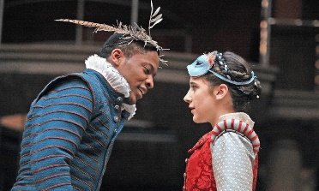 | 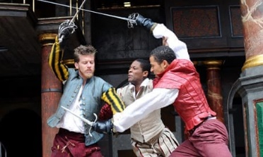 | 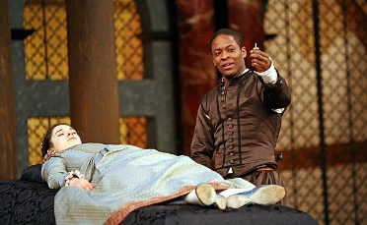

Complete the Word Lists

Romeo | Juliet
Impulsive | Cautious

Finish the Sentences

- Love is presented as an emotion characterised by…
- The importance of honour is shown when…
- The consequences of violence are vividly demonstrated through…
- A key difference between Romeo and Juliet is…
- A defining moment in the play for Juliet is…
- An important scene for understanding the character of Romeo is…
- A particularly important event in the play is…

