Romeo and Juliet
Exploring the Context of the Play
……………………………………………………….

- Civil Disorder

- Female Conduct

- Love and Marriage

- Parent-Child Relationships

- Dramatic Verse

- The Globe Theatre

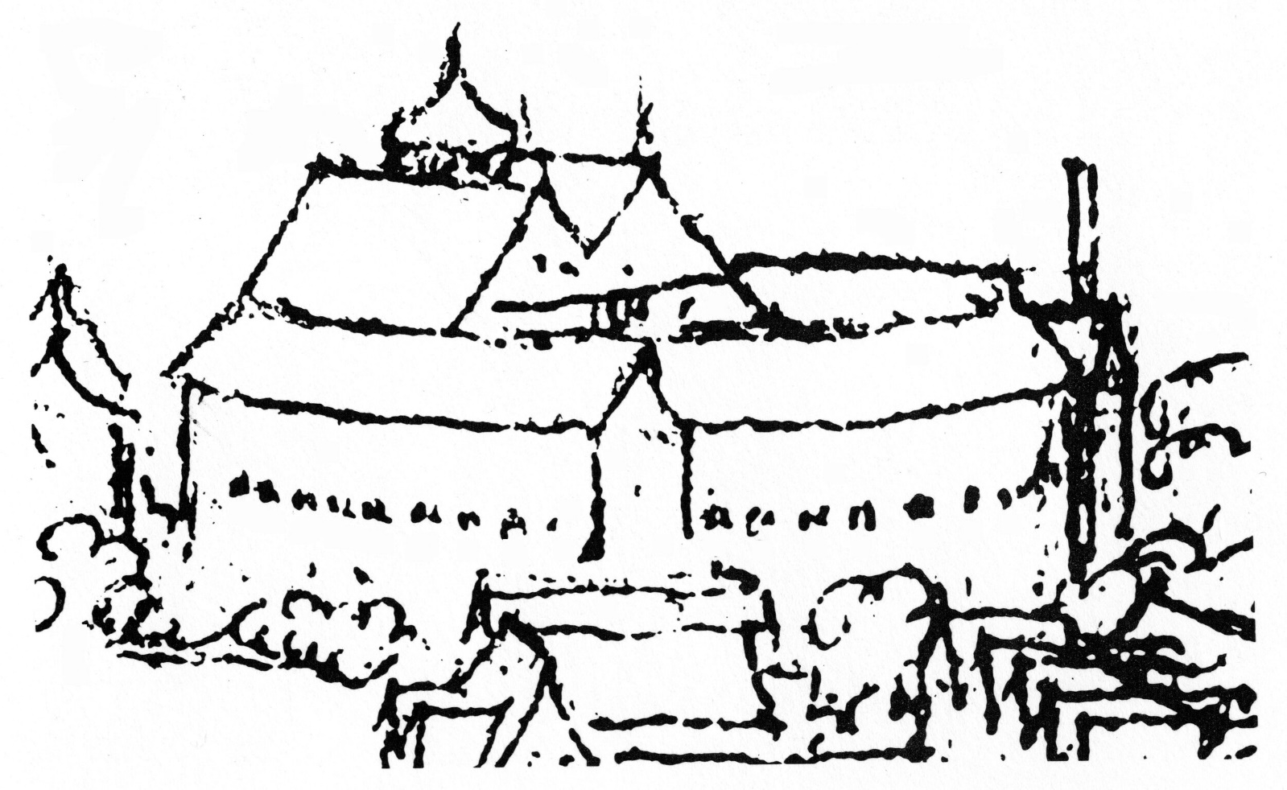

Sources from The British Library: Civil Disorder

- What do we learn about the reasons why civil disorder arose, how it was enacted, and how it was punished?

- What do we learn about the concept of honour and the consequences of dishonour?

Rebellion by London Apprentices in 1595
In June 1595, around 1,000 apprentices took part in a riot on Tower Hill in London. The rioters were mostly very poor and they were protesting about the appalling social conditions of 1590s London. Their grievances included the scarcity and rising cost of food, the greed of the mayor and of other wealthy citizens, and the mistreatment of other apprentices who had been punished harshly for smaller demonstrations earlier in the month. The riot on Tower Hill was the largest uprising in the City of London in nearly 80 years, and was unusual in its direct criticism of the elite. Five of the rioters were convicted of treason and were hanged, drawn and quartered on Tower Hill.
The woodcut illustration on the title page of this pamphlet records the gruesome fate of the convicted protesters and emphasises the military strength of the authorities. The pamphlet itself, which purports to be written by a student and sometime apprentice from London, urges calm and obedience from his fellow apprentices.

Elizabethan Fencing Manual
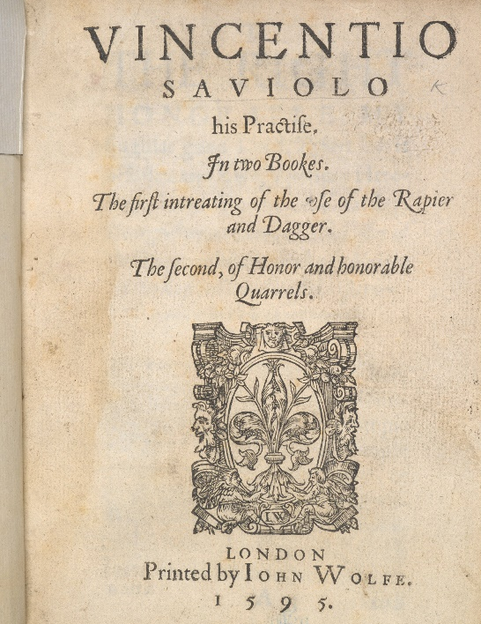
Vincentio Saviolo, author of one of the first manuals, was a Paduan fencing master who taught at, and later took over, an Italian fencing school in London’s Blackfriars district. The school was located under a building that would later become the second Blackfriars playhouse, so the controversial worlds of theatre and fencing often overlapped. At the time, the Italian fashion for fencing with rapiers – narrow, double-edged swords – was still a novelty in England and it prompted mixed reactions. Fencing provoked outrage in some courtly circles and there were attempts to ban duels. But this manual, dedicated to the Earl of Essex, shows the growing status of this ‘Militarie’ art, even among Elizabeth’s favourites.
Saviolo promotes the art of fencing as a means to resolve quarrels when the law offers no solution. He claims to provide gentleman and soldiers with skills that will allow them to defend ‘just causes’ and maintain their honour. But he is also keenly aware that hot-headed youths fly into fights at the slightest provocation. He warns of the great dangers of ‘frivolous quarrell[s]’ which descend into ‘deadly hatreds’.
In the first part of the book, Saviolo uses illustrations and a dialogue between a swordsman and student to explain how to handle these weapons. He imports Italian terms for tricky fencing manoeuvres: ‘the stoccata, the imbroccata, the punta riversa’. The second part of the manual explains the complex codes of honour surrounding man-to-man duels – how to issue a challenge accusing someone of an offence and how to counter that with a ‘lie’ insisting the claim is unfounded.

Sources from The British Library: Female Conduct

- What do we learn about the expectations placed on wives and daughters?

- What do we learn about the characteristics and perceptions of male friendship?

Conduct Book for Christian Women
Juan Luis Vives’ Instruction of a Christen Woman was a hugely popular conduct book for Tudor women. Written from a male perspective, it gives moral and practical guidance on all aspects of a woman’s life from infancy to puberty and from marriage to widowhood. In some ways, the book seems progressive: for example, it recommends education for women. However, it still foregrounds the virtues of chastity and obedience to one’s parents and husband.
This provides an interesting context for strong Shakespearean women like Juliet, Beatrice and Katherina, who seem caught between passion and patriarchal control, and between silence and elegant self-expression.
Vives has a bleak view of love – the dangerous ‘kingdome of Venus’. The ‘miserable yonge woman’ who is entangled by love would be better ‘to have broken a legge of [her] bodie’. Love causes global devastation: ‘murther’, ‘slaughter’, ‘distruction of cities, of countreys, and nacions’. When it comes to choosing a husband, maidens should keep quiet, and leave these decisions to their parents: ‘it becometh not a maide to talke, where hir father and mother be in communicacion about hir mariage’. But parents should take their duties seriously, preferring ‘Good and wise’ husbands over the ‘Faire’, ‘riche’ or ‘noble’.

William Gouge’s Domestic Duties Book
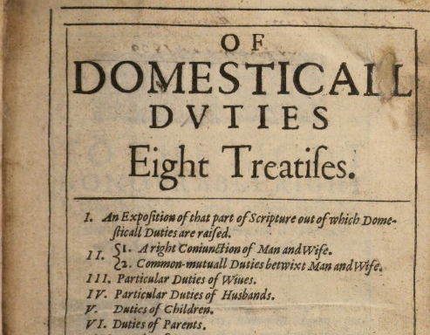
Of Domesticall Duties was a popular and widely read conduct book providing advice and rules for family life. It was written by the Church of England clergyman William Gouge. Gouge’s work embraces patriarchy, placing the husband at the head of the household. He says a wife should show ‘obedience’ to her husband’s authority and ‘come when he calls’ her. She should refrain from ‘ambition’ and abandon any idea that ‘wives are their husbands equals’. This was not an unusual view for the time, although Gouge did note that when he preached on female subservience in church he often observed discontented murmurings from the women in his congregation.

Friendship in George Wither’s Emblem Book
’Emblems’ are illustrations that use symbols to represent complex or abstract ideas, such as friendship, virtue, wisdom and mortality. Such images were often collected in emblem books alongside explanatory and instructional verse, the illustration and text working together to provide a moral lesson. The image displayed on the right shows the emblem for ‘friendship’ – a pair of clasped hands holding a crowned and flaming heart, circled with linked rings.
The Latin tag around the engraving reads ‘bona fide’, which means ‘with good faith’. The epigram above the engraving describes friendship as ‘true love, indeed’, and the verses below talk of constancy and generosity in friendship.
In the early modern period, same-sex friendship (and particularly male friendship) was held in high esteem and could be described with an intensity and vocabulary that we would nowadays associate with romantic love. There is a blurring of lines here: sometimes same-sex friendships were intense but platonic (i.e. non-sexual); on other occasions, the intimacy of same-sex friendship gave a framework within which same-sex desire could be explored and expressed.
Sources from The British Library: Love and Marriage

- What do we learn about the expectations placed upon ‘knights’ and ‘ladies’ in the courtly love tradition?

- What do we learn about the tensions that emerged in customs of courtship and marriage?

Courtly Love
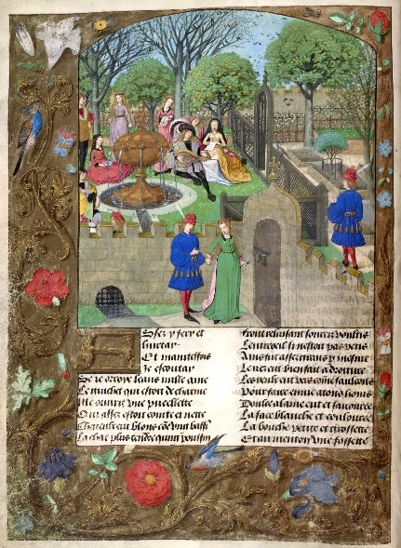
The term ‘courtly love’ conjures up images of romantic liaisons between knights and ladies, or colourful jousting tournaments overlooked by adoring female spectators. Widely popular in Europe throughout the Middle Ages, courtly love was characterised by a series of stylised rituals between a knight and a married lady of high rank. These idealised customs were based on the traditional codes of conduct associated with knighthood, such as duty, honour, courtesy and bravery. Just as the knight owed obedience and loyalty to his lord, enduring hardship and dangers in his service, so he must show faithful devotion and obedience to his lady, performing heroic deeds in an effort to win her favour.
Typically the knight’s love is unrequited, and the real reward for his devoted service is an educational one. These relationships and rituals became a powerful force in shaping the literature of the day, in particular through their significant contribution to the ever-popular tales of romance and chivalry.

Marriage and Courtship
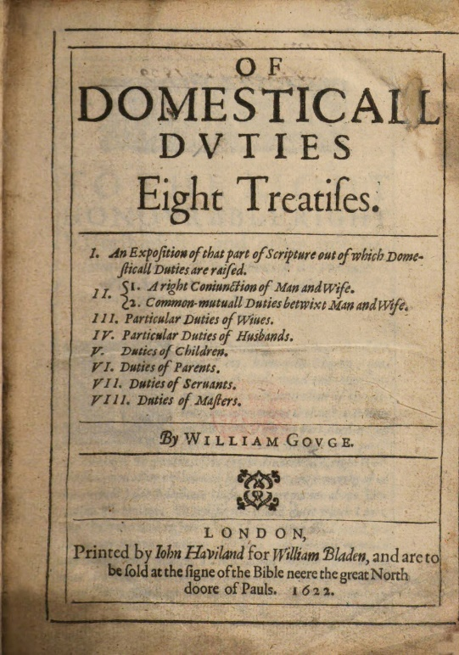
In the early modern period, customs of courtship and marriage were undergoing significant shifts. Throughout the medieval period, money, class or alliance governed and regulated marriage. As Europe modernized, however, the Puritans and others began to champion the novel idea of marriages based on mutual inclination and love. Time and again, Shakespeare’s plays dramatise the conflict between the old order in which fathers chose husbands for their daughters and the new order in which daughters wished to choose their own mates based on affection.
In Shakespeare’s England, the process for getting married could be complex. A couple wishing to marry had first to obtain the blessing of the church, either by obtaining a licence to marry, or by having the ‘banns’ read – that is, announcing the couple’s names and their intent to marry – on three successive Sundays from church pulpits in the home parishes of both parties. Couples who paid for a license and testified that there were no obstacles to their union still had to wait one month before they could be married. For some, the process was too slow. Consequentially, a culture of clandestine marriage emerged.

Sources from The British Library: Parent-Child Relationships

- What do we learn about the expectations placed upon daughters of ‘respectable families’?

- What do we learn about the consequences of defying those expectations ?

Parent-Child Relationships
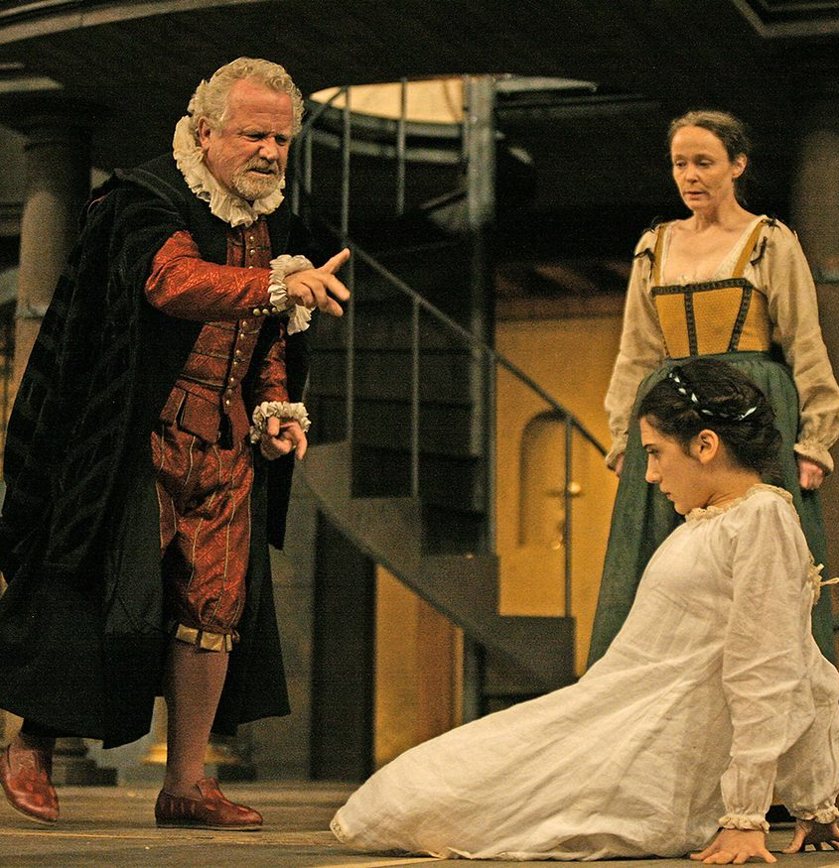
When we consider that Shakespeare lived in an age when all actors were male and the subject matter of serious drama focused heavily on the exploits of men, it’s hardly surprising that female characters are in a minority in his plays. And yet Shakespeare created many complex and engaging female roles for his young male actors to perform. Parent-child relationships feature heavily, and a significant number of these involve fathers and daughters.
Interestingly, mothers are often absent from the drama, throwing the daughter-father relationship into sharp relief. A father of two daughters himself, Shakespeare’s dramatic daughters make a formidable line-up of young women, most of them at a transitional stage between the protection of their childhood home and an adult life beyond it. The transition is rarely a smooth one: tension rises as daughters go in search of love, adventure and independence.

Paris’s Wooing of Juliet
Romeo and Juliet may be a love story, but a daughter-father relationship lies at the heart of the play’s events. Juliet is not yet 14 when the young nobleman Paris approaches her father Capulet for permission to woo his daughter. At first, Capulet seems protective of Juliet, his only surviving child, and proposes that ‘two more summers’ should pass before ‘we may think her ripe to be a bride’. But Paris is a good prospect, a relative of the Prince of Verona, so Capulet agrees to Paris’s request, inviting him to a family feast that very evening which Juliet will be attending.
In Shakespeare’s time, daughters of respectable families, like Juliet, could expect their fathers to have a significant involvement in choosing their future husband. This reflected the subordinate position of women, and particularly the traditional view that daughters were a commodity and could be used in marriage to forge useful alliances.

Juliet’s Defiance
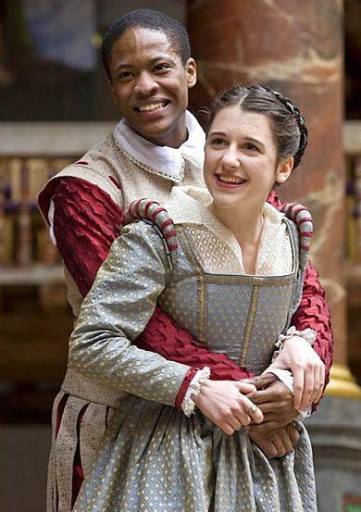
The obedient way young women of the 16th century were meant to behave towards their parents was not only reflected in religious teaching but also well documented in publications known as ‘conduct books’. At the beginning of the play, Lady Capulet – sent to speak to Juliet by her husband – tells Juliet about Paris’s interest in her and encourages her to consider him. Unfortunately, Juliet falls in love with Romeo and marries him in secret. Inevitably then, she must disobey her father later in the play by refusing to marry Paris. Capulet is furious. Despite Juliet’s attempts to remain respectful towards him, he threatens to disown her if she doesn’t comply with his wishes.
It’s part of Juliet’s tragedy that she’s unable to tell her authoritarian father about her marriage to Romeo, even though she could express her love with an eloquence that could overcome anger and hatred. Capulet is determined to ‘give’ her to Paris (a father’s prerogative, even enshrined in the marriage ceremony) and she feels she has little option but to agree to Friar Laurence’s drastic plan to fake her own death in order to extricate herself from this situation.
Sources from The British Library: Dramatic Verse

- What are the main differences between ‘verse’ and ‘prose’?

- What different effects are achieved by placing a particular emphasis on individual words in lines of verse?

Verse and Prose
On the page, prose runs continuously from margin to margin, while verse is set out in narrower blocks, neatly aligned on the left (where lines all begin with capital letters), but forming a slightly ragged right-hand edge. It’s easy then to distinguish between the ‘natural’ mode of prose, where the layout is determined only by the width of the page or the change from one speaker to another, and the ‘artificial’ mode of poetry, where the length of the line is measured in some other way.
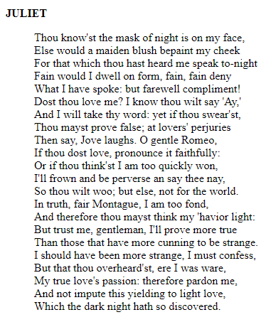
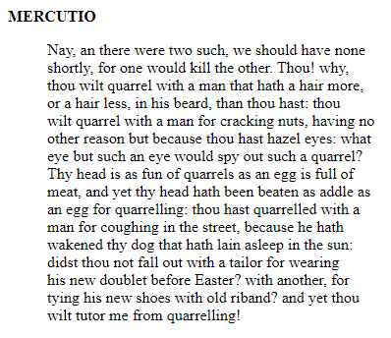
Verse
Prose

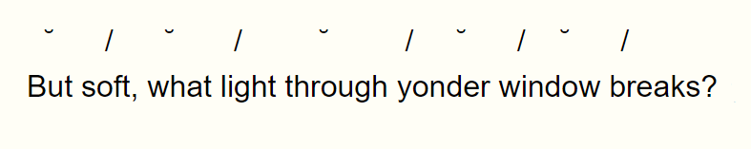
Verse

Blank Verse and Iambic Pentameter
Shakespeare’s dramatic verse is often referred to as blank verse, because it doesn’t rhyme. As for rhythm – the arrangement of stressed and unstressed syllables – it takes the iambic pentameter pattern used so commonly in English poetry from Chaucer onwards, and illustrated above with Romeo’s famous line when he sees Juliet appear at her window:
Read Romeo’s question aloud, and you will be able to hear the alternation of the unstressed and stressed syllables that give the line its regular rhythm: ‘de-DUM, de-DUM, de-DUM, de-DUM, de-DUM’.
- Each ‘de-DUM’ is a rhythmic unit called an iamb

- A pentameter line consists of five iambs (i.e. five units)

- Collecively, we call this pattern imabic pentameter

In Romeo’s line, an actor may put more emphasis on ‘what’ in order to express admiration at the sight of Juliet. So the distinction between stressed and unstressed syllables tends to be a matter of degree, and sometimes also a matter of choice, since actors can often adjust the amount of stress in order to make subtle changes to meaning.

Sources from The British Library: The Globe Theatre

- What do we learn about how theatres were perceived by the authorities in London?

- What do we learn about the ‘experience’ of going to the theatre?

Shakespeare’s London
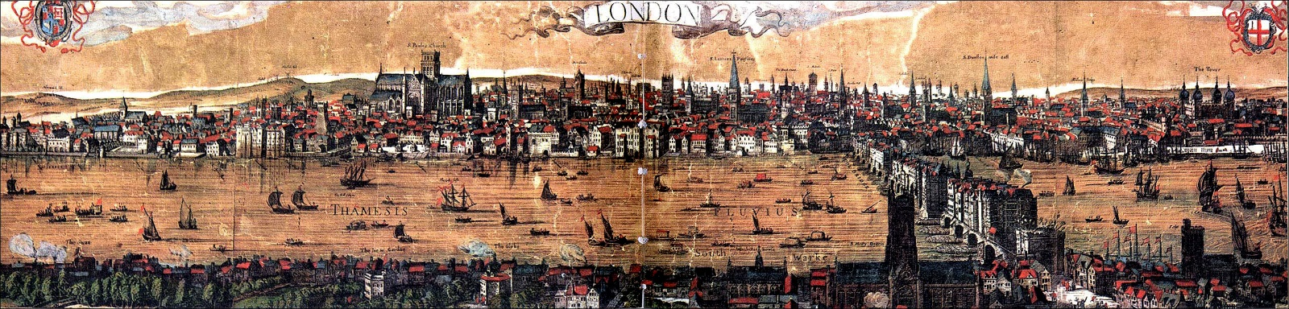
The panorama of London (above) was produced in 1616, and includes an illustration of the Globe Theatre, where Shakespeare performed many of his plays. The view of London, from the South Bank of the River Thames, looks across old London Bridge to the Tower of London, the spires of the City, and St Paul’s Cathedral.
The first public playhouses were built in London in the late 1500s. Theatres were not permitted within the boundaries of the City itself, but were tolerated in outer districts of London, such as Southwark, where the Globe was located. Southwark was notorious for its noisy, chaotic entertainments and for its sleazy low-life: its theatres, brothels, bear baiting pits, pickpockets and the like.

The Globe Theatre
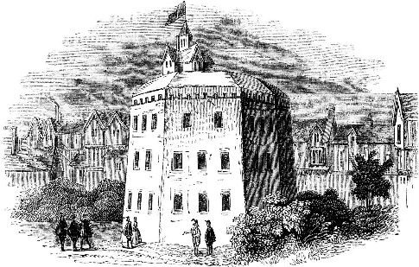
The Globe, best-known of the great open-air theatres, has a remarkable history. The Lord Chamberlain’s Men, the acting company to which Shakespeare belonged, had played for years at the Theatre, to the north in Shoreditch. The company owned the building but leased the land it stood on. When its lease expired, the landlord sought to appropriate the building as well as the land, and so the Chamberlain’s Men played temporarily at the Curtain. Then, on a frosty night in 1598, three days after Christmas, a carpenter and several men associated with the company secretly dismantled the Theatre and removed the timbers. In the spring, they ferried the timbers across the Thames and used them to build a larger theatre in Southwark: the Globe.
The Globe opened in 1599 and provided a leading dramatic venue for the next 14 years. In 1613, however, during a fateful performance of Henry VIII, a stage cannon ignited the thatched roof and the Globe burned to the ground ‘all in less than two hours’, according to a contemporary account, ‘the people having enough to do to save themselves’. Less than a year later, another Globe rose from the ashes of its predecessor and remained open until 1642.
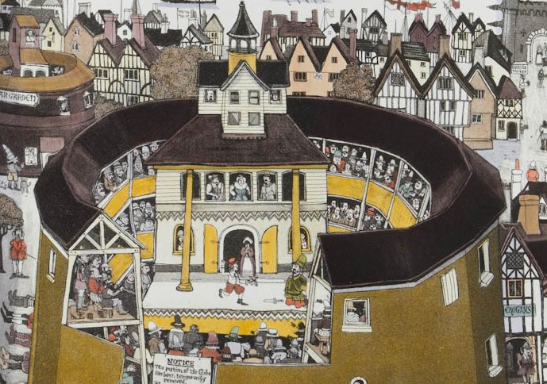
Thanks to contemporary drawings of similar playhouses, we know roughly what the Globe looked like. Roughly 30 meters in diameter, it could accommodate an audience of 3,000. The stage protruded into the standing area, so players downstage were surrounded on three sides by the groundlings, who were presumably talking, belching, eating nuts, and sometimes engaging in discussions with the actors onstage. There was a trapdoor to a cellar beneath the stage; when ghostly, demonic, or otherwise dead characters appeared, they would emerge from the cellar, accompanied perhaps by smoke, noise, or other special effects. Below the roof, a balcony held musicians.

