Key Moments

- The Opening of the Play  - The Engagement  - The Inspector Arrives  - The Inspector Questions Birling  - The Inspector Questions Sheila  - Divisions Continue to Emerge | Page 1
- The Inspector Questions Gerald  - Gerald Leaves the Stage  - The Inspector Questions Mrs Birling  - The Inspector Questions Eric | Page 2
- The Inspector’s Final Speech  - The Identity of the Inspector is Debated  - The Ending of the Play | Page 3

Overviews

- Key Contextual Information | Page 4
- Theatrical Devices | Page 5
- The Generational Divide | Page 6
- The Central Message of the Play | Page 7
- Important Moments and Quotations | Page 8
- Common Misconceptions | Page 9

Essay Tasks

 | - Eric |  | Page 10
 | - Selfishness
 | - Social Class
Moment 1: The Opening of the Play

The play was first performed in 1946. However, it is set in 1912. This is an important detail because it means that an audience watching at the time would be able to look back on how things used to be in England and reflect on how things had changed; they would also know far more than the characters on stage.

- What was life like in 1912?
- What had changed by 1946?
- Why did Priestley choose to set the play in 1912?
- What do we learn about the Birling family from the opening stage directions?

Moment 2: The Engagement

The opening scene of the play shows the Birling family celebrating the engagement of Sheila to Gerald. The mood is relaxed and cheerful, and the soft pink stage lighting helps to create a comfortable atmosphere.

- What clues do we get that things aren’t quite as good as they seem?
- What makes Gerald the son-in-law that Birling ‘always wanted’?
- How are Mrs Birling and Gerald different from the other members of the family?

Moment 3: The Inspector Arrives

Shortly after Birling expresses his hopes for the future, there is a ‘sharp ring of a front door bell’ and the Inspector arrives on stage. From this point onwards, the atmosphere becomes more tense and we start to learn about how each member of the Birling family was involved in the suicide of Eva Smith.

- How does Priestley use staging techniques to make the Inspector’s arrival dramatic?
- How does Birling initially react to the Inspector?
- What do we learn about Eva Smith?

Moment 4: The Inspector Questions Birling

Birling is clearly irritated by the Inspector’s presence and he shows very little empathy when he’s told details of Eva Smith’s suicide. When later questioned by the Inspector, he becomes increasingly defensive and is ultimately unwilling to accept any responsibility.

- What is Birling’s role in the suicide?
- How does he respond to being involved in the suicide?

Moment 5: The Inspector Questions Sheila

At the start of the play, Sheila is preoccupied with her engagement to Gerald. She is ‘very pleased with life and rather excited.’ However, her mood changes as soon as she hears news of the suicide.

- What is Sheila’s role in the suicide?
- How does she react to being involved in the suicide?
- How does her reaction differ to Birling’s reaction?

Moment 6: Divisions Continue to Emerge

By the start of Act Two, the atmosphere on stage has changed. It’s no longer comfortable and celebratory. Rather, it’s very tense and we continue to see divisions emerge between the ‘younger’ and ‘older’ members of the family.

- How has the relationship between Sheila and Gerald changed?
- How has the relationship between Sheila and Mrs Birling changed?

Moment 7: The Inspector Questions Gerald

Gerald’s earlier portrayal as a charming, agreeable ‘man-about-town’ is undermined as the first act ends and the second begins. His affair with Daisy Renton demonstrates that he is untrustworthy and his attempt to coerce Sheila into secrecy reveals that he is manipulative.

- Why is the name Daisy Renton significant?
- What does Gerald’s account of the affair reveal about the treatment of women?

Moment 8: Gerald Leaves the Stage

After revealing details of his affair with Daisy Renton, Gerald leaves the stage. He’s visibly upset and it appears that he had genuine feelings of affection for her. The extent to which we might judge him favourably because of this is entirely down to us, but we should be cautious about excusing or validating his behaviour.

- What is Gerald’s role in the suicide?
- How does he react to the news that he is involved?

Moment 9: The Inspector Questions Mrs Birling

Mrs Birling is the next character to be questioned by the Inspector. Like Birling, she is uncooperative and becomes increasingly irritable. She accepts no responsibility for the role in the ‘chain of events’ that resulted in the suicide of Eva Smith.

- What is Mrs Birling’s role in the suicide?
- What does Mrs Birling’s treatment of Eva Smith reveal about the lives of vulnerable women?

Moment 10: The Inspector Questions Eric

The final member of the Birling family to be questioned is Eric. He returns to the stage just after his mother unwittingly argues that he is ‘entirely responsible’ for the death of Eva Smith. It is an uncomfortable, but particularly revealing moment in the play.

- What is Eric’s role in the suicide?
- How does Eric react to being implicated?

Moment 11: The Inspector’s Final Speech

After Eric has been questioned, the Inspector delivers his final speech. He summarises the ‘chain of events’ that caused the death of Eva Smith and provides a final warning to Birling family.

- What final judgements does the Inspector make about the Birlings?
- What final message does he deliver?

Moment 12: The Identity of the Inspector is Debated

After the Inspector leaves the stage, Sheila is the first to question whether or not he was a real inspector. Either way, she believes that it doesn’t really matter. However, Birling is the first to argue that his identity is crucial.

- How do the Birling family behave immediately after the Inspector leaves?
- What does the uncertainty about the Inspector’s identity reveal about the Birling family?

Moment 13: The Ending of the Play

First Birling and then Gerald substantiate the claim that the Inspector is a ‘fake’ and that his investigation was ‘just a lot of moonshine’. They’re both delighted and, in their triumph, fail to understand why Sheila and Eric remain angry and distressed.

- Who or what is the Inspector?
- To what extent does the ending of the play offer hope?

Key Contextual Information

Society in 1912 was divided: there was a large gap between the rich and the poor. Roughly 10% of the population controlled 90% of the wealth. Gerald and Mrs Birling are part of the aristocracy, which is to say that they are both from families that have been wealthy for many generations. Mr Birling is slightly different; he is part of the emerging upper-middle class because he has made his money more recently. Think back to his conversation with Gerald about Crofts Limited being both ‘older and bigger than Birling and Company’. Birling has ‘new’ money, whilst his wife and Gerald have ‘old’ money.

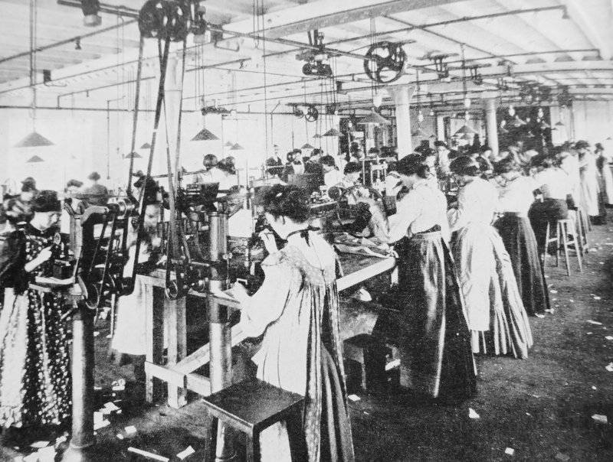 | 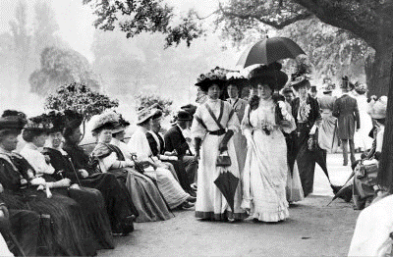

Society in 1946 was different. World War I and II resulted in significant financial losses for families like the Birlings. In addition to this, the wars had required people from different backgrounds to mix and this helped to change what were once firmly established conventions. Society was becoming more equal and there was widespread desire for further change.

1912 | 1914 | 1917 | 1939 | 1945
The Titanic Sinks | World War I Begins | The Russian Revolution | World War II Begins | Labour Party Elected

As a socialist – someone who believed in social equality – Priestley wanted to remind his audience about how bad things were in 1912 as a way of encouraging them to continue pushing for changes that would result in greater freedom and fairness. Always remember as you’re reading the play that Priestley uses dramatic irony: the audience will always know more than the characters on stage. We know when they make mistakes and we know when they behave badly.

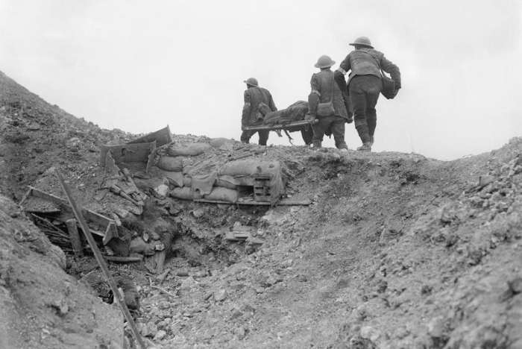 | 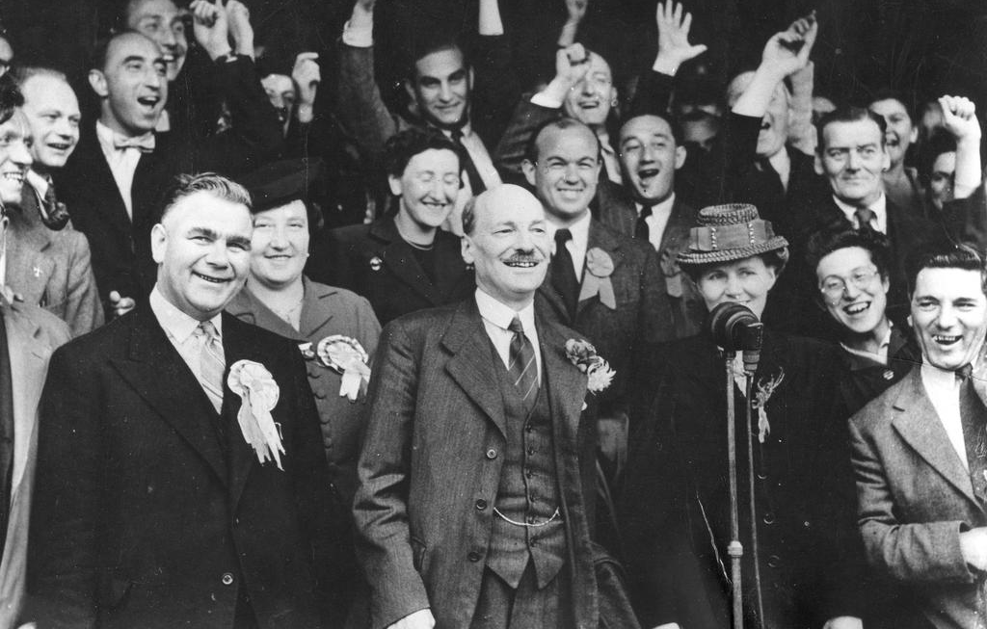

Aristocracy | Capitalism | Socialism
Wealth | Poverty | Equality
Theatrical Devices

Start of the Play
- ‘It has good solid furniture of the period’ (161 | A1)
- ‘The lighting should be pink and intimate until the Inspector arrives, and then it should be brighter and harder’ (161 | A1)
- ‘Edna, the parlour-main, is just clearing the table’ (161 | A1)
- ‘All five are in evening dress of the period, the men in tails and white ties, not dinner-jackets’ (161 | A1)

End of the Play
- ‘The telephone rings sharply’ (220 | A3)
- ‘As they state guiltily and dumbfounded, the curtain falls’ (220 | A3)

Arrival of the Inspector
- ‘We hear the sharp ring of a front doorbell’ (168 | A1)
- ‘He is a man in his fifties, dressed in a plain darkish suit of the period’ (169 | A1)
- ‘He speaks carefully, weightily, and has a disconcerting habit of looking hard at the person he addresses’ (169 | A1)
- ‘The Inspector interposes himself between them and the photograph’ (170 | A1)

Exit of the Inspector
- ‘He walks straight out, leaving them staring, subdued and wondering’ (207 | A3)
- ‘Birling, the only active one hears the front door slam’ (207 | A3)

Entrances on Stage
- ‘Now Mrs Birling enters, briskly and self-confidently, quite out of key with the little scene that has just passed’ (185 | A2)
- ‘Enter Birling, looking rather agitated’ (196 | A2)
- ‘Eric enters, looking extremely pale and distressed’ (201 | A2)
- ‘As he hesitates, there is a ring at the front door’ (211 | A3)

Exits from Stage
- ‘We hear the front door slam’ (194 | A2)
- ‘We hear the front door slam again’ (195 | A2)
- ‘He goes to open the door while Sheila takes her mother out’ (204 |A3)

Changing Emotions

Birling | Mrs Birling | Sheila | Eric | Gerald | Inspector
‘Laugh’ | ‘Smiling’ | ‘Excited’ | ‘Noisily’ | ‘Smiling’ | ‘Calmly’
‘Angrily’ | ‘Staggered’ | ‘Distressed’ | ‘Miserably’ | ‘Startled’ | ‘Harshly’
‘Excitedly’ | ‘Triumphantly’ | ‘Bitterly’ | ‘Sulkily’ | ‘Decisively’ | ‘Masterfully’

The Generational Divide

As the play progresses, a generational divide emerges between the ‘older’ and ‘younger’ Birlings. This divide is primarily expressed through the different ways in which the family react to the suicide of Eva Smith. Our job is to consider what their differing reactions reveal about the political and moral values they hold, and how Priestley might have wanted us to respond to what we see on stage.

Opening Stage Directions
- ‘large suburban house’
- ‘good solid furniture’
- ‘not cosy and homelike’

Birling | Mrs Birling | Gerald | Sheila | Eric | Eva Smith
‘middle fifties’ | ‘about fifty’ | ‘about thirty’ | ‘early twenties’ | ‘early twenties’ | ‘Twenty-four’

Act 1
- The mood at the beginning of the play
- The relationship between Birling and Eric
- The contrast in reactions between Birling and Sheila to the news of Eva’s suicide

Act 2
- Mrs Birling’s unawareness of Eric’s heavy drinking
- Sheila’s plea to Birling and Mrs Birling to be honest with the Inspector
- Mrs Birling’s unwitting denouncement of Eric

Act 3
- Birling’s anger at Eric’s theft
- Eric’s anger at Mrs Birling for not helping Eva
- The reactions to the Inspector’s final speech
- The mood during the period of discussion about the identity of the Inspector
- The mood at the end of the play

Changing Language
- ‘Yes, go on, Mummy (A1 | 162)
- ‘You’ve got a lot to learn yet’ (A1 | 166)
- ‘Nothing to do with you, Sheila. Run along’ (A1 | 174)
- ‘You seem to have made a great impression on this child, Inspector’ (A2 | 185)
- ‘You’re looking tired, dear. I think you out to go to bed’ (A2 | 185)
- ‘But, Mother, do stop before it’s too late’ (A2 | 186)
- ‘He’s just talking to my son, Eric, who seems to be in an excitable silly mood’ (A2 | 187)
- ‘Mother, I think it was cruel and vile’ (A2 | 198)
- ‘You don’t understand anything. You never did’ (A3 | 206)
- ‘I don’t give a damn now whether I stay here or not’ (A3 | 215)
- ‘And I agree with Sheila. It frightens me too’ (A3 | 220)
The Central Message of The Play

By reminding the audience about the inequalities and limitations of life for ‘millions and millions’ of people in 1912, and by hinting at the devastating conflicts to come, Priestley emphasises the importance of working together for greater social change. In this sense, the central message of the play is both a warning and a call for further action: a warning about the consequences of selfishness and a call to continue campaigning for a fairer and more socially responsible society. Remember that the Labour Party was elected in 1945 and the leader, Clement Attlee, made a pledge to provide welfare to all British citizens who needed it. In this this sense – despite the grizzly events that unfold on stage – the play is actually very optimistic.

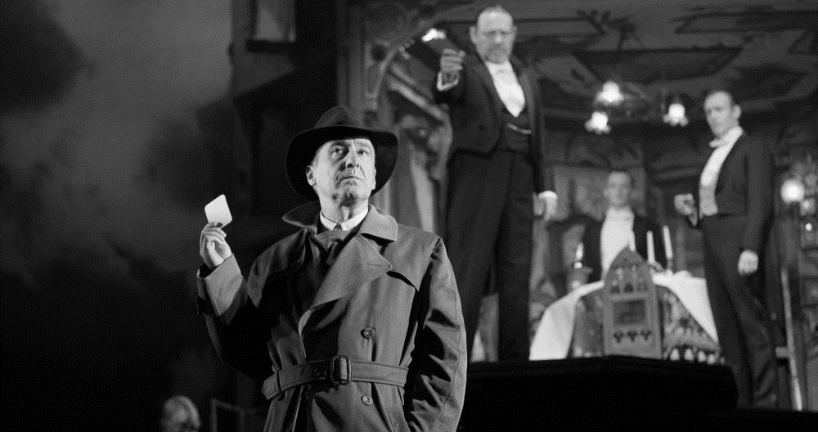

A Reminder of Inequalities and Limitations in 1912
- Why is the character of Edna important?
- Why are the names Eva Smith and Daisy Renton significant?
- Why is the suicide of Eva Smith described (twice) in such graphic detail?
- Why is it significant that Eva Smith is unable to find employment immediately after getting fired?
- Why is the character of Alderman Meggarty significant?
- What ‘capital’ do the Birlings possess other than financial wealth?
- What is Birling’s immediate concern after the Inspector leaves?

A Call for Further Action in 1946
- Why does the stage lighting change when the Inspector enters?
- Why is the name Inspector Goole significant?
- How does Priestley emphasise that the Inspector is a credible character (i.e. not a ‘crank’)?
- What does the Inspector mean when he says ‘we are members of one body’?
- What is the meaning of the reference the Inspector makes to ‘fire and blood and anguish’?
- Does it matter if the Inspector is a ‘fake’?
- What does it mean when people describe the Inspector as ‘Priestley’s mouthpiece’?
Important Moments and Quotations

In the exam, you’ll be given a choice of two questions. It’s likely that one of them will focus on a specific character and the other will focus on a theme (i.e. a big idea that is explored throughout the play). Whatever the questions turn out to be, I think there are aspects of the play – ‘important moments’ – that have a sort of universal value in the sense that you can write about them in pretty much any scenario. Our job today is to consider their significance.

Moments
- Edna’s silent clearing of the dinner table
- Priestley’s use of dramatic irony during Birling’s early speeches
- The change in lighting when the Inspector arrives
- The Inspector’s emphasis of Eva’s desperation before her employment at Milwards
- Gerald’s decision to leave the stage
- The Inspector’s final speech
- Birling delight at thinking that the Inspector was a ‘fake’
- Sheila’s decision to return her engagement ring to Gerald

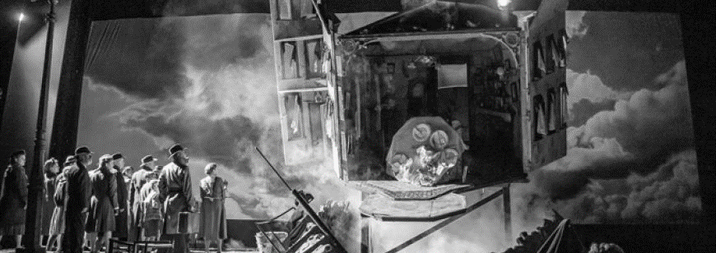

You won’t have access to a copy of the text in the exam and this isn’t a problem at all. You know the play well and you can instinctively recall the most memorable lines. For example: ‘unsinkable’, ‘absolutely furious’, ‘fairy prince’, ‘millions and millions’, and so on. However, there are some less recognisable quotations that are just as useful to know. And once again, our job is to consider their significance.

Quotations
- ‘You’re just the kind of son-in-law I always wanted’ (A1 | 163)
- ‘You seem to be a nice well-behaved family’ (A1 | 167)
- ‘We can keep it from him’ (A1 | 182)
- ‘It’s a favourite haunt of women of the town’ (A2 | 189)
- ‘You and I aren’t the same people who sat down to dinner here’ (A2 | 194)
- ‘She was claiming elaborate fine feelings and scruples’ (A2 | 199)
- ‘I hate these fat old tarts round the town’ (A3 | 204)
- ‘You’re not the kind of father a chap could go to when he’s in trouble’ (A3 | 205)
- ‘In the morning they’ll be as amused as we are’ (A3 | 220)
Common Misconceptions

Gerald did nothing wrong
The Inspector says that Gerald ‘at least had some affection’ for Eva (Daisy). However, the uncomfortable truth remains that his behaviour was predatory. He took advantage of Eva’s desperate circumstances and embarked on a relationship with her knowing that it couldn’t possibly last. He’s no ‘fairy prince’, despite what he might like to think.

Birling is stupid
Birling’s incorrect predictions about the future don’t necessarily show that he’s stupid. Limited, perhaps, but not stupid. However, they do highlight his arrogance. He speaks with a misplaced confidence and won’t entertain Eric’s (reasonable) attempts to challenge him – ‘You’ve a lot to learn yet.’

Birling did nothing wrong
In a legal sense, Birling did nothing wrong. He acted within his rights as an employer. However, his dismissal of Eva for causing ‘trouble’ is morally questionable. As Eric points out, his father could’ve ‘kept her on instead of throwing her out’ – particularly because, by his own admission, she was a ‘good worker’.

Sheila is naive
Sheila might appear to have very little understanding of the wider world around her and, to an extent, this is very much the case. However, she does possess more knowledge that it initially seems. For example, she’s suspicious of the reasons behind Gerald’s absence and she is fully aware of the double-lives lived by men like Alderman Meggarty.

Socialism is communism
Socialism is about the inequalities that arise within capitalist societies; the aim of socialists is to reduce those inequalities. In a communist country, there are no private businesses and no private property. The Inspector might be a ‘crank’, accounting to Birling at least, but he is not a communist.

Edna is unimportant
Edna is unimportant in the sense that she has few lines in the play and only appears a handful of times on stage. However, her understated presence at the beginning of the play – ‘just clearing the table’ – signifies the Birling family’s wealth and acts as a reminder of the rigid social hierarchy of Edwardian England.

Eric’s drunkenness excuses his behaviour
Eric was ‘in that state when a chap easily turns nasty’. However, his drunkenness in no way excuses what he did. The issue is around consent: he pressurises her into having sex by threatening ‘to make a row’. The Inspector calls it out when he says that Eric used her ‘as if she was an animal, a thing, not a person.’
Essay Tasks
