Review Task Booklet

An Inspector Calls

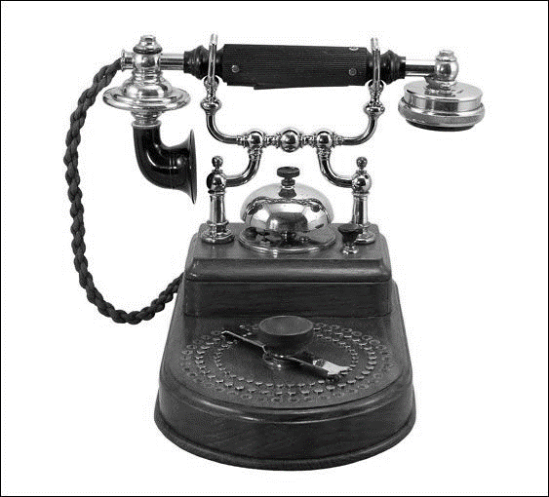

Contents

3 | Review Questions Based on An Introduction to An Inspector Calls
4 | Starter for Five Questions
5 | Plot Review Task
6 | Retrieval Grid
7 | Quiz Questions: 1-25
8 | Quiz Questions: 26-50
9 | Multiple-Choice Questions: 1
10 | Multiple-Choice Questions: 2
11 | Multiple-Choice Questions: 3
12 | Character Focus: Birling
13 | Character Focus: Sheila
14 | Character Focus: Gerald
15 | Character Focus: Mrs Birling
16 | Character Focus: Eric
17 | Specimen Exam Questions: SAMs 2
18 | Specimen Exam Questions: SAMs 3

Review Questions Based on An Introduction to An Inspector Calls

Source: https://www.bl.uk/20th-century-literature/articles/an-introduction-to-an-inspector-calls

‘Priestley’s play revolves around a central mystery, the death of a young woman, but whereas a traditional detective story involves the narrowing down of suspects from several to one, An Inspector Calls inverts this process as, one by one, nearly all the characters in the play are found to be guilty.’

- How did Eva die? Retrieve a short quotation

- In which order are the characters questioned by Inspector Goole?

- In what ways are each of the characters ‘guilty’ of playing a part in the death of Eva Smith?

‘In this way, Priestley makes his larger point that society is guilty of neglecting and abusing its most vulnerable members. A just society, he states through his mysterious Inspector, is one that respects and exercises social responsibility.’

- Birling says to the Inspector, ‘It’s a free country, I told them.’ How does Eric respond? Retrieve a short quotation

- After questioning Birling, what does the Inspector reveal about how Eva spent ‘the next two months’?

- Why was Eva ‘lucky to get taken on’ at Milwards?

‘Social responsibility is the idea that a society’s poorer members should be helped by those who have more than them. Priestley was a socialist, and his political beliefs are woven through his work.’

- How do Birling’s views on social responsibility differ from the Inspector’s views? Retrieve a short quotation

- The Inspector says to Birling, ‘it’s better to ask for the earth than to take it.’ Which page is the quotation on?

‘Socialism stands in opposition to a capitalist society, such as ours, where trade and industry is mostly controlled by private owners, and these individuals or companies keep the profits made by their businesses, rather than distributing them evenly between the workers whose labour produced them.’

- Gerald says to Birling, ‘Hear, hear! And I think my father would agree to that.’ What is Gerald talking about?

- Birling says, ‘And we’re in for a time of steadily increasing prosperity.’ Which page is the quotation on?

- By how much did Eva and the workers want their ‘rates raised’? Retrieve a short quotation

‘When Inspector Goole arrives everything changes.’

- How should the stage be lit before the Inspector arrives?

- How should the lighting change when he enters during act one?

‘But who is the Inspector? He says he is newly posted to Brumley, and he is impervious to Arthur Birling’s threats about his close relationship with the chief constable ‘I don’t play golf’, he tells Birling.’

- What is the name of the chief constable?

- Mrs Birling says to the Inspector, ‘my husband was Lord Mayor’. Which page is the quotation on?

‘Throughout the course of the Inspector’s investigation, and the testimony of Gerald and each of the Birlings, the supposedly respectable city of Brumley is revealed to be a place of deep class divisions and hypocrisy.’

- Which character is referred to as a ‘notorious womanizer’?

- Mrs Birling says, ‘we are learning something tonight.’ What does she mean?

- Mrs Birling also says, ‘It’s disgusting to me’. What does she mean?

Starter for Five Questions

- ‘You’re squiffy!’ What does it mean?

- ‘Just let me finish, Eric’ Who said it?

- Jealous Which character?

- ‘I’m still on the Bench’ Who said it?

- 1912 or 1914 When is the play set?

- ‘Half-drunk and goggle-eyed’ Which character?

- Empathetic Which character?

- Remorseful Which character?

- ‘Young and fresh’ Which character?

- ‘And I drink to you’ Who said it?

- ‘Good lad!’ Who is?

- Arrogant Which character?

- ‘We went to the County Hotel’ Who said it?

- Charming Which character?

- Naïve Who is?

- ‘Yes. Sit down, Inspector’ Who said it?

- Defensive Which character?

- Employed by Birling Who was?

- ‘I’ve got a headache’ Who said it?

- ‘I was in a furious temper’ Who said it?

- ‘Mother had been against it’ Who said it?

- ‘It’s my duty to ask questions’ Who said it?

- A heavy drinker Who is?

- Millwards or Milwards Which is correct?

- Steals £50 Who did?

- ‘Fiddlesticks!’ Who said it?

- ‘You admit being prejudiced’ Who was?

- ‘A hysterical child’ Who is?

- ‘Steady the buffs!’ What does it mean?

- Prosperous What does it mean?

Plot Review Task

 | 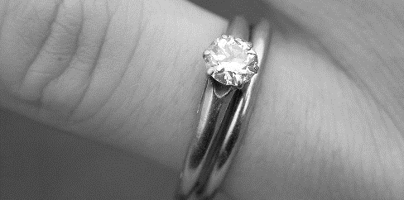 | 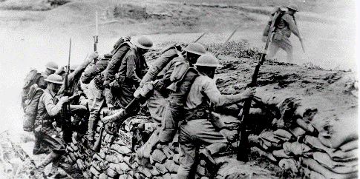
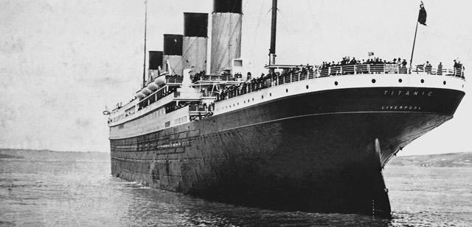 | 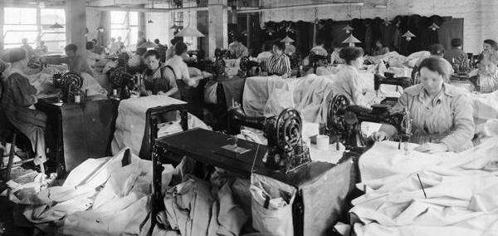 | 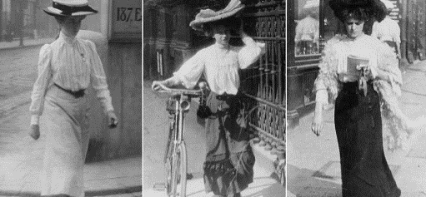
 | 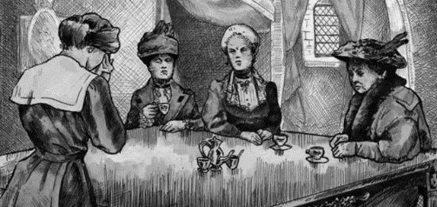

Retrieval Grid

Quiz Questions

1 | What is Gerald’s surname?
2 | When is the play set?
3 | Which character is in his ‘middle twenties’?
4 | Which character is described as a ‘handsome chap’?
5 | What is the name of the parlour maid?
6 | Which character says, ‘I’m treating Gerald like one of the family’?
7 | Who became the prime minister in 1945?
8 | Which character says, ‘Now, Sheila, don’t tease him’?
9 | How many acts are there in the play?
10 | In which year was the play first performed?
11 | Which character says, ‘The Germans don’t want war’?
12 | What is the name of the family business that Gerald will eventually be in charge of?
13 | Which character says, ‘Yes, you’ve piled it on a bit tonight, Father’?
14 | What is the ‘Kaiser’ a reference to?
15 | What is Mrs Birling’s first name?
16 | What is Mr Birling’s first name?
17 | Which character says, ‘It isn’t if you can’t go and work somewhere else’
18 | Which character is interrogated first by the inspector?
19 | What is the Inspector’s surname?
20 | Where is the play set?
21 | What is the name of the bar where Eric and Gerald meet Eva?
22 | What is the name of the real town that the setting of the play is based on?
23 | Which character says, ‘What’s all this about?’
24 | How many shillings in total did Eva ask to be paid shortly before going on strike?
25 | Which character says, ‘A little promising life there’?

Quiz Questions

26 | Which character says, ‘So I’m really responsible?’
27 | In which year did World War 1 begin?
28 | What do the ‘J’ and ‘B’ stand for in J. B. Priestley?
29 | Did Priestley fight in World War I or World War II?
30 | Which character says, ‘All right. I knew her. Let’s leave it at that’?
31 | What is the name of the shop that Eva works at after being sacked by Birling?
32 | To which social class do Gerald and Mrs Birling belong?
33 | Which character says, ‘You seem to have made a great impression on this child?’
34 | From the start of the play, how many years ago was Mr Birling Lord Mayor?
35 | Which character says, ‘I’m glad I amuse you’?
36 | In which month does Gerald admit to meeting Daisy Renton?
37 | Which character is says, ‘Fiddlesticks!’?
38 | What is the name of the local alderman who ‘wedged’ Daisy into a corner?
39 | Where does Gerald take Eva for dinner?
40 | Which character says, ‘First, she called herself Mrs Birling!’?
41 | What is the name of Mrs Birling’s charity organisation?
42 | What is the name of Gerald’s friend who goes to Canada for six months?
43 | In which month did Eric meet Eva?
44 | How much money did Eric steal from his father?
45 | Did Sheila accept the money from Eric?
46 | Which character says, ‘There’ll be a public scandal’?
47 | Who does Birling phone to check the identity of the Inspector?
48 | Which character proposes that the Inspector is a fake?
49 | Which character says, ‘That doesn’t matter to me. The one I knew is dead’?
50 | Which character says, ‘The famous generation who know it all’?

Multiple-Choice Quiz

- Which adjective most accurately describes the character of Arthur Birling?

Pretentious | Stupid | Helpful | Honest | Arrogant

- Birling says, ‘I’m on the Bench’ – what does he mean?

He has the authority to preside over court cases | He’s unsure about how to answer a question

- Which adjective most accurately describes the character of Eric Birling?

Misunderstood | Shy | Erratic | Violent | Deceitful

- How does Sheila Birling react to Gerald Croft’s narrative about Daisy Renton?

She becomes increasingly angry | She begrudgingly forgives Gerald | She eventually respects his honesty

- Which adjective most accurately describes the character of Sybil Birling?

Polite | Charitable | Moral | Spiteful

- What does Inspector Goole encourage the Birling family to do in his final speech?

Forget about Eva Smith | Remember all the vulnerable members of society

- Why is Birling relieved to hear that the Inspector be a ‘fake’?

There will not be a public scandal | He will not have to pay compensation | The wedding can go ahead

- Which adjective best describes Eric Birling’s attitude towards his parents at the end of the play?

Disappointed | Proud | Loving | Unsatisfied | Disgusted

- Which adjective most accurately describes the reaction of Birling when he answers the phones at the end of the play?

Shocked | Relieved | Vindicated | Annoyed

- ‘And a police inspector is on his way here…’ – how does the quotation from act three finish?

‘ – to ask some – questions – ’ | ‘ – to investigate – a crime – ’

Multiple-Choice Quiz

- Which of the statements below most fairly summarises the presentation of Arthur Birling?

A | A respectable businessman who, despite making an unfortunate decision, does nothing wrong
B | A character who does his best to protect himself and his family from the Inspector’s unfair questions
C | A greedy character who is rightly challenged by the Inspector and begins to understand that he must change
D | A defensive character who understands that he has acted foolishly, but does his best to hide the truth
E | An arrogant, conceited character who fails to take any responsibility and believes he is blameless

- Which of the statements below most fairly summarises the presentation of Sybil Birling?

A | A character who has no empathy for vulnerable, desperate working-class women
B | A wealthy, privileged woman who is unable to fully understand the plight of those less fortunate than her
C | A powerful socialite who enjoys punishing those her come to her asking for help
D | A misunderstood character who makes a poor decision and regrets it immediately afterwards
E | An aristocratic woman trapped in an unhappy marriage

- Which of the statements below most fairly summarises the presentation of Sheila Birling?

A | A naive young woman who has very little understanding of the wider world around her
B | A compliant and agreeable young woman who possess more knowledge about the realities of life that it initially seems
C | A shallow, materialistic young woman with little interest in anything beyond her own appearance
D | An awkward character who purposefully antagonises her brother and tries to undermine her father
E | A likeable, but fundamentally flawed character, who is presented by Priestley as privileged and selfish

- Which of the statements below most fairly summarises the presentation of Gerald Croft?

A | A charming and attractive young man who behaves irresponsibly
B | A generous and romantic character who genuinely helps Daisy in a time of need
C | A predatory character who takes advantage Daisy when she is particularly vulnerable
D | A deceitful character who does not love his fiancée
E | A selfless character who takes the difficult decision to end the relationship with Daisy to avoid hurting Sheila

Multiple-Choice Quiz

- ‘Do you know what happened to this girl after she left my works’ – where did Eva work after she was fired by Birling?

A | She didn’t manage to find formal employment
B | Milwards – after two weeks
C | Milwards – after two months
D | She worked as a barmaid at the Palace – after a week
E | She worked as a barmaid at the Palace – after three weeks

- ‘I think she went away – to be alone, to be quiet’ – where did Eva go?

A | To the seaside
B | To the countryside
C | To central Brumley
D | To a friend’s house
E | To the Palace Variety Theatre

- ‘I blame the young man’ – why does Mrs Birling initially blame the father of Eva’s unborn child for her death?

A | Because he refused to support her
B | Because he refused to marry her
C | Because he left Brumley without a trace
D | Because he was incapable to supporting her
E | Because he was angry with her

- ‘but was he really a police inspector’ – which character first suspects that the Inspector might be a fake?

A | Arthur Birling
B | Sybil Birling
C | Sheila Birling
D | Eric Birling
E | Gerald Croft

Character Focus on Birling

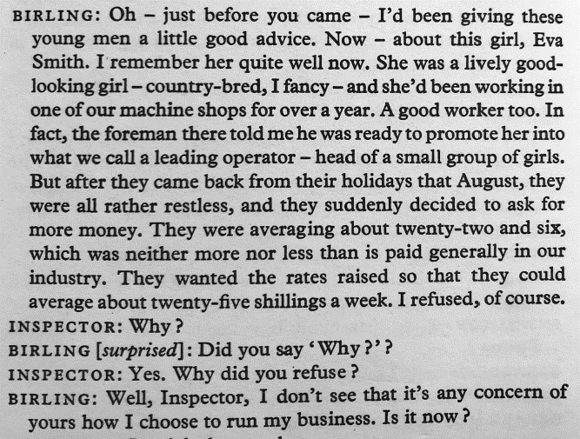

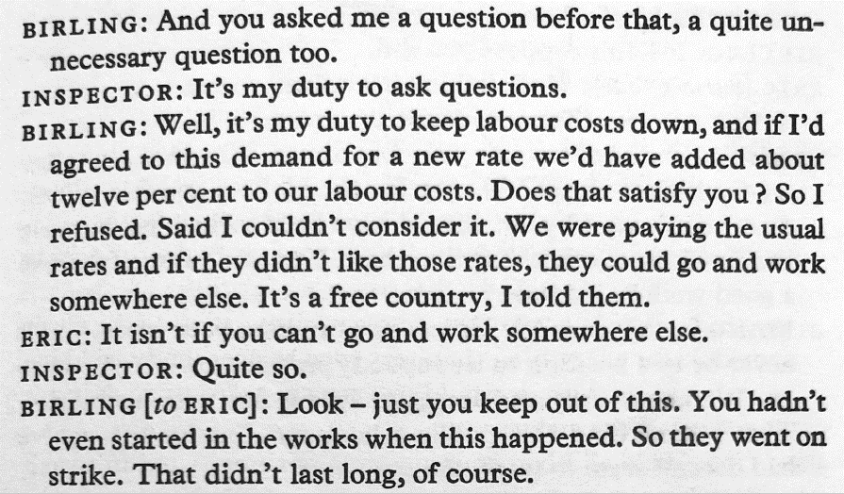

Character Focus on Sheila

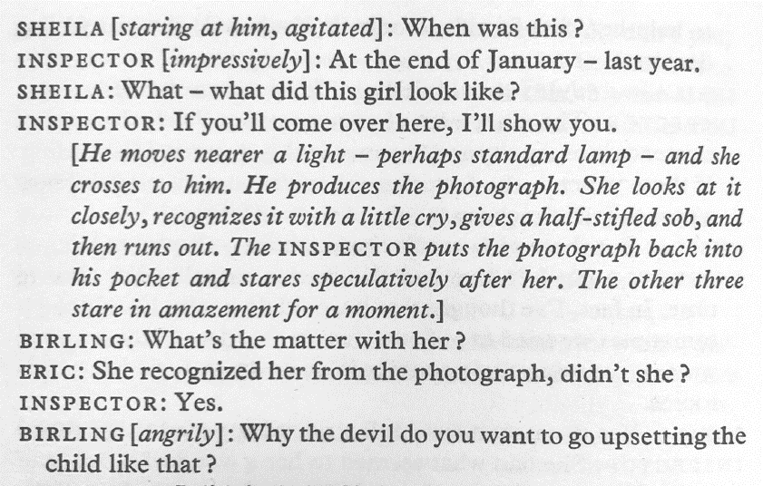

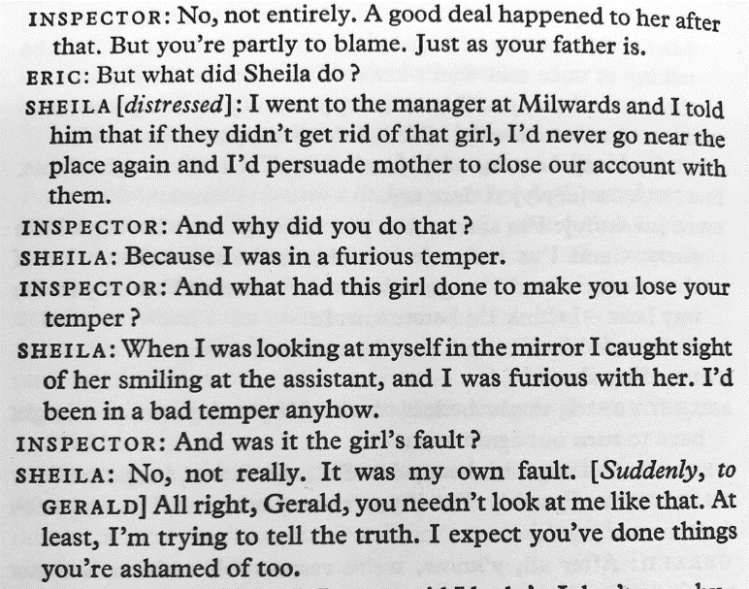

Character Focus on Gerald

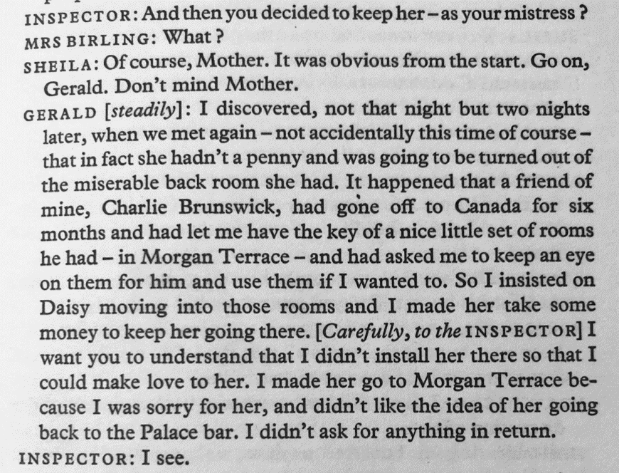

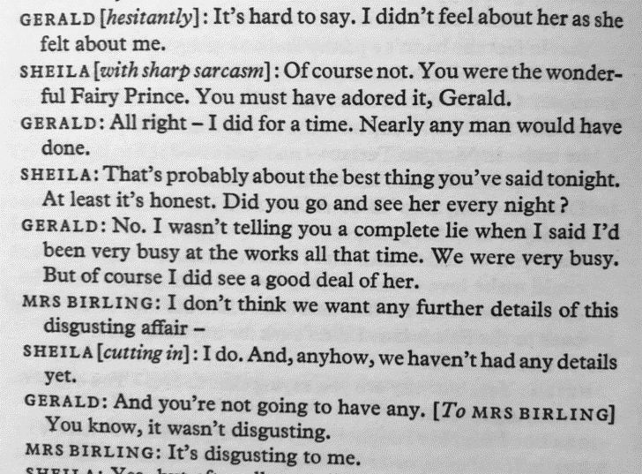

Character Focus on Mrs Birling

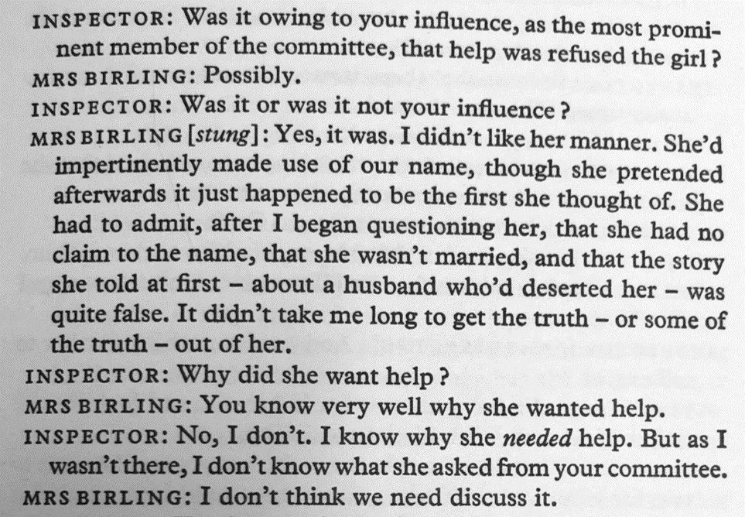

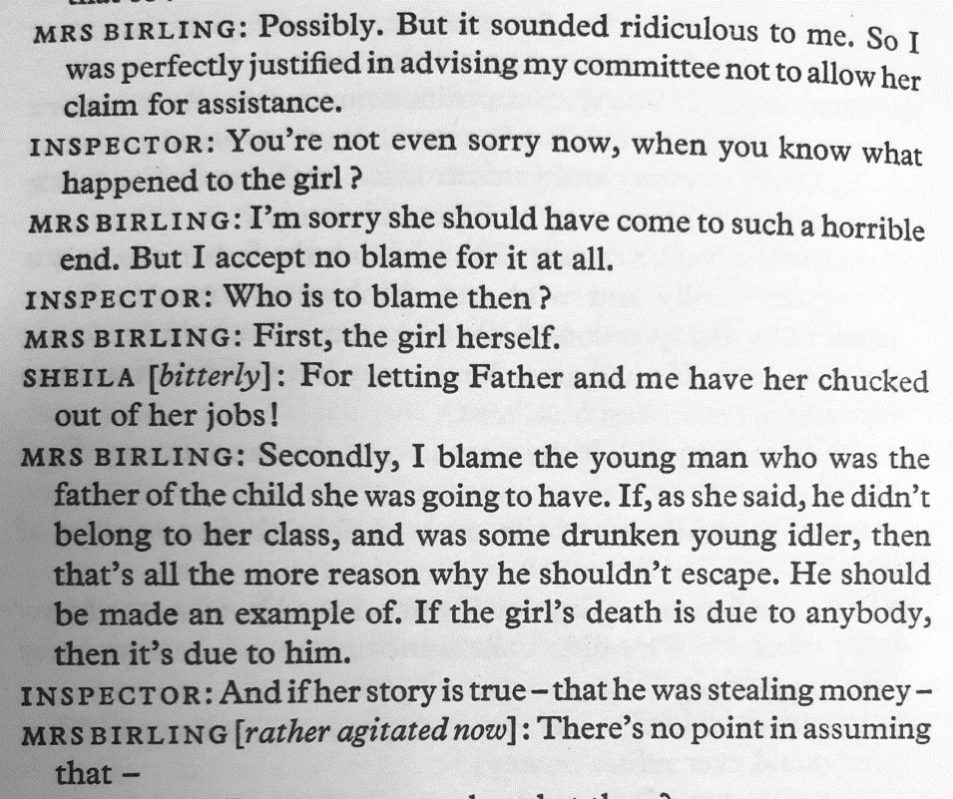

Character Focus on Eric

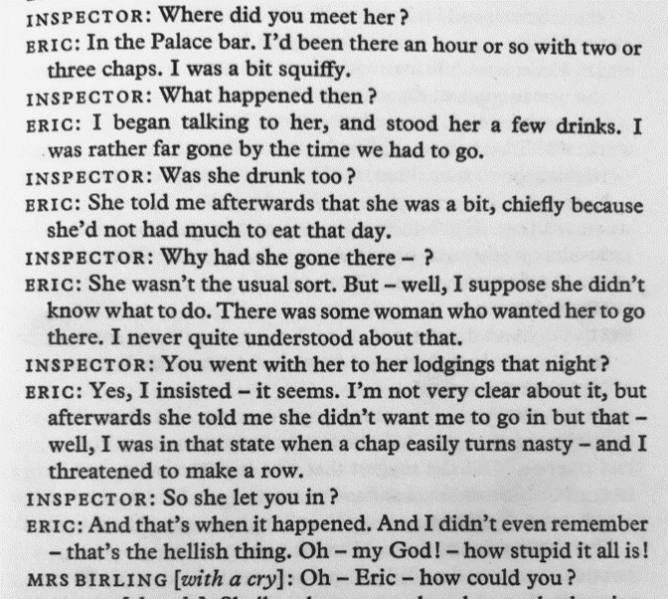

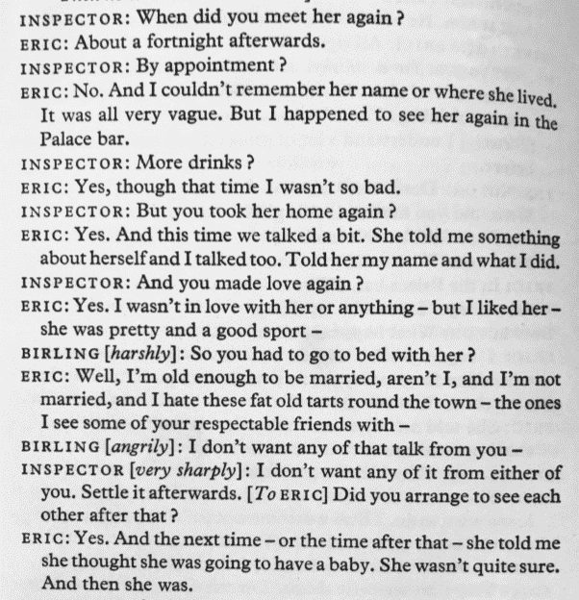
Specimen Exam Questions

Source: AQA SAMs 2

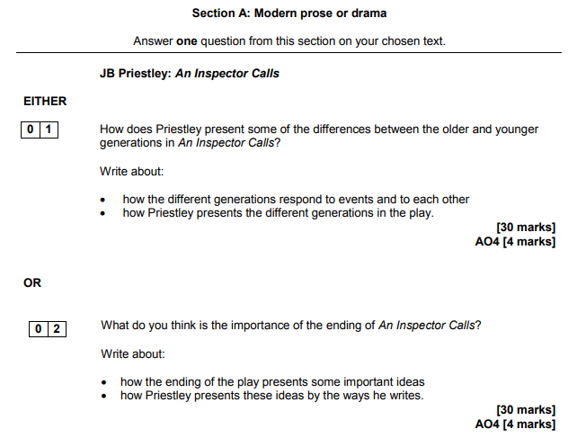

Specimen Exam Questions

Source: AQA SAMs 3

