**Chapter 1: Christmas Eve**

1. What is Arthur’s mood like before the family tell ghost stories to each other?
2. How does he react when he is asked to tell a story himself?
3. What does he say he will do at the end of the chapter?

**Chapter 2: A London Particular**

1. Why does Mr Bentley ask Arthur to go to Eel Marsh House?
2. What does it mean to be called a ‘rum ‘un’?

**Chapter 3: The Journey North**

1. What is the weather like during the train journey?
2. Who does Arthur meet on the train to Crythin Gifford?
3. What does he offer to do?

**Chapter 4: The Funeral of Mrs Drablow**

1. What big local event is due to take place on the day of the funeral?
2. What is the weather like on the day of the funeral?
3. What does Arthur see after the mysterious mourner disappears?
4. What makes access to Eel Marsh House difficult?

**Review**

1. Explain why Arthur becomes increasingly irritated by the local people he encounters
2. Write a description of the mourner he sees at the funeral
3. Provide two reasons why Eel Marsh House is described as a ‘remarkable’ place
4. Choose three things that make the novel seem ‘ghostly’

**Personal Response**

* Write a paragraph on what happens before, during and after this part of the novel

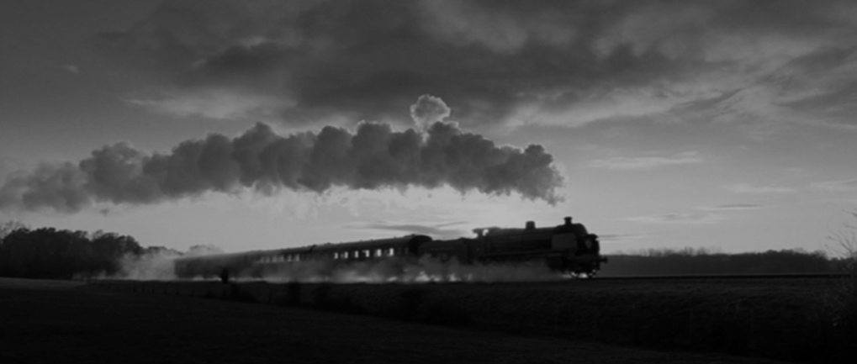

**Chapter 5: Across the Causeway**

1. What are Arthur’s first impressions of the countryside before he arrives at the causeway?
2. How does he describe the mysterious woman he sees in the grounds of Eel Marsh House?

**Chapter 6: The Sound of a Pony and Trap**

1. What disturbing event does Arthur witness on the causeway?
2. Why is he initially confused when Keckwick arrives?
3. How does Arthur feel when he eventually arrives back at the Gifford Arms?

**Chapter 7: Mr Jerome is Afraid**

1. How does Mr Jerome behave when Arthur visits him?
2. How has Arthur’s attitude about Eel Marsh House changed since the previous evening?

**Chapter 8: Spider**

1. How does Mr Daily treat Arthur when he arrives for dinner?
2. What advice does he give Arthur?
3. Why does he provide Arthur with his dog?

**Review**

1. Explain how Arthur’s attitude towards Eel Marsh House has changed since the start of the novel
2. Provide three examples of local people being kind to Arthur
3. Explain how the weather conditions influence the mood when Arthur is at Eel Marsh House

**Personal Response**

* Write a paragraph on what you know about the character of Keckwick
* What he does and says
* Arthur’s view of him
* Your view of him

**Chapter 9: In the Nursery**

1. What does Arthur’s decision to return to Eel Marsh House reveal about his character?
2. How does the presence of Spider help to build tension in the chapter?
3. What sort of a character does Jennet appear to be from her letters?

**Chapter 10: Whistle and I’ll Come to You**

1. What are three things that happen in the chapter that build tension?
2. What does Arthur’s rescue of Spider reveal about his character?

**Chapter 11: A Packet of Letters**

1. What does Arthur find has changed in the nursery?
2. What three words best describe Samuel Daily’s house?
3. What are two things that Arthur feels about Jennet as he reads her letters?
4. How is Keckwick connected to Jennet?
5. How did Jennet’s feelings towards Alice Drablow change?

**Chapter 12: The Woman in Black**

1. How does Arthur feel about leaving the Daily household?
2. What happens within six weeks after he leaves London?
3. What event happens at the end of the chapter that mirrors the one in chapter six?

**Review**

1. Write down five words to describe Jennet
2. Explain how the locals of Crythin Gifford are affected by the ghostly presence of Jennet
3. Explain how Arthur’s life changes when he leaves Crythin Gifford

**Personal Response**

* Write a paragraph explaining why the nursery room is a sad and disturbing place

