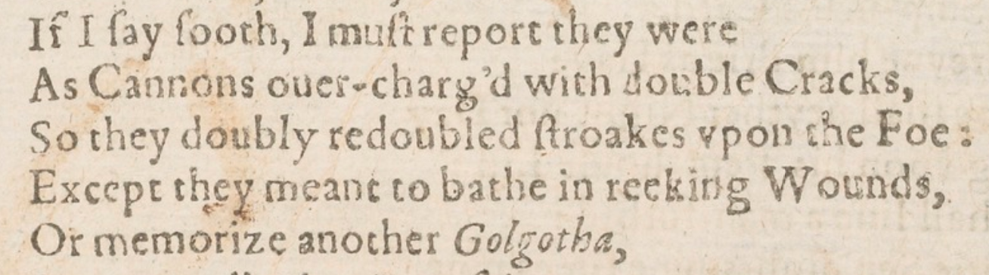

Act-by-Act Revision Booklet
Macbeth
Mr Wise
English

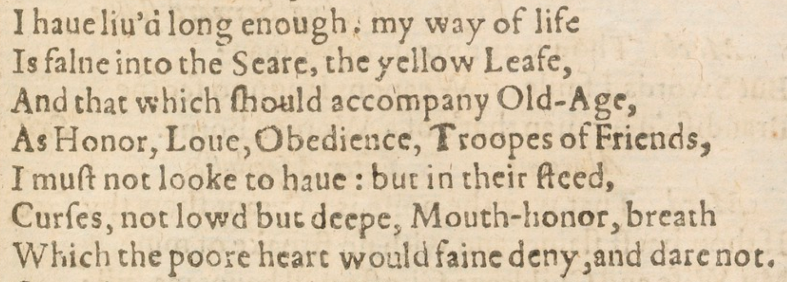

Act 1

- Write down two reasons why the weather conditions at the beginning of A1-S1 are important
- Write down what ‘hurlyburly’ means
- Explain what you know about witches’ ‘familiars’

- Write down three adjectives to describe Macbeth based on his presentation in A1-S2
- Fill in the gaps: ‘This is the sergeant who like a _____ and _____ soldier fought _____ my captivity’ (p5)
- Fill in the gaps: ‘But all’s to weak for _____ Macbeth’ (p5)
- Write down the name of the King of Norway
- Explain how Duncan chooses to reward Macbeth

- Retrieve three short quotations that describe the physical appearance of the Witches in A1-S3
- Write down two reasons why the physical appearance of the Witches is important
- Explain in fifty words what James I believed about witches and witchcraft
- Write down what the Witches prophecise about Macbeth
- Explain in fifty words how Banquo is both ‘lesser than Macbeth, and greater’ (p13)
- Fill in the gaps: ‘And oftentimes, to win us to our harm, the instruments of _____ tell us _____’ (p17)
- Explain what Macbeth is thinking of when he reflects on the ‘horrid image’ that makes his ‘heart knock’ at his ribs
- Explain what a ‘tragic flaw’ is and how it relates to the character of Macbeth

- Write down the character who says, ‘There’s no art to find the mind’s construction in the face’ in A1-S4
- Fill in the gaps: ‘Our eldest, Malcolm, whom we name hereafter the _____ of _____’ (p27)
- Explain what Macbeth is referring to when he reflects on his ‘black and deep desires’

- Write down what Lady Macbeth is doing at the start of A1-S5
- Explain in fifty words why Lady Macbeth ‘fears’ Macbeth’s nature
- Retrieve two short quotations that show Lady Macbeth is a ruthless character
- Write the character Lady Macbeth is referring to when she says, ‘O never shall sun that morrow see’
- Fill in the gaps: ‘Look like th’ _____ flower, but be the _____ under’t’ (p33)
- Explain what you know about the Divine Right of Kings

- Find the line in A1-S7 where Macbeth says, ‘He’s here in double trust’
- Explain what Macbeth means by ‘double trust’
- Explain what you know about soliloquies
- Retrieve two short quotations that show Lady Macbeth is a manipulative character
- Explain in fifty words Lady Macbeth’s plan to murder Duncan
- Fill in the gaps: ‘_____ face must _____ what the _____ heart doth know’ (p43)
Act 2

- Write down the name of the first character to speak in A2-S1
- Fill in the gaps: ‘Is this a _____ which I see before _____, the _____ toward my hand?’ (p51)
- Explain what Macbeth means when he refers to his ‘heat-oppressed brain’
- Write two things that blood symbolises
- Explain in fifty words how Macbeth has changed since the beginning of the play

- Write down the reason Lady Macbeth gives in A2-S2 for not being able to kill Duncan herself
- Write down what Macbeth is referring to when he says, ‘This is a sorry sight’
- Explain how Lady Macbeth responds to Macbeth’s statement
- Write down what Macbeth claims to have ‘heard a voice cry’ after murdering Duncan
- Fill in the gaps: ‘Go get some water, and _____ this _____ witness from your _____’ (p57)
- Explain why it is important that the murder weapons are returned to Duncan’s bedchamber
- Explain in fifty words what disturbed sleep and bloody hands reveal about Macbeth’s state of mind
- Fill in the gaps: ‘Wake _____ with thy _____. I would thou _____’ (p59)

- Write down two reasons why the weather conditions during the night of Duncan’s murder A2-S3 are important
- Explain why Macduff has arrived at Macbeth’s castle
- Explain what you understand about the crime of treason
- Fill in the gaps: ‘O horror, _____, _____!’ (p69)
- Explain why Macduff describes the murder of Duncan as ‘sacrilegious’
- Fill in the gaps: ‘Had I but died an _____ before this _____, I had lives a _____ time’ (p71)
- Explain how Macbeth justifies killing the guards to Macduff
- Write down three adjectives to describe Macduff based on his presentation in the scene
- Write down the counties that Malcolm and Donalbain flee to after the murder
- Explain why they choose to leave Scotland

- Explain what the Old Man says happened to Duncan’s horses when he speaks to Ross in A2-S4
- Fill in the gaps: ‘The ’tis most like the _____ will fall upon _____’ (p77)
- Write down where Macduff says he will go instead of Scone where Macbeth is due to be crowned

Act 3

- Write down the name of the character who Banquo is thinking about at the start of A3-S1
- Retrieve a quotation that shows Banquo suspects Macbeth of murdering Duncan
- Write down the names of the two characters Macbeth calls ‘bloody cousins’
- Fill in the gaps: ‘Our fears in _____ stick _____’ (p87)
- Explain why Macbeth believes his crown is ‘fruitless’ and his sceptre ‘barren’
- Fill in the gaps: ‘Both of you know _____ was your _____’ (p93)
- Write down the name of Banquo’s son
- Explain why his death is ‘no less material’ than the death of Banquo

- Write down three adjectives to describe Macbeth’s state of mind in A3-S2
- Fill in the gaps: ‘We have _____ the _____, not killed it’ (p95)
- Explain why Macbeth says his mind is ‘full of scorpions’
- Retrieve a quotation that shows Macbeth does not reveal his murderous plans to Lady Macbeth

- Explain in fifty words what happens in A3-S3
- Fill in the gaps: ‘O _____! Fly good _____, _____, _____, fly!’ (p105)

- Explain what Macbeth means when he says, ‘You know your own degrees, sit down’ at the start of A3-S3
- Explain in fifty words what the importance of the feast is to Macbeth and Lady Macbeth
- Explain what Macbeth means when he questions if Banquo is ‘safe’
- Explain why the ‘locks’ of Banquo’s ghost are ‘gory’
- Fill in the gaps: ‘The _____ is momentary, upon a thought he will again be _____’ (p109)
- Retrieve a quotation that shows Lady Macbeth questions Macbeth’s masculinity
- Explain Lady Macbeth’s reference to the ‘air-drawn dagger’
- Fill in the gaps: ‘My worthy _____, your noble _____ do _____ you’ (p111)
- Explain in fifty words what the sighting of Banquo’s ghost reveals about Macbeth’s state of mind
- Write down two reasons why the ‘most admired disorder’ that Macbeth creates is significant
- Fill in the gaps: ‘It will have _____, they say; _____ will have _____’ (p113)
- Write down what Macbeth plans to do at the end of the scene

Act 4

- Write two reasons why the Witches speak in rhyming couplets in A4-S1
- Fill in the gaps: ‘By the _____ of my _____, _____ wicked this _____ comes’ (p129)
- Retrieve a quotation that shows Macbeth initially speaks disdainfully to the Witches
- Write down the form that the first apparition takes
- Fill in the gaps: ‘Macbeth, Macbeth, _____, beware _____’ (p131)
- Write down the form that second first apparition takes
- Fill in the gaps: ‘The power of _____, for none of _____ born shall _____ Macbeth’ (p133)
- Explain in fifty words how Macbeth reacts to the sight of the three apparitions
- Write down what the Witches show Macbeth that ‘sear’ his ‘eyeballs’
- Explain why Macbeth says it is a ‘horrible sight’
- Retrieve two short quotations that show Macbeth is distressed
- Write down the name of the character whose castle Macbeth vows to ‘surprise’

- Write down what the First Murderer accuses Macduff of being in A4-S2
- Write down five adjectives to describe how Macduff’s Son is presented in the scene

- Retrieve a quotation that shows Malcolm is suspicious of Macduff at the start of A4-S3
- Fill in the gaps: ‘Angels are _____ still, though the _____ fell’ (p151)
- Explain the significance of the reference to Satan and the concept of Divine Authority
- Explain why Macduff says that Scotland is ‘bleeding’
- Explain what Malcolm means when says that Macbeth is ‘as pure as snow’ compared to him
- Write down why Malcolm is not being truthful to Macduff
- Explain why Macduff exclaims, ‘O Scotland, Scotland!’
- Find the line where Malcolm says, ‘Devilish Macbeth’
- Fill in the gaps: ‘No, they were _____ at _____, when I did _____ ‘em’ (p161)
- Write down two connotations of the ‘hell kite’ metaphor that Macduff uses to describe Macbeth
- Write down two connotations of the ‘pretty chickens’ metaphor that Macduff uses to describe his children

Act 5

- Explain what is happening at the start of A5-S1
- Write down how many nights the Doctor has been watching Lady Macbeth
- Write down two reasons why Lady Macbeth’s disturbed sleep is important
- Fill in the gaps: ‘A great _____ in nature, to _____ receive at once the benefit of _____’ (p171)
- Write down that the ‘spot’ is that Lady Macbeth refers to whilst she is sleepwalking
- Fill in the gaps: ‘Out damned _____, _____ I say!’ (p173)
- Write down the name of the Thane of Fife?
- Explain what happened to his wife
- Explain the significance of Lady Macbeth believing that her hands will ‘ne’er be clean’
- Fill in the gaps: ‘What’s _____ cannot be _____’ (p175)

- Explain the reference to ‘let them all fly’ at the beginning of A5-S3
- Explain what Macbeth means when he calls the English soldiers ‘epicures’
- Retrieve a quotation that suggests Macbeth will refuse to surrender or admit defeat
- Write down how many soldiers the Servant says are gathered outside Macbeth’s castle
- Fill in the gaps: ‘I will not be afraid of _____ and _____, till _____ forest come to _____’ (p183)

- Retrieve a quotation that shows Macbeth is confident he can defeat Malcom’s army at the beginning of A5-S5
- Write down the name of the character to informs Macbeth that Lady Macbeth is dead
- Fill in the gaps: ‘Out, _____, brief _____! Life’s but a _____ _____’ (p193)
- Explain why Macbeth calls the Messenger a ‘liar and a slave’

- Explain what Macbeth means when he says he will fight ‘bear-like’ at the beginning of A5-S7
- Retrieve the quotation where Young Siward alludes to the ‘devil himself’
- Explain the connection between the devil and Macbeth
- Provide a definition of the word ‘tyrant’

- Explain Macbeth’s reference to ‘the Roman fool’ at the beginning of A5-S8
- Fill in the gaps: ‘Turn _____ _____, turn!’ (p199)
- Write down three adjectives to describe Macduff’s presentation in the scene

- Explain what is happening at the start of A5-S9
- Explain what Ross means when he talks about a ‘soldier’s debt’
- Write down what Macduff is holding when he enters the scene
- Fill in the gaps: ‘Of this _____ _____, and his fiend-like _____’ (p205)

