AQA Power and Conflict Poetry

- GCSE English Literature

- Supplementary Study Booklet

- Mr Wise

- E1

Ozymandias, by Percy Bysshe Shelley

London, by William Blake

Extract from The Prelude, by William Wordsworth

My Last Duchess, by Robert Browning

The Charge of the Light Brigade, by Alfred Lord Tennyson

Exposure, by Wilfred Owen

Storm on the Island, by Seamus Heaney

Bayonet Charge, by Ted Hughes

Remains, by Simon Armitage

Poppies, by Jane Weir

War Photographer, by Carol Ann Duffy

Tissue, by Imtiaz Dharker

The Emigrée, by Carol Rumens

Checking Out Me History, by John Agard

Kamikaze, by Beatrice Garland

Ozymandias, by Percy Bysshe Shelley (1818)

- The once ‘vast’ statue of Ozymandias is now just a ‘colossal wreck’

- The ruins remind us that power, even for a self-proclaimed ‘King of Kings’, is transient

- In one sense, the words on the pedestal are ironic because there is nothing left to make others ‘despair’

- However, in another, they provide a warning that all rulers will eventually share the same fate

- The most striking image is the ‘boundless and bare’ desert, which hints at the enduring power of the natural world

- Arrogance A exaggerated sense of self-importance

- Transient Impermanent; something that doesn’t last

- Tyrant A cruel, ruthless ruler

- London, by William Blake

- My Last Duchess, by Robert Browning

- Checking Out Me History, by John Agard

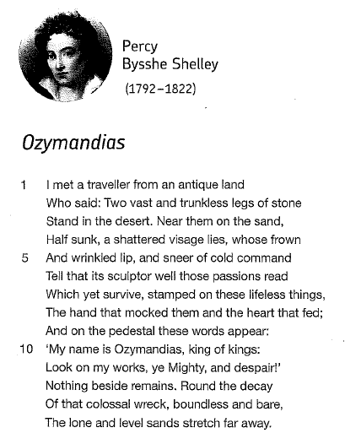

London, by William Blake (1792)

- The city of London is characterised by images of claustrophobia, oppression and violence

- The inhabitants are miserable and their faces are marked with ‘weakness’ and ‘woe’

- The sounds of the city reflect this sense of misery: the infants ‘cry’, the soldiers ‘sigh’ and the harlots ‘curse’

- The ‘blood’ on the palace walls hints at the possibility of a revolution (like the one in France that began in 1789)

- Blake presents London as existing in a state of moral, physical and political turmoil

- Imagination The ability to think creatively and form new ideas

- Liberty Freedom, the power to pursue a chosen way of life

- Morality Perceptions of acceptable and unacceptable behaviour

- Oppression Treatment that is cruel and unfair

- Revolution The forcible overthrow of a government

- London, by William Blake

- Extract from The Prelude, by William Wordsworth

- Storm on the Island, by Seamus Heaney

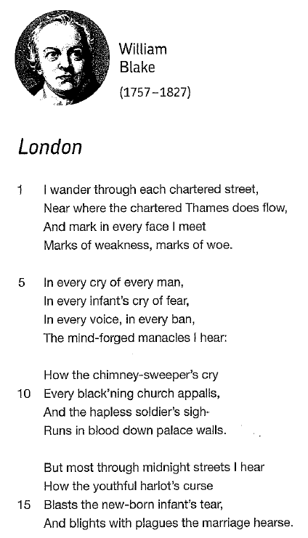

Extract from The Prelude, by William Wordsworth (1799)

- The speaker of the poem (probably Wordsworth himself) embarks on journey, both literally and metaphorically

- At first, the speaker is struck by the beauty of the ‘glittering’ and ‘sparkling light’ on the lake

- However, a contrast soon emerges between the ‘little boat’ and the ‘huge peak’

- The landscape becomes threatening and the speaker is soon in a ‘grave’ and ‘serious’ mood

- The speaker seems both troubled and fascinated by the sensation of feeling so insignificant

- Imagination The ability to think creatively and form new ideas

- Sublime A feeling characterised by a mixture of fear and awe

- London, by William Blake

- My Last Duchess, by Robert Browning

- Exposure, by Wilfred Owen

- Storm on the Island, by Seamus Heaney

- Kamikaze, by Beatrice Garland

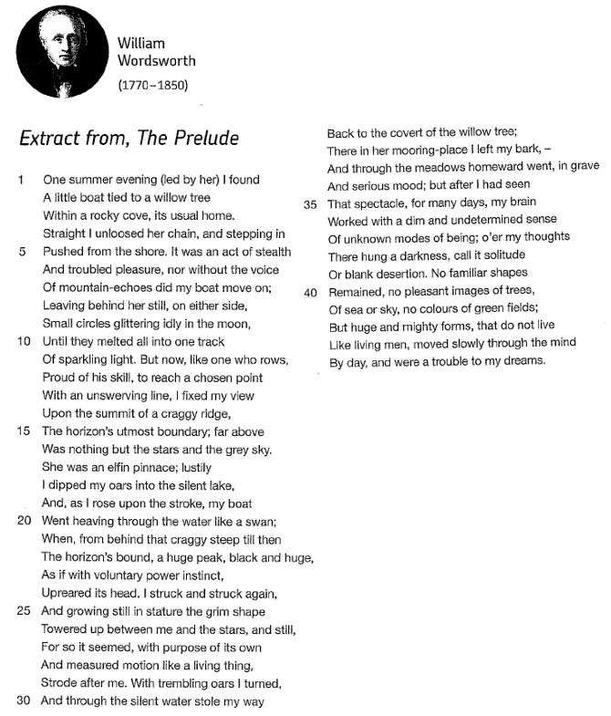

My Last Duchess, by Robert Browning (1842)

- The Duke’s monologue is initially characterised by overt gestures of flattery and politeness

- However, it soon becomes clear that he is possessive and demanding

- The syntax of the monologue becomes increasingly fragmented as the focus shifts to the Duchess’s behaviour

- The Duke’s admits that he ‘gave commands’ to stop her ‘smiles’, which implies that he ordered her murder

- The final image of Neptune ‘taming a sea-horse’ reflects the Duke’s desire to control those around him

- Authoritarian Behaviour characterised by a desire to control; the expectation of obedience

- Monologue A speech presented by a single character

- Possessive Controlling; fearful of loss

- Syntax The arrangements of words and punctuation marks in a sentence

- Ozymandias, by Percy Bysshe Shelley

- The Emigrée, by Carol Rumens

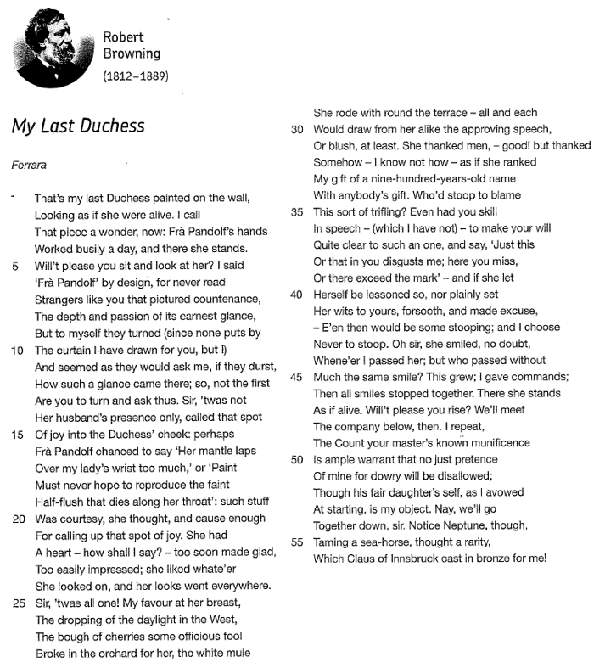

The Charge of the Light Brigade, by Alfred Lord Tennyson (1854)

- Tennyson praises the heroism of the cavalrymen (i.e. the Light Brigade) who fought in the Battle of Balaklava

- He highlights that they were vastly outnumbered as they rode ‘into the Valley of Death’

- The reference to the ‘blunder’d’ command suggests a disastrous miscommunication

- The distinctive rhythm of the poem reflects the powerful, decisive galloping of the horses

- The structure follows the dramatic movement of the cavalrymen as they are ‘stormed at with shot and shell’

Artillery Heavy, powerful guns

Dutiful Obedient and reliable; keen to meet expectations

Heroism Remarkable bravery

Massacre Brutal slaughter on a large scale

Patriotism National loyalty and enthusiasm

- Exposure, by Wilfred Owen

- Bayonet Charge, by Ted Hughes

- Remains, by Simon Armitage

- Poppies, by Jane Weir

- War Photographer, by Carol Ann Duffy

- Kamikaze, by Beatrice Garland
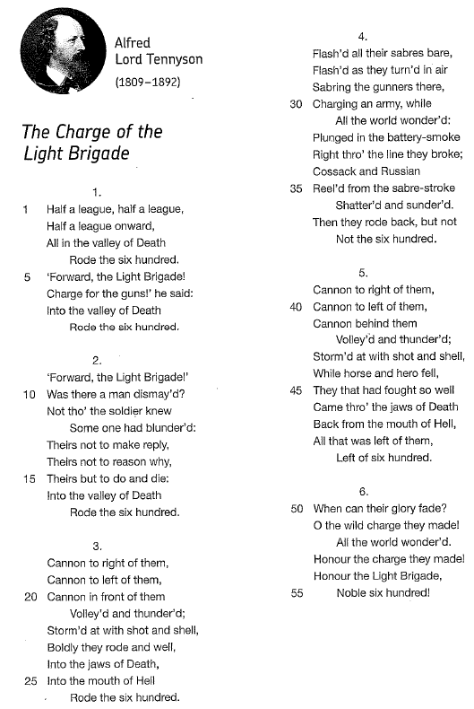

Exposure, by Wilfred Owen (1918)

- Owen describes the physical and mental trauma caused by frontline fighting as he and others experienced it

- The poem begins with the anticipation of conflict as the silence is disturbed by ‘successive flights of bullets’

- The freezing temperatures are presented as being just as deadly as the enemy soldiers

- Owen contrasts the ‘iced winds’ and ‘pale flakes’ with the ‘dark-red jewels’ of the fires at home

- The temporary shift to the third-person perspective conveys the impression of being totally lost in thought

Exposure Unprotected from something harmful; the revelation of damaging or unexpected information

Hallucination The experience of perceiving something not actually present or real

Inevitable Certain to happen; unavoidable

Trauma The enduring effects of frightening, stressful experiences

- The Charge of the Light Brigade, by Alfred Lord Tennyson

- Bayonet Charge, by Ted Hughes

- Remains, by Simon Armitage

- Poppies, by Jane Weir

- War Photographer, by Carol Ann Duffy

- Kamikaze, by Beatrice Garland

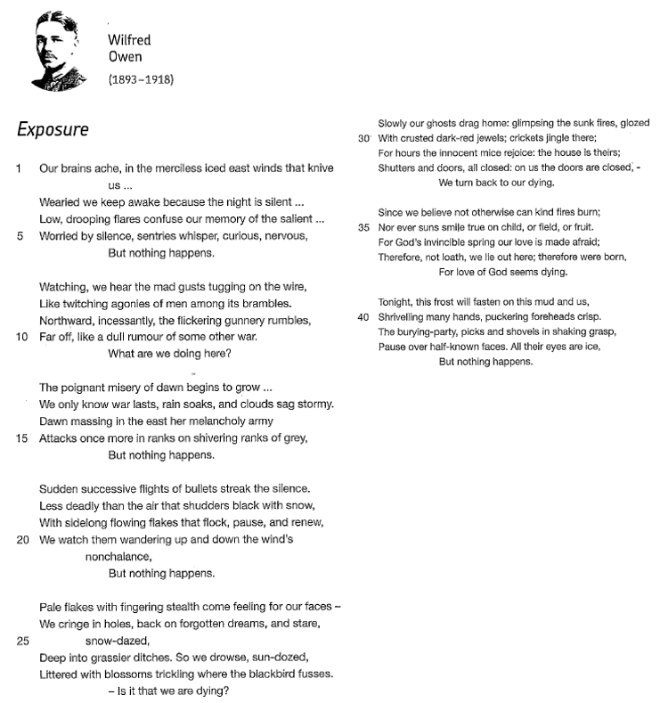

Storm on the Island, by Seamus Heaney (1966)

- The poem opens with a collective statement of intent from the islanders to endure the coming storm

- Heaney uses military metaphors to convey its power – ‘blast’, ‘pummels’, ‘salvo’, ‘bombarded’

- The weather is presented as a formidable, dangerous and unpredictable force

- The landscape of the island is sparse and exposed, but the community have adapted to survive

- The poem is perhaps an allegory for the on-going political troubles in Northern Ireland that began in the 1960s

Ambiguous Open to interpretation; unclear

Defiant Challenging; resisting authority or power

Isolation Feeling alone; being alone

- Extract from The Prelude, by William Wordsworth

- Exposure, by Wilfred Owen

- Kamikaze, by Beatrice Garland

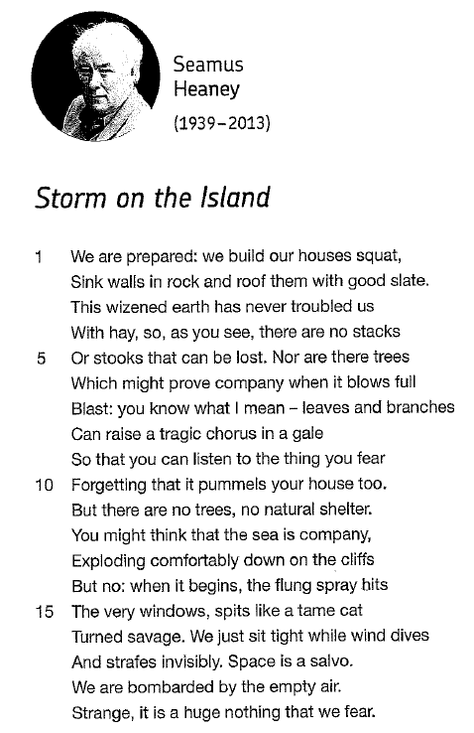

Bayonet Charge, by Ted Hughes (1957)

- Hughes immediately places the reader on the frontline in a scene that is characterised by chaos and confusion

- The intensity of the imagery in the first stanza emphasises the violent reality of combat

- The imagery then takes on a hallucinatory quality as the solider struggles to make sense of the situation he is in

- The movements of the solider are clumsy and desperate – ‘stumbling’, ‘lugged’, ‘plunged’

- Faced with such horrors, the solider loses his ‘human dignity’ as fear and panic overwhelm him

- Hallucination The experience of perceiving something not actually present or real

- Patriotism National loyalty and enthusiasm

- Terror Extreme fear

- The Charge of the Light Brigade, by Alfred Lord Tennyson

- Exposure, by Wilfred Owen

- Remains, by Simon Armitage

- Poppies, by Jane Weir

- War Photographer, by Carol Ann Duffy

- Kamikaze, by Beatrice Garland

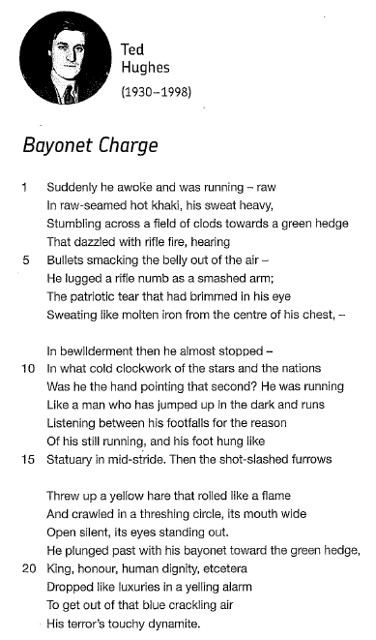

Remains, by Simon Armitage (2008)

- The title of the poem refers to both the literal remains of the looter and the trauma that clearly still remains

- The speaker alludes to ‘another occasion’ at the start of the poem, which implies acts of violence are common

- The brutality of the shooting contrasts with the speaker’s casual narration of the details

- The looter’s body is ‘carted off in the back of the lorry’ and disposed of unceremoniously

- The ‘bloody hands’ are an allusion to Macbeth and help to convey the speaker’s enduring feelings of guilt

- Brutal Extremely violent; harsh

- Colloquial Informal; chatty; conversational

- Looter A person who opportunistically steals, typically during a war or a period of social unrest

- Trauma The enduring effects of frightening, stressful experiences

- The Charge of the Light Brigade, by Alfred Lord Tennyson

- Exposure, by Wilfred Owen

- Poppies, by Jane Weir

- War Photographer, by Carol Ann Duffy

- Kamikaze, by Beatrice Garland

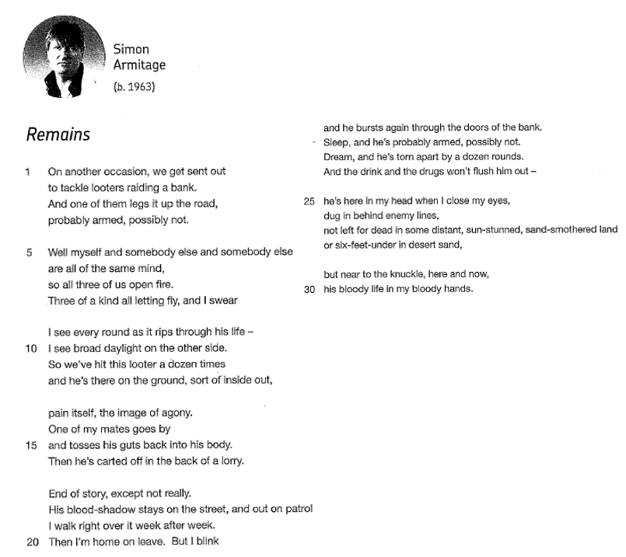

Poppies, by Jane Weir (2005)

- Poppies are a universal symbol of remembrance and a reminder to the speaker of the risks her son will take

- Weir’s use of enjambment helps to create the impression of an open and emotionally complex inner monologue

- The ‘blackthorns’ metaphor used to describe the hair of the speaker’s son has connotations of religious sacrifice

- In contrast, the ‘treasure chest’ simile emphasises the great sense of adventure that awaits him

- The speaker continues to feel conflicted, but ultimately accepts the inevitability of her son’s departure

- Conflicted A feeling characterised by confusion and worry

- Monologue A speech presented by a single character

- Wistful A feeling characterised by a sense of loss and longing

- The Charge of the Light Brigade, by Alfred Lord Tennyson

- Exposure, by Wilfred Owen

- Remains, by Simon Armitage

- War Photographer, by Carol Ann Duffy

- Kamikaze, by Beatrice Garland
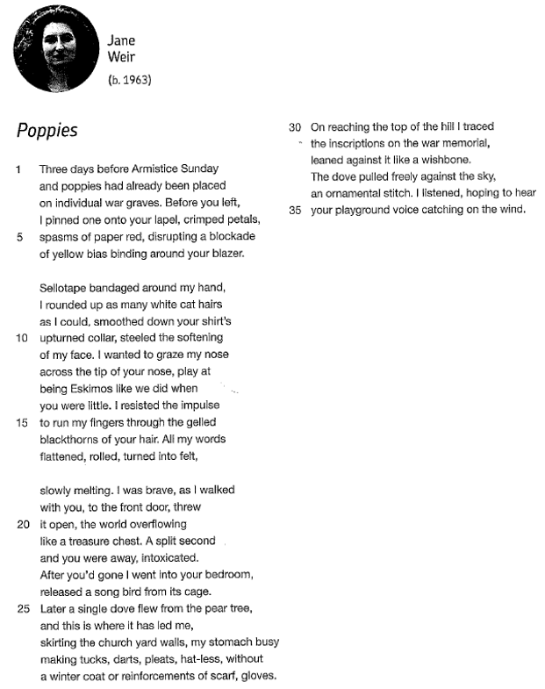

War Photographer, by Carol Ann Duffy (1985)

- The red light in the darkroom that ‘softly glows’ connotes blood and mortality, and creates a sombre tone

- ‘All flesh is grass’ is a reference from the Bible that emphasises the fragile and transient nature of human life

- Duffy creates a contrast between the safety of rural England and the ‘hundred agonies’ suffered by those abroad

- The close focus on the ‘stranger’ and his ‘wife’ provide a vivid and disturbing insight into the effects of war

- Duffy challenges our typically indifferent, desensitised responses to media coverage of global conflicts

- Desensitised A lack of feeling towards distressing scenes of violence and injustice

- Iconic Widely recognised

- Napalm A highly flammable chemical used by the American army during the Vietnam War

- Suffer To undergo extreme pain or hardship

- The Charge of the Light Brigade, by Alfred Lord Tennyson

- Exposure, by Wilfred Owen

- Remains, by Simon Armitage

- Poppies, by Jane Weir

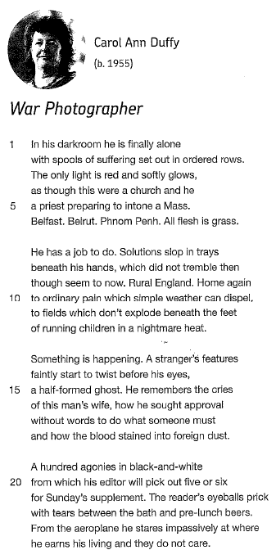

Tissue, by Imtiaz Dharker (2006)

- The poem opens with a vibrant and beautiful image of ‘light’ that conveys a sense of optimism for the future

- As the poem progresses, light is described different ways – it ‘shines’, it is ‘luminous’ and there is ‘daylight’

- Light has strong symbolic significance: it is associated with life and growth, and also truth (think: enlightened)

- It ‘shines through’ the borderlines of maps and is able to ‘break through capitals and monoliths’

- In the same way that light changes, so does paper and ‘living tissue’, and this process of transformation is positive

- Abstract Something based on an idea; something conceptual

- Optimistic Hopeful; confident about the future

- The Emigrée, by Carol Rumens

- Checking Out Me History, by John Agard

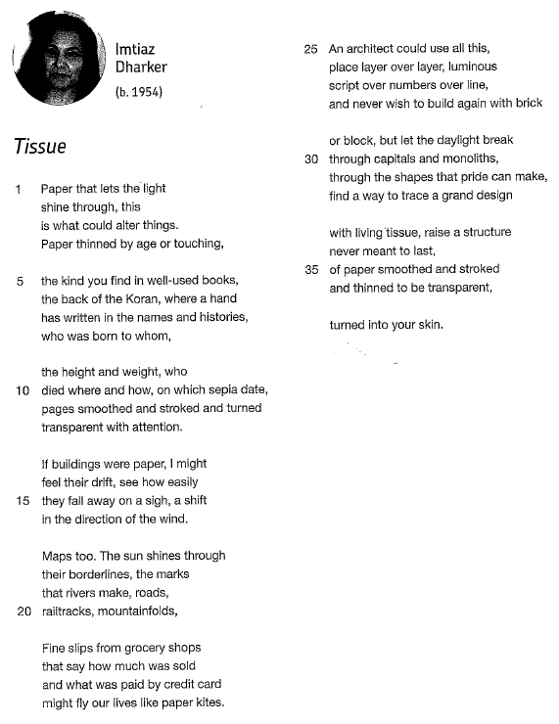

The Emigrée, by Carol Rumens (1993)

- The speaker of the poem appears to be in exile whilst ‘tyrants’ run the country

- Contrasts between light and darkness are established to emphasise positive and negative perspectives

- The speaker’s memories are vividly associated with sunlight and colour

- The speaker’s native language has been ‘banned’, but it remains unforgotten

- The personification of ‘my city’ highlights the intense emotional connection felt by the speaker

- Contrast To differ significantly

- Exile Being blocked from returning to a native country, usually for political or punitive reasons

- Idealised Something that is regarded as being far better than it is in reality

- Identity Sense of self; beliefs, values, language, characteristics, appearance

- Tissue, by Imtiaz Dharker

- Checking Out Me History, by John Agard

- Kamikaze, by Beatrice Garland

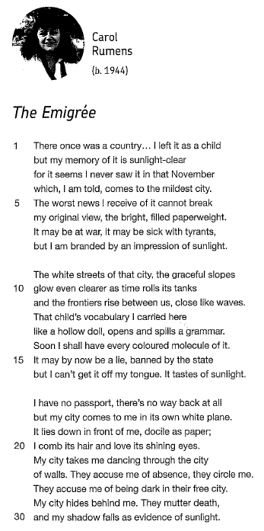

Checking Out Me History, by John Agard (2005)

- The poem opens with a contrast between ‘Dem’ (the educational establishment) and ‘me’ (the speaker)

- The metaphor of a ‘bandage’ is used to emphasise the intentional denial of cultural and historical knowledge

- The speaker argues that the Eurocentric historical narratives taught in schools exclude more global perspectives

- The speaker combines anger with an emphatic celebration of great historical figures like Toussaint L’Ouverture

- The rejection of Standard English and the use of free verse help to create a powerfully authentic voice

- Creole A language created by combining and developing and other languages

- Eurocentric Singular focus on European history and culture; exclusion of more global perspectives

- Grand Narrative Reductive, but widely accepted, historical perspectives (e.g. Black history as ‘just’ slavery)

- Standard English The form of English closely associated with authority, schooling and politics

- Subversive Challenging, particularly towards established powers and ways of thinking

- Ozymandias, by Percy Bysshe Shelley

- My Last Duchess, by Robert Browning

- Tissue, by Imtiaz Dharker

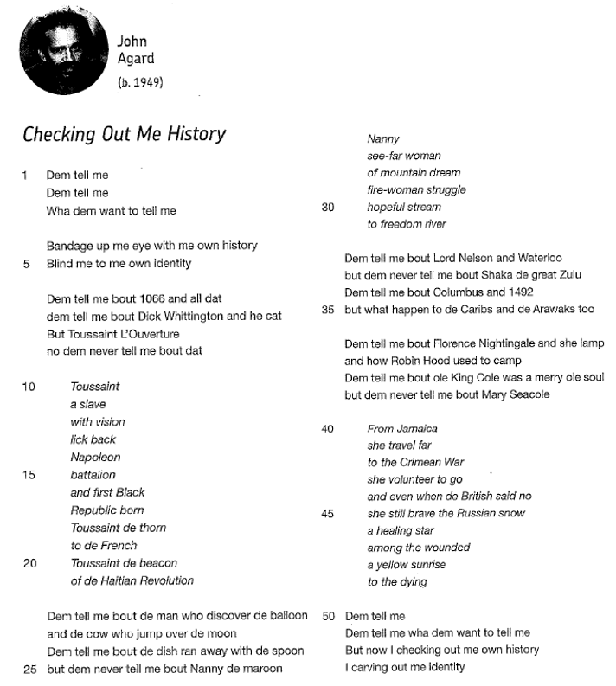

Kamikaze, by Beatrice Garland (2013)

- The samurai sword evokes the concepts of honour and loyalty

- The pilot, as he looks down from his plane, is struck by the beauty and vitality of the natural world

- The imagery is characterised by vibrant colours and dynamic movements – ‘flashing’, ‘silver’, ‘swivelled’

- In contrast, the tuna is ‘dark’ and ‘dangerous’ and is perhaps representative of Emperor Hirohito

- The consequences of the pilot’s decision to fly back are severe, but the speaker avoids making judgements

- Culture Common values, beliefs and traditions of a community

- Honour Actions that confer respect and admiration

- Sacrifice To lose, reject or give away something valuable

- Shunned To be intentionally avoided and ignored

- The Charge of the Light Brigade, by Alfred Lord Tennyson

- Poppies, by Jane Weir

- The Emigrée, by Carol Rumens

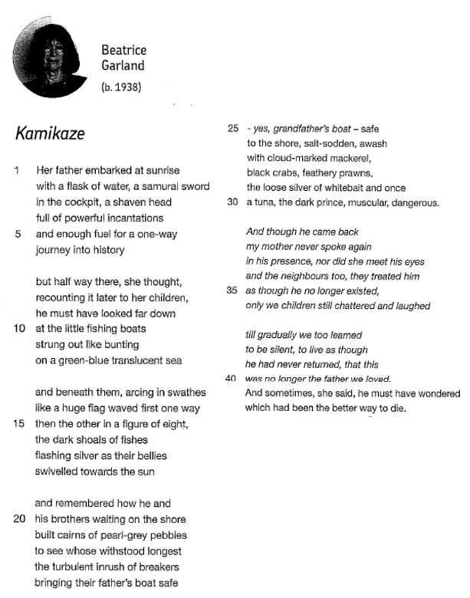

Useful Websites

GCSE Grade Descriptors | Exam Paper (June 2017) | Mark Scheme (June 2017)

BBC Bitesize | LitCharts | British Library

Genius | PM Tutor Notes | Wider Reading Booklet

