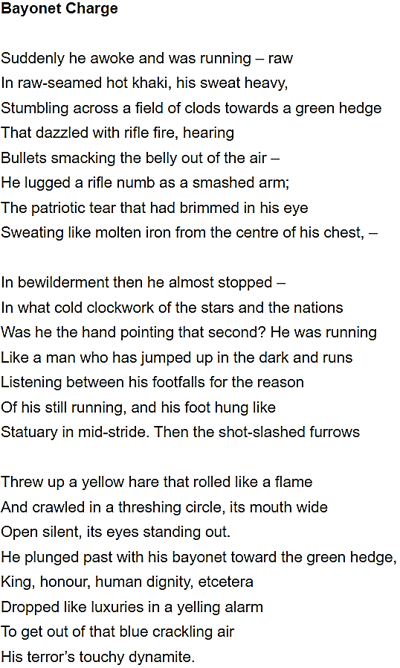

Summary | Total
 | / 30

Academic Writing Targets
- Use Templates to make your points clearer e.g. not only… but also + this is significant because + this reveals

- Use Extenders to develop your ideas e.g. furthermore + additionally + also

- Use Connecters to make stronger links e.g. in contrast to + a similarity is + a difference is + equally + however

- Use Signposts to make your line of argument clearer e.g. before + after + initially + as the text progresses + finally

- Use Analysers to develop your inferences e.g. this implies + this conveys + this reinforces + this emphasises

- Use Qualifiers to refine your analysis e.g. although + despite + whilst + whereas

Analysis Targets
- Explore the significance of the title of each poem

- Try to avoid simply retelling what happens in each poem

- Remember that you need to make inferences as you go (e.g. we learn from this…)

- Get started more quickly and aim to write a bit more

- Begin a new paragraph each time you shift the focus to a new part of the poem

- Zoom-in on single words and explore the significance of them

- Use a wider range of literary terms (e.g. metaphor, simile, personification)

- Zoom-in on vivid or striking images and explain why they’re significant

- Consider how the form of the poems is relevant (e.g. enjambment to create a stream of consciousness effect)

- Make stronger links within and between the poems

- Embed short quotations into your sentences

- Continue to think hard about your vocabulary choices and always aim for precision

- Try to write more legibly

Points of Comparison for Next Time
- Explore the effects of war on individuals (e.g. Remains or Exposure)

- Explore the effects of war on others (e.g. Poppies or Kamikaze)

- Explore the effects of war on humanity (e.g. War Photographer)

- Explore points of comparison with the natural world (e.g. Exposure or Storm on the Island)

- Explore how perspective is used to create immediacy / distance (e.g. 1st person in Remains / 3rd person in Light Brigade)

- Explore how the poems convey ideas about the reality of war

- Explore the relationship between individual soldiers and those for whom they fought

