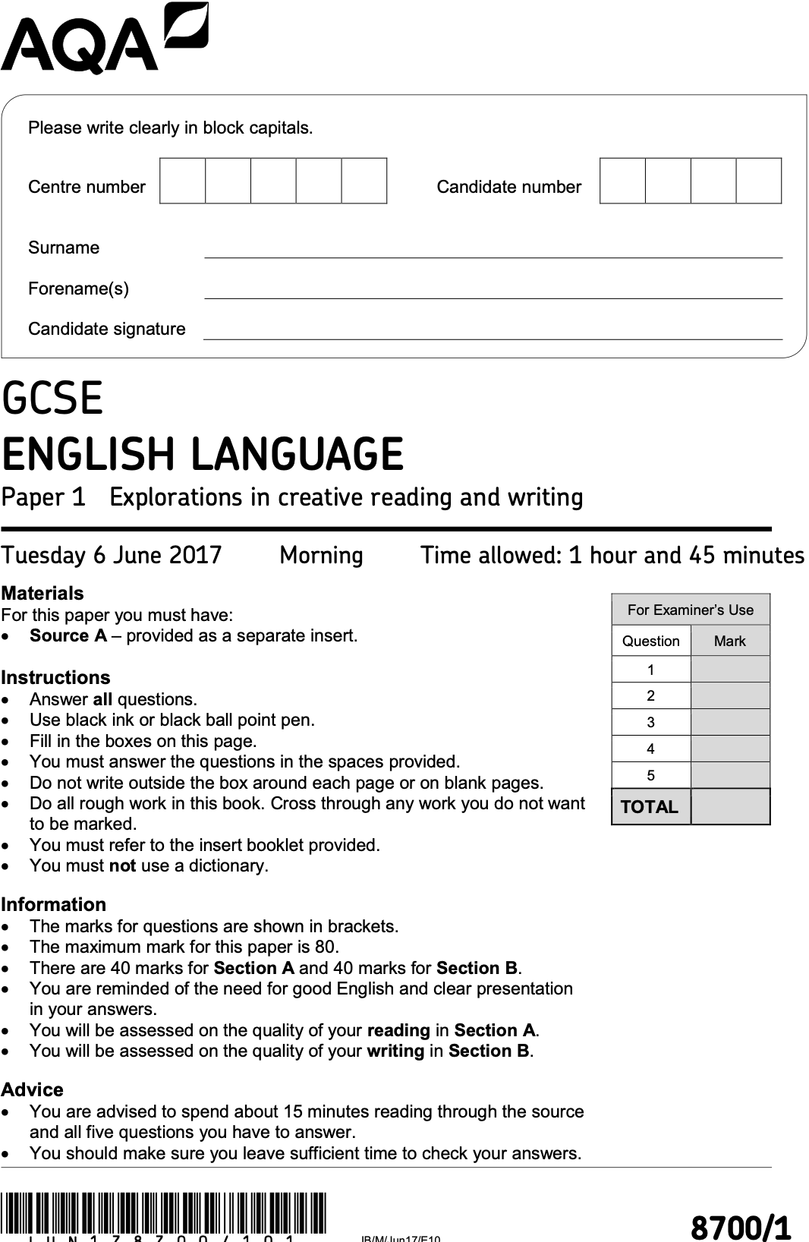

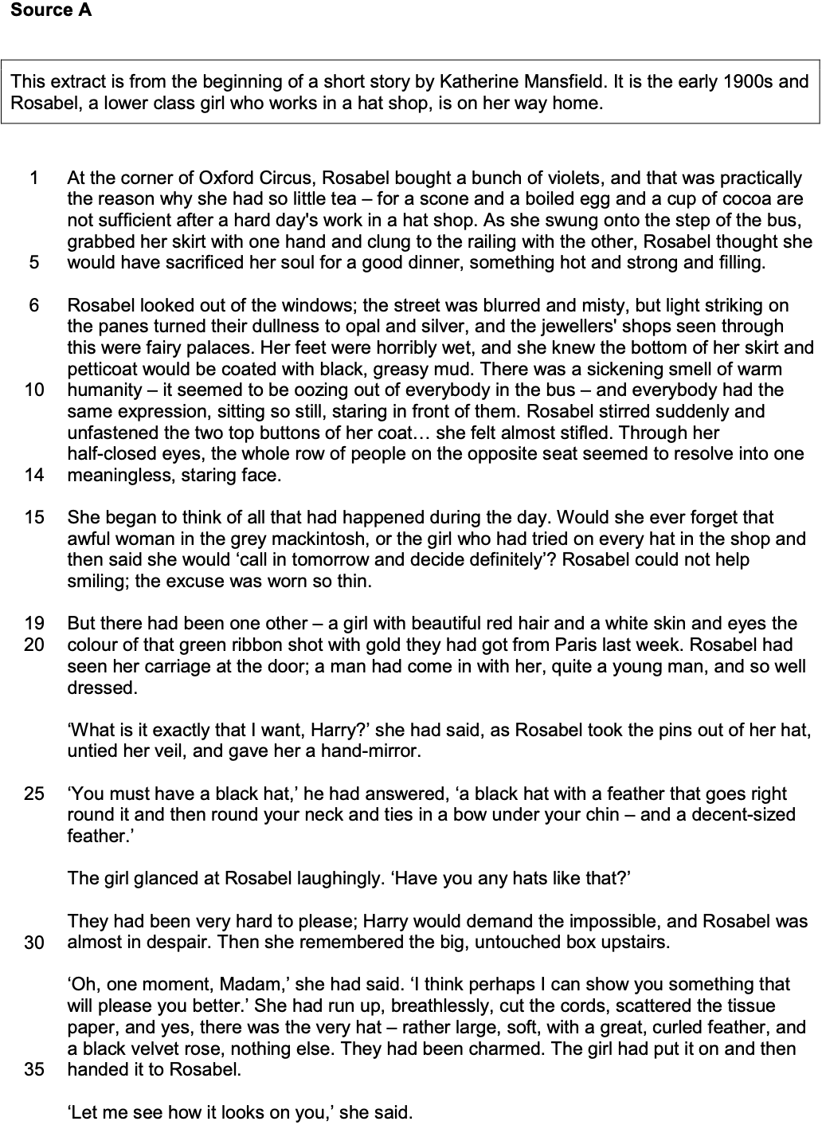

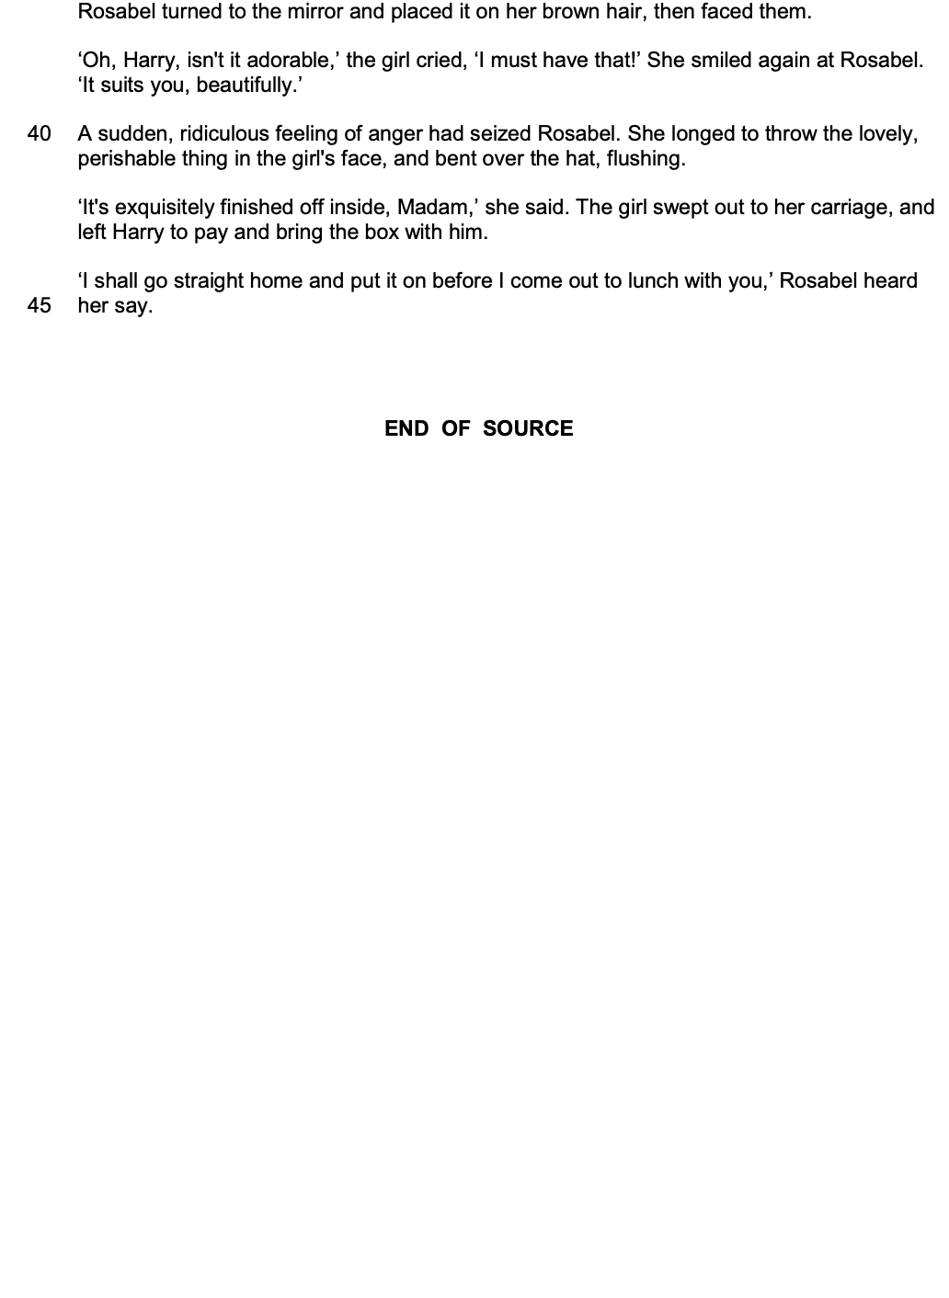

Section A: Reading

Answer all questions in this section.
You are advised to spend about 45 minutes on this section.

_______________________________________________________________________________________________________

Q1 Read again the first part of Source A from lines 1 to 5.

Answer all parts of this question.

Tick ( ü ) one box for each question.

Q1 . 1 What type of flowers does Rosabel buy?

Roses
Violets
Tulips
[1 mark]
Q1 . 2 What has Rosabel eaten?

A scone and an egg
A sandwich
Soup and a roll
[1 mark]
Q1 . 3 Where does Rosabel work?

A hat shop
A flower shop
A coffee shop
[1 mark]
Q1 . 4 How is Rosabel travelling?

By taxi
By tram
By bus
[1 mark]

Q2 Look in detail at this extract, from lines 6 to 14 of the source.

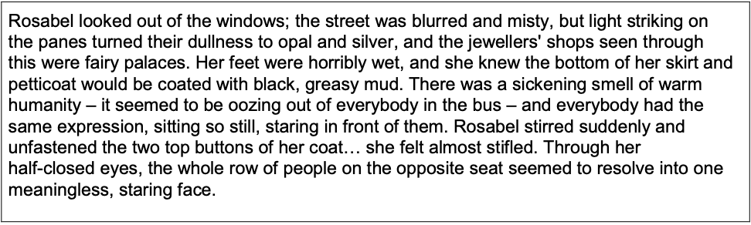

How does the writer use language here to describe Rosabel’s bus journey home?

You could include the writer’s choice of:

- words and phrases
- language features and techniques
- sentence forms.
[8 marks]

- The writer uses the word [ ? ] to show…
- This has the effect of...
- This is important because…
- The writer uses the image of [ ? ] to show...
- We learn from this...
- This shows…
- Furthermore...

_______________________________________________________________________________________________________

_______________________________________________________________________________________________________

_______________________________________________________________________________________________________

_______________________________________________________________________________________________________

_______________________________________________________________________________________________________

_______________________________________________________________________________________________________

_______________________________________________________________________________________________________

_______________________________________________________________________________________________________

_______________________________________________________________________________________________________

_______________________________________________________________________________________________________

_______________________________________________________________________________________________________

_______________________________________________________________________________________________________

_______________________________________________________________________________________________________

_______________________________________________________________________________________________________

_______________________________________________________________________________________________________

_______________________________________________________________________________________________________

_______________________________________________________________________________________________________

_______________________________________________________________________________________________________

_______________________________________________________________________________________________________

_______________________________________________________________________________________________________

_______________________________________________________________________________________________________

_______________________________________________________________________________________________________

_______________________________________________________________________________________________________

_______________________________________________________________________________________________________

_______________________________________________________________________________________________________

_______________________________________________________________________________________________________

_______________________________________________________________________________________________________

_______________________________________________________________________________________________________

_______________________________________________________________________________________________________

_______________________________________________________________________________________________________

_______________________________________________________________________________________________________

_______________________________________________________________________________________________________

_______________________________________________________________________________________________________

_______________________________________________________________________________________________________

_______________________________________________________________________________________________________

_______________________________________________________________________________________________________

_______________________________________________________________________________________________________

_______________________________________________________________________________________________________

_______________________________________________________________________________________________________

_______________________________________________________________________________________________________

_______________________________________________________________________________________________________

_______________________________________________________________________________________________________

_______________________________________________________________________________________________________

_______________________________________________________________________________________________________

_______________________________________________________________________________________________________

_______________________________________________________________________________________________________

_______________________________________________________________________________________________________

_______________________________________________________________________________________________________

_______________________________________________________________________________________________________

_______________________________________________________________________________________________________

_______________________________________________________________________________________________________

_______________________________________________________________________________________________________

_______________________________________________________________________________________________________

_______________________________________________________________________________________________________

_______________________________________________________________________________________________________

Q3 You now need to think about the structure of the source as a whole.

This text is from the beginning of a short story.

How has the writer structured the text to highlight a contrast between the experiences of the women?

You could write about:

- How the contrast is made more or less evident by the end of the source
- How the write uses structure to create an effect
- The writer’s use of any other structural features, such as changes in mood, tone or perspective.

[8 marks]

- At the beginning of the source, the focus is on…
- The writer zooms-in / zooms-out...
- One reason for this is...
- This has the effect of...
- As the source progresses, the focus shifts to…
- This is important because...
- At the end of the source, the focus is on...
- This is similar / different to the start because...

_______________________________________________________________________________________________________

_______________________________________________________________________________________________________

_______________________________________________________________________________________________________

_______________________________________________________________________________________________________

_______________________________________________________________________________________________________

_______________________________________________________________________________________________________

_______________________________________________________________________________________________________

_______________________________________________________________________________________________________

_______________________________________________________________________________________________________

_______________________________________________________________________________________________________

_______________________________________________________________________________________________________

_______________________________________________________________________________________________________

_______________________________________________________________________________________________________

_______________________________________________________________________________________________________

_______________________________________________________________________________________________________

_______________________________________________________________________________________________________

_______________________________________________________________________________________________________

_______________________________________________________________________________________________________

_______________________________________________________________________________________________________

_______________________________________________________________________________________________________

_______________________________________________________________________________________________________

_______________________________________________________________________________________________________

_______________________________________________________________________________________________________

_______________________________________________________________________________________________________

_______________________________________________________________________________________________________

_______________________________________________________________________________________________________

_______________________________________________________________________________________________________

_______________________________________________________________________________________________________

_______________________________________________________________________________________________________

_______________________________________________________________________________________________________

_______________________________________________________________________________________________________

_______________________________________________________________________________________________________

_______________________________________________________________________________________________________

_______________________________________________________________________________________________________

_______________________________________________________________________________________________________

_______________________________________________________________________________________________________

_______________________________________________________________________________________________________

_______________________________________________________________________________________________________

_______________________________________________________________________________________________________

_______________________________________________________________________________________________________

_______________________________________________________________________________________________________

_______________________________________________________________________________________________________

_______________________________________________________________________________________________________

_______________________________________________________________________________________________________

_______________________________________________________________________________________________________

_______________________________________________________________________________________________________

_______________________________________________________________________________________________________

_______________________________________________________________________________________________________

_______________________________________________________________________________________________________

_______________________________________________________________________________________________________

_______________________________________________________________________________________________________

_______________________________________________________________________________________________________

_______________________________________________________________________________________________________

_______________________________________________________________________________________________________

_______________________________________________________________________________________________________

_______________________________________________________________________________________________________

_______________________________________________________________________________________________________

_______________________________________________________________________________________________________

_______________________________________________________________________________________________________

_______________________________________________________________________________________________________

Q4 Focus this part of your answer on the second part of the source, from line 19 to the end.

In this part of the source, it is clear that the red-haired girl has many advantages in life, and Rosabel is right to be angry.

To what extent do you agree or disagree with this statement?

In your response, you could:

- consider your impressions of the red-haired girl and of Rosabel’s reaction
- comment on the methods the writer uses to present the red-haired girl and of Rosabel’s reaction
- support your response with references to the text.

[20 marks]

- I agree / disagree with the statement because...
- The writer’s use of the word [ ? ] / image [ ? ] supports my view because...
- This has the effect of...
- Another reason I agree / disagree with the statement is...
- An important method the writer uses is...
- This is significant because...
- Furthermore...
- As the source progresses, it is significant that...
- A quotation that supports my view is...
- This is because...

_______________________________________________________________________________________________________

_______________________________________________________________________________________________________

_______________________________________________________________________________________________________

_______________________________________________________________________________________________________

_______________________________________________________________________________________________________

_______________________________________________________________________________________________________

_______________________________________________________________________________________________________

_______________________________________________________________________________________________________

_______________________________________________________________________________________________________

_______________________________________________________________________________________________________

_______________________________________________________________________________________________________

_______________________________________________________________________________________________________

_______________________________________________________________________________________________________

_______________________________________________________________________________________________________

_______________________________________________________________________________________________________

_______________________________________________________________________________________________________

_______________________________________________________________________________________________________

_______________________________________________________________________________________________________

_______________________________________________________________________________________________________

_______________________________________________________________________________________________________

_______________________________________________________________________________________________________

_______________________________________________________________________________________________________

_______________________________________________________________________________________________________

_______________________________________________________________________________________________________

_______________________________________________________________________________________________________

_______________________________________________________________________________________________________

_______________________________________________________________________________________________________

_______________________________________________________________________________________________________

_______________________________________________________________________________________________________

_______________________________________________________________________________________________________

_______________________________________________________________________________________________________

_______________________________________________________________________________________________________

_______________________________________________________________________________________________________

_______________________________________________________________________________________________________

_______________________________________________________________________________________________________

_______________________________________________________________________________________________________

_______________________________________________________________________________________________________

_______________________________________________________________________________________________________

_______________________________________________________________________________________________________

_______________________________________________________________________________________________________

_______________________________________________________________________________________________________

_______________________________________________________________________________________________________

_______________________________________________________________________________________________________

_______________________________________________________________________________________________________

_______________________________________________________________________________________________________

_______________________________________________________________________________________________________

_______________________________________________________________________________________________________

_______________________________________________________________________________________________________

_______________________________________________________________________________________________________

_______________________________________________________________________________________________________

_______________________________________________________________________________________________________

_______________________________________________________________________________________________________

_______________________________________________________________________________________________________

_______________________________________________________________________________________________________

_______________________________________________________________________________________________________

_______________________________________________________________________________________________________

_______________________________________________________________________________________________________

_______________________________________________________________________________________________________

_______________________________________________________________________________________________________

_______________________________________________________________________________________________________

_______________________________________________________________________________________________________

_______________________________________________________________________________________________________

_______________________________________________________________________________________________________

_______________________________________________________________________________________________________

_______________________________________________________________________________________________________

_______________________________________________________________________________________________________

_______________________________________________________________________________________________________

_______________________________________________________________________________________________________

_______________________________________________________________________________________________________

_______________________________________________________________________________________________________

_______________________________________________________________________________________________________

_______________________________________________________________________________________________________

_______________________________________________________________________________________________________

_______________________________________________________________________________________________________

_______________________________________________________________________________________________________

_______________________________________________________________________________________________________

_______________________________________________________________________________________________________

_______________________________________________________________________________________________________

_______________________________________________________________________________________________________

_______________________________________________________________________________________________________

_______________________________________________________________________________________________________

Section B: Writing

You are advised to spend about 45 minutes on this section.
Write in full sentences.
You are reminded of the need to plan your answer.
You should leave enough time to check your work at the end.

_______________________________________________________________________________________________________

Q5


































































































































































































