Teaching and Learning
Remote Teaching and Social Comparison Theory
…………………………………………………………………………………………………………………………………………………………………………………………

I know that a number of live lessons have already been delivered remotely to our sixth form students. If you’ve been involved, I salute you. It’s not a simple undertaking. We tend to believe that what works in one domain will work seamlessly in another where shared purposes and common elements exist – but that’s rarely the case.

One of the reasons that remote learning can be hard is connected to Social Comparison Theory. We tend to establish our social and personal worth by comparing ourselves to others. In the environment of a classroom, social comparisons provide students with plenty of critical feedback on how to behave and be successful. In contrast, online learning environments (e.g. Teams) provide fewer of these cues. And this presents greater levels of challenge for us all. Something we obviously already know from lockdown.

So, what can we do to make remote learning easier? Suggestions below

#

- Signal to students in advance that you will be conducting a live lesson

- Over-communicate your expectations

- Over-communicate verbal cues (e.g. I now want you all to turn to page twelve)

- Introduce ‘pause points’ to enable reflection before discussion

- Use ‘cold call’ questions

- Celebrate success

Teaching and Learning
Using a Visualiser
…………………………………………………………………………………………………………………………………………………………………………………………

What is a visualiser?
A visualiser is a movable camera mounted on a stem that is used to project what the lens can see onto a screen or whiteboard. The brand we use is IPEVO (model V4K).

What are the main functions?
- Zoom-in and zoom-out
- Video filters (i.e. different colour filters for the visually impaired)
- Screen freeze
- Gridlines
- Snapshot (i.e. take a picture)
- Video recording

What can I use it to do?

- I-We-You: Model success for the ‘I’ part of the process by planning or partially constructing a response to a task
- I-We-You: Work with the class for the ‘We’ part of the process by asking for ideas and opinions
- Gradual reveal: Conceal information and reveal it gradually to your wards – discuss as you go
- Highlight and annotate: Focus on part of a poem, diagram or equation (etc.) and get students to follow along
- Connect with your study booklet: Take students through the information and tasks you’ve constructed
- Show and don’t tell: Display a piece of work and ask the class to suggest how it could be improved
- Compare student work: Display a piece of work and ask students to compare it to their own
- Display student work: Critique what your wards have done, emphasise what success looks like and give praise
- Live marking: Mark a piece of student work and provide a commentary as you go

What else?
Remember that you can use your visualiser to ‘stream’ a lesson. Position the camera in any direction you want to help capture the best perspective. The stem is easily adjustable and it’s also pretty simple to rotate the head. Each visualiser comes with a built-in microphone.

Is that it?
Nearly. As I’ve said before, accepting trial and error means accepting error. We’re currently in a stormy period of experimentation, but it won’t last forever. There’s no ‘right way’ to use a visualiser and you’ll find out what works best you and your classes soon enough. But in the meantime, keep talking and keep sharing.

Teaching and Learning
Guide to the Visualiser Camera Head Buttons
…………………………………………………………………………………………………………………………………………………………………………………………

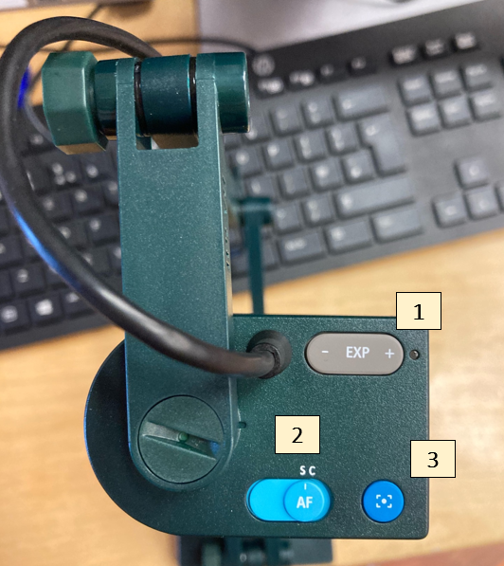

- ‘EXP’ stands for ‘exposure’ and the button will allow you to adjust the brightness levels

- ‘AF’ stands for ‘Auto Focus’ – ‘S’ if you’re displaying something static; ‘C’ for something that is continually moving

- This is the ‘focus’ button – press it once if the image quality is blurry
Teaching and Learning
Opting Out of Questions
…………………………………………………………………………………………………………………………………………………………………………………………

Earlier in the week, I sent a brief missive about our entirely natural disinclination to engage with effortful thinking. In the classroom, this often manifests itself in passive behaviours like slouching, slumping and staring. And opting out of questions.

#
Me: ‘Why is it significant that the stage lighting becomes ‘brighter and harder’ when the Inspector enters?’
Javier: ‘I don’t know.’
Me: ‘What are your initial thoughts?’
Javier: ‘I don’t have any.’

It’s by no means a perfect solution – nor an original one – but it’s worth asking another student to provide either a cue or the correct answer; from that point onwards, you can return to the original student and ask them to vocalise the answer themselves.

Me: ‘Charlotte, can you tell me the answer?’
Charlotte: ‘Light is symbolic of truth; the brighter light suggests that greater scrutiny will soon follow.’
Me: ‘Javier, please repeat the answer back to me…’

Getting students who would ordinarily opt out of questions to contribute in this basic way serves as a reminder of your expectations provides them with a (small) opportunity to experience success and feel included. And that’s important because success leads to motivation, not the other way around.

Teaching and Learning
Evaluating Teaching and Learning
…………………………………………………………………………………………………………………………………………………………………………………………

One of the purposes of a lesson visit is to establish how effectively a teacher is helping students to engage with, and ultimately master, defined curriculum goals. Where this is the case, it’s worth keeping in mind that evaluating teaching and learning is actually really hard to do (and we typically think we’re better at it than we are). See the yellow boxes below for factors to be mindful of when you enter a colleague’s classroom.

Remember that no two classes are the same

- Try to understand the context of the class – you don’t know the students as well as the teacher does

- Be mindful of the halo and golem effects – it’s easy to be unduly influenced by positive or poor performance

- Avoid being domineering – don’t say, ‘I would’ve done…’

Acknowledge the complexities involved with teaching and learning

- Ask how the lesson went – you will inevitably have missed a lot of what went on

- Don’t feel like you have to define next steps – vague or contrived targets are useless

- Understand that your observation is a snapshot – a single observation is not definitive

Don’t forget that performance and learning are different

- Read Robert Coe’s poor proxies for learning summary – e.g. students are engaged, a calm classroom…

- Remember that learning is liminal – it occurs over time and not in a single moment

- Ask about the intentions behind the actions – the assumptions you make can be wrong

Further reading:

- Building a More Complete Understanding of Teacher Evaluation, by Julie Cohen and Dan Goldhaber (2016)
- What Do Teacher Observation Scores Really Measure?, by Matthew Steinberg and Rachel Garrett (2016)
- Folk Knowledge and Academic Learning, by David Geary (2012)
- Student evaluation of teaching ratings and student learning are not related, by Bob Uttl et al. (2016)
- Self-Perceived Expertise Predicts Claims of Impossible Knowledge, by Stav Atir et al. (2015)

Teaching and Learning
Fundamental Questions
…………………………………………………………………………………………………………………………………………………………………………………………

Fundamental Questions
A list of questions based around ‘fundamental’ or ‘core’ knowledge for a topic on the curriculum.

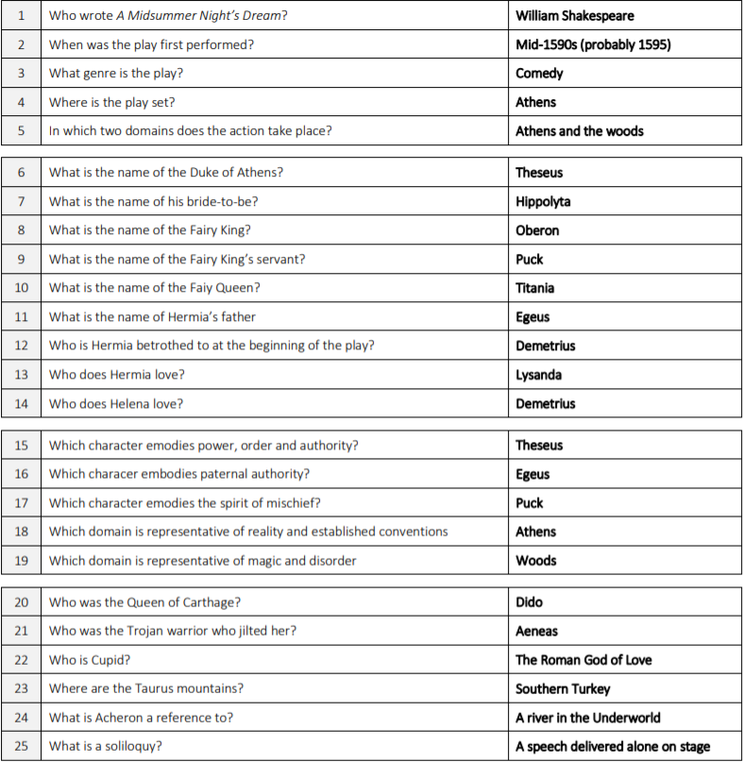

- Memorise answers to the questions and then self-quiz (who was the Queen of Carthage?)

- Ask quick-fire questions and insist on a ‘no hand-up’ rule

- Elaborate on the answers to the questions (How is Puck presented in A2-S1?)

Teaching and Learning
Recap Tasks
…………………………………………………………………………………………………………………………………………………………………………………………

Recap Tasks
Simple tasks to help students review their knowledge at the beginning of a lesson.

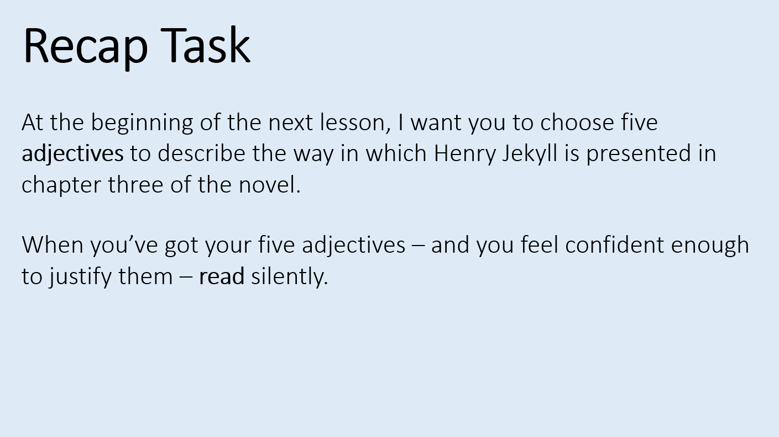

- Choose a selection of letters and ask student to find relevant words (e.g. to describe the character of Macbeth)
- Display part of a statement and ask students to finish it (e.g. Macbeth is a tyrannical character because…)
- Choose two characters (or chapters etc.) and ask students to make a list of key similarities and differences
- Create a list of words and get students to choose the one that is the least connected to the text or topic
- Write a contentious statement on the board and to ask students to explain why it’s right or wrong
- Pick a topic and ask students write a short summary (e.g. of a character, chapter or aspect of context)
- Create a list of tier two and tier three words and ask students to use them to write a series of short sentences
- Take a big question from a previous lesson and get students to make notes on everything they can remember

Teaching and Learning
High Expectations
…………………………………………………………………………………………………………………………………………………………………………………………

The Pygmalion Myth
In Greek mythology, Pygmalion was a sculptor who fell in love with his own creation: an impossibly beautiful carving that he named Galatea. The strength of his feelings for Galatea were so intense that Aphrodite, the goddess of love, transformed the sculpture into a real woman. They married and – yep, you guessed it – lived happily ever after.

The Pygmalion Effect
If we have high expectations our of students, they will typically rise to meet them. Conversely, low expectations tend to be conducive to undesirable behaviours (this is called the Golem effect).

The Study
In the 1960s, Robert Rosenthal and Lenore Jacobson conducted an experiment that hinged on a lie: they told teachers that a group of their students were potential high achievers when, in fact, they had been chosen at random. The progress of the students was monitored for a year, and Rosenthal and Jacobson published their findings. The key one is below and, intriguingly, it was particularly boys and students from minority ethnic backgrounds who seemed to benefit.

‘When teachers expected that certain children would show greater intellectual development, those children did show greater intellectual development.’

Classroom Implications
Ultimately, as teachers, we are all responsible for establishing, promoting and exemplifying high expectations.

- Truly believe that all students can succeed
- Embody the behaviours you want students to adopt
- Don’t ‘dumb down’ aspects of the curriculum
- Remember that academic learning is ‘unnatural’ and effortful (see: David Geary’s essay on folk knowledge...)
- Never apologise for getting students to engage in effortful thinking or tasks which require sustained effort
- Accept that progress takes time and doesn’t follow a nice and tidy flight path
- Reflect on which students you provide the most feedback to and typically ask the most questions
- Provide plenty of good quality exemplar material and model the steps necessary to achieve success
- Consistently praise good behaviour and challenge bad behaviour
- Insist that students sit up straight and face the front when you’re talking

Disclaimer
Later studies (like this one by Lee Jussim and Kent Harber) suggest that the Pygmalion Effect is not as influential as we might like to believe: the correlation itself isn’t disputed, just the significance of the accumulated benefits.
Teaching and Learning
The GI Joe Fallacy
…………………………………………………………………………………………………………………………………………………………………………………………

The GI Joe fallacy describes the disparity between our knowledge and our behaviour. For example, rationally, we know about the halo effect and our tendency to be disproportionately influenced by superficially attractive characteristics. However, crucially, this knowledge doesn’t prevent us from making flawed judgements. This is something that Timothy Wilson and Nancy Brekke explore in a paper called ‘Mental Contamination and Mental Correction’ – you can read it by clicking here. The bit below, taken from the first page, seems particularly relevant…
‘Teachers would rather not give a student a high grade because the student is physically attractive, yet there have been repeated demonstrations of such halo effects.

The wider debate about the accuracy of Teacher Assessed Grades is an important one. In short – and this is uncomfortable to accept – we’re likely to judge disadvantaged students less favourably than their more affluent peers despite being aware of common cognitive biases like the halo effect (above), affinity bias (we judge those who are similar to us more positively) and confirmation bias (we seek out information that confirms our beliefs). And the debate doesn’t end there. We’re also likely to judge students from black and ethnic minority backgrounds less favourably. Ultimately, the inconvenient truth that knowledge alone does not improve performance will always remain.
If you still have doubts about the GI Joe fallacy, I’ll offer one more example that I hope you’ll find persuasive. Once again, it’s connected to the halo effect. In their study on the validity of lesson observations, Julie Cohen and Dan Goldhaber demonstrate that observers are prone to biases based on ‘the composition of students’ in a class and they highlight that ‘teachers with students with higher prior achievement receive higher observation ratings.’ Despite our very best efforts to be fair and meticulous, the judgements we make are never entirely objective. You can read the paper by clicking here.
I’ll sign-off by citing a final study, which you can read by clicking here. It seems that people – including me – believe that biased thinking is an affliction that affects everyone else. There’s a pithy comment to be made somewhere, but I’m just not smart or funny enough to make it (I do know at least that much). So, instead, I’ll give you one of the headline findings…
‘The more strongly people believed that biases widely existed, the more inclined they were to ascribe biases to others but not themselves.’.

So, now you know: knowing isn’t half the battle…
However, there is good news: plenty of evidence to support TAG judgements and meaningful conversations after lesson observations are likely to have mitigating effects.
Teaching and Learning
Wait Time
…………………………………………………………………………………………………………………………………………………………………………………………

Question: How long do teachers typically wait for students to reply after asking a question?

Answer: One second.

Intervening early (e.g. to reframe the question, ask another student or provide the answer) is a natural thing to do.
- A swift round of questioning can serve as a useful behaviour management technique

- Silences can sometimes be awkward

- We’re sensitive to making students feel uncomfortable

However, it is beneficial to wait. Three seconds is the magic threshold. Highlights from a paper by Mary Budd Row below…
- The quality of student responses is higher when wait time is extended to three seconds.

- ‘I don’t know’ responses are disproportionally higher when the mean wait time is below two seconds.

- Longer wait times tend to make ‘invisible’ students more visible

Teaching and Learning
The Edison Fallacy
…………………………………………………………………………………………………………………………………………………………………………………………

Thomas Edison said in 1913 that ‘books will soon be obsolete in public schools and scholars will be instructed through the eye.’ A bold prediction. Indeed, he went on to claim that it would be ‘possible to teach every branch of human knowledge with the motion picture’ within ten years. Clearly, he was wrong and it’s easy to see why: he based his judgements on the widely held misconception that learning is a simple and equal process of input and output. Teachers convey knowledge and students retain it.

There’s a connection of sorts to be made with remotely delivered live lessons. All the superficial similarities are there. We can send resources, deliver instructions and share our screens in real time; we can, in short, provide a window into our classrooms. A flawless transaction, or so it seems. However, a number of challenges lurk beneath the surface. For example…
- Students can appear to be present on Teams, but engaged in something entirely different

- Misconceptions are harder to identify and correct

- Performance is difficult to judge and monitor

- It’s hard to split our attention between the students in front of us and those at home

- Students at home can’t receive the subtle physical cues that you convey both consciously and subconsciously

Our PowerPoint slides, study booklets and other resources aren’t the lesson: we are. If we weren’t, Edison would’ve been proved right by now and we’d have been replaced long ago by sleek, angular monitors. Learning is fundamentally much more chaotic and effortful from a distance and through a screen. We’re social creatures and we thrive on interactivity. That’s not my way of clumsy signalling that we shouldn’t provide remotely delivered live lessons. I believe we should, particularly because they appear to genuinely help mitigate feelings of anxiety. However, there will be times and situations where doing so isn’t the best option.

And that’s where our professional judgement is crucial. As I said in a missive last week, we’re currently in a stormy and stressful period of experimentation. We can only do what we feel is right and realistic. Parents and carers are understandably influenced by the Edison fallacy and, of course, we need to be mindful of their needs and expectations. However, we must always prioritise the mental processes of learning over attempts to mimic the surface features of a classroom. So, by way of a summary…
- Keep experimenting

- Prioritise what you think will help students learn most effectively

- Do what you think is right and realistic

- Share your successes and failures

- Ask for support when you need it

Teaching and Learning
The Illusion of Skill Acquisition
…………………………………………………………………………………………………………………………………………………………………………………………

My eldest son, Charlie, religiously watches a couple of blokes on YouTube who call themselves the F2. Their channel streams short videos which showcase them successfully performing improbably difficult football skills and tricks. They’re as outrageously talented at kicking a ball as they are at managing their public images. And because they make everything seem so effortless (they’re also excellent editors), Charlie tends to believe that he’ll be able to replicate what they do. And, of course, he can’t.

The reason for this is linked to what Michael Kardas and Ed O’Brien call the Illusion of Skill Acquisition. Key points below…
- Watching others is enjoyable and convenient, but people typically cannot master new skills from sight alone.

- When people repeatedly watch others perform before ever attempting the skill themselves, they may overestimate the degree to which they can perform the skill.

- The more people watch others perform (without corresponding practice), the more they think they can also perform the skill

An obvious link with teaching and learning is this: it’s easy for students to think they’ve grasped a concept or understood a tricky text when, actually, they haven’t at all. It’s the reason why some of our wards express indignant surprise when they achieve a low test result or a poor grade on a mock exam paper.
Novices just aren’t particularly good at making judgements about what they can and can’t do.
So, what’s the antidote? Plenty of deliberate practice and effortful struggling between ‘formal’ assessments. If students don’t get stuff in the moment or initially seem unable to apply what they’ve learned, it’s not necessarily a bad thing. Actually, it’s entirely natural. Learning is a liminal process and, as such, doesn’t happen in neat and tidy lesson-sized units.

Teaching and Learning
Chauffer Knowledge
…………………………………………………………………………………………………………………………………………………………………………………………

In 1918, the Nobel Prize for Physics was awarded to Max Planck. He swiftly embarked on a tour of Germany and, sensibly enough, delivered the same lecture over and over again. His chauffer became so familiar with it that, for a good ol’ wheeze, he asked to take one of the lectures himself. Which he did. And the ruse – enacted at the University of Munich – went undiscovered. Until he invited questions from the audience.

The complexities of teaching and learning can often get lost in reductive, albeit attractive, ‘chauffer knowledge’ narratives. We know, for example, that regular retrieval practice is good. However, we’re perhaps less clear on the effects of unsuccessful retrieval attempts on learning and how even slight adjustments to the way in which we frame our questions can significantly alter the answers we’re likely to receive. And there’s also the issue of how the prompts we give have the power to both improve and inhibit learning depending on how and when they’re used. And so on…
In short: it’s complicated. And I want to both embrace and explore some of the gnarly complexities after Easter.
With that in mind, my plan is to spend time gaining a clearer and more refined understanding of what good teaching looks like in each subject area. I’ll pop into a number of different lessons during the first four weeks after we return; please just ignore me. I’ll share my findings after May half-term so they can be discussed and, crucially, challenged. What that’ll hopefully enable us to do is work towards two goals:
- A clearer whole-school understanding of the core principles of good quality teaching and learning

- A more refined departmental understanding of how these principles can be meaningfully adapted and enacted

Teaching and Learning
The Watchful Eyes Effect
…………………………………………………………………………………………………………………………………………………………………………………………

We behave differently when we think we’re being watched. For example, researchers from the University of Newcastle found that a simple poster of human eyes displayed above a cluster of bicycle racks reduced the number of thefts by 62%. And researchers commissioned by The Royal Society discovered that people paid nearly three times as much for their coffee when the image of a pair eyes was displayed near to an honesty box. Clearly, we’re sensitive to both being watched and the feeling that we might be – even if that feeling is vague.

One of the reasons for this, sensibly enough, is our aversion to the risk of being caught and sanctioned for engaging in illegal activities (e.g. theft) or socially undesirable behaviours (e.g. parsimony). However, there’s more. We also have a strong desire to build and maintain a good reputation because of the benefits that are conferred through the acquisition of social capital. Despite the allure and romanticism of the rebel without a cause archetype, we tend to crave social acceptance.

The connection with the return to school on Monday is with the importance of being visible. I’m not sure we’re quite ready for the introduction of Orwellian ‘watchful eyes’ posters in the corridors just yet so, as far as time and social distancing rules allow, next week provides a great opportunity to encourage ‘pro-social’ behaviour through overtly signalling our collective presence.

Often, just being around during breaktimes and periods of transition is enough to keep things nice and calm. And, when we’re not able to be out and about, the expectation that someone else might appear at any moment will usually have a positive nudge effect.

Teaching and Learning
Constructing Multiple-Choice Quizzes
…………………………………………………………………………………………………………………………………………………………………………………………

- Put the majority of information in the stem and not the responses. This will reduce the number of ‘redundant’ words and help to focus student attention. Ideally, students should have a tentative idea of what the answer might be before reading the available options.
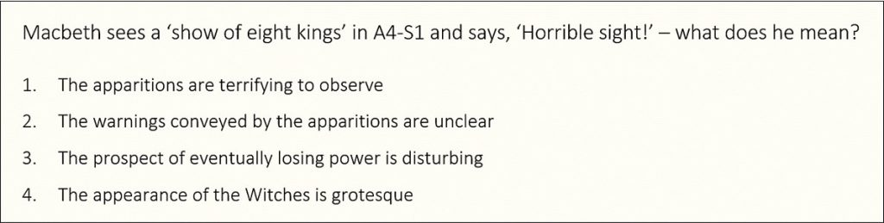
- Aim to make the form and structure of the responses consistent. Making one of the options longer or more technically complex than the others is likely to provide students with a clue that might enable them to select the correct answer without possessing the requisite knowledge.
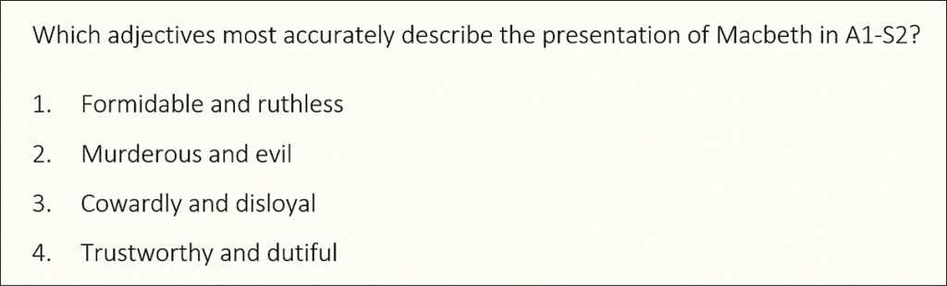
- Aim to make the incorrect responses (i.e. ‘distractors’) seem plausible. Responses that are clearly incorrect won’t meaningfully test student knowledge. Ideally, they should be sufficiently inaccurate to be considered wrong, but also reasonable enough to seem right so that effortful thinking is required to rule them out.
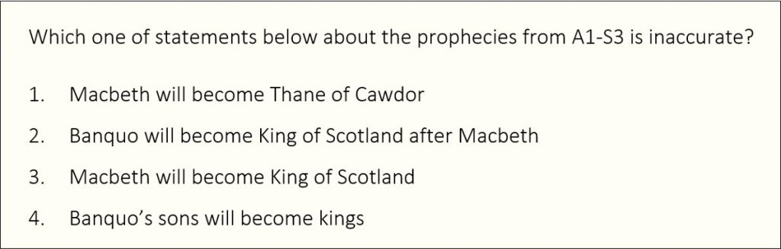
- Spread the correct answers equally across the response options. This will avoid creating a pattern that might help students to guess the answers. Aim to use each response option as the correct answer (e.g. 1, 2, 3 and 4) roughly the same amount of times.

Teaching and Learning
Making Objective Judgements
…………………………………………………………………………………………………………………………………………………………………………………………

- Basing Decisions on Evidence
‘Each teacher assessed grade or outcome should be a holistic professional judgement, balancing different sources of evidence. Judgements should be based on records and evidence that demonstrate a student’s performance in relation to the subject content that they have been taught.’
‘Centres should be confident that work produced is the student’s own and that the student has not been given inappropriate levels of support to complete it, either in the centre, at home or with an external tutor.’
- Student work produced in response to assessment materials
- Non-exam assessment (NEA)
- Student work produced in centre-devised tasks that reflect the specification
- Records of a student’s capability and performance over the course of study in performance-based (e.g. Dance)
- Records of each student’s standard of work over the course of study

…………………………………………………………………………………………………………………………………………………………………………………………

- Being Aware of Unconscious Effects on Objectivity
‘Without always realising it, everyone holds unconscious beliefs about others […] There is a risk that objective judgements can be affected by unconscious beliefs and other types of bias.’
- Confirmation bias  - Halo effects | - Primacy effects  - Recency effects | - Selective perceptions  - Contrast effects | - Conformity bias  - Affinity bias

…………………………………………………………………………………………………………………………………………………………………………………………

- Reviewing Judgements with Others
‘Dialogue with others can support effective reflection and review and help minimise bias. It can be used to check that judgements are evidence-based, to challenge any possible biases and to review any other evidence that may identify possible bias.’
- Teachers  - Subject teams  - Heads of Department | - SENDCos  - Learning Support Assistants  - Other SEND experts | - CMAT colleagues  - Exam board contacts  - Subject network contacts

…………………………………………………………………………………………………………………………………………………………………………………………

Click here to access the full document from Ofqual, which was published on the 24 March 2021.

