Of Mice and Men Study Booklet

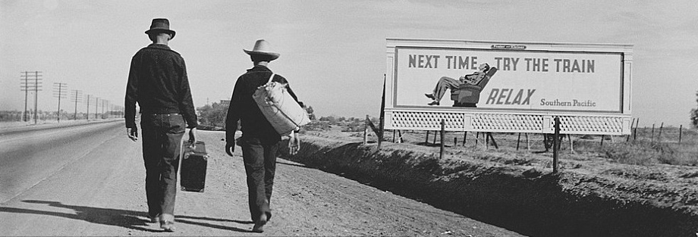

2 | Knowledge Organiser
3 | Contextual Overview
5 | BQ1: What do Steinbeck’s first descriptions of George and Lennie reveal about them?
7 | BQ2: What does the dialogue between George and Lennie reveal about the nature of their relationship?
9 | Five Key Points to Remember
10 | BQ3: What does the language used by Candy to describe Crooks reveal about racial tensions in 1930s America?
12 | BQ4: What words and phrases does Steinbeck use in introducing us to Curley, which suggest he might be trouble?
13 | BQ5: How is the character of Curley’s wife presented when she enters the bunk house?
14 | BQ6: What leads Slim to conclude that Lennie has the mental age of a child and is not deliberately mean or wicked?
15 | Letter from John Steinbeck to Claire Luce
16 | Review Tasks
18 | BQ7: Why does Curley pick a fight with Lennie, the strongest of all the men on the ranch?
19 | BQ8: What does Crooks’s attitude towards the other ranchers reveal about attitudes towards race in 1930s America?
20 | BQ9: Why does Crooks eventually choose not to become part of Lennie’s plan to buy a ranch?
22 | Review Questions: Chapters 1-4
23 | BQ10: What has Lennie done at the beginning of the chapter that suggests he is irresponsible and dangerous?
24 | BQ11: To what extent does Steinbeck present Curley’s wife as an unfortunate victim?
25 | Five Key Points to Remember
26 | Review Tasks
27 | BQ12: In what ways are Lennie’s two hallucinations at the beginning of chapter six significant?
28 | Review Questions: Chapters 1-6
29 | Assessments
33 | ‘To a Mouse’, by Robert Burns

Key Events
Chapter 1 | George and Lennie walk through the Californian countryside; George becomes frustrated with Lennie; George throws away Lennie’s dead mouse; George alludes to Weed
 | ‘Tell about what we’re gonna have in the garden and about the rabbits in the cages and about the rain in the winter and the stove’
Chapter 2 | George and Lennie are greeted at the bunkhouse by Candy; they are reprimanded by the boss; they meet Curley’s wife and then Curley; Slim is introduced
Chapter 3 | George confides in Slim about Lennie; Carlson shoots Candy’s dog; Candy overhears George talking about his plans; Curley looks for this wife; Lennie breaks Curley’s hand
 | ‘Lennie held on to the closed fist. Curley was white and shrunken; by now, and his struggling had become weak. He stood crying, his fist lost in Lennie's paw.’
Chapter 4 | Crooks sits alone; Lennie sees a light and enters; Crooks taunts him; Candy enters and they discuss the dream ranch; Curley’s wife quietly enters and becomes angry
Chapter 5 | Lennie sits alone; Curley’s wife approaches him and asks about the dead puppy; she confides in him about her past; Lennie strokes her hair, but eventually kills her
Chapter 6 | Lennie waits for George; he hallucinates; George appears and Lennie asks him to talk about their dream ranch; George shoots Lennie; Slim and George walk-off together
Key Characters |  | Key Themes |  | Key Words
George | - Looks after Lennie  - Frequently gets frustrated with him  - Becomes reconciled to his precarious lifestyle | Dreams | - Wider context of the ‘American Dream’  - Linked to freedom and escapism  - Largely unattainable | - Soledad  - Salinas  - California  - America  - Depression  - Economy  - Migration  - Agriculture  - Itinerant  - Friendship  - Status  - Loyalty  - Masculinity  - Femininity  - Hierarchy  - Prejudice  - Respect
Lennie | - Reliant on George  - Possesses the mind of a child  - Unable to control his strength | Friendship | - George and Lennie’s friendship  - Seen as strange and suspicious  - George sacrifices his friendship at the end
Curley’s Wife | - Unhappily married to Curley  - Lonely and unfulfilled  - Eventually killed by Lennie | Isolation | - The ranchers live transient lives  - Curley’s wife is married, but feels lonely  - Crooks is symbolically isolated
Curley | - Insecure and aggressive  - Possessive of his wife  - Son of the boss | Violence | - Violence can be used to gain power  - Threats of violence are used to coerce  - Violence is often unpreventable
Slim | - Respected by the ranchers  - An authoritative presence on the ranch  - Forms a friendship with George | Money | - The Great Depression and the New Deal  - The ranchers are easily exploitable  - Women occupy particularly precarious positions

Overview

Written by American author John Steinbeck, Of Mice and Men was first published in 1937. The novel is set in a place called Soledad, (a Spanish word meaning solitude or loneliness) in California. The novel is set during the Great Depression, a period of significant poverty and unemployment across the USA following the Wall Street Crash in 1929.

John Steinbeck was born in Salinas, California in 1902. Although his family was not poor, when he was a teenager he spent time working on ranches near his home and this had a big impact on his writing. His experience of working with farm labourers and his interest in their lives is clearly evident in Of Mice and Men, as well as in some of his other books, like The Grapes of Wrath.

The Great Depression

The Great Depression took place following the Wall Street Crash in October 1929 and affected the world’s economy. Wall Street is a street in New York City, where many financial firms are based, and the term ‘Wall Street’ is used to describe the American sector, even though not all American finance companies are actually based there. The Great Depression lasted for ten years worldwide, and for the USA it did not fully end until 1941 when the country became involved in World War Two. The depression got increasingly worse between 1929 and 1932. At the peak of the Great Depression, it is thought that between 13 million and 15 million people in the USA were unemployed. Industrial production in the country dropped by almost half and house building decreased by 80%. Many people across America suffered from poverty, hunger and disease as a result of the depression. Benefits that we are used to having access to today, like Jobseekers’ Allowance, did not exist in America at this time, so people who lost their jobs could also lose their homes and found it very difficult to buy food.

Itinerant Workers

Farmers were usually less affected than the rest of the population during depressions because they were able to grow their own food; however, during the Great Depression, there was also the Dust Bowl – drought and dust storms swept across several states in mid-west America. This resulted in crops being very poor in these areas, which was coupled with falling prices for food. Small farmers were affected particularly badly by these conditions. Many small farmers were in debt because they would borrow money from banks to buy seeds and then pay back the loans when the crops came in; during the Dust Bowl, farmers could not pay back these loans and could also not afford to feed themselves and their families. In worst case scenarios, this led to banks repossessing farms, making the farmers and their families homeless.

As a result, many farmers migrated to California to look for work, as this state was perceived to have spare land and a lot of work. However, because so many people moved to California (an estimated 1.3 million), work was not so easy to find. Ranch workers like George and Lennie often moved from one place to another looking for work, as jobs on ranches would be temporary and seasonal. Wages for men like these were low and jobs were scarce, so the lifestyle that they lived was very insecure. Without work, people would have no way of supporting themselves. This is why the dream is so important to George and Lennie: it would give them a sense of safety and independence.

African Americans in the 1930s

Although all Americans were affected by the Great Depression, African Americans were hit the hardest. It is thought that by the end of 1932, 50% of black Americans were unemployed. In some cities in the northern states, white people called for black people to be fired from their jobs due to unemployment in the white communities. African-Americans received less aid than their white counterparts and were sometimes even not allowed to use charity soup kitchens.

Racism increased during the Great Depression and racial violence, which had been decreasing, rose again during the economic downturn. Although Crooks has a stable job, his character reflects the discrimination that many black Americans had to endure during this period in the USA.

Source: BBC Bitesize | https://www.bbc.co.uk/bitesize/guides/zgdr82p/revision/1

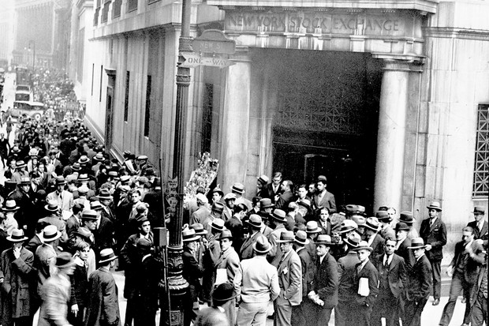

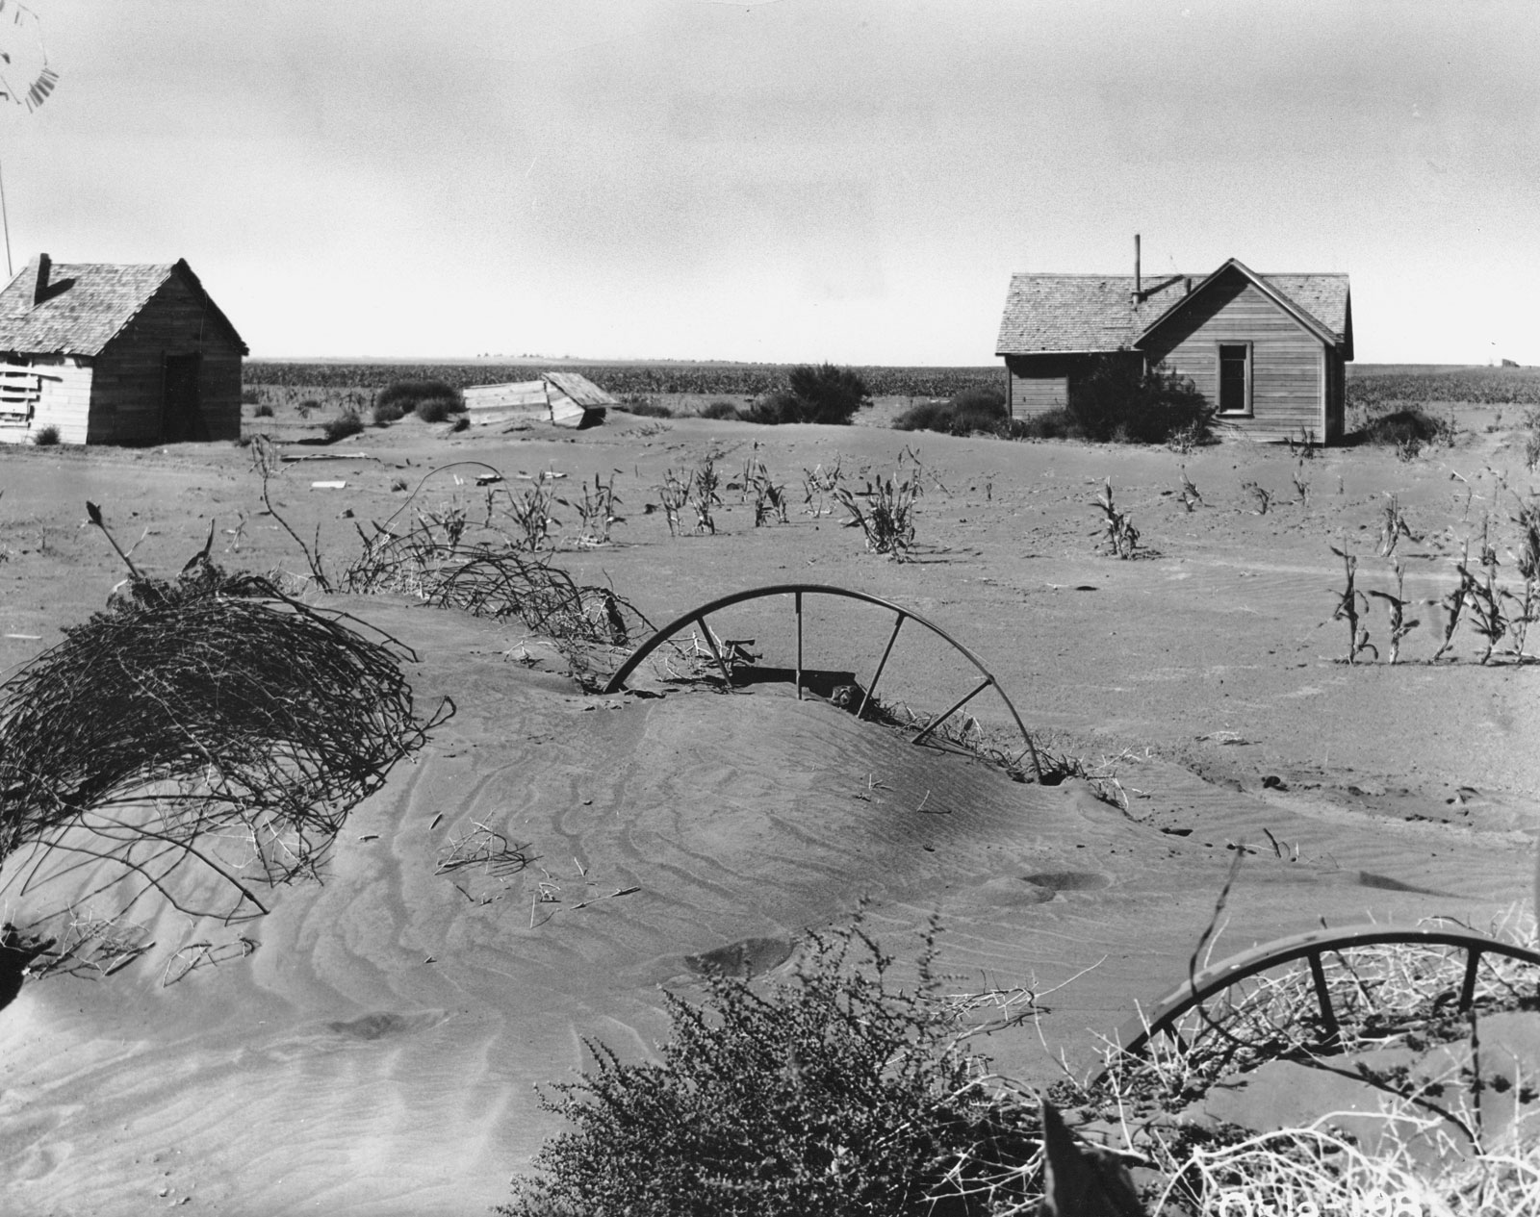

Big Question

What do Steinbeck’s first descriptions of George and Lennie reveal about them?

Vocabulary

Migrant | Farm | Money | Transience
Worker | Labour | Livelihood | Isolation
Ranch | Employment | Friendship | Frustration

Retrieval

- George and Lennie walk down the Salinas River

- Lennie drinks water from a pool of still water

- George warns Lennie not to drink too much

- George grows frustrated at the memory of the bus ride

- Lennie reveals he has lost his work card and bus ticket

Extract

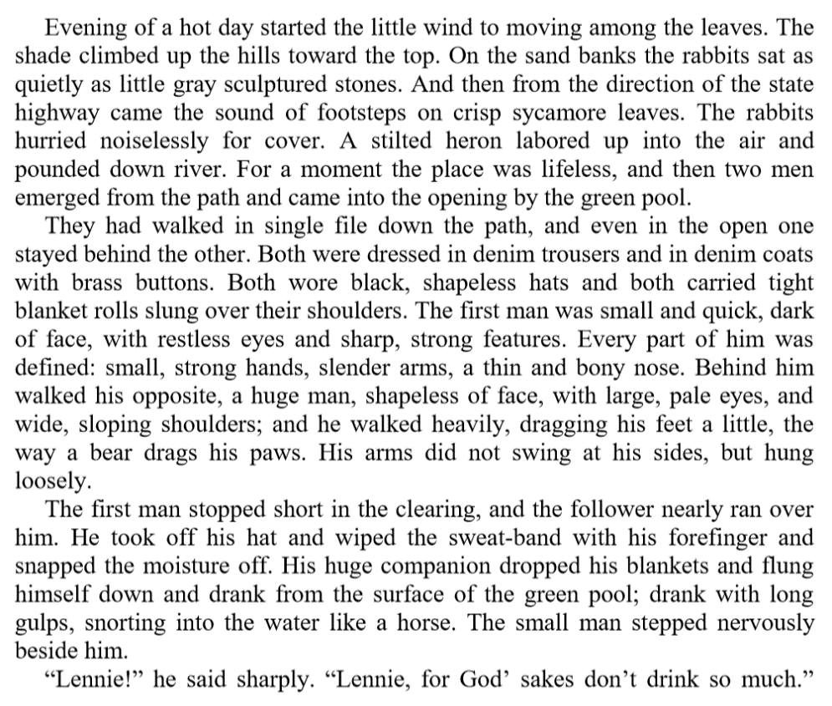

Multiple-Choice Question

‘He walked heavily, dragging his feet a little’ – which adjectives most accurately describe Lennie’s movement?

- Strong and agile

- Slow and lethargic

- Lumbering and clumsy

- Swift and energetic

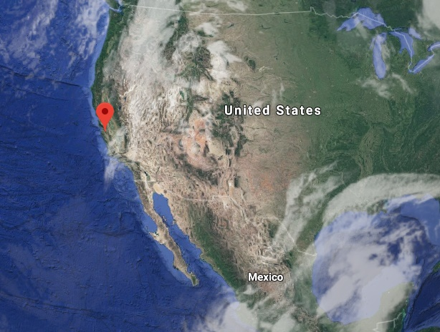

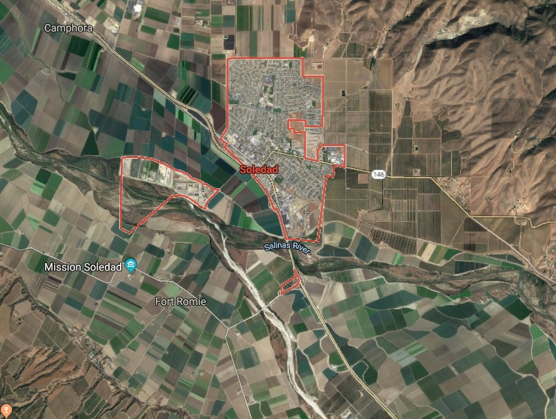
Big Question

What does the dialogue between George and Lennie reveal about the nature of their relationship?

Vocabulary

Anger | Loyalty | Discipline | Support
Irritation | Help | Questions | Relationship
Trust | Advice | Responsibility | Patience

Retrieval

- George says he has Lennie’s work card and bus ticket

- Lennie reveals he has a dead mouse in his hand

- George demands that Lennie hands over the mouse

- Lennie pleads with George to let him keep the mouse

- George refers to the ranch in Weed

Extract

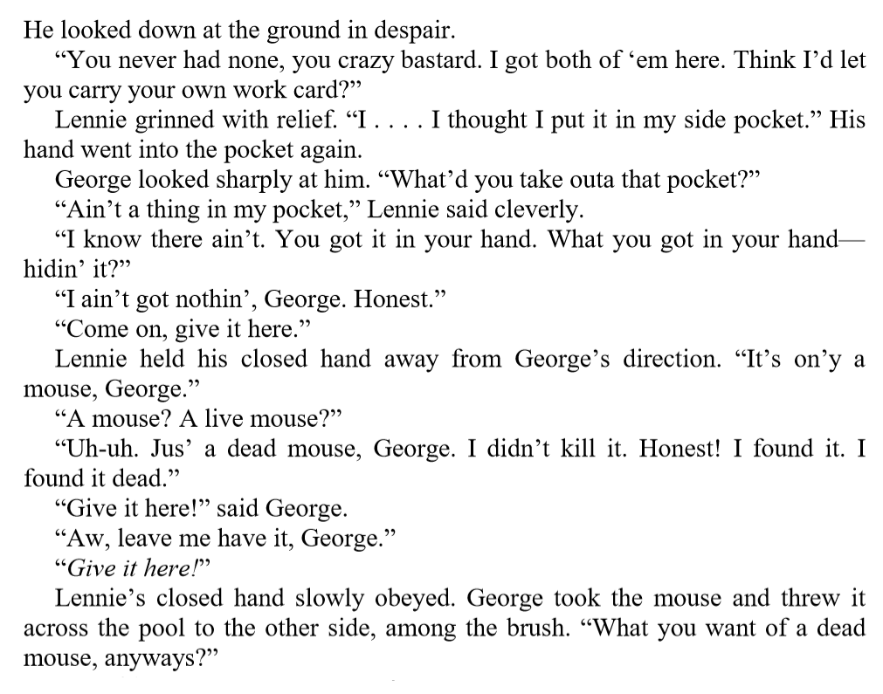

Multiple-Choice Question

Which statement most accurately describes the relationship between George and Lennie at the start of chapter one?

- Friendly and good-natured

- Fractious, but based on genuine companionship

- Cold and distant

- Uneasy, but steadily improving

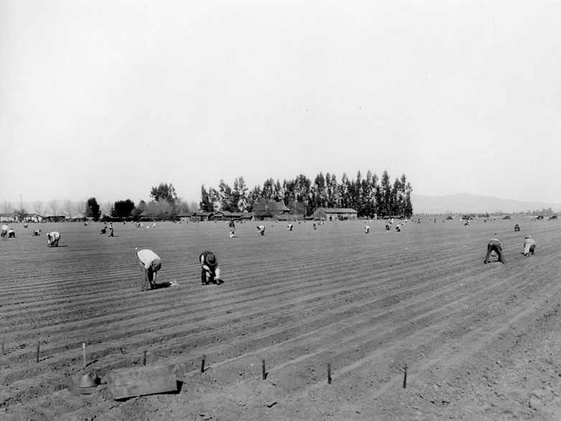

Five Key Points to Remember

- Lennie has a child-like mentality and struggles to remember simple instructions; this irritates George

- George regularly swears at Lennie and images his life without him, but this does not mean he despises Lennie

- Lennie provides George with companionship; they are not like other ranchers (or so they believe)

- George alludes to former events in Weed; it is clear that George has been vital to Lennie’s survival

- Lennie is compared to powerful animals at the start of the novel – a bear and a horse

Big Question

What does the language used by Candy to describe Crooks reveal about racial tensions in 1930s America?

Vocabulary

Discrimination | Hostility | Isolation | Change
Racism | Anger | Loneliness | Relationships
Prejudice | Resentment | Injustice | Inequality

Retrieval

- Candy reminds George and Lennie that they are late

- Candy shows George and Lennie to their bunks

- Candy reminisces about when the ranchers got drunk

- George and Lennie are introduced to the boss

- George blames the bus driver for their late arrival

Extract

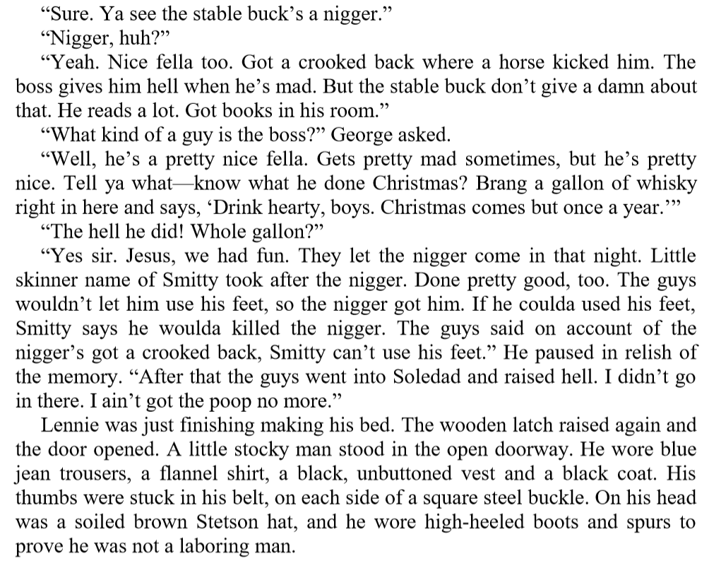

Multiple-Choice Question

Based on Candy’s remarks, which statement most accurately describes Crooks’s status on the ranch?

- A marginalised and lonely figure

- An important and experienced rancher

- A skilful worker who is appreciated by the boss

- A worker who has chosen to isolate himself

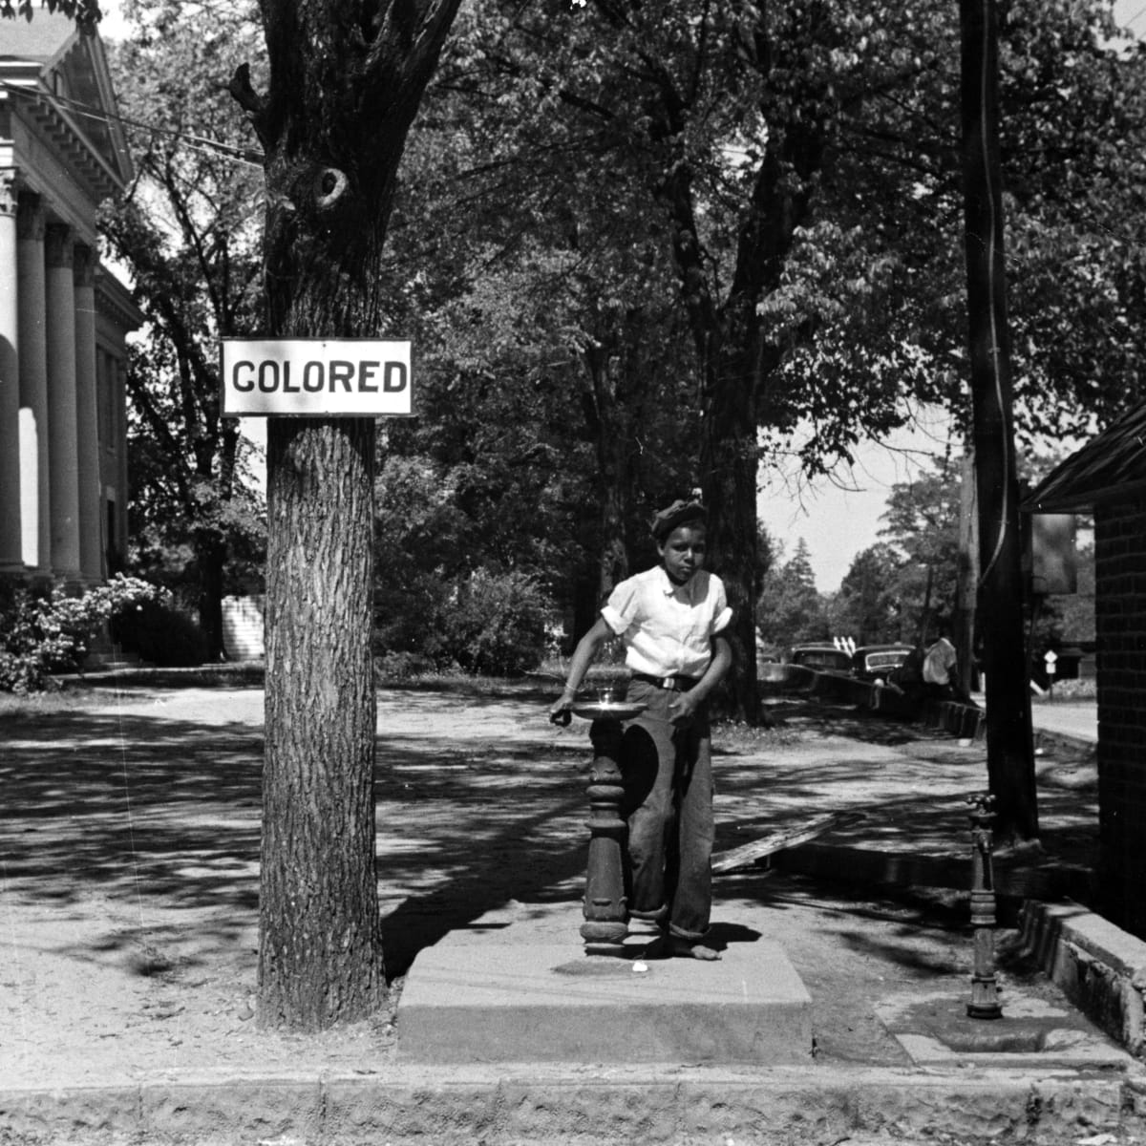

Big Question

What words and phrases does Steinbeck use in introducing us to Curley, which suggest he might be trouble for Lennie?

Vocabulary

Power | Influence | Bullying | Insecurity
Hierarchy | Aggression | Hate | Fear
Authority | Intimidation | Prejudice | Threat

Retrieval

- Curley enters the bunkhouse

- Curley asks about the whereabouts of his father

- Curley stares at Lennie

- George answers Curley’s question on behalf of Lennie

- Curley leaves the bunkhouse in frustration

Extract

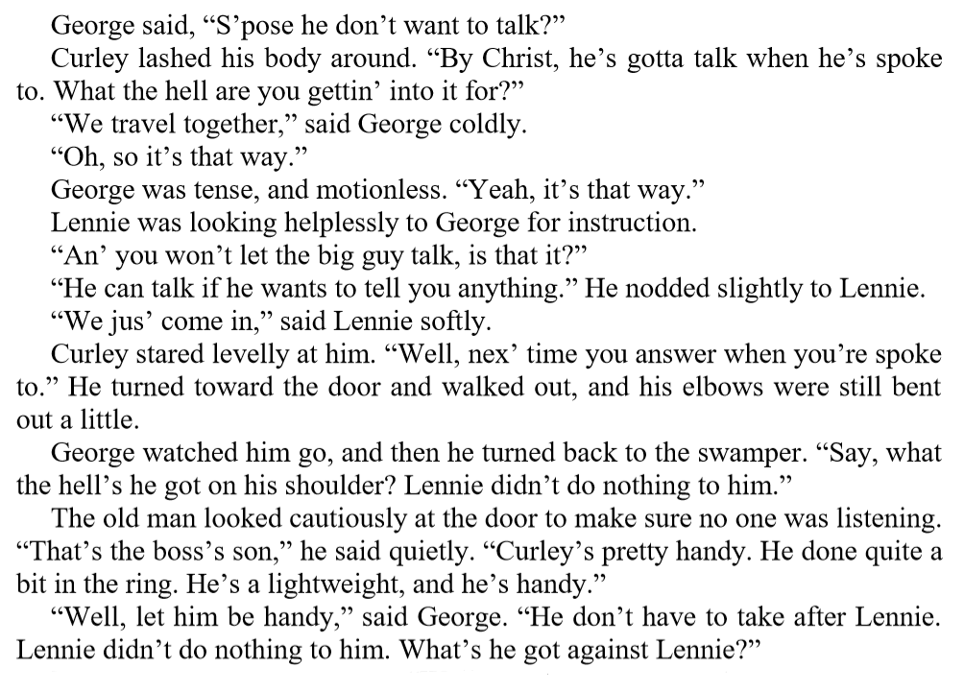

Multiple-Choice Question

Which two adjectives below most accurately describe Curley?

- Calm and patient

- Violent and angry

- Aggressive and intimidating

- Welcoming and friendly

Big Question

How is the character of Curley’s wife presented when she enters the bunk house?

Vocabulary

Woman | Suspicious | Beauty | Desire
Ranch | Misogyny | Superficiality | Hatred
Loneliness | Objectification | Trust | Pity

Retrieval

- George indicates to Candy that he dislikes Curley

- Candy suggests that Curley’s wife is flirtatious

- George warns Lennie to stay away from Curley

- Curley’s wife enters the bunkhouse

- George and Lennie meet Slim

Extract

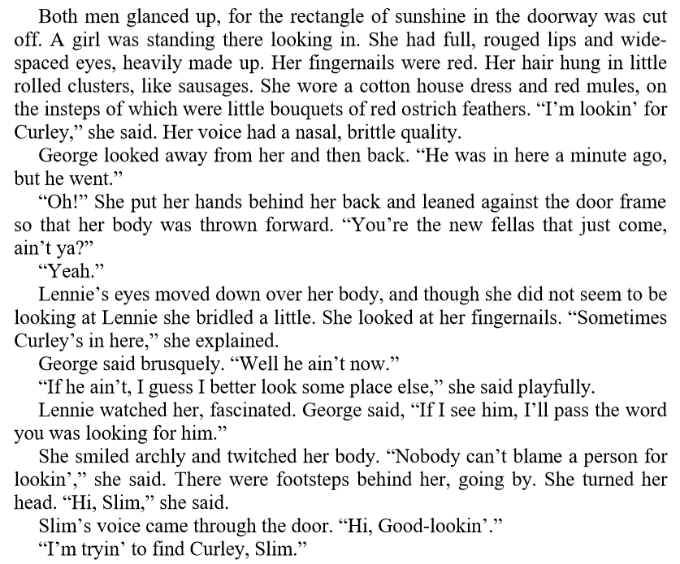

Multiple-Choice Question

Which statement most accurately describes the presentation of Curley’s wife?

- A flirtatious and superficial woman

- An untrustworthy and manipulative temptress

- A lonely, isolated and misunderstood woman

- A friendly and sociable woman
Big Question

What leads Slim to conclude that Lennie has the mental age of a child and is not deliberately mean or wicked?

Vocabulary

Kindness | Empathy | Danger | Secret
Respect | Mentality | Responsibility | Escape
Tolerance | Trust | Violence | Vulnerability

Retrieval

- George thanks Slim for giving Lennie a puppy

- Slim talks about George and Lennie’s relationship

- George tells Slim that George isn’t crazy

- George recalls a time when Lennie almost drowned

- George recalls the trouble Lennie got into in Weed

Extract

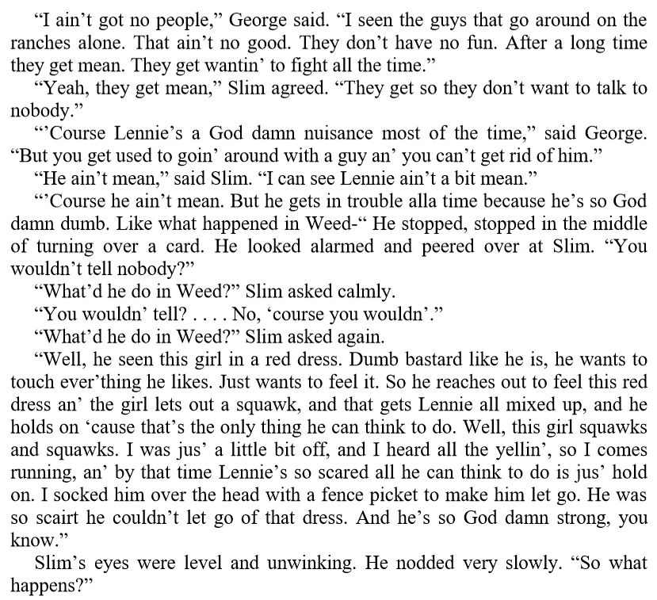

Multiple-Choice Question

Which statement most accurately describes Slim’s relationship with George?

- A relationship built upon mutual trust and respect

- A close and enduring friendship

- An uneasy and fragile alliance

- A distant association between two workers
Letter from John Steinbeck to Claire Luce

To Claire Luce

Los Gatos, 1938

Dear Miss Luce,

Annie Laurie says you are worried about your playing of the part of Curley’s wife although from the
reviews it appears that you are playing it marvellously. I am deeply grateful to you and to the others
in the cast for your feeling about the play. You have surely made it much more than it was by such a
feeling.

About the girl – I don’t know of course what you think about her, but perhaps if I should tell you a
little about her as I know her, it might clear your feeling about her. She grew up in an atmosphere of
fighting and suspicion. Quite early she learned that she must never trust anyone, but she was never
able to carry out what she learned. A natural trustfulness broke through constantly and every time it
did, it got her. Her moral training was most rigid. She was told over and over that she must remain
a virgin because that was the only way she could get a husband. This was harped on so often that it
became a fixation. It would have been impossible to seduce her. She had only that one thing to sell
and she knew it.

Now, she was trained by threat not only at home but by other kids. And any show of fear or
weakness brought an instant persecution. She learned to be hard to cover her fright. And
automatically she became hardest when she was most frightened. She is a nice, kind girl, not a
floozy. No man has ever considered her as anything except a girl to try to make. She has never talked
to a man except in the sexual fencing conversation. She is not highly sexed particularly but knows
instinctively that if she is to be noticed at all, it will be because some one finds her sexually desirable.

As to her actual sexual life – she has had none except with Curley and there has probably been no
consummation there since Curley would not consider her gratification and would probably be
suspicious if she had any. Consequently, she is a little starved. She knows utterly nothing about sex
except the mass misinformation girls tell one another. If anyone – a man or woman – ever gave her a
break – treated her like a person – she would be a slave to that person. Her craving for contact is
immense but she, with her background, is incapable of conceiving any contact without some sexual
context. With all this – if you knew her, if you could ever break down a thousand little defences she
has built up, you would find a nice person, an honest person, and you would end up by loving her.
But such a thing could never happen.

I hope you won’t think I’m preaching. I’ve known this girl and I’m just trying to tell you what she is
like. She is afraid of everyone in the world. You’ve known girls like that, haven’t you? You can see
them in Central Park on a hot night. They travel in groups for protection. They pretend to be wise
and hard and voluptuous.

I have a feeling that you know all this and that you are doing all this. Please forgive me if I seem to
intrude on your job. I don’t intend to and I am only writing this because Annie Laurie said you
wondered about the girl. It’s a devil of a hard part. I am very happy that you have it.

Sincerely,

John Steinbeck

Review Task

Think about all the characters in the novel: what they’re like, what they do, how they interact with each other.
Create a ranch hierarchy. Start with the character who possess the highest status and work your way down.

Review Task

George and Lennie have obvious differences between them. However, they also share similarities.
Make two lists.

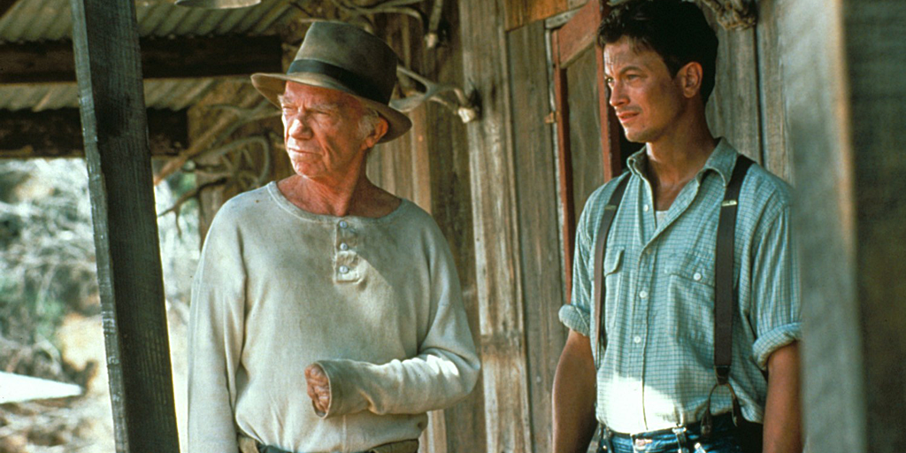

Big Question

Why does Curley pick a fight with Lennie, the strongest of all the men on the ranch?

Vocabulary

Aggressive | Forceful | Hostile | Defiant
Violent | Vicious | Destructive | Frightened
Insecure | Powerful | Apprehensive | Confused

Retrieval

- Curley enters the bunk house and asks about his wife

- Curley asks about Slim

- George warns Lennie to stay away from trouble

- Curley enters the bunk house and picks on Lennie

- Lennie crushes Curley’s fist

Extract

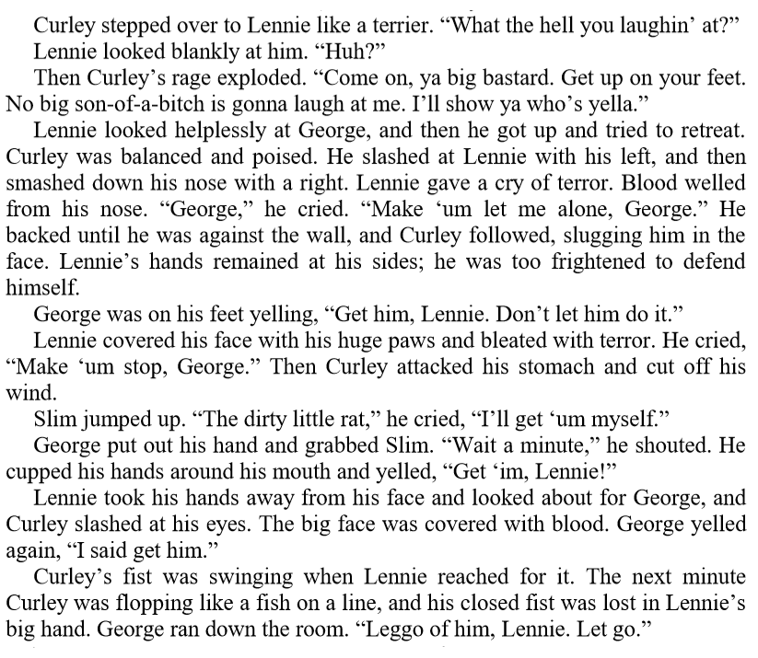

Multiple-Choice Question

Which statement most accurately describes the aftermath of the fight between Curley and Lennie?

- A triumphant victory for Lennie

- A deserved beating for Curley

- A dramatic and unexpected victory for Lennie

- A humiliating defeat for Curley
Big Question

What does Crooks’s attitude towards the other ranchers reveal about attitudes towards race in 1930s America?

Vocabulary

Ranch | Isolation | Segregation | Insecurity
Health | Possessions | Suffering | Respect
Horses | Appearance | Anger | Resentment

Retrieval

- Lennie enters Crooks’s room

- Crooks reacts angrily to Lennie’s unannounced visit

- Lennie explains that he saw a light on in the barn

- Crooks tells Lennie that he is not welcome

- Crooks tells Lennie about his childhood in California

Extract

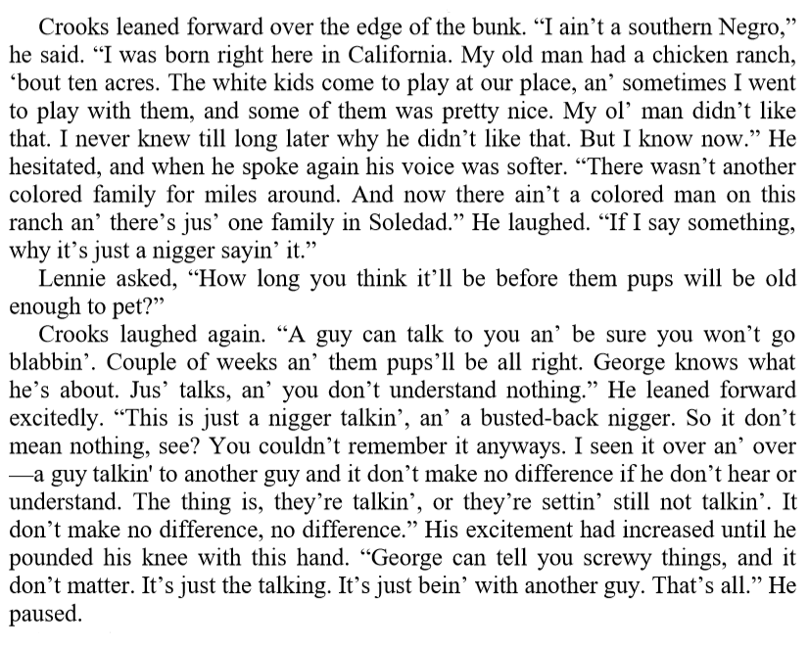

Multiple-Choice Question

Which statement most accurately describes Crooks’s initial reaction to Lennie’s unexpected visit to the stable?

- He welcomes Lennie warmly and asks him to stay

- He is happy to have some company

- He is suspicious of Lennie’s motives for visiting

- He is angrily resentful at the invasion of his privacy
Big Question

Why does Crooks eventually choose not to become part of Lennie’s plan to buy a ranch?

Vocabulary

Dream | Stability | Doubt | Uncertainty
Ambition | Hope | Pessimism | Delusion
Realism | Plan | Hesitation | Cynicism

Retrieval

- Candy enters Crooks’s room

- Crooks offers to work at the ranch

- Curley’s wife enters Crooks’s room

- Curley’s wife enquires about Lennie’s fight with Curley

- Curley’s wife threatens to have Crooks lynched

Extract

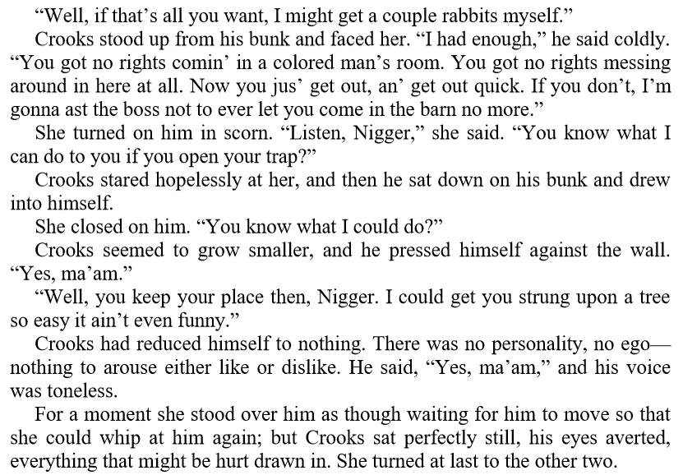

Multiple-Choice Question

Which statement most accurately describes Crooks’s initial reaction to Lennie’s unexpected visit to the stable?

- He is aware that the dream is ultimately unattainable

- He knows that he cannot afford to pay rent

- He likes George, but does not trust Lennie

- He believes that he would still be treated as an outcast

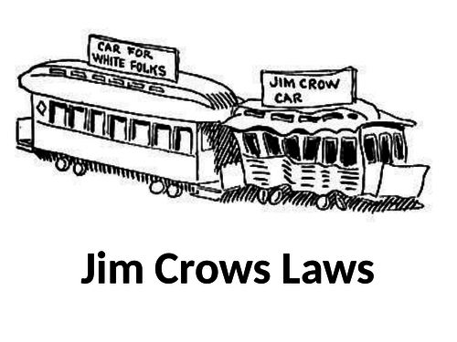

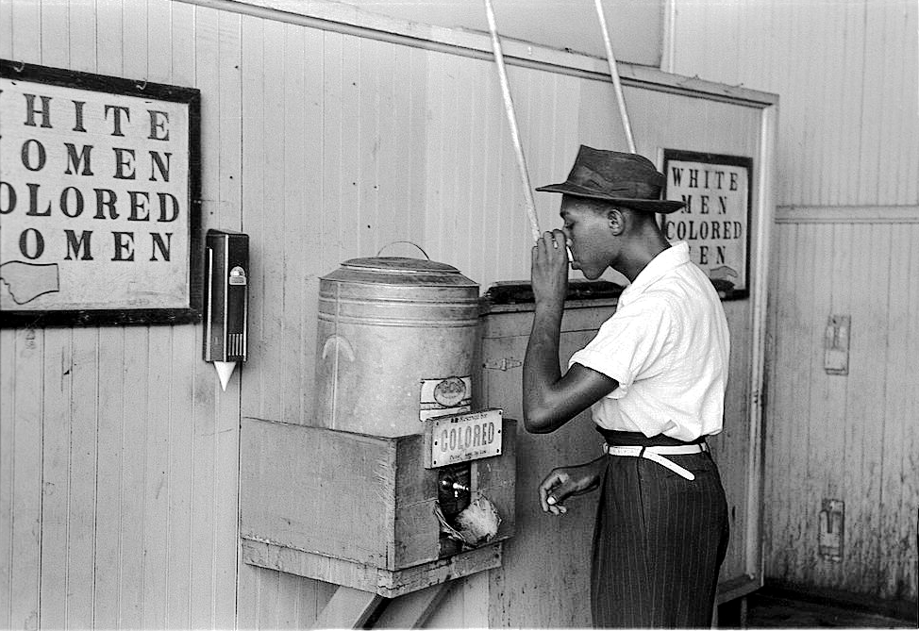

Review Questions: Chapters 1-4

- Who wrote Of Mice and Men?
- In which decade is the novel set?
- In which American town is the ranch where George and Lennie work?
- How many miles short of the ranch does the bus driver leave George and Lennie?
- What does George demand that Lennie handover to him?
- What is the name of Lennie’s aunt?
- Who is the first character that George and Lennie meet on the ranch?
- Why does George object to his assigned bed?
- Why does George speak on behalf of Lennie when Curley questions him?
- What colour is particularly associated with Curley’s wife?
- Why does Carlson object to Candy’s dog?
- Which rancher (apart from Curley) appears to have the highest status on the ranch?
- What does Slim offer to give to Lennie?
- Which character does Curley constantly appear to be looking for on the ranch?
- What does Lennie do that provides Curley with an opportunity to start a fight?
- What does Lennie do to Curley during the fight?
- What story do the ranchers agree on to explain Curley’s injury?
- What does Lennie see that he believes makes it acceptable to enter Crooks’s room?
- What does Curley’s wife threaten to have done to Crooks?
- Which other characters enter Crooks’s room before George returns from town?

Big Question

What has Lennie done at the beginning of the chapter that suggests he is irresponsible and dangerous?

Vocabulary

Murder | Violence | Remorse | Misery
Revenge | Escape | Fear | Hope
Justice | Chase | Regret | Dream

Retrieval

- The men play horseshoes outside the barn

- Lennie sits alone in the barn

- Lennie speaks softly to the dead puppy

- Lennie becomes angry at the dead puppy

- Curley’s wife enters the barn

Extract

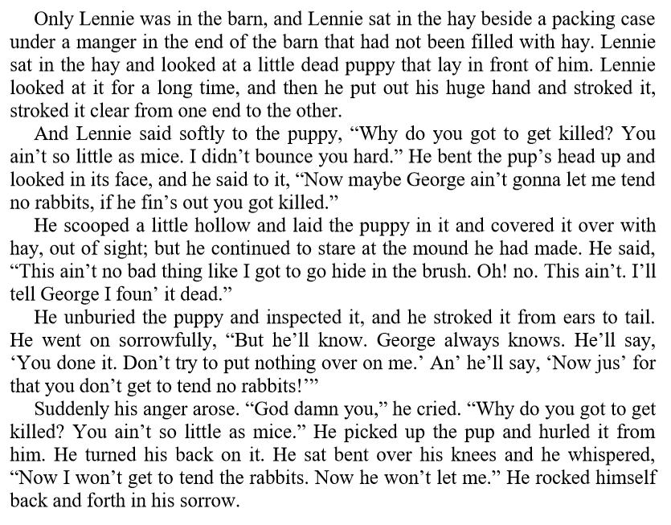

Multiple-Choice Question

Which statement most accurately explains Lennie’s sense of fear and frustration at the start of the chapter?

- He knows that Slim will not give him another puppy

- He believes that Curley will tell him to leave the ranch

- He thinks Slim will be angry with him

- He thinks that George will be angry with him
Big Question

To what extent does Steinbeck present Curley’s wife as an unfortunate victim?

Vocabulary

Childhood | Determination | Sadness | Responsibility
Ambition | Hierarchy | Isolation | Hope
Excitement | Memory | Consequences | Dream

Retrieval

- Curley’s wife tells Lennie about how she met Curley

- Curley’s wife says that she could have been an actress

- Curley’s wife invites Lennie to stroke her hair

- Curley’s wife panics when Lennie becomes too forceful

- Lennie breaks the neck of Curley’s wife

Extract

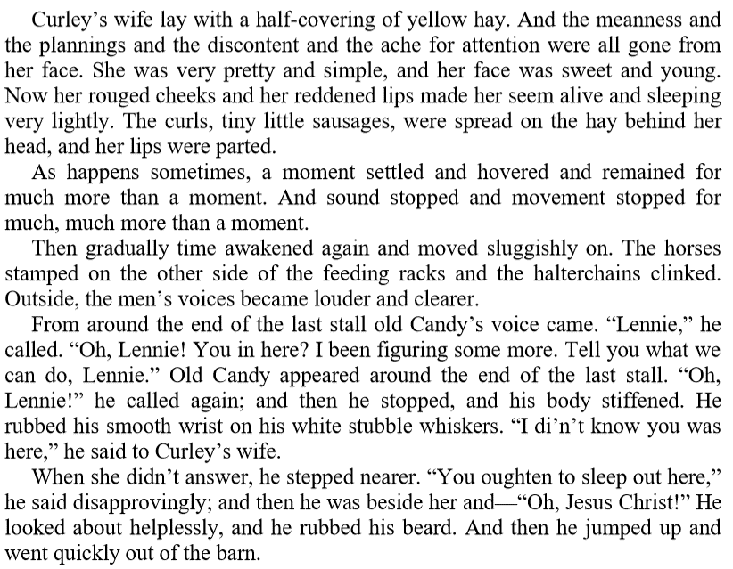

Multiple-Choice Question

Which adjective most accurately describes presentation of Curley’s wife after she has died?

- Peaceful

- Insignificant

- Beautiful

- Innocent
Five Key Points to Remember

- A ‘femme fatale’ is a sexually attractive character who seduces men and leads them into dangerous situations
- Curley’s wife is not given a name: she is defined solely in terms of being the possession of her husband
- She is particularly associated with the colour red, which is symbolic of – amongst other things – lust and danger
- The threat to have Crooks lynched reveals that Curley’s wife has the capacity to be predatory and cruel
- Curley’s wife’s dream of becoming an actress helps to humanise her and evokes pathos

Review Task

How do the male characters speak about women in the novel?
Make a list of short quotations.

Review Task

Curley’s wife calls Lennie, Candy and Crooks the ‘weak ones’ in chapter five. In what ways are they ‘weak’?
Make three spider-diagrams of your ideas.

Review Task

Look at the way in which the setting is described at the start of chapter six. It’s the same setting that’s described in chapter one.
What differences can you identify and why might they be significant?

Big Question

In what ways are Lennie’s two hallucinations at the beginning of chapter six significant?

Vocabulary

Hallucination | Anxiety | Apprehension | Frustration
Vision | Fear | Punishment | Pressure
Dream | Guilt | Anger | Concern

Retrieval

- Lennie emerges from the brush

- Lennie begins speaking softly to himself

- Lennie ‘sees’ Aunt Clara

- Lennie ‘sees’ a gigantic rabbit

- George meets Lennie

Extract

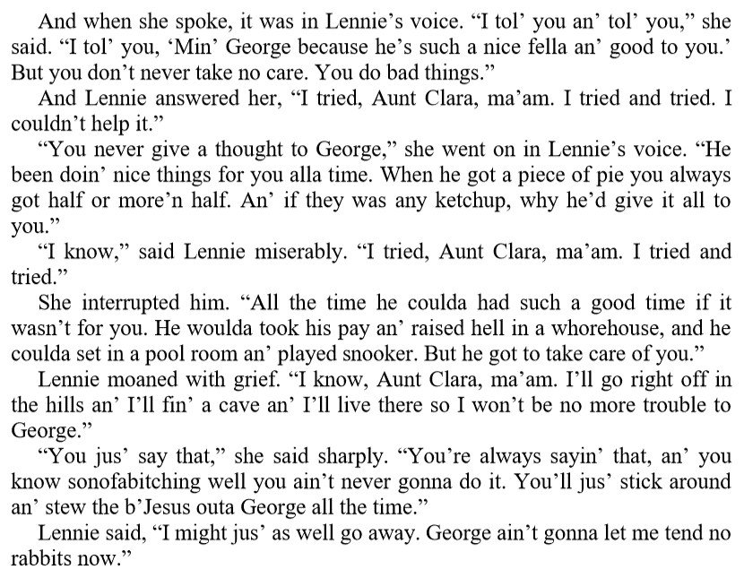

Multiple-Choice Question

Which statement most accurately describes Lennie’s state of mind at the beginning of chapter six?

- He is deeply regretful that Curley’s wife is dead

- He vaguely understands he has ‘done a bad thing’

- He doesn’t care about how George will react

- He feels isolated and vulnerable
Review Questions: Chapters 1-6

- What is George’s surname?

- What is Lennie’s surname?

- ‘You take a good big drink’ >> Who said it?

- ‘Small and quick’ >> Who is it?

- ‘Snorting into the water like a horse’ >> Who is it?

- Who is Slim?

- What colour is associated with Curley’s wife?

- ‘He’s dumb as hell’ >> Who is it?

- ‘Looks kinda scummy’ >> Who said it?

- ‘He wore high-heeled boots’ >> Who is it?

- What were the Jim Crow Laws?

- What is the relevance of Crooks’s name?

- ‘Well, we ain’t got any’ >> Who said it?

- ‘He walked heavily’ >> Who is it?

- ‘Come on in and set a while’ >> Who said it?

- In which chapter is the fight scene?

- What animal does Lenny ‘pet’ in chapter one?

- ‘S’pose you didn't have nobody’ >> Who said it?

- ‘Baloney!’ >> Who said it?

- ‘Then – it's all off?’ >> Who said it?

- What is the name of Lennie’s aunt?

- In which chapter is Curley’s wife introduced?

- ‘Tell how it’s gonna be’ >> Who said it?

- ‘Did he have my gun?’ >> Who said it?

- ‘You hadda, George’ >> Who said it?

- Who is the subject of Lennie’s first hallucination?

- What is a ‘luger’?

- ‘I don’t want no trouble’ >> Who said it?

- ‘You’re nuts’ >> Who said it?

- ‘Yeah. He had your gun’ >> Who said it?

Assessment 1

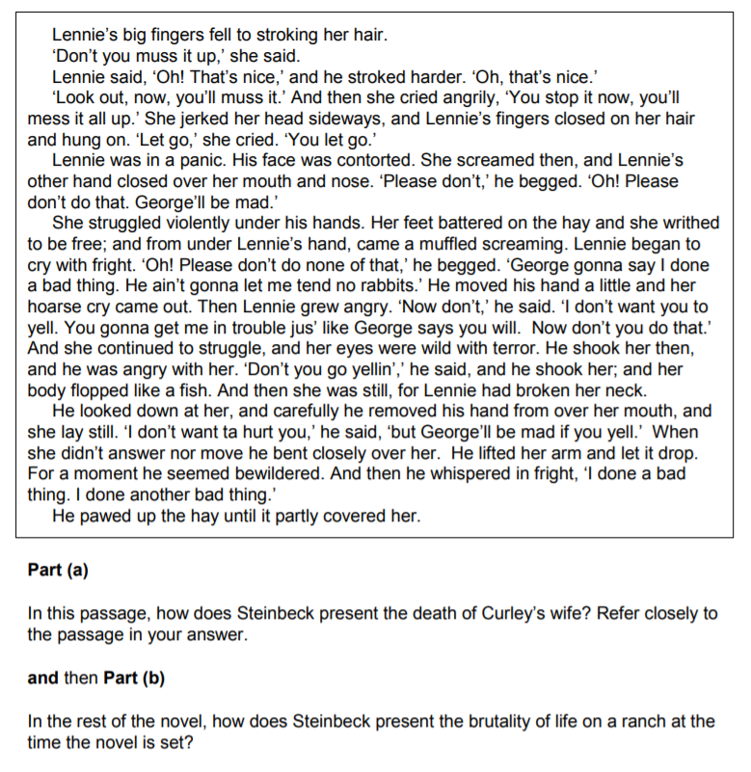
Source: GCSE English Literature exam paper 1H, June 2015 (eAQA)

Assessment 2

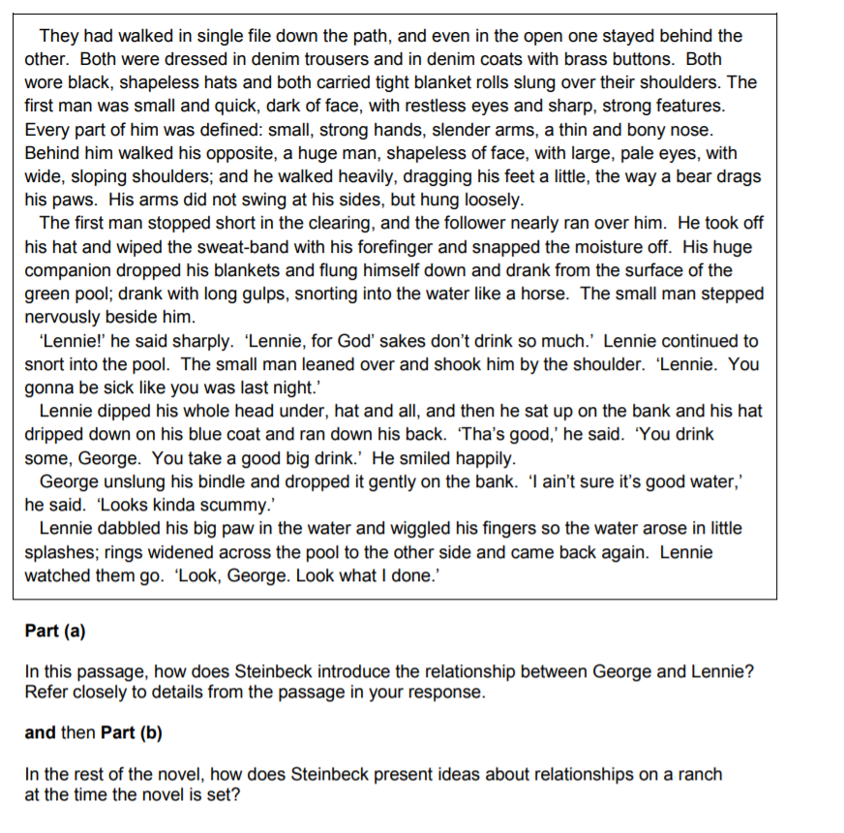
Source: GCSE English Literature exam paper 1H, June 2014 (eAQA)

Assessment 3

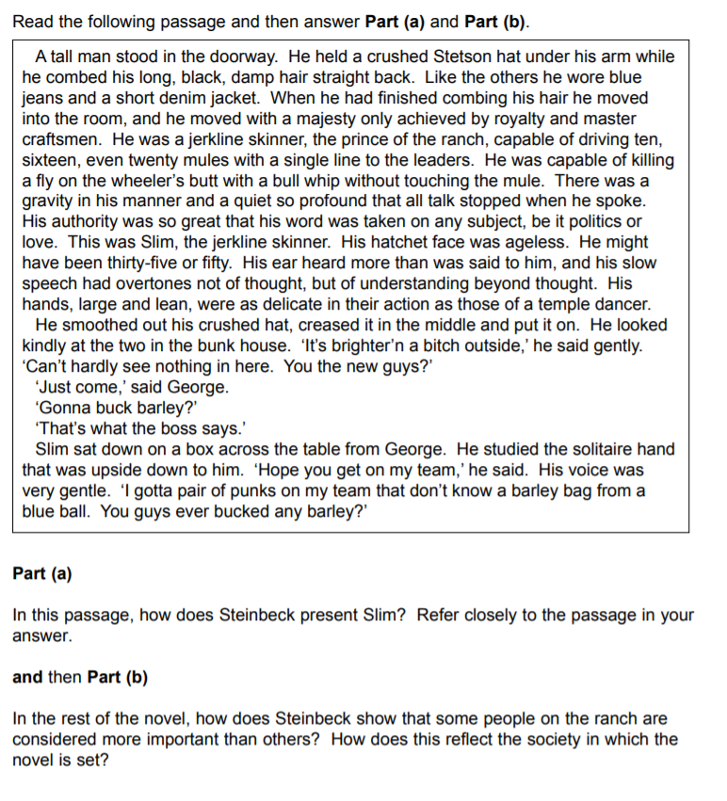
Source: GCSE English Literature exam paper 1H, June 2013 (eAQA)

Assessment 4

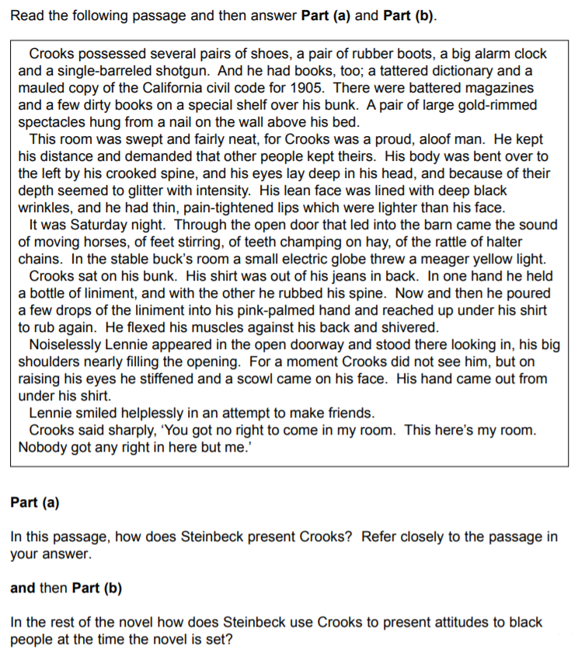
Source: GCSE English Literature exam paper 1H, January 2013 (eAQA)

‘To a Mouse’, by Robert Burns

Wee, sleekit, cowran, tim’rous beastie,
O, what a panic’s in thy breastie!
Thou need na start awa sae hasty,
Wi’ bickering brattle!
I wad be laith to rin an’ chase thee,
Wi’ murd’ring pattle!

I’m truly sorry Man’s dominion
Has broken Nature’s social union,
An’ justifies that ill opinion,
Which makes thee startle,
At me, thy poor, earth-born companion,
An’ fellow-mortal!

I doubt na, whyles, but thou may thieve;
What then? poor beastie, thou maun live!
A daimen-icker in a thrave ‘S a sma’ request:
I’ll get a blessin wi’ the lave,
An’ never miss’t!

Thy wee-bit housie, too, in ruin!
It’s silly wa’s the win’s are strewin!
An’ naething, now, to big a new ane,
O’ foggage green!
An’ bleak December’s winds ensuin,
Baith snell an’ keen!

Thou saw the fields laid bare an’ wast,
An’ weary Winter comin fast,
An’ cozie here, beneath the blast,
Thou thought to dwell,
Till crash! the cruel coulter past
Out thro’ thy cell.

That wee-bit heap o’ leaves an’ stibble,
Has cost thee monie a weary nibble!
Now thou’s turn’d out, for a’ thy trouble,
But house or hald.
To thole the Winter’s sleety dribble,
An’ cranreuch cauld!

But Mousie, thou are no thy-lane,
In proving foresight may be vain:
The best laid schemes o’ Mice an’ Men,
Gang aft agley,
An’ lea’e us nought but grief an’ pain,
For promis’d joy!

Still, thou art blest, compar’d wi’ me!
The present only toucheth thee:
But Och! I backward cast my e’e,
On prospects drear!
An’ forward, tho’ I canna see,
I guess an’ fear!

