**Anthology of Non-Fiction Texts**

KS3 English

Mr Wise

**Adventure**

1. *Mud, Sweat and Tears*, by Bear Grylls
2. *Explorers or Just Boys Messing Around?*, by Steven Morris

**History**

1. *The Diary of Florence Nightingale*, by Florence Nightingale
2. *Marys Seacole creator: ‘History doesn’t like to remember black women’*, by Jade Cuttle

**Gender**

1. *The Ladies’ Book of Etiquette*, by Florence Hartley
2. *The Hidden Sexism in Workplace Language*, by Mark Peters

**Class**

1. *The Road to Wigan Pier*, by George Orwell
2. *I had to fight my way through class barriers into my job*, by Jamie Fahey

**Technology**

1. *Admit It, the Cybertruck Is Awesome*, by Saahil Desai
2. *The 1899 Car With a Full-Size Wooden Horse Head Stuck to the Front*, by Alex Davies

|  |  |
| --- | --- |
| **A** | **Mud, Sweat and Tears**  Written by Bear Grylls | Published in 2011 |
| 5  10  15  20  25  30 | Acclimatisation is all about allowing the body to adjust to having less oxygen to function with, and the key is being patient about how fast you ascend. Once you start getting up high, the effects of altitude sickness can kill very quickly. If you get this process wrong, swelling of the brain, loss of consciousness and haemorrhaging from the eyes are some of the pleasant symptoms that can strike at any time. It is why playing at high altitude is just like playing with fire: unpredictable and dangerous.  From the peak of Everest, the land of Tibet lies sprawled out across the horizon to the north, as far as the eye can see. To the south, the summit looks over the vast range of the Himalayas, all the way down to the Nepalese plains. No other bit of land stands above this point on the entire planet. But what lies beneath the peak, for the ambitious climber, is a treacherous mix of thousands of feet of rock, snow and ice that has claimed a disproportionate number of top mountaineers.  Here is why. Under the summit, the descent off the south-east ridge is lined by faces of sheer rock and blue ice. These lead to a narrow couloir of deep powder snow, then eventually down to a col some three thousand feet beneath the peak. This col, the site of where our camp four would be, sits beneath the two huge peaks of Lhotse to the south and Everest to the north. It would take us the best part of six weeks’ climbing just to reach this col. Beneath the South Col, the gradient drops sharply away, down a five-thousand-foot ice wall known as the Lhotse Face. Our camp three would be carved into the ice, halfway up this.  At the foot of this wall starts the highest and most startling ice valley in the world. Halfway along this glacier would be our camp two, and at the lower end, our camp one. This vast tongue of ice is known simply as the Western Cwm – or the Valley of Silence. From the lip of the glacier, the ice is funnelled through the steep valley mouth where it begins to rupture violently, breaking up into a tumbling cascade of ice.  It is similar to when a flowing river narrows through a ravine, turning the water into frothing rapids. But here the water is frozen solid. The blocks of ice, often the size of houses, grumble as they slowly shift down the face. This gushing frozen river, some five hundred yards wide, is called the Khumbu Icefall, and is one of the most dangerous parts of the ascent. Finally, at its feet, lies Everest’s base camp.  Mick and I spent those early weeks together climbing in the lower foothills of the Himalayas, acclimatising ourselves, and starting to get a sense of the scale of the task that lay ahead. We hiked our way higher and higher into the heart of the mountains, until eventually we found ourselves at 17,450 feet, at the foot of the Khumbu Icefall and the start of the Everest climb in earnest. We pitched our tents at the base of the big mountain and waited for the rest of the team to arrive in two days’ time.  Sitting, waiting – staring up above – neck craned at Everest, I felt a sickness in the pit of my stomach. I just wanted whatever was going to unfold, to begin. The waiting is always the hard part. I had never felt so terrified, excited, anxious – and out of breath – in all my life. But this wasn’t even the beginning. It was both before and below the beginning. |

|  |  |
| --- | --- |
| **A** | **Mud, Sweat and Tears**  Written by Bear Grylls | Published in 2011 |



**Do Now**

|  |  |  |
| --- | --- | --- |
| 1. What is ‘acclimatisation’? | Paragraph 1 | 1 mark |
| 1. What is the ‘key’ to acclimatisation? | Paragraph 1 | 1 mark |
| 1. What has ‘claimed a disproportionate number’ of mountaineers? | Paragraph 2 | 1 mark |
| 1. How many weeks of climbing will it take to reach camp four? | Paragraph 3 | 1 mark |
| 1. What is another name for the Western Cwm? | Paragraph 4 | 1 mark |
| 1. What makes the Khumbu Icefall so dangerous? | Paragraph 5 | 1 mark |

**Close Focus**

|  |  |  |
| --- | --- | --- |
| 1. Explain what you learn about mountain climbing | Lines 1-6 | 2 marks |
| **‘Tibet lies *sprawled* out across the horizon to the north’** |  |  |
| 1. Explain what the word *sprawled* suggests about the geography of Tibet | Line 7 | 1 mark |
| **‘This vast *tongue* of ice is known simply as the Western Cwm’** |  |  |
| 1. Explain what the image of a *tongue* suggests about the shape of the glacier | Line 19 | 1 mark |
| 1. Describe the Khumbu Icefall + embed a short quotation | Lines 21-24 | 2 marks |
| 1. Explain how Bear Grylls feels + use the words because and but | Lines 30-34 | 3 marks |

**Wide Focus**

|  |  |
| --- | --- |
| **‘I felt a sickness in the pit of my stomach’** | |
| * Climbing Mount Everest is clearly very dangerous. Why do you think Bear Grylls chose to do it? | |
| * Embed a short quotation * Use the words because and but * Use the phrase this shows | |
| **B** | **Explorers or Just Boys Messing Around?**  Written by Steven Morris | Published in 2003 |
| 5  10  15  20  25  30 | Their last expedition ended in farce when the Russians threatened to send in military planes to intercept them as they tried to cross into Siberia via the icebound Bering Strait. Yesterday, a new adventure undertaken by British explorers Steve Brooks and Quentin Smith almost led to tragedy when their helicopter plunged into the sea off Antarctica. The men were plucked from the icy water by a Chilean naval ship after a nine-hour rescue which began when Mr Brooks contacted his wife, Jo Vestey, on his satellite phone asking for assistance. The rescue involved the Royal Navy, the RAF and British coastguards.  Last night there was resentment in some quarters that the men’s adventure had cost the taxpayers of Britain and Chile tens of thousands of pounds. Experts questioned the wisdom of taking a small helicopter – the four – seater Robinson R44 has a single engine – into such a hostile environment. There was also confusion about what exactly the men were trying to achieve. A website set up to promote the Bering Strait expedition claims the team were planning to fly from the north to south pole in their ‘trusty helicopter’. But Ms Vestey claimed she did not know what the pair were up to, describing them as ‘boys messing about with a helicopter.’  The drama began at around 1am British time when Mr Brooks, 42, and 40-year-old Mr Smith, also known as Q, ditched into the sea 100 miles off Antarctica, about 36 miles north of Smith Island, and scrambled into their life raft. Mr Brooks called his wife in London on his satellite phone. She said: ‘He said they were both in the life raft but were okay and could I call the emergency people?’  Meanwhile, distress signals were being beamed from the ditched helicopter and from Mr Brooks’ Breitling emergency watch, a wedding present. The signals from the aircraft were deciphered by Falmouth coastguard and passed on to the rescue coordination centre at RAF Kinloss in Scotland. The Royal Navy’s ice patrol ship, HMS Endurance, which was 180 miles away surveying uncharted waters, began steaming towards the scene and dispatched its two Lynx helicopters. One was driven back because of poor visibility but the second was on its way when the men were picked up by a Chilean naval vessel at about 10.20am British time. Though the pair wore survival suits and the weather at the spot where they ditched was clear, one Antarctic explorer told Mr Brooks’ wife it was ‘nothing short of a miracle’ that they had survived.  Despite their experience, it is not the first time they have hit the headlines for the wrong reasons. In April, Mr Brooks and another explorer, Graham Stratford, were poised to become the first to complete a crossing of the 56-mile wide frozen Bering Strait between the US and Russia in an amphibious vehicle, Snowbird VI, which could carve its way through ice floes and float in the water in between. But they were forced to call a halt after the Russian authorities told them they would scramble military helicopters to lift them off the ice if they crossed the border.  The wisdom of the team’s latest adventure was questioned by Günter Endres, editor of Helicopter Markets and Systems. He said: ‘I’m surprised they used the R44. I wouldn’t use it to go so far over the sea. The Ministry of Defence said the taxpayer would pick up the bill, as was normal in rescues in the UK and abroad. The spokesperson said it was ‘highly unlikely’ it would recover any of the money. |

|  |  |
| --- | --- |
| **B** | **Explorers or Just Boys Messing Around?**  Written by Steven Morris | Published in 2003 |

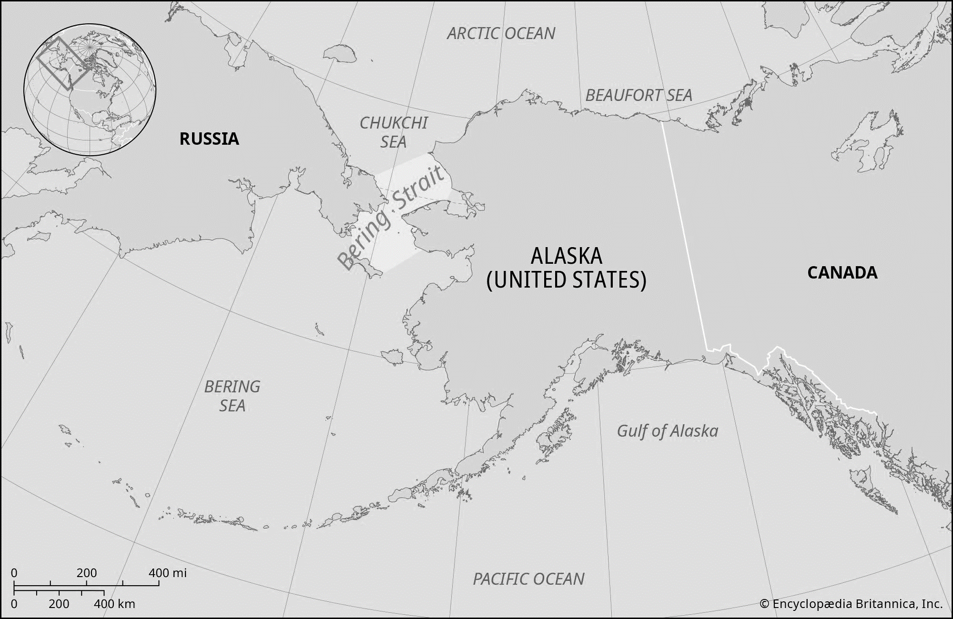

**Do Now**

|  |  |  |
| --- | --- | --- |
| 1. What happened to the helicopter flown by Steve Brooks and Quentin Smith? | Paragraph 1 | 1 mark |
| 1. What caused ‘resentment in some quarters’ about the expedition? | Paragraph 2 | 1 mark |
| 1. Why did experts ‘question the wisdom’ of the expedition? | Paragraph 2 | 1 mark |
| 1. What time did the ‘drama’ begin? | Paragraph 3 | 1 mark |
| 1. What were the two men eventually ‘picked-up’ by? | Paragraph 4 | 1 mark |

**Close Focus**

|  |  |  |
| --- | --- | --- |
| 1. Explain the difference between ‘explorers’ and ‘boys messing around’ | Title | 2 marks |
| **‘*scrambled* into their life raft’** |  |  |
| 1. Explain what the word *scrambled* suggests + use the phrase this shows | Line 14 | 1 mark |
| **‘it is not the first time they have hit the headlines for the *wrong reasons*’** |  |  |
| 1. Explain what the phrase *wrong reasons* means | Line 24 | 1 mark |
| 1. Explain how we know Günter Endres is someone who possesses expertise | Paragraph 6 | 1 mark |

**Wide Focus**

|  |  |
| --- | --- |
| **‘Explorers or just boys messing around?’** | |
| * Which label for the two men do you think is fairest and why? | |
| * Use the word because * Use the word however * Use the word furthermore | |
| **C** | **The Diary of Florence Nightingale**  Written by Florence Nightingale | Published in 1855 |
| 5  10  15  20  25 | A message came to me to prepare for 510 wounded on our side of the hospital who were arriving from the dreadful affair of the 5th November from Balaklava, in which battle were 1763 wounded and 442 killed, besides 96 officers wounded and 38 killed. We had but half an hour’s notice before they began landing the wounded. Between one and 9 o’clock we had the mattresses stuffed, sewn up, laid down – alas! Only upon matting on the floor the men washed and put to bed, and all their wounds dressed.  I wish I had more time. But oh, you gentlemen of England who sit at home in all the well-earned satisfaction of your successful cases, can have little idea from reading the newspapers of the misery (in a military hospital) of operating upon these dying, exhausted men. A London hospital is a garden of flowers to it.  We live in one tower of the barrack. All the wounded have been laid down in two corridors, with a line of beds down each side, just room for one person to pass between. Yet in the midst of this appalling horror (we are steeped up to our necks in blood) there is good, and I can truly say, like St. Peter, ‘It is good for us to be here’ – though I doubt whether if St Peter had been here, he would have said so.  As I went on my night-rounds among the newly wounded that first night, there was not one murmur, not one groan, the strictest discipline – the most absolute silence prevailed – and I heard a man say, ‘I was dreaming of my friends at home,’ and another said, ‘I was thinking of them.’ These poor fellows bear pain with an unshrinking heroism which is really superhuman, and die, or are cut up without a complaint.  The wounded are now lying up to our very door, and we are landing 540 more wounded soon. I feel like a brigadier general, because 40 females, whom I have with me, are more difficult to manage than 4000 men. Let no lady come out here who is not used to fatigue and privation.… Every ten minutes an orderly runs, and we have to cram lint into the wound until a surgeon can be sent for, and stop the bleeding as well as we can.  In all our corridor, I think we have not an average of three limbs per man. And there are two ships more ‘loading’ at the Crimea with wounded (this is our phraseology). Then come the operations, and a melancholy, not an encouraging list is this. They are all performed in the wards – no time to move them; one poor fellow exhausted with haemorrhage has his leg amputated as a last hope, and dies ten minutes after the surgeon has left him. Almost before the breath has left his body, it is sewn up in its blanket, and carried away and buried the same day.  We have no room for corpses in the wards. The surgeons pass on to the next, an excision of the shoulder-joint, beautifully performed and going on well. Ball lodged just in the head of the joint and fracture starred all round. The next poor fellow has two stumps for arms, and the next has lost an arm and a leg. |

|  |  |
| --- | --- |
| **C** | **The Diary of Florence Nightingale**  Written by Florence Nightingale | Published in 1855 |

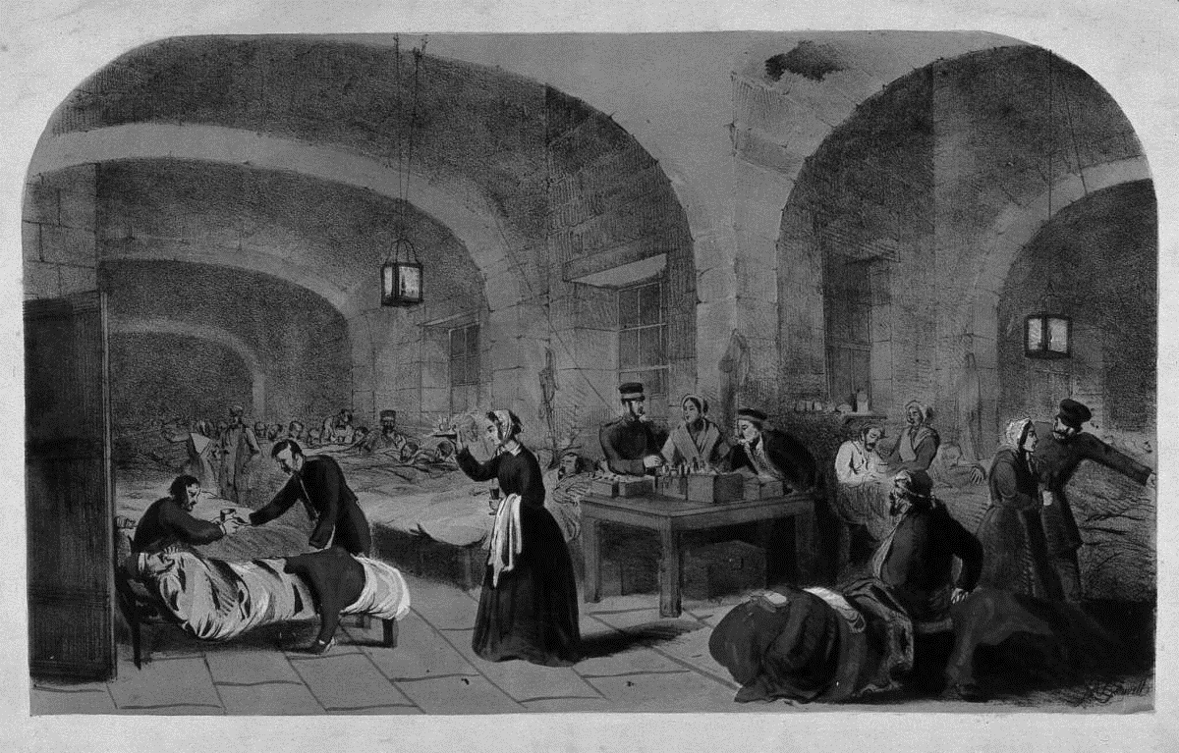

**Do Now**

|  |  |  |
| --- | --- | --- |
| 1. What ‘message’ came to Florence Nightingale? | Paragraph 1 | 1 mark |
| 1. What is a ‘garden of flowers’ compared to the military hospital? | Paragraph 2 | 1 mark |
| 1. What is the ‘appalling horror’ that Nightingale witnesses around her? | Paragraph 3 | 1 mark |
| 1. What are two more ships being ‘loaded’ with at Crimea? | Paragraph 6 | 1 mark |

**Close Focus**

|  |  |  |
| --- | --- | --- |
| 1. Identify who Nightingale is criticising and explain why + use the word because | Paragraph 2 | 2 marks |
| 1. Choose a word to describe her tone | Paragraph 2 | 1 mark |
| **‘A London hospital is a garden of flowers’** |  |  |
| 1. Explain the point that Nightingale is making + use the phrase to emphasise | Line 8 | 1 mark |
| 1. Explain what the ‘good’ is in the situation that Nightingale describes | Line 10 | 1 mark |
| 1. Explain what behaviour Nightingale believes is ‘superhuman’ | Line 15 | 1 mark |
| 1. Identify two details that convey the brutality of war + embed two quotations | Paragraph 7 | 2 marks |

**Wide Focus**

|  |  |
| --- | --- |
| * What sort of person is Florence Nightingale? | |
| * Choose two separate parts of the extract to focus on * Use the phrase This is significant because * Use the word furthermore | |
| **D** | **Marys Seacole creator: ‘History doesn’t like to remember black women’**  Written by Jade Cuttle | Published in 2022 |
| 5  10  15  20  25  30 | ‘Mary Seacole stands before us. If you don’t know who she is, well, look her the f*** up.’ So begins *Marys Seacole* (we’ll get to the ‘Marys’ of the title later), an experimental bio-drama by the Pulitzer prizewinning playwright Jackie Sibblies Drury, opening this week at the Donmar Warehouse in London. It explores the inspiring life of Mary Seacole, the British-Jamaican who defied war, prejudice and the British government by self-funding a trip to Crimea, now part of Ukraine, to set up a ‘British Hotel’ and care for soldiers on the battlefront.  Seacole – born Mary Jane Grant in Kingston, Jamaica, in 1805 – learnt herbal remedies from her mother and was an alarmingly keen student. ‘Whatever disease was most prevalent in Kingston, be sure my poor doll soon contracted it,’ she wrote in her autobiography, *Wonderful Adventures of Mrs Seacole in Many Lands*. It wasn’t just dolls: Seacole practised on dogs, cats and herself as a young child, before moving on to the cholera and yellow fever victims of Kingston, Panama and Crimea. Hailed as ‘the black Florence Nightingale’, she was voted the greatest black Briton in 2004. But she wasn’t always so esteemed.  On October 12, 1854, the *Times Constantinople* correspondent, Thomas Chenery, called for medical aid after the battle of Alma: ‘We are told of patients lying for hours, and even days, and making desperate attempts to catch the surgeon in his flying visits from ward to ward. There are no nurses at Scutari […] there is not even linen and lint to bind wounds […] The fever patients and the wounded suffer a dreadful thirst.’  Shortly after, a convoy of nurses led by Nightingale was sent to Crimea. Seacole travelled to England and asked the British War Office if she could join, but was refused – some say because of her race – despite her track record of saving cholera patients. Unfazed, she funded her own trip to Crimea and established the British Hotel in 1855 near Balaclava; ‘the softest, cleanest establishment’, according to Drury’s script, ‘in this nasty brutal pointless war.’  *Marys Seacole* premiered at the Lincoln Center Theater in New York in 2019. Drury, who is from New Jersey, came up with the idea while scrolling through Instagram where she spotted the Florence Nightingale Museum in London. She noticed the museum had a small section devoted to Seacole and felt she deserved her own stage.  ‘I went onto Amazon and was, like, Oh my gosh, there’s so many books about her!’ Drury tells me between rehearsals at the Donmar Warehouse. ‘I ordered them all but when they came, they were children’s books on cardboard pages.’ In other words, a flimsy homage to ‘Mother Seacole’, as she was known to the British soldiers she nursed in Crimea, sometimes while under fire.  The play is directed by Nadia Latif, who also directed Drury’s Pulitzer prize-winner Fairview, about a black middle-class family, at the Young Vic in 2019. ‘My mind boggles that this woman crossed the planet for a war [of which] she had no horse in the race,’ Latif says. ‘It blows my mind. Imagine riding towards the explosion, not away. But history doesn’t like to remember women, especially black women.’ |

|  |  |
| --- | --- |
| **D** | **Marys Seacole creator: ‘History doesn’t like to remember black women’**  Written by Jade Cuttle | Published in 2022 |

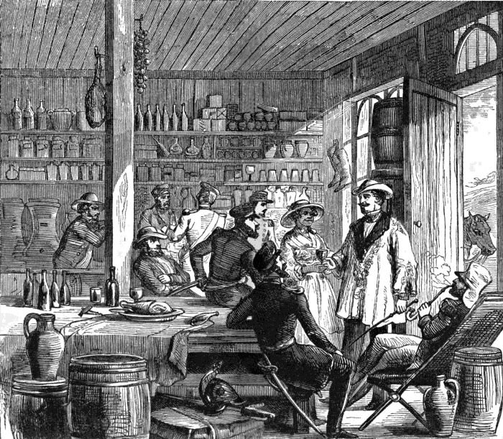

**Do Now**

|  |  |  |
| --- | --- | --- |
| 1. Why did Mary Seacole have to fund her own voyage to Crimea? | Paragraph 4 | 1 mark |
| 1. What motivated Jackie Sibblies Drury to write the play? | Paragraph 5 | 1 mark |
| 1. What did Drury notice about all the books on Mary Seacole? | Paragraph 6 | 1 mark |
| 1. What does Nadia Latif (director) say about history in the final paragraph? | Paragraph 7 | 1 mark |

**Close Focus**

|  |  |  |
| --- | --- | --- |
| **‘If you don’t know who she is, well, look her the f*** up’** |  |  |
| 1. Describe the tone of the quotation and then explain it | Line 1 | 2 marks |
| **‘an *alarmingly* keen student’** |  |  |
| 1. Explain what the word *alarmingly* suggests about Seacole | Line 7 | 1 mark |
| 1. Explain what you learn about Seacole’s personality + use the phrase this shows | Paragraph 4 | 2 marks |
| **‘Oh my gosh, there’s so many books about her!’** |  |  |
| 1. Explain what the exclamation mark shows about Drury’s outlook | Line 26 | 1 mark |
| 1. Explain the nickname ‘Mother Seacole’ + use the word because | Line 28 | 1 mark |
| **‘But history doesn’t like to remember women, especially black women’** |  |  |
| 1. Identify one piece of evidence in the extract that supports Latif’s view | Line 34 | 1 mark |

**Wide Focus**

|  |  |
| --- | --- |
| What are the similarities between Mary Seacole and Florence Nightingale? | |
| * Make two separate points * Use the words similarly * Use the word furthermore * Use the word however | |
| **E** | **The Ladies’ Book of Etiquette**  Written by Florence Hartley | Published in 1860 |
| 5  10  15  20  25  30 | A lady’s conduct is never so entirely at the mercy of critics, because never so public, as when she is in the street. Her dress, carriage, walk, will all be exposed to notice; every passer-by will look at her, if it is only for one glance; every unlady-like action will be marked; and in no position will a dignified, lady-like deportment be more certain to command respect. Let me start with you upon your promenade, my friend, and I will soon decide your place upon the list of well-bred ladies.  First, your dress. Not that scarlet shawl, with a green dress, I beg, and – oh! spare my nerves! – you are not so insane as to put on a blue bonnet. That’s right. If you wish to wear the green dress, don a black shawl, and – that white bonnet will do very well. One rule you must lay down with regard to a walking dress. It must never be conspicuous. Let the material be rich, if you will; the set of each garment faultless; have collar and sleeves snowy white, and wear neatly-fitting, whole, clean gloves and boots. Every detail may be scrupulously attended to, but let the whole effect be quiet and modest. Wear a little of one bright colour, if you will, but not more than one. Let each part of the dress harmonise with all the rest; avoid the extreme of fashion, and let the dress suit you. If you are short and plump, do not wear flounces, because they are fashionable, and avoid large plaids, even if they are the very latest style. If tall and slight, do not add to the length of your figure by long stripes, a little mantilla, and a caricature of a bonnet, with long, streaming ribbons. A large, round face will never look well, staring from a tiny, delicate bonnet; nor will a long, thin one stand the test much better. Wear what is becoming to yourself, and only bow to fashion enough to avoid eccentricity. To have everything in the extreme of fashion, is a sure mark of vulgarity.  Wear no jewellery in the street excepting your watch and brooch. Jewellery is only suited for full evening dress, when all the other details unite to set it off. If it is real, it is too valuable to risk losing in the street, and if it is not real, no lady should wear it. Mock jewellery is utterly detestable.  Why did you not dress before you came out? It is a mark of ill-breeding to draw your gloves on in the street. Now your bonnet-strings, and now – your collar! Pray arrange your dress before you leave the house! Nothing looks worse than to see a lady fussing over her dress in the street. Take a few moments more in your dressing-room, and so arrange your dress that you will not need to think of it again whilst you are out.  Do not walk so fast! you are not chasing anybody! Walk slowly, gracefully! Oh, do not drag one foot after the other as if you were fast asleep – set down the foot lightly, but at the same time firmly; now, carry your head up, not so; you hang it down as if you feared to look any one in the face! Nay, that is the other extreme! Now you look like a drill-major on parade! So! that is the medium. Upright, yet, at the same time, easy and elegant.  Now, my friend, do not swing your arms. You don’t know what to do with them? Your parasol takes one hand; hold your dress up a little with the other. Not so! No lady should raise her dress above the ankle. |

|  |  |
| --- | --- |
| **E** | **The Ladies’ Book of Etiquette**  Written by Florence Hartley | Published in 1860 |

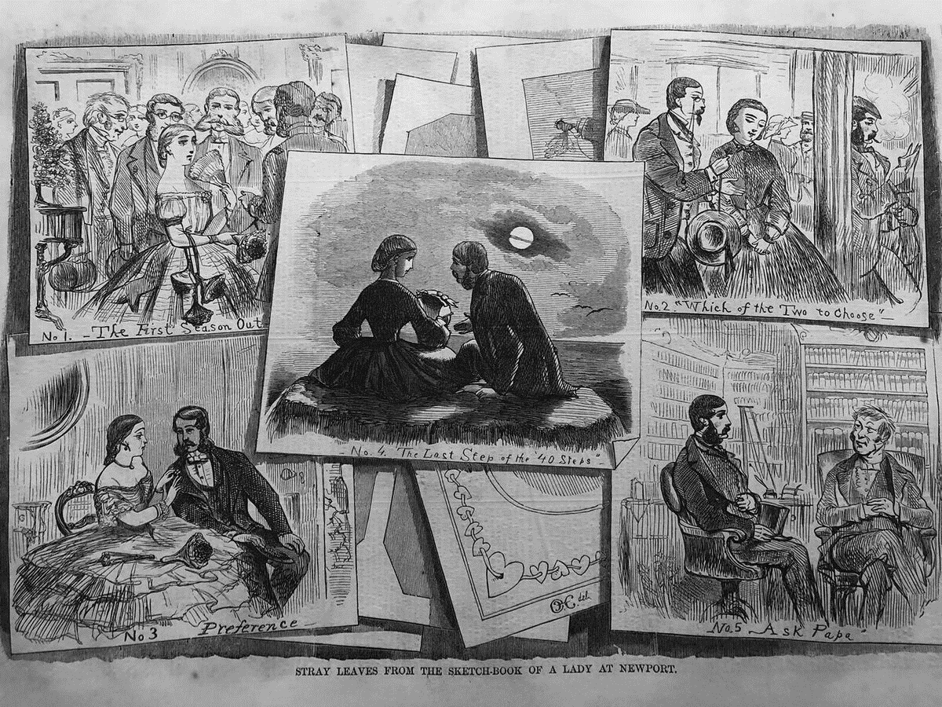

**Do Now**

|  |  |  |
| --- | --- | --- |
| 1. When is a lady particularly at ‘the mercy’ of critics? | Paragraph 1 | 1 mark |
| 1. What would a lady be ‘insane’ to wear? | Paragraph 2 | 1 mark |
| 1. How much of a ‘bright colour’ is it acceptable to wear? | Paragraph 2 | 1 mark |
| 1. What are the only pieces of jewellery acceptable to wear? | Paragraph 3 | 1 mark |

**Close Focus**

|  |  |  |
| --- | --- | --- |
| **‘I beg, and – oh! spare my nerves!’** |  |  |
| 1. Describe the tone of the quotation | Line 6 | 1 mark |
| 1. Retrieve two quotations that show women should dress in an understated way | Paragraph 2 | 2 marks |
| 1. Explain Hartley’s views on jewellery + use the word because | Paragraph 3 | 1 mark |
| 1. List five things a woman should do in order to rebel against etiquette | Extract | 5 marks |

**Wide Focus**

|  |
| --- |
| * What does the exact reveal about attitudes towards women during the Victorian era? |
| * Make two separate points * Embed a short quotation * Use the phrase this shows * Use the phrase we learn from this |

|  |  |
| --- | --- |
| **F** | **The Hidden Sexism in Workplace Language**  Written by Mark Peters | Published in 2017 (*BBC*) |
| 5  10  15  20 | Disentangling language and gender isn’t easy, since the two have a long-term relationship that is complicated. The two intermingle in so many ways, some obvious and some more subtle.  Many terms are objectively gendered, like the ones Deb Liu, a Facebook executive, started collecting at work. Some are old-fashioned, like a *gentleman’s agreement*, an expression that’s been around since the 1920s, but feels even older. Some are sports-related, like *man-on-man defence* and *quarterback*. Others sound like a team of 1940s superheroes: *wingman*, *strawman*, *middleman*, *right-hand man* and *poster boy*. Many female terms noted by Liu are negative. No one, male or female, wants to be called a *prima donna*, *drama queen*, *mean girl*, *Debbie Downer*, or *Negative Nancy*, despite the appeal of alliteration.  Some words have onion-like layers of meaning that could make an etymologist cry. *Guy* is a prime example of the tricky, illogical evolution of language and how it reflects gender. The plural form *guys* is often used to mean *men and women*, though the singular form is almost always male. *Two guys in a garage* is commonly used as shorthand for a start-up, but this could suggest two men or two people, depending on your interpretation. So is *guy* (or *guys*) okay for the workplace? A safer alternative might be *folks*, a word often used by Barack Obama.  Today’s gendered language, though far from harmless, is a quantum leap from some formerly common ways of describing women. Words such as *hostess*, *stewardess*, and *waitress* are still around, though passé, but they have dozens of sister words that sound bonkers today. A woman who wrote a book was once called an *authoress*, a term first found in the 1400s. In the 1800s, a female assassin could be called an *assassinatress*. Similarly preposterous – but real – words include *cousiness*, *fornicatress*, *greengroceress*, *inventress*, *murdermongress*, *pythoness*, and *revengeress*. Language is strange. A similar trend put *lady* at the front of words. The Oxford English Dictionary notes examples including *lady-nurse*, *lady-housekeeper*, and *lady-cook*.  Of course, we can look back on words like *authoress*, *inventress* or *greengroceress* and feel like we’ve made a lot of progress. But in the future, people may look back at *poster boy* and *two guys in a garage* and think they’ve made a lot of progress. We can always do better. Right, folks? |

|  |  |
| --- | --- |
| **F** | **The Hidden Sexism in Workplace Language**  Written by Mark Peters | Published in 2017 (*BBC*) |

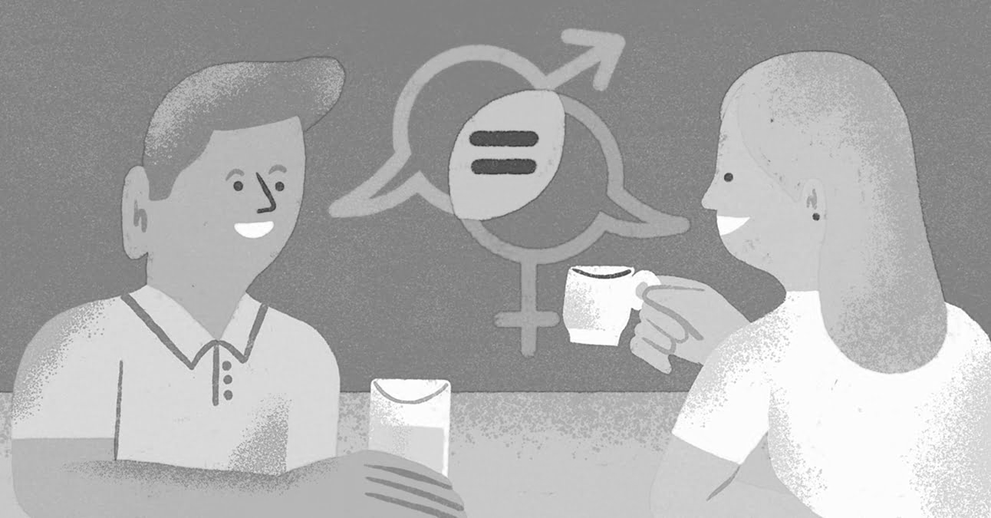

**Do Now**

|  |  |  |
| --- | --- | --- |
| 1. What ‘isn’t easy’ to disentangle? | Paragraph 1 | 1 mark |
| 1. What is Deb Liu’s role at Facebook? | Paragraph 2 | 1 mark |
| 1. What is the ‘safter alternative’ to the word ‘guys’ that Barack Obama uses? | Paragraph 3 | 1 mark |
| 1. What three ‘passé’ words are still used? | Paragraph 4 | 1 mark |
| 1. What was a female author once called? | Paragraph 5 | 1 mark |
| 1. What was a female greengrocer once called? | Paragraph 5 | 1 mark |

**Close Focus**

|  |  |  |
| --- | --- | --- |
| 1. Write down an alternative word for ‘subtle’ | Line 2 | 1 mark |
| 1. Explain why the term ‘drama queen’ has negative connotations | Line 8 | 1 mark |
| **‘Some words have onion-like layers of meaning’** |  |  |
| 1. Explain what this metaphor means + use the word because | Line 9 | 1 mark |
| 1. Write down an alternative word for ‘bonkers’ | Line 17 | 1 mark |

**Wide Focus**

|  |  |
| --- | --- |
| * The term ‘mean girl’ is common whereas the term ‘mean boy’ is not. What does this reveal? | |
| * Use the word because * Use the word shows | |
| **G** | **The Road to Wigan Pier**  Written by George Orwell | Published in 1937 |
| 5  10  15 | The train bore me away, through the monstrous scenery of slag-heaps, chimneys, piled scrap-iron, foul canals, paths of cindery mud criss-crossed by the prints of clogs. This was March, but the weather had been horribly cold and everywhere there were mounds of blackened snow. As we moved slowly through the outskirts of the town we passed row after row of little grey slum houses running at right angles to the embankment.  At the back of one of the houses a young woman was kneeling on the stones, poking a stick up the leaden waste-pipe which ran from the sink inside and which I suppose was blocked. I had time to see everything about her – her sacking apron, her clumsy clogs, her arms reddened by the cold. She looked up as the train passed, and I was almost near enough to catch her eye. She had a round pale face, the usual exhausted face of the slum girl who is twenty-five and looks forty, thanks to miscarriages and drudgery; and it wore, for the second in which I saw it, the most desolate, hopeless expression I have ever seen.  It struck me then that we are mistaken when we say that ‘It isn’t the same for them as it would be for us,’ and that people bred in the slums can imagine nothing but the slums. For what I saw in her face was not the ignorant suffering of an animal. She knew well enough what was happening to her – understood as well as I did how dreadful a destiny it was to be kneeling there in the bitter cold, on the slimy stones of a slum backyard, poking a stick up a foul drain-pipe. |

|  |  |
| --- | --- |
| **G** | **The Road to Wigan Pier**  Written by George Orwell | Published in 1937 |

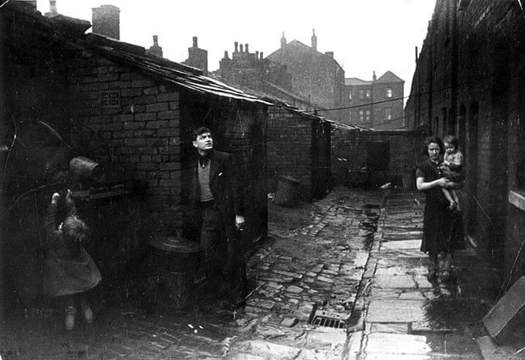

**Do Now**

|  |  |  |
| --- | --- | --- |
| 1. What vehicle is George Orwell travelling on? | Paragraph 1 | 1 mark |
| 1. What month is it? | Paragraph 1 | 1 mark |
| 1. How old does Orwell think the woman looks? | Paragraph 2 | 1 mark |
| 1. What sort of expression does she have on her face? | Paragraph 2 | 1 mark |

**Close Focus**

|  |  |  |
| --- | --- | --- |
| **‘the *monstrous* scenery of slag-heaps’** |  |  |
| 1. Provide two connotations of *monstrous* + use the phrase not only… but also | Line 1 | 2 marks |
| 1. Explain why the snow is ‘blackened’ + use the word because | Line 3 | 1 mark |
| 1. Explain what the word ‘hopeless’ means | Line 10 | 1 mark |
| **‘She knew well enough what was *happening* to her’** |  |  |
| 1. Explain what the woman knows is *happening* to her | Line 13 | 1 mark |

**Wide Focus**

|  |  |
| --- | --- |
| **‘The train bore me away’** | |
| * What do Orwell’s observations reveal about the industrial town he travelled through in the 1930s? | |
| * Make two separate points * Embed a short quotation * Use the phrase we learn that * Use the phrase this shows | |
| **H** | **I had to fight my way through class barriers into my job: why has so little changed?**  Written by Jamie Fahey | Published in 2022 |
| 5  10  15  20  25 | Entering a middle-class profession from a working-class background means all manner of things for society. Consider the recent Social Mobility Foundation report on the social class pay gap, which found working-class employees were paid on average about £7,000 less than those from better-off backgrounds. It’s a colossal price to pay for the sheer circumstance of birthplace and family background. The price is higher for women, who face a pay gap of £9,500. Someone from a working-class Bangladeshi background, or with black Caribbean heritage, can expect losses of £10,432 and £8,770 compared with their white peers. Losses can mount up when forced into playing the UK’s intersectionality lottery of misfortune.  But don’t get hung up on the figures. Think instead of what it’s like trying to navigate the middle-class world of our so-called professional occupations. I’m a senior journalist now, but most days I feel I’m still running after nearly 30 years of tumbles and scrapes as a class-barrier hurdler. I was raised in a chaotically jobless household, in a Liverpool postcode stuck in the most deprived 0.1% of England. My dad was from that generation of ex-dockers for whom the indignities of TV’s Boys from the Blackstuff aped reality.  Though I tick some of the most obvious boxes (council house, comprehensive, free school meals, first one in my family to attend university), I never felt inferior. I was far from alone in Liverpool as the Thatcher experiment played out. No one I knew seemed to know anyone in a secure job, let alone in something as socially distant to us as journalism. Ignorance was bliss. Where I do differ from many working-class kids is that I’ve been fortunate. Before I could dream of being insulted about my accent, I struck lucky by getting the crucial – and expensive – NCTJ industry qualification for free after enrolling on an NVQ journalism course at a further education college while on benefits, taking advantage of the employment training (ET) programme, or ‘extra tenner’ scheme.  I moved on, breaching the border controls with my first reporting job in 1994 on a weekly paper in Southport. It wasn’t easy. Indeed, it speaks to what is still happening to working-class would-be border breachers now. It was six months, all unpaid, doing the same job the middle-class boys in the office were getting paid for. Their salary was about £7,000 – the same deduction imposed on working-class employees even now.  But what choice did I have? I applied, in vain, for the graduate trainee scheme at a Liverpool newspaper. When I got a job there, two gruelling years later, I learned what it was that had held me back: they preferred Oxbridge graduates or youngsters with semi-notable parents. Another class, another lesson, from an organisation that trumpeted its mission to proudly represent working-class readers. |

|  |  |
| --- | --- |
| **H** | **I had to fight my way through class barriers into my job: why has so little changed?**  Written by Jamie Fahey | Published in 2022 |

**Do Now**

|  |  |  |
| --- | --- | --- |
| 1. How much less on average are working-class employees paid? | Paragraph 1 | 1 mark |
| 1. How much can a working-class Bangladeshi woman expect to lose? | Paragraph 1 | 1 mark |
| 1. What is Jamie Fahey’s occupation? | Paragraph 2 | 1 mark |
| 1. In which city was he born? | Paragraph 3 | 1 mark |
| 1. How much was he paid for his first reporting job in 1994? | Paragraph 4 | 1 mark |

**Close Focus**

|  |  |  |
| --- | --- | --- |
| **‘It’s a *colossal* price to pay’** |  |  |
| 1. Explain why Fahey uses the word *colossal* as opposed to *big* or *large* | Line 3 | 1 mark |
| 1. Explain why Fahey believes he is a ‘hurdler’ of class-barriers | Line 10 | 1 mark |
| **‘Ignorance was bliss’** |  |  |
| 1. Explain what Fahey was ignorant about when he was young | Line 16 | 1 mark |
| **‘It wasn’t easy’** |  |  |
| 1. Explain why it wasn’t easy for Fahey to secure his first reporting job | Line 22 | 1 mark |

**Wide Focus**

|  |  |
| --- | --- |
| **‘Another class, another lesson’** | |
| * What ‘lesson’ has Fahey learnt from his experiences of trying to secure a job in journalism? | |
| * Embed a short quotation * Use the word although | |
| **I** | **Admit It, the Cybertruck Is Awesome**  Written by Saahil Desai | Published in 2023 |
| 5  10  15  20  25  30 | Of the many quirks of Elon Musk’s Cybertruck, the Cybertruckiest of them all might be this: its windshield wiper. Not wipers, wiper. Tesla’s electric pickup, which debuted today and starts at $61,000, has just a single gigantic rain-wicking blade – a monstrosity that stretches several feet and that Musk says is ‘like a katana.’ (The original idea, laser-beam wipers, apparently didn’t work).  Nothing about the wiper or, frankly, about the Cybertruck makes much sense. It is a subzero fridge on wheels, a chef’s knife that went on the supersize-me diet and gained thousands of pounds. Tesla’s long-awaited model, its first entirely new one in four years, has a bullet- and arrow-proof exoskeleton, but it apparently struggles to climb up a dirt hill. The car is capable of pulling ‘near infinite mass’ (according to earlier Tesla marketing) and can ‘serve briefly as a boat’ (according to Musk), but its angular design means that even tiny manufacturing flaws stick out ‘like a sore thumb’ (again, according to Musk).  Frankly, it is an impractical meme car for an impractical meme CEO – the perfect vehicle for the edgelord X magnate. ‘This car is very amateurish,’ Adrian Clarke, a former car designer for Land Rover and a writer for the Autopian, told me. But at least it’s different. Most other EVs can’t say as much, even though the electric age can and should be a chance to make cars not just harder, faster, stronger, and better, but also stranger.  Traditional cars have hulking grilles in the front, because the internal combustion engine gets very hot very quickly from all of the tiny explosions that power your car. You have to cram into the backseat in part because the transmission, drive shaft, fuel tank, exhaust systems, catalytic converter, and fuel injector take up so much space. EVs don’t have to deal with any of that: they have a huge battery (the Cybertruck’s primo ‘Cyberbeast’ model has an estimated range of up to 320 miles) and a tiny motor splayed out on a flat ‘skateboard’ beneath the car – and that’s basically it.  The Cybertruck isn’t my style, and it may not be yours (which is fine: it’s not even slated to hit the market until next year, starting with the most expensive versions, which top out at just shy of $100,0000). The Cybertruck ‘will be competitive with its electric challengers but does not undercut them in range and price,’ Corey Cantor, an EV analyst at BloombergNEF, told me. Even so, there’s no denying Tesla’s influence: many major automakers are planning to use the company’s charging adapter, and touch-screen dashboards now abound. In part because of Tesla, every car company, it seems, wants to be a tech company. ‘There’s been some nice vehicle launches this year, but not one that I think is as big as this, in terms of normal interest,’ Cantor said.  Perhaps the Cybertruck’s odd design might trickle down to more practical yet still strange and futuristic EVs from other companies. A bonanza of vanilla EVs isn’t inspiring purchases in much of the country. Maybe a katana windshield wiper can. |

|  |  |
| --- | --- |
| **I** | **Admit It, the Cybertruck Is Awesome**  Written by Saahil Desai | Published in 2023 |

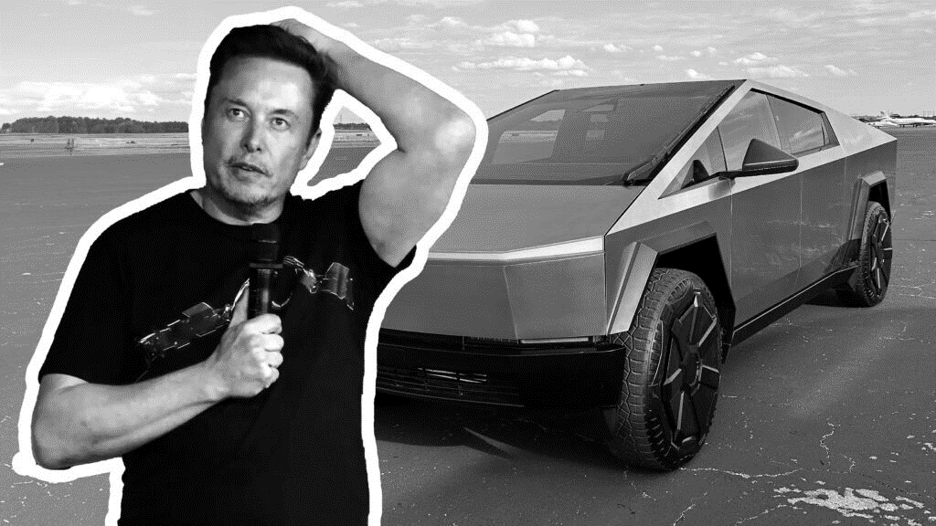

**Do Now**

|  |  |  |
| --- | --- | --- |
| 1. What was Elon Musk’s original idea for the windscreen wipers? | Paragraph 1 | 1 mark |
| 1. What other sort of vehicle can the Cybertruck ‘serve’ as if necessary? | Paragraph 2 | 1 mark |
| 1. How does Adrian Clarke describe the car? | Paragraph 3 | 1 mark |
| 1. How much does the premium model of the Cybertruck cost? | Paragraph 4 | 1 mark |

**Close Focus**

|  |  |  |
| --- | --- | --- |
| **‘It is a subzero fridge on wheels’** |  |  |
| 1. Explain the similarity between a Cybertruck and a fridge | Line 5 | 1 mark |
| 1. Pick out a detail that undermines the quality of the Cybertruck | Paragraph 2 | 1 mark |
| **‘an impractical meme CEO’** |  |  |
| 1. Identify two things suggested about Musk + use the phrase not only… but also | Line 11 | 2 marks |
| 1. Explain how the Cybertruck is different from traditional cars | Paragraph 3 | 1 mark |
| 1. Provide two examples of how Tesla has been influential | Paragraph 4 | 2 marks |

**Wide Focus**

|  |  |
| --- | --- |
| **‘Admit It, the Cybertruck Is Awesome’** | |
| * In what ways is the Cybertruck an ‘awesome’ vehicle? | |
| * Make two separate points * Embed a short quotation * Use the word secondly | |
| **J** | **The 1899 Car With a Full-Size Wooden Horse Head Stuck to the Front**  Written by Alex Davies | Published in 2015 |
| 5  10  15  20  25  30  35 | The early years of the American auto industry looked a lot like Silicon Valley today. Instead of countless apps and startups aiming to fix problems that probably don’t exist, the entrepreneurs of the age were making all sorts of new kinds of cars, before the industry was pared down to just a few juggernauts. That includes Uriah Smith of Battle Creek, Michigan, a Seventh-day Adventist preacher who also dabbled in engineering. He figured the biggest problem with cars was that they scared the bejeezus out of horses, with dangerous results.  This was a serious issue: Horses scare easily and run fast, which is a problem when people have tied them to heavy carts (they also bite, kick, and liberally distribute manure). In 1900, they killed 200 people in New York City, according to the University of California Transportation Center’s ACCESS magazine. In 2014, when the city’s population was four times larger, fewer than 300 people were killed in all traffic accidents. So presumably, anything that could make horses less likely to freak out would have been welcome. And in 1899, Smith announced his vehicle, the Horsey Horseless. According to his patent, it was a ‘new and original design for a vehicle body, and it has for its object to provide a design of this character that shall be both useful and ornamental.’ (If you’ve ever wondered how someone who spends his time in the pulpit would write a patent application, there’s your answer).  More simply, it was a car with a big wooden horse head stuck on the front of it. It looked as if someone had grabbed the figurehead from the prow of a ship and plunked it on a car as a massively oversized hood ornament. Added bonus: the hollow equine bust doubled as a fuel tank. The idea was straightforward: If a car looks like a horse, actual horses won’t be scared of it. And they won’t cause a ruckus. ‘The live horse would be thinking of another horse,’ Smith said, ‘and before he could discover his error and see that he had been fooled, the strange carriage would have passed, and it would then be too late to grow frantic and fractious.’ Problem solved.  The Horsey Horseless didn’t catch on. It’s not even clear if Smith ever produced or sold one. But we do know that had he convinced people to give him money for this thing, it wouldn’t have worked. ‘A horse would not be fooled,’ says Lauren Fraser, a horse behaviour consultant in British Columbia. ‘The animals deserve – but don’t always receive – a bit more credit than that for their intelligence.’ They didn’t get it from Smith. Plus, Smith missed the bigger point: visual trickery wasn’t the way to go. ‘The biggest thing that horses use for recognition is smell,’ says Dr. Carey Williams, an equine specialist at Rutgers University. It doesn’t matter how much mare urine you pour on the wooden sculpture, ‘it’s not gonna smell like a horse.’ Especially since the vehicle will produce other scents – like gasoline, oil, and wood – that reveal it to be something else.  Yes, horses can spook easily. However, they also have good memories, and stop freaking out once they’re used to a new thing. For today’s carriage horses in cities like New York, for example, ‘their first or second time might be a little scary because it’s all new,’ Williams says. But after a few more trips, ‘they don’t even look at the cars anymore, cause they know they’re not gonna get hurt.’ Ultimately, it’s that ability to learn that made their cohabitation with the automobile possible. |

|  |  |
| --- | --- |
| **J** | **The 1899 Car With a Full-Size Wooden Horse Head Stuck to the Front**  Written by Alex Davies | Published in 2015 |

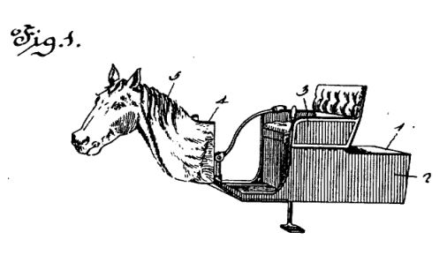

**Do Now**

|  |  |  |
| --- | --- | --- |
| 1. Who was the inventor of the Horsey Horseless? | Paragraph 1 | 1 mark |
| 1. What effect did the first cars have on horses? | Paragraph 1 | 1 mark |
| 1. In which year was it invented? | Paragraph 2 | 1 mark |
| 1. Was it a success? | Paragraph 4 | 1 mark |
| 1. What made ‘cohabitation’ between horses and cars possible? | Paragraph 5 | 1 mark |

**Close Focus**

|  |  |  |
| --- | --- | --- |
| 1. Explain the connection between the American car industry and Silicon Valley | Line 1 | 1 mark |
| 1. Explain what the ‘biggest point’ is that Uriah Smith missed | Line 27 | 1 mark |
| **‘horses can *spook* easily’** |  |  |
| 1. Provide a definition of the word ‘spook’ | Line 31 | 2 marks |

**Wide Focus**

|  |
| --- |
| **‘The Horsey Horseless didn’t catch on’** |
| * The Horsey Horseless didn’t catch on, but will the Cybertruck? |
| * Make three separate points * Use the word furthermore |