Non-Fiction: Views from the Verge
Extracts: The Mariana Trench to Inner City Lagos

- Murky Waters Ahead | The Guardian Newspaper
‘Other parts of the deep sea are at immediate risk’ – Why are parts of the deep sea at immediate risk?

- Emma Watson Opens Up About Therapy After ‘Harry Potter’ | Forbes Magazine
‘Watson opened up on her experience since Harry Potter’ – Is Emma Watson more than just Hollywood star?

- At Home In Lagos With Chimamanda Ngozi Adichie | Esquire Magazine
‘Other parts of the deep sea are at immediate risk’ – Why are parts of the deep sea at immediate risk?

- The Great Buenos Aires Bank Heist | GQ Magazine
‘For more than six hours, the nation was transfixed’ – How is the article structured to create a feeling of suspense?

- Everything You Know About Obesity Is Wrong | The Huffington Post
‘And so it’s time for a paradigm shift’ – How does the writer forcefully convey his views about obesity?

- Gimme Shelter | Harper’s Magazine
‘It offered about as much space as an overhead bin’ – How does the writer present his temporary home?

- Mavericks | n+1 Magazine
‘The inconvenience is unavoidable’ – What makes the Mavericks International such an appealing competition?

From Murky Waters Ahead
Published: 2nd February, 2020
Source: The Guardian Newspaper

The reaches of the sea beneath 6km are known as the hadal zone, taking their name from the underworld of the ancient Greeks: the depth of the Mariana Trench ensures it is perpetually dark, and that temperatures are only just above freezing. Yet we are discovering that if it is an inhospitable space for humans, it is far from deserted. Four years ago, a live video feed from a remotely operated vessel allowed ordinary viewers to see 5 the abundant, though ‘not very diverse’, life to be found down there. The area now enjoys protection, escaping unscathed after it was listed as one of the 27 national monuments that Donald Trump placed under review in 2017.

Other parts of the deep sea are at immediate risk. Even as researchers increase their ability to explore this world, the race is on to exploit it. An analysis published last month in the journal One Earth warned of the 10 threat to the oceans from ‘blue acceleration’, the recent rise in marine industrialisation, which includes seabed mineral mining.

Greenpeace warned last year that 29 ocean-floor exploration licences had been issued, covering an area totalling 1.3 million sq km – threatening to worsen the climate emergency by disrupting carbon stores in seafloor sediments, as well as destroying barely explored habitats that might offer extraordinary scientific 15 insights – and even new medicines. Though the UN is supposed to wrap up a global ocean treaty this year, many campaigners are pessimistic about the prospect of it offering the kind of protection they believe is needed. Governments must do better. To fall short would not only threaten the habitats and creatures of the deep, but humans too, however unlikely most of us are to ever venture down there.

Big Question
‘Other parts of the deep sea are at immediate risk’ – Why are parts of the deep sea at immediate risk?

………………………………………………………………………………………………………………………………………………………………………………………..

Quick Review Questions
- How far down is the ‘hadal zone’?
- Where does the ‘hadal zone’ get its name?
- What does ‘inhospitable’ mean?
- What does ‘exploit’ mean?
- What is ‘blue acceleration’?
- What does ‘pessimistic’ mean?

Aspects to Consider
- The difference between the ‘Mariana Trench’ and the ‘other parts of the deep sea’
- The warning from the journal One Earth
- The warning from Greenpeace
- The UN global ocean treaty

From Emma Watson Opens Up About Therapy After ‘Harry Potter’
Published: 6th November, 2019
Source: Forbes Magazine

August 2020 will mark 20 years since Daniel Radcliffe, Emma Watson and Rupert Grint were cast as the core trio of characters in the Harry Potter film series. Speaking to Paris Lees for British Vogue, Watson opened up on her experience since Harry Potter, saying she decided to go to therapy to sort through her thoughts and feelings of guilt about starring as Hermione Granger in the franchise.

5 ‘I’ve sat in therapy and felt really guilty about it. I’m like, why me? Somebody else would have enjoyed and wanted this aspect of it more than I did. And I’ve struggled a lot with the guilt around that. I’m like, I should be enjoying this a lot more, I should be more excited and I’m actually really struggling.’

It’s refreshing to see somebody of Watson’s fame and history given the opportunity to be candid about her experience of the pressures of being in a role with such high expectations from the age of eleven. Whilst the 10 world saw her as Hermione Granger for over a decade, Watson said remaining rooted in her own identity helped her eventually ‘find peace:’

‘Part of what’s helped me find peace is there were moments when it got so big where I almost had vertigo and felt it got so big that I felt l disconnected, and part of the peace within myself is remembering my identity. I am someone’s daughter. I am my mother’s daughter, I am my father’s daughter, I am a sister. I belong to a 15 family. I come from a place, I have roots. There’s a whole big existence and identity that I have that’s really important and weighted and solid, that has nothing to do with any of that.’

Outside of her acting career since Harry Potter, Emma Watson has given her voice and platform to women’s rights, LGBT+ rights, and sustainability campaigns. She serves as UN Women Goodwill Ambassador, advocating the HeForShe campaign to end gender inequality. Watson kicked off the campaign at a special 20 event at the UN Headquarters in 2014 with a rousing, bold speech on being a feminist and ending sexual harassment, closing with a memorable call to action: ‘Ask yourself – if not me, who? If not now, when?’

She has since served on global summit panels for years, and earlier this year sat down with Nobel Peace Prize winner Dr Denis Mukwege in London for a sombre conversation organised by New York Times about gender- based violence, and Mukwege’s work as a human rights activist and doctor working to end the use of rape as 25 a weapon of war. Watson also contributed to the original TimesUp campaign and #MeToo fund to support victims of sexual harassment after Harvey Weinstein was exposed by several women in the movie industry for subjecting them to sexual harassment and assault. She also set up a hotline for victims of sexual harassment in the workplace.
Big Question
‘Watson opened up on her experience since Harry Potter’ – Is Emma Watson more than just Hollywood star?

………………………………………………………………………………………………………………………………………………………………………………………..

Quick Review Questions
- What is the name of the journalist who conducted the interview?
- Why does Watson feel ‘really guilty’?
- How long is a decade?
- What is her role with the UN?
- What is the name of the Nobel Peace Prize winner she ‘sat down with’?
- What sort of a hotline did Watson set up?

Extracts to Consider
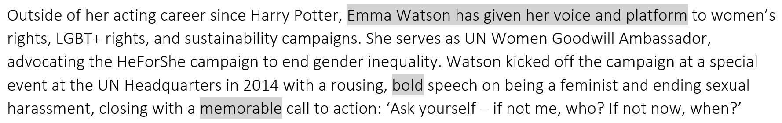

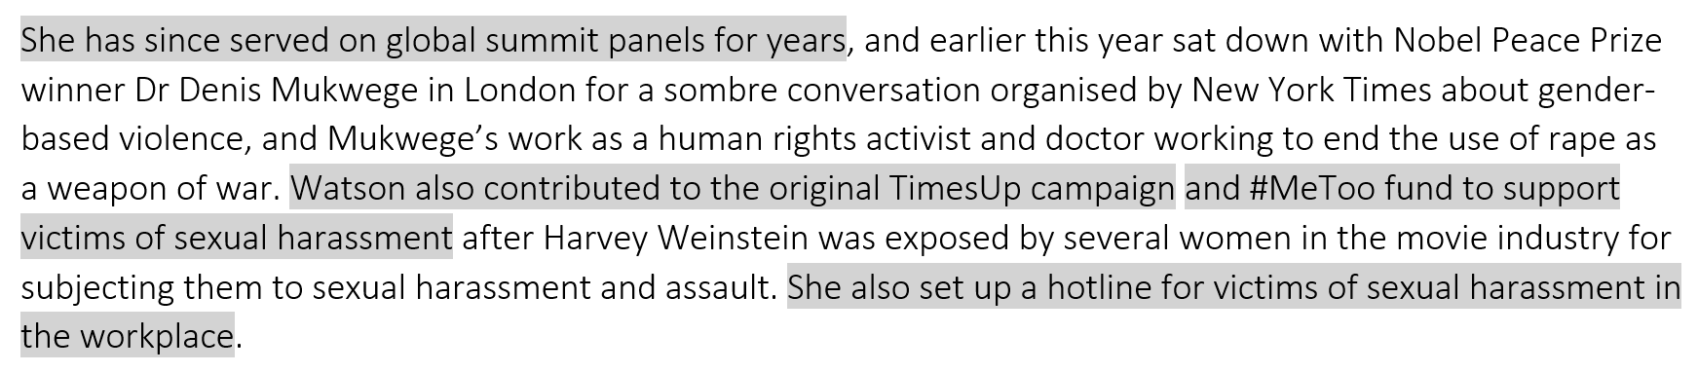

Multiple-Choice Question
Which two adjectives most precisely convey Watson’s characteristics (as presented in the article)?
- Pessimistic and unenthusiastic
- Happy and hopeful
- Ungrateful and impolite
- Candid and determined

From At Home In Lagos With Chimamanda Ngozi Adichie
Published: 29th April, 2019
Source: Esquire Magazine

Lagos will not court you. It is a city that is what it is. I have lived part-time in Lagos for 10 years and I complain about it each time I return from my home in the US – its allergy to order, its stultifying traffic, its power cuts. I like, though, that nothing about Lagos was crafted for the tourist, nothing done to appeal to the visitor. Tourism has its uses, but it can mangle a city, especially a developing city, and flatten it into a permanent 5 shape of service: the city’s default becomes a simpering bow, and its people turn the greyest parts of themselves into colourful props. In this sense, Lagos has a certain authenticity because it is indifferent to ingratiating itself; it will treat your love with an embrace, and your hate with a shrug. What you see in Lagos is what Lagos truly is.

And what do you see? A city in a state of shifting impermanence. A place still becoming. In newer Lagos, 10 houses sprout up on land reclaimed from the sea, and in older Lagos, buildings are knocked down so that ambitious new ones might live. A street last seen six months ago is different today, sometimes imperceptibly so – a tiny store has appeared at a corner – and sometimes baldly so, with a structure gone, or shuttered, or expanded. Shops come and go. Today, a boutique’s slender mannequin in a tightly pinned dress; tomorrow, a home accessories shop with gilt-edged furniture on display.

15 Admiralty Road is cluttered, pulsing, optimistic. It is the business heart of Lekki, in the highbrow part of Lagos called The Island. Twenty years ago, Lekki was swampland and today the houses in its estates cost millions of dollars. It was supposed to be mostly residential but now it is undecided, as though partly trying to fend off the relentless encroachment of commerce, and partly revelling in its ever-growing restaurants, nightclubs and shops.

20 So forward-looking is Lagos, headlong, rushing, dissatisfied in its own frenzy, that in its haste it might very well sacrifice long-term planning or the possibility of permanence. Or the faith of its citizens. One wonders always: have things been done properly? Eko Atlantic City, the new ultra-expensive slice of land reclaimed from the Atlantic Ocean, has already been mostly sold to developers, and promises Dubai-like infrastructure, but my reaction remains one of scepticism. I cannot stop imagining the ocean one day re-taking its own.

Big Question
‘What you see in Lagos is what Lagos truly is’ – How does Adichie present the Nigerian city of Lagos?

………………………………………………………………………………………………………………………………………………………………………………………..

Retrieval
- Lagos is a busy, bustling city
- Lagos is a city that is expanding
- Lagos can be a frustrating place to live – at least at times

Images
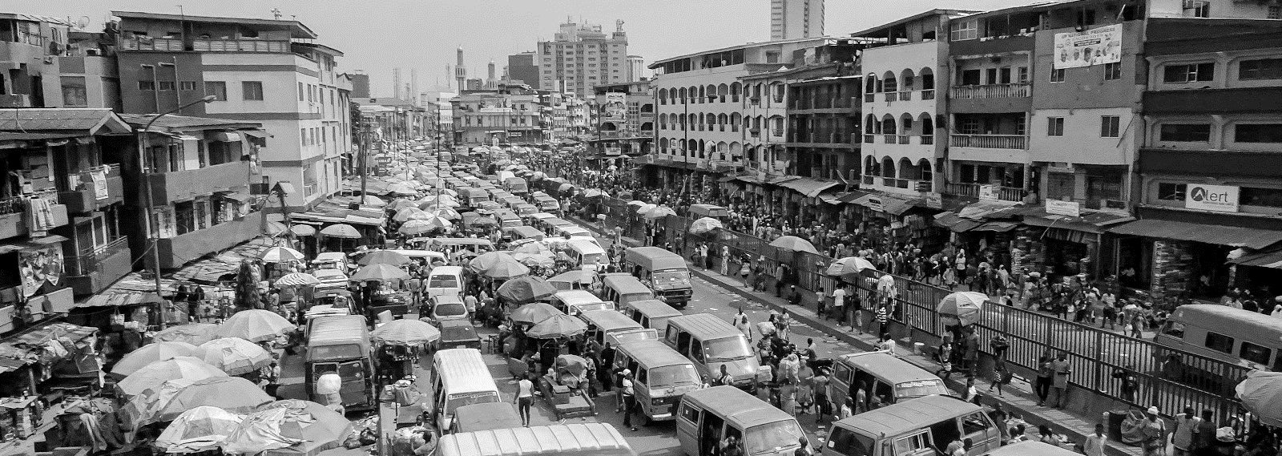

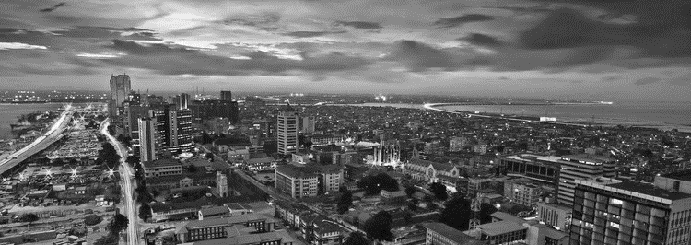

Key Quotations
- ‘In newer Lagos, houses sprout up on land reclaimed from the sea’ (9-10)
- ‘Admiralty Road is cluttered, pulsing, optimistic’ (15)
- ‘So forward-looking is Lagos, headlong, rushing, dissatisfied in its own frenzy’ (20)
- ‘One wonders always: have things been done properly?’ (21-22)

From The Great Buenos Aires Bank Heist
Published: 20th April, 2020
Source: GQ Magazine

There were five thieves in the bank, costumed in various disguises, and now they were trapped, along with 23 hostages. Outside, the streets were swarming with police, who soon established radio contact with one of the robbers, who called himself Walter. The thieves knew they were surrounded, Walter said, but they weren’t yet ready to give up. And until they were, the police had better stay back.

5 For more than six hours, the nation was transfixed. The police had nicknamed Walter ‘the Man in the Gray Suit.’ He was instantly famous. The hostages, Walter said, were being treated well. The mood inside seemed oddly ebullient: At one point, Walter and another robber could be heard singing ‘Happy Birthday’ to a bank employee whose phone had been buzzing with birthday messages from friends and family. At 3:30 in the afternoon, Walter asked for pizzas; the hostages were hungry, he said. Then, only a few minutes later, Walter 10 went silent. For over three hours, police leaders and city officials fretted over what to do as further attempts to reach Walter failed.

Finally, a team of special-forces officers took up position outside the bank. At 7pm, they burst inside. But there was no shoot-out, no commotion. And no sign of the thieves. The hostages were dispersed on three floors – the lobby level, a mezzanine space, and down in a basement conference room, which had been 15 locked from the inside. They were all unharmed. It wasn’t until detectives reached the basement that they discovered what the robbers had truly been after. There, in the expanse of the bank’s subterranean level, hundreds of reinforced-steel safe-deposit boxes lined the walls. And in a place like San Isidro, at a time like 2006, those boxes represented a veritable treasure trove.

Argentines are uniquely distrustful of their banks, and for good reason. They’ve been betrayed by them, over 20 and over. Most famously in 2001, when the collapse of the national banking system, known as the corralito, erased entire fortunes, affecting millions. With no faith in accounts, bank customers began tucking their savings – their cash, jewellery, and other valuables – into safe-deposit boxes. And this particular bank, situated in one of the richest enclaves of Argentina, must have seemed especially enticing, flush as its deposit boxes were sure to be with the fortunes of the city’s most well-to-do.

25 Somehow the thieves had smashed open a huge number of the boxes – 143 of the bank’s 400 – and cleaned them out. But what exactly they’d grabbed, or where they’d gone, was a mystery. Cops swept every inch of the bank’s three floors but failed to locate a single member of the gang. The bank had only two exits—both of which had been covered by police since the siege began. All of the building’s windows were intact. And the robbers were not hiding among the hostages. They’d simply vanished.
Big Question
‘For more than six hours, the nation was transfixed’ – How is the article structured to create a feeling of suspense?

………………………………………………………………………………………………………………………………………………………………………………………..

Quick Review Questions
- How many thieves were there?
- How many hostages did they take?
- Who is Walter?
- What was his nickname?
- Were any of the hostages harmed?
- What does ‘subterranean’ mean?
- Do Argentines typically trust banks?
- How many of the deposit boxes did the thieves force open?

Questions to Consider
- How does the article open?
- How is Walter introduced?
- What events unfold over the ‘six hours’ that keep the nation ‘transfixed’?
- What is the focus of the penultimate paragraph?
- What is the focus of the final paragraph?

Key Words
- Beginning
- Middle
- End
- Focus
- Shift
- Zoom-in
- Zoom-out
- Contrast
- Develop

From Everything You Know About Obesity Is Wrong
Published: 19th September, 2018
Source: Huffington Post

Obesity, we are told, is a personal failing that strains our health care system, shrinks our GDP and saps our military strength. It is also an excuse to bully fat people in one sentence and then inform them in the next that you are doing it for their own good. That’s why the fear of becoming fat, or staying that way, drives Americans to spend more on dieting every year than we spend on video games or movies. Forty-five percent of adults 5 say they’re preoccupied with their weight some or all of the time – an 11-point rise since 1990. Nearly half of 3 to 6 year old girls say they worry about being fat. The emotional costs are incalculable. I have never written a story where so many of my sources cried during interviews, where they double and triple checked that I would not reveal their names, where they shook with anger describing their interactions with doctors and strangers and their own families.

10 For 60 years, doctors and researchers have known two things that could have improved, or even saved, millions of lives. The first is that diets do not work. Not just paleo or Atkins or Weight Watchers or Goop, but all diets. Since 1959, research has shown that 95 to 98 percent of attempts to lose weight fail and that two- thirds of dieters gain back more than they lost. The reasons are biological and irreversible. As early as 1969, research showed that losing just 3 percent of your body weight resulted in a 17 percent slowdown in your 15 metabolism – a body-wide starvation response that blasts you with hunger hormones and drops your internal temperature until you rise back to your highest weight. Keeping weight off means fighting your body’s energy- regulation system and battling hunger all day, every day, for the rest of your life.

The second big lesson the medical establishment has learned and rejected over and over again is that weight and health are not perfect synonyms. Yes, nearly every population-level study finds that fat people have 20 worse cardiovascular health than thin people. But individuals are not averages: Studies have found that anywhere from one-third to three-quarters of people classified as obese are metabolically healthy. They show no signs of elevated blood pressure, insulin resistance or high cholesterol. Meanwhile, about a quarter of non- overweight people are what epidemiologists call ‘the lean unhealthy.’ A 2016 study that followed participants for an average of 19 years found that unfit skinny people were twice as likely to get diabetes as fit fat people. 25 Habits, no matter your size, are what really matter. Dozens of indicators, from vegetable consumption to regular exercise to grip strength, provide a better snapshot of someone’s health than looking at her from across a room.

The terrible irony is that for 60 years, we’ve approached the obesity epidemic like a fad dieter: If we just try the exact same thing one more time, we’ll get a different result. And so it’s time for a paradigm shift. We’re not going to become a skinnier country. But we still have a chance to become a healthier one.
Big Question
‘And so it’s time for a paradigm shift’ – How does the writer forcefully convey his views about obesity?

………………………………………………………………………………………………………………………………………………………………………………………..

Quick Review Questions
- What does ‘incalculable’ mean?
- What two things have doctors and researchers known that ‘could have improved, or even saved, millions of lives’?
- What does ‘irreversible’ mean?
- What are synonyms?
- What does a ‘paradigm shift’ involve?

Retrieval
- More Americans are concerned about their now than in 1990
- Very young children worry about being fat
- Our general understanding of how to deal with obesity is flawed
- Being obese is not the same as being unhealthy

Key Quotations
- ‘Forty-five percent of adults say they’re preoccupied with their weight’ (4-5)
- ‘I have never written a story where so many of my sources cried during interviews’ (6-7)
- ‘The first is that diets do not work’ (11)
- ‘losing just 3 percent of your body weight resulted in a 17 percent slowdown in your metabolism’ (14-15)
- ‘The terrible irony is that for 60 years, we’ve approached the obesity epidemic like a fad dieter’ (28)

From Gimme Shelter
Published: 1st December, 2019
Source: Harper’s Magazine

Inside, my hovel smelled musty as a summer cottage in the off-season. The walls were unpainted plywood. The floor, tongue-and-groove softwood, had never been stained, except by rain, which had leached through the boards, turning the fir underfoot a buttery brown. At eye level was a loft. It was intended as sleeping quarters, to maximize the square footage, but in fact it offered about as much space as an overhead bin on an 5 economy flight. A treacherous ladder, built like a game of Jenga, led up to this compartment. I had pilfered a tattered twin mattress from the front house, and I laid it across the water-warped floor. The mattress carpeted the softwood nearly wall-to-wall, so that to dress I had to stand on my bed, and to lace my shoes I kicked open the French doors and stretched my feet into the yard.

It rained. First for days, then for weeks. The yard filled up with a quarter foot of water, as if somewhere a 10 levee had collapsed, and the heads of coyote mint and monkey flower became lily pads. At night, ghosts of mist rose from the pools, and inside my shack I could see my breath, even with my space heater turned to ten. The power flickered. To use the toilet or kitchen in Erik’s house I dashed through the mud, high-stepping, and returned to the shack soaked and shivering. There was nowhere to sit or lie other than my mattress, so I spent most nights pupated in my sleeping bag, the zipper under my chin, the space heater tucked under the 15 covers with me as I watched the rain fall outside and the waterline creep slowly up the walls.

Across the street from my shack was Easy Liquor. A few weeks earlier, I’d been walking home in a downpour when I stumbled on a shirtless man circling its parking lot, shouting angrily, his hands clutched over his stomach. I asked if I could help. ‘Pull it out!’ he shouted, and he shook his fists at me, revealing a knife handle where his belly button should have been. Another evening, on West MacArthur, I watched a large man shove 20 his shopping cart into the path of a techie on a bicycle. The techie swerved and fell, and the homeless man put one foot on his victim’s chest and tugged at his Google laptop bag.

‘It is a feeling of relief, almost of pleasure, at knowing yourself at last genuinely down and out,’ George Orwell wrote in Down and Out in Paris and London. ‘You have talked so often of going to the dogs – and well, here are the dogs, and you have reached them, and you can stand it. It takes off a lot of anxiety.’

25 The powerful thing about smallness, it occurred to me, isn’t actually smallness for its own sake – the point, instead, is a matter of scale. If you reduce the size of your life enough, then the smallest change can be a profound improvement. Yet the hardest thing is to recognize your smallness without being diminished by it. In my shack I was always balancing that tension – I didn’t want to become so small that I disappeared, I just wanted to hide for a little while.

Big Question
‘It offered about as much space as an overhead bin’ – How does the writer present his temporary home?

………………………………………………………………………………………………………………………………………………………………………………………..

Multiple-Choice Questions
Which adjective most precisely describe the ‘hovel’
- Cosy
- Claustrophobic
- Small
- Spacious

Which statement most precisely describes the neighbourhood?
- A violent and dangerous place
- A supportive community
- A sophisticated and modern urban area
- A charming, but unpredictable development

Extracts to Consider
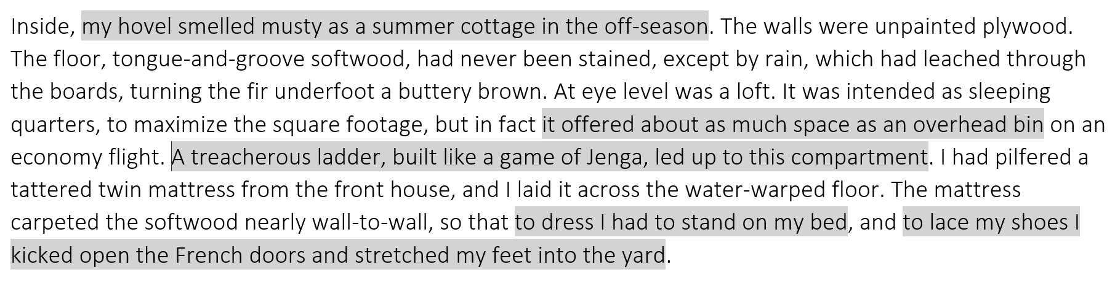

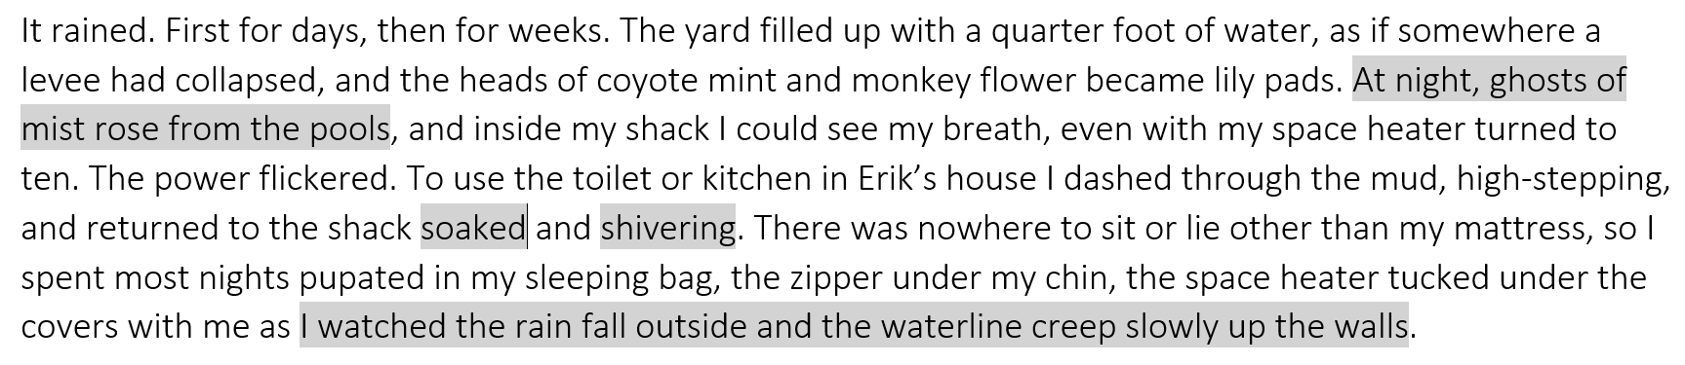

From Mavericks
Published: 1st September, 2013
Source: n+1 Magazine

The air smells faintly of salt water, and strongly of bonfires, diesel fuel, and weed. seagulls squawk, the sky on the horizon is just turning green, and the air is cold in that prankish West Coast way that’s impossible to take seriously and pointless to dress for. Once the sun comes up and the fog burns off, it’s going to be a perfect day. It’s 6am, high tide, and I’m a thirty-minute, eucalyptus-dense drive south of San Francisco in Princeton- 5 by-the-Sea, a tiny village with some of the biggest waves in the world and not much else. Shadowy figures are perched in the beds of pickup trucks; they speak in low voices and occasionally take sips of coffee. I’m sitting on the ground in the near dark, waiting for a surf contest to begin.

An unusually steep, unusually deep Pliocene-epoch sedimentary reef rises half a mile offshore. This is where Mavericks breaks, where from November to March waves can top out at 100 feet, making them roughly ten 10 times the height of what most surfers would consider ‘big’. Sharks are common, as are riptides and exposed rocks. Accomplished big-wave surfers – famous ones – have died here. Some years – when tides and swells and winds and storms combine infelicitously – the waves here fail to break at anything above twenty feet, which means for Mavericks that they are hardly waves at all. If the conditions aren’t right, the contest doesn’t happen. When it does happen, the Mavericks Invitational is announced a few days ahead of time, and even in 15 this case the plan is provisional at best. The inconvenience is unavoidable; one elemental change can ruin the wave.

It’s Sunday, and the Mavericks Invitational was announced on Thursday, which means that twelve of the twenty-four competitors had to buy plane tickets – from Los Angeles, Hawaii, Brazil, and South Africa – fast. The other twelve live less than an hour’s drive away, and would probably be surfing here today, contest or no 20 contest. They all know each other, and most surf together regularly. On this winter morning, it’s been three years since the last invitational. Compared with most professional athletes, these guys are ancient. Matt Ambrose of Pacifica is 40. Shane Desmond and Ken ‘Skindog’ Collins, both from Santa Cruz, are 42 and 43, respectively. At 31, Shawn Dollar, also from Santa Cruz, is one of the youngest competitors. He also holds the world record for the biggest wave ever paddled into (sixty-one feet, a scale at which almost every other surfer 25 would opt for tow-in). I ask Dollar why the surfers at Mavericks are so old. It’s ‘scary as shit,’ he says, raising his eyebrows. ‘It takes you years and years and years to break down fear. Put a 16-year-old kid out there? He’s probably going to drown.’

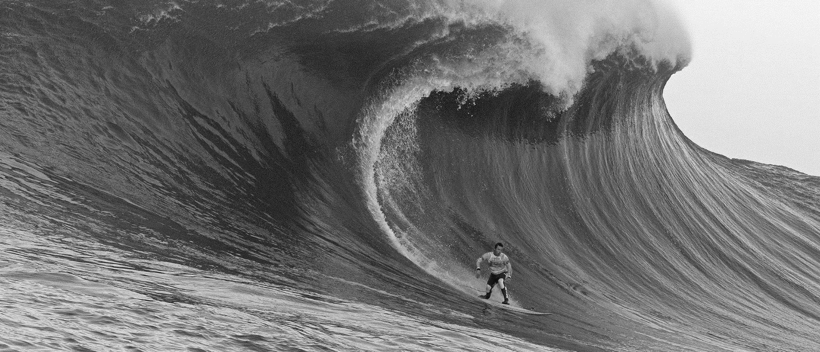
Big Question
‘The inconvenience is unavoidable’ – What makes the Mavericks International such an appealing competition?

………………………………………………………………………………………………………………………………………………………………………………………..

Quick Review Questions
- What sport is the article about?
- What does the air smell of?
- What is the writer waiting for?
- How high can waves rise at Mavericks from November to March?
- Do sharks inhabit the waters?
- How far in advance is the Mavericks Invitational typically announced?
- How old is Shawn Dollar?
- Who holds the record for the biggest wave ever paddled into?

Images
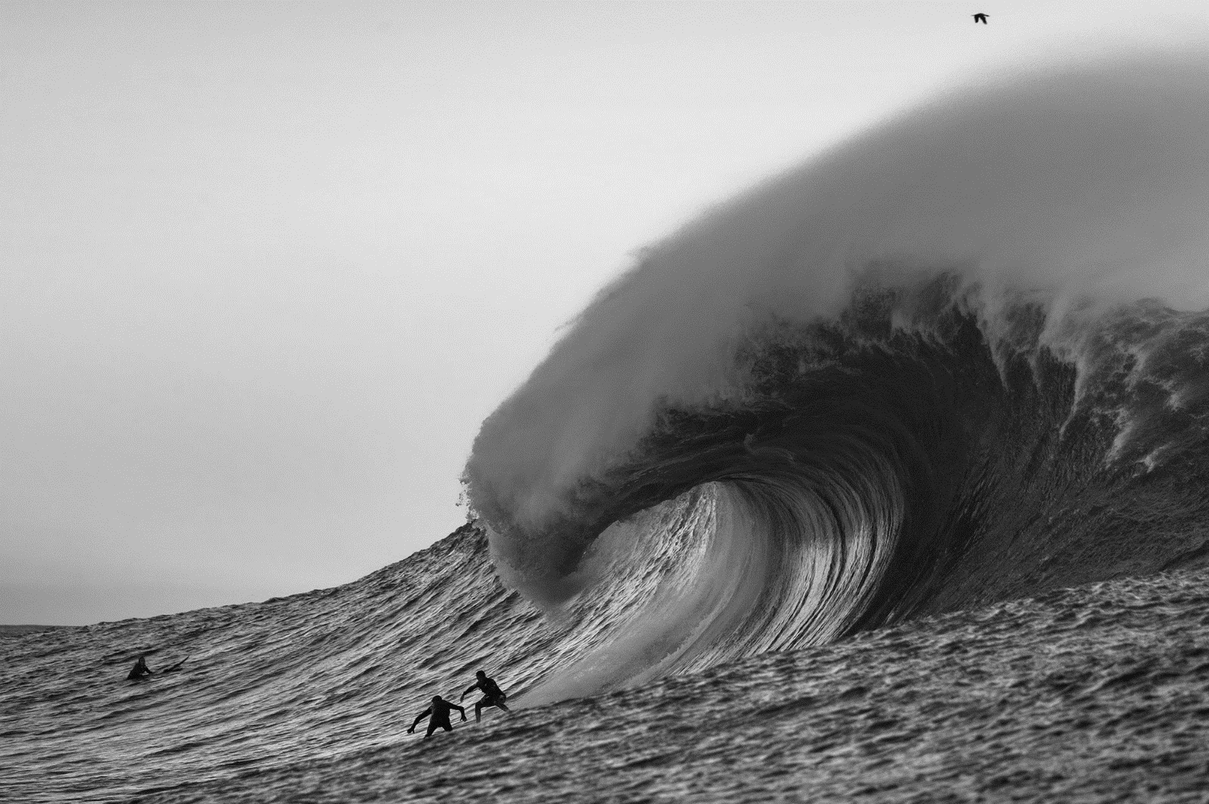

Aspects to Consider
- The unpredictability of the surf
- The characteristics of the water
- The competitors

