Mock Exam Handbook
English Literature
Mr Wise

1 hour and 45 minutes
Macbeth
AQA Power and Conflict Poetry

Macbeth

Ambition

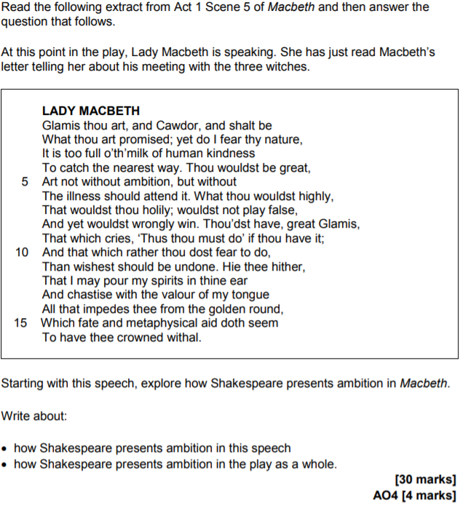

- Read the question and highlight the area of focus (i.e. ambition)
- Highlight two aspects of the extract you want to focus on and make brief annotations
- Choose three other scenes and make a list of comparison points (e.g. A2-S2, A3-S4, A5-S1…)
- Follow the writing frame on page four

Ambition | A1-S5
 | A2-S2
 | A3-S4
 | A5-S1

A1-S5 x 2

What idea does Shakespeare present about ambition? Shakespeare presents ambition as…
How is it presented? Shakespeare uses…
This is important because…
It is also significant because…
Why is it presented in that way? Shakespeare warns the audience about…

A2-S2

What idea is presented and what is the link? Shakespeare presents the damaging effects of ambition in…
How is it presented? Shakespeare uses the blood on Macbeth’s hands to show…
This is important because…
It is also significant that…
Why is it presented in that way and what is the link? Shakespeare highlights that the murder of a monarch is…

Repeat for A3-S4 and A5-S1
What? | Initially, Macbeth…  Later, Macbeth…  Furthermore, Lady Macbeth…  Crucially, Macbeth…  Contrastingly, Banquo…  Despite Macbeth’s initial scepticism about the prophecies…  Although Macbeth outwardly expresses happiness at the news that Malcolm will become the Prince of Cumberland…  Banquo is repulsed by the appearance of the Witches, but also…  Lady Macbeth understands that Macbeth is ambitious, but also…  At the start of the scene…  As the scene develops…  At the end of the scene…  The ‘wither’d’ and ‘wild’ physical appearance of the Witches is significant because…  Banquo’s observation that Macbeth is ‘rapt withal’ is important because…  Macbeth’s belief that Duncan’s death is a ‘horrid image’ is relevant because…  Macbeth concedes that the Witches are ‘imperfect’ speakers, but…  Macbeth declares his loyalty to Duncan, but…
How? | An important word / image / technique…  The stormy weather at the beginning of the play creates…  The way in which Macbeth demands to hear more from the Witches shows…
Why? | The play emphasises…  James I, who first published Daemonologie in 1597, believed that…  The play, first performed in 1606, explores…  Lady Macbeth, immediately after reading the letter from Macbeth, expresses concern that…  Macbeth’s fatal flaw, also known as his hamartia, is revealed when…  The purpose of the aside…  The purpose of dialogue…  The purpose of the scene…  The purpose of Banquo’s warning…  The purpose of the soliloquy…

AQA Power and Conflict Poetry

Effects of Conflict

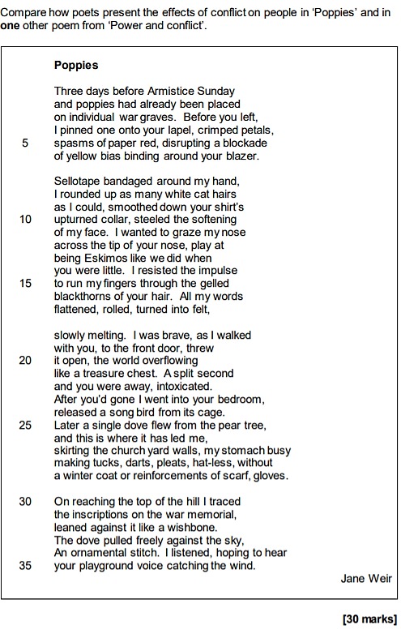

- Read the question and highlight the area of focus (i.e. the effects of conflict on people)
- Highlight three aspects of the poem that you want to focus on and make brief annotations
- Choose one other poem and make a list of comparison points (e.g. Exposure, Remains…)
- Follow the writing frame on page two

Effects of Conflict
Poppies | Remains

Poppies

What is the effect of conflict? Weir presents the effects of conflict as…
How is it presented? Weir uses…
This is important because…
It is also significant because…
Why is it presented in that way? Weir challenges the reader to…

Remains

What is the effect of conflict and what is the link? Armitage provides a different perspective on…
How is it presented? Armitage repeats the line…
This is important because…
It is also significant because…
Why is it presented in that way and what is the link? Armitage wanted to…

Repeat…
What? | Initially, the poet…  Later, the poet…  Furthermore, the poet…  Crucially, the poet…  Contrastingly, the poet…  Despite suggesting that…  Although the poet uses the image…  At the start of the poem…  As the poem develops…  At the end of the poem…
How? | The word / phrase / line / image ‘______________’ is significant because…  The poet’s observation / view / statement that ‘______________’ is relevant because…  The purpose / message of the poem is important because…  The poet invites / encourages / challenges / the reader to ‘______________’, but…  The poet suggests / conveys / states / highlights ______________, but…  An important word is…  An important image is…  An important technique is…  An important moment is…  An important contextual factor is…  The word / image / technique ‘______________’ implies…  The word / image / technique image ‘______________’ reflects…  The word / image / technique ‘______________’ emphasises…
Why? | The purpose of the poem is…  The message of the poem is…  The purpose of the stanza is…  The purpose of the rhyme scheme is…  The purpose of the form is…

Sparknotes on Macbeth

British Library articles on Macbeth

BBC Bitesize resources on Macbeth

PMT notes on Macbeth

PMT Notes on the Power and Conflict poems

Wider reading booklet on Power and Conflict poems

