Study Booklet

**Maggot Moon**

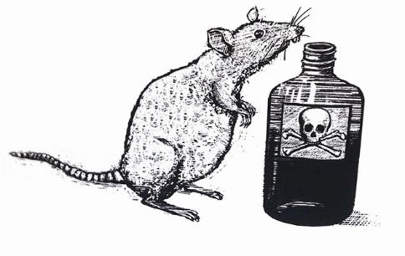

**Big Question**

‘**Standish Treadwell isn’t bright**’ – How is the character of Standish Treadwell initially presented?

Pages: 1 - 32

**Vocabulary**

|  |  |  |
| --- | --- | --- |
| Dystopia | Hierarchy | Totalitarianism |

**Review Questions**

1. Finish the quotation: ‘What if the football…’ (1)
2. What did Miss Connolly, Standish’s old teacher, always used to say?
3. What is the name of the planet that Standish and Hector have invented?
4. What is a ‘Cadillac’?
5. Whose muscles are ‘made out of old army tanks’?
6. Finish the quotation: ‘Here the sky fell in…’ (7)
7. What is the name of the country that Standish lives in?
8. Finish the quotation: ‘Salty water wasted in…’ (11)
9. Which character isn’t ‘a neat number’?
10. What does the corridor leading up to the Headmaster’s office smell of?
11. What is the name of the school warden Standish meets just before he sees the Headmaster?
12. How does she help him?
13. What is the ‘genius’ of the bench outside the Headmaster’s office’ (19)
14. Why did Standish used to hate school?
15. What is the ‘dubious honour’ he holds?
16. Who is the leader of the bullies?
17. Finish the quotation: ‘I sat down, my heart an…’ (22)
18. What word does Standish use to describe the wall ‘that runs along the side of the railway track’? (23)
19. What does Gramps say is cursed?
20. Who was it allegedly cursed by?
21. What has happened to Standish’s mum and dad?
22. Who does Standish say is a ‘silver fox’?
23. Who does Standish say is a Mother of Purity? (31)

**Key Extract**

Page: 9

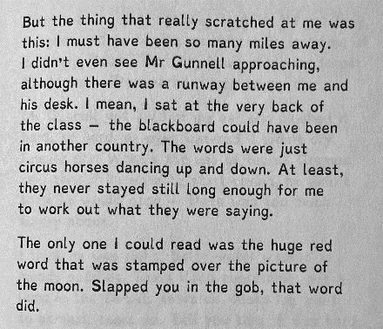

**Big Question**

‘**Are you going to kill us?**’ – How does the relationship between the Treadwell and Lush families develop?

Pages: 33 - 61

**Vocabulary**

|  |  |  |
| --- | --- | --- |
| Isolated | Precarious | Mutualistic |
| Supportive | Trusting | Hopeful |

**Review Questions**

1. Finish the quotation: ‘By the time we had agreed to do it, the…’ (33)
2. What is Cellar Street?
3. Where does Standish say you don’t see many civilians?
4. Finish the quotation: ‘The man was coat-hanger thin, with a…’ (35)
5. What is the name of Standish’s grandfather?
6. Who is ‘not nervous like the man and woman’?
7. What is the name of the country that Standish live in?
8. How many rats does Standish’s grandfather shoot?
9. What prompts Standish to form the view that his grandfather trusts the Lush family?
10. Finish the quotation: ‘If we stay together we are…’ (42)
11. What do the Treadwell and Lush families drink a toast to?
12. Why does Standish say he eventually began to sleep properly?
13. Why was Mr Lush exiled from the Motherland?
14. How about Mrs Lush?
15. Finish the quotation: ‘I rocketed off my seat when the…’ (45)
16. What does Standish say is ‘solid as Sunday’? (47)
17. Who is described as looking like a ‘deflated Zeppelin’?
18. What does Standish discover his parents used to do as jobs?
19. Finish the quotation: ‘It is Thursday , 19th July, 1956, the day the…’ (54)
20. Who does Standish say has ‘X-ray eyes’?
21. What does Stanley’s grandfather say is a waste of money?

**Key Extract**

Page: 35

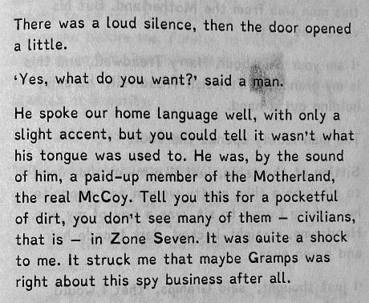

**Big Question**

‘**Everyone was silent**’ – In what ways are our expectations subverted?

Pages: 63 - 97

**Vocabulary**

|  |  |  |
| --- | --- | --- |
| Menace | Violence | Retribution |

**Review Questions**

1. Finish the quotation: ‘Hector had been sent to my school, to the…’ (63)
2. Who replaced Miss Connolly at Standish’s teacher?
3. What does ‘patriotic’ mean?
4. Who is ‘too present, too there, to be ignored’?
5. What is the ‘crappy crap’ that Hans Fielder and his friends ‘swallow’?
6. Finish the quotation: ‘I refuse to…’ (69)
7. What does Standish do to momentarily stop Hans and his friends from beating him?
8. Finish the quotation: ‘Mr Gunnell tripped backwards and his…’ (76)
9. Whose eyes are ‘glazed over with a look of pure hatred’?
10. Finish the quotation: ‘Little Eric was on the ground, curled into…’ (77)
11. What is Little Eric’s surname?
12. Who says, ‘I demand respect’?
13. Who calls the ambulance for Little Eric?
14. Finish the quotation: ‘Mr Hellman looked at me as if I was…’ (77)
15. Where does Standish say you inevitably become ‘fly fodder’?
16. What is the name of the maths teacher who tries ‘his best to make the fuzz go away’? (87)
17. Is the President of the Motherland male or female?
18. Who is described as having ‘gobstopper eyes’?
19. Finish the quotation: ‘You see, I was certain that in among all those scientists, I spied…’ (93)
20. What colour is the rocket?
21. What sort of glasses do the detectives wear?
22. Finish the quotation: ‘He rose from that bench like…’ (96)

**Key Extract**

Page: 85

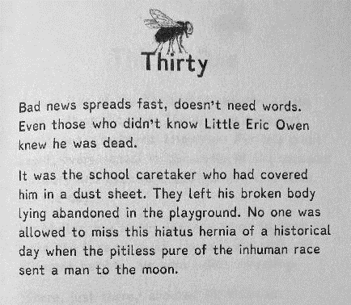

**Big Question**

‘**You and your grandfather are in grave danger**’ – What more do we learn about how the Motherland is governed?

Pages: 99 - 131

**Vocabulary**

|  |  |  |
| --- | --- | --- |
| Threat | Violence | Surveillance |
| Paranoia | Danger | Restriction |

**Review Questions**

1. Finish the quotation: ‘The leather-coat man was…’ (99)
2. Which character has one blue eye and one brown eye?
3. Does the leather-coat man believe that Standish is stupid?
4. What happens to Mr Hellman’s watch?
5. What happens to Mr Gunnell?
6. What does ‘elephantine’ mean?
7. Finish the quotation: ‘I was an undesirable among the…’ (107)
8. What does Standish discover in his desk?
9. What does Miss Phillips whisper to Standish whilst the camera is not focused on her?
10. Finish the quotation: ‘I walked, snail-slow out of the school, wondering why…’ (109)
11. What does Standish say he and his grandfather want most in Zone Seven?
12. Finish the quotation: ‘He wasn’t made up of any…’ (112)
13. Who smiles at Standish ‘like it was a good summer afternoon’?
14. What shines ‘brighter than the stars’?
15. What does ‘forfeiting’ mean?
16. In which month is Standish’s birthday?
17. What does Standish’s grandfather give him as a present?
18. What does Mrs Lush make for him?
19. Finish the quotation: ‘It cast a long shadow over everybody in…’ (125)
20. How does the football go missing?
21. What is ‘propaganda’?
22. Roughly how far is the moon away from Earth?

**Key Extract**

Page: 115

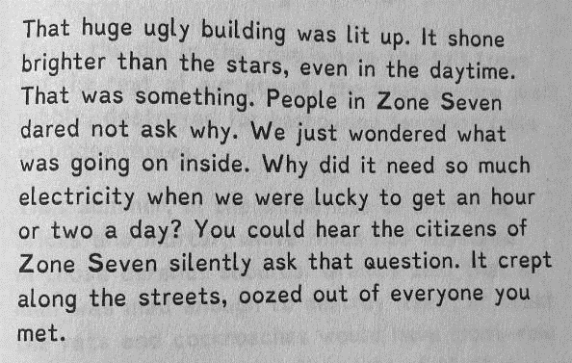

**Big Question**

‘**The wound kept oozing grief**’ – How do Standish and his grandfather react to the sudden disappearance of the Lush family?

Pages: 133 - 165

**Vocabulary**

|  |  |  |
| --- | --- | --- |
| Shock | Grief | Confusion |
| Mourning | Despondency | Anger |

**Review Questions**

1. Finish the quotation: ‘She said a doctor with no medicine is the same as…’ (133)
2. What does Standish’s grandfather believe is the ‘quickest way to become oven-roasted meat’?
3. Who manages to get a bottle of aspirin for Hector?
4. Finish the quotation: ‘Maybe the illness had taken more out of him than…’ (139)
5. Is it Standish or Hector who retrieves the lost football?
6. What does Hector believe ‘the best thing we have’ is?
7. Finish the quotation: ‘I knew they had been…’ (148)
8. What does Standish’s grandfather tell him to do for Hector?
9. What do Standish and his grandfather drink after Hector and his family have been taken?
10. Finish the quotation: ‘You see, once you have been rubbed out you…’ (153)
11. Who looks older after ‘the Lushes went’?
12. What time to do the detectives take a break?
13. What did Standish’s grandfather do before the war?
14. What did he do during the war?
15. Finish the quotation: ‘You see, Gramps had painted a perfect illusion of a…’ (159)
16. Is it brown rats or grey rats that are particularly common?
17. Finish the quotation: ‘Take off the moon man’s helmet and fast, otherwise…’ (163)
18. Who is the moon man identified as?
19. Finish the quotation: ‘It cast a long shadow over everybody in…’ (125)
20. How does the football go missing?
21. What is ‘propaganda’?
22. Roughly how far is the moon away from Earth?

**Key Extract**

Page: 153

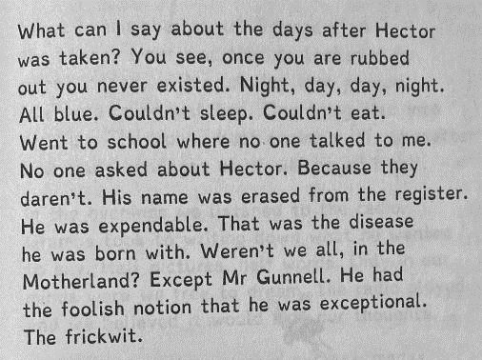

**Big Question**

‘**I was bloody terrified**’ – In what ways does life get increasingly dangerous for Standish and his grandfather?

Pages: 167 - 196

**Vocabulary**

|  |  |  |
| --- | --- | --- |
| Tension | Threat | Conflict |

**Review Questions**

1. Finish the quotation: ‘By the time we reached our house the front…’ (167)
2. What has happened to Standish’s house?
3. What does Standish half-dream of?
4. What smothers ‘everything with its stench’?
5. Why does the moon man draw pictures instead of speaking?
6. Finish the quotation: ‘Do not be frightened into believing that the Motherland has the capacity to…’ (171)
7. Who does Standish say was ‘too well-dressed’?
8. Finish the quotation: ‘The moon man emerged from the cellar, relived to…’ (179)
9. What word is sewn onto the moon man’s spacesuit?
10. What word does the moon man write and show Standish?
11. Who looks as if they’ve been ‘beaten up pretty badly’?
12. What has happened to Miss Phillip’s hair?
13. Finish the quotation: ‘It was only then that it dawned on me that…’ (171)
14. How long have Standish’s grandfather and Miss Phillips been ‘courting’?
15. What is the name of the capital city of the Motherland?
16. What does the word ‘cacophony’ mean?
17. Where does Standish’s grandfather hide Miss Phillips when the Greenflies arrive?
18. Finish the quotation: ‘I wasn’t expecting to see…’ (190)
19. Who is described as a ‘kettle of liquid fury about to reach boiling point’?
20. What do the Greenflies bring up from the cellar?
21. What does Standish believe is in ‘that hideous building’ called the ‘people’s palace’? (194)
22. Finish the quotation: ‘And the stone-thrower would be…’ (196)

**Key Extract**

Page: 189

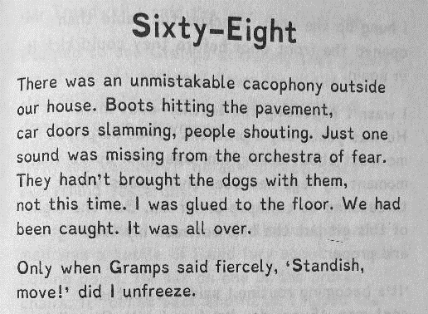

**Big Question**

‘**Bring down the curtain**’ – In what ways do both Standish and his grandfather demonstrate bravery?

Pages: 197 - 222

**Vocabulary**

|  |  |  |
| --- | --- | --- |
| Sacrifice | Stoicism | Courage |

**Review Questions**

1. Finish the quotation: ‘Today he is a…’ (197)
2. Who does Standish believe is very clever?
3. Why have mass graves been dug for ‘everyone who has worked on the project’?
4. Why does the moon man recognise Hector?
5. What happened to Hector’s little finger?
6. Finish the quotation: ‘I would hold up a big piece of paper with the word…’ (205)
7. Who becomes ‘spitting angry’?
8. Finish the quotation: ‘Gramps was shaking as if an earthquake was…’ (207)
9. What does the moon man write on the notepad?
10. Whose thoughts are ‘too loud’ for Standish?
11. Who do the cardboard silhouettes look like?
12. What is written on the wide belt that Standish’s grandfather gives him?
13. Finish the quotation: ‘Here it is, a grave in the earth, ready and…’ (218)
14. Why is there blood dripping down Standish’s leg?
15. What excuse does Standish give to the guard who seizes him?

**Key Extract**

Page: 211

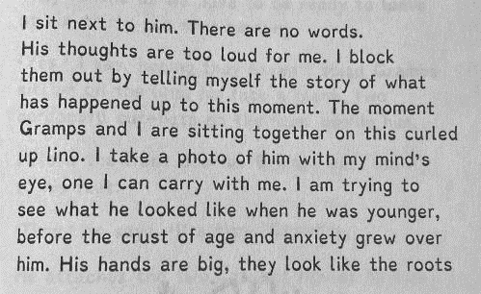

**Big Question**

‘**The more I see of all this, the less optimistic I feel**’ – Why doesn’t Standish give up when his chance of success is so small?

Pages: 223 - 251

**Vocabulary**

|  |  |  |
| --- | --- | --- |
| Expectation | Hope | Bravery |

**Review Questions**

1. Finish the quotation: ‘The moon man told me there were thousands of…’ (223)
2. Who is the ‘only one with a plan’?
3. What advice is Standish given by the woman who kindly shared her bunk with him?
4. What is Standish given for his breakfast?
5. What are the ‘things the Motherland likes a lot’? (226)
6. What colour is the moon dust?
7. What is a thing of ‘efficient ugliness’?
8. What number is Standish given?
9. Finish the quotation: ‘All these nevers are what I’m going to…’ (232)
10. What does the man in the white coat tell Standish to do?
11. Finish the quotation: ‘I am doing my best to think the bread and the water are…’ (236)
12. What does Standish notice at the side of the trench that will help him?
13. Finish the quotation: ‘I emerge from the trench to find Mr Gunnell’s…’ (240)
14. Why does the guard say that Standish is lucky?
15. Who does Standish discover in the dark room?
16. Finish the quotation: ‘He is a huddle, a…’ (245)
17. Whose voice is ‘weak’?
18. Who is described as a ‘sleeper’?
19. Finish the quotation: ‘The lights go on so suddenly that it feels as if…’ (249)
20. What was Standish’s ‘best bit of luck so far’?

**Key Extract**

Page: 235

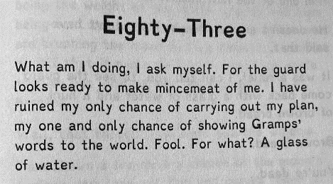

**Big Question**

‘**That’s when I make my move**’ – To what extent is Standish a heroic character?

Pages: 253 - 287

**Vocabulary**

|  |  |  |
| --- | --- | --- |
| Expectations | Archetype | Conform |
| Subvert | Reinforce | Challenge |

**Review Questions**

1. Finish the quotation: ‘I don’t want him thinking…’ (253)
2. Who needs medicine?
3. What is the only medicine Standish has? (254)
4. Why does Standish get slapped round the head by the guard?
5. Finish the quotation: ‘I want to be a…’ (261)
6. What particularly worries Standish about Hector?
7. How many mattresses does the guard bring in? (263)
8. What meal does the guard bring Standish?
9. Does Hector eat the meal he is given?
10. Finish the quotation: ‘Nothing matters except…’ (267)
11. Who seems to have aged ‘about a hundred years’?
12. What looks ‘impressively useless’?
13. Finish the quotation: ‘If this was really happening the astronaut inside would be…’ (272)
14. Why is Standish worried about his belt?
15. Who is the leather-coat man looking for?
16. Finish the quotation: ‘The landing craft doors slide open and there is…’ (281)
17. Finish the quotation: ‘The plug is pulled on…’ (285)
18. Who is described as a ‘sleeper’?
19. Finish the quotation: ‘The lights go on so suddenly that it feels as if…’ (249)
20. Where does the sun shine in Technicolor?

**Key Extract**

Page: 285

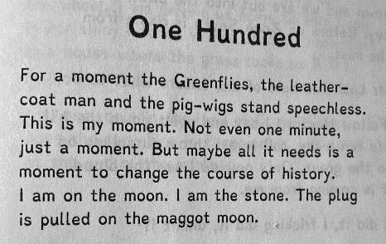

**A Brief History of the Space Race**

https://www.theguardian.com/news/gallery/2007/oct/04/internationalnews.spaceexploration

**October 4, 1957**: The world's first artificial satellite, Sputnik I, is launched by the Soviet Union from the Baikonur cosmodrome in Kazakhstan. Its *beep-beep* signal picked up on Earth signalled the dawn of a new era.

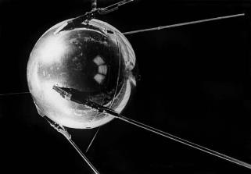

**October 6, 1957 | Moscow, Russia**: Technicians trace the orbit of Sputnik I.

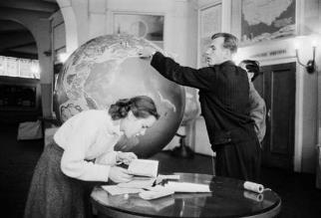

**November 1957, Rome, Italy**: A man observes a model of Sputnik I on display in a department store.

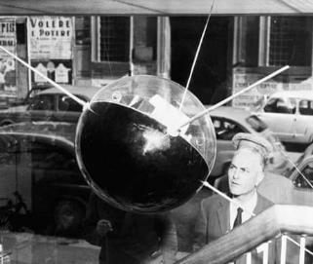

**November 5, 1957**: Laika, the female dog who was a passenger on board Sputnik II.

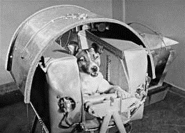

**January 31, 1958**: The first US satellite, Explorer I, lifts off at Cape Canaveral, Florida.

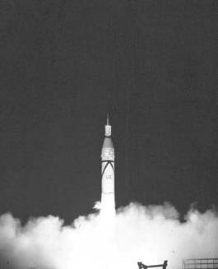

**April 12, 1961**: Yuri Gagarin prepares to board the Vostok I spaceship at the Baikonur launchpad shortly before its take-off. He was the first man to travel in space, completing a circuit of the Earth.

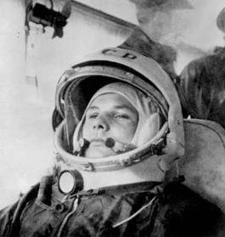

**February 20, 1962**: The launch of Friendship 7, the first American manned orbital space flight.

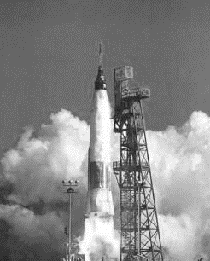

**1962**: John Glenn Jr in his silver mercury spacesuit during pre-flight training activities at Cape Canaveral.

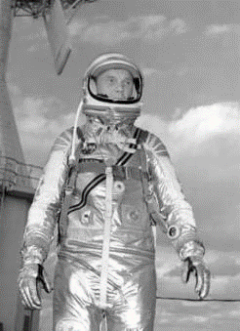

**1963**: Valentina Tereshkova practises feeding in simulated flight conditions for her flight as the first woman in space on the Vostok VI mission.

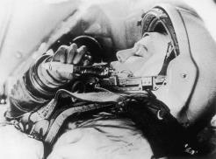

**Power Politics Always Drives Space Conquest**

https://www.theguardian.com/commentisfree/2019/jan/06/power-politics-always-drives-space-conquest-china-coup-is-no-different

Nasa rejected it as too difficult and costly an undertaking. Last week, China declared ‘mission accomplished’ after landing a spacecraft, Chang’e-4, on the far side of the moon. It was a **remarkable endeavour**. As the far side of the moon never faces the Earth, mission control cannot communicate directly with the spacecraft, but only via an orbiting satellite. The terrain is more broken and cratered than the near side, so landing a craft is that much more difficult. Even Nasa was impressed: ‘a first for humanity and an impressive accomplishment!’, the administrator tweeted.

Yet mixed with admiration was **trepidation**. China, a latecomer to the space race, is now beginning to threaten the supremacy of America and Russia. Almost every report on Chang’e-4’s mission declared it a ‘propaganda coup’ for China. That it certainly is and one that Beijing will fully exploit. But then Russia and America have long played their space exploration programmes for propaganda purposes.

From the beginning, the space race was intimately bound up with the needs of the **cold war**. In 1957, the Soviet Union launched Sputnik, the first human craft to orbit the Earth. Four years later, Yuri Gagarin became the first man in space. It was, Nikita Khrushchev claimed, ‘the greatest triumph of the immortal Lenin’s ideas’.

Eight years later, on 21 July 1969, Neil Armstrong and Buzz Aldrin became the first humans to tread on the moon. Their journey may have been fuelled in part by cold war desperation, but it was also an extraordinary triumph of knowledge and will, an act of the technological sublime. Once America was satisfied that the Soviet Union had been put in its place, space exploration became **politically** less important. Manned moon missions ended in 1972. Nasa was normalised into a regular government technology programme.As America downgraded its space ambitions, Chinese aspirations took flight. In 1992, the Chinese government approved the Shenzhou manned spaceflight programme. Eleven years later, Yang Liwei became the first Chinese astronaut in space.

America barred China from participating in the International Space Station (ISS). In 2011, China launched the first of two prototypes of its own space station. It plans to launch the core module of a permanent space station, Tianhe, by 2020. The ISS is due to be retired by 2028; China may then have the only functioning orbiting station. By the end of that decade, Beijing aims to be the dominant force in space exploration. There will be many more ‘**propaganda coups**’.

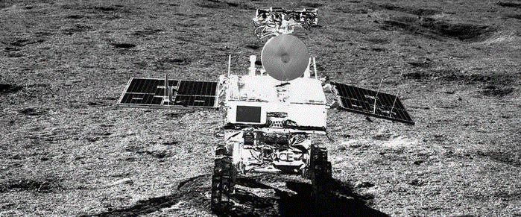

Fears about Chinese ambitions have been heightened by the changing context of the space race. In the 1960s, America was willing to throw whatever resources were necessary to achieve its cold war goals. Today, Nasa is unsure of its purpose and America less committed to funding it. During the cold war, America feared the Soviet Union, but was determined to thwart Moscow’s aims. Today, American apprehension stems from the worry that China’s emergence as the **dominant global force** cannot be checked, nor Beijing’s brutal despotism challenged. As liberal democracy frays in the west and authoritarian capitalism becomes entrenched in the east, self-doubt shapes US attitudes to China.

Space exploration has long been fuelled by a mixture of **humanistic dreams, technological leaps and tawdry politics**. The Chang’e-4 mission is no different. How the space race will play out over the next decade, and what role China will adopt in global politics, remains uncertain. In the meantime, let us celebrate our new perspective of the dark side of the moon.