Macbeth
William Shakespeare
Study Booklet

1 | Useful Words
2 | Context and Literary Snapshots
4 | A1S1 and A1S3: The Witches
 | Writing Focus: Significant Because
5 | A1S2: Victorious Macbeth
 | Writing Focus: Because-But Sentences
6 | A1S3: Prophecies of Greatness
 | Writing Focus: Because-But Sentences
7 | A1S4: Macbeth’s Ambition
 | Writing Focus: Before-After Sentences
8 | A1S5: Lady Macbeth
 | Writing Focus: This Shows Sentences
9 | A1S7: Macbeth’s Doubts and Fears
 | Writing Focus: Although Sentences
10 | A2S1: Macbeth’s Soliloquy
 | Writing Focus: Mixed Practice Sentences
11 | A2S2: The Murder
 | Writing Focus: Not Only… But Sentences
12 | A2S3 and A2S4: The Aftermath of the Murder
 | Writing Focus: Before-After Sentences
13 | A3S1 and A3S2: Fears About Banquo
 | Writing Focus: When-Although
14 | A3S4: Banquo’s Ghost
 | Writing Focus: Mixed Practice Sentences
15 | A4S1: Return to the Witches
 | Writing Focus: Appositive Sentences
16 | A4S2 and A4S3: The Slaughter of Macduff’s Family
 | Writing Focus: Appositive Sentences + Mixed Practice Sentences
17 | A5S1: Lady Macbeth Sleepwalks
 | Writing Focus: Above All Sentences
18 | A5S3 and A5S5: The Death of Lady Macbeth
 | Writing Focus: Jumbled Sentences + As Revealed Sentences
19 | A5S7, A5S8 and A5S9: The Death of Macbeth
 | Writing Focus: Fragment Sentences

Useful Words

Connected to Tragedy
- Tragic Hero The main character in a tragedy who experiences a significant downfall
- Tragic Flaw The character flaw responsible for the downfall of the tragic hero
- Hamartia A fatal error of judgement
- Hubris Excessive pride
- Anagnorisis A moment where the tragic hero has a profound insight or a heightened sense of awareness
- Catharsis Release of strong emotions resulting in a feeling of relief and renewal
- Fate Events that happen inevitably and beyond the control of individuals

Connected to Context
- Hierarchy Ordering of people according to their social status and perceived importance
- Regicide The act of killing a king
- Prophecy A prediction for the future based on spiritual or mystical knowledge
- Apparition A ghostly image of person

Connected to Macbeth
- Brave Showing strength in a challenging situation
- Dominant Possessing power over others
- Doubtful A feeling of skepticism or doubt
- Conflicted Anxiety that arises from having different ideas, feelings or beliefs
- Murderous Possessing the intent and capability to commit murder
- Insecure A feeling of anxiety connected to safety or status
- Isolated Separated from others
- Vengeful Seeking to harm someone in return for a perceived injustice
- Fearful Feeling or showing fear or anxiety
- Distraught Very worried or upset

Connected to Lady Macbeth
- Ruthless Showing limited pity or compassion in the pursuit of a particular goal
- Ambitious Possessing a strong desire to succeed
- Intelligent Having the ability to understand things and deal with difficult situations
- Persuasive The ability to influence people
- Forceful Strong and assertive
- Manipulative The ability to use influence for personal gain
- Calculating Scheming in a determined way
- Delusional Belief in things that are not true
- Regretful Feeling or showing regret

Context Snapshots

James I
Source: BBC History Magazine
In 1589, James was betrothed to Anne of Denmark, but she almost lost her life in a violent tempest when she set sail across the North Sea to meet her new husband. In an uncharacteristic show of chivalry, James resolved to sail across to Denmark and collect her in person. But on their return voyage, the royal fleet was battered by more storms and one of the ships was lost. James immediately placed the blame on witches, claiming that they must have cast evil spells upon his fleet.

Witch Hunts
Source: BBC History Magazine
In James’s view, the English law was by no means strict enough in prosecuting the crime. Barely a year after his accession, James therefore ordered that the Elizabethan statute on witchcraft be replaced by a much harsher version. Until [then], those who practised witchcraft were severely punished only if they were found to have committed murder or other injuries through their devilish arts. However, James wanted the practice of any form of magic to be severely punished, regardless of whether it had caused harm to others. The Witchcraft Act of 1604 made hanging mandatory for a first offence of witchcraft.

The Gunpowder Plot
Source: The Globe Theatre
Jacobeans believed that the whole universe had an order to it which was decided by God. Anything unnatural was against this divine order. Shakespeare’s ‘Scottish Play’ was probably written in 1606, just three years after King James I was crowned as Elizabeth I’s successor, and so undoubtedly seems to be paying homage to the succession of the Scottish King to the English throne. But within that time, in November 1605, the Gunpowder Plot had been discovered: the plan to blow up the Houses of Parliament, kill James, and replace him with a Catholic monarch failed, and the plotters were tortured and horribly executed […] Many of Macbeth’s themes resonate with the attempted revolt: it’s a play about treason, the overthrow of a King, and the downfall of his murderers.

Regicide
Source: English and Media Centre
In Macbeth, as in any play of the period, the ultimate taboo is regicide: to kill the king is a heinous act, violating feudal loyalties and offending against God. Macbeth always knows that Duncan’s murder is ‘deep damnation’ […] Macbeth’s own intense mental, emotional and spiritual suffering is evident from his anguish before (and, of course, after) Duncan’s murder up to his final soliloquy where he finds only ‘Nothing’ at the heart of life. The isolation of his suffering is part of the horror of the play. […] Macbeth’s solitude is inherent to his tragedy; equally, Lady Macbeth is tormented by nightmare, horror and isolation. These two have embraced a world of blood and it haunts them.’

Literary Snapshots

Tragedy
Source: English and Media Centre
The protagonist is a character with whom the audience can identify, someone who makes a wrong decision for good reasons or with the best of intentions. Aristotle called the protagonist’s error of judgement hamartia. It is often the result of a condition called hubris, the excessive pride which brings down divine punishment upon the head of the protagonist. A.C. Bradley’s Shakespearean Tragedy (1904) proposed the idea of the tragic flaw in the psychological make-up of the protagonist. This [should not] be confused with the notion of hamartia, which is a matter of action, not character.

Good and Evil
Source: The British Library
Good and evil are a potent source of conflict within Macbeth. Not only do we have the overtly evil presence of the witches and the domineering Lady Macbeth, but we also have the deeply divided character of Macbeth himself, where this conflict works itself out in depth. The first act of the play offers an increasing insight into the complex interaction of good and evil in Macbeth’s mind. The noble, valiant and loyal soldier of the early scenes is tempted by the visions of future personal glory conjured by the witches and comes increasingly under their influence.

Soliloquies
Source: The New York Times
‘Soliloquies and monologues are both spoken by a single person. The difference between these two literary and theatrical devices, however, is not who is speaking, but rather, who is listening. In a soliloquy, the speaker is talking to him or herself. In a monologue, the speaker is talking to the audience. [A soliloquy] reveals the innermost thoughts of a character in a play, is not so much an expression of what the character knows, as a discovery of what he or she thinks. [The] speech is kept private from the other characters in the play, and, although the audience is privy to the character’s thoughts, the character is talking to him or herself alone. Soliloquies can create dramatic irony, because the audience is made aware of thoughts and events that the other characters in the play are not.’

Hospitality
Source: Essay on the influence of hunger in Macbeth
Hospitality expressed through food is central to Macbeth, with the hero first hosting a feast to celebrate Duncan’s victory over the rebels and later attempting to cement his own kingship through the banquet at which Banquo’s ghost makes its unwelcome appearance. It is significant, then, that Macbeth’s attempt to consolidate and cement his position as king is dramatised in the pivotal banquet scene of A3S4, rather than through his coronation, which is not staged.

Food and Feasting
Source: Essay on the influence of hunger in Macbeth
The coronation marks the symbolic transference of power onto the new king, but it is the hosting of the feast – proving his ability to provide abundance of food for himself and his followers, demonstrating that he […] is in a position to be bountiful – that will mark him as a truly powerful leader. Sufficient sustenance and the ability to eat in peace seem to be the figurative benchmarks by which Macbeth measures his success, security, comfort, and happiness. Food becomes [is] a symbol of unifying significance.

A1S1 and A1S3: The Witches

Questions to Consider
- Why might Shakespeare have chosen to make witches such a prominent part of the play?
- Why is the weather stormy?
- Why do the witches speak in such a distinctive way?
- Why do we see them on stage before Macbeth?
- Why do the witches talk at length about punishing a sailor and his wife?
- Why do the witches look so strange and grotesque?

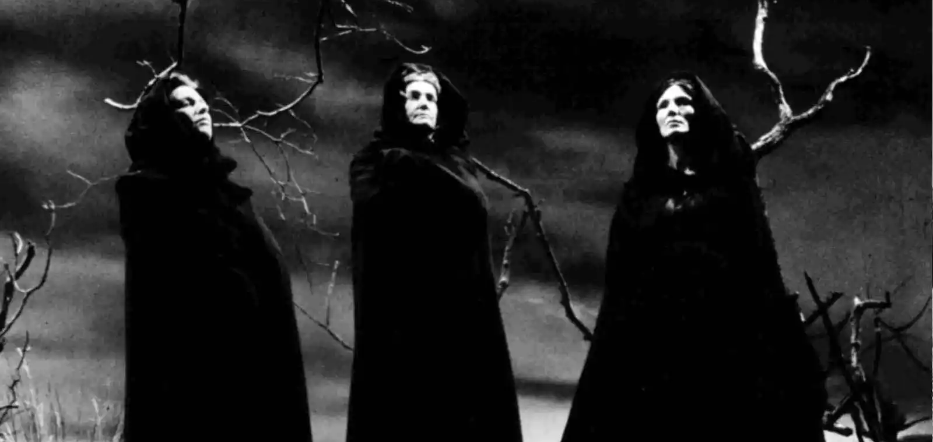

James I
Source: BBC History Magazine
In 1589, James was betrothed to Anne of Denmark, but she almost lost her life in a violent tempest when she set sail across the North Sea to meet her new husband. In an uncharacteristic show of chivalry, James resolved to sail across to Denmark and collect her in person. But on their return voyage, the royal fleet was battered by more storms and one of the ships was lost. James immediately placed the blame on witches, claiming that they must have cast evil spells upon his fleet.

Witch Hunts
Source: BBC History Magazine
In James’s view, the English law was by no means strict enough in prosecuting the crime. Barely a year after his accession, James therefore ordered that the Elizabethan statute on witchcraft be replaced by a much harsher version. Until [then], those who practised witchcraft were severely punished only if they were found to have committed murder or other injuries through their devilish arts. However, James wanted the practice of any form of magic to be severely punished, regardless of whether it had caused harm to others. The Witchcraft Act of 1604 made hanging mandatory for a first offence of witchcraft.

Significant Because Sentences
- The prominent focus on witches is significant because…
- The ‘thunder and lightning’ at the start of the play is significant because…
- The distinctive way in which the witches speak is significant because…
- The anecdote about the curse placed on the sailor is significant because…
- The ‘withered’ and ‘wild’ appearance of the witches is significant because…

A1S2: Victorious Macbeth

Questions to Consider
- What does the Captain report about Macbeth?
- What images does he use?
- How does Duncan react to what he’s told?
- How does he reward Macbeth?

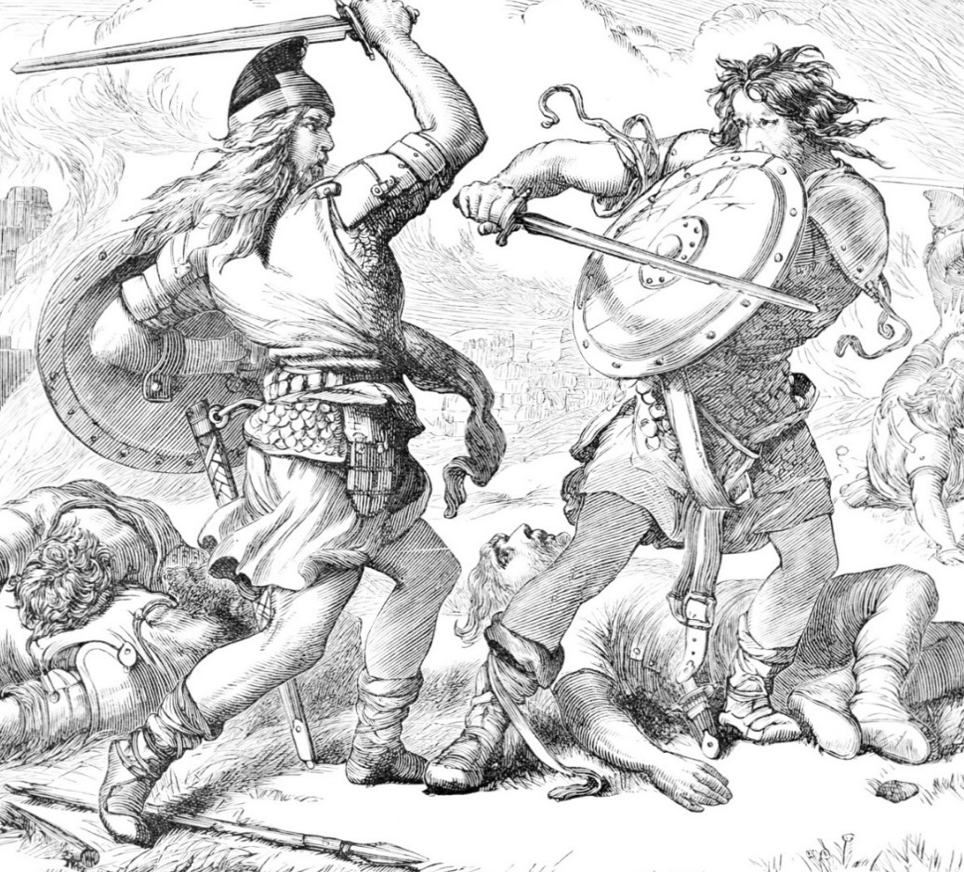

Quotations
- ‘But all’s too weak for brave Macbeth’
- ‘Till he unseamed him from the nave to the chops’
- ‘As cannons overcharged with double cracks’

Because-But Sentences
- The Captain reports that victory looked ‘doubtful’ because…
- The Captain reports that victory looked ‘doubtful’, but…
- The Captain uses the adjective ‘brave’ to describe Macbeth because…
- The violent imagery connected to Macdonwald’s death is significant because…
- The ‘cannons’ simile is significant because…
- The King of Norway launched a ‘fresh assault’ after Macdonwald was defeated, but…

A1S3: Prophecies of Greatness

Questions to Consider
- What do the witches prophecise?
- How does Macbeth react?
- What is the purpose of the ‘asides’?
- How does Banquo react?
- How do both characters react to Macbeth being made the new Thane of Cawdor?

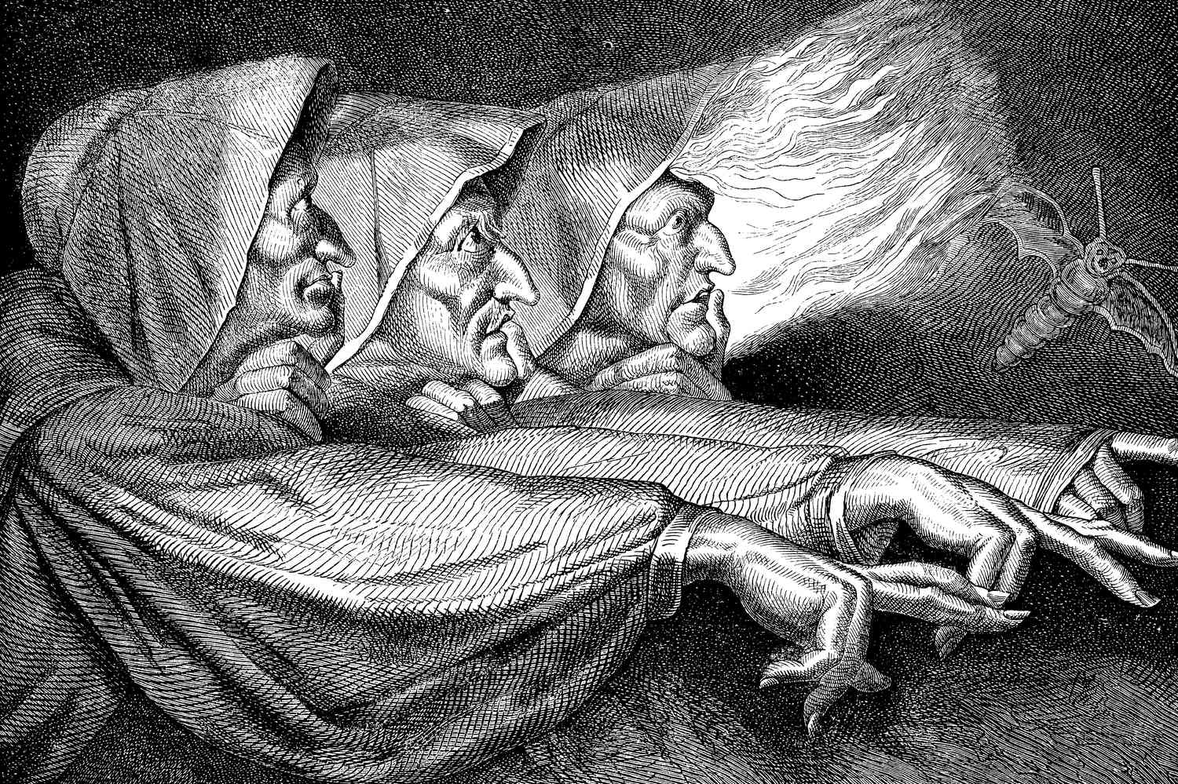

Tragedy
Source: English and Media Centre
The protagonist is a character with whom the audience can identify, someone who makes a wrong decision for good reasons or with the best of intentions. Aristotle called the protagonist’s error of judgement hamartia. It is often the result of a condition called hubris, the excessive pride which brings down divine punishment upon the head of the protagonist. A.C. Bradley’s Shakespearean Tragedy (1904) proposed the idea of the tragic flaw in the psychological make-up of the protagonist. This [should not] be confused with the notion of hamartia, which is a matter of action, not character.

Quotations
- ‘So _______ and _______ a day I have not seen’
- ‘And oftentimes, to win us to our _______, the instruments of darkness tell us _______’
- ‘Why do I yield to that suggestion whose horrid _______ doth unfix my hair and make my seated _______ knock at my ribs’

Because-But Sentences
- Macbeth believes the former Thane of Cawdor ‘lives a prosperous gentleman’, but…
- Banquo questions whether he and Macbeth have ‘eaten on the insane root’ because…
- Macbeth uses the metaphor of ‘borrowed robes’ because…
- Macbeth asks if Banquo hopes his ‘children shall be kings’, but…
- Macbeth reflects on the ‘imperial theme’ of the third prophecy, but…
A1S4: Macbeth’s Ambition

Questions to Consider
- How does Duncan greet Macbeth?
- How does Macbeth behave towards Duncan?
- What announcement does Duncan make?
- What does Macbeth’s ‘aside’ reveal?
- What imagery does Macbeth use to describes his true feelings?

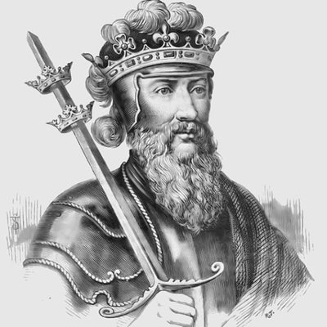

Quotations
- ‘There’s no _______ to finding the _______ _______ in the _______’
- ‘O _______ cousin’
- ‘The service and the _______ I owe in doing it pays itself’
- ‘Our eldest, _______, whom we name hereafter the _______ of _______’
- ‘The _______ of _______ – that is a _______ on which I must _______ _______, or else _______’
- ‘Stars _______ your fires, let not _______ see my black and deep desires’

Before-After Sentences
- Before Macbeth and Banquo arrive on stage…
- After Macbeth and Banquo arrive on stage…
- Before Duncan announces that Malcolm will be made Prince of Cumberland…
- After Duncan announces that Malcolm will be made Prince of Cumberland…

A1S5: Lady Macbeth

Questions to Consider
- What does Macbeth’s letter reveal?
- What do we learn from Lady Macbeth’s first soliloquy?
- What do we learn from her second?
- What imagery does Lady Macbeth use to describes her true feelings?
- What does Macbeth agree to do?

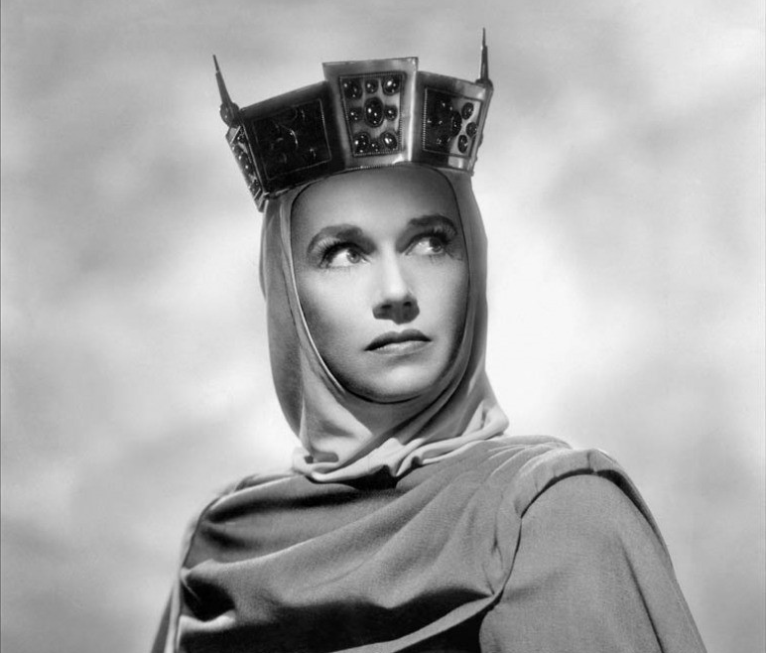

Quotations
- ‘I fear thy nature is too full o’ th’ _______ of human kindness’
- ‘Come you _______ that tend on mortal thoughts, unsex me here’
- ‘And take my milk for _______’
- ‘And pall thee in the dunnest smoke of hell’
- ‘Look like th’ innocent _______, but be the _______ under’t’

This Shows Sentences
- Lady Macbeth fears that Macbeth is ‘too full o’ th’ milk of human kindness’. This shows…
- Lady Macbeth appeals to evil spirits to ‘unsex’ her. This shows…
- Lady Macbeth tells Macbeth to ‘leave all the rest’ to her. This shows…

A1S7: Macbeth’s Doubts and Fears

Questions to Consider
- What conflicting thoughts are revealed in Macbeth’s soliloquy?
- What are Macbeth’s views on Duncan as a king?
- How does Lady Macbeth respond to Macbeth’s reluctance to murder Duncan?

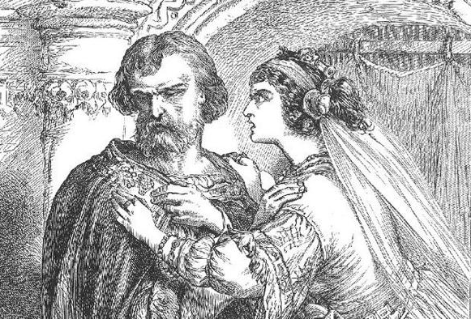

Good and Evil
Source: The British Library
Good and evil are a potent source of conflict within Macbeth. Not only do we have the overtly evil presence of the witches and the domineering Lady Macbeth, but we also have the deeply divided character of Macbeth himself, where this conflict works itself out in depth. The first act of the play offers an increasing insight into the complex interaction of good and evil in Macbeth’s mind. The noble, valiant and loyal soldier of the early scenes is tempted by the visions of future personal glory conjured by the witches and comes increasingly under their influence.

Although Sentences
- Although Macbeth seemed to accept the importance of murdering Duncan in A1S5…
- Although Macbeth states that he will ‘proceed no further’ with the murder of Duncan…
- Although Macbeth protests that he ‘dare do all that may become a man’…
- Although Macbeth expresses concerns about the plan failing…
- Although Macbeth is presented as a conflicted character at the start of the scene…

A2S1: Macbeth’s Soliloquy

Questions to Consider
- What do we learn from the interaction between Macbeth and Banquo at the start of the scene?
- How is Macbeth’s state of mind presented during his soliloquy?
- What is the significance of the dagger?
- Why is it significant that the scene is set at night?

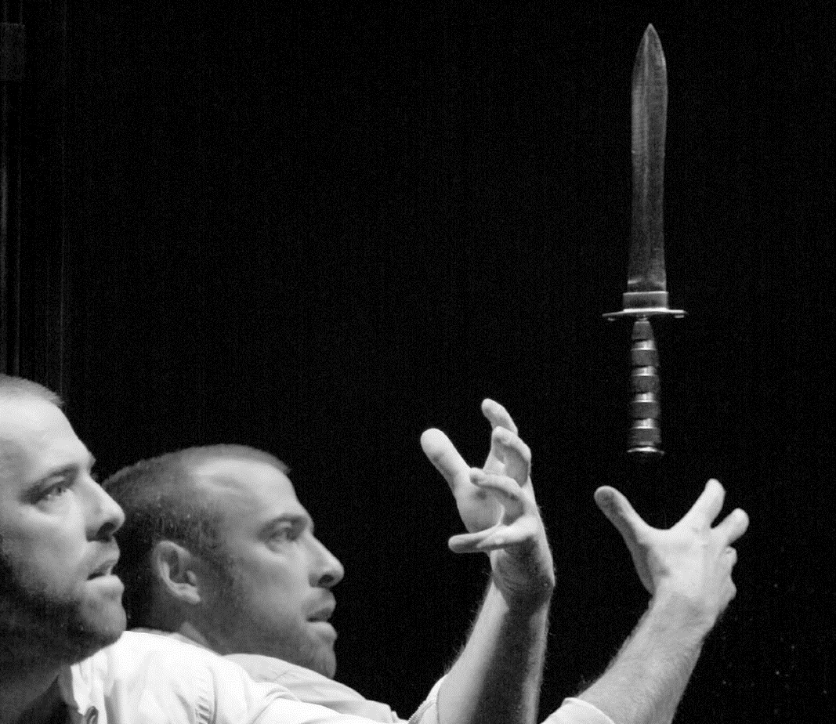

Soliloquies
Source: The New York Times
‘Soliloquies and monologues are both spoken by a single person. The difference between these two literary and theatrical devices, however, is not who is speaking, but rather, who is listening. In a soliloquy, the speaker is talking to him or herself. In a monologue, the speaker is talking to the audience. [A soliloquy] reveals the innermost thoughts of a character in a play, is not so much an expression of what the character knows, as a discovery of what he or she thinks. [The] speech is kept private from the other characters in the play, and, although the audience is privy to the character’s thoughts, the character is talking to him or herself alone. Soliloquies can create dramatic irony, because the audience is made aware of thoughts and events that the other characters in the play are not.’

Mixed Practice Sentences
- Banquo says to Fleance that ‘there’s husbandry in heaven’. This shows…
- Macbeth tells Banquo that he does not ‘think’ of the witches because…
- Macbeth tells Banquo that he does not ‘think’ of the witches, but…
- Although Macbeth sees a dagger in ‘palpable’ form…
- After Macbeth hears the ‘bell’, he…
- This part of the play is particularly important because…
A2S2: The Murder

Questions to Consider
- What do we learn about how Lady Macbeth feels at the start of the scene?
- How is Macbeth presented?
- How is Lady Macbeth presented?
- What is significance of the blood on Macbeth’s hands and his fears about not being able to sleep?

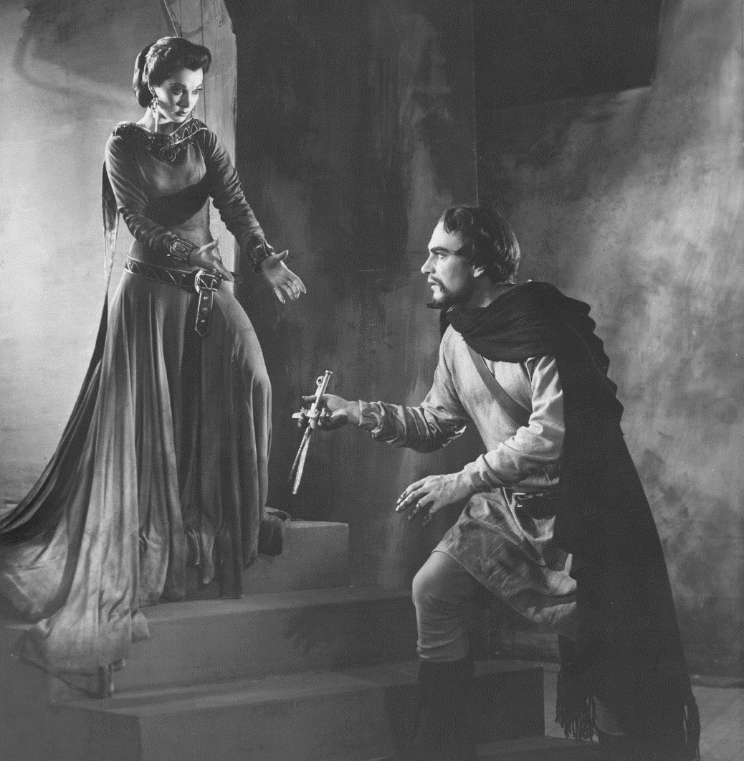

Language
Source: English and Media Centre
The audience will also sit up and take notice if there is a stretch of lines which don’t rhyme (blank verse) and then some which do rhyme. Shakespeare inherited a convention of ending scenes with rhyming couplets. Something else he does is to chart the relationships between characters, particularly the power relationships, by splitting a line between characters. You need to think about whether the second character is filling in a gap or a pause when the first one has finished or whether the second character is interrupting.

Not Only… But Also Sentences
- The blood on Macbeth’s hands is not only significant because [ ? ] but also [ ? ]
- Macbeth’s fear that he will ‘sleep no more’ is not only significant because [ ? ] but also [ ? ]
- Lady Macbeth’s anger at Macbeth’s erratic behaviour is not only shown through [ ? ] but also [ ? ]

A2S3 and A2S4: The Aftermath of the Murder

Questions to Consider
- What is the purpose of the scene with the porter?
- What is the significance of the stormy weather?
- What are the differences between the way in which Macduff and Macbeth speak?
- Why is it significant that Lady Macbeth faints?
- Why do Malcolm and Donalbain decide to leave Scotland?
- What is the significance of the conversation between the Old Man and Ross?

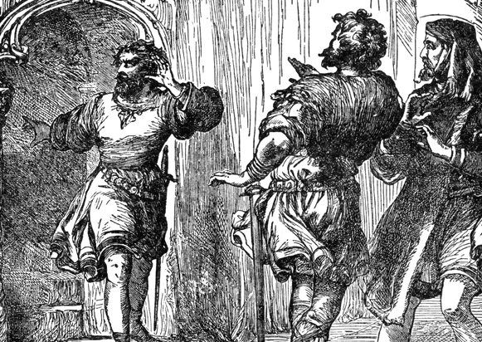

Quotations
- ‘O _______, _______, horror!’
- ‘Most _______ murder’

The Gunpowder Plot
Source: The Globe Theatre
Jacobeans believed that the whole universe had an order to it which was decided by God. Anything unnatural was against this divine order. Shakespeare’s ‘Scottish Play’ was probably written in 1606, just three years after King James I was crowned as Elizabeth I’s successor, and so undoubtedly seems to be paying homage to the succession of the Scottish King to the English throne. But within that time, in November 1605, the Gunpowder Plot had been discovered: the plan to blow up the Houses of Parliament, kill James, and replace him with a Catholic monarch failed, and the plotters were tortured and horribly executed […] Many of Macbeth’s themes resonate with the attempted revolt: it’s a play about treason, the overthrow of a King, and the downfall of his murderers.

Before-After Sentences
- Before Macduff enters Duncan’s bedchamber…
- After Macduff enters Duncan’s bedchamber…

A3S1 and A3S2: Fears About Banquo

Questions to Consider
- What ‘fear’ about Macbeth does Banquo express at the start of the scene?
- Why does Macbeth describe Malcolm and Donalbain as ‘our bloody cousins’?
- What ‘fears’ about Banquo does Macbeth express in his soliloquy?
- What does Macbeth ‘conclude’ about Banquo?
- Why doesn’t Macbeth reveal details of his plan to Lady Macbeth?
- What does this suggest about the shifting balance of power in the relationship?

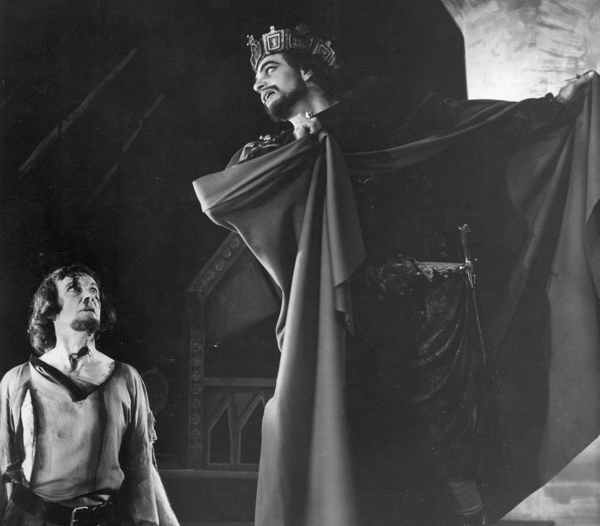

Quotations
- ‘But that myself should be the _______ and father of many kings’
- ‘Upon my head they placed a _______ crown and put a _______ sceptre in my gripe’
- ‘O full of _______ is my mind’
- ‘Come seeling _______, scarf up thy tender eye of pitiful day’

When-Although Sentences
- When Macbeth uses the metaphor of a ‘fruitless crown’, he…
- When Macbeth uses the metaphor of a ‘barren sceptre’, he…
- Although Macbeth is king, he…
- When Macbeth says that his mind is ‘full of scorpions’, he…
- Although Lady Macbeth asks Macbeth to reveal his plans, he…

A3S4: Banquo’s Ghost

Questions to Consider
- What news do the murders give to Macbeth?
- How does Macbeth react to seeing the ghost of Banquo?
- How does Lady Macbeth react towards Macbeth?
- How does Macbeth react when the ghost of Banquo appears for the second time?
- What does Macbeth say he will do at the end of the scene?

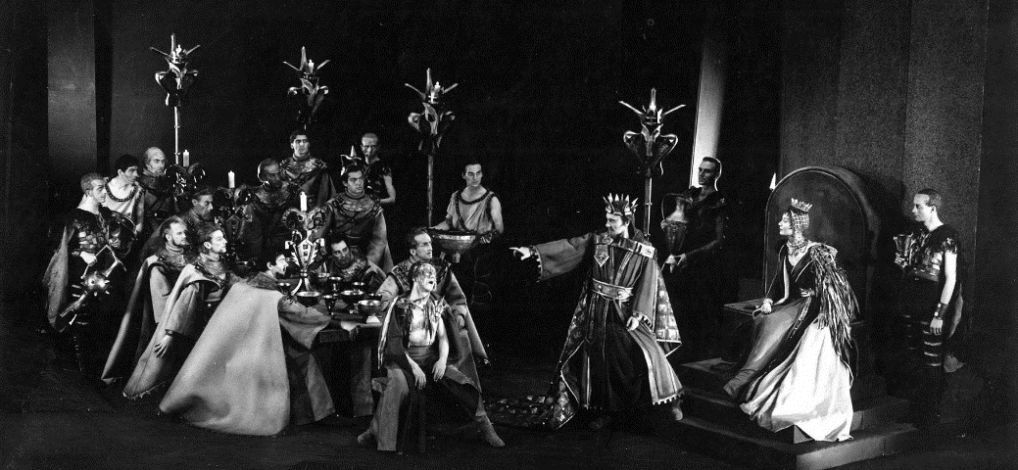

Hospitality
Source: Essay on the influence of hunger in Macbeth
Hospitality expressed through food is central to Macbeth, with the hero first hosting a feast to celebrate Duncan’s victory over the rebels and later attempting to cement his own kingship through the banquet at which Banquo’s ghost makes its unwelcome appearance. It is significant, then, that Macbeth’s attempt to consolidate and cement his position as king is dramatised in the pivotal banquet scene of A3-S4, rather than through his coronation, which is not staged.

Food and Feasting
Source: Essay on the influence of hunger in Macbeth
The coronation marks the symbolic transference of power onto the new king, but it is the hosting of the feast – proving his ability to provide abundance of food for himself and his followers, demonstrating that he […] is in a position to be bountiful – that will mark him as a truly powerful leader. Sufficient sustenance and the ability to eat in peace seem to be the figurative benchmarks by which Macbeth measures his success, security, comfort, and happiness. Food becomes [is] a symbol of unifying significance.

Mixed Practice Sentences
- Although Macbeth is told that Banquo ‘is safe in a ditch’…
- The adjective ‘safe’ is used because…
- Before the ghost of Banquo appears…
- Macbeth’s reaction to the appearance the ghost is significant because…
- After Ross remarks that Macbeth is ‘not well’…
- The ghost of Banquo disappears, but…
- Lady Macbeth’s reaction to Macbeth’s behavior is characterised not only by [ ? ] but also [ ? ]
- At the end of the scene, Macbeth says that he will visit the ‘Weird Sisters’. This shows…
A4S1: Return to the Witches

Questions to Consider
- What similarities are there between the opening of the scene and the beginning of the play?
- How does Macbeth initially address the witches?
- What is the significance of the first apparition?
- How about the second?
- How about the third?
- What do the witches show Macbeth at the end?
- How does he react?

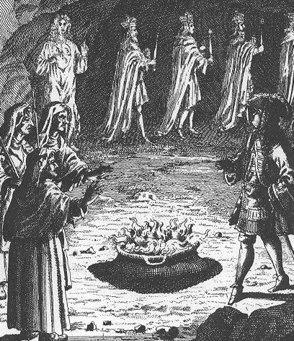

Appositive Sentences
an armed head | a bloody child | the last carrying a mirror | described as ‘midnight hags’ | a crowned child with a tree in its hand
- The witches, ____________________ , conjure three apparitions from their cauldron
- The first apparition, ____________________ , warns Macbeth to ‘beware Macduff’
- The second apparition, ____________________ , says that ‘none of woman born’ will be able to harm Macbeth
- The third apparition____________________ , appears to offer further reassurance to Macbeth
- Macbeth is finally shown a procession of eight kings, ____________________ , followed by Banquo at the end

A4S2 and A4S3: The Slaughter of Macduff’s Family

Questions to Consider
- What happens to Lady Macduff and her son after the messenger has delivered a warning?
- What dismays Macduff about Malcolm’s attitude?
- Why does Macduff describe Scotland as ‘O nation miserable’?
- What does Malcolm do when Macduff finally convinces him that he is loyal?
- What news does Ross deliver to Macduff?
- What imagery is connected to Macduff’s family?

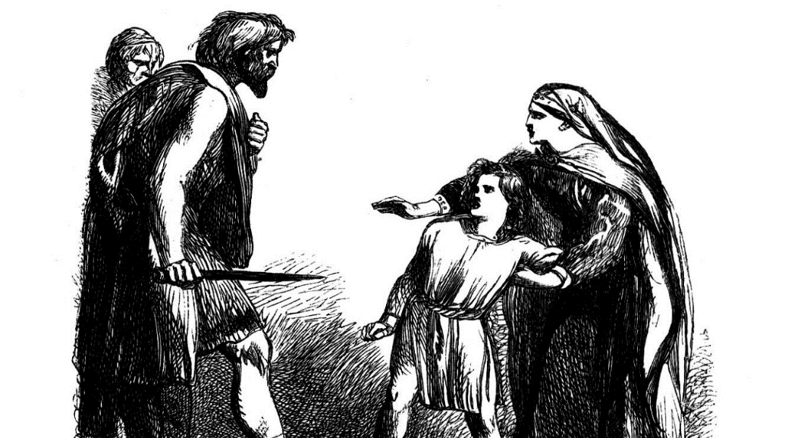

Regicide
Source: English and Media Centre
In Macbeth, as in any play of the period, the ultimate taboo is regicide: to kill the king is a heinous act, violating feudal loyalties and offending against God. Macbeth always knows that Duncan’s murder is ‘deep damnation’ […] Macbeth’s own intense mental, emotional and spiritual suffering is evident from his anguish before (and, of course, after) Duncan’s murder up to his final soliloquy where he finds only ‘Nothing’ at the heart of life. The isolation of his suffering is part of the horror of the play. […] Macbeth’s solitude is inherent to his tragedy; equally, Lady Macbeth is tormented by nightmare, horror and isolation. These two have embraced a world of blood and it haunts them.’

Appositive Sentences
reluctant to deliver the news | dismayed by Malcolm’s attitude | ‘convinced by Macduff’s noble passion’
- Macduff, _________________________, uses the metaphor of Scotland bleeding to emphasise his distress
- Malcolm, _________________________, eventually reveals that everything he previously said is untrue
- Ross, _________________________, does not immediately reveal that Macduff’s family have been ‘savagely slaughtered’

Mixed Practice Sentences
- Malcolm exclaims ‘merciful heaven!’ after he hears the news that Macduff’s family have been killed. This shows…
- The metaphor of a ‘hell-kite’ not only emphasises [ ? ] but also [ ? ]
- Macduff describes his children as ‘pretty chickens’ because…
- Although Macduff is clearly distraught, Malcolm advises him too…
- Before the end of the scene, Macduff…
A5S1: Lady Macbeth Sleepwalks

Questions to Consider
- What does Lady Macbeth do as she sleepwalks?
- What are the views of the doctor and gentlewoman?
- Where else is a lack of sleep mentioned in the play?
- Where else are bloody hands mentioned in the play?

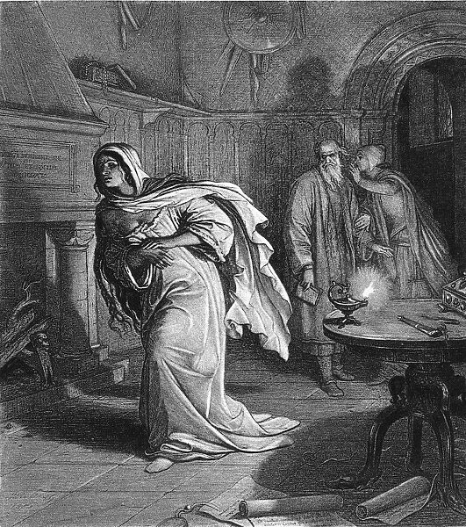

Quotations
- ‘Yet who would have thought the _______ _______ to have had so much _______ in him?’
- ‘Out damned _______, out I say!’
- ‘Here’s the smell of _______ still; all the _______ of Arabia will not sweeten this little hand’

Above All Sentences
- Above all, Lady Macbeth is presented as…
- Above all, this scene is significant because…

A5S3 and A5S5: The Death of Lady Macbeth

Questions to Consider
- How does Macbeth react to the news that Malcolm is planning to attack the castle?
- How does the doctor describe Lady Macbeth’s condition?
- What news does Seyton deliver about Lady Macbeth?
- How does Macbeth react?

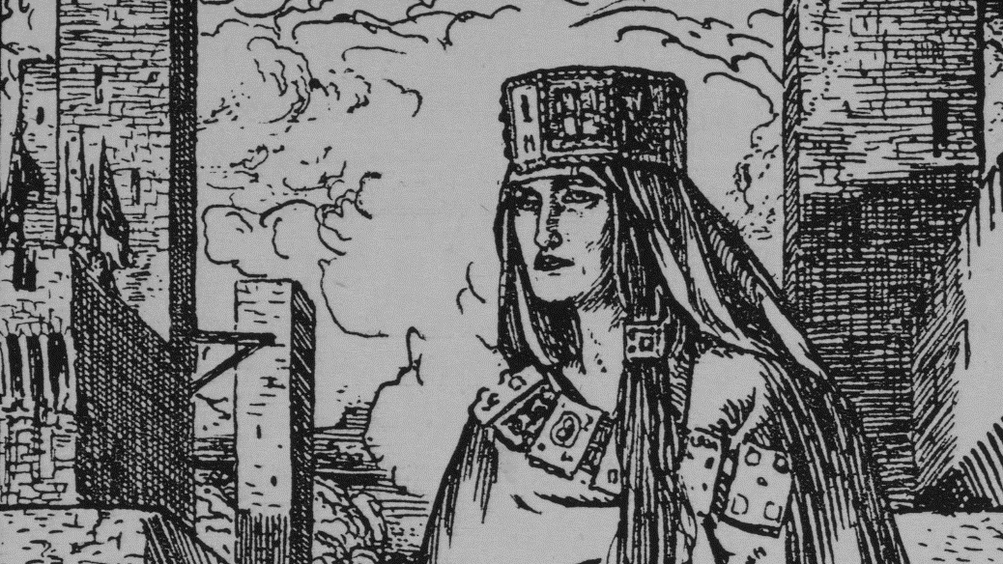

Jumbled Sentences
- is used by The metaphor of a ‘brief candle’ Macbeth the brevity of life to emphasise
- a ‘walking shadow’ the experience of life to Macbeth compares
- of ‘sound and fury’ The image that life is essentially meaningless conveys Macbeth’s view

As Revealed Sentences
- As revealed by her eventual death, Lady Macbeth…
- As revealed by Macbeth’s reaction to the news that Lady Macbeth has died, he…

A5S7, A5S8 and A5S9: The Death of Macbeth

Questions to Consider
- What does Young Siward say about Macbeth’s name (i.e. ‘title’)?
- How does Macduff address Macbeth when he encounters him on the battlefield?
- Why does Macbeth believe he lives a ‘charmed life’?
- How do we know that Macduff is eventually victorious?
- How does Malcolm describe Macbeth and Lady Macbeth at the end of the play?

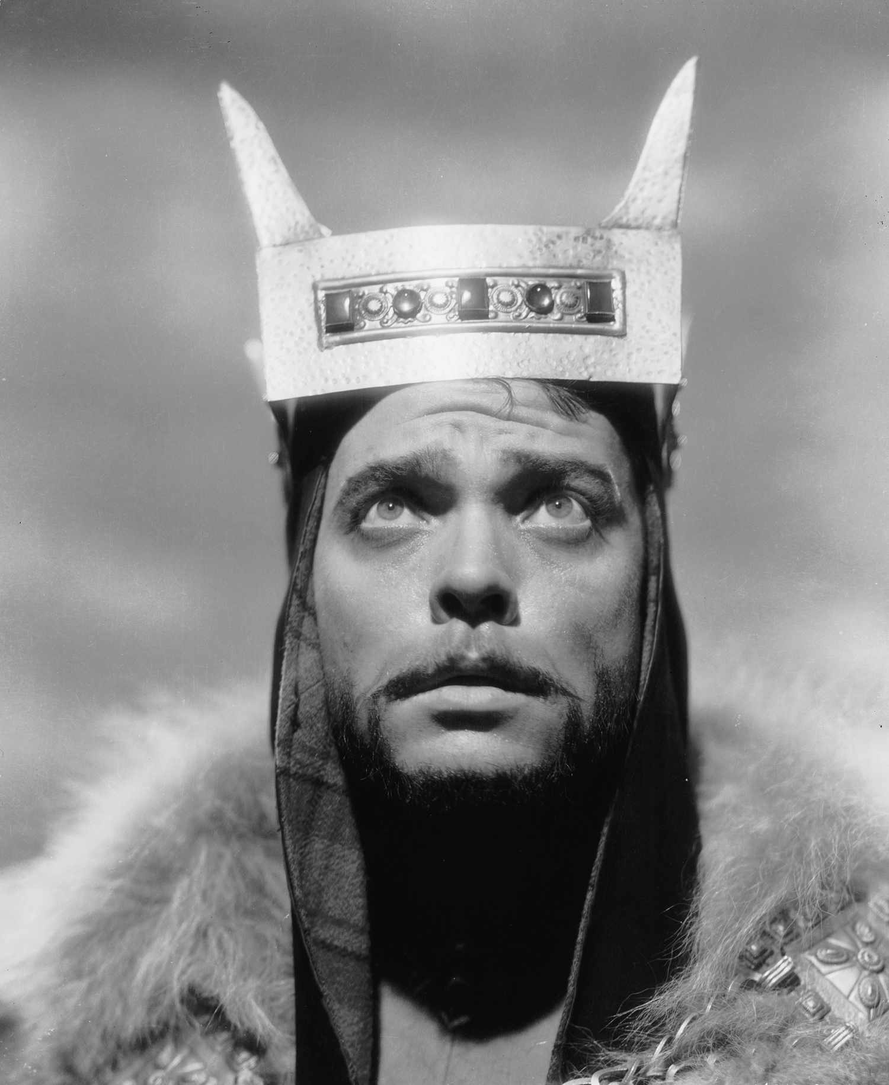

Fragment Sentences
- Young Siward + Macbeth + ‘devil’ + shows
- Although + ‘charmed life’
- Before + Macduff + encounters
- Describes + ‘tyrant’
- Macduff + revenge + victorious
- Malcolm + restored + rightful
- Macbeth + ‘dead butcher’ + not only + but also
- Lady Macbeth + ‘fiend-like queen’ + because

