Macbeth
‘Start the Lesson’ Booklet

Write down everything you can think of connected to the areas listed below

- Weather

- Witches

- Loyalty

- Violence

- Theatre

- James I
Write responses to the questions listed below

- Who was James I betrothed to and what happened to her?

- What book did James I publish in 1597 and what was it about?

- In which year was the Witchcraft Act passed and what did it entail?

- Within the context of witchcraft, what is a ‘familiar?

- In what ways is the stormy weather significant in A1-S1?

Write responses to the tasks listed below

- Cite a piece of evidence that shows James I feared witches

- Write down two reasons why the weather is stormy in A1-S1

- Retrieve two quotes that show Macbeth fought bravely in A1-S2

- Explain how Duncan rewards Macbeth

- Write down the three prophecies that the Witches make in A1-S3

Highlight the errors in the passage below and then make the corrections

Three witches plan to meet Macbeth, a warrior and Thane, after an uprising against king duncan. As the victorius Macbeth and Banquo cross a heath, the witche’s appear to them. They adress Macbeth first as thane of glamis (his current title), then as Thane of Cawdor (the title of one of the rebels) and finally as King. They also tell banquo that his descendants shall be kings. The witches vanish and noblemen approach Mcbeth to tell him that duncan has named him the knew Thane of Cawdor

Source: British Library website

Rewrite the sentences below and correct the errors

- Macbeths tragic flaw (hamartia) is his exessive ambition

- malcolm is named the Prince of Cumberland by duncan

- Mcbeth likens him to a step he ‘must fall down, or else o’erleap

- Macbeth vow’s to hide his ‘black and deap desires’

- Lady Macbeth also apeals to the darknes – ‘come thick night’

- Macbeth conceedes Duncan has bean so ‘clear in his great office’

- After having doubts Macbeth eventualy declares he is ‘settled’

Rewrite and correct the words below

- Dramatic Ironey

- Soliloquey

- Audiance

- Theater

- Shakespear

Retrieve one quotation for each of the images below

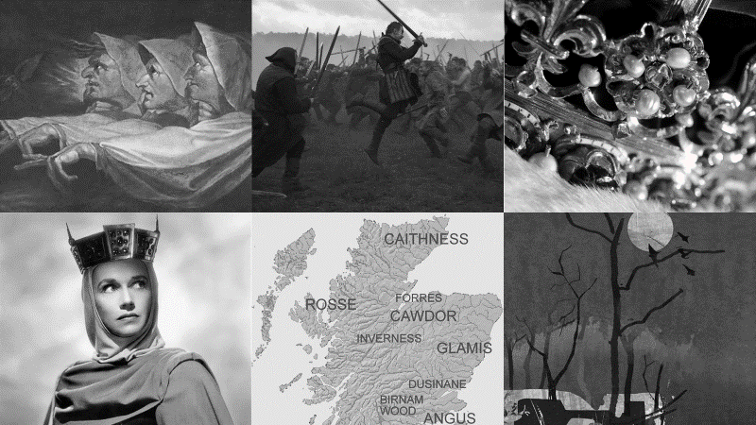

1.

2.

3.

4.

5.

6.

Write down two related words for each of the letters below

A

B

D

F

L

M

T

W

List the similarities between an archetypal tragic hero and Macbeth

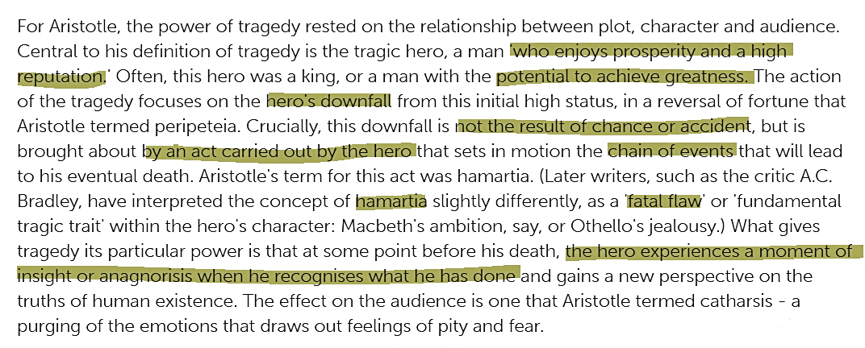

1.

2.

3.

4.

5.

6.

7.

Identify the speaker and point in the play

- ‘Methought I heard a voice cry ‘Sleep no more!’’

- ‘Approach the chamber, and destroy your sight’

- ‘Thou hast it now: king, Cawdor, Glamis, all’

- ‘Thou art too like the spirit of Banquo: down!’

- ‘Did you say all? O hell-kite! All?’

- ‘What, will these hands ne’er be clean?’

- ‘I’ll fight till from my bones my flesh be hack’d!’

Identify the speaker and point in the play

- ‘As cannons overcharged with double cracks’

- ‘That is a step on which I must fall down, or else o’erleap’

- ‘That I may pour spirits in thine ear’

- ‘I dare do all that may become a man’

- ‘A little water clears us of this deed’

- ‘O full of scorpions is my mind, dear wife’

- ‘Horrible sight!’

Retrieve a supporting quotation for each of the statements

- Macbeth regrets killing Duncan

- Lady Macbeth calls Macbeth a coward

- Macbeth stops confiding in Lady Macbeth

- Macbeth grows increasingly paranoid

Retrieve a supporting quotation for each of the statements

- Macbeth fights bravely against two rebel armies

- Macbeth has doubts about killing Duncan

- Lady Macbeth reacts angrily towards Macbeth

- Macbeth becomes increasingly isolated

Retrieve a supporting quotation for each of the highlighted statements

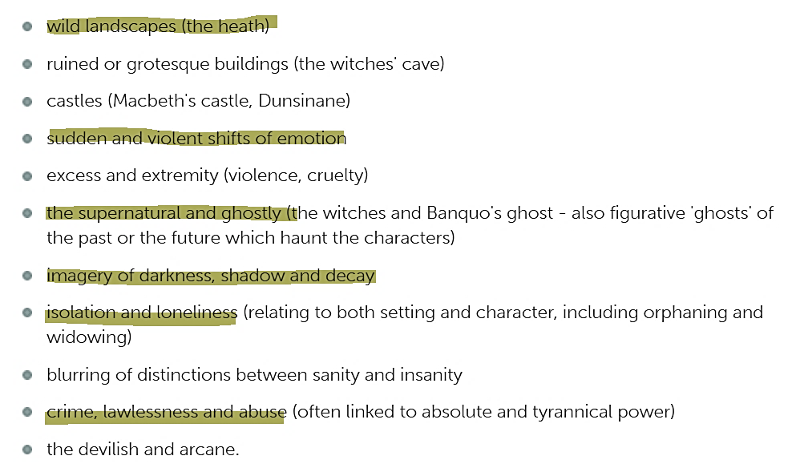

Finish the sentences for each of the acts listed below

- Act 1
Lady Macbeth is presented as…

This is shown by…

- Act 2
Lady Macbeth is presented as…

This is shown by…

- Act 3
Lady Macbeth is presented as…

This is shown by…

- Act 5
Lady Macbeth is presented as…

This is shown by…

Finish the sentences for each of the acts listed below

- Act 1
Macbeth is presented as…

This is shown by…

- Act 2
Macbeth is presented as…

This is shown by…

- Act 3
Macbeth is presented as…

This is shown by…

- Act 5
Macbeth is presented as…

This is shown by…

Put the quotations in order

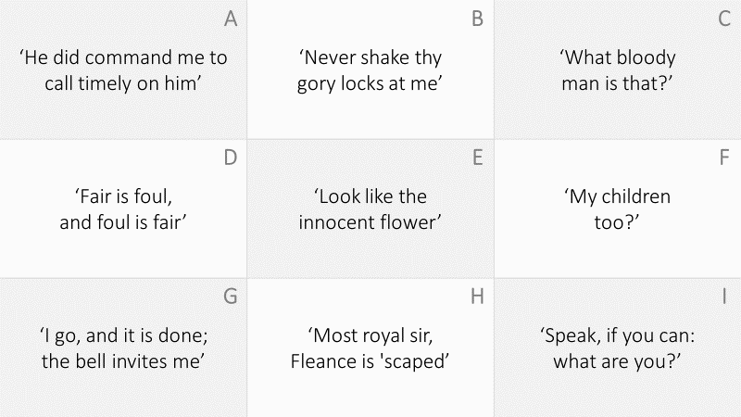

1. D

2.

3.

4.

5.

6.

7.

8.

9.

Put the events in order

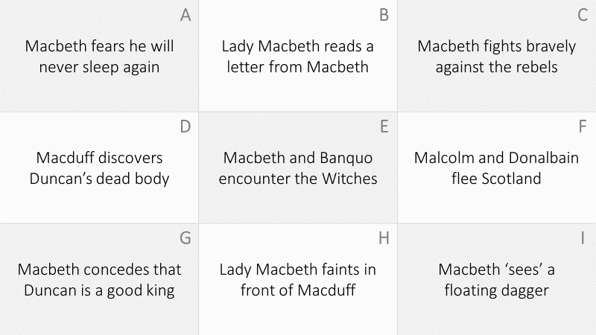

1. C

2.

3.

4.

5.

6.

7.

8.

9.

Put the quotations in order

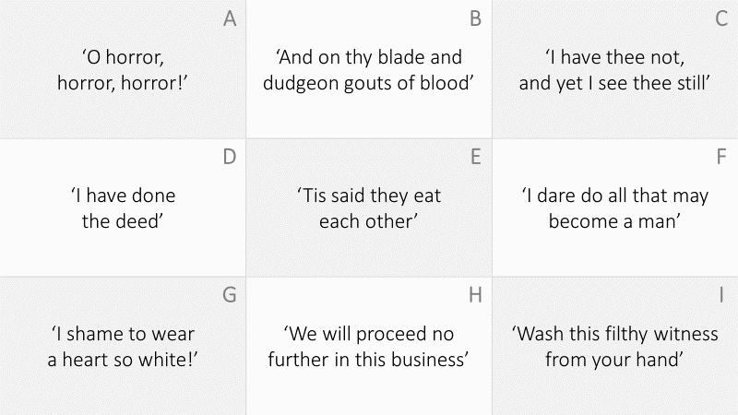

1. H

2.

3.

4.

5.

6.

7.

8.

9.

Put the events in order

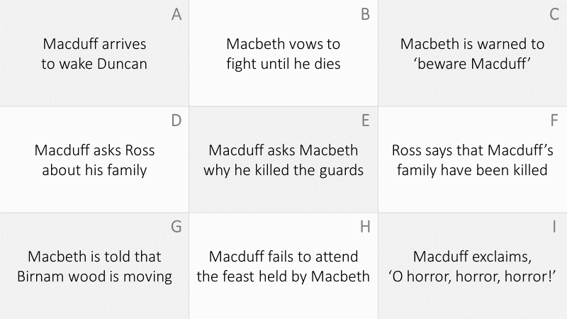

1. A

2.

3.

4.

5.

6.

7.

8.

9.

Put the events in order

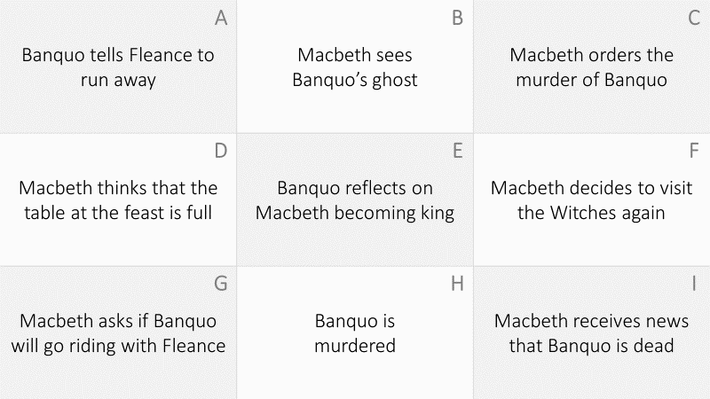

1. E

2.

3.

4.

5.

6.

7.

8.

9.

Put the events in order

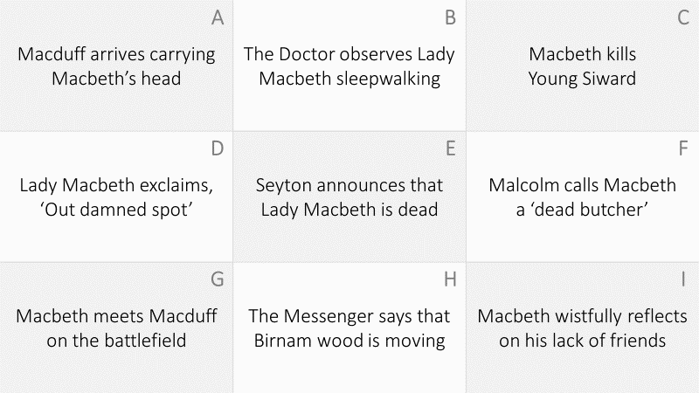

1. B

2.

3.

4.

5.

6.

7.

8.

9.

