Retrieve two quotations that  show Macbeth is courageous | What does the word  ‘enigmatic’ mean? | What did James I believe  about witches and witchcraft?
What is the  Divine Right of Kings? | 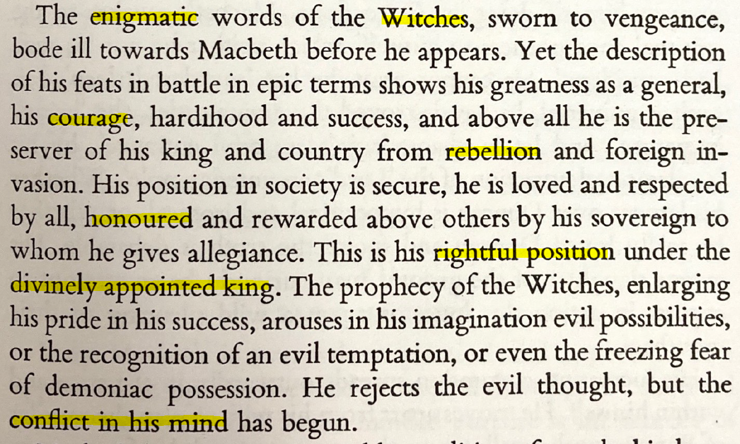  Source: Introduction to The Players’ Shakespeare edition of Macbeth (Heinemann) | Which event from 1605 has a parallel  with the rebellion against Duncan?
How does Duncan  ‘honour’ Macbeth? | Retrieve two quotations that  show Macbeth is ‘conflicted’ | How does Macbeth’s ‘rightful position’  link to the Great Chain of Being?
The Murderer announces that Banquo is dead,  but what has happened to Fleance? | What does the word  ‘emblematic’ mean? | What does the word  ‘supplant’ mean?
How does Macbeth initially react  when he sees Banquo’s ghost in his seat? | 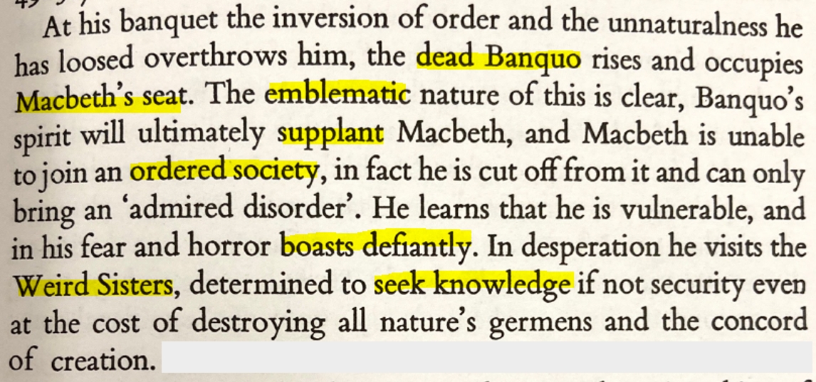  Source: Introduction to The Players’ Shakespeare edition of Macbeth (Heinemann) | What is ‘ordered society’  a reference to?
Find the line where Macbeth  says he will visit the Witches? | Retrieve two quotations that  show Macbeth ‘boasts defiantly’ | What ‘knowledge’ do the  Witches convey to Macbeth?

How do Macbeth and Banquo describe  the appearance of the Witches in A1-S3? | What does the word  ‘preoccupied’ mean? | What supernatural powers do the witches  claim to possess in lines 8-10 of A1-S3?
In which year was  Macbeth first performed? | 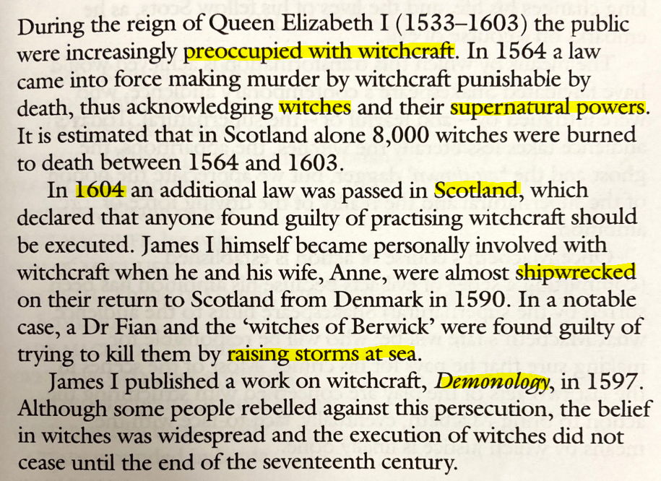  Source: Introduction to The RSA Shakespeare edition of Macbeth (Heinemann) | Why might the play be set in  Scotland (and not England)?
Find the lines from A1-S3 where the witches say they will raise a storm to punish the sea-captain | What is a rough translation  of the word ‘Demonology’? | Why does the First Witch  have a ‘pilot’s thumb’ in A1-S3?
What does the word  ‘compulsive’ mean? | What reasons ‘against the deed’ (i.e. murdering Duncan) does Macbeth reflect upon in A1-S7? | What does lack of sleep and  disturbed sleep symbolise?
Retrieve two quotations that show Macbeth  feels guilty after murdering Duncan | 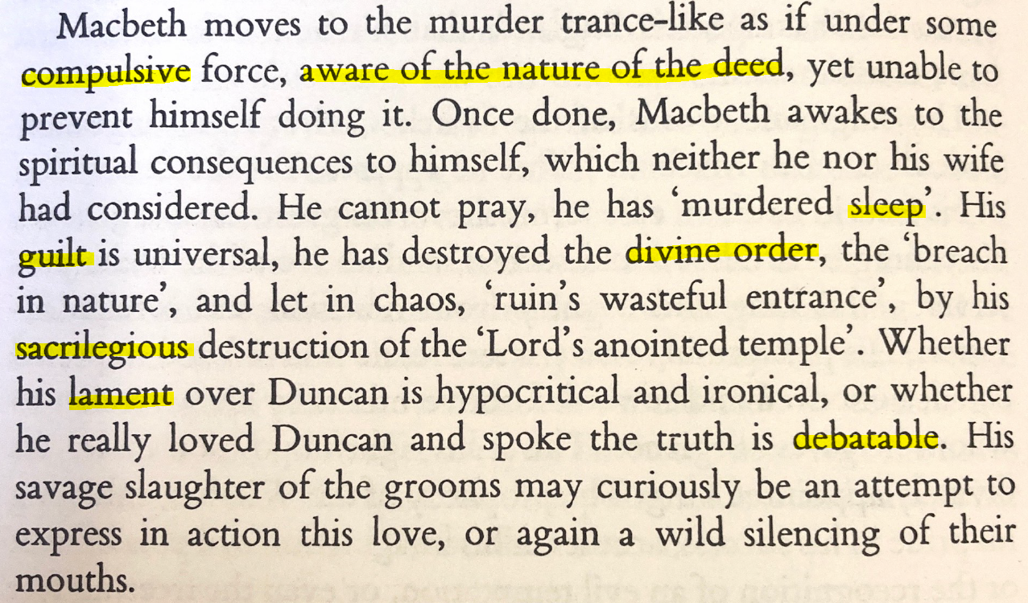  Source: Introduction to The Players’ Shakespeare edition of Macbeth (Heinemann) | What is ‘divine order’  a reference to?
How does the word ‘sacrilegious’  link to the Divine Right of Kings? | What does the word  ‘lament’ mean? | What does the word  ‘debatable’ mean?

At which point (or points) of the play do you think Macbeth’s ‘course of action is established’? | Retrieve two quotations that  show Macbeth is ambitious | What ‘hints’ does Shakespeare  provide the audience with?
What ‘evil acts’ does  Macbeth commit? | 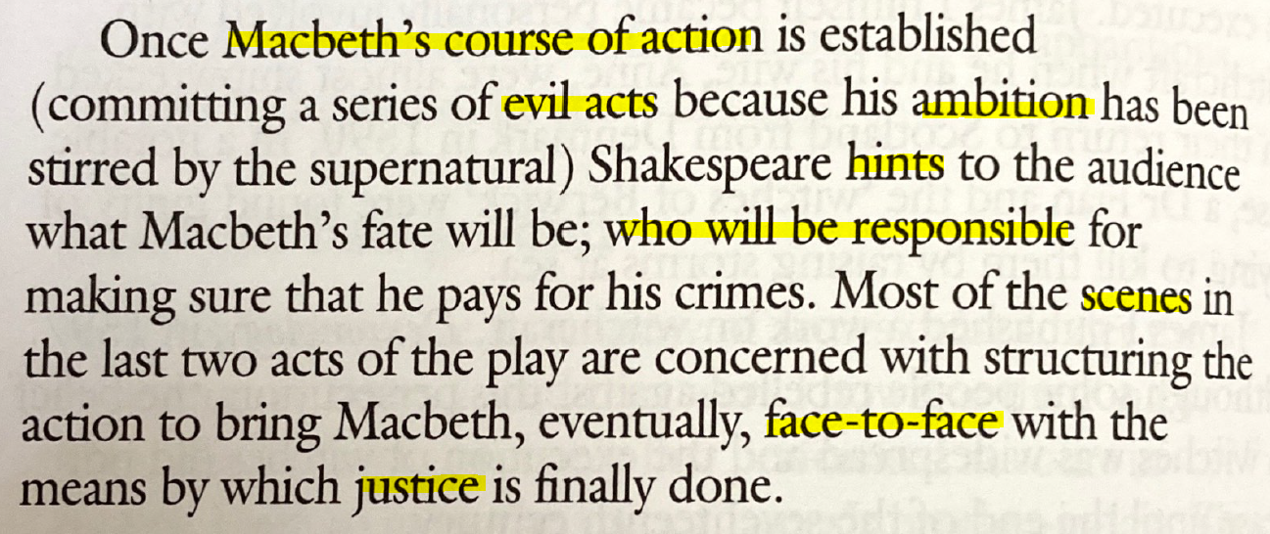  Source: Introduction to The RSA Shakespeare edition of Macbeth (Heinemann) | Who is ultimately responsible for making  sure Macbeth ‘pays for his crimes’?
In what ways is ‘justice’ finally  done at the end of the play? | Who does Macbeth eventually come  ‘face-to-face’ with and how does he react? | Retrieve two quotations from scenes that  focus on Macbeth being brought to justice

When did James I become King of England and  what threats were there to his kingship? | What ‘order’ did the  Jacobeans believe in? | What ‘unnatural’ events are reported in A2-S4 that suggest the divine order has been subverted?
What does the word  ‘divine’ mean? | 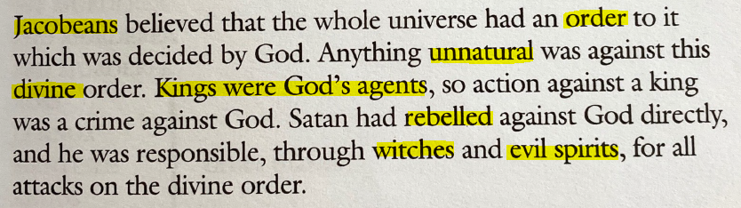  Source: Introduction to The RSA Shakespeare edition of Macbeth (Heinemann) | In what ways is a monarch  the ‘agent’ of God?
How are the Witches presented  in A1-S1 and A1-S3? | Why does Lady Macbeth  appeal to evil spirits in A1-S5? | What are the parallels between the  rebellious Thane of Cawdor and Macbeth?

