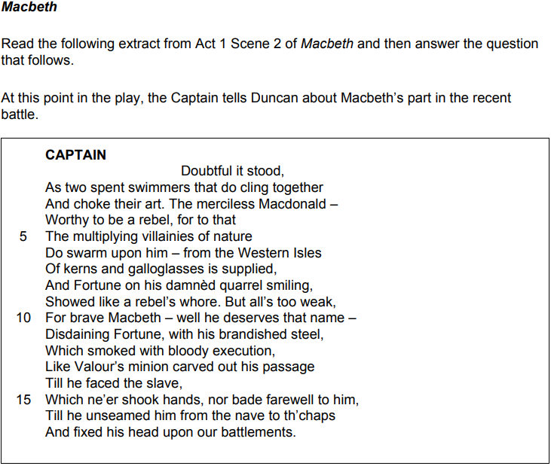

Starting with this speech, explore how far Shakespeare presents Macbeth as a hero
Write about:
- How Shakespeare presents Macbeth as a hero in this speech
- How Shakespeare presents Macbeth as a hero in the play as a whole

Key Quotations from the Extract
- ‘Doubtful it stood’ (1)

- ‘But all’s too weak for brave Macbeth’ (9-10)

- ‘Like Valour’s minion’ (13)

- ‘Till he unseamed him from the nave to th’chaps’ (16)
Key Points on the Extract
- Macbeth and Banquo are likened to swimmers drowning at sea, yet they still manage to defeat Macdonald

- This ‘doubtful’ situation on the battlefield, from which they emerge triumphant, emphasises their skill as warriors

- The Captain states that Macbeth ‘deserves’ to be called ‘brave’ – and bravery becomes his defining characteristic

- Macbeth’s prowess on the battlefield is further emphasised by his comparison to ‘Valour’s minion’

- Indeed, he fights so fiercely that his sword appears to ‘smoke’ from the slaughter of so many enemy soldiers

- Ultimately, Macbeth’s unwavering loyalty to Duncan is vividly demonstrated by his brutal execution of Macdonald

- The message to the audience is clear: loyalty is rewarded, whilst treachery is punished

- At this early stage of the play, Macbeth is a hero because he upholds the established hierarchy
Links with Act 1
- A1S3 – Macbeth reveals his ambitious nature by expressing his hope that ‘chance may crown’ him king

- A1S5 – Lady Macbeth expresses her concern that Macbeth is ‘too full o’th’ milk of human kindness’

- A1S7 – Macbeth has doubts about killing Duncan and Lady Macbeth accuses him of cowardice
Feedback
WWW:

EBI:

Reflection Tasks
- The witches are presented as looking particularly strange and grotesque. This is significant because…

- Banquo describes the witches as the ‘instruments of darkness’. This is significant because…

- Macbeth describes the thought of Duncan’s murder as a ‘horrid image’. This is significant because…

- Macbeth uses the metaphor of a ‘step’ to describe Malcolm because…

- Lady Macbeth accepts that Macbeth is ‘not without ambition’, but…

- Before Macbeth arrives on stage, Lady Macbeth… This is significant because…

- Macbeth is conflicted about murdering Duncan because…

- After Macbeth states ‘we will proceed no further in this business’, Lady Macbeth… This is significant because…

