Assessment

Read the following extract form Act 2 Scene 2 of Macbeth and then answer the question that follows. At this point in the play, Macbeth has returned to Lady Macbeth after murdering Duncan.

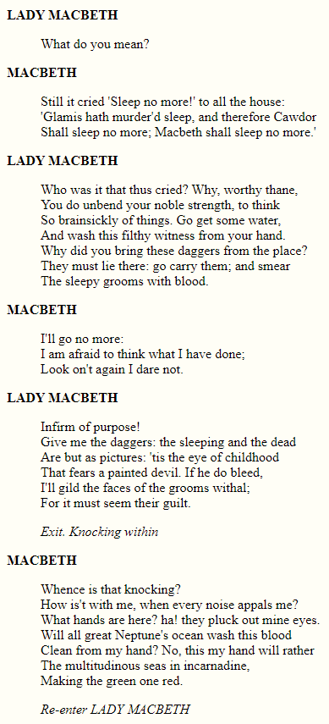

Starting with this extract, explain how you think Shakespeare presents ideas about guilt.

Write about:

- How Shakespeare presents ideas about guilt in the extract

- How Shakespeare presents ideas about guilt in the play as a whole
[30 marks]

AO4 [4 marks]
Points on the Extract

- Macbeth’s fragile, disturbed state of mind is event from his unwavering belief that he ‘hath murder’d sleep’
- Macbeth repeats ‘sleep no more’ three times to emphasise his desperation
- Lack of sleep and disturbed sleep reflect feelings of guilt and regret
- Initially, Lady Macbeth appears to be sympathetic towards Macbeth and calls her husband ‘worth thane’
- She suggests that ‘some water’ will literally cleanse the blood from his hands and metaphorically wash away the guilt
- Lady Macbeth’s frustration at Macbeth’s unwillingness to return the daggers leads her exclaim that he is ‘infirm of purpose!’
- The ‘knocking within’ builds dramatic tension and has the effect of prompting another feverish outburst form Macbeth
- He asks a series of rhetorical questions that reflect his irrational thoughts
- Macbeth believes that ‘all great Neptune’s ocean’ will be insufficient to remove the blood from his hands
- Blood is symbolic of violence and guilt

Links

- A3-S2: Macbeth grows increasingly paranoid about Banquo and exclaims that his ‘mind is full of scorpions’
- A3-S4: Macbeth hallucinates and shouts ‘let the earth hide thee!’ at Banquo’s ghost; Lady Macbeth says he lacks sleep
- A5-S1: The Doctor and Gentlewoman discuss Lady Macbeth’s sleepwalking; she exclaims, ‘Out, damn spot! Out I say!’
- A5-S3: The Doctor informs Macbeth that Lady Macbeth is ‘troubled with ‘thick coming fancies’
- A5-S5: Seyton informs Macbeth that his wife is dead; Macbeth reflects on his own insignificance – ‘Life’s but a walking shadow’

Points to Remember

- Disturbed sleep and bloody hands and are symbolic of guilt
- In the immediate aftermath of the murder, Macbeth feels intensely guilty and is unable to think or behave rationally
- Lady Macbeth’s determination contrasts to Macbeth’s mental fragility
- Later in the play, as Macbeth becomes increasingly paranoid and murderous, Lady Macbeth succumbs to feelings of guilt

Extracts from Conjuring darkness in Macbeth, by John Mullan

Key scenes of the play are set at night, and even in many of the daytime scenes characters are aware of the fading of the light. The Witches who open the play agree that they will meet Macbeth ‘ere the set of sun’; Duncan arrives at Macbeth’s castle at evening; the First Murderer, instructed by Macbeth to kill Banquo and Fleance, notes how ‘The west yet glimmers with some streaks of day’. We often feel darkness coming, especially because both Macbeth and Lady Macbeth seem to invoke and invite it. They need darkness to do their worst.

Darkness may seem to become Macbeth’s element, but his wife, once the prime mover of their plots, comes to dread it. Watching her sleepwalking, her Gentlewoman tells the Doctor that ‘she has light by her continually, ’tis her command’. Once she called ‘Come, thick night, / And pall thee in the dunnest smoke of hell’; now she feels and fears ‘Hell is murky’. In her final scene before her death, Shakespeare shows how the horror of her deeds has possessed her, and does so by dramatising the most elemental and childlike of fears: fear of the dark.

Source: https://www.bl.uk/shakespeare/articles/conjuring-darkness-in-macbeth

