Assessment

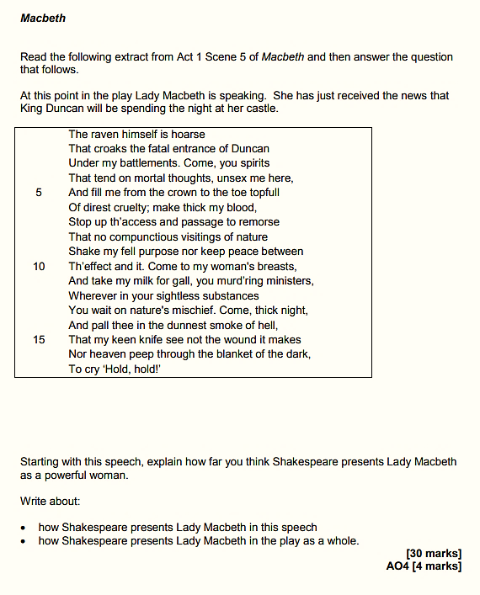

Source: https://filestore.aqa.org.uk/resources/english/AQA-87021-SQP-V1.PDF

Points on the Extract

- This is the first time the audience sees Lady Macbeth
- The raven is symbolic of death and Lady Macbeth’s murderous intentions
- Lady Macbeth’s direct appeal to the spirit world emphasises her cruel, evil nature
- This is further emphasised by her references to the ‘thick night’ and ‘smoke of hell’
- Lady Macbeth’s rejection of her femininity helps to establish her as a ruthless character
- Techniques to explore: tone, alliteration, sibilance, symbolism, metaphor.

Links

- A1-S5: Lady Macbeth concedes that her husband lacks ruthlessness; she initially flatters him; she reassures about her plan
- A1-S7: Lady Macbeth calls her husband a coward; she accuses him of breaking his promise; she attempts to reassure him
- A2-S2: More accusations of cowardice; Lady Macbeth’s confidence and strength contrasts to Macbeth’s mental fragility
- A3-S4: Lady Macbeth attempts to reassure the Scottish nobles; she despairs at Macbeth’s erratic behaviour
- A5-S1: Lady Macbeth is plagued by guilt; she sleepwalks whilst darkly remembering Duncan and Macduff’s family

Extracts from Character analysis: Lady Macbeth, by Michael Donkor

Act 1, Scene 5 of Macbeth is set in Macbeth’s castle in Inverness. It forms part of the audience’s first encountering of Lady Macbeth. Lady Macbeth has just read Macbeth’s letter, which outlines the weird sisters’ prophecies. She proceeds to express to herself her concern that Macbeth does not possess the steeliness or desire to use underhand means to acquire the glittering titles the witches have said lay before him.

In this scene, Lady Macbeth’s characterisation is used to continue the play’s steady ratcheting up of tension. The suspense of this passage is enhanced by the fact that Lady Macbeth’s soliloquy after the messenger has left is uttered in a stolen moment of stillness before action and fretful dialogue commences. It is a fleeting opportunity for her to consider her own feelings and responses to the unfolding events before Macbeth enters with weaknesses that will inevitably require her ‘tending’.

The soliloquy’s opening image – a croaking raven – is a telling one. The bird not only has associations of ill omens but was also renowned for eating the decayed flesh of fallen soldiers on battlefields, closely linking to the idea of the Macbeths – and Lady Macbeth in particular – being a sinister, parasitical couple feeding on the lives of those more powerful and benevolent than themselves.

[Lady Macbeth] does not want to remain in a sexless, physically diminished state. She also wants to be reconstituted and refigured as a being hard and armoured like her warrior husband; as a monstrous being with unnaturally thickened blood and breasts that produce deadly poisonous ‘gall’.

The most familiar, recognisable reading of Lady Macbeth’s role in the play is that she is the puppet master who pulls – often mercilessly yanks – at Macbeth’s strings. Several aspects of her portrayal in Act 1, Scene 5 add to this view. When Macbeth enters, not only does she shape and direct his behaviour, she also speaks significantly more than he does. Macbeth’s utterances are concise and practical, hers expansive, detailed and richly embroidered with imagery, reflecting the elaborate workings of a mind masterminding a dastardly plan.

Source: https://www.bl.uk/shakespeare/articles/character-analysis-lady-macbeth

