**Plot**

**1**

1. What is the significance of the stormy weather in A1-S1?
2. What images are used to describe Macbeth in A1-S2?
3. In what ways is the physical appearance of the witches significant in A1-S3
4. How does Macbeth react when Malcolm is named as Duncan’s successor in A1-S4?
5. What doubt does Lady Macbeth have about Macbeth in A1-S5?
6. What reasons does Macbeth have for not going ahead with the murder in A1-S7?

**Characterisation**

1. Explain how Macbeth is presented in A1-S2 (i.e. before he meets the witches)
2. Explain how the reactions of Macbeth and Banquo differ when they hear the prophecies in A1
3. Explain how Lady Macbeth is presented in A1-S5 (i.e. when she first appears on stage)
4. Explain how the relationship between Macbeth and Lady Macbeth is presented in A1
5. Explain which of Macbeth’s characteristics are particularly emphasised in A1

**Quotations**

1. Fair is _______________ , and foul is _______________
2. But all’s too _______________ for brave _______________
3. All hail, _______________ , that shalt be _______________ hereafter
4. If _______________ will have me king, why, _______________ may crown me, without my stir
5. That is a _______________ on which I must fall down or else _______________
6. I fear thy _______________ is too full o’ th _______________ of human kindness
7. Look like the _______________ _______________, but be the _______________ under’t
8. He’s here in double _______________
9. Vaulting _______________

**Personal Response**

* Write a detailed paragraph on what happens before, during and after this part of the play

**Plot**

**2**

1. What is the significance of the nocturnal setting in A2-S1?
2. What sounds build tension in A2-S2?
3. In what sense does Macbeth have red hands and a white heart in A2-S2?
4. Why does Lady Macbeth accuse Macbeth of cowardice in A2-S2?
5. Why is Lennox’s report about the weather in A2-S3 significant?
6. Why does Macduff call the murder of Duncan a sacrilegious act in A2-S3
7. Why does Lady Macbeth faint in A2-S3?
8. What happens in A2-S3 to leave Macbeth free to claim the throne?
9. What three unnatural events do Ross and the Old Man say have occurred in A2-S4?

**Characterisation**

1. Explain how Macbeth behaves after murdering Duncan in A2
2. Explain how the relationship between Macbeth and Lady Macbeth is presented in A2
3. Explain which of Lady Macbeth’s characteristics are particularly emphasised in A2
4. Explain how the audience know there is growing tension between Macbeth and Macduff in A2

**Quotations**

1. Is this a _______________ which I see before me / the handle toward my hand?
2. This is a _______________ sight’
3. My _______________ are of your color, but I shame / To wear a heart so _______________
4. O _______________, horror, _______________ !
5. By th’ clock ’tis day / And yet dark _______________ strangles the traveling _______________

**Personal Response**

* Write a detailed paragraph on how Macbeth is presented in the passage below from A2-S2

**Plot**

**3**

1. What fears does Banquo express in his soliloquy in A3-S1?
2. What anxieties does Macbeth express in A3-S1?
3. Why does Lady Macbeth advise Macbeth to change his mood A3-S2?
4. How does Macbeth react to the news that Fleance is still alive in A3-S4?
5. What earlier vision does Lady Macbeth recall when Macbeth sees Banquo’s ghost in A3-S4 ?
6. What is the symbolic significance of the feast ending in chaos in A3-S4?
7. What character does Macbeth say is notably absent at the end of A3-S4?

**Characterisation**

1. Explain how the relationship between Macbeth and Lady Macbeth has changed in A3
2. Explain which of Macbeth’s characteristics are particularly emphasised in A3
3. Identify three things that show Macbeth is an increasingly isolated figure in A3

**Quotations**

1. Thou hast it now – _______________ , Cawdor, Glamis, all
2. Upon my head they placed a _______________ _______________
3. O, full of _______________ is my mind, dear wife!
4. Most royal sir, _______________ is ’scaped
5. The _______________ full’
6. Never shake thy _______________ _______________ at me
7. You lack the season of all natures, _______________

**Personal Response**

* Write a paragraph that explains how Macbeth has risen from Thane of Glamis to King of Scotland

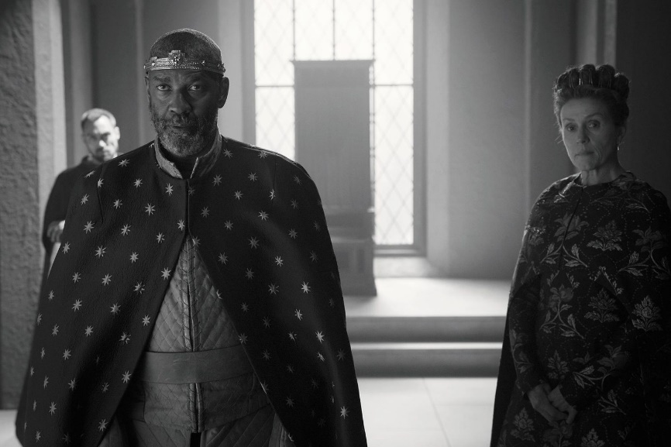

**Plot**

**4**

1. What is the significance of the weather at the start of in A4-S1?
2. What three apparitions is Macbeth shown in A4-S1?
3. How does Macbeth react to seeing the procession of kings in A4-S1?
4. Why does Macduff visit Malcolm in England in A4-S3?
5. How does Macduff react to the news that his family has been slaughtered in A4-S3?
6. What imagery is Scotland associated with in A4-S3?
7. What imagery is Macbeth associated with in A4-S3?

**Characterisation**

1. Explain how Macbeth’s outlook changes after he sees the apparitions in A4
2. Explain which of Macbeth’s characteristics are particularly emphasised in A4
3. Identify three characteristics that define the character of Macduff in A4

**Quotations**

1. How now, you secret, black, and _______________ hags
2. Macbeth! _______________ ! Macbeth! Beware _______________ !
3. For none of _______________ born shall harm Macbeth
4. Macbeth shall never vanquished be until Great _______________ Wood to high Dunsinane Hill
5. Thy _______________ does sear mine eyeballs
6. _______________, _______________, poor country!
7. What, all my _______________ _______________ and their dam at one fell swoop

**Personal Response**

* Write a paragraph about how Macduff uses language to convey his feelings about the murders

**Plot**

**5**

1. What do the Doctor and Gentlewoman believe is troubling Lady Macbeth in A5-S1?
2. What images are particularly significant in A5-S1?
3. How does Macbeth react to the news that the English army is advancing in A5-S3?
4. What moment of insight does Macbeth have in A5-S3?
5. How does Macbeth respond to the news of the death of Lady Macbeth in A5-S5?
6. How does Macduff describe Macbeth in A5-S8?
7. How does Malcolm describe Macbeth and Lady Macbeth at the end of A5-S9?

**Characterisation**

1. Explain which of Macbeth’s characteristics are particularly emphasised in A5
2. Identify three characteristics that define the character of Macduff in A5
3. Explain how Macbeth has changed since the start of the play when compared to A5

**Quotations**

1. Out, damned _______________ , _______________ , I say!
2. What, will these _______________ ne’er be _______________ ?
3. My way of life is fall’n into the sere, the _______________ leaf
4. _______________ and tomorrow and _______________
5. Out, out, brief _______________ !
6. Turn, _______________ , turn!
7. This _______________ butcher and his fiend-like _______________

**Personal Response**

* Write a paragraph explaining why Lady Macbeth is called a ‘fiend-like queen’

