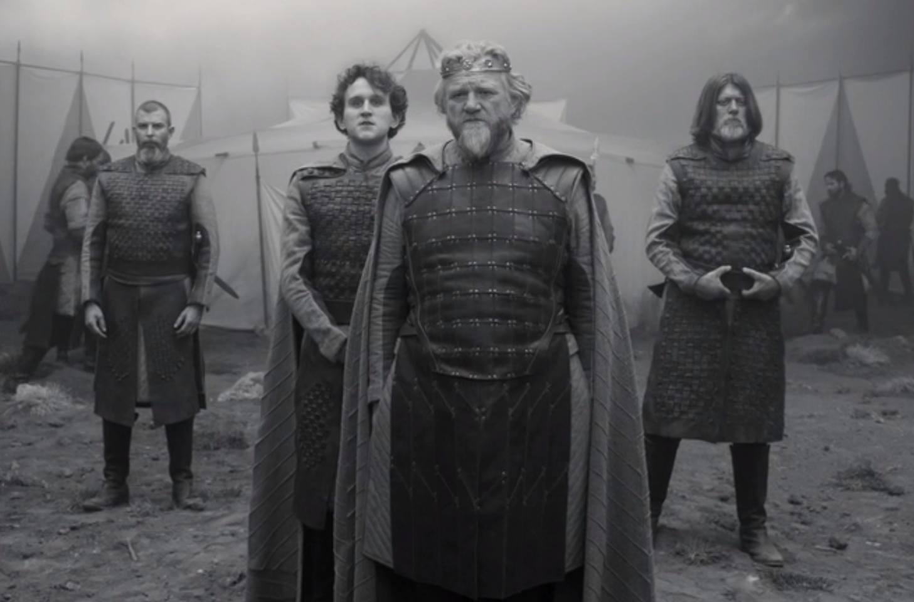  ‘Go pronounce his present death,  And with his former title greet Macbeth’ | 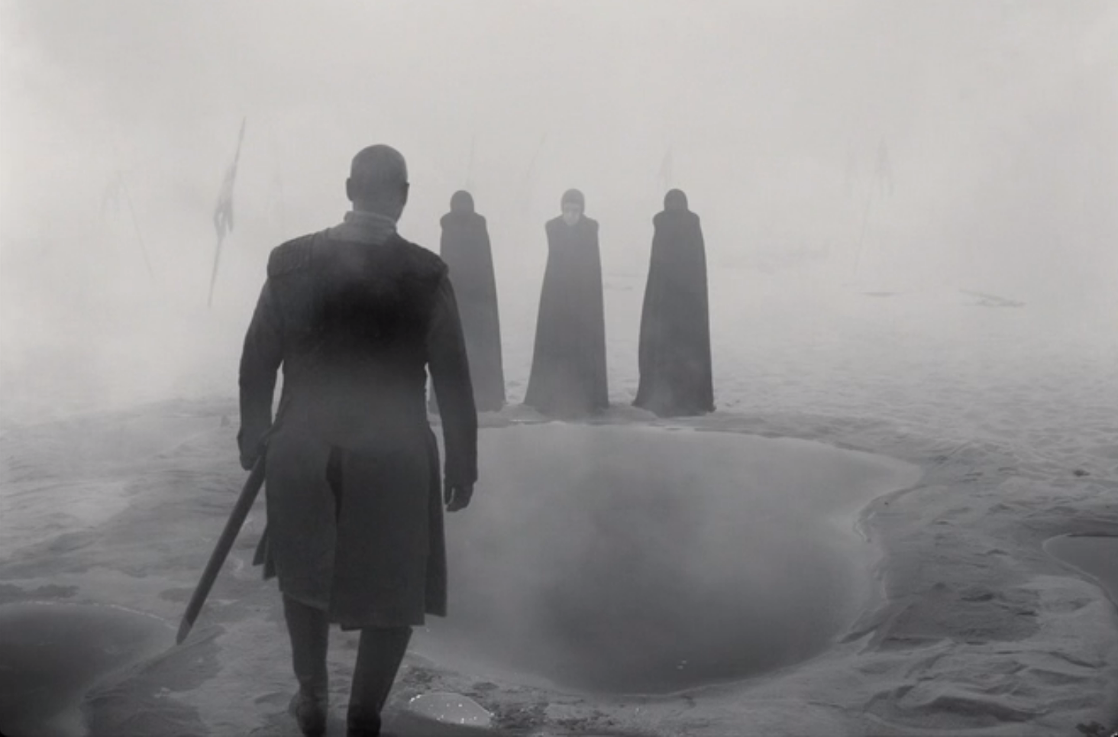  ‘If chance will have me King, why chance may crown me  Without my stir’
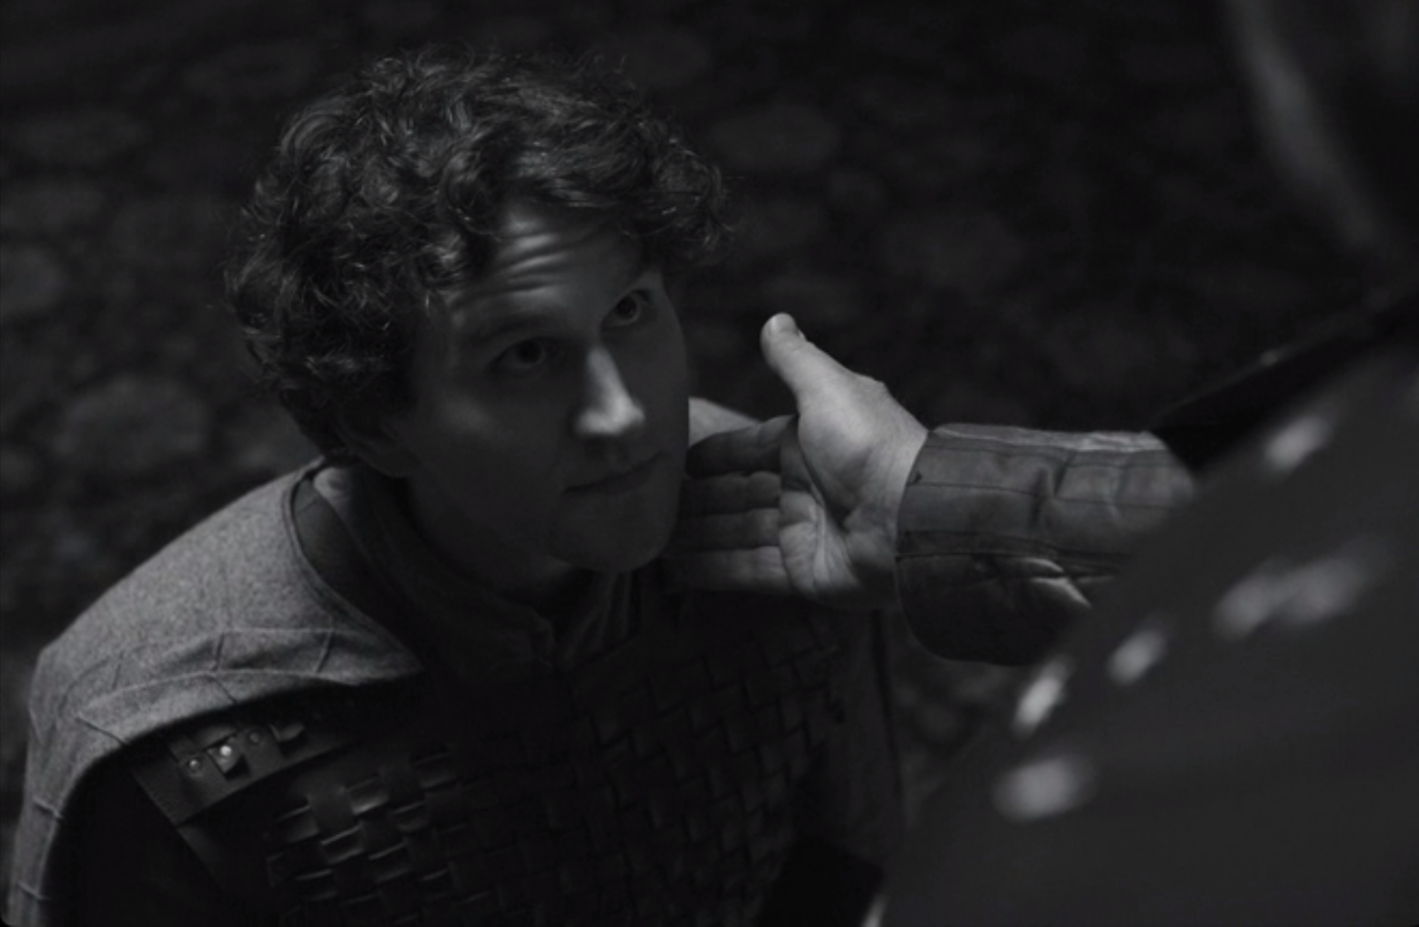  ‘The Prince of Cumberland – that is a step,  On which I must fall down, or else o’erleap’ | 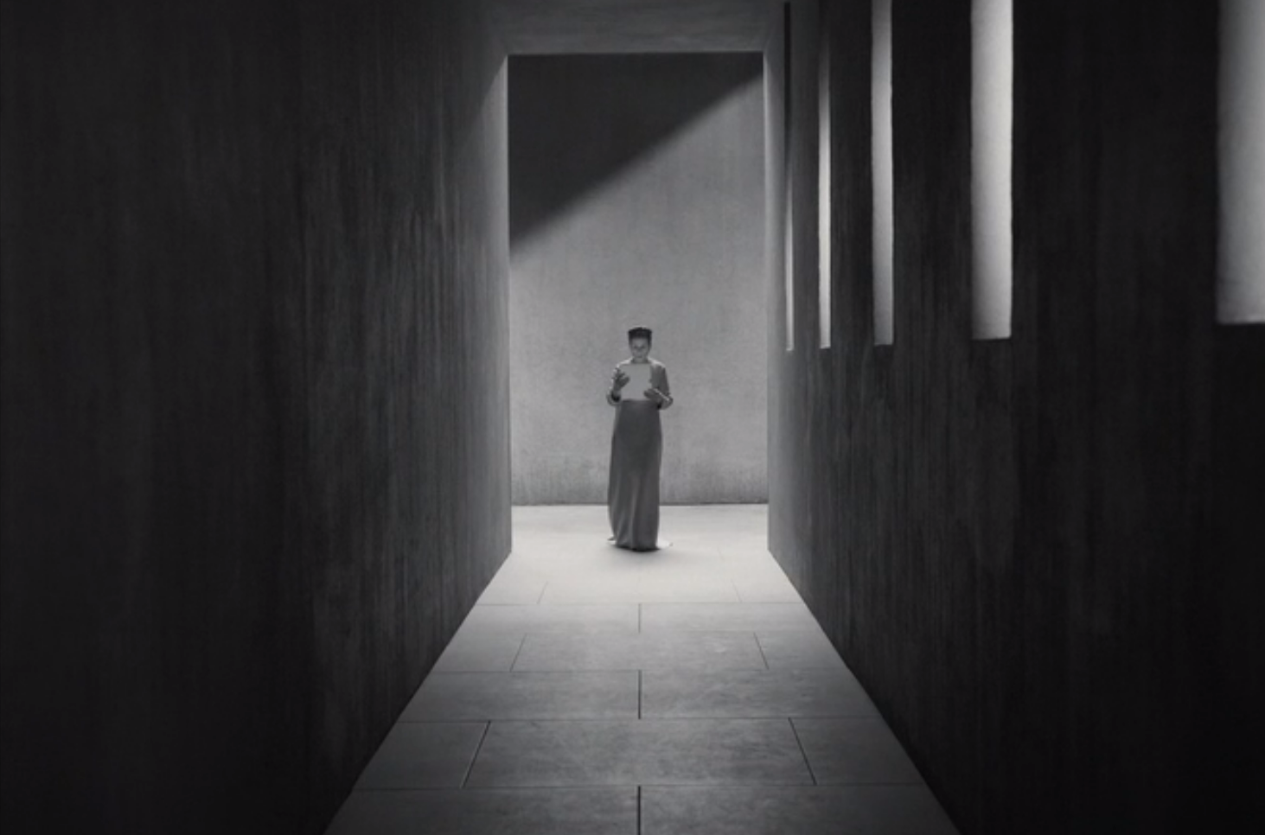  ‘I fear thy nature,  It is too full o’ th’ milk of human kindness’
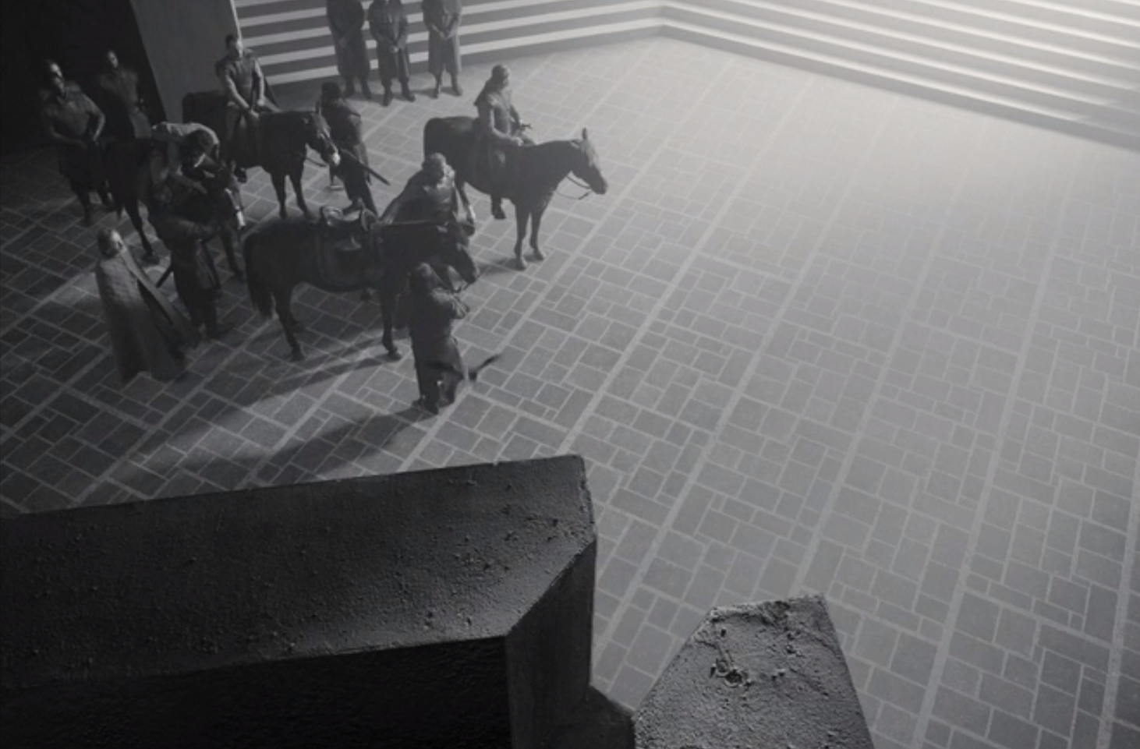  ‘My dearest love.  Duncan comes here tonight’ | 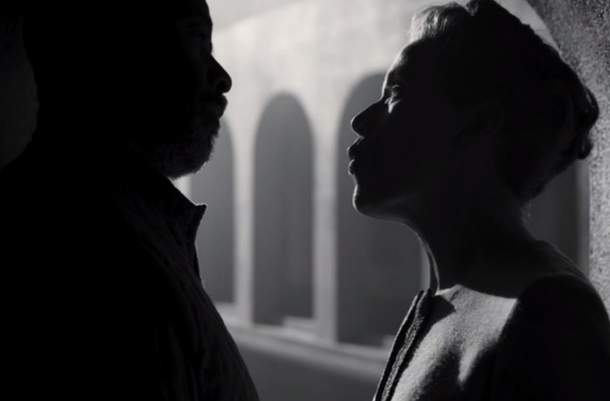  ‘We will proceed no further in this business.  He hath honoured me of late’
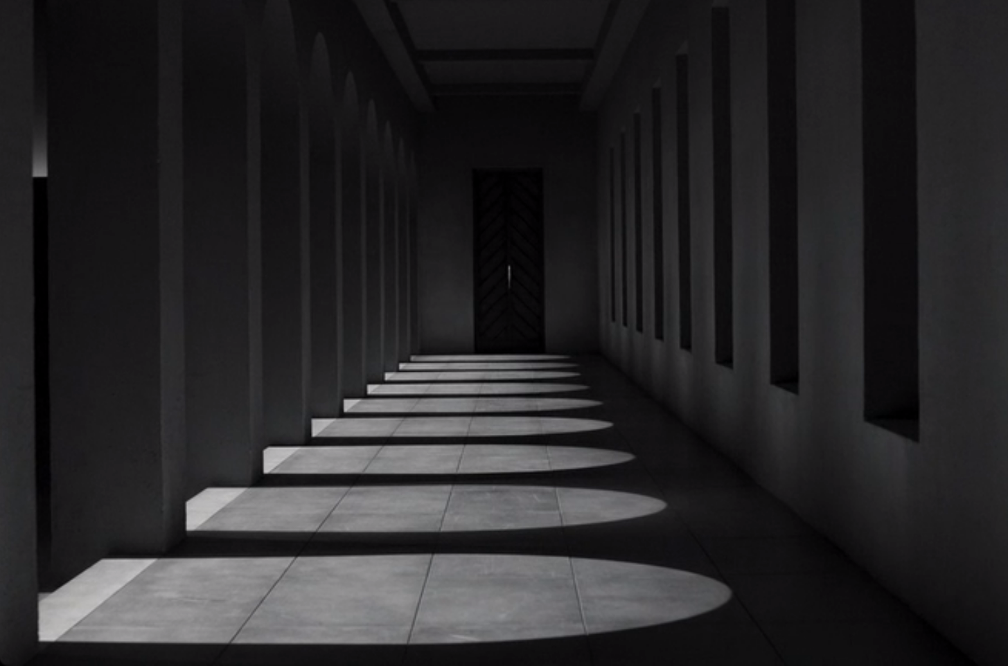  ‘Hear it not Duncan, for it is a knell  That summons thee to heaven or to hell’ | 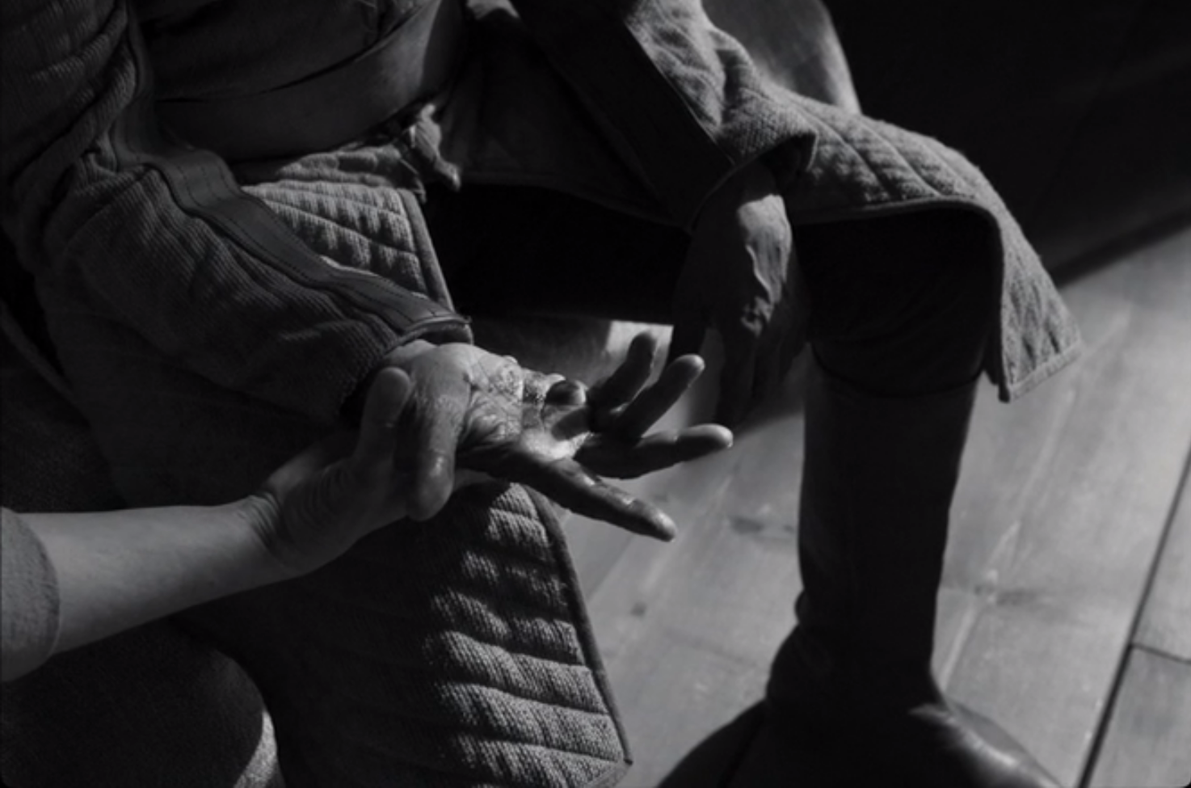  ‘Will all great Neptune’s ocean wash this blood  Clean from my hand?’
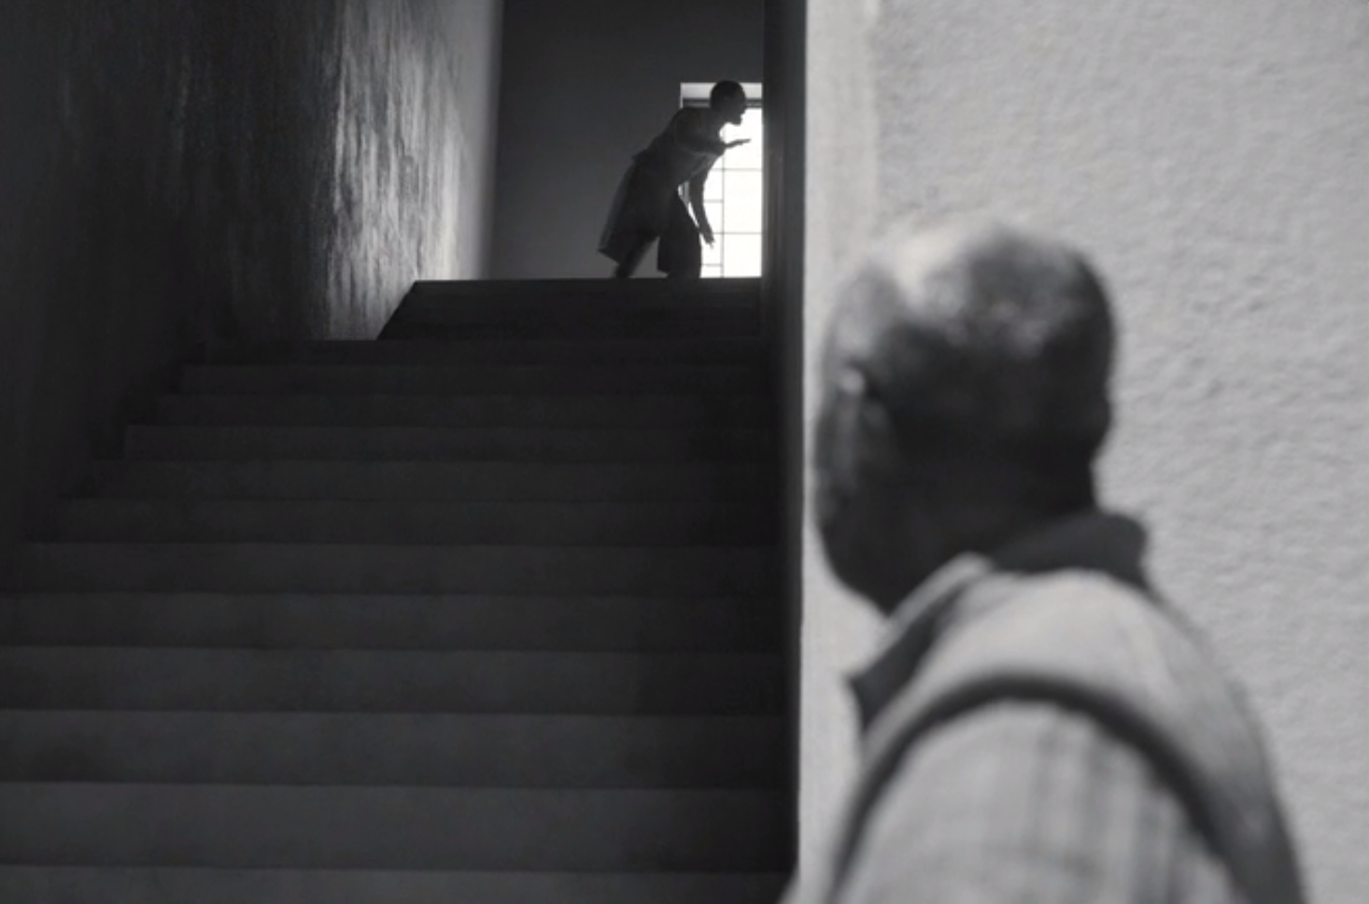  ‘O horror, horror, horror! Tongue nor heart  Cannot conceive nor name thee’ | 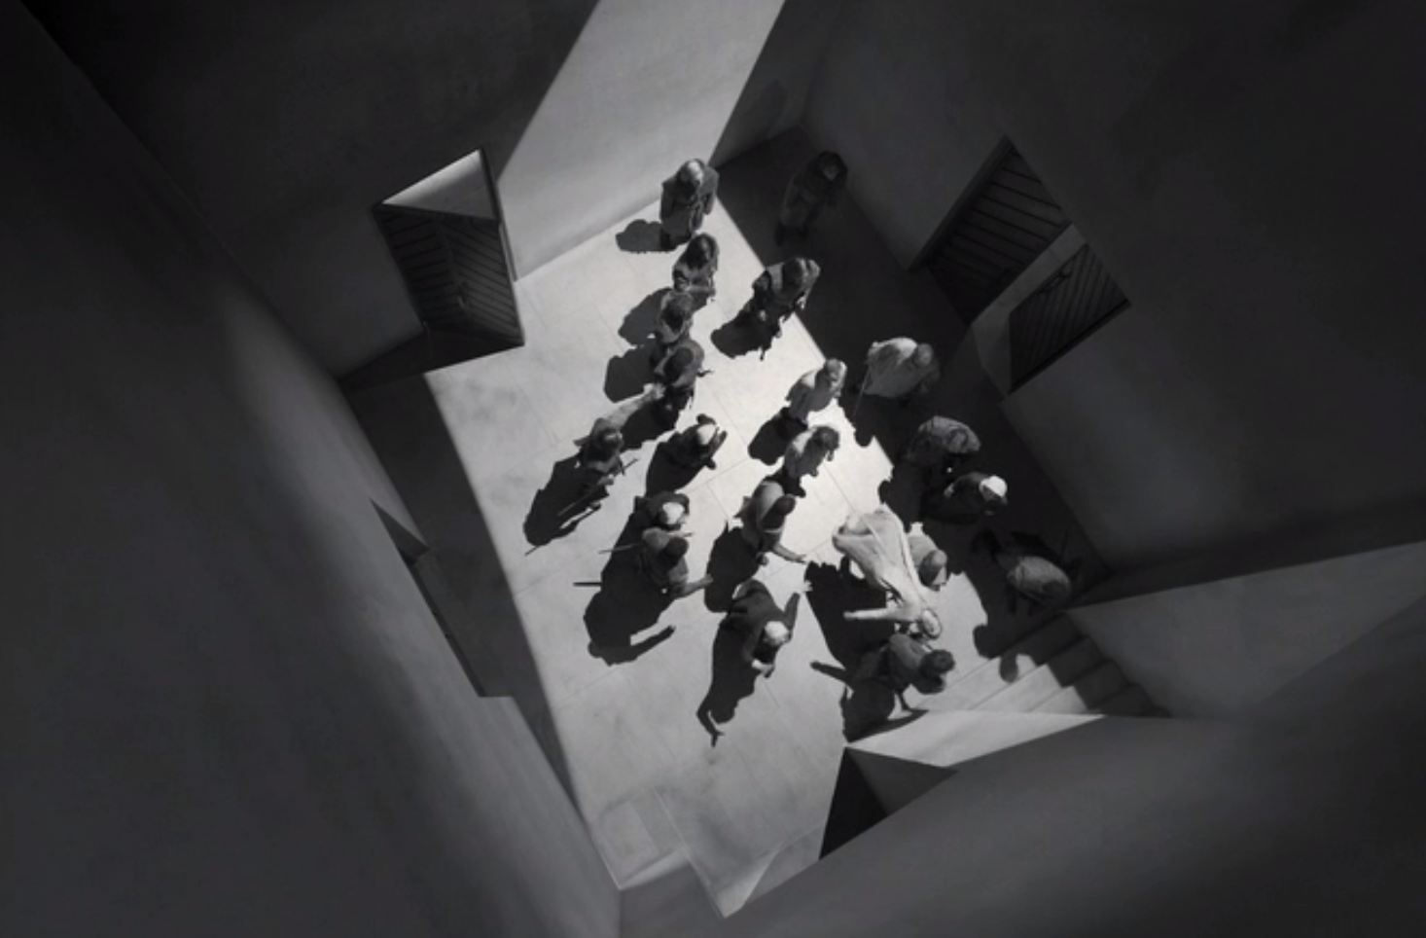  ‘O gentle lady,  ’Tis not for you to hear what I can speak’
‘The Prince of Cumberland – that is a step,  On which I must fall down, or else o’erleap’ | ‘I fear thy nature,  It is too full o’ th’ milk of human kindness’
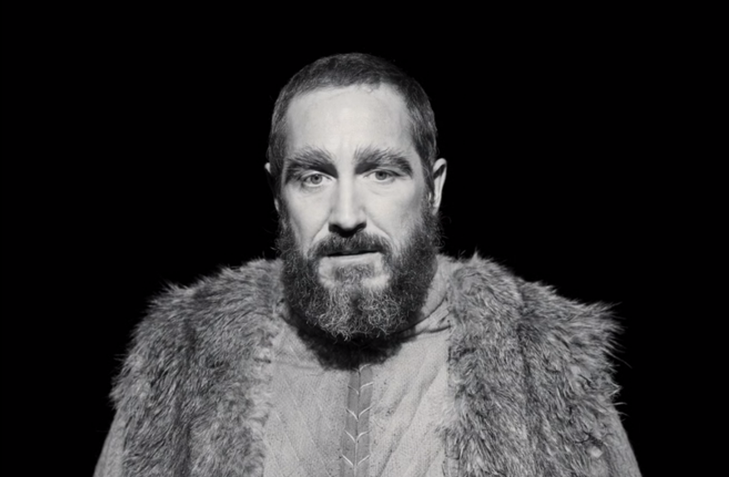  ‘Thou hast in now, King, Cawdor, Glamis, all,  As the weird women promised’ | 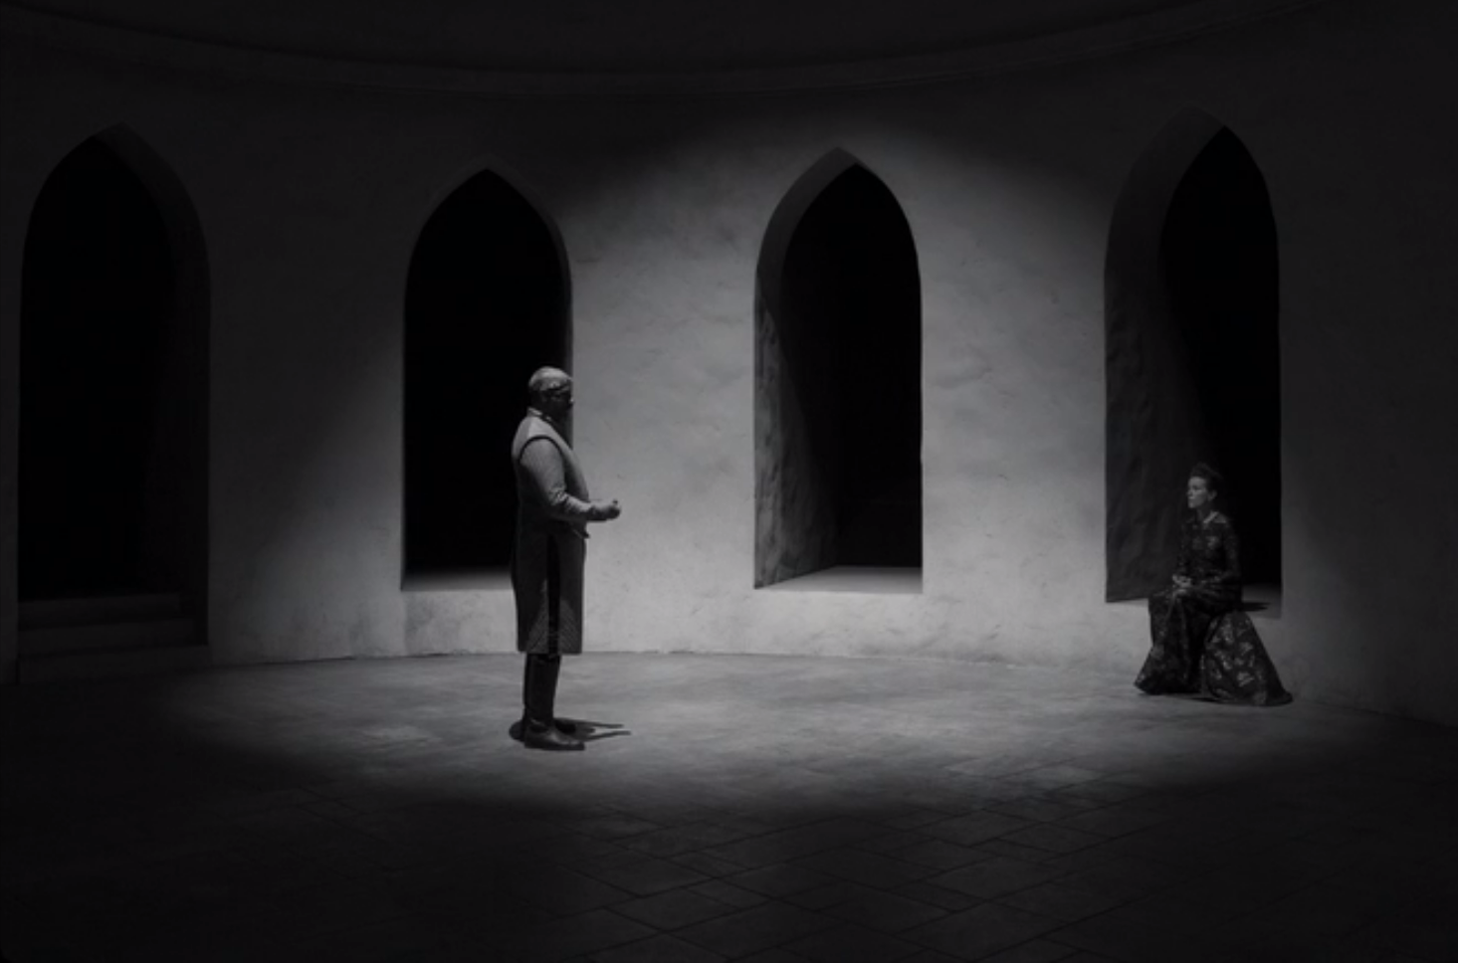  ‘O full of scorpions is my mind, dear wife.  Thou know’st that Banquo and his Fleance, lives’
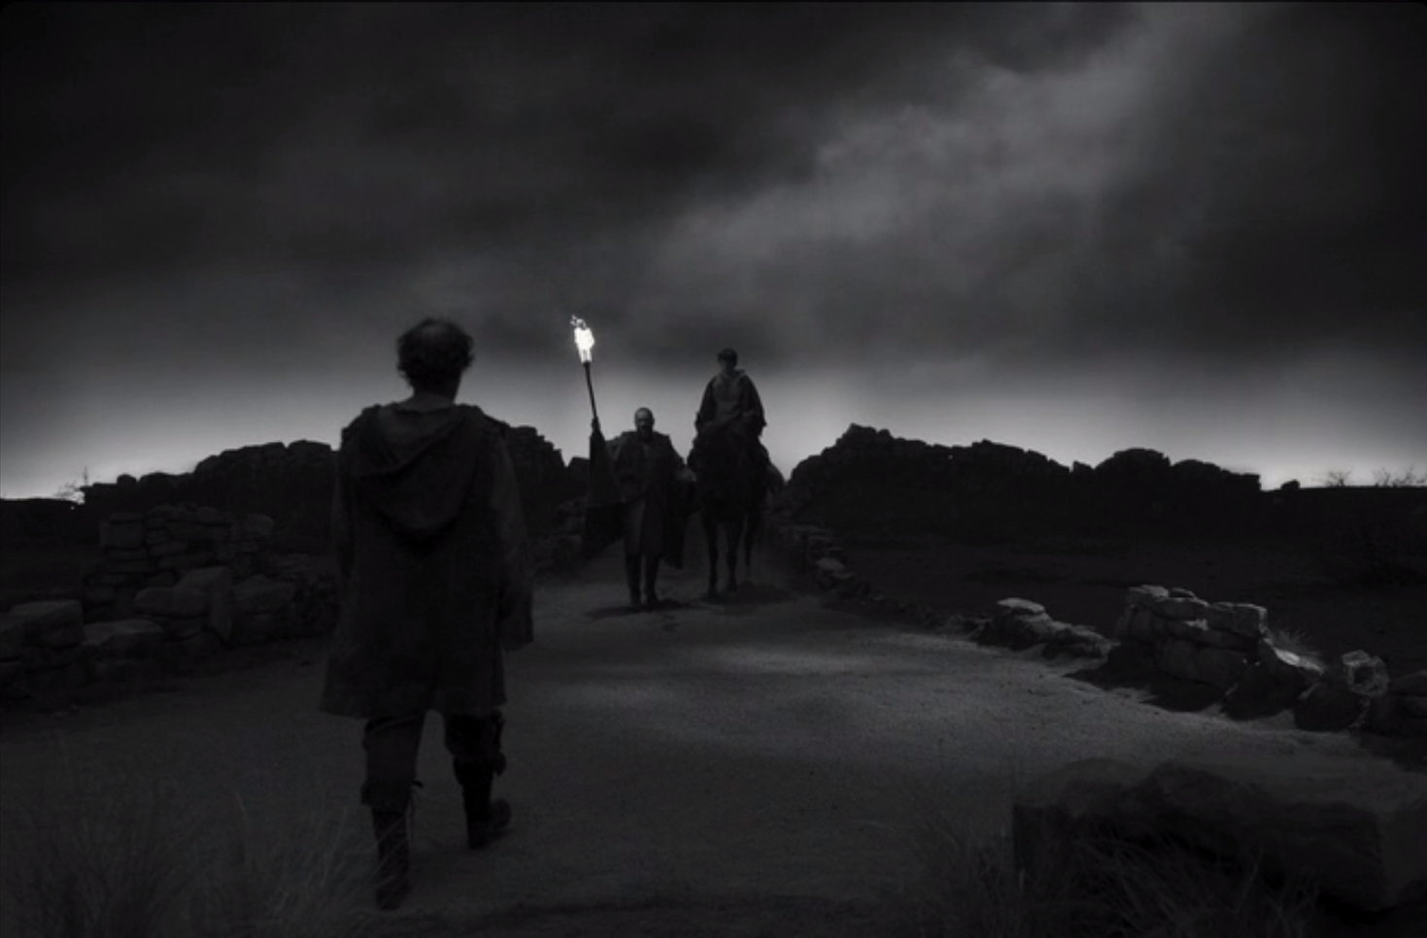  ‘O treachery! Fly good Fleance, fly, fly, fly!  Thou mayest revenge’ | 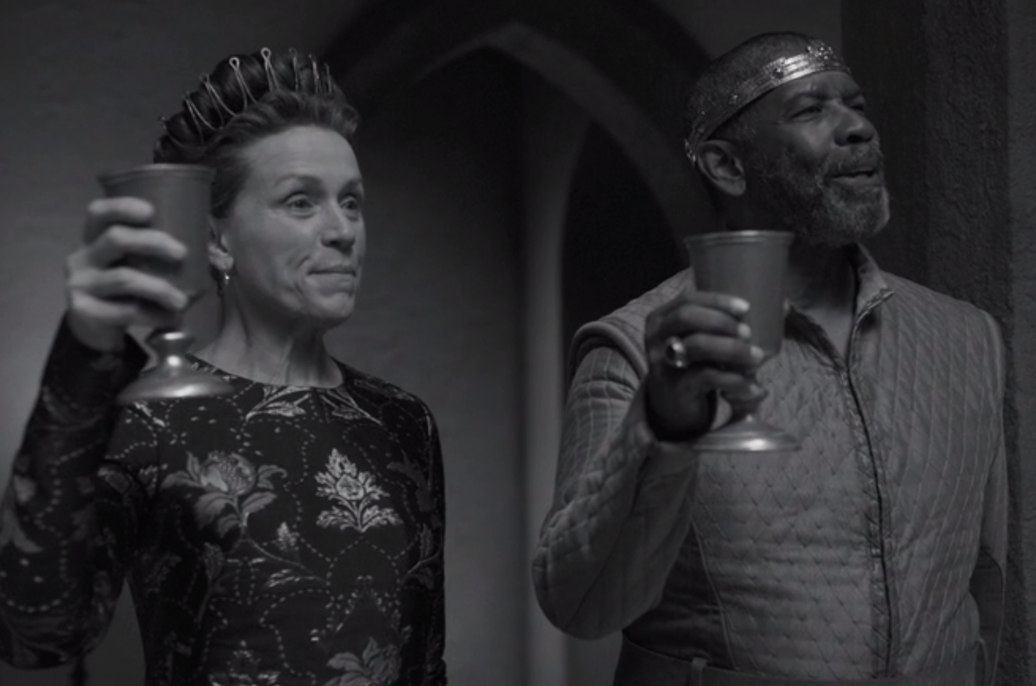  ‘Be large in mirth, anon we’ll drink a measure  The table round’
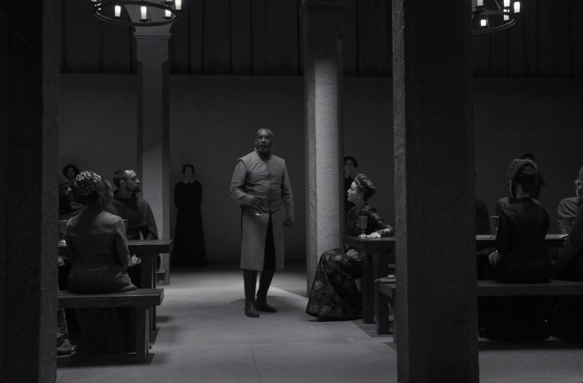  ‘Thou canst not say I did it; never shake  Thy gory locks at me’ | 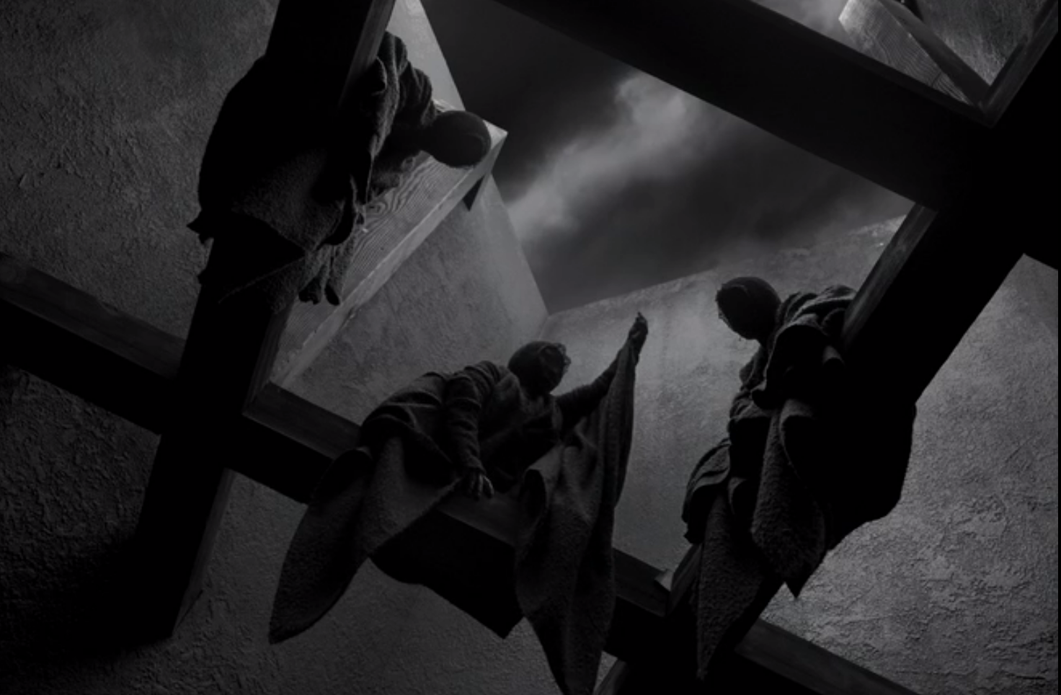  ‘How now, you secret, black, and midnight hags!  What is’t you do?
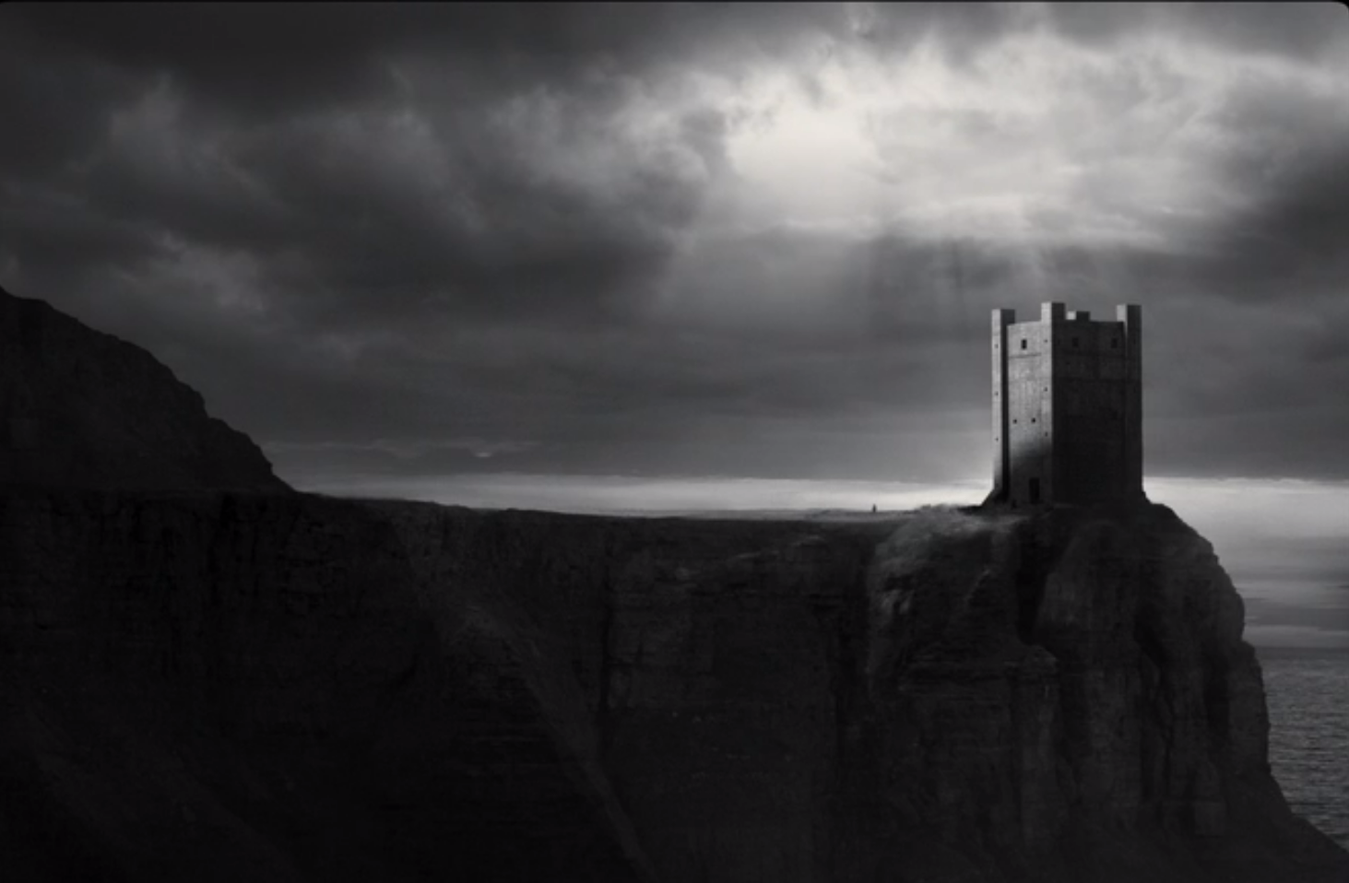  ‘The castle of Macduff I will surprise,  Seize upon Fife’ | 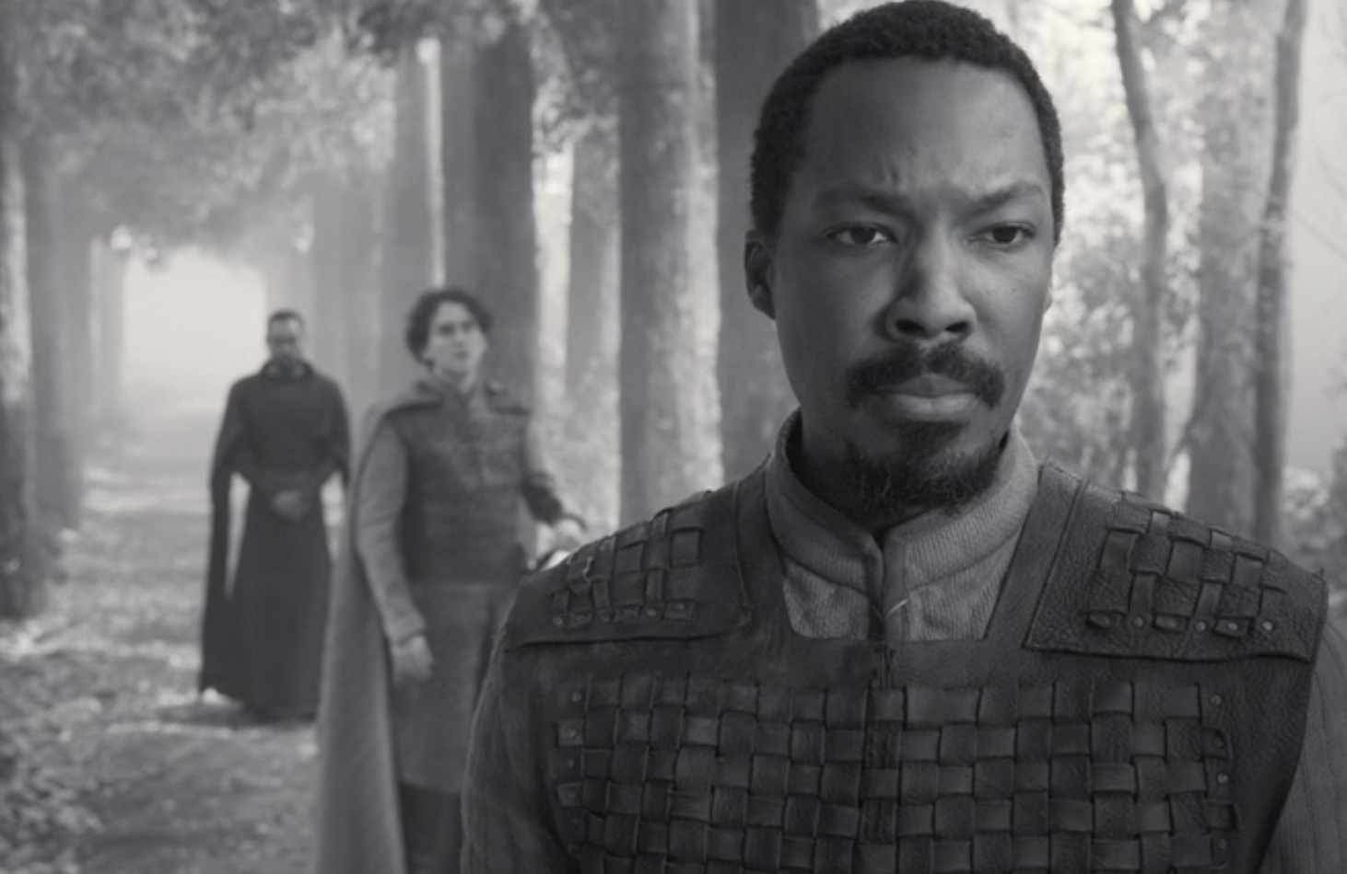  ‘All my pretty ones?  Did you say all? O hell-kite! All?’
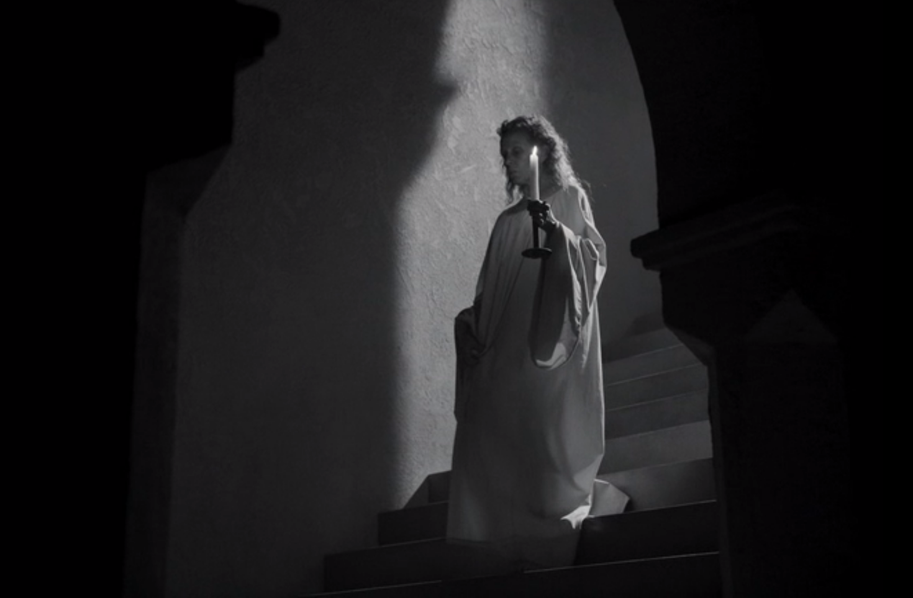  ‘She has light by her  continually, ’tis her command’ | 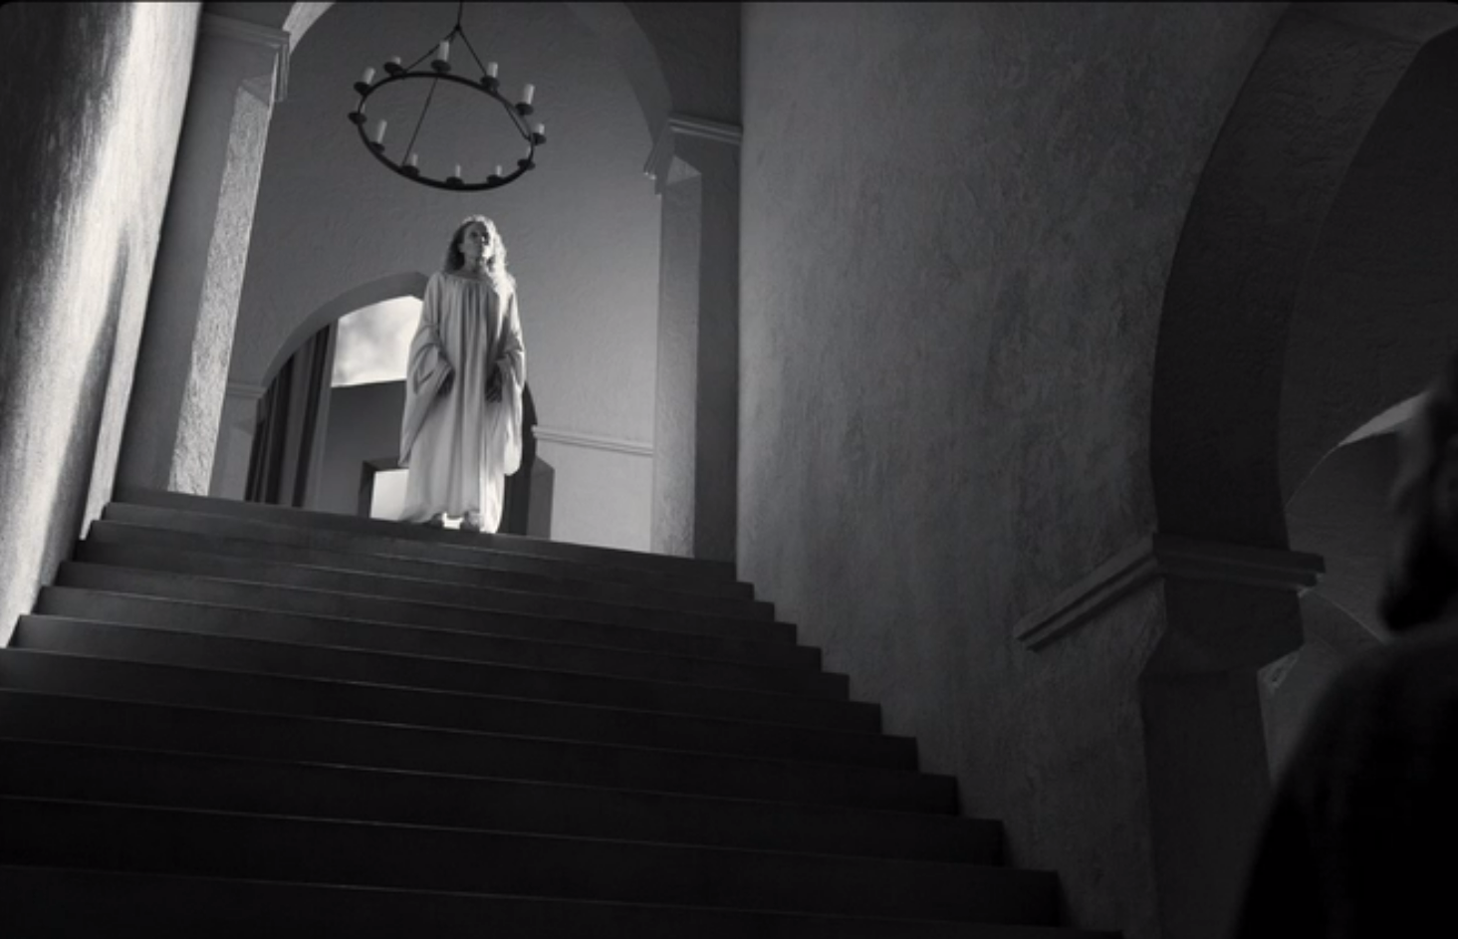  ‘She should have died hereafter;  There would have been a time for such a word’
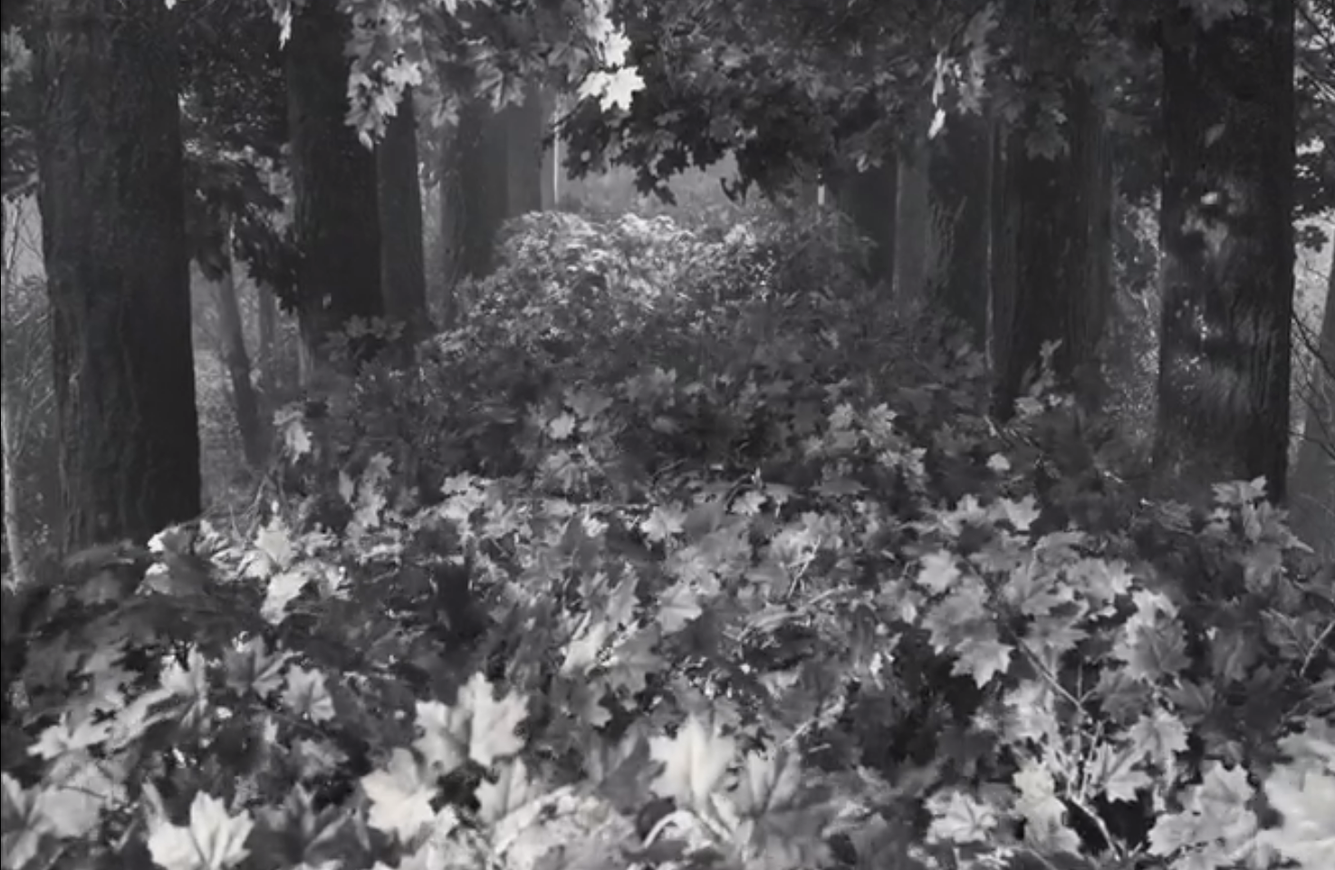  ‘I looked toward Birnam, and anon methought  The wood began to move’ | 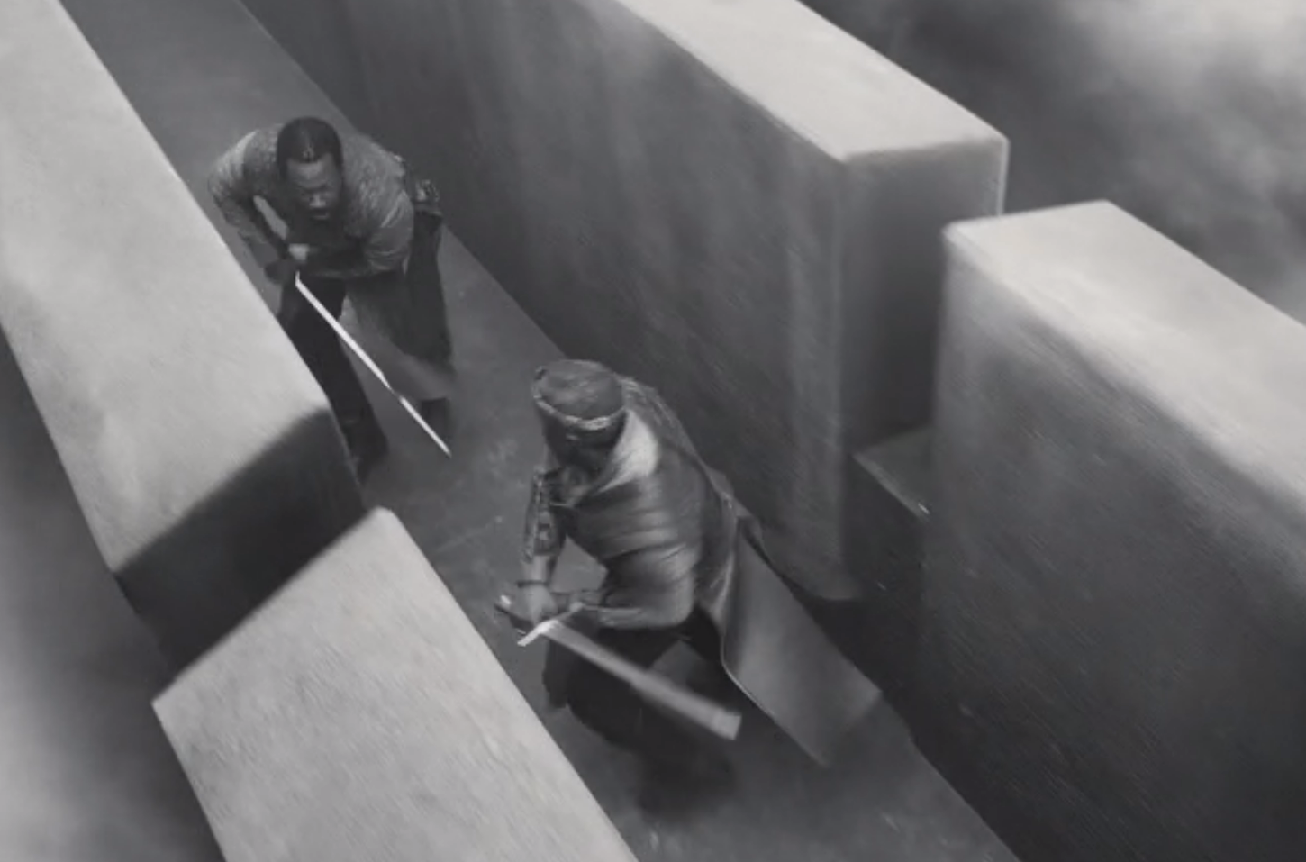  ‘I will not yield,  To kiss the ground before young Malcolm’s feet’

