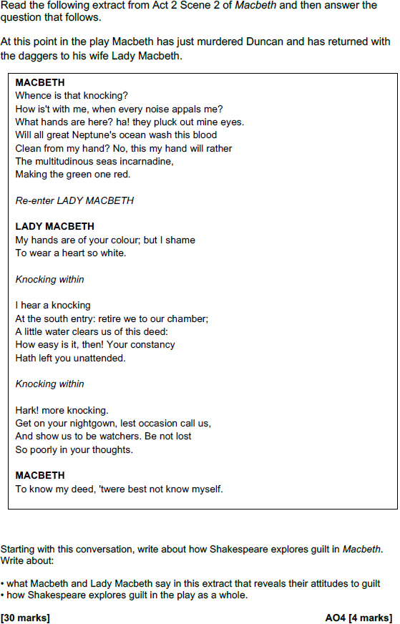

Introduction

- Briefly explain the context of the extract
- State that Macbeth experiences intense feelings of guilt and explain why

Section 1

- Write about Macbeth’s mindset at the start of the extract
- Include an explanation of what blood symbolises
- Explain why the blood on Macbeth’s hands is significant
- Explore why ‘a little water’ will not ‘clear’ Macbeth of the deed

Section 2

- Explain why Lady Macbeth accuses Macbeth of having a ‘white’ heart
- Write about the importance of Lady Macbeth taking control of the situation
- Explain how the knocking builds tension

Section 3

- Make a link with Lady Macbeth’s control over Macbeth in A1-S5
- Write about her concern that he lacks ruthlessness
- Write about the reversal of traditional gender roles

Section 4

- Make a link with the frustration Lady Macbeth feels towards Macbeth in A1-S7
- Explain that there has always been an imbalance of power between them
- Explain that the extract shows there is a growing divide between them
- Highlight that both characters are united by their excessive ambition
- Explain that the key difference is in how they deal with the consequences

Summary

Content Targets

- Explore how Lady Macbeth’s behaviour challenges traditional gender roles
e.g. She calls upon evil spirits to ‘unsex’ her in A1-S5 and she accuses Macbeth of cowardice in A1-S7

- Explore how feelings of guilt put pressure on Macbeth and Lady Macbeth’s relationship
e.g. Lady Macbeth eventually succumbs to feelings of guilt and is observed sleepwalking in A5-S1

- Explore how Macbeth becomes an increasingly isolated figure as the play progresses
e.g. The feast ends in chaos and the guests are forced to leave in A3-S4

- Explore how power between Macbeth and Lady Macbeth shifts as the play progresses
e.g. Macbeth chooses not to confide in Lady Macbeth about the murder of Banquo in A3-A2

- Explore how other images in the play (like darkness and stormy weather) are significant
e.g. Ross and the Old Man discuss the perpetual darkness that follows Duncan’s murder in A2-S4

- Develop your analysis by making stronger links with other relevant scenes
e.g. Try to focus on a broad section of the play and not just the opening scenes

- Develop your analysis by exploring the social and political issues of the time
e.g. James I was fearful of threats to his kingship and England was politically divided at the time

- Develop your existing points further by analysing Shakespeare’s use of language
e.g. There is a contrast between Macbeth anxious questioning and Lady Macbeth’s bold exclamation

Academic Writing Targets

- Start each paragraph with a clear topic sentence that directly addresses the essay question
e.g. In this scene, Shakespeare reveals the growing tension between Macbeth and Lady Macbeth...

- Use appositives (i.e. extra information placed within commas) to add depth to your analysis
e.g. Lady Macbeth, frustrated at Macbeth’s inability to remain calm, accuses him of...

- Choose language that conveys a formal tone (and avoid using words that are ‘chatty’)
e.g. Macbeth is deeply disturbed when he arrives on stage after the murder of Duncan...

- Embed short quotations into your sentences when you form a point
e.g. Lady Macbeth accuses Macbeth of being ‘infirm of purpose’ when he refuses to...

