Literary Snapshots

2 | All the Pretty Horses, by Cormac McCarthy
3 | To Kill a Mockingbird, by Harper Lee
4 | Anita and Me, by Meera Syal
5 | Captain Corelli’s Mandolin, by Louis de Bernières
6 | The Reluctant Fundamentalist, by Mohsin Hamid
7 | Norwegian Wood, by Haruki Murakami
8 | As I Walked Out One Midsummer Morning, by Laurie Lee
9 | Mrs Dalloway, by Virginia Woolf
10 | The Line of Beauty, by Alan Hollinghurst
11 | The Kite Runner, by Khalid Hosseini
12 | American Gods, by Neil Gaiman
13 | Memento Mori, by Muriel Spark
14 | The End of the Affair, by Graham Greene
15 | Paddy Clarke Ha Ha Ha, by Roddy Doyle
16 | Spies, by Michael Frayn
17 | Vernon God Little, by DBC Pierre
18 | High-Rise, by J. G. Ballard
19 | White Teeth, by Zadie Smith
20 | Wide Sargasso Sea, by Jean Rhys
21 | The Buddha of Suburbia, by Hanif Kureishi

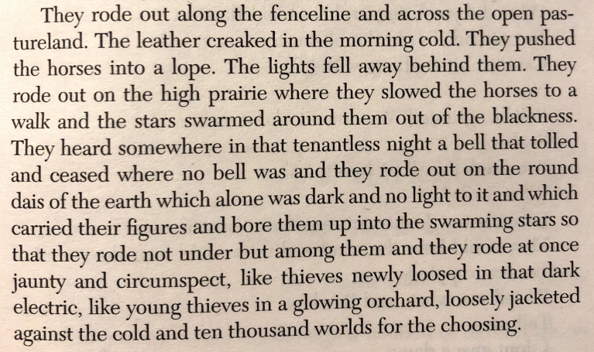
All the Pretty Horses, by Cormac McCarthy
- What material ‘creaked’ in the morning cold?
- Where are ‘they’ (the two men) riding?
- What does McCarthy mean by ‘tenantless night’?
- The two young riders have ‘ten thousand worlds for the choosing – what does this suggest?
- The third sentence contains very few punctuation marks – what effect does this have?

…………………………………………………………………………………………………………………………………………………………………………………………

…………………………………………………………………………………………………………………………………………………………………………………………

…………………………………………………………………………………………………………………………………………………………………………………………

…………………………………………………………………………………………………………………………………………………………………………………………

…………………………………………………………………………………………………………………………………………………………………………………………

…………………………………………………………………………………………………………………………………………………………………………………………

…………………………………………………………………………………………………………………………………………………………………………………………

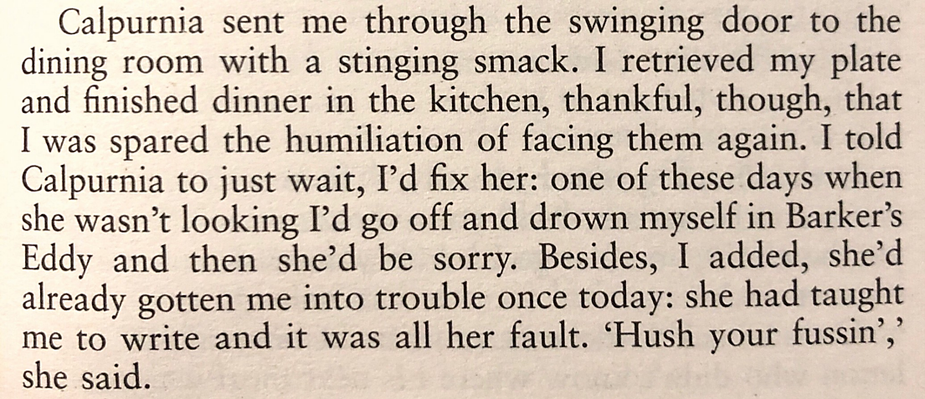
To Kill a Mockingbird, by Harper Lee
- What does the narrator (Scout Finch) retrieve from the dining room?
- What is she ‘spared’?
- What does Scout mean when she says she’ll ‘fix’ Calpurnia?
- What might Calpurnia be ‘sorry’ if Scout drowns herself in Barker’s Eddy?
- How do we know that Calpurnia does not take Scout’s threats seriously?

…………………………………………………………………………………………………………………………………………………………………………………………

…………………………………………………………………………………………………………………………………………………………………………………………

…………………………………………………………………………………………………………………………………………………………………………………………

…………………………………………………………………………………………………………………………………………………………………………………………

…………………………………………………………………………………………………………………………………………………………………………………………

…………………………………………………………………………………………………………………………………………………………………………………………

…………………………………………………………………………………………………………………………………………………………………………………………

…………………………………………………………………………………………………………………………………………………………………………………………

…………………………………………………………………………………………………………………………………………………………………………………………

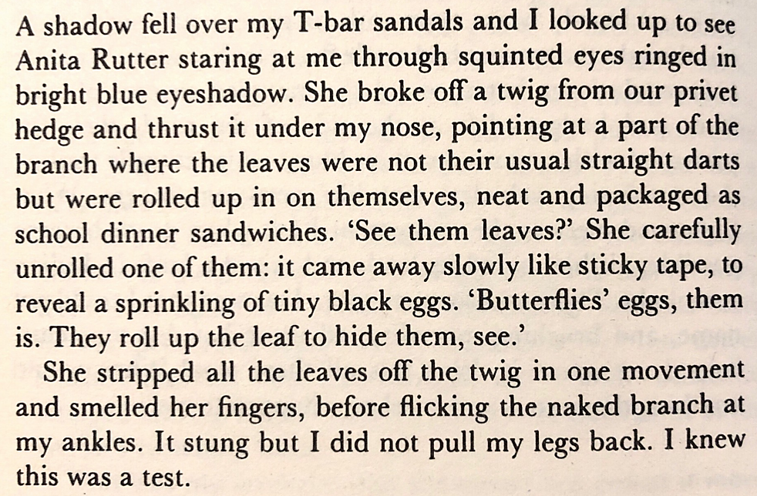
Anita and Me, by Meera Syal
- What is the narrator (Meena) wearing on her feet?
- What colour is Anita’s eyeshadow?
- The leaves on the branch are ‘neat and packaged as school dinner sandwiches’ – what does this suggest?
- Why does Anita say ‘them is’ instead of ‘they are’?
- What sort of ‘test’ is Anita giving Meena?

…………………………………………………………………………………………………………………………………………………………………………………………

…………………………………………………………………………………………………………………………………………………………………………………………

…………………………………………………………………………………………………………………………………………………………………………………………

…………………………………………………………………………………………………………………………………………………………………………………………

…………………………………………………………………………………………………………………………………………………………………………………………

…………………………………………………………………………………………………………………………………………………………………………………………

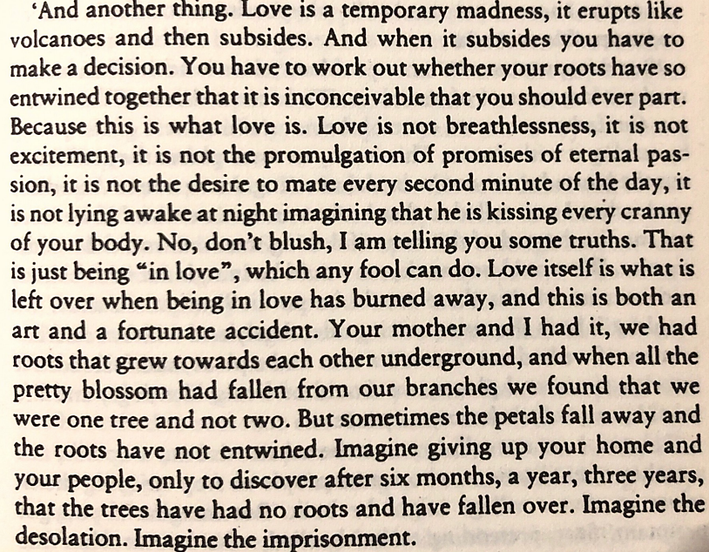
Captain Corelli’s Mandolin, by Louis de Bernières
- Why is love compared to an erupting volcano?
- What can ‘any fool’ do?
- What is left when ‘being in love has burned away’?
- What do the roots represent?
- What do the petals that have fallen away represent?

…………………………………………………………………………………………………………………………………………………………………………………………

…………………………………………………………………………………………………………………………………………………………………………………………

…………………………………………………………………………………………………………………………………………………………………………………………

…………………………………………………………………………………………………………………………………………………………………………………………

…………………………………………………………………………………………………………………………………………………………………………………………
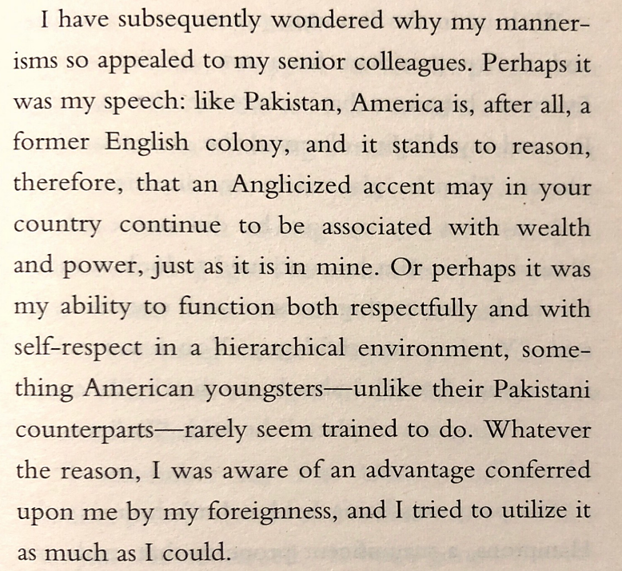
The Reluctant Fundamentalist, by Mohsin Hamid
- What is the narrator (Changez) reflecting on as the passage opens?
- Which two countries does the Changez name as former English colonies
- What is a ‘hierarchical environment’?
- What does it seem American youngsters are rarely ‘trained to do’?
- Which two adjectives precisely describe the tone of Changez’s narration?

…………………………………………………………………………………………………………………………………………………………………………………………

…………………………………………………………………………………………………………………………………………………………………………………………

…………………………………………………………………………………………………………………………………………………………………………………………

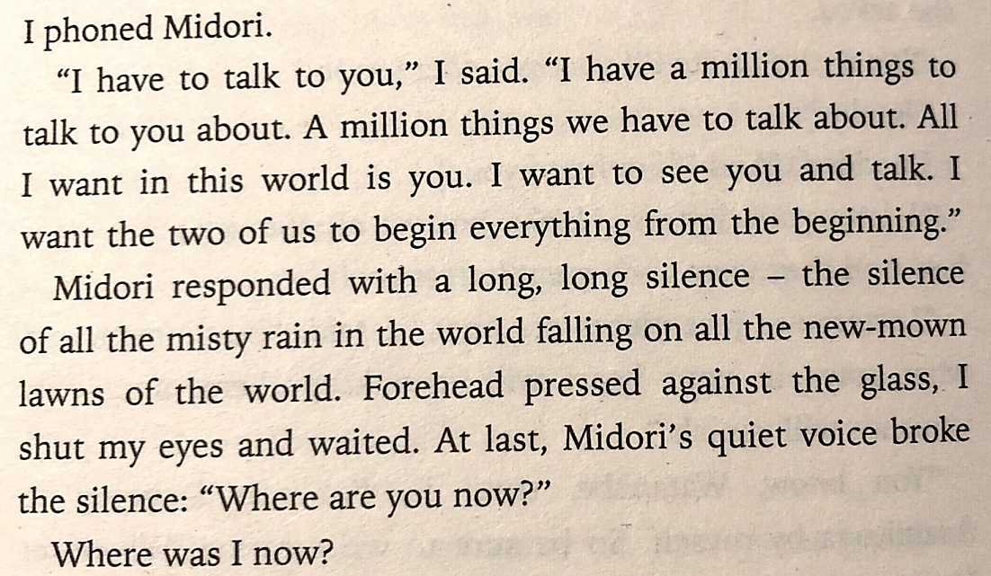
Norwegian Wood, by Haruki Murakami
- Who does the narrator (Toru Watanabe) need to speak to?
- Why does Watanabe exaggerate and say they have a ‘million things’ to talk about?
- What does the ‘long, long silence’ imply?
- What mood does the image of ‘misty rain’ evoke?
- Why does Watanabe press his forehead against the glass?

…………………………………………………………………………………………………………………………………………………………………………………………

…………………………………………………………………………………………………………………………………………………………………………………………

…………………………………………………………………………………………………………………………………………………………………………………………

…………………………………………………………………………………………………………………………………………………………………………………………

…………………………………………………………………………………………………………………………………………………………………………………………

…………………………………………………………………………………………………………………………………………………………………………………………

…………………………………………………………………………………………………………………………………………………………………………………………

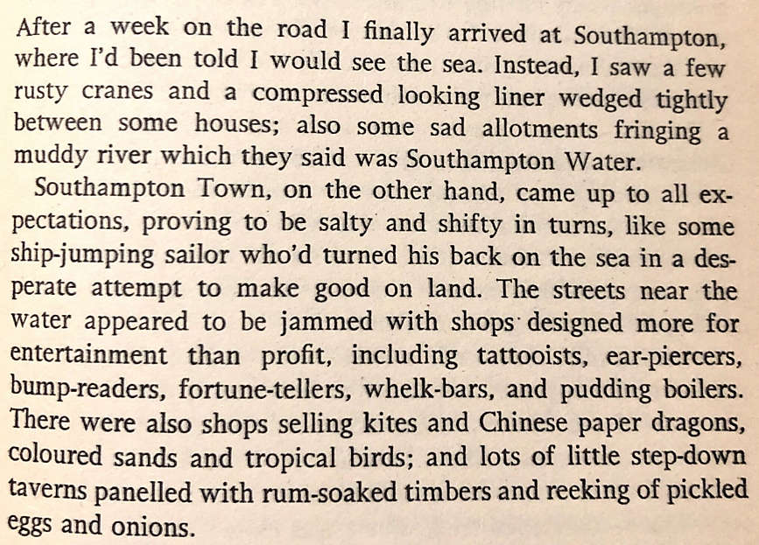
As I Walked Out One Midsummer Morning, by Laurie Lee
- How are Southampton and Southampton town different?
- What does the ‘ship-jumping sailor’ simile suggest about Southampton Town?
- The streets are ‘jammed’ – what does this mean?
- Does the narrator (Laurie Lee) like Southampton Town and how do we know?
- Which five adjectives precisely describe Southampton Town?

…………………………………………………………………………………………………………………………………………………………………………………………

…………………………………………………………………………………………………………………………………………………………………………………………

…………………………………………………………………………………………………………………………………………………………………………………………

…………………………………………………………………………………………………………………………………………………………………………………………

…………………………………………………………………………………………………………………………………………………………………………………………

…………………………………………………………………………………………………………………………………………………………………………………………
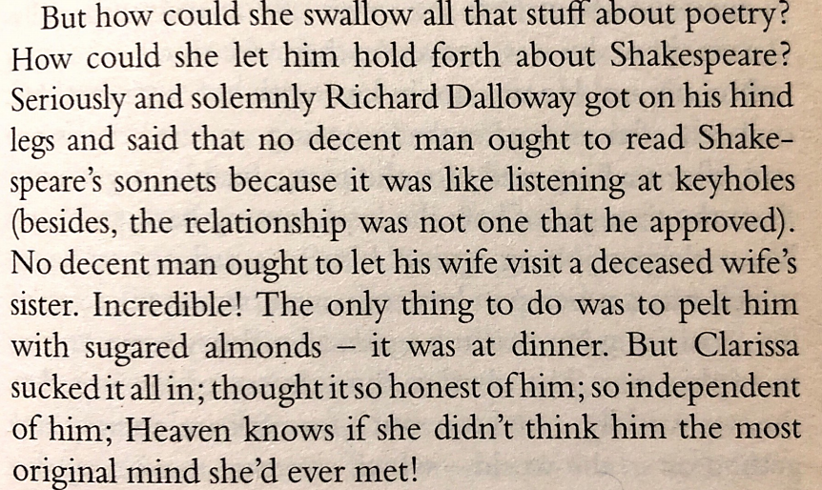
Mrs Dalloway, by Virginia Woolf
- Does the narrator (Clarissa Dalloway) feel that Richard’s views on Shakespeare’s sonnets are fair?
- Why does Richard believe that reading the sonnets is like ‘listening at keyholes’?
- Do Clarissa and Richard argue at dinner?
- Does Clarissa believe that Richard is intelligent?
- Which two adjectives precisely describe Clarissa’s feelings about Richard?

…………………………………………………………………………………………………………………………………………………………………………………………

…………………………………………………………………………………………………………………………………………………………………………………………

…………………………………………………………………………………………………………………………………………………………………………………………

…………………………………………………………………………………………………………………………………………………………………………………………

…………………………………………………………………………………………………………………………………………………………………………………………

…………………………………………………………………………………………………………………………………………………………………………………………

…………………………………………………………………………………………………………………………………………………………………………………………

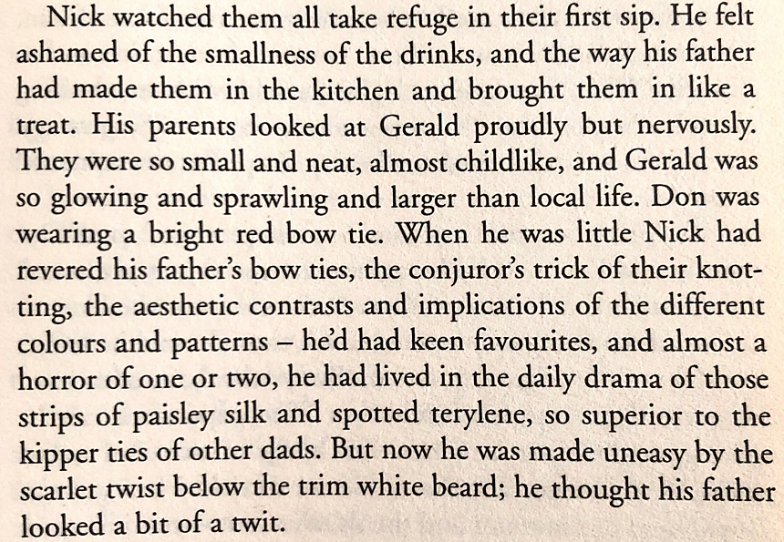
The Line of Beauty, by Alan Hollinghurst
- Are the drinks that Don provides large or small?
- Which details suggest that Gerald (a local MP) is an important guest?
- Why might Nick’s parents feel both proud and nervous?
- Which item of his father clothing did Nick used to particularly like?
- Which details suggest that Nick feels embarrassed?

…………………………………………………………………………………………………………………………………………………………………………………………

…………………………………………………………………………………………………………………………………………………………………………………………

…………………………………………………………………………………………………………………………………………………………………………………………

…………………………………………………………………………………………………………………………………………………………………………………………

…………………………………………………………………………………………………………………………………………………………………………………………

…………………………………………………………………………………………………………………………………………………………………………………………

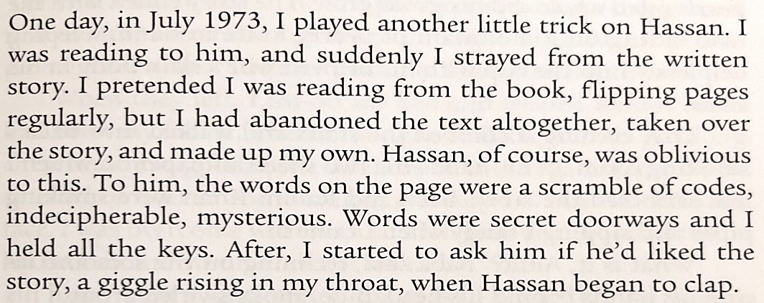
The Kite Runner, by Khalid Hosseini
- What is the trick that the narrator (Amir) plays on Hassan?
- Is Hassan aware that he is being tricked?
- Can Hassan read and how do we know?
- If words are like ‘secret doorways’, why does Amir hold ‘all the keys’?
- Why does Hassan clap at the end of the extract?

…………………………………………………………………………………………………………………………………………………………………………………………

…………………………………………………………………………………………………………………………………………………………………………………………

…………………………………………………………………………………………………………………………………………………………………………………………

…………………………………………………………………………………………………………………………………………………………………………………………

…………………………………………………………………………………………………………………………………………………………………………………………

…………………………………………………………………………………………………………………………………………………………………………………………

…………………………………………………………………………………………………………………………………………………………………………………………

…………………………………………………………………………………………………………………………………………………………………………………………

…………………………………………………………………………………………………………………………………………………………………………………………

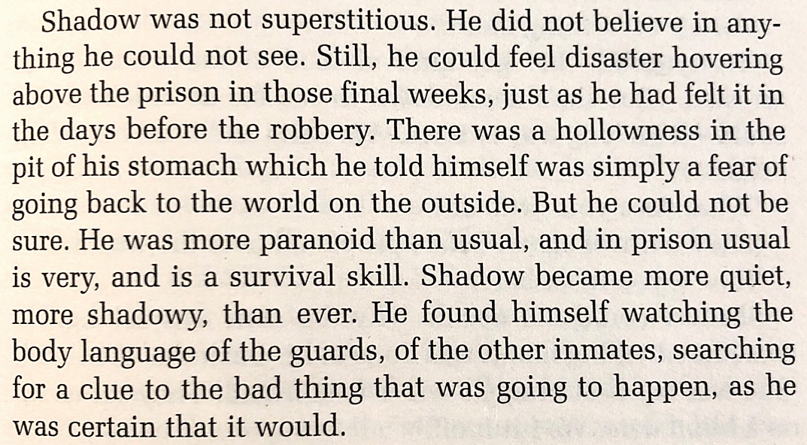
American Gods, by Neil Gaiman
- Where is Shadow?
- Shadow feels ‘disaster hovering’ – what does this mean?
- What is described as a ‘survival skill’?
- Shadow becomes more ‘shadowy’ – what does this mean?
- What is Shadow certain of?

…………………………………………………………………………………………………………………………………………………………………………………………

…………………………………………………………………………………………………………………………………………………………………………………………

…………………………………………………………………………………………………………………………………………………………………………………………

…………………………………………………………………………………………………………………………………………………………………………………………

…………………………………………………………………………………………………………………………………………………………………………………………

…………………………………………………………………………………………………………………………………………………………………………………………

…………………………………………………………………………………………………………………………………………………………………………………………

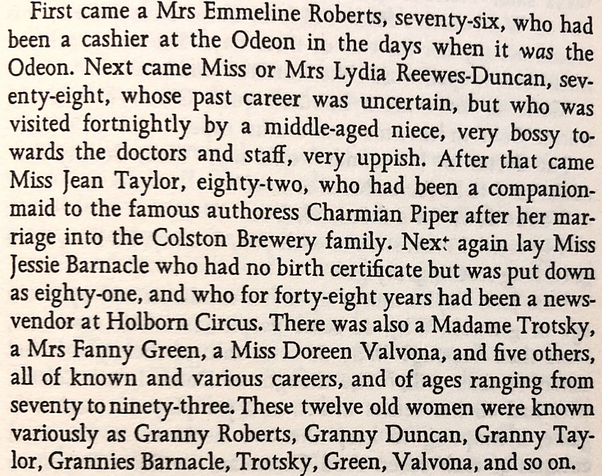
Memento Mori, by Muriel Spark
- Why is ‘was’ on the second italicised?
- Lydia Reewes-Dawson’s niece is described as ‘very uppish’ – what does this mean?
- How old is Jean Taylor?
- Which lady has no birth certificate?
- What is the age range of the ladies?

…………………………………………………………………………………………………………………………………………………………………………………………

…………………………………………………………………………………………………………………………………………………………………………………………

…………………………………………………………………………………………………………………………………………………………………………………………

…………………………………………………………………………………………………………………………………………………………………………………………

…………………………………………………………………………………………………………………………………………………………………………………………
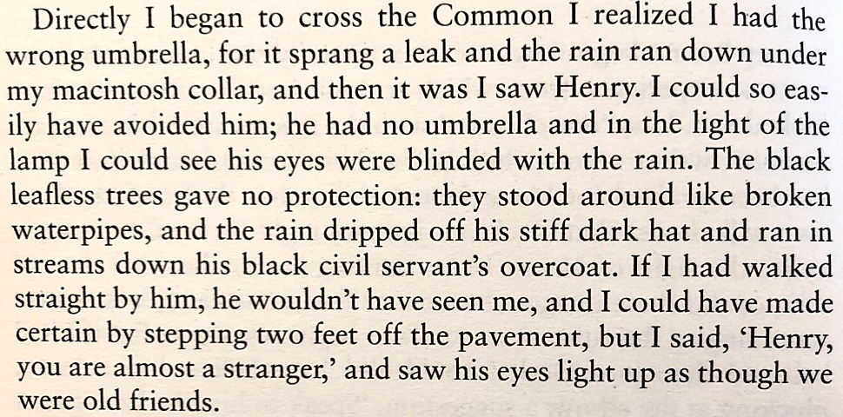
The End of the Affair, by Graham Greene
- What is wrong with the umbrella?
- Why does the narrator (Maurice Bendrix) think he could have avoided Henry?
- Why is the ‘broken waterpipes’ simile particularly appropriate?
- What colour is Henry’s hat?
- How do we know that Henry feels no animosity towards Maurice?

…………………………………………………………………………………………………………………………………………………………………………………………

…………………………………………………………………………………………………………………………………………………………………………………………

…………………………………………………………………………………………………………………………………………………………………………………………

…………………………………………………………………………………………………………………………………………………………………………………………

…………………………………………………………………………………………………………………………………………………………………………………………

…………………………………………………………………………………………………………………………………………………………………………………………

…………………………………………………………………………………………………………………………………………………………………………………………

…………………………………………………………………………………………………………………………………………………………………………………………

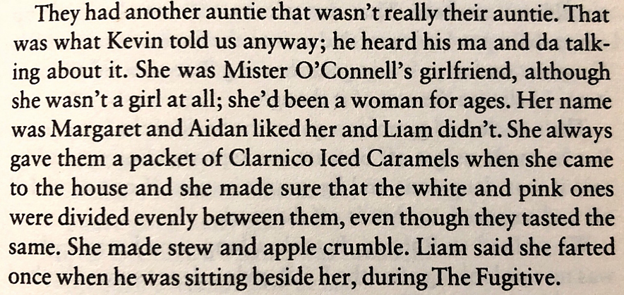
Paddy Clarke Ha Ha Ha, by Roddy Doyle
- What do the words ‘ma’ and ‘da’ mean?
- Which details from the extract suggest that the narrator (Paddy Clarke) is a child?
- Does Liam like Margaret?
- Which details suggest that Margaret is a nice person?
- Why do you think Margaret is referred to as an ‘auntie’?

…………………………………………………………………………………………………………………………………………………………………………………………

…………………………………………………………………………………………………………………………………………………………………………………………

…………………………………………………………………………………………………………………………………………………………………………………………

…………………………………………………………………………………………………………………………………………………………………………………………

…………………………………………………………………………………………………………………………………………………………………………………………

…………………………………………………………………………………………………………………………………………………………………………………………

…………………………………………………………………………………………………………………………………………………………………………………………

…………………………………………………………………………………………………………………………………………………………………………………………

…………………………………………………………………………………………………………………………………………………………………………………………
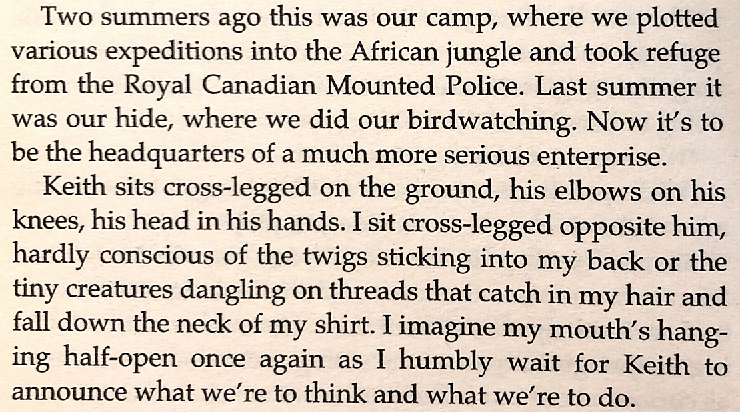
Spies, by Michael Frayn
- How do we know that the narrator (Stephen) is a child?
- Which of the two boys is in charge and how do we know?
- How are both boys sat?
- Stephen is ‘hardly conscious’ of his discomfort – why is this?
- What does the adverb ‘humbly’ mean?

…………………………………………………………………………………………………………………………………………………………………………………………

…………………………………………………………………………………………………………………………………………………………………………………………

…………………………………………………………………………………………………………………………………………………………………………………………

…………………………………………………………………………………………………………………………………………………………………………………………

…………………………………………………………………………………………………………………………………………………………………………………………

…………………………………………………………………………………………………………………………………………………………………………………………

…………………………………………………………………………………………………………………………………………………………………………………………

…………………………………………………………………………………………………………………………………………………………………………………………
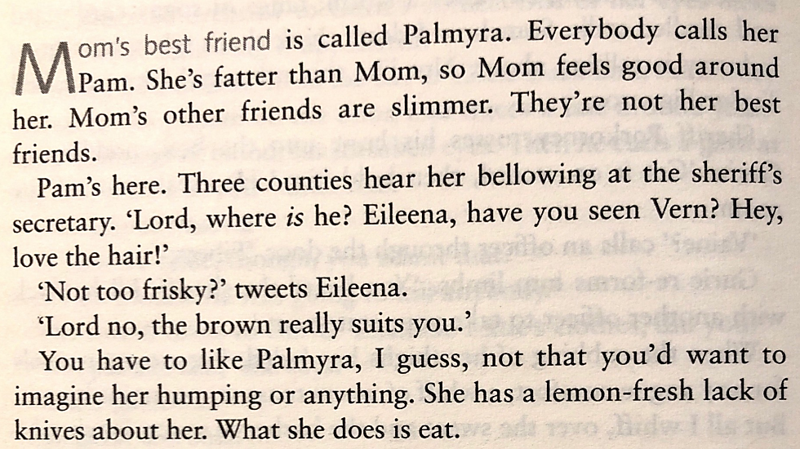
Vernon God Little, by DBC Pierre
- The narrator is a boy called Vernon Gregory Little – what sort of character is he?
- What is the name of his mother’s best friend?
- Which two adjectives precisely describe Vernon’s mother?
- Why is the word ‘is’ italicised?
- What does ‘lemon-fresh’ suggest?

…………………………………………………………………………………………………………………………………………………………………………………………

…………………………………………………………………………………………………………………………………………………………………………………………

…………………………………………………………………………………………………………………………………………………………………………………………

…………………………………………………………………………………………………………………………………………………………………………………………

…………………………………………………………………………………………………………………………………………………………………………………………

…………………………………………………………………………………………………………………………………………………………………………………………

…………………………………………………………………………………………………………………………………………………………………………………………

…………………………………………………………………………………………………………………………………………………………………………………………
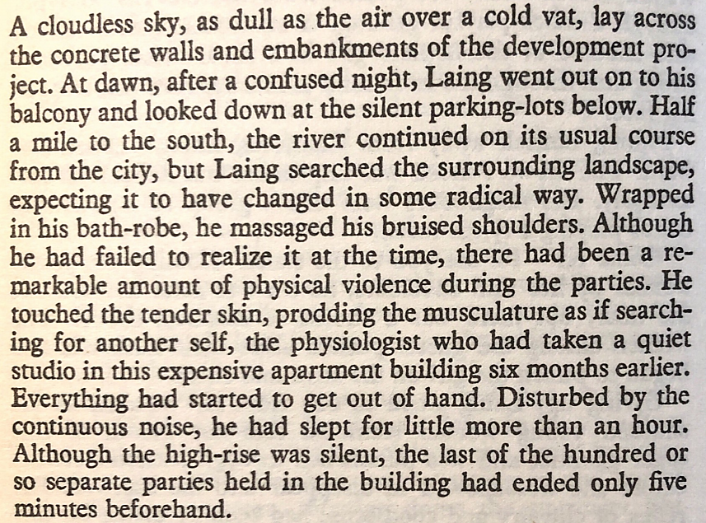
High-Rise, by J. G. Ballard
- What is the main character called?
- Is it morning or evening?
- What does the adjective ‘radical’ mean?
- What does the informal phrase ‘get out of hand’ mean?
- What seems to have happened to the main character?

…………………………………………………………………………………………………………………………………………………………………………………………

…………………………………………………………………………………………………………………………………………………………………………………………

…………………………………………………………………………………………………………………………………………………………………………………………

…………………………………………………………………………………………………………………………………………………………………………………………

…………………………………………………………………………………………………………………………………………………………………………………………

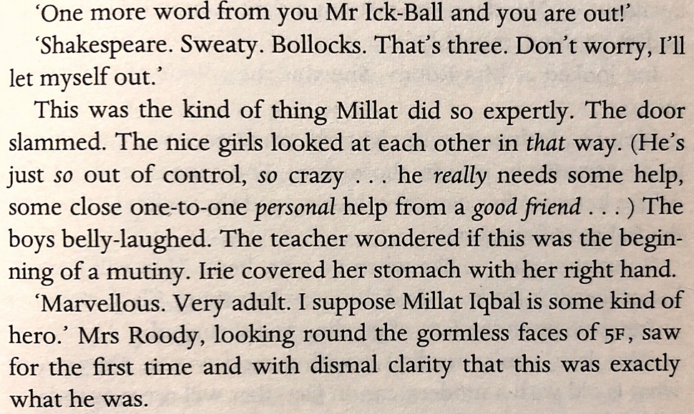
White Teeth, by Zadie Smith
- What does the exclamation mark in the first line suggest about the speaker (a teacher called Mrs Roody)?
- Why are some words italicised?
- What is a ‘mutiny’?
- What does the adjective ‘gormless’ mean?
- How do the students in 5F view Millat Iqbal?

…………………………………………………………………………………………………………………………………………………………………………………………

…………………………………………………………………………………………………………………………………………………………………………………………

…………………………………………………………………………………………………………………………………………………………………………………………

…………………………………………………………………………………………………………………………………………………………………………………………

…………………………………………………………………………………………………………………………………………………………………………………………

…………………………………………………………………………………………………………………………………………………………………………………………

…………………………………………………………………………………………………………………………………………………………………………………………

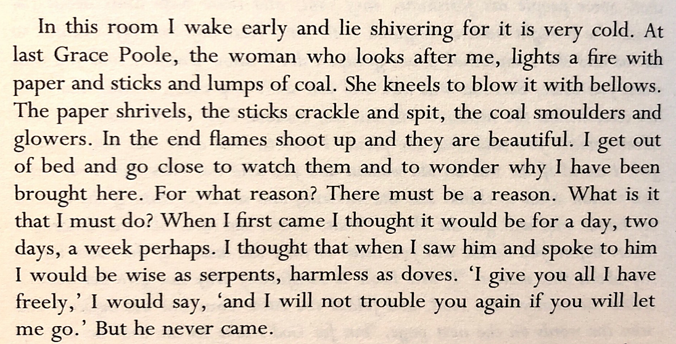
Wide Sargasso Sea, by Jean Rhys
- What details suggest that the narrator (Antoinette Mason) is confused?
- What details suggest that she is uncomfortable?
- Has Antoinette been in the room for a long time?
- What does Antoinette think is ‘beautiful’?
- How do we know that Antoinette is being held against her will?

…………………………………………………………………………………………………………………………………………………………………………………………

…………………………………………………………………………………………………………………………………………………………………………………………

…………………………………………………………………………………………………………………………………………………………………………………………

…………………………………………………………………………………………………………………………………………………………………………………………

…………………………………………………………………………………………………………………………………………………………………………………………

…………………………………………………………………………………………………………………………………………………………………………………………

…………………………………………………………………………………………………………………………………………………………………………………………

…………………………………………………………………………………………………………………………………………………………………………………………

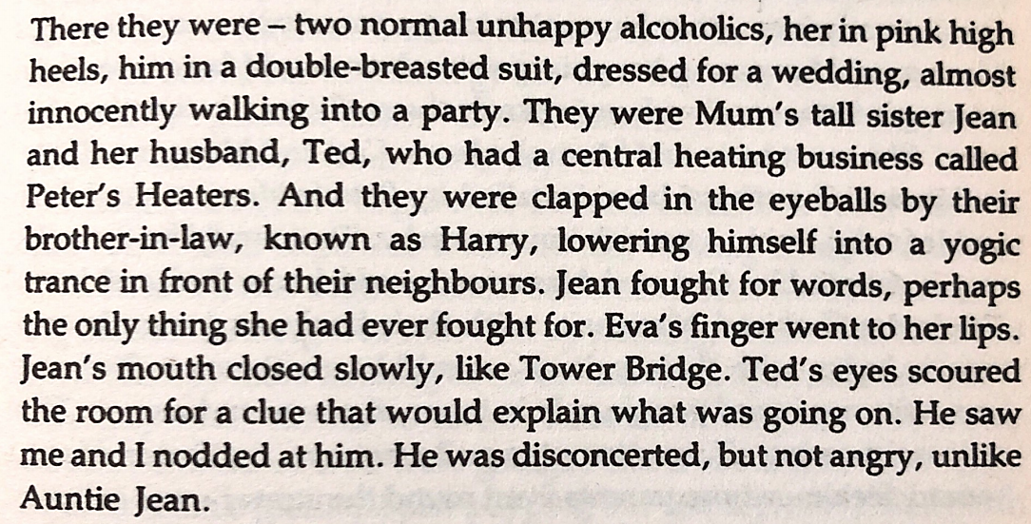
The Buddha of Suburbia, by Hanif Kureishi
- What are the names of the ‘two normal unhappy alcoholics’?
- What does ‘fought for words’ mean?
- What does the Tower Bridge simile suggest about Jean’s opinion of what she has seen?
- What does ‘disconcerted’ mean?
- Which character is angry?

…………………………………………………………………………………………………………………………………………………………………………………………

…………………………………………………………………………………………………………………………………………………………………………………………

…………………………………………………………………………………………………………………………………………………………………………………………

…………………………………………………………………………………………………………………………………………………………………………………………

…………………………………………………………………………………………………………………………………………………………………………………………

…………………………………………………………………………………………………………………………………………………………………………………………

…………………………………………………………………………………………………………………………………………………………………………………………

…………………………………………………………………………………………………………………………………………………………………………………………

