**Fighting Talk**

War Poetry: Troy to Paddington Station

1. Extract from *The Iliad*, by Homer
2. Extract from *Beowulf*, by unknown poet
3. ‘Drummer Hodge’, by Thomas Hardy
4. ‘Many Sisters to Many Brothers’, by Rose Macaulay
5. ‘Suicide in the Trenches’, by Siegfried Sassoon
6. ‘Strange Meeting’, by Wilfred Owen
7. ‘Last Post’, by Carol Ann Duffy
8. ‘MCMXIV’, by Philip Larkin
9. ‘Pluck’, by Eva Dobell
10. ‘Platform One’, by Ted Hughes
11. ‘The Death of the Ball Turret Gunner’, by Randall Jarrell
12. ‘Flag’, by John Agard

…………………………………………………………………………………………………………………………………………………………………………………………

‘But I sit here, and you’re under fire’

…………………………………………………………………………………………………………………………………………………………………………………………

* What is the poem about?
* In what ways is the title significant?
* Which three lines seem to be particularly important?
* Which three individual words stand out?
* What poetic devices can you identify?
* How do they help to shape meaning?
* How is the poem structured (i.e. organised)?
* Is the poem written in an identifiable form?

**Adjective**

Adjectives are words that describe or modify nouns

*I knew a simple soldier boy / Who grinned at life in empty joy* (‘Suicide in the Trenches’, by Siegfried Sassoon)

**Adverb**

Adverbs describe or modify verbs, adjectives or other adverbs

*He’s forgotten utterly where he is* (‘Platform One’, by Ted Hughes)

**Verb**

Verbs typically describe actions and states of being

*A foundling to start with, he would flourish later on* (Extract from *Beowulf*, by unknown poet)

**Metaphor**

A figure of speech in which one thing is described in the terms of another

*Charioteers were struck dumb when they saw that fire* (Extract from *The Iliad*, by Homer)

**Personification**

Personification is the attribution of human qualities to inanimate objects

*I hunched in its belly till my wet fur froze* (‘The Death of the Ball Turret Gunner’, by Randall Jarrell)

**Repetition**

Repetition is a unifying element in poetry and prose

*And by his smile, I knew that sullen hall, / By his dead smile I knew we stood in Hell* (‘Strange Meeting’, by Wilfred Owen)

**Simile**

A simile is a figure of speech in which one thing is explicitly likened to another

*The coach’s soft wingbeat – as light / And straight as a dove’s flight.* (‘Platform One’, by Ted Hughes)

**Symbol**

A symbol is an object which represents or ‘stands’ for something else

*It’s just a piece of cloth / that makes the guts of men grow bold* (‘Flag’, by John Agard)

**Tone**

The overall feeling or mood of a poem

*Oh, it’s you that have the luck, out there in blood and muck* (‘Many Sisters to Many Brothers’, by Rose Macaulay)

***Extract from* The Iliad**

Homer

Circa 8th Century BC

And Trojans hearing the brazen voice of Aeacides,

all their spirits quaked – even sleek-maned horses,

sensing death in the wind, slewed their chariots round

and charioteers were struck dumb when they saw that fire,

relentless, terrible, burst from proud-hearted Achilles’ head, 5

blazing as fiery-eyed Athena fuelled the flames.

***Extract from* Beowulf**

Unknown

Circa 10th Century

The Spear-Danes in days gone by

and the kings who ruled them had courage and greatness.

We have heard of those princes’ heroic campaigns.

There was Shield Sheafson, scourge of many tribes,

a wrecker of mead-benches, rampaging among foes. 5

This terror of the hall-troops had come far.

A foundling to start with, he would flourish later on

as his powers waxed and his worth was proved,

In the end each clan on the outlying coasts

beyond the whale-road had to yield to him 10

and begin to pay tribute. That was one good king.

**Drummer Hodge**

Thomas Hardy

1899

They throw in Drummer Hodge, to rest

Uncoffined – just as found:

His landmark is a kopje-crest

That breaks the veldt around;

And foreign constellations west 5

Each night above his mound.

Young Hodge the Drummer never knew –

Fresh from his Wessex home –

The meaning of the broad Karoo,

The Bush, the dusty loam, 10

And why uprose to nightly view

Strange stars amid the gloam.

Yet portion of that unknown plain

Will Hodge for ever be;

His homely Northern breast and brain 15

Grow up a Southern tree,

And strange-eyed constellations reign

His stars eternally.

**Many Sisters to Many Brothers**

Rose Macaulay

1914

When we fought campaigns (in the long Christmas rains)

With soldiers spread in troops on the floor,

I shot as straight as you, my losses were as few,

My victories as many, or more.

And when in naval battle, amid cannon’s rattle, 5

Fleet met fleet in the bath,

My cruisers were as trim, my battleships as grim,

My submarines cut as swift a path.

Or, when it rained too long, and the strength of the strong

Surged up and broke away with blows, 10

I was as fit and keen, my fists hit as clean,

Your black eye matched my bleeding nose.

Was there a scrap or ploy in which you, the boy,

Could better me? You could not climb higher,

Ride straighter, run as quick (and to smoke made you sick) 15

…. But I sit here, and you’re under fire.

Oh, it’s you that have the luck, out there in blood and muck:

You were born beneath a kindly star;

All we dreamt, I and you, you can really go and do,

And I can’t, the way things are. 20

In a trench you are sitting, while I am knitting

A hopeless sock that never gets done.

Well, here’s luck, my dear; – and you’ve got it, no fear;

But for me… a war is poor fun.

**Suicide in the Trenches**

Siegfried Sassoon

1918

I knew a simple soldier boy

Who grinned at life in empty joy,

Slept soundly through the lonesome dark,

And whistled early with the lark.

In winter trenches, cowed and glum, 5

With crumps and lice and lack of rum,

He put a bullet through his brain.

No one spoke of him again.

You smug-faced crowds with kindling eye

Who cheer when soldier lads march by, 10

Sneak home and pray you’ll never know

The hell where youth and laughter go.

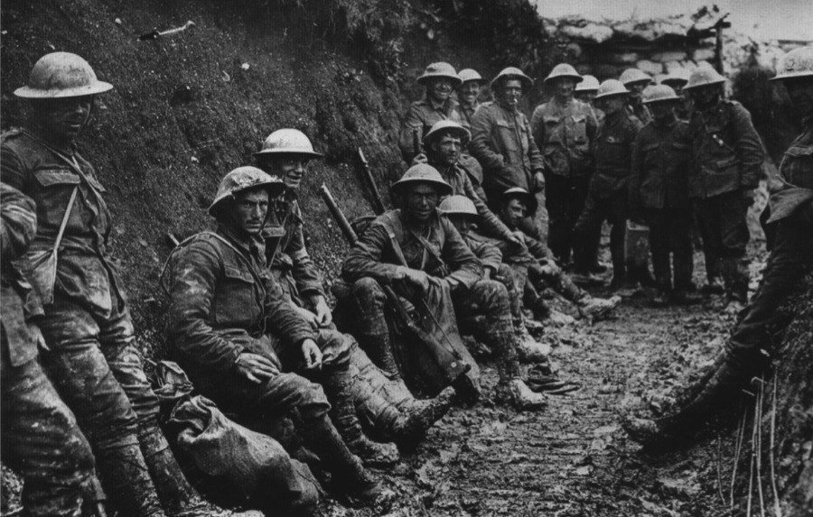

**Strange Meeting**

Wilfred Owen

1918

It seemed that out of battle I escaped

Down some profound dull tunnel, long since scooped

Through granites which titanic wars had groined.

Yet also there encumbered sleepers groaned,

Too fast in thought or death to be bestirred. 5

Then, as I probed them, one sprang up, and stared

With piteous recognition in fixed eyes,

Lifting distressful hands, as if to bless.

And by his smile, I knew that sullen hall,

By his dead smile I knew we stood in Hell. 10

With a thousand fears that vision’s face was grained;

Yet no blood reached there from the upper ground,

And no guns thumped, or down the flues made moan.

‘Strange friend,’ I said, ‘here is no cause to mourn.’

‘None,’ said that other, ‘save the undone years, 15

The hopelessness. Whatever hope is yours,

Was my life also; I went hunting wild

After the wildest beauty in the world,

Which lies not calm in eyes, or braided hair,

But mocks the steady running of the hour, 20

And if it grieves, grieves richlier than here.

For by my glee might many men have laughed,

And of my weeping something had been left,

Which must die now. I mean the truth untold,

The pity of war, the pity war distilled. 25

Now men will go content with what we spoiled.

Or, discontent, boil bloody, and be spilled.

They will be swift with swiftness of the tigress.

None will break ranks, though nations trek from progress.

Courage was mine, and I had mystery; 30

Wisdom was mine, and I had mastery:

To miss the march of this retreating world

Into vain citadels that are not walled.

Then, when much blood had clogged their chariot-wheels,

I would go up and wash them from sweet wells, 35

Even with truths that lie too deep for taint.

I would have poured my spirit without stint

But not through wounds; not on the cess of war.

Foreheads of men have bled where no wounds were.

‘I am the enemy you killed, my friend. 40

I knew you in this dark: for so you frowned

Yesterday through me as you jabbed and killed.

I parried; but my hands were loath and cold.

Let us sleep now…’

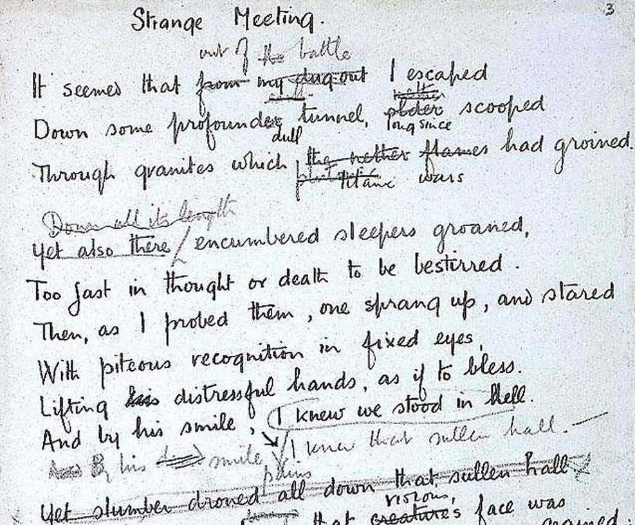

**Last Post**

Carol Ann Duffy

2009

*In all my dreams, before my helpless sight,*

*He plunges at me, guttering, choking, drowning*.

​If poetry could tell it backwards, true, begin

that moment shrapnel scythed you to the stinking mud…

but you get up, amazed, watch bled bad blood 5

run upwards from the slime into its wounds;

see lines and lines of British boys rewind

back to their trenches, kiss the photographs from home –

mothers, sweethearts, sisters, younger brothers

not entering the story now 10

to die and die and die.

Dulce – No – Decorum – No – Pro patria mori.

You walk away.

You walk away; drop your gun (fixed bayonet)

like all your mates do too – 15

Harry, Tommy, Wilfred, Edward, Bert –

and light a cigarette.

There’s coffee in the square,

warm French bread

and all those thousands dead 20

are shaking dried mud from their hair

and queuing up for home. Freshly alive,

a lad plays Tipperary to the crowd, released

from History; the glistening, healthy horses fit for heroes, kings.

You lean against a wall, 25

your several million lives still possible

and crammed with love, work, children, talent, English beer, good food.

You see the poet tuck away his pocket-book and smile.

If poetry could truly tell it backwards,

then it would. 30

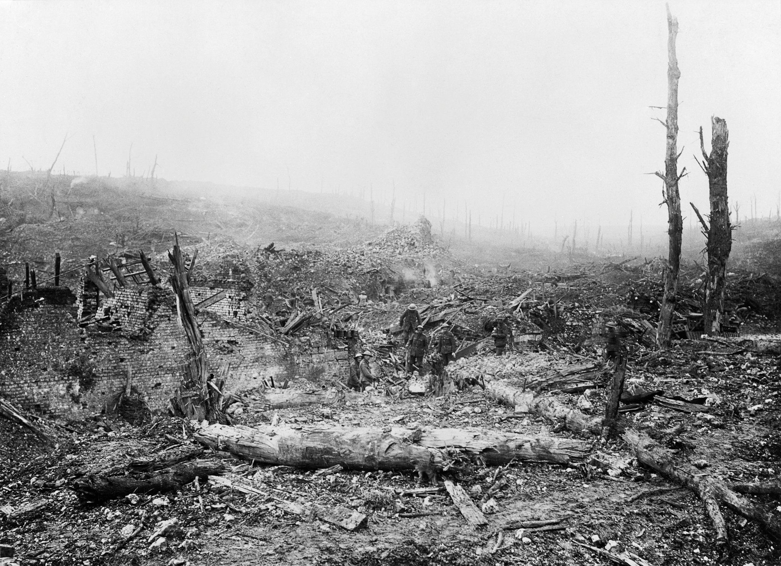

**MCMXIV**

Philip Larkin

1964

Those long uneven lines

Standing as patiently

As if they were stretched outside

The Oval or Villa Park,

The crowns of hats, the sun 5

On moustached archaic faces

Grinning as if it were all

An August Bank Holiday lark;

And the shut shops, the bleached

Established names on the sunblinds, 10

The farthings and sovereigns,

And dark-clothed children at play

Called after kings and queens,

The tin advertisements

For cocoa and twist, and the pubs 15

Wide open all day;

And the countryside not caring:

The place-names all hazed over

With flowering grasses, and fields

Shadowing Domesday lines 20

Under wheat’s restless silence;

The differently-dressed servants

With tiny rooms in huge houses,

The dust behind limousines;

Never such innocence, 25

Never before or since,

As changed itself to past

Without a word – the men

Leaving the gardens tidy,

The thousands of marriages 30

Lasting a little while longer:

Never such innocence again.

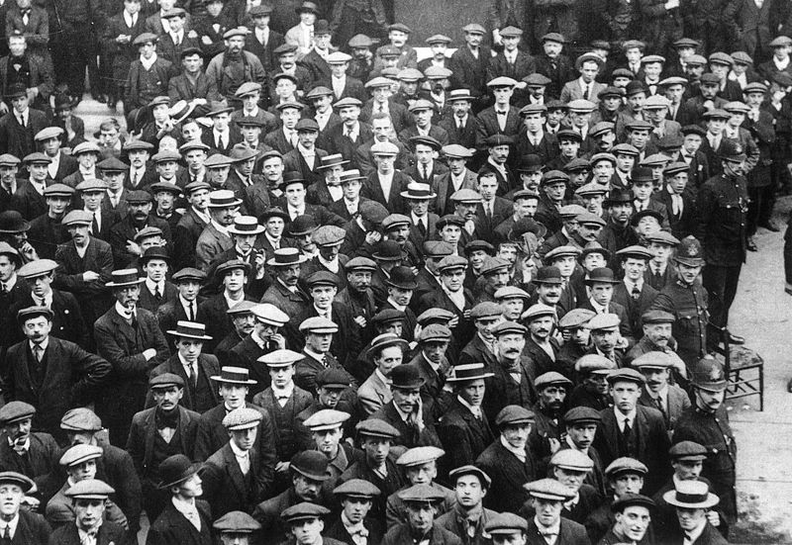

**Pluck**

Eva Dobell

1916

Crippled for life at seventeen,

His great eyes seem to question why:

With both legs smashed it might have been

Better in that grim trench to die

Than drag maimed years out helplessly. 5

A child – so wasted and so white,

He told a lie to get his way,

To march, a man with men, and fight

While other boys are still at play.

A gallant lie your heart will say. 10

So broke with pain, he shrinks in dread

To see the ‘dresser’ drawing near;

And winds the clothes about his head

That none may see his heart-sick fear.

His shaking, strangled sobs you hear. 15

But when the dreaded moment’s there

He’ll face us all, a soldier yet,

Watch his bared wounds with unmoved air,

(Though tell-tale lashes still are wet),

And smoke his woodbine cigarette. 20

**Platform One**

Ted Hughes

1998

Holiday squeals, as if all were scrambling for their lives,

Panting aboard the ‘Cornish Riviera’.

Then overflow of relief and luggage and children,

Then duckling to smile out as the station moves.

Out there on the platform, under the rain, 5

Under his rain-cape, helmet and full pack,

Somebody, head bowed reading something,

Doesn’t know he’s missing his train.

He’s completely buried in that book.

He’s forgotten utterly where he is. 10

He’s forgotten Paddington, forgotten

Timetables, forgotten the long, rocking

Cradle of a journey into the golden West,

The coach’s soft wingbeat – as light

And straight as a dove’s flight. 15

Like a graveyard statue sentry cast

In blackened bronze. Is he reading poems?

A letter? The burial service? The raindrops

Beaded along his helmet rim are bronze.

The words on his page are bronze. Their meanings bronze. 20

Sunk in his bronze world he stands, enchanted.

His bronze mind is deep among the dead.

Sunk so deep among the dead that, much

As he would like to remember us all, he cannot.

**The Death of the Ball Turret Gunner**

Randall Jarrell

1945

From my mother’s sleep I fell into the State,

And I hunched in its belly till my wet fur froze.

Six miles from earth, loosed from its dream of life,

I woke to black flak and the nightmare fighters.

When I died they washed me out of the turret with a hose. 5

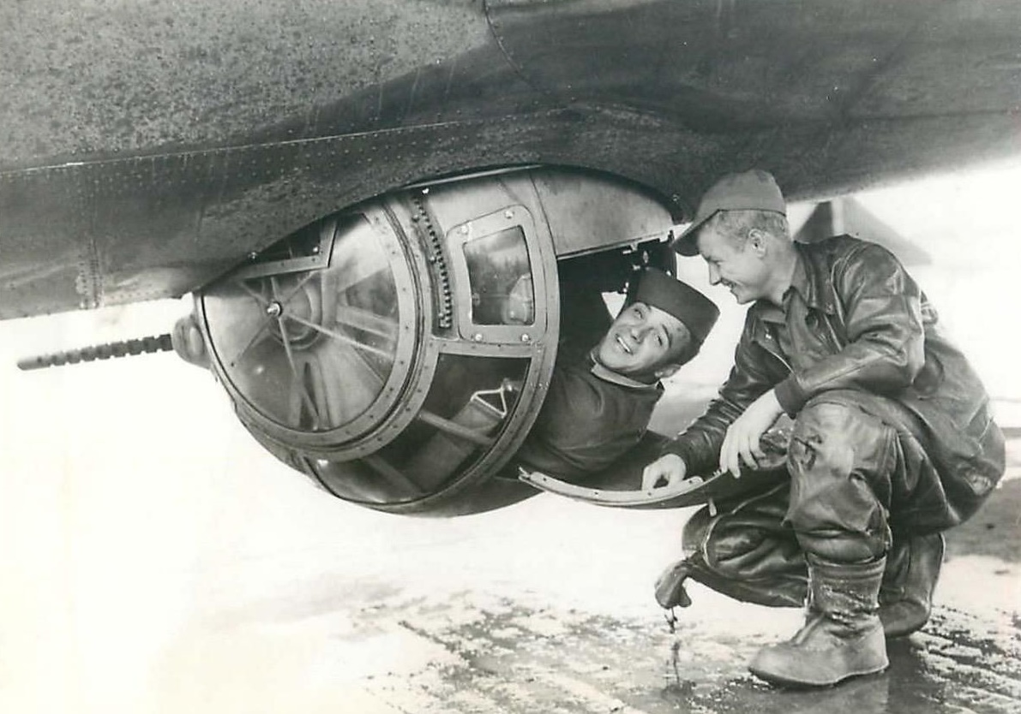

**Flag**

John Agard

2005

What’s that fluttering in a breeze?

It’s just a piece of cloth

that brings a nation to its knees.

What’s that unfurling from a pole?

It’s just a piece of cloth 5

that makes the guts of men grow bold.

What’s that rising over a tent?

It’s just a piece of cloth

that dares the coward to relent.

What’s that flying across a field? 10

It’s just a piece of cloth

that will outlive the blood you bleed.

How can I possess such a cloth?

Just ask for a flag my friend.

Then blind your conscience to the end. 15

**Fighting Talk**

Wider Reading: Monsters and Mayhem

1. *Monsters and heroes in Beowulf*, by Victoria Symons
2. *How did soldiers cope with war?*, by Matthew Shaw
3. *We need more focus on the women poets of World War I*, by Lisa Regan
4. *Top 10 war poems*, by Jon Stallworthy
5. *Close reading of John Agard’s ‘Flag’*, by Daljit Nagra

…………………………………………………………………………………………………………………………………………………………………………………………

‘Men responded differently under fire’

…………………………………………………………………………………………………………………………………………………………………………………………

**Extract from** ***Monsters and heroes in Beowulf***

Victoria Symons

Source: <https://www.bl.uk/medieval-literature/articles/monsters-and-heroes-in-beowulf>

It’s no overstatement to say that *Beowulf* is – today – one of the most important surviving works of medieval literature. It is by far the longest Old English poem and – at just over 3,000 lines – preserves about one tenth of surviving English verse from before the Norman Conquest. But it’s also very much a mystery. There isn’t a lot we know about who composed it, or why, or even when. There is only one surviving copy from the whole of the medieval period.

For a long time, academics didn’t really know what to make of *Beowulf*. An early criticism was that it ‘puts the irrelevancies in the centre and the serious things on the outer edges’. By ‘irrelevancies’, Ker means the three monster fights that make up most of the action. Most critics today would disagree: the monsters now hold a ‘central importance… crucial to the very structure of the poem’. After all, *Beowulf* is – at its heart – the story of a heroic man who kills three monsters and then dies. So, to understand this ancient poem, we need first to understand its monsters.

First up is Grendel: in many ways an unknown quantity. He’s a shadowy figure (literally, ‘border-stepper’, whose eyes glow with a ‘grim light’. He’s descended from Cain, the fratricidal son of Adam and Eve, whose murder of his own brother sees him cast out by God and fated to wander the world in exile. This gives the impression that Grendel is human, or at least humanoid, and we’re told that he goes on ‘in the shape of a man’. But he’s much larger than that: it takes four warriors simply to lift his head. He lives in a gloomy underwater lair somewhere beyond the ‘dark moor’. He eats his victims – bones and all – and fights without weapons or armour in frenzied attacks that leave dozens dead in his wake. These details emerge in fits and starts over the course of the poem: always suggestive, never specific. In the best traditions of horror narratives, the more that’s left to the imagination the better.

Grendel attacks the Danes night after night for years, until Beowulf comes to their aid in an epic encounter that literally shakes the Danish hall to its foundations. Grendel’s final incursion into Heorot begins with a bloody assault on one of Beowulf’s sleeping warriors:

*Grendel tore without hesitation,*

*bit the bone-locks, drank the blood of the veins,*

*swallowed sinful bites; soon he had*

*entirely consumed the unliving one,*

*down to his feet and hands*.

**Extract from** ***How did soldiers cope with war?***

Matthew Shaw

Source: <https://www.bl.uk/world-war-one/articles/how-did-soldiers-cope-with-war>

Given our understanding of the horrors of war, it is often difficult to understand how men coped with life at the Front during the First World War. Many, of course, did not: it is during this period that shell shock and what we now know as post-traumatic stress disorder were first described and diagnosed.

Men responded differently under fire. For many, the helplessness of suffering artillery bombardment was the hardest thing to deal with. Many could not stay hunkered down but could only cope with the noise and danger of death by walking around, thereby increasing their risk of becoming a casualty. Group panic could break out during an attack, as could more serious breaches of discipline, particularly when troops were especially exhausted or bore grievances against the officers. Those immediately thrown into heavy action tended to cope less well than novices who were gradually exposed to conflict.

Soldiers also had to cope with long stretches of anxious waiting, or even boredom, as well as responding to or participating in attacks. To counteract this, busy routines were put in place, ensuring that trenches were repaired, men supplied, and all was ready for the long, wakeful nights (daytime was usually too dangerous for major activity). Soldiers could also comfort themselves with the knowledge of the inefficiency of most First World War weaponry. Men often resorted to black or gallows humour, as well as a bitter fatalism and superstition, as a means of dealing with everyday reality; doses of rum may also have played their part in steadying nerves. However, many of course did not cope with the stresses of the war. This manifested itself in a number of ways, including the reporting of physical ailments, such as trench foot, which, in the British army, was tracked as a marker of morale. Recognising that a rise in certain diseases was linked to problems with morale, the British army recorded the incidence of trench foot and asked officers to produce a report if the number rose. Others responded to the strains with what was called ‘shirking’, a general lassitude and lack of aggression in combat.

Medical opinion, and the rates of psychological breakdown after returning to the field, suggested that those who temporarily left their post (that is, were convicted of the charge of ‘Absence without Leave’) were suffering from the mental effects of war. Suicide offered another way out. It was much underreported, as at least 3,828 German soldiers killed themselves; a figure that does not reflect the numbers who simply walked into enemy fire or whose death was ambiguous. Those that returned also had to readjust to civilian life, often during periods of great political and social upheaval. Millions also had to cope with physical trauma or the loss of family members and friends. Many men found it difficult to talk about their experiences or found it hard to relate their sense of service with a society that increasingly came to lament the loss. The psychological consequences of the war continued to be felt for a generation or more.

**Extract from** ***We need more focus on the women poets of World War I***

Lisa Regan

Source: <https://theconversation.com/we-need-more-focus-on-the-women-poets-of-world-war-i-30229>

We’ve become very accustomed to connecting World War I with its soldier-poets. And the centenary celebrations in Britain have very rightly reminded us how important key figures such as Wilfred Owen, Isaac Rosenberg and Siegfried Sassoon were to their own generation and continue to be for future generations.

But for all that I was struck by actress Penelope Keith’s reading of Rose Macaulay’s poem, ‘Many Sisters to Many Brothers’ at Westminster Abbey’s candle-lit vigil. It was refreshing – not least because Macaulay is an author often edged off the literary map. But despite this I was left wondering whether this particular poem was the right poem to choose.

Macaulay’s 1914 poem expresses women’s envy of men’s freedom to go to war (service being voluntary until conscription began in 1916). The sister of the poem voices her frustration to her absent brother at not being able to play her part:

*In a trench you are sitting, while I am knitting*

*A hopeless sock that never gets done*.

This feeling was not a rare one. Vera Brittain, another young woman aspiring to equal her brother, had felt similarly. In her war diaries she records how she felt in 1914: ‘To-day I started the only work it seems possible as yet for women to do, the making of garments for the soldiers. I started knitting sleeping-helmets.’ And while she struggles to knit, her brother volunteers for military service.

To us, this envy might appear naïve. But we need to bear in mind that these young middle-class women were caught up in that initial romaticisation of the war which followed the declaration. And this was before women had been granted the vote and entry into many professions – these were freedoms that would only come after the war. It was also before either Macaulay or Brittain had the opportunity to join the war effort as Voluntary Aid Detachment nurses from 1915 – an experience that Brittain would later describe in her war memoir, *Testament of Youth* as ‘the tutelage to horror and death’.

At this time, a century ago, no one could guess at the tragedy and bereavement war would bring. Brittain lost not only her brother, but also her fiancé and two close male friends. Macaulay’s brother survived, though badly wounded, but she was to feel keenly the loss of her poet-friend Rupert Brooke.

**Extract from** ***Top 10 war poems***

Jon Stallworthy

Source: <https://www.theguardian.com/books/2014/jul/30/top-10-war-poems-first-world-war-jon-stallworthy>

**‘Drummer Hodge’, by Thomas Hardy**

In the 50 years between the writing of Tennyson’s Charge’, and this heart-wrenching poem of Hardy’s, the new ‘humane’ tradition had come to challenge nine centuries of the old ‘heroic’ one. Hardy didn’t see the Boer war burial party ‘throw in Drummer Hodge to rest / Uncoffined – just as found’, but his lifelong absorption in the little world of Wessex enabled him, imaginatively, to witness the boy’s graveside.

**‘Strange Meeting’, by Wilfred Owen**

Not the most flawless of Owen’s poems, but the most visionary, this reaches back to the heroic epics of Homer and Virgil and forward to voice in its last lines a compassionate humanity in striking contrast to the last speech of Byrhtnoth, the doomed warrior in The Battle of Maldon.

**‘MCMXIV’, by Philip Larkin**

No poem written since MCMXIV (Latin numerals for 1914, as found on first world war memorials) speaks so eloquently, so poignantly, of the future awaiting the children at play, ‘the men leaving the gardens tidy, / The thousands of marriages’, all seen as in a fine-grained sepia photograph.

**‘Platform One’, by Ted Hughes**

Hughes’s father and uncle fought in the Great War and one senses their shadowy presence behind this elegy for those who did not survive it as they did. Focusing on Platform One’s larger-than-life bronze statue in Paddington station, his imagination travels from a peacetime present, in which holiday-bound families are ‘scrambling for their lives’, to a past in which soldiers left that platform to scramble for their lives – and lose them – on foreign battlefields.

**‘The Death of the Ball Turret Gunner’, by Randall Jarrell**

Many of the most moving and memorable poems to emerge from the second world war were written by Americans. Jarrell, who served in the US Army Air Corps, was concerned with victims, the most famous of whom was the subject of this poem. To get the full force of it one needs to know that a ball turret was a plexiglass sphere set into the belly of a bomber and contained two machine guns and one small man – he had to be small. When this gunner tracked with his machine gun a fighter attacking his bomber from below, he revolved with the turret. Hunched upside down in his little sphere, he looked like a foetus in a womb. Jarrell’s gunner wakens from a dream of life to the reality of death: ‘‘When I died they washed me out of the turret with a hose.’ Only with the last word – (and it would have been a steam hose) – does the full force of the abortion metaphor hit us.

**Extract from** ***Close reading of John Agard’s ‘Flag’***

Daljit Nagra

Source: <https://www.bl.uk/20th-century-literature/articles/close-readings-of-john-agards-checking-out-me-history-flag-and-half-caste>

‘Flag’ is a gently reflective song whose cadences revolve around a series of rhetorical questions. The opening tercet, the unit of three lines, is ironic and gently mocking for the way it considers a flag as a ‘piece of cloth’, and for the way this cloth brings ‘a nation to its knees’. The simple language here, which relies on clichés, is all the more shocking in its rueful tone, and makes us wonder, how a piece of cloth could reduce a mass of people to a single identity. The simple style almost seems to reflect how easy it is for leaders of nations to win people over to their own cause, which often ends in humiliating people who subscribe to a different ‘piece of cloth’. The dismay of the speaker about the charm, the magical properties of the flag leads to the refrain, ‘It’s just a piece of cloth’. The poet is incredulous at the cloth’s power. The poem shows how easily we are led by symbols; how emotive certain aspects of national identity are at making us work together for a cause.

List poems such as ‘Flag’, in which the reader is held on the spot with a single fascination, rely on strong conclusions. As readers, we want to be rewarded for our patience. ‘Flag’ doesn’t disappoint: it supplies a knowing ending that’s suffused with rage as it offers its damning instruction, ‘Then bind your conscience to the end’. The verb, ‘bind’ is loaded with the idea of the self being wound up in the flag – restrained and imprisoned by it. It also suggests the idea of being bound, as in being dutiful to the cause of the flag. There’s also a passing hint of ‘blind’, that our conscience is not only devoted to a greater cause, but that it’s not our own anymore, because we are ‘blind’, because we have handed our conscience over to the demands of the flag. As a victim of slavery and empire, Agard knows something of the worst excesses of this act of subscribing to a flag.