Wisdom and the World

An Anthology of Poetry for KS3 Students

- Fall, Leaves, Fall, by Emily Brontë (1846)
- The Eagle, by Alfred Tennyson (1851)
- An Emerald is as Green as Grass, Christina Rossetti (1872)
- In Time of Silver Rain, Langston Hughes (1947)
- The Trees, Philip Larkin (1974)
- Nettles, Vernon Scannell (1980)
- The Ideal, James Fenton (1983)
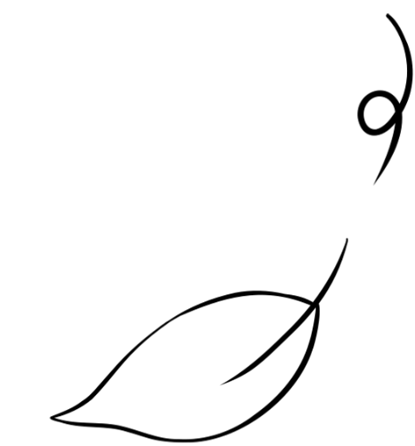
- Praise Song For My Mother, Grace Nichols (1984)
- Indian Cooking, Moniza Alvi (1993)
- December, Carol Ann Duffy (2005)
- A Chant Against Death, by Mervyn Morris (2006)
- Remember, by Matt Goodfellow (2020)

Fall, Leaves, Fall (1846)
Fall, leaves, fall; die, flowers, away;
Lengthen night and shorten day!
Every leaf speaks bliss to me,
Fluttering from the autumn tree.

I shall smile when wreaths of snow
Blossom where the rose should grow;
I shall sing when night’s decay
Ushers in a drearier day.

Emily Brontë

Tone

Elements of a text that reveal the writer’s attitude

Autumn and Winter are not seasons we typically associate with joy

Why do you think Brontë chooses to celebrate them in the poem?

The Eagle (1851)
He clasps the crag with crooked hands;
Close to the sun in lonely lands,
Ring’d with the azure world, he stands.

The wrinkled sea beneath him crawls;
He watches from his mountain walls,
And like a thunderbolt he falls.

Alfred Tennyson

Alliteration

The repetition of consonant sounds

The poem depicts a powerful bird of prey taking flight

How does Tennyson use language to reflect its power and movement?

An Emerald is as Green as Grass (1872)
An emerald is as green as grass;
A ruby red as blood;
A sapphire shines as blue as heaven;
A flint lies in the mud.
A diamond is a brilliant stone,
To catch the world’s desire;
An opal holds a fiery spark;
But a flint holds fire.

Christina Rossetti

Simile

A comparison of two things usually using ‘like’ or ‘as’

Flint is very different to the other precious stones in the poem

How does Rosetti use language and structure to draw attention to its qualities?

In Time of Silver Rain (1947)
In time of silver rain
The earth
Puts forth new life again,
Green grasses grow
And flowers lift their heads,
And over all the plain
The wonder spreads
Of life, of life, of life!

In time of silver rain
The butterflies lift silken wings
To catch a rainbow cry,
And trees put forth
New leaves to sing
In joy beneath the sky
As down the roadway passing boys
And girls go singing, too,
In time of silver rain
When spring
Adjective

A word that modifies a noun
And life are new.

Langston Hughes
Rain is not something we typically associate with optimism

How does Hughes use language and form to draw attention to its qualities?

The Trees (1974)
The trees are coming into leaf
Like something almost being said;
The recent buds relax and spread,
Their greenness is a kind of grief.

Is it that they are born again
And we grow old? No, they die too.
Their yearly trick of looking new
Is written down in rings of grain.

Yet still the unresting castles thresh
In fullgrown thickness every May.
Last year is dead, they seem to say,
Begin afresh, afresh, afresh.

Philip Larkin

Symbolism

Use of an object or entity to represent ideas or qualities
Trees might seem like a strange choice for the subject of a poem

What bigger ideas does Larkin explore through them?
Nettles (1980)
My son aged three fell in the nettle bed.
‘Bed’ seemed a curious name for those green spears,
That regiment of spite behind the shed:
It was no place for rest. With sobs and tears
The boy came seeking comfort and I saw
White blisters beaded on his tender skin.
We soothed him till his pain was not so raw.
At last he offered us a watery grin,
And then I took my billhook, honed the blade
And went outside and slashed in fury with it
Till not a nettle in that fierce parade
Stood upright anymore. And then I lit
A funeral pyre to burn the fallen dead,
But in two weeks the busy sun and rain
Had called up tall recruits behind the shed:
My son would often feel sharp wounds again.

Vernon Scannell
Allegory

A story containing another symbolic story or hidden meaning
The poem is about the experience of a young boy falling into a patch of nettles

What is it also about?

The Ideal (1983)
This is where I came from.
I passed this way.
This should not be shameful
Or hard to say.

A self is a self.
It is not a screen.
A person should respect
What he has been.

This is my past
Which I shall not discard.
This is the ideal.
This is hard.

James Fenton

Enjambment

Where the syntax of a phrase runs over two or more lines of poetry

The poem is formed of a series of simple statements

How do these statements help to create a powerful voice?
Praise Song For My Mother (1984)
You were
water to me
deep and bold and fathoming...

Grace Nichols

Metaphor

Language that transports meaning from one place to another

Water is the central metaphor in the poem

How does it convey praise for the speaker’s mother?

Indian Cooking (1993)
The bottom of the pan was a palette –
paprika, cayenne, dhania
haldi, heaped like powder-paints.

Melted ghee made lakes, golden rivers.
The keema frying, my mother waited
for the fat to bubble to the surface.

Friends bought silver-leaf.
I dropped it on khir –
special rice pudding for parties.

I tasted the landscape, customs
of my father’s country –
its fever on biting a chilli.

Moniza Alvi

Imagery

Language used to engage and immerse the senses

The preparation of food is presented as a joyful activity

Why else is food preparation important to the speaker?

December (2005)
The year dwindles and glows
to December’s red jewel,
my birth month.

The sky blushes,
and lays its cheek
on the sparkling fields.

Then dusk swaddles the cattle,
their silhouettes
simple as faith.

These nights are gifts,
our hands unwrapping the darkness
to see what we have.

The train rushes, ecstatic,
to where you are,
my bright star.
Verb

A word used to identify an action or state

Carol Ann Duffy
The poem has similarities with Fall, Leaves, Fall, by Emily Brontë

In what ways is it similar and what are the differences?

A Chant Against Death (2006)
say family
say friends
say wife
say love
say life

say learning
laughter
sunlight
rain

say cycle
circle
music
memory

say night & day
say sun & moon

say
Free Verse

Poetry that does not follow established conventions of form and metre
see you soon.

Mervyn Morris
The poem is written using a particularly distinctive form

What effect do the white spaces have on the rhythm?
Remember (2020)
when shadows creep across your mind
and smiles are thin and tight
when you do what you believe in
but question if it’s right
when you focus not on what you’ve got
but all the things you lack
there may be rain at the front of the house
but sunshine round the back

when you can’t remember where you found
the words you used to say
when your heartbeat is the music
that you listen to each day
when you turn away from talent
in case you lose the knack
there may be rain at the front of the house
but sunshine round the back

Matt Goodfellow
Juxtaposition

Placing objects, images or ideas together to contrast them
The poem contains a series of contrasting images

How do they help convey the central message of the poem?

