The Strange Case of Dr Jekyll and Mr Hyde
and the Gothic Tradition

‘The Past Isn't Dead. It Isn't Even Past’

– William Faulkner

A Timeline of Key Publications

1818 | Mary Shelley’s Frankenstein is published | Dr Frankenstein is an overreaching scientist whose monstrous creation pursues and eventually destroys him. Dr Jekyll also overreaches and is ultimately destroyed for doing so. Both novels employ layered, framed narratives that help to generate a sense of unsettling opacity.
1859 | Charles Darwin’s The Origin of Species is published | Charles Darwin′s Origin of Species challenged traditional Victorian perceptions of science and scientific possibilities, whilst also undermining the value of religion as a guiding force. The resulting debates around morality and existentialism are clearly present throughout Jekyll and Hyde.
1871 | Charles Darwin’s The Descent of Man is published | Darwin considered ‘whether man, like every other species, is descended from some pre-existing form’. Jekyll and Hyde captures many of the anxieties that arose from late nineteenth-century evolutionary thought, specifically the fear of regression. It is notable that Hyde is described as ‘ape-like’ and ‘troglodytic’.
1885 | Criminal Law Amendment Act | Henry Jekyll is part of a circle formed of respectable professional men. His life, outwardly at least, is sterile and self-consciously repressed. Hyde’s ‘undignified’ and ‘monstrous’ nocturnal acts are suggestive of what, at the time, would have been classified as gross indecency.
Robert Louis Stevenson publishes The Strange Case of Dr Jekyll and Mr Hyde in 1886
1888 | The Whitechapel murders are committed. | The first of the eleven unsolved Whitechapel murders were committed two years after Jekyll and Hyde was published. Speculation in newspapers that the identity of the murderer was Edward Hyde did not, at the time, seem entirely implausible and they helped to fuel the widespread ‘urban terror’.
1890 | Oscar Wilde’s The Picture of Dorian Gray is published | Both Dorian and Jekyll lead double lives and, outwardly, maintain gentlemanly exteriors. Each character is able to create a double, with all the resources necessary to indulge in the ‘sordid and sensual’ whilst avoiding public shame. However, Dorian, like Jekyll soon grows ‘deadly sick’.
1895 | Oscar Wilde’s trial results in his imprisonment | Section 11 of the Criminal Law Amendment Act was used to send Wilde to prison; he was convicted of sodomy. A number of oblique references to Jekyll’s homosexuality are made in the novel, and the power of Hyde to blackmail him over the ‘concealed pleasures’ of his past greatly concerns Utterson.
1897 | Bram Stoker’s Dracula is published | Dracula’s dual identity as a refined Count and primitive monster mirrors Jekyll’s own duality. The novel, like Jekyll and Hyde, is a dramatization of fears at the time that civilisation was only a thin veneer, emphasised by the common imperialistic view that colonial subjects were primitive savages.

Experiment on a Bird in the Air Pump, by Joseph Wright of Derby (1768)

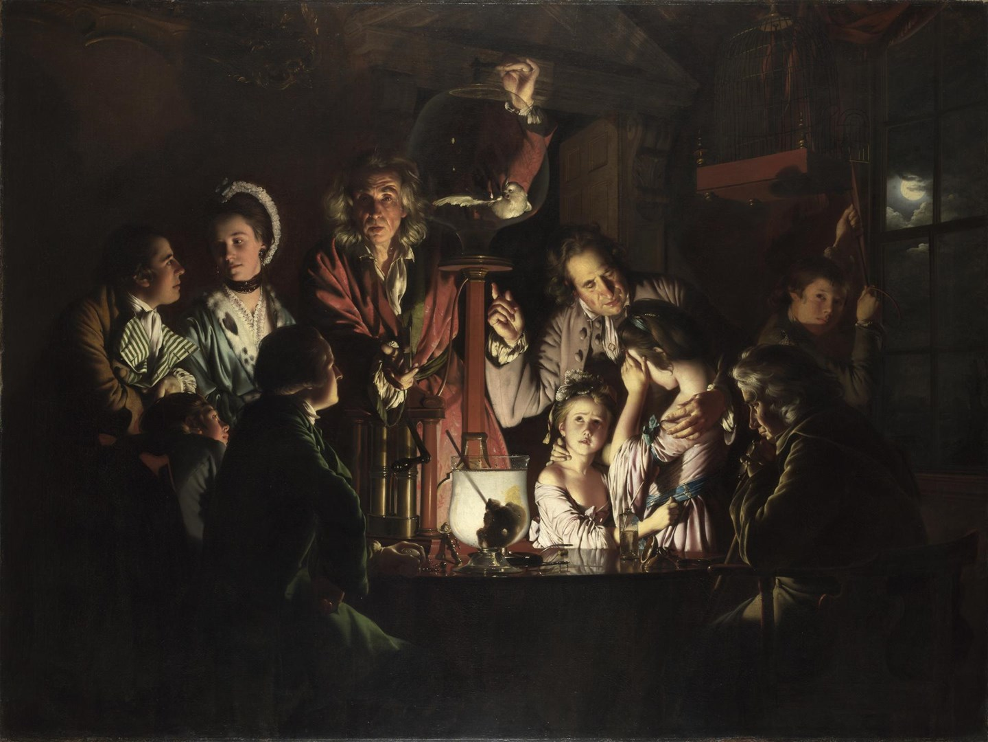

Joseph Wright of Derby’s painting, Experiment on a Bird in the Air Pump, shows a family gathered around to watch as a travelling scientist slowly suffocates a bird in a jar, and it tends to be broadly interpreted as a celebration of science, a rebuttal to those who worried that the age of enlightenment might also usher in an age of unprecedented uncertainty. The extreme lighting that makes this scene such a compelling piece of drama is not the benevolent light of scientific progress, but the eery flash of a lightning strike, or perhaps something else entirely. The moon, glimpsed through the window, is a shorthand for the kind of haunted house so essential to Gothic novels while the wild-haired scientist, hardly the image of a man of reason, is recast as a magus or sorcerer from an ancient age of magic and superstition.

The painting is suddenly ambivalent, no longer cheerleading for scientific advancement but giving vent to the anxieties that accompanied it. Was God, like the dying bird, being killed by science? And if so, what would fill the vacuum? Such concerns about the Pandora’s box that science might open were nowhere more strenuously articulated than in Mary Shelley’s Frankenstein; even today Frankenstein is synonymous with irresponsible scientists, concerned more with the realisation of their ambitions than the moral obligations that come with scientific discovery.

Source: https://theartsdesk.com/tv/art-gothic-britains-midnight-hour-bbc-four
Extracts from Victorian Gothic: An Introduction, by Julian Thompson

Stevenson uses Gothic doubling in The Strange Case of Dr Jekyll and Mr Hyde (1886), where the middle-aged, highly moral Doctor proves no match for his cynical, youthful and violent other self. Oscar Wilde doubled his hero in The Picture of Dorian Gray (1891), where an immortal young aesthete goes about the dark parts of town with impunity, while his double, in the form of an increasingly grotesque work of art hidden in an attic, does his suffering for him. In Ambrose Bierce’s An Occurrence at Owl Creek Bridge (1890), the double life of the Confederate saboteur is short and sharp. In his dream world he thinks he escapes the hangman’s noose and returns to his family. In our world this is a fantasy, indulged and then abruptly curtailed as he drops through the air to his death.

Stevenson, Wilde and Bierce use realism to ground their stories, but Victorian Gothic likes to mix it with ‘impossible things’, as in the nonsense writings of Carroll and Lear. A favourite quotation in Victorian ghost-stories is Hamlet’s ‘There are more things in heaven and earth, Horatio, than are dreamt of in your philosophy.’ M. R. James, an accomplished scholar and academic in his day-job, very fond of this quotation, plants half-forgotten demons in cellars and dusty tomes, suggesting that men of learning, like Dr Jekyll, should be careful what they wish for, or at least search for.

In an age of increasing religious uncertainty, spiritualistic experiment and imperial fears, Gothic provided a safe space for both ancient demons and modern psychological anxiety. Writers were able to privilege mystery over explanation, ambiguity over what Keats called ‘irritable reaching after fact and reason’, capturing the dark side of the Victorian soul in all its energetic and self-revealing doubt.

Source: http://writersinspire.org/content/victorian-gothic-introduction

Extracts from Gothic Motifs, by John Bowen

Strange Places

Think: Hyde lives in a disreputable part of London – Soho – and Utterson describes the area in grim detail in chapter four.

It is usual for characters in Gothic fiction to find themselves in a strange place; somewhere other, different, mysterious. It is often threatening or violent, sometimes sexually enticing, often a prison.

Clashing Time Periods

Think: Utterson remarks in chapter two that there is ‘something troglodytic’ about Hyde.

Just as places are often mysterious, lost, dark or secret in Gothic fiction, so too are its characteristic times. Gothics often take place at moments of transition (between the medieval period and the Renaissance, for example) or bring together radically different times. There is a strong opposition (but also a mysterious affinity) in the Gothic between the very modern and the ancient or archaic, as everything that characters and readers think that they’ve safely left behind comes back with a vengeance. Gothic novels are full of such uncanny effects – simultaneously frightening, unfamiliar and yet also strangely familiar. A past that should be over and done with suddenly erupts within the present and deranges it.

Power and Constraint

Think: Utterson feels vulnerable prior to meeting Hyde in chapter two; later on, in chapter four, Hyde savagely attacks Carew.

The Gothic world is fascinated by violent differences in power, and its stories are full of constraint, entrapment and forced actions. Scenes of extreme threat and isolation – either physical or psychological – are always happening or about to happen.

A World of Doubt

Think: Lanyon accuses Jekyll of committing ‘scientific heresies’; the sight of Hyde’s transformation shocks him to death.

Gothic is thus a world of doubt, particularly doubt about the supernatural and the spiritual. It seeks to create in our minds the possibility that there may be things beyond human power, reason and knowledge. But that possibility is constantly accompanied by uncertainty. The uncertainty that goes with Gothic is very characteristic of a world in which orthodox religious belief is waning; there is both an exaggerated interest in the supernatural and the constant possibility that even very astonishing things will turn out to be explicable. This intellectual doubt is constantly accompanied by the most powerful affects or emotions that the writer can invoke. The 18th-century philosopher and politician Edmund Burke in his 1757 A Philosophical Enquiry into the Origin of Our Ideas of the Sublime and Beautiful made a vital distinction between the beautiful and the sublime which has shaped much modern thinking about art. Beauty, for Burke, is characterised by order, harmony and proportion. Sublime experiences, by contrast – the kind we get for example from being on a high mountain in a great storm – are excessive ones, in which we encounter the mighty, the terrible and the awesome. Gothic, it is clear, is intended to give us the experience of the sublime, to shock us out of the limits of our everyday lives with the possibility of things beyond reason and explanation, in the shape of awesome and terrifying characters, and inexplicable and profound events.

Source: https://www.bl.uk/romantics-and-victorians/articles/gothic-motifs

Literary Research Tasks

What is the novel Frankenstein about and what parallels are there with Jekyll and Hyde?

Clue: Dr Frankenstein is an overreaching scientist whose monstrous creation pursues and eventually destroys him.

It was on a dreary night of November that I beheld the accomplishment of my toils. With an anxiety that almost amounted to agony, I collected the instruments of life around me, that I might infuse a spark of being into the lifeless thing that lay at my feet. It was already one in the morning; the rain pattered dismally against the panes, and my candle was nearly burnt out, when, by the glimmer of the half-extinguished light, I saw the dull yellow eye of the creature open; it breathed hard, and a convulsive motion agitated its limbs.

What is the novella The Picture of Dorian Gray about and what parallels are there with Jekyll and Hyde?

Clue: Both Dorian and Jekyll lead double lives and, outwardly, maintain gentlemanly exteriors.

For the wonderful beauty that had so fascinated Basil Hallward, and many others besides him, seemed never to leave him. Even those who had heard the most evil things against him – and from time to time strange rumours about his mode of life crept through London and became the chatter of the clubs – could not believe anything to his dishonour when they saw him. He had always the look of one who had kept himself unspotted from the world.

What is the novel Dracula about and what parallels are there with Jekyll and Hyde?

Clue: Dracula’s dual identity as a refined Count and primitive monster mirrors Jekyll’s own duality.

When the Count saw my face, his eyes blazed with a sort of demoniac fury, and he suddenly made a grx`ab at my throat. I drew away and his hand touched the string of beads which held the crucifix. It made an instant change in him, for the fury passed so quickly that I could hardly believe that it was ever there.

