Review Task Booklet

Jekyll and Hyde

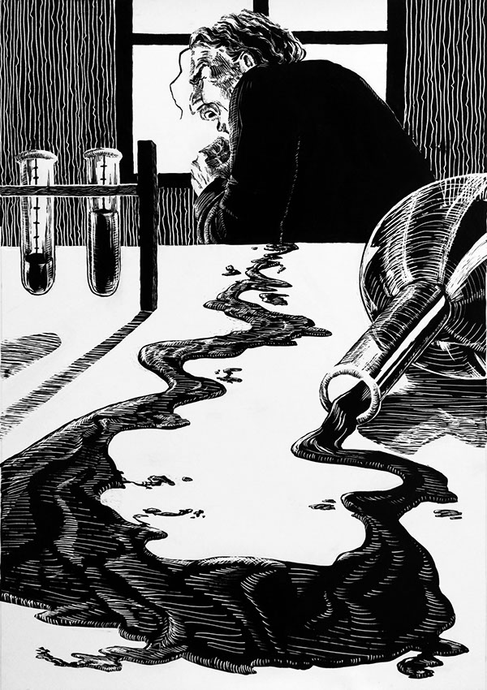

Contents

3 | Quotation Retrieval Grid
4 | Quiz Questions: 1 - 25
5 | Quiz Questions: 26 - 50
6 | Extract to Annotate on Edward Hyde
8 | Extract to Annotate on Henry Jekyll
10 | Multiple-Choice Quiz 1
11 | Multiple-Choice Quiz 2
12 | Multiple-Choice Quiz 3
13 | Chapter-by-Chapter Review Questions
17 | Starter for Five Questions
18 | Specimen Exam Question: SAMs 2
19 | Specimen Exam Question: SAMs 3

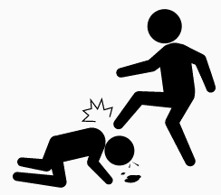 | 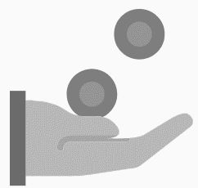 | 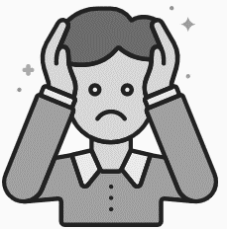

Quiz Questions

1 | Which chapter is called ‘Search for Mr Hyde’?
2 | How are Enfield and Utterson related?
3 | Which character narrates the ‘Story of the Door’?
4 | Which character has ‘an evil face, smoothed by hypocrisy’?
5 | Which character is alleged to have committed ‘scientific heresies’?
6 | Which character is described as being ‘pale and dwarfish’?
7 | Who witnesses the murder of Sir Danvers Carew?
8 | In which chapter is Jekyll described as ‘looking deadly sick’?
9 | What is Utterson’s profession?
10 | In which year was Jekyll and Hyde published?
11 | What does Poole use to break down the door to Jekyll’s laboratory?
12 | Which chapter is called ‘Remarkable Incident of Dr Lanyon’?
13 | On which day to Enfield and Utterson typically go walking together?
14 | What is ‘Coutts’ a reference to?
15 | What is Lanyon’s first name?
16 | Which character was born ‘to a large fortune’?
17 | What does Hyde use to murder Sir Danvers Carew?
18 | What is a ‘sawbones’?
19 | What time is Enfield walking home at in chapter one?
20 | Which character is described as a ‘hearty, healthy, dapper, red-faced gentleman’?
21 | Which character says that he shall be ‘Mr Seek’?
22 | Which contemporary scientist proposed that human beings had evolved from apes?
23 | What is the study of physiognomy?
24 | In which chapter is Dr Jekyll ‘Quite at Ease’?
25 | Which character is described as a ‘hide-bound pedant’?
Quiz Questions

26 | Which character is described in chapter 1 as ‘a man of rugged countenance’?
27 | What is Enfield’s first name?
28 | Which character narrates the final chapter of the novel?
29 | How many pounds in gold does Hyde pay in compensation to the girl’s family?
30 | In which area of London is Lanyon’s house situated?
31 | What is the name of Jekyll’s butler?
32 | What is the title of chapter four?
33 | Who does Jekyll leave all his possessions to in the case of his death?
34 | How old is Jeykll?
35 | Which character says, ‘The moment I choose, I can be rid of Mr Hyde’?
36 | What is the name of the respected MP murdered by Hyde?
37 | Which character is described as looking ‘small and particularly wicked-looking’?
38 | In which area of London does Hyde live?
39 | Which character’s dwelling is ‘furnished with luxury and good taste’?
40 | What is the title of chapter seven?
41 | Which chapter is titled ‘The Last Night’?
42 | Which character writes in an ‘odd, upright hand’?
43 | What is the name of Utterson’s head clerk?
44 | On which day do Utterson and Enfield witness the ‘incident at the window’?
45 | In which month does ‘the last night’ take place?
46 | How long has ‘a thing that cries to heaven’ been locked in Jekyll’s cabinet?
47 | Why does the chemist at Maws get ‘main angry’?
48 | What colour is the door that opens into Jekyll’s cabinet?
49 | What is the title of chapter ten?
50 | What is the date on the letter containing Dr Lanyon’s narrative?

Extracts to Annotate on Edward Hyde

Violent | Disturbing | Furious | Callous | Wicked
Brutal | Disconcerting | Primal | Evil | Deformed
Remorseless | Grotesque | Depraved | Mysterious | Debauched
Powerful | Cruel | Instinctive | Immoral | Repugnant

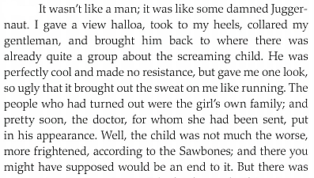
Chapter 1

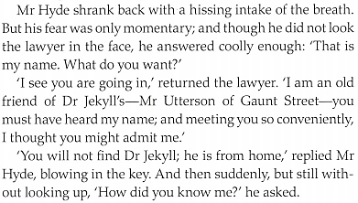
Chapter 2

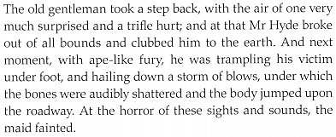
Chapter 4

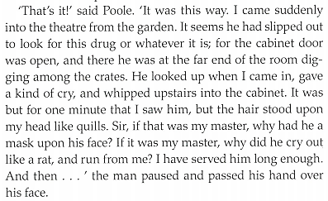
Chapter 8

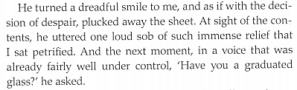
Chapter 9

Extracts to Annotate on Henry Jekyll

Respectable | Sociable | Articulate | Dishonest | Foolish
Professional | Generous | Ambitious | Deceitful | Irrational
Rational | Affectionate | Determined | Calculating | Wretched
Hospitable | Intelligent | Manipulative | Perceptive | Desperate

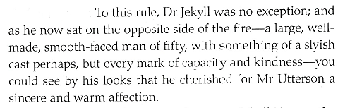
Chapter 3

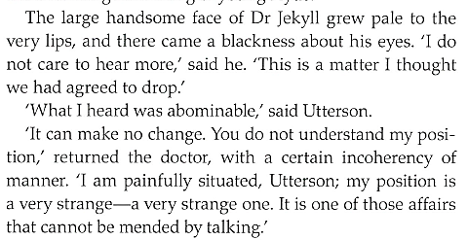
Chapter 3

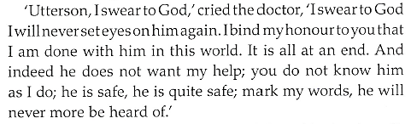
Chapter 5
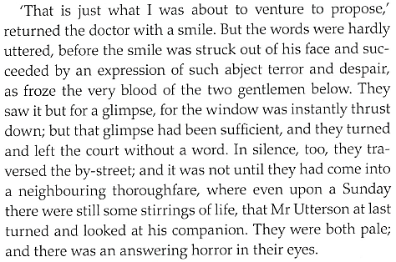
Chapter 7

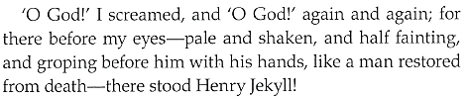
Chapter 9

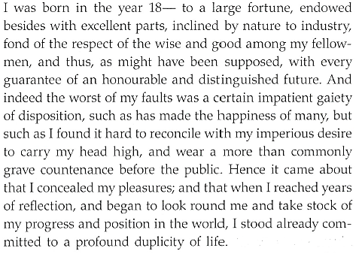
Chapter 10
Multiple-Choice Quiz

Which adjective most accurately describes the character of Gabriel Utterson?

Intrusive | Pedantic | Dull | Loyal | Rational

Lanyon says, ‘it is more than ten years since Henry Jekyll became too fanciful for me’ – what does he mean?

Henry Jekyll’s behaviour is morally dubious | Henry Jekyll’s behaviour is amusing and light-hearted

Which adjective best describes Jekyll at the beginning of chapter three?

Withdrawn | Apologetic | Sociable | Secretive | Charming

Utterson heaves ‘an irrepressible sigh’ at the end of chapter three – what does this reveal?

He is deeply concerned | He is particularly tired | He is frustrated

Which adjective most accurately describes the character of Sir Danvers Carew?

Mysterious | Friendly | Aggressive | Vulnerable

What does Jekyll’s feverish manner in chapter five reveal?

He feels very ill | He is deeply distressed

Why do Richard Enfield and Utterson leave Jekyll with ‘an answering horror in their eyes’ in chapter seven?

They are shocked by Jekyll’s appearance | They are irritated by Jekyll’s behaviour | They are worried that Jekyll is ill

Which adjective best describes Jekyll’s behaviour (as reported by Poole) in chapter eight?

Erratic | Violent | Calm | Frightening | Reassuring

Which adjective most accurately describes the reaction of Lanyon when he witnesses the transformation?

Impressed | Terrified | Amused | Satisfied

‘I stood already committed to…’ – how does the quotation from chapter ten finish?

‘a profound duplicity of life’ | ‘an honourable and distinguished future’

Multiple-Choice Quiz

Which of the statements below most fairly summarises the presentation of Henry Jekyll?

1 | An ambitious, intelligent scientist who is unfairly criticised by his friends
2 | A conflicted and flawed man who is responsible for his own downfall
3 | A remorseful character who is honest about his shortcomings and deeply regretful of his actions
4 | A selfish, destructive character who is not strong enough to control his primitive desires
5 | A respectable doctor who acts foolishly

Which of the statements below most fairly summarises the presentation of Edward Hyde?

1 | An unpleasant character who deserves to be treated with suspicion
2 | An evil and remorseless character who commits crimes of the most horrific and disturbing nature
3 | A character who is misunderstood and mistreated by those around him
4 | A mysterious and powerful character who lacks self-control and pity
5 | A strange character who does not conform to standards of Victorian morality

Which of the statements below most fairly summarises the presentation of Gabriel Utterson?

1 | A calm and respectable Victorian gentleman
2 | An intelligent, persistent character who becomes increasingly concerned at Jekyll’s behaviour
3 | A naïve and arrogant character who takes far too long to discover the truth about Jekyll’s actions
4 | A stern and domineering character
5 | A reserved character who does not act swiftly enough to confront Jekyll about his relationship with Hyde

Which of the statements below most fairly summarises the presentation of Hastie Lanyon?

1 | A moral, respectable doctor who contrasts to Jekyll
2 | A disloyal character who not care about Jekyll
3 | A character who is similar to Utterson in his suspicion of Jekyll’s behaviour
4 | An arrogant, volatile character who holds a grudge against Jekyll
5 | A character who is jealous of Jekyll’s achievements

Multiple-Choice Quiz

‘The murderer was gone long ago; but there lay his victim in the middle of the lane’ – who is the victim?

1 | The young girl – chapter one
2 | The young girl – chapter three
3 | Sir Danvers Carew – chapter three
4 | Sir Danvers Carew – chapter four
5 | The matchstick woman – chapter ten

“I have a document here in his handwriting; it is between ourselves” – who is Utterson speaking to?

1 | Poole – chapter three
2 | Guest – chapter three
3 | Poole – chapter four
4 | Guest – chapter five
5 | Hyde’s housekeeper – chapter four

“I should like to very much; but no, no, no, it is quite impossible; I dare not” – what does Jekyll dare not do?

1 | Admit the truth about the will to Utterson
2 | Discuss Hyde’s action
3 | Take a walk outside with Utterson
4 | Take a walk outside with Utterson and Enfield
5 | Allow Poole to enter his cabinet

‘I am now finishing this statement under the influence of the last of the old powders’ – what is the statement about?

1 | Lanyon’s observations of Hyde transforming into Jekyll
2 | Lanyon’s observations of Jekyll transforming into Hyde
3 | Utterson’s views about Jekyll’s strange behaviour
4 | Jekyll’s version of events
5 | Poole’s memoirs about his work in Jekyll’s household

Review of Chapter 1

- Which character narrates the ‘Story of the Door’?

- Which character witnesses Hyde trample on a young girl?

- In which city is the novel set?

- Which character is compared to a ‘damned Juggernaut’?

- What does the word ‘apocryphal’ mean?

- What does a ‘sawbones’ do?

- How much money does Hyde pay the girl and her family?

- Which character banks at Coutts?

- What does Utterson call ‘that place with the door’?

- Which character says that Hyde ‘must be deformed somewhere’?

Review of Chapter 2

- What is the title of chapter two?

- Which important document is kept in Utterson’s safe?

- Where does Lanyon live?

- Which character is ‘too fanciful’ for Lanyon?

- What does the word ‘protégé’ mean?

- What does Utterson hear before he eventually sees Hyde for the first time?

- Who is the ‘common friend’ shared by Utterson and Hyde?

- What is the name of Jekyll’s lawyer?

- Which character ‘never dines’ at Jekyll’s house?

- Why does Utterson fear for Jekyll’s safety?

Review of Chapter 3

- How much time has passed between the end of chapter two and the beginning of chapter three?

- What are ‘cronies’?

- How old is Jekyll?

- Which character does Jekyll describe as a ‘hide-bound pedant’?

- What is the ‘matter’ that Jekyll thought Utterson had ‘agreed to drop’?

- How does Jekyll describe his ‘position’?

- Who does Jekyll claim to trust ‘before any man alive’?

- Who does Jekyll say he ‘can be rid’ of at any moment of his choosing?

- What ‘point’ does Jekyll want Utterson to understand?

- What promise does Utterson make at the end of the chapter?

Review of Chapter 4

- In which month does the action of chapter four take place?

- Which character witnesses the murder of Sir Danvers Carew?

- What object is broken into two pieces as a result of the murder?

- What objects are found upon the body of Sir Danvers Carew?

- In which area of London does Hyde live?

- What does ‘blackguardly’ mean?

- Which character has ‘excellent’ manners?

- Which character’s ‘habits’ are described as ‘irregular’?

- What drink is stocked in Hyde’s closet?

- Is Hyde’s house tidy or messy?

Review of Chapter 5

- Does the chapter begin in the morning or the afternoon?

- What colour is the door to Jekyll’s cabinet?

- What is the name of Jekyll’s butler?

- What news is being ‘cried’ in the streets?

- What does Jekyll claim to have received from Hyde?

- What is the name of Utterson’s head clerk?

- What does Utterson claim is a ‘sad business’?

- What does Utterson receive from Jekyll towards the end of the chapter?

- What conclusion does Guest arrive at?

- What makes Utterson’s blood run ‘cold in his veins’?

Review of Chapter 6

- How much money is offered in reward for information about the location of Hyde?

- Which character is said to have had ‘strange associates’?

- How does Jekyll initially behave in Hyde’s absence?

- On what date is Jekyll’s door ‘shut against’ Utterson?

- Who does Utterson anxiously visit to enquire about Jekyll?

- Which character declares himself a ‘doomed man’?

- Which character does Utterson write to towards the end of the chapter?

- Which character has a funeral?

- What document does Utterson deposit in his private safe?

- Which character has ‘no very pleasant news to communicate’?

Review of Chapter 7

- On what day does the chapter take place?

- Is it late morning or early evening?

- Which character accompanies Utterson on his walk?

- How many windows are visible on the building?

- Which character is described as a ‘disconsolate prisoner’?

- Which character says, ‘I trust you are better’?

- Which character says, ‘I am very glad to see you’?

- Which character has a look of ‘such abject terror’ in his face?

- Which characters feel like their blood has frozen?

- Which character says, ‘God forgive us’?

Review of Chapter 8

- Which character visits Utterson at the beginning of the chapter?

- In which month does the chapter take place?

- What are the weather conditions like?

- Which characters are ‘huddled together like a flock of sheep’?

- What does Poole say made the hairs on his head stand ‘like quills’?

- Which character breaks down the door to Jekyll’s cabinet with an axe?

- What colour is the door?

- Whose body does Utterson discover inside the cabinet?

- What does Poole find on ‘the desk among the neat array of papers’?

- Which character says, ‘he was alive and here this day’?

Review of Chapter 9

- Which character wrote a letter to Lanyon?

- In which month was the letter written?

- At which time is Lanyon directed to admit a stranger into his house?

- What does the ‘press marked E’ contain?

- What is notable about the clothes worn by the stranger?

- Which character says, ‘Compose yourself’?

- What is the initial colour of the potion?

- What is the final colour of the potion?

- Into which character does the stranger transform?

- Which character screams, ‘Oh God!’?

Review of Chapter 10

- What does Jekyll describe as one of his ‘worst’ faults?

- What is the ‘truth’ that Jekyll discovers?

- What makes Jekyll experience the most ‘racking pangs’?

- Is Hyde taller, shorter or the same height as Jekyll?

- Does Jekyll feel threefold or tenfold more wicked as Hyde?

- Is Hyde ‘comingled out of good and evil’ or is he ‘pure evil’?

- How does Jekyll describe the ‘pleasures’ he indulges in as Hyde?

- In which area of London does Jekyll keep ‘a little room’?

- Who does Hyde say he ‘smote’ in the face before she ‘fled’?

- What does Jekyll come to believe was ‘impure’?

Review of Big Questions

- How is the character of Gabriel Utterson presented in the opening pages of chapter one?

- How is the character of Edward Hyde presented in the chapter one?

- How is the relationship between Hastie Lanyon and Henry Jekyll presented in the opening pages of chapter two?

- What does Hyde’s behaviour reveal when he meets Utterson for the first time in chapter two?

- How is the character of Jekyll presented in chapter three?

- How is the attack on Sir Danvers Carew presented in chapter four?

- How is the character of Jekyll presented in chapter five?

- How has the character of Lanyon changed in chapter six?

- How is the character of Jekyll presented in chapter seven, and how has he changed since the beginning of chapter six?

- How is tension created in the first half of chapter eight?

- How is tension created in the second half of chapter eight?

- What does Jekyll’s letter reveal about his state of mind and how does Lanyon initially react?

- How does Lanyon react to witnessing Hyde’s transformation back into Jekyll in chapter nine?

- How does Jekyll attempt to justify his actions in the first part of chapter ten?

- How do Jekyll’s feelings about transforming into Hyde change as chapter ten progresses?

Starter for Five Questions

- ‘Did you ever remark that door?’ >> Who said it?
- ‘There something wrong with his appearance’ >> Who said it?
- 1886 or 1896 >> When was the novel published?
- ‘A person of small stature’ >> Who is it?
- ‘A smooth-faced man of fifty’ >> Who is it?

- ‘Thousands of pounds were offered in reward’ >> For what?
- Deformed >> Which character?
- Anxious >> Which character?
- ‘Hide-bound pedant’ >> Which character?
- Incident at the Window >> Which chapter?

- ‘I have been twenty years in this man’s house’ >> Who has?
- Determined >> Which character?
- ‘The hair stood upon my head like quills’ >> What sight causes this?
- Austere >> Which character?
- Cavendish Square >> Who lives there?

- ‘I was born in the year 18– to a large fortune’ >> Who was?
- Soho >> Who lives there?
- ‘Such unscientific balderdash’ >> Who said it?
- Remorseless >> Which character?
- ‘I shall be Mr Seek’ >> Who said it?

- Distant cousins >> Who are?
- The Story of the Door >> Which chapter?
- ‘I am a man to be trusted’ >> Who said it?
- Sir Danvers Carew >> Who is he?
- ‘You stay too much indoors’ >> Who does?

- ‘Have you a graduated glass?’ >> Who said it?
- ‘I mauled the unresisting body’ >> Who did?
- Respectable >> Who is?
- Rational >> Who is?
- No one has ever suffered such torments’ >> Which character?

Specimen Exam Question

Source: AQA SAMs 2

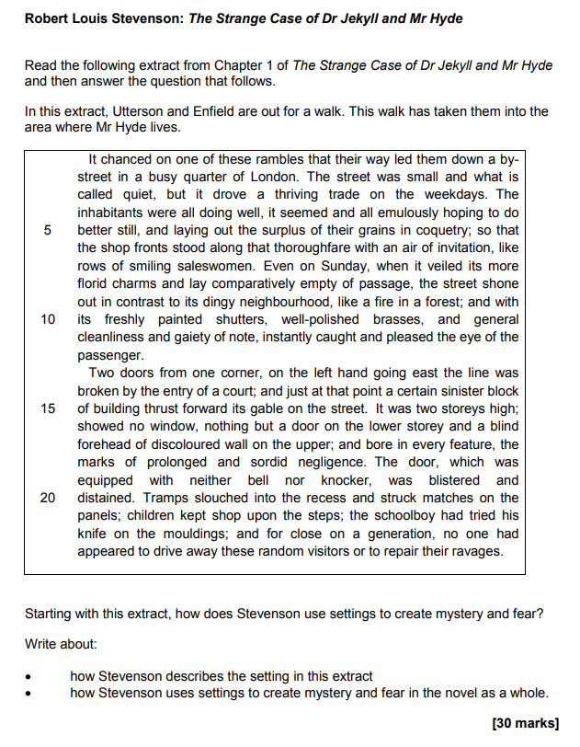

Specimen Exam Question

Source: AQA SAMs 3

