Frankenstein  Page 3 | Page 4  1818 | The Origin of Species  Page 5  1859
The Descent of Man  Page 6  1871 | Criminal Law Amendment Act  Page 7  1885
The Illustrated Police News  Page 8  1888 | The Picture of Dorian Gray  Page 9  1890
De Profoundis  Page 10  1905 | Dracula  Page 11  1897
Jekyll and Hyde | A Timeline of Events and Publications

1818 | Mary Shelley’s Frankenstein is published | Dr Frankenstein is an overreaching scientist whose monstrous creation pursues and eventually destroys him. Dr Jekyll also overreaches, and is ultimately destroyed for doing so. Both novels employ layered, framed narratives that help to generate a sense of unsettling opacity.
1859 | Charles Darwin’s The Origin of Species is published | Charles Darwin′s Origin of Species challenged traditional Victorian perceptions of science and scientific possibilities, whilst also undermining the value of religion as a guiding force. The resulting debates around morality and existentialism are clearly present throughout Jekyll and Hyde.
1871 | Charles Darwin’s The Descent of Man is published | Darwin considered ‘whether man, like every other species, is descended from some pre-existing form’. Jekyll and Hyde captures many of the anxieties that arose from late nineteenth-century evolutionary thought, specifically the fear of regression. It is notable that Hyde is described as ‘ape-like’ and ‘troglodytic’.
1885 | Criminal Law Amendment Act | Henry Jekyll is part of a circle of respectable Victorian professionals. His life, outwardly, is sterile and self-consciously repressed. Hyde’s ‘undignified’ and ‘monstrous’ nocturnal acts are suggestive of what, at the time, would have been classified as gross indecency.
Robert Louis Stevenson publishes The Strange Case of Dr Jekyll and Mr Hyde in 1886
1888 | The Whitechapel murders are committed. | The first of the eleven unsolved Whitechapel murders were committed two years after Jekyll and Hyde was published. Speculation in newspapers that the identity of the murderer was Edward Hyde did not, at the time, seem entirely implausible.
1890 | Oscar Wilde’s The Picture of Dorian Gray is published | Both Dorian and Jekyll lead double lives and, outwardly, maintain gentlemanly exteriors. Each character is able to create a double, with all the resources necessary to indulge in the ‘sordid and sensual’ whilst avoiding public shame. However, Dorian, like Jekyll soon grows ‘deadly sick’.
1895 | Oscar Wilde’s trial results in his imprisonment | Section 11 of the Criminal Law Amendment Act was used to send Wilde to prison; he was convicted of sodomy. A number of oblique references to Jekyll’s homosexuality are made in the novel, and the power of Hyde to blackmail him over the ‘concealed pleasures’ of his past greatly concerns Utterson.
1897 | Bram Stoker’s Dracula is published | Dracula’s dual identity as a refined Count and primitive monster mirrors Jekyll’s own duality. The novel, like Jekyll and Hyde, is a dramatization of fears at the time that civilisation was only a thin veneer, emphasised by the common imperialistic view that colonial subjects were primitive savages.

Frankenstein, by Mary Shelley | Chapter 5

It was on a dreary night of November that I beheld the accomplishment of my toils. With an anxiety that almost amounted to agony, I collected the instruments of life around me, that I might infuse a spark of being into the lifeless thing that lay at my feet. It was already one in the morning; the rain pattered dismally against the panes, and my candle was nearly burnt out, when, by the glimmer of the half-extinguished light, I saw the dull yellow eye of the creature open; it breathed hard, and a convulsive motion agitated its limbs.

How can I describe my emotions at this catastrophe, or how delineate the wretch whom with such infinite pains and care I had endeavoured to form? His limbs were in proportion, and I had selected his features as beautiful. Beautiful! Great God! His yellow skin scarcely covered the work of muscles and arteries beneath; his hair was of a lustrous black, and flowing; his teeth of a pearly whiteness; but these luxuriances only formed a more horrid contrast with his watery eyes, that seemed almost of the same colour as the dun-white sockets in which they were set, his shrivelled complexion and straight black lips.

The different accidents of life are not so changeable as the feelings of human nature. I had worked hard for nearly two years, for the sole purpose of infusing life into an inanimate body. For this I had deprived myself of rest and health. I had desired it with an ardour that far exceeded moderation; but now that I had finished, the beauty of the dream vanished, and breathless horror and disgust filled my heart. Unable to endure the aspect of the being I had created, I rushed out of the room and continued a long time traversing my bed-chamber, unable to compose my mind to sleep. At length lassitude succeeded to the tumult I had before endured, and I threw myself on the bed in my clothes, endeavouring to seek a few moments of forgetfulness. But it was in vain; I slept, indeed, but I was disturbed by the wildest dreams […] I started from my sleep with horror; a cold dew covered my forehead, my teeth chattered, and every limb became convulsed; when, by the dim and yellow light of the moon, as it forced its way through the window shutters, I beheld the wretch—the miserable monster whom I had created. He held up the curtain of the bed; and his eyes, if eyes they may be called, were fixed on me. His jaws opened, and he muttered some inarticulate sounds, while a grin wrinkled his cheeks. He might have spoken, but I did not hear; one hand was stretched out, seemingly to detain me, but I escaped and rushed downstairs. I took refuge in the courtyard belonging to the house which I inhabited, where I remained during the rest of the night, walking up and down in the greatest agitation, listening attentively, catching and fearing each sound as if it were to announce the approach of the demoniacal corpse to which I had so miserably given life.
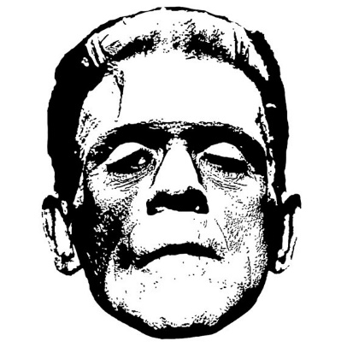
- How is Frankenstein’s monster presented by Shelley?
- What indications are we given that Frankenstein has overreached?

Frankenstein, by Mary Shelley | Chapter 24

My life, as it passed thus, was indeed hateful to me, and it was during sleep alone that I could taste joy. O blessed sleep! Often, when most miserable, I sank to repose, and my dreams lulled me even to rapture. The spirits that guarded me had provided these moments, or rather hours, of happiness that I might retain strength to fulfil my pilgrimage. Deprived of this respite, I should have sunk under my hardships. During the day I was sustained and inspirited by the hope of night, for in sleep I saw my friends, my wife, and my beloved country; again I saw the benevolent countenance of my father, heard the silver tones of my Elizabeth’s voice, and beheld Clerval enjoying health and youth. Often, when wearied by a toilsome march, I persuaded myself that I was dreaming until night should come and that I should then enjoy reality in the arms of my dearest friends. What agonising fondness did I feel for them! How did I cling to their dear forms, as sometimes they haunted even my waking hours, and persuade myself that they still lived! At such moments vengeance, that burned within me, died in my heart, and I pursued my path towards the destruction of the dæmon more as a task enjoined by heaven, as the mechanical impulse of some power of which I was unconscious, than as the ardent desire of my soul.

What his feelings were whom I pursued I cannot know. Sometimes, indeed, he left marks in writing on the barks of the trees or cut in stone that guided me and instigated my fury. ‘My reign is not yet over’—these words were legible in one of these inscriptions—’you live, and my power is complete. Follow me; I seek the everlasting ices of the north, where you will feel the misery of cold and frost, to which I am impassive. You will find near this place, if you follow not too tardily, a dead hare; eat and be refreshed. Come on, my enemy; we have yet to wrestle for our lives, but many hard and miserable hours must you endure until that period shall arrive.’

Scoffing devil! Again do I vow vengeance; again do I devote thee, miserable fiend, to torture and death. Never will I give up my search until he or I perish; and then with what ecstasy shall I join my Elizabeth and my departed friends, who even now prepare for me the reward of my tedious toil and horrible pilgrimage!

- How is Frankenstein’s struggle presented by Shelley?
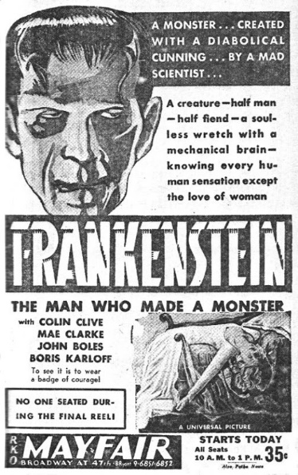
- To what extent has Frankenstein been punished for overreaching?

The Origin of Species, by Charles Darwin | Chapter 5

For myself, I venture confidently to look back thousands on thousands of generations, and I see an animal striped like a zebra, but perhaps otherwise very differently constructed, the common parent of our domestic horse (whether or not it be descended from one or more wild stocks) of the ass, the hemionus, quagga, and zebra.

He who believes that each equine species was independently created, will, I presume, assert that each species has been created with a tendency to vary, both under nature and under domestication, in this particular manner, so as often to become striped like the other species of the genus; and that each has been created with a strong tendency, when crossed with species inhabiting distant quarters of the world, to produce hybrids resembling in their stripes, not their own parents, but other species of the genus. To admit this view is, as it seems to me, to reject a real for an unreal, or at least for an unknown cause. It makes the works of God a mere mockery and deception; I would almost as soon believe with the old and ignorant cosmogonists, that fossil shells had never lived, but had been created in stone so as to mock the shells now living on the sea-shore.

- Which scientific claim does Darwin challenge?
- What, according to Darwin, ‘makes the works of God a mere mockery and deception’?

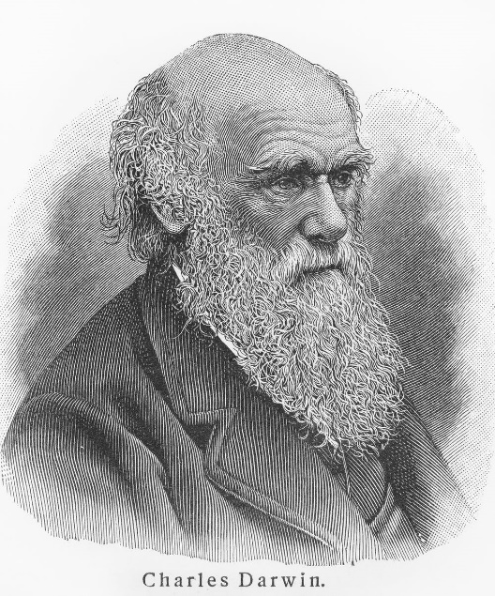

The Descent of Man, by Charles Darwin | Introduction

The sole object of this work is to consider, firstly, whether man, like every other species, is descended from some pre-existing form; secondly, the manner of his development; and thirdly, the value of the differences between the so-called races of man. As I shall confine myself to these points, it will not be necessary to describe in detail the differences between the several races—an enormous subject which has been fully described in many valuable works. The high antiquity of man has recently been demonstrated by the labours of a host of eminent men, beginning with M. Boucher de Perthes; and this is the indispensable basis for understanding his origin. I shall, therefore, take this conclusion for granted, and may refer my readers to the admirable treatises of Sir Charles Lyell, Sir John Lubbock, and others. Nor shall I have occasion to do more than to allude to the amount of difference between man and the anthropomorphous apes; for Prof. Huxley, in the opinion of most competent judges, has conclusively shewn that in every visible character man differs less from the higher apes, than these do from the lower members of the same order of Primates.

This work contains hardly any original facts in regard to man; but as the conclusions at which I arrived, after drawing up a rough draft, appeared to me interesting, I thought that they might interest others. It has often and confidently been asserted, that man's origin can never be known: but ignorance more frequently begets confidence than does knowledge: it is those who know little, and not those who know much, who so positively assert that this or that problem will never be solved by science. The conclusion that man is the co-descendant with other species of some ancient, lower, and extinct form, is not in any degree new.

- How is Jekyll presented by Stevenson during the first half of the Jekyll and Hyde?
- To what extent does the character of Edward Hyde represent a ‘lower’ form?

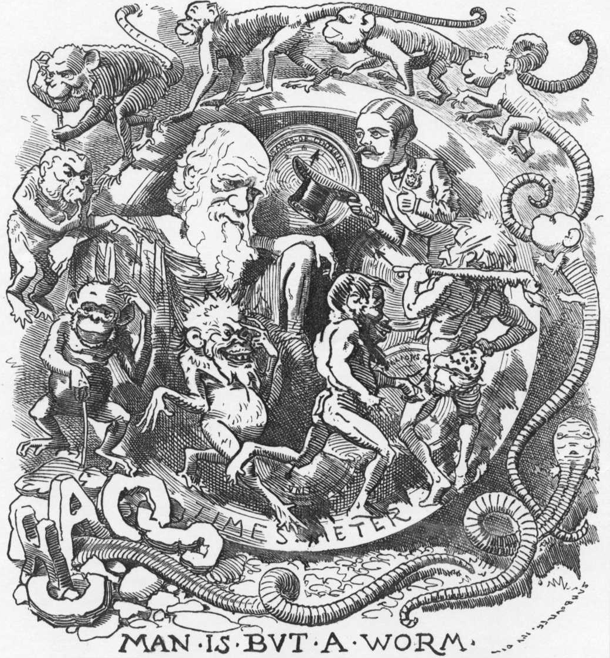

Section 11 of the Criminal Law Amendment Act 1885

Any male person who, in public or private, commits, or is a party to the commission of, or procures, or attempts to procure the commission by any male person of, any act of gross indecency with an other male person, shall be guilty of a misdemeanour, and being convicted thereof, shall be liable at the discretion of the Court to be imprisoned for any term not exceeding two years, with or without hard labour.

- Why might it be relevant that Utterson worries so much about the ‘capers’ of Jekyll’s past?
- To what extent is it relevant that Jekyll’s ‘certain appetites’ are never made explicit?

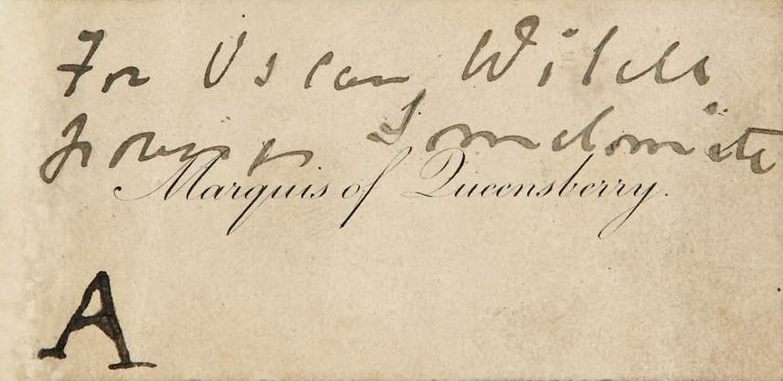

The Illustrated Police News | Attack on Ada Wilson

On Wednesday morning at half past twelve a desperate attempt to murder a young dressmaker was made at Bow.
Screams for help were heard proceeding from Maidman-street, Burdett-road, a small thoroughfare lying midway between the East India Docks and Bow roads, and a couple of young woman rushed up to some police-constables on duty outside the Royal Hotel and said that a woman was being murdered.

[…]

It appears that she occupies both portions of the house, and was about to retire to rest, when she heard a knock at the door, and upon going there found a total stranger waiting, who demanded money from her, adding that if she did not at once produce the cash she had but a few moments to live. She refused to give the money, and the man drew from his pocket a clasp-knife, with which he stabbed her twice in the throat and immediately made off. From the details of the man's appearance given by Wilson, the following will be found an approximate, if not a certain description of the would-be assassin. About thirty, height 5 ft, 6 in., face sunburnt, with fair moustache, dressed in dark coat, light trousers, and wide-awake hat. Detective-inspectors Wildy and Dillworth have charge of the case and are making every endeavour to ascertain the whereabouts of the missing man. It is thought impossible that the injured woman can recover. Rose Bierman: a young Jewess lodging at 9 Maidman-street made the following statement:

‘Ada Wilson, the injured woman, is the occupier of the house, but at the time of the outrage she was under notice to quit. I knew Mrs Wilson as a married woman, although I had never seen her husband. In the evening she came into the house accompanied by a male companion, but whether he was her husband or not I could not say. She has often visitors to see her, but I have rarely seen them myself, as Mrs Wilson lives in the front rooms, her bedroom being just at the back, adjoining the parlour. I occupy two rooms upstairs. Well, I don't know who the young man was, but about midnight I heard the most terrible screams one can imagine. Running downstairs I saw Mrs Wilson, partially dressed, wringing her hands and crying, ‘Stop that man from cutting my throat. He has stabbed me.’ Then she fell fainting in the passage. I saw all that as I was coming downstairs, but as soon as I commenced to descend, I noticed a fair young man run to the front door and let himself out. He did not seem somehow to unfasten the catch as if he had been accustomed to do so before. He had a light coat on I believe.’

- How is the assailant presented in the newspaper article?
- What parallels are there between the attack on Ada Wilson and chapters one and four of Jekyll and Hyde?

The Picture of Dorian Gray, by Oscar Wilde | Chapter 11

For the wonderful beauty that had so fascinated Basil Hallward, and many others besides him, seemed never to leave him. Even those who had heard the most evil things against him— and from time to time strange rumours about his mode of life crept through London and became the chatter of the clubs— could not believe anything to his dishonour when they saw him. He had always the look of one who had kept himself unspotted from the world. Men who talked grossly became silent when Dorian Gray entered the room. There was something in the purity of his face that rebuked them. His mere presence seemed to recall to them the memory of the innocence that they had tarnished. They wondered how one so charming and graceful as he was could have escaped the stain of an age that was at once sordid and sensual.

Often, on returning home from one of those mysterious and prolonged absences that gave rise to such strange conjecture among those who were his friends, or thought that they were so, he himself would creep upstairs to the locked room, open the door with the key that never left him now, and stand, with a mirror, in front of the portrait that Basil Hallward had painted of him, looking now at the evil and aging face on the canvas, and now at the fair young face that laughed back at him from the polished glass. The very sharpness of the contrast used to quicken his sense of pleasure. He grew more and more enamoured of his own beauty, more and more interested in the corruption of his own soul. He would examine with minute care, and sometimes with a monstrous and terrible delight, the hideous lines that seared the wrinkling forehead or crawled around the heavy sensual mouth, wondering sometimes which were the more horrible, the signs of sin or the signs of age. He would place his white hands beside the coarse bloated hands of the picture, and smile. He mocked the misshapen body and the failing limbs.

There were moments, indeed, at night, when, lying sleepless in his own delicately scented chamber, or in the sordid room of the little ill-famed tavern near the docks which, under an assumed name and in disguise, it was his habit to frequent, he would think of the ruin he had brought upon his soul with a pity that was all the more poignant because it was purely selfish. But moments such as these were rare. That curiosity about life which Lord Henry had first stirred in him, as they sat together in the garden of their friend, seemed to increase with gratification. The more he knew, the more he desired to know. He had mad hungers that grew more ravenous as he fed them.

- Why, when presented with the sight of the picture, does Dorian smile?
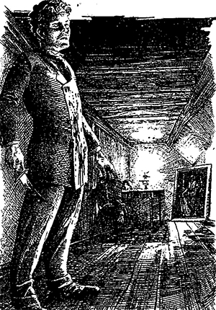
- What parallels are there between Dorian and Jekyll?

De Profoundis, by Oscar Wilde

I must say to myself that I ruined myself, and that nobody great or small can be ruined except by his own hand. I am quite ready to say so. I am trying to say so, though they may not think it at the present moment. This pitiless indictment I bring without pity against myself. Terrible as was what the world did to me, what I did to myself was far more terrible still.

I was a man who stood in symbolic relations to the art and culture of my age. I had realised this for myself at the very dawn of my manhood, and had forced my age to realise it afterwards. Few men hold such a position in their own lifetime, and have it so acknowledged. It is usually discerned, if discerned at all, by the historian, or the critic, long after both the man and his age have passed away. With me it was different. I felt it myself, and made others feel it. Byron was a symbolic figure, but his relations were to the passion of his age and its weariness of passion. Mine were to something more noble, more permanent, of more vital issue, of larger scope.

The gods had given me almost everything. But I let myself be lured into long spells of senseless and sensual ease. I amused myself with being a flâneur, a dandy, a man of fashion. I surrounded myself with the smaller natures and the meaner minds. I became the spendthrift of my own genius, and to waste an eternal youth gave me a curious joy. Tired of being on the heights, I deliberately went to the depths in the search for new sensation. What the paradox was to me in the sphere of thought, perversity became to me in the sphere of passion. Desire, at the end, was a malady, or a madness, or both. I grew careless of the lives of others. I took pleasure where it pleased me, and passed on. I forgot that every little action of the common day makes or unmakes character, and that therefore what one has done in the secret chamber one has some day to cry aloud on the housetop. I ceased to be lord over myself. I was no longer the captain of my soul, and did not know it. I allowed pleasure to dominate me. I ended in horrible disgrace. There is only one thing for me now, absolute humility.

- In what ways did Wilde ‘ruin’ himself?
- What parallels are there between De Profoundis and Jekyll’s Full Statement of the Case?

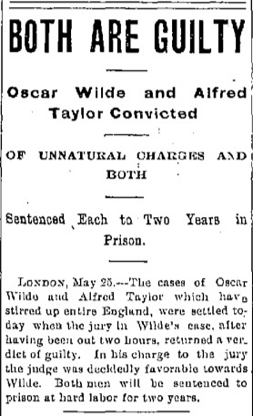

Dracula, by Bram Stoker | Chapter 2

I only slept a few hours when I went to bed, and feeling that I could not sleep any more, got up. I had hung my shaving glass by the window, and was just beginning to shave. Suddenly I felt a hand on my shoulder, and heard the Count's voice saying to me, ‘Good morning.’ I started, for it amazed me that I had not seen him, since the reflection of the glass covered the whole room behind me. In starting I had cut myself slightly, but did not notice it at the moment. Having answered the Count's salutation, I turned to the glass again to see how I had been mistaken. This time there could be no error, for the man was close to me, and I could see him over my shoulder. But there was no reflection of him in the mirror! The whole room behind me was displayed, but there was no sign of a man in it, except myself.

This was startling, and coming on the top of so many strange things, was beginning to increase that vague feeling of uneasiness which I always have when the Count is near. But at the instant I saw the cut had bled a little, and the blood was trickling over my chin. I laid down the razor, turning as I did so half round to look for some sticking plaster. When the Count saw my face, his eyes blazed with a sort of demoniac fury, and he suddenly made a grab at my throat. I drew away and his hand touched the string of beads which held the crucifix. It made an instant change in him, for the fury passed so quickly that I could hardly believe that it was ever there.

‘Take care,’ he said, ‘take care how you cut yourself. It is more dangerous that you think in this country.’ Then seizing the shaving glass, he went on, ‘And this is the wretched thing that has done the mischief. It is a foul bauble of man's vanity. Away with it!’ And opening the window with one wrench of his terrible hand, he flung out the glass, which was shattered into a thousand pieces on the stones of the courtyard far below. Then he withdrew without a word. It is very annoying, for I do not see how I am to shave, unless in my watch-case or the bottom of the shaving pot, which is fortunately of metal.

- How is the Dracula presented in the extract above?
- How does Dracula make Johnathan Harker feel, and what parallels can you make with Jekyll and Hyde?

