Past Papers

Jekyll and Hyde

- Summer 2018

- Summer 2019

- Summer 2020

- Autumn 2021

- Summer 2022

- Summer 2023

Summer 2018

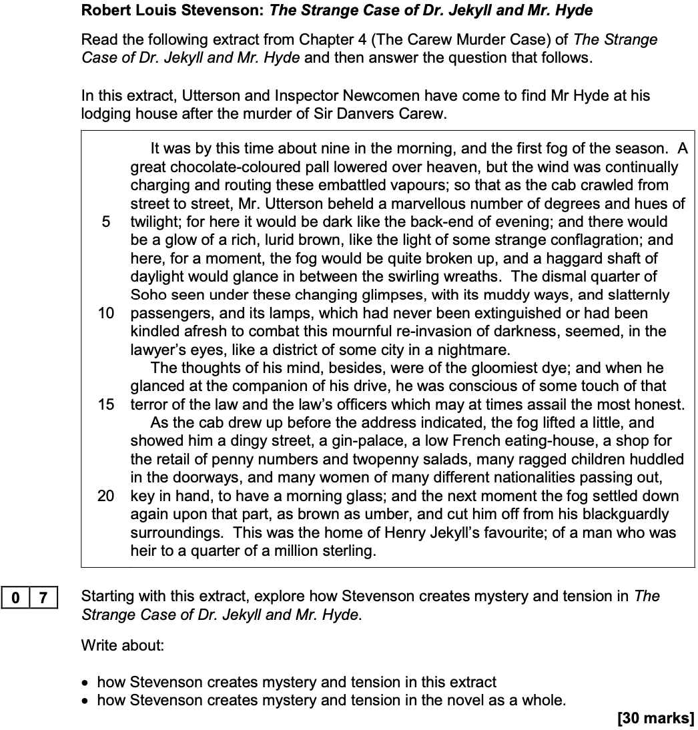

Summer 2019

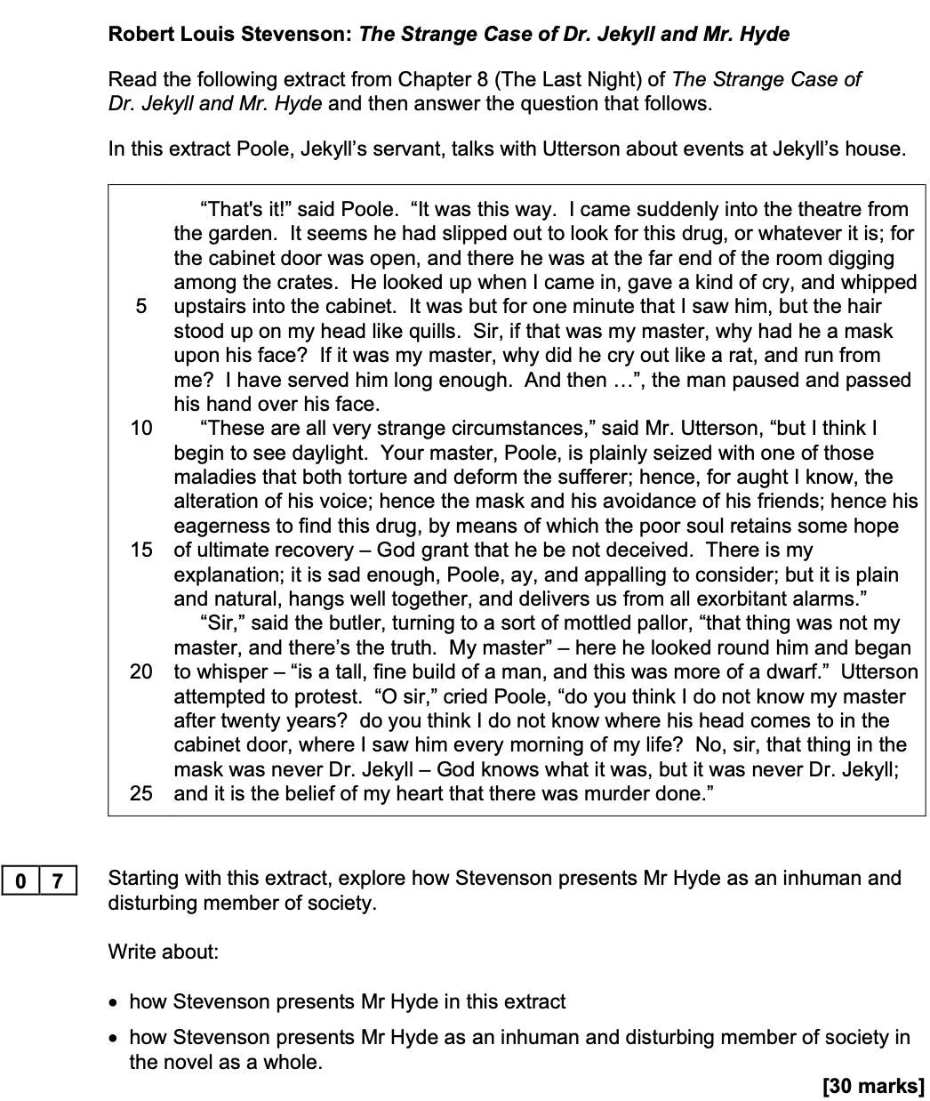

Summer 2020

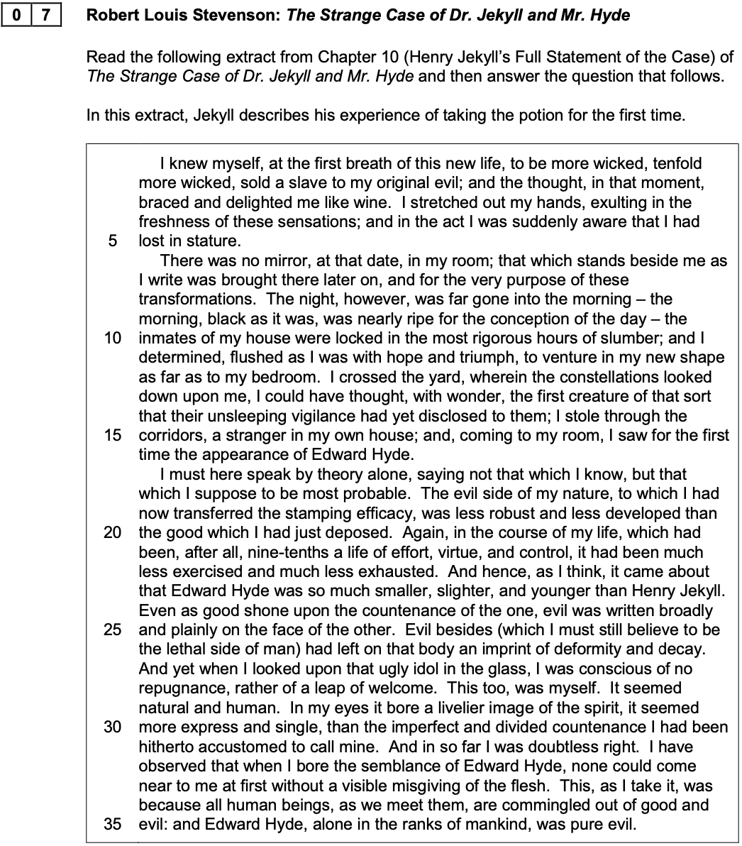

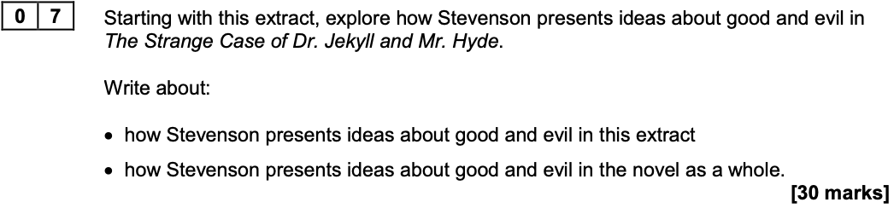
Autumn 2021

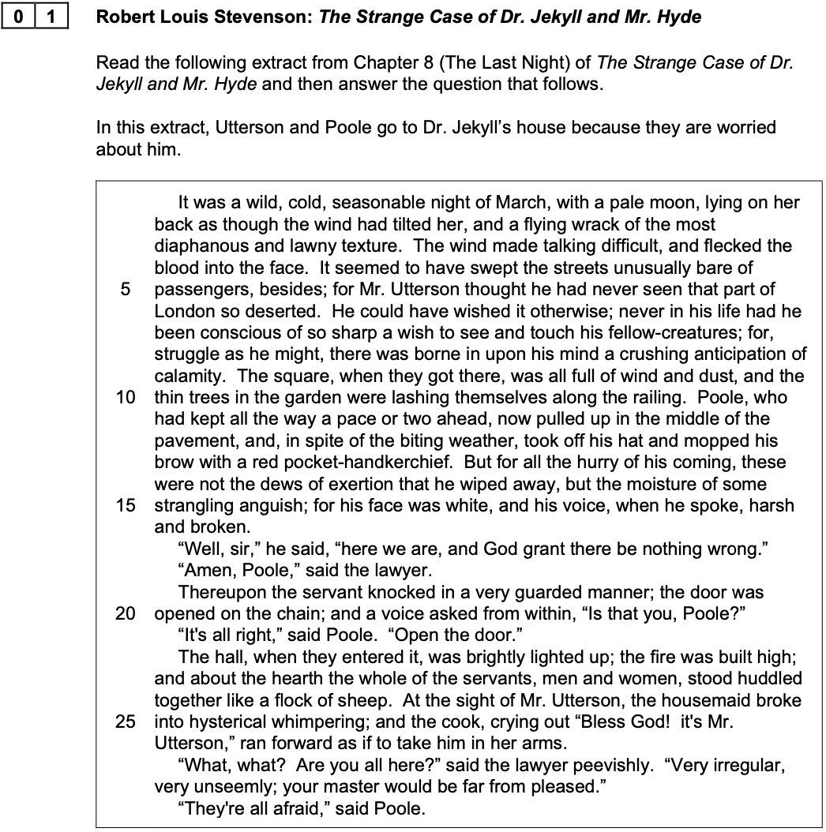

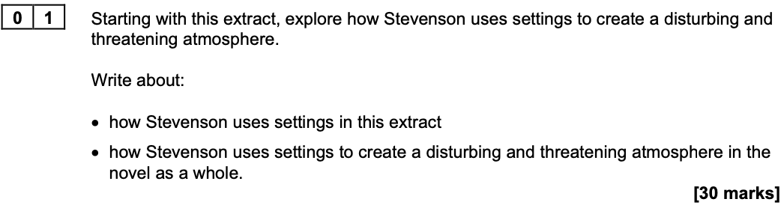

Summer 2022

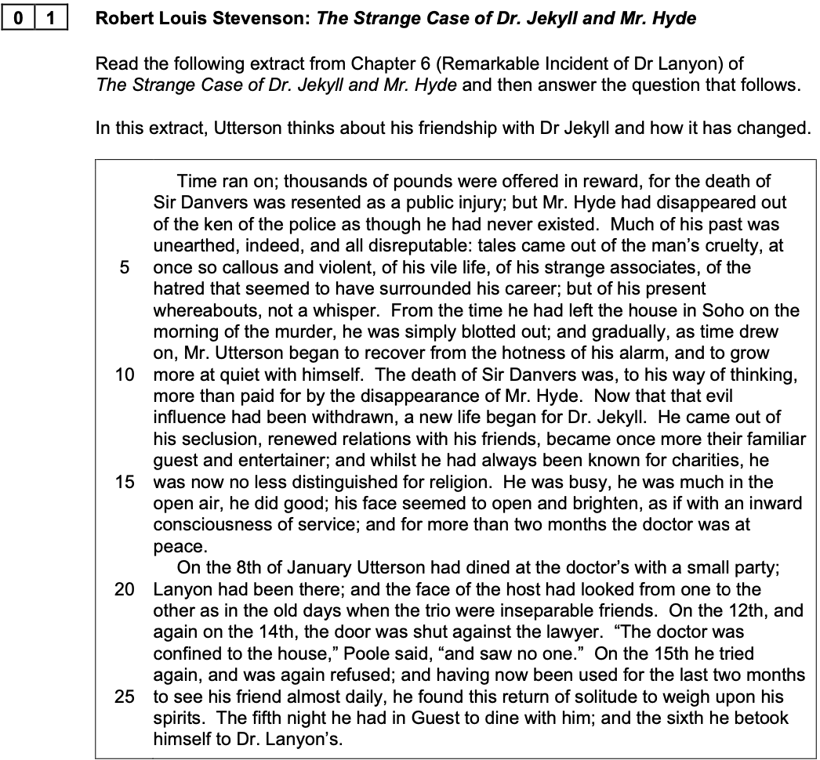

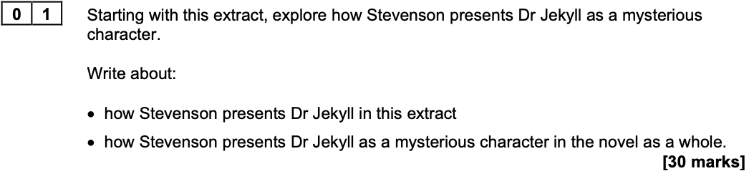

Summer 2023

