The three lessons are based on a model of roughly 20 minutes of input, 20 minutes of independent work and 20 minutes of discussion.

Macbeth, by William Shakespeare | Lesson 1

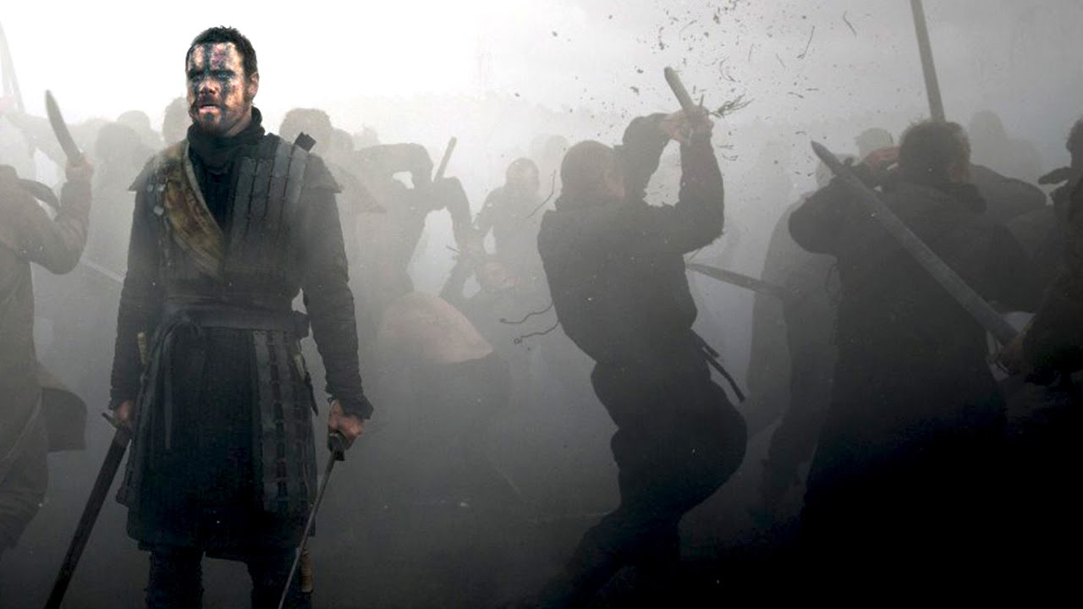

Macbeth is brave and formidable warrior. At the beginning of the play, he fights alongside his brother-in-arms Banquo and successfully defeats two invading forces. King Duncan rewards his courage and loyalty by making him Thane of Cawdor. However, it doesn’t end there for Macbeth; even greater things are prophesised by three mysterious witches…

- What are the main events of the play?  Starting point: https://www.bl.uk/works/macbeth  - What are the main features of a tragedy?  Starting point: https://www.bbc.co.uk/bitesize/guides/zpdq2hv/revision/1  - Why is Macbeth still a relevant play?  Starting point: https://www.youtube.com/watch?v=rD5goS69LT4 | 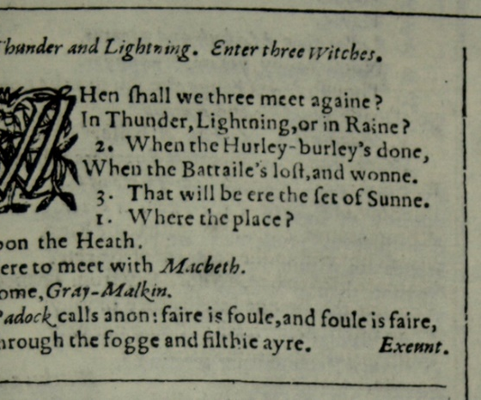

Macbeth, by William Shakespeare | Lesson 2

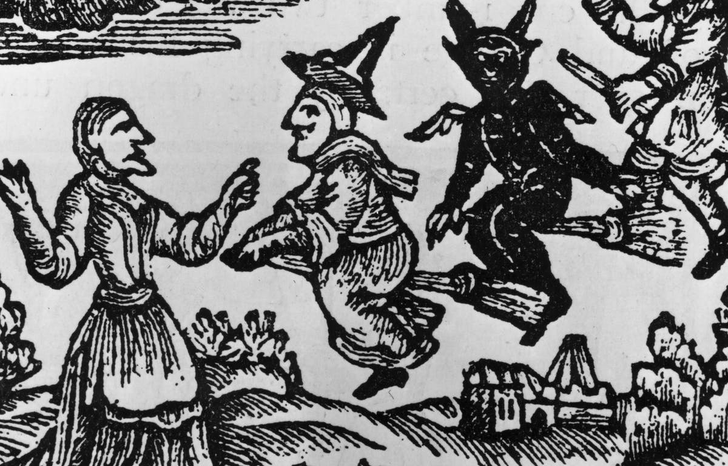

Macbeth was first performed in 1606. At the time, James I was King of England and he had a genuine fear of witches and witchcraft. An indication of how strongly he felt is conveyed by the Witchcraft Act of 1604 he passed just a year after his coronation. Under the new law, those found guilty of practising witchcraft were automatically sentenced to death.

Article: https://www.historyextra.com/period/stuart/shakespeares-macbeth-and-king-jamess-witch-hunts/

- What influenced James I’s obsession with witches and witchcraft?

- What was the purpose of the publication Daemonolgie and what sort of information did it contain?

- What factors prompted playwrights of the time to write about witches and witchcraft?

Video: https://www.youtube.com/watch?v=BktNjd3C4XA

- What happened to James in 1590?

- Why did prosecutions for the crime of witchcraft go down after the Witchcraft Act of 1604 was passed?

- What were ‘some of the most famous witch trials in history’?
Macbeth, by William Shakespeare | Lesson 3

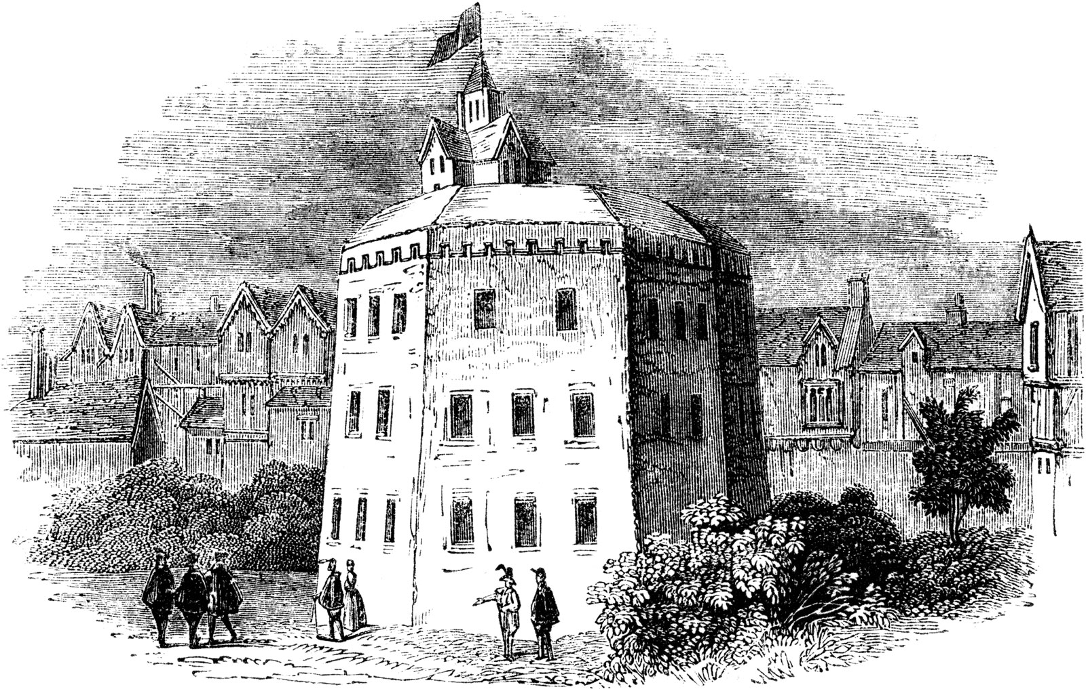

When Shakespeare wrote his plays (during the reign of Queen Elizabeth I and, later, James I), actors had to be licensed in order to perform and needed the patronage of a nobleman. To avoid arrest, unlicenced actors – typically those who toured the country – performed beyond city boundaries in areas that contained brothels and bear-baiting arenas. Indeed, the original Globe Theatre was built in Southwark which, at the time, was unregulated by City of London officials and considered to be particularly disreputable.

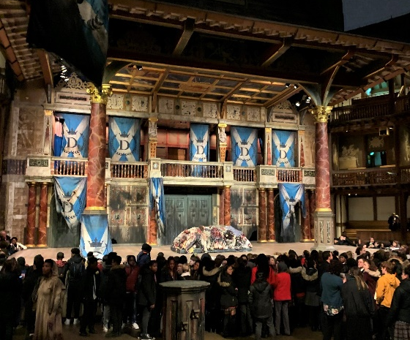
- What experience would a trip to the theatre typically entail?
Starting point: https://teach.shakespearesglobe.com/fact-sheet-audiences

- How was the Globe Theatre designed for actors and audiences?
Starting point: https://www.youtube.com/watch?v=95ec5xtt6Hs

- What factors need to be considered when staging the play?
Starting point: https://www.bbc.co.uk/bitesize/guides/zy7xtfr/revision/1

