Introduction to Charles Dickens

 | 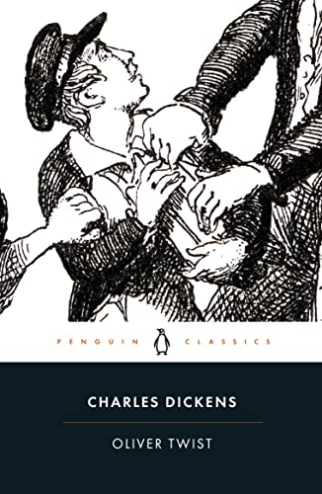  Page 1 | 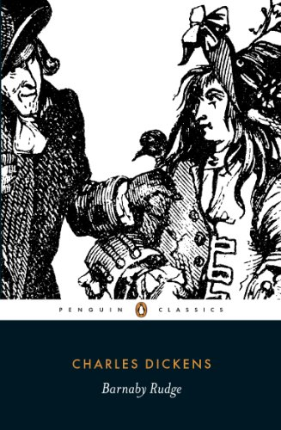  Page 2
 | 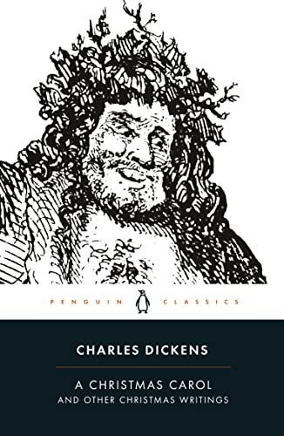  Page 3 | 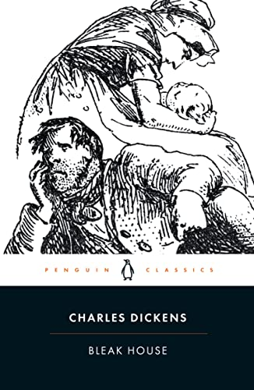  Page 4
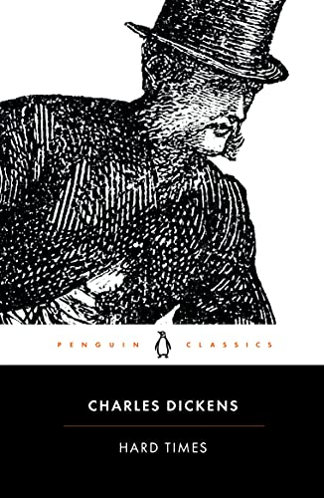  Page 5 | 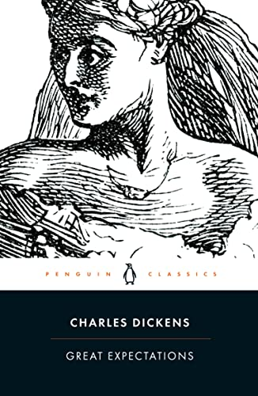  Page 6 | 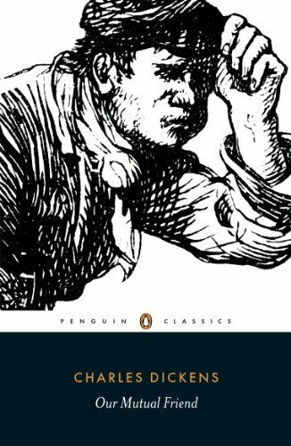  Page 7
Oliver Twist
1837

5  10  15  20  25 | Among other public buildings in a certain town, which for many reasons it will be prudent to refrain from mentioning, and to which I will assign no fictitious name, there is one anciently common to most towns, great or small: to wit, a workhouse; and in this workhouse was born; on a day and date which I need not trouble myself to repeat, inasmuch as it can be of no possible consequence to the reader, in this stage of the business at all events; the item of mortality whose name is prefixed to the head of this chapter.  For a long time after it was ushered into this world of sorrow and trouble, by the parish surgeon, it remained a matter of considerable doubt whether the child would survive to bear any name at all; in which case it is somewhat more than probable that these memoirs would never have appeared; or, if they had, that being comprised within a couple of pages, they would have possessed the inestimable merit of being the most concise and faithful specimen of biography, extant in the literature of any age or country.  Although I am not disposed to maintain that the being born in a workhouse, is in itself the most fortunate and enviable circumstance that can possibly befall a human being, I do mean to say that in this particular instance, it was the best thing for Oliver Twist that could by possibility have occurred. The fact is, that there was considerable difficulty in inducing Oliver to take upon himself the office of respiration – a troublesome practice, but one which custom has rendered necessary to our easy existence; and for some time he lay gasping on a little flock mattress, rather unequally poised between this world and the next: the balance being decidedly in favour of the latter. Now, if, during this brief period, Oliver had been surrounded by careful grandmothers, anxious aunts, experienced nurses, and doctors of profound wisdom, he would most inevitably and indubitably have been killed in no time. There being nobody by, however, but a pauper old woman, who was rendered rather misty by an unwonted allowance of beer; and a parish surgeon who did such matters by contract; Oliver and Nature fought out the point between them. The result was, that, after a few struggles, Oliver breathed, sneezed, and proceeded to advertise to the inmates of the workhouse the fact of a new burden having been imposed upon the parish, by setting up as loud a cry as could reasonably have been expected from a male infant who had not been possessed of that very useful appendage, a voice, for a much longer space of time than three minutes and a quarter.

Quick Review Questions
A | What is ‘common’ to most ancient towns?
B | What is ‘the best thing for Oliver Twist that could by possibility have occurred’?
C | What does ‘rendered rather misty’ mean?
D | How do we know that Oliver nearly died after he was born?

Big Question
What sort of character is Oliver Twist and what do we learn about the world he is born into?

Barnaby Rudge
1841

5  10  15  20  25 | In the year 1775, there stood upon the borders of Epping Forest, at a distance of about twelve miles from London – measuring from the Standard in Cornhill, or rather from the spot on or near to which the Standard used to be in days of yore – a house of public entertainment called the Maypole; which fact was demonstrated to all such travellers as could neither read nor write (and at that time a vast number both of travellers and stay-at-homes were in this condition) by the emblem reared on the roadside over against the house, which, if not of those goodly proportions that Maypoles were wont to present in olden times, was a fair young ash, thirty feet in height, and straight as any arrow that ever English yeoman drew.  The Maypole – by which term from henceforth is meant the house, and not its sign – the Maypole was an old building, with more gable ends than a lazy man would care to count on a sunny day; huge zig-zag chimneys, out of which it seemed as though even smoke could not choose but come in more than naturally fantastic shapes, imparted to it in its tortuous progress; and vast stables, gloomy, ruinous, and empty. The place was said to have been built in the days of King Henry the Eighth; and there was a legend, not only that Queen Elizabeth had slept there one night while upon a hunting excursion, to wit, in a certain oak-panelled room with a deep bay window, but that next morning, while standing on a mounting block before the door with one foot in the stirrup, the virgin monarch had then and there boxed and cuffed an unlucky page for some neglect of duty. The matter-of-fact and doubtful folks, of whom there were a few among the Maypole customers, as unluckily there always are in every little community, were inclined to look upon this tradition as rather apocryphal; but, whenever the landlord of that ancient hostelry appealed to the mounting block itself as evidence, and triumphantly pointed out that there it stood in the same place to that very day, the doubters never failed to be put down by a large majority, and all true believers exulted as in a victory.  Whether these, and many other stories of the like nature, were true or untrue, the Maypole was really an old house, a very old house, perhaps as old as it claimed to be, and perhaps older, which will sometimes happen with houses of an uncertain, as with ladies of a certain, age. Its windows were old diamond-pane lattices, its floors were sunken and uneven, its ceilings blackened by the hand of time, and heavy with massive beams. Over the doorway was an ancient porch, quaintly and grotesquely carved; and here on summer evenings the more favoured customers smoked and drank – ay, and sang many a good song too, sometimes – reposing on two grim-looking high-backed settees, which, like the twin dragons of some fairy tale, guarded the entrance to the mansion.

Quick Review Questions
A | When was the Maypole said to have been built?
B | Which famous monarch slept there according to ‘legend’?
C | How are the floors of the Maypole described?
D | What are described as looking like ‘the twin dragons of some fairy tale’?

Big Question
Is the Maypole presented as a place to be visited or avoided?

A Christmas Carol
1843

5  10  15  20  25 | Marley was dead: to begin with. There is no doubt whatever about that. The register of his burial was signed by the clergyman, the clerk, the undertaker, and the chief mourner. Scrooge signed it. And Scrooge’s name was good upon ‘Change, for anything he chose to put his hand to.  Old Marley was as dead as a door-nail.  Mind! I don’t mean to say that I know, of my own knowledge, what there is particularly dead about a door-nail. I might have been inclined, myself, to regard a coffin-nail as the deadest piece of ironmongery in the trade. But the wisdom of our ancestors is in the simile; and my unhallowed hands shall not disturb it, or the Country’s done for. You will therefore permit me to repeat, emphatically, that Marley was as dead as a door-nail.  Scrooge knew he was dead? Of course he did. How could it be otherwise? Scrooge and he were partners for I don’t know how many years. Scrooge was his sole executor, his sole administrator, his sole assign, his sole residuary legatee, his sole friend, and sole mourner. And even Scrooge was not so dreadfully cut up by the sad event, but that he was an excellent man of business on the very day of the funeral, and solemnised it with an undoubted bargain. The mention of Marley’s funeral brings me back to the point I started from. There is no doubt that Marley was dead. This must be distinctly understood, or nothing wonderful can come of the story I am going to relate. If we were not perfectly convinced that Hamlet’s Father died before the play began, there would be nothing more remarkable in his taking a stroll at night, in an easterly wind, upon his own ramparts, than there would be in any other middle-aged gentleman rashly turning out after dark in a breezy spot – say Saint Paul’s Churchyard for instance – literally to astonish his son’s weak mind.  Scrooge never painted out Old Marley’s name. There it stood, years afterwards, above the warehouse door: Scrooge and Marley. The firm was known as Scrooge and Marley. Sometimes people new to the business called Scrooge ‘Scrooge’ and sometimes ‘Marley’ but he answered to both names. It was all the same to him.  Oh! But he was a tight-fisted hand at the grind-stone, Scrooge! A squeezing, wrenching, grasping, scraping, clutching, covetous, old sinner! Hard and sharp as flint, from which no steel had ever struck out generous fire; secret, and self-contained, and solitary as an oyster. The cold within him froze his old features, nipped his pointed nose, shrivelled his cheek, stiffened his gait; made his eyes red, his thin lips blue; and spoke out shrewdly in his grating voice. A frosty rime was on his head, and on his eyebrows, and his wiry chin.

Quick Review Questions
A | How many references are there to Marley being dead?
B | How do the emotions Scrooge publicly showed about Marley’s death differ from his true emotions?
C | Why is it so important that we know Marley did actually die?

Big Question
What makes Scrooge such an unlikable character?
Bleak House
1853

5  10  15  20  25 | London. Michaelmas term lately over, and the Lord Chancellor sitting in Lincoln’s Inn Hall. Implacable November weather. As much mud in the streets as if the waters had but newly retired from the face of the earth, and it would not be wonderful to meet a Megalosaurus, forty feet long or so, waddling like an elephantine lizard up Holborn Hill. Smoke lowering down from chimney-pots, making a soft black drizzle, with flakes of soot in it as big as full-grown snowflakes – gone into mourning, one might imagine, for the death of the sun. Dogs, undistinguishable in mire. Horses, scarcely better; splashed to their very blinkers. Foot passengers, jostling one another’s umbrellas in a general infection of ill temper, and losing their foot-hold at street-corners, where tens of thousands of other foot passengers have been slipping and sliding since the day broke (if this day ever broke), adding new deposits to the crust upon crust of mud, sticking at those points tenaciously to the pavement, and accumulating at compound interest.  Fog everywhere. Fog up the river, where it flows among green aits and meadows; fog down the river, where it rolls deified among the tiers of shipping and the waterside pollutions of a great (and dirty) city. Fog on the Essex marshes, fog on the Kentish heights. Fog creeping into the cabooses of collier-brigs; fog lying out on the yards and hovering in the rigging of great ships; fog drooping on the gunwales of barges and small boats. Fog in the eyes and throats of ancient Greenwich pensioners, wheezing by the firesides of their wards; fog in the stem and bowl of the afternoon pipe of the wrathful skipper, down in his close cabin; fog cruelly pinching the toes and fingers of his shivering little ‘prentice boy on deck. Chance people on the bridges peeping over the parapets into a nether sky of fog, with fog all round them, as if they were up in a balloon and hanging in the misty clouds.  Gas looming through the fog in divers places in the streets, much as the sun may, from the spongey fields, be seen to loom by husbandman and ploughboy. Most of the shops lighted two hours before their time – as the gas seems to know, for it has a haggard and unwilling look.  The raw afternoon is rawest, and the dense fog is densest, and the muddy streets are muddiest near that leaden-headed old obstruction, appropriate ornament for the threshold of a leaden-headed old corporation, Temple Bar. And hard by Temple Bar, in Lincoln’s Inn Hall, at the very heart of the fog, sits the Lord High Chancellor in his High Court of Chancery. Never can there come fog too thick, never can there come mud and mire too deep, to assort with the groping and floundering condition which this High Court of Chancery, most pestilent of hoary sinners, holds this day in the sight of heaven and earth.

Quick Review Questions
A | Which details in the first paragraph make it clear that the weather is awful?
B | How many mentions of the word ‘fog’ are there in the second paragraph?
C | Why are most of the shops ‘lighted two hours before their time’?
D | Who ‘sits’ in Lincoln’s Inn Hall?

Big Question
What is it about London that makes life there seem so miserable?
Hard Times
1854

5  10  15  20  25 | ‘Now, what I want is, Facts. Teach these boys and girls nothing but Facts. Facts alone are wanted in life. Plant nothing else, and root out everything else. You can only form the minds of reasoning animals upon Facts: nothing else will ever be of any service to them. This is the principle on which I bring up my own children, and this is the principle on which I bring up these children. Stick to Facts, sir!’  The scene was a plain, bare, monotonous vault of a school-room, and the speaker’s square forefinger emphasised his observations by underscoring every sentence with a line on the schoolmaster’s sleeve. The emphasis was helped by the speaker’s square wall of a forehead, which had his eyebrows for its base, while his eyes found commodious cellarage in two dark caves, overshadowed by the wall. The emphasis was helped by the speaker’s mouth, which was wide, thin, and hard set. The emphasis was helped by the speaker’s voice, which was inflexible, dry, and dictatorial. The emphasis was helped by the speaker’s hair, which bristled on the skirts of his bald head, a plantation of firs to keep the wind from its shining surface, all covered with knobs, like the crust of a plum pie, as if the head had scarcely warehouse-room for the hard facts stored inside. The speaker’s obstinate carriage, square coat, square legs, square shoulders – nay, his very neckcloth, trained to take him by the throat with an unaccommodating grasp, like a stubborn fact, as it was – all helped the emphasis.  ‘In this life, we want nothing but Facts, sir; nothing but Facts!’  The speaker, and the schoolmaster, and the third grown person present, all backed a little, and swept with their eyes the inclined plane of little vessels then and there arranged in order, ready to have imperial gallons of facts poured into them until they were full to the brim.  Thomas Gradgrind, sir. A man of realities. A man of facts and calculations. A man who proceeds upon the principle that two and two are four, and nothing over, and who is not to be talked into allowing for anything over. Thomas Gradgrind, sir – peremptorily Thomas – Thomas Gradgrind. With a rule and a pair of scales, and the multiplication table always in his pocket, sir, ready to weigh and measure any parcel of human nature and tell you exactly what it comes to. It is a mere question of figures, a case of simple arithmetic. You might hope to get some other nonsensical belief into the head of George Gradgrind, or Augustus Gradgrind, or John Gradgrind, or Joseph Gradgrind (all supposititious, non-existent persons), but into the head of Thomas Gradgrind – no, sir!

Quick Review Questions
A | Which aspect of teaching seems to be most important to Thomas Gradgrind?
B | Which details about Gradgrind’s appearance make him seem unpleasant?
C | Who are the ‘little vessels’?
D | What does the description ‘a man of realities’ suggest about Gradgrind’s outlook on life?

Big Question
Is Thomas Gradgrind a good teacher?
Great Expectations
1861

5  10  15  20  25 | My father’s family name being Pirrip, and my Christian name Philip, my infant tongue could make of both names nothing longer or more explicit than Pip. So, I called myself Pip, and came to be called Pip.  I give Pirrip as my father’s family name, on the authority of his tombstone and my sister – Mrs Joe Gargery, who married the blacksmith. As I never saw my father or my mother, and never saw any likeness of either of them (for their days were long before the days of photographs), my first fancies regarding what they were like, were unreasonably derived from their tombstones. The shape of the letters on my father’s, gave me an odd idea that he was a square, stout, dark man, with curly black hair. From the character and turn of the inscription, ‘Also Georgiana Wife of the Above,’ I drew a childish conclusion that my mother was freckled and sickly. To five little stone lozenges, each about a foot and a half long, which were arranged in a neat row beside their grave, and were sacred to the memory of five little brothers of mine – who gave up trying to get a living, exceedingly early in that universal struggle – I am indebted for a belief I religiously entertained that they had all been born on their backs with their hands in their trousers-pockets, and had never taken them out in this state of existence.  Ours was the marsh country, down by the river, within, as the river wound, twenty miles of the sea. My first most vivid and broad impression of the identity of things, seems to me to have been gained on a memorable raw afternoon towards evening. At such a time I found out for certain, that this bleak place overgrown with nettles was the churchyard; and that Philip Pirrip, late of this parish, and also Georgiana wife of the above, were dead and buried; and that Alexander, Bartholomew, Abraham, Tobias, and Roger, infant children of the aforesaid, were also dead and buried; and that the dark flat wilderness beyond the churchyard, intersected with dykes and mounds and gates, with scattered cattle feeding on it, was the marshes; and that the low leaden line beyond, was the river; and that the distant savage lair from which the wind was rushing, was the sea; and that the small bundle of shivers growing afraid of it all and beginning to cry, was Pip.  ‘Hold your noise!’ cried a terrible voice, as a man started up from among the graves at the side of the church porch. ‘Keep still, you little devil, or I’ll cut your throat!’  A fearful man, all in coarse grey, with a great iron on his leg. A man with no hat, and with broken shoes, and with an old rag tied round his head. A man who had been soaked in water, and smothered in mud, and lamed by stones, and cut by flints, and stung by nettles, and torn by briars; who limped, and shivered, and glared and growled; and whose teeth chattered in his head as he seized me by the chin.

Quick Review Questions
A | What is the name of Pip’s sister?
B | What does the ‘terrible voice’ first say to Pip?
C | Which detail suggests that the ‘fearful man’ is cold?

Big Question
What makes Pip’s encounter with the ‘fearful man’ seem so threatening?
Our Mutual Friend
1865

5  10  15  20  25 | In these times of ours, though concerning the exact year there is no need to be precise, a boat of dirty and disreputable appearance, with two figures in it, floated on the Thames, between Southwark Bridge which is of iron, and London Bridge which is of stone, as an autumn evening was closing in.  The figures in this boat were those of a strong man with ragged grizzled hair and a sun-browned face, and a dark girl of nineteen or twenty, sufficiently like him to be recognisable as his daughter. The girl rowed, pulling a pair of sculls very easily; the man, with the rudder-lines slack in his hands, and his hands loose in his waistband, kept an eager look out. He had no net, hook, or line, and he could not be a fisherman; his boat had no cushion for a sitter, no paint, no inscription, no appliance beyond a rusty boathook and a coil of rope, and he could not be a waterman; his boat was too crazy and too small to take in cargo for delivery, and he could not be a lighterman or river-carrier; there was no clue to what he looked for, but he looked for something, with a most intent and searching gaze. The tide, which had turned an hour before, was running down, and his eyes watched every little race and eddy in its broad sweep, as the boat made slight head-way against it, or drove stern foremost before it, according as he directed his daughter by a movement of his head. She watched his face as earnestly as he watched the river. But, in the intensity of her look there was a touch of dread or horror.  Allied to the bottom of the river rather than the surface, by reason of the slime and ooze with which it was covered, and its sodden state, this boat and the two figures in it obviously were doing something that they often did, and were seeking what they often sought. Half savage as the man showed, with no covering on his matted head, with his brown arms bare to between the elbow and the shoulder, with the loose knot of a looser kerchief lying low on his bare breast in a wilderness of beard and whisker, with such dress as he wore seeming to be made out of the mud that begrimed his boat, still there was a business-like usage in his steady gaze. So with every lithe action of the girl, with every turn of her wrist, perhaps most of all with her look of dread or horror; they were things of usage.  ‘Keep her out, Lizzie. Tide runs strong here. Keep her well afore the sweep of it.’  Trusting to the girl’s skill and making no use of the rudder, he eyed the coming tide with an absorbed attention. So the girl eyed him. But, it happened now, that a slant of light from the setting sun glanced into the bottom of the boat, and, touching a rotten stain there which bore some resemblance to the outline of a muffled human form, coloured it as though with diluted blood. This caught the girl’s eye, and she shivered.

Quick Review Questions
A | Where is the boat ‘floating’ between?
B | What is the name of the girl in the boat?
C | What catches the girl’s eye and makes her shiver?

Big Question
How suspicious should we be of the two boaters?

