**The World of William Shakespeare**

**Shakespeare’s Heroes and Villains**

**The World of William Shakespeare**

1. William Shakespeare
2. London
3. Playhouses
4. The First Globe
5. Audiences
6. Costumes
7. Special Effects

* **What was it like to go to the theatre in Shakespeare’s day?**
* **What challenges did actors of the time face?**
* **How has our experience of going to the theatre changed?**
* **You’re going to the theatre: which experience would you prefer?**

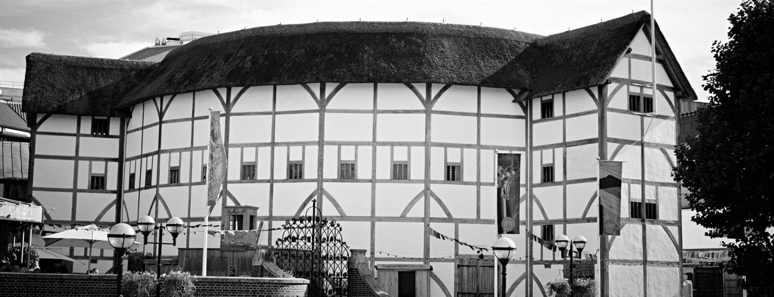

|  |  |
| --- | --- |
| **A** | **William Shakespeare**  Source: Shakespeare’s Globe Online |
| 5  10  15  20 | William Shakespeare was born in 1564 in Stratford-upon-Avon, a market town in a farming area of the Midlands. Only about 1000 people lived there. It’s possible that he was been born on St George’s Day, given that he was baptised on 26th April.  **What was Shakespeare’s family like?**  Shakespeare was born to prosperous parents. His mother, Mary, was the daughter of a local farmer. His father, John, was a glove-maker and wool trader with a large family house. When Shakespeare was four years old, his father was elected to the position of Bailiff of Stratford. However, his early life wasn’t easy. Although Shakespeare was the third of eight children, he grew up as the oldest. His two older sisters both died at a very young age and he was lucky to survive. When he was just a baby, plague killed about 200 people in Stratford – 1 in 5 of the local population.  **Where did Shakespeare go to school?**  From the age of seven, boys like Shakespeare usually went to grammar school. There was one in Stratford and it is still there today. However, schooling was different then to how it is now. Boys learned to read, speak and write in Latin. They also had to memorise and perform stories from history – useful skills for an actor and writer. Shakespeare probably left school aged around fifteen.  **What do we know of Shakespeare’s family life?**  Practically nothing. We know Shakespeare and his wife, Anne Hathaway, had three children and that his family was based in a large house in Stratford. However, Shakespeare spent most of his time 100 miles away in London working in theatres.  **When did Shakespeare die?**  After 1613, Shakespeare spent more time at Stratford. Then, in January 1616, he made a will and died on the 23rd April 1616. He is buried in Holy Trinity church in Stratford-upon-Avon. |

|  |  |
| --- | --- |
| **B** | **London**  Source: Shakespeare’s Globe Online |
| 5  10  15  20 | London was the biggest and richest city in England; it was the home of the first permanent playhouses. Wealthy traders and manufacturers lived there and they had money to go to the theatre. By 1600, London’s theatre-goers numbered roughly 20,000 per week. London was also home to royalty and much of the nobility. Rich noblemen became patrons of theatre companies, giving financial and legal support. Royalty also supported the theatre. From 1603 to 1613, Shakespeare’s company played at the court of King James about 15 times per year.  **What was London like?**  London was growing fast, mostly due to migrants from the countryside and from Europe. Between 1550 and 1600, it is estimated the city grew from around 50,000 residents to over 200,000. Inside the city’s old medieval walls, every available space was being built on. Outside, the suburbs expanded steadily into the countryside. London swiftly became a bustling, overcrowded city. In 1599, a Swiss visitor said, ‘one simply cannot walk along the streets for the crowds.’ Another visitor called the crowded streets ‘dark and narrow.’ That darkness attracted thieves and the overcrowding brought disease, and plagues struck most summers. In 1593, about 10,000 people were killed and all the theatres were closed. In 1607, John Donne, a poet, called London a city ‘full of danger and vice.’  **Where did Shakespeare live and work in London?**  Shakespeare lived and worked in London from about 1590 to about 1613. In the mid-1590’s, Shakespeare lived in the London parish of St Helens, just north of London Bridge and close to the Theatre and the Curtain playhouses. We know he was twice assessed for taxes there, but failed to pay both times. From about 1598-1602, he seems to have lived in the Paris Gardens area of Bankside near the Globe where he worked. And from about 1602, Shakespeare rented lodgings in the Silver Street house of the Mountjoys, a wealthy family who made expensive hats. |

|  |  |
| --- | --- |
| **C** | **Playhouses**  Source: Shakespeare’s Globe Online |
| 5  10  15  20  25  30 | There were two different types of playhouse in London during Shakespeare’s time. There were outdoor playhouses, also known as ‘amphitheatres’ or ‘public’ playhouses, and indoor playhouses, also known as ‘halls’ or ‘private’ playhouses. These were very different theatres that attracted different types of audiences.  **Where was the first playhouse built?**  The first playhouse, the Red Lion, was built in 1567 by John Brayne. He converted the Red Lion Inn, in Stepney, outside the city walls. There is little evidence of how successful it was, but the demand must have been there, because many more playhouses opened between the 1570s and the 1620s.  **Where were the next playhouses built?**  In 1576, Brayne and James Burbage built the Theatre, just outside the city walls. Burbage was an actor with the Earl of Leicester’s Men, who played in the Theatre for its first two years. Newington Butts theatre was built to the south in the same year. In 1577, the Curtain was built near the Theatre. After this, five more theatres were built and companies also performed regularly in the yards of several London inns. Shakespeare’s company played at both the Curtain and the Theatre, as well as the Globe. They also played for Queen Elizabeth I and then, later, for King James I.  **Why build playhouses south of the Thames?**  Playhouses drew big audiences, but they were not popular with everyone. The officials who ran the City of London thought that playhouses were noisy and disruptive, and that they attracted thieves and other ‘undesirable’ people. So people built playhouses on sites outside the control of city officials. In most cases, this meant outside the city wall. The south bank of the River Thames was outside the city and already had animal baiting arenas and taverns.  **Who built playhouses?**  Playhouses were sometimes built by businessmen who saw the rising popularity of the touring acting companies that played in the yards of inns and other open spaces around the city. They had money to spare, while the acting companies did not. Typically, a businessman leased some land, built a playhouse and then leased it to acting companies for a set number of years. The company paid the playhouse owner a share of the takings, which was usually half the income from galleries.  **What did the outdoor playhouses look like?**  Most playhouses had a brick base with timber-framed walls. The gaps between the timbers were filled with sticks and plaster. The roofs were thatched or tiled. All outdoor playhouses had five common features:   * A central yard that was open to the sky * A raised stage sticking out into the yard * A roof over the stage called ‘the heavens’ * A backstage area where actors dressed and waited to come on |

|  |  |
| --- | --- |
| **D** | **The First Globe**  Source: Shakespeare’s Globe Online |
| 5  10  15  20 | The first Globe was built by the company that Shakespeare was in – the Lord Chamberlain’s Men. Richard Burbage was the company’s leading actor. They had originally played at the Theatre, built by the Burbage family on leased land, but the lease was not renewed. As the Burbage family couldn’t afford to lease a new theatre site, they offered five of the company, including Shakespeare, the chance to become part-owners of the new theatre for £10 each. With this money, they leased land on the south bank of the River Thames in an area called Southwark.  **When and where was the Globe built?**  Southwark was a good place for the new theatre. It was outside the control of the city officials (who were hostile to theatres) and people already went there to be entertained. The walls were made from big timber frames, filled with smaller slats of wood covered with plaster. As the owners were struggling for money, they used the cheapest options in the building process. For example, the roof of the theatre was thatched with reeds, not covered with more expensive tile. In 1599, the theatre opened and was a huge success.  **What plays were performed at the Globe?**  Probably the first Shakespeare play to be performed at the Globe was *Julius Caesar*, in 1599. Other Shakespeare plays performed there were *As You Like It*, *Hamlet*, *Measure for Measure*, *Othello*, *King* *Lear* and *Macbeth*.  **What happened to the first Globe?**  Disaster struck the Globe in 1613. On 29 June, during a performance, some small cannons were fired. For dramatic effect, the workers didn’t use cannon balls, choosing instead to use gunpowder held down by wadding. A piece of the burning wadding set fire to the thatch and the theatre burned down in about an hour. Fortunately, the company managed to build a second Globe theatre on the brick foundations of the first. It was the same size and shape, but was much more extravagantly decorated because the company could now afford it. It also had a tiled roof, not a thatched one. |

|  |  |
| --- | --- |
| **E** | **Audiences**  Source: Shakespeare’s Globe Online |
| 5  10  15  20  25 | Theatres in Elizabethan and Jacobean London (like the Globe theatre) could hold up to 3000 people. With many theatres offering at least one play each day, it’s possible that between 10,000 and 20,000 people regularly visited each week.  **Who went to the theatre?**  All sorts of people went to the theatre. One visitor, in 1617, described the crowd around the stage as ‘a gang of porters and carters’. Others talked of servants and apprentices spending all their spare time there. However, wealthier people were often in the audience as well. In 1607, the Venetian ambassador bought all the most expensive seats for a performance of Shakespeare’s *Pericles*. Even the royal family loved watching plays. For example, companies of actors were often summoned to perform at the courts of Elizabeth I and James I.  **How much did it cost?**  In open air theatres, the cheapest price was of entry was a penny (roughly equivalent to the price of a loaf of bread). This bought a place amongst the ‘groundlings’ standing in the ‘yard’ around the stage. For another penny, a bench seat in the lower galleries could be bought. And for a penny or so more than that, a cushion could be rented. Admission to indoor theatres typically started at six pence. Today, the place where theatre tickets are bought is called the box office. In Shakespeare’s day, as people came into the theatre or climbed the steps to their seats, audiences had to put their money in a box – hence the term ‘box office’.  **What did they get for their money?**  The ‘groundlings’ were very close to the action on stage. They could buy food and drink during the performance – apples, oranges, nuts, gingerbread and ale. However, there were no toilets and the floor they stood on would probably have just been sand or ash. Some visitors complained that the pit smelled strongly of garlic, beer and body odour.  **How did the audience behave?**  Although some people went to the theatre to be seen and admired, it didn’t necessarily mean that they would behave well. Most of the audience didn’t sit and watch the performances in silence like they would do today. They clapped the heroes and booed the villains, and cheered at the special effects. Heckling was also common. Pickpocketing was a problem and, in 1612, magistrates banned music at the end of plays at the Fortune theatre, saying that the crowd had caused ‘tumults and outrages’ with their dances. |

|  |  |
| --- | --- |
| **F** | **Costumes**  Source: Shakespeare’s Globe Online |
| 5  10  15 | In Shakespeare’s time, clothes reflected a person’s status in society and there were laws controlling what you could (and couldn’t) wear. As plays had kings, queens and wealthy people in them, the actors’ costumes reflected their characters’ social status. Costumes were mainly the modern dress of the time. So for less important roles, actors might wear their own clothes. However, for a play set in ancient Greece or Rome, the company might try for an ‘ancient’ look for the important characters by giving the main characters togas over their normal clothes. The company reused costumes if they could – changing a cloak or putting on some expensive lace. Sometimes they had to have a new costume made. A typical company would probably spend about £300 per-year on costumes, which in today’s money would be over £35,000.  **What about women’s costumes?**  All actors were male, meaning that men and boys played all the female roles. As you might expect, the costumes of female characters usually reflected the social status of the character the actor was playing at the time. Actors also wore wigs that aimed to show the age and status of their characters.  **How was stage make-up used?**  Most of the time, harmless natural ingredients were used. For example, powdered animal bones mixed with poppy oil gave actors playing women pale skin. However, the same effect could also be achieved by mixing poisonous white lead and vinegar in a concoction called ‘ceruse’. We know from the accounts of the Rose theatre that people were hired to ‘paint the players’ faces’. However, this is not recorded often, and most actors probably applied their own make-up. |

|  |  |
| --- | --- |
| **G** | **Special Effects**  Source: Shakespeare’s Globe Online |
| 5  10  15  20 | Acting companies could produce very dramatic special effects. Thunder and lightning filled the theatre for storms, and there were a variety of effects to suggest that magic was at work. However, many special effects needed special ingredients and were expensive to perform, so they were not used all the time.  **How were special effects produced?**  The easiest way to make the noise of thunder was to beat drums offstage or roll a cannonball across the floor of the Heavens over the stage. Some companies used a ‘thunder machine’, which was a wooden box balanced like a seesaw from which a cannon ball could be rolled from one end to the other to make a thundering noise. Storms needed lightning, too. Flashes were made by throwing a powder made from resin into a candle flame. The companies could also make lightning bolts. The machinery for this was called a ‘swevel’. Workers fixed a wire from the roof to the floor of the stage and then attached a firecracker to the wire. When lit, the firecracker shot from the top of the wire to the bottom, showering sparks all the way.  **What about magic?**  Magical spirits, devils and gods and goddesses often appear in plays from Shakespeare’s time. Good spirits and gods and goddesses usually entered through a trapdoor in the Heavens. The actors were lowered on a rope or a wire. This was called ‘flying in’. Evil spirits and devils came up from Hell, which was under the stage and through a trapdoor. Companies often set off firecrackers when devils appeared or magic was used. At the time, firecrackers were made by filling rolls of thick paper with gunpowder, which produced sparks when lit and then a bang.  **Were the special effects dangerous?**  Aside from the fire at the Globe theatre in 1613, it’s unlikely that anything serious happened very often. However, many of the ingredients used to create special effects smelt very bad. Sulphur has a rotten egg smell, while saltpetre (made from dung) smells particularly bad when set alight. Both were used to form gunpowder. |

**Shakespeare’s Heroes and Villains**

1. Henry V
2. Henry V
3. Richard III
4. Othello
5. Richard II
6. King Lear
7. Hamlet
8. Macbeth
9. Much Ado About Nothing
10. Romeo and Juliet

* **What characteristics does a Shakespearean hero possess?**
* **How does a Shakespearean hero compare to our more modern ones?**
* **What similarities are there between Shakespeare’s villains?**
* **What do Shakespeare’s plays reveal about the time they were written?**
* **What themes (i.e. big ideas) does Shakespeare explore that are still relevant today?**

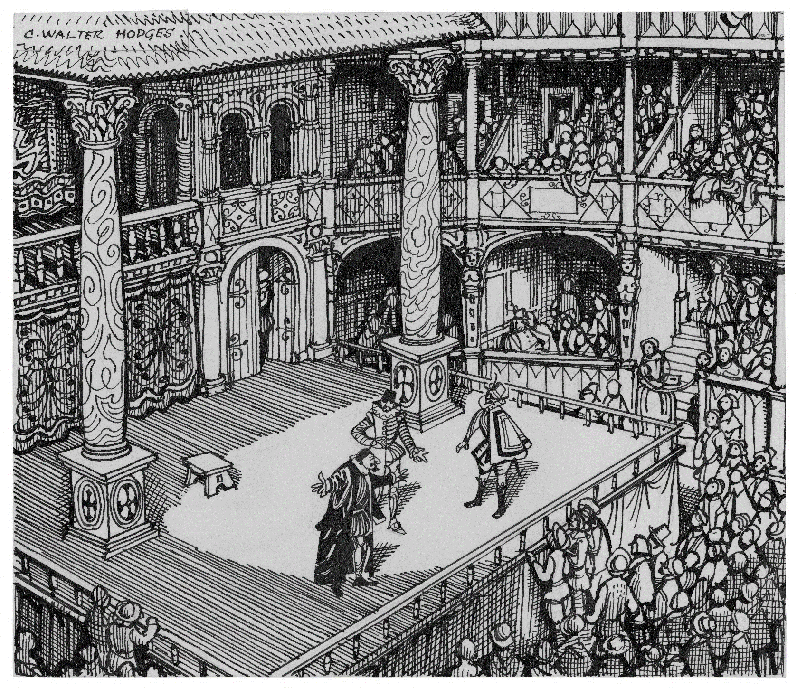

|  |  |  |
| --- | --- | --- |
| **A** | **Henry V**  First Performed in 1599 | |
|  | The Chorus acknowledges the limitations of the theatrical space (i.e. the ‘wooden O’) and emphasises that the collective imagination of the audience is required to bring the vast historical narrative of the play to life. Participation and collaboration are strongly encouraged. | |
| 5  10  15  20  25  30 | **Chorus**  A kingdom for a stage, princes to act  And monarchs to behold the swelling scene!  Then should the warlike *Harry*, like himself,  Assume the *port of Mars*; and at his heels,  Leash’d in like hounds, should famine, sword and fire  *Crouch for employment*. But pardon, and gentles all,  The flat unraised spirits that have dared  On this unworthy *scaffold* to bring forth  So great an object: can this cockpit hold  The vasty fields of France? or may we cram  Within this *wooden O* the very casques  That did affright the air at *Agincourt*?  O, pardon! since a crooked figure may  Attest in little place a million;  And let us, ciphers to this great accompt,  On your imaginary forces work.  Suppose within the *girdle* of these walls  Are now confined two mighty *monarchies*,  Whose high upreared and abutting fronts  The perilous narrow ocean parts asunder:  *Piece out our imperfections with your thoughts*;  Into a thousand parts divide on man,  And make imaginary *puissance*;  Think when we talk of horses, that you see them  Printing their proud hoofs i’ the receiving earth;  For ‘tis your thoughts that now must deck our kings,  Carry them here and there; jumping o’er times,  Turning the accomplishment of many years  Into an *hourglass*: for the which supply,  Admit me Chorus to this history;  Who prologue-like your humble patience pray,  Gently to hear, kindly to judge, our play. | *Henry V*  *Demeanour; Mars is the God of War*  *Wait for orders*  *Stage where the play is being performed*  *Theatre; a circular or oval-shaped stage*  *The Battle of Agincourt took place in 1415*  *A belt or band; the walls of the theatre*  *Henry V (England) and Charles VI (France)*  *The audience should use their imaginations*  *Strength; a strong imagination*  *Condensing of historical events on stage* |

|  |  |  |
| --- | --- | --- |
| **B** | **Henry V**  First Performed in 1599 | |
|  | Henry V, King of England, addresses his troops on the eve of the Battle of Agincourt. He acknowledges that some are destined to die. However, he then emphasises the great glory and honour that will await those who survive and reminds them that their exploits will be remembered for generations. | |
| 5  10  15  20 | **Henry V**  If we are *mark’d* to die, we are enough  To do our country loss: and if to live,  The fewer the men, the greater share of honour.  He that hath no *stomach* to this fight,  Let him depart, his *passport* shall be made,  And crowns for convoy put in his purse:  We would not die in that man’s company,  That fears his fellowship to die with us.  This day is called the *Feast of Crispian*:  He that outlives this day, and comes safe home,  Will stand a *tip-toe* when this day is named,  And rouse him at the name of Crispian.  He that shall live this day, and see old age,  Will yearly on the *vigil* feast his neighbours,  And say, to-morrow is Saint Crispian.  Then will he strip his sleeve, and show his scars:  Old men forget; yet all shall be forgot:  But he’ll remember, with advantages,  What feats he did that day. Then shall our names,  Be in their *flowing cups* freshly remember’d.  We few, we happy few, we band of brothers:  For he today that sheds his blood with me,  Shall be my brother. | *Destined*  *Courage and determination*  *Permission to depart*  *Celebrated on the 25th October*  *Stand tall and with pride*  *The night before a religious festival*  *A symbol of feasting and celebration* |
|  |  |  |

|  |  |  |
| --- | --- | --- |
| **C** | **Richard III**  First Performed in 1593 | |
|  | Richard, Duke of Gloucester, reflects that England has emerged from period of political turmoil and war into a time of peace and prosperity. His older brother, Edward IV, is on the throne. However, unlike everybody else, Richard says that he will not join in with the celebrations and complains about his bad luck. | |
| 5  10  15  20  25  30 | **Richard**  Now is the winter of our discontent  Made glorious summer by this *sun of York*;  And all the clouds that *lour’d* upon our house  In the deep bosom of the ocean buried.  Now are our brows bound with victorious wreaths;  Our bruised arms hung up for monuments;  Our stern *alarums* changed to merry meetings,  Our dreadful marches to delightful measures.  Grim-visaged war hath smooth’d his wrinkled front;  And now, instead of mounting *barded steeds*  To fright the souls of fearful adversaries,  He *capers nimbly* in a lady’s chamber  To the lascivious pleasing of a lute.  But I, that am not *shaped* for sportive tricks,  Nor made to court an amorous looking-glass;  I, that am *rudely stamp’d*, and want love’s majesty  To *strut before a wanton ambling nymph*;  I, that am *curtail’d* of this fair proportion,  Cheated of feature by dissembling nature,  Deformed, unfinish’d, *sent before my time*  Into this breathing world, *scarce half made up*,  And that so lamely and unfashionable  That dogs bark at me as I halt by them;  Why, I, in this weak *piping time of peace*,  Have no delight to pass away the time,  Unless to spy my shadow in the sun  And *descant* on mine own deformity:  And therefore, since I cannot prove a lover,  To entertain these fair well-spoken days,  I am determined to prove a villain  And hate the idle pleasures of these days. | *A reference to the House of York*  *Frowned upon or scorned*  *Alarms related to the noise of battle*  *Horses equipped with armour*  *Dances or moves lightly and playfully*  *Physically formed*  *Roughly created*  *To flirt with a woman*  *Deprived*  *Born prematurely*  *Incomplete or not fully formed*  *A time of peace*  *To talk at length* |
|  |  |  |

|  |  |  |
| --- | --- | --- |
| **D** | **Othello**  First Performed in 1604 | |
|  | Iago explains to Roderigo that he serves Othello, a powerful and respected military general, simply to benefit himself. He differentiates himself from those who unquestioningly obey their leaders and says that he disguises his self-interest by appearing to be dutiful and obedient. | |
| 5  10  15  20  25 | **Iago**  O, *sir*, content you;  I follow him to *serve my turn* upon him:  We cannot all be masters, nor all masters  Cannot be truly follow’d. You shall mark  Many a duteous and *knee-crooking knave*,  That, doting on his own *obsequious bondage*,  Wears out his time, much like his *master’s ass*,  For nought but provender, and when he’s old, *cashier’d*:  Whip me such honest *knaves*. Others there are  Who, trimm’d in *forms and visages of duty*,  Keep yet their *hearts attending on themselves*,  And, throwing but shows of service on their lords,  Do well thrive by them and when they have lined their coats  Do themselves homage: *these fellows have some soul*;  And such a one do I profess myself. For, sir,  It is as sure as you are Roderigo,  Were I the Moor, I would not be Iago:  In following him, I follow but myself;  Heaven is my judge, not I for love and duty,  O But seeming so, for *my peculiar end*:  For when my outward action doth demonstrate  The native act and figure of my heart  In *compliment extern*, ‘tis not long after  But *I will wear my heart upon my sleeve*  For *daws to peck at*: I am not what I am. | *Iago is speaking to Roderigo*  *To achieve his own goals*  *A person who excessively bows or submits*  *Excessively fond of submissive behaviour*  *An obedient, ageing workhorse*  *Discarded*  *Servants*  *Outwardly appearing dutiful and respectful*  *Selfish motives*  *Individuals with some integrity*  *Selfish or personal goal*  *Outward display or expression*  *Openly display emotions*  *To criticise* |
|  |  |  |

|  |  |  |
| --- | --- | --- |
| **E** | **Richard II**  First Performed in 1595 | |
|  | John of Gaunt, the uncle of Richard II, describes England as a beautiful country with a glorious history and strong natural defences. However, he also expresses great sadness at how things are changing. He believes that the country is a state of moral and political decline because of the way in which it is governed. | |
| 5  10  15  20  25 | **John of Gaunt**  This royal throne of kings, this *scepter’d* isle,  This earth of majesty, this *seat* of *Mars*,  This other *Eden*, demi-paradise,  This fortress built by Nature for herself  Against infection and the hand of war,  This happy breed of men, this little world,  This precious stone set in the silver sea,  Which serves it in the office of a wall  Or as a moat defensive to a house,  Against the envy of less happier lands,  This blessed plot, this earth, this realm, this England,  This nurse, this teeming womb of royal kings,  Feared by their breed and famous by their birth,  Renowned for their deeds as far from home  For Christian service and true *chivalry*  This land of such dear souls, this dear, dear land,  Dear for her reputation through the world,  Is now leased out – I die pronouncing it –  Like to a tenement or *pelting farm*.  England, bound in with the triumphant sea,  Whose rocky shore beats back the envious siege  Of wat’ry *Neptune*, is now bound in with shame,  With *inky blots* and rotten parchment bonds.  That England that was wont to conquer others  Hath made a shameful conquest of itself. | *A sceptre is a symbol of royal authority*  *Home; Mars is the God of War*  *The paradise where Adam and Eve lived*  *A religious and moral code for knights*  *A farm that produces meagre returns*  *Neptune is the God of the Sea*  *Stains* |

|  |  |  |
| --- | --- | --- |
| **F** | **King Lear**  First Performed in 1605 | |
|  | Goneril expresses frustration at the behaviour of her father, Lear, who has come to visit her. Prior to his visit, he gave away half of his kingdom to her and the other half to her sister. Goneril particularly objects to her father’s attempts to remain in control even though he now has no authority. | |
| 5  10  15  20  25 | **Goneril**  Sir, I love you more than words can wield the matter;  Dearer than eye-sight, space, and *liberty*;  Beyond what can be valued, rich or rare;  No less than life, with grace, health, beauty, honour;  As much as child e’er loved, or father found;  A love that *makes breath poor*, and speech unable;  Beyond all manner of so much I love you.  …  **Goneril**  Did my father strike my gentleman for *chiding* of his *Fool*?  **Oswald**  Ay, madam.  **Goneril**  By day and night he *wrongs me*. Every hour  He flashes into one gross crime or other  That *sets us all at odds*. I’ll not endure it.  His knights grow riotous, and himself *upbraids* us  On every *trifle*. When he returns from hunting,  I will not speak with him. Say I am sick.  If you come slack of former services,  You shall do well. The fault of it I’ll answer.  **Oswald**  He’s coming, madam. I hear him.  **Goneril**  Put on what weary negligence you please,  You and your fellows. I’d have it come to question.  If he distaste it, let him to my sister,  *Whose mind and mine I know in that are one*,  Not to be overruled. Idle old man  That still would manage those authorities  That he hath given away. Now, by my life,  Old fools are babes again and must be used  With *checks as flatteries*, when they are seen abused.  Remember what I have said. | *Freedom and independence*  *Breathless caused by intensity*  *Scolding*; *court jester*  *Insults me*  *Creates disagreements among people*  *Criticises*  *Something small and insignificant*  *Goneril and her sister have similar views*  *Praise and criticism* |

|  |  |  |
| --- | --- | --- |
| **G** | **Hamlet**  First Performed in 1600 | |
|  | Hamlet, the Prince of Denmark, reflects on the nature of life and death. He wonders whether it is better to stoically endure the hardships of life or to take action against them. He contemplates ending his troubles through death, but expresses uncertainty and anxiety about what might come afterwards. | |
| 5  10  15  20  25  30 | **Hamlet**  To be, or not to be, that is the question:  Whether ‘tis nobler in the mind to suffer  The *slings and arrows of outrageous fortune*,  Or to *take arms* against a sea of troubles  And by opposing end them. To die – to *sleep*,  No more; and by a sleep to say we end  The heartache and the thousand natural shocks  That flesh is heir to: ‘tis a consummation  Devoutly to be wish’d. To die, to sleep;  To sleep, perchance to dream – ay, there's the rub:  For in that sleep of death what *dreams* may come,  When we have shuffled off this *mortal coil*,  Must give us pause – there’s the respect  That makes calamity of so long life.  For who would bear the *whips and scorns of time*,  *Th’ oppressor’s wrong*, the proud man’s contumely,  *The pangs of dispriz’d love*, the law's delay,  The insolence of office, and the spurns  That patient merit of th’unworthy takes,  When he himself might his *quietus* make  With a *bare bodkin*? Who would fardels bear,  To grunt and sweat under a weary life,  But that the dread of something after death,  *The undiscovere'd country*, from whose bourn  No traveller returns, puzzles the will,  And makes us rather bear those ills we have  Than fly to others that we know not of?  Thus conscience doth *make cowards of us all*,  And thus the native *hue of resolution*  Is sicklied o’er with the pale cast of thought,  And enterprises of great pith and moment  With this regard their *currents turn awry*  And lose the name of action. | *Unpredictable and challenging events*  *Death is likened to peaceful sleep*  *Hamlet wonders if dreams are part of death*  *Life*  *Hardships endured in life*  *The injustices inflicted by those with power*  *The pain of unrequired love*  *Release or end*  *Dagger*  *The unknown afterlife*  *Fear of the unknown*  *Strength of determination*  *Plans change* |

|  |  |  |
| --- | --- | --- |
| **H** | **Macbeth**  First Performed in 1606 | |
|  | Lady Macbeth confronts Macbeth about his unwillingness to go ahead with their plan to murder Duncan, the King of Scotland, and seize the throne for themselves. As Duncan’s subject and host for the night, Macbeth has told her that he feels obligated to serve and protect him. | |
| 5  10  15 | **Lady Macbeth**  Was the hope drunk,  Wherein you dress’d yourself? Hath it slept since?  And wakes it now, to look so *green and pale*  At what it did so freely? From this time  Such I account thy love. Art thou *afeard*  To be the same in thine own act and valour,  As thou art in desire? Wouldst thou have that  Which thou esteem’st the *ornament of life*,  And live a coward in thine own esteem,  Letting ‘I dare not’ wait upon ‘I would,’  Like *the poor cat i’ th’ adage*?  What beast was’t then,  That made you break this enterprise to me?  When you durst do it, then you were a man;  And, to be more than what you were, you would  Be so much more the man. Nor time, nor place  Did then adhere, and yet you would make both:  *They have made themselves*, and that their fitness now  *Does unmake you*.  . | *Sickly in appearance*  *Afraid*  *Honour and glory*  *The cat and the well*  *The opportunity has presented itself*  *To weaken or undermine* |
|  |  |  |

|  |  |  |
| --- | --- | --- |
| **I** | **Much Ado About Nothing**  First Performed in 1598 | |
|  | Beatrice and Benedick, both of whom claim to dislike each other, are at a masked ball. Beatrice is aware that it’s Benedick behind the mask, but Benedick is unaware that his identity is not a secret. Beatrice takes the opportunity to tease and criticise him. | |
| 5  10  15  20  25 | **Benedick**  What’s he?  **Beatrice**  I am sure you know him well enough.  **Benedick**  Not I, believe me.  **Beatrice**  Did he never make you laugh?  **Benedick**  I pray you, what is he?  **Beatrice**  Why, he is the *prince’s jester*: a very dull fool;  only his gift is in devising *impossible* *slanders*:  none but *libertines* delight in him; and the  commendation is not in his wit, but in his villainy;  for he both pleases men and angers them, and then  they laugh at him and beat him. I am sure he is in  the fleet: I would he had boarded me.  **Benedick**  When I know the gentleman, I'll tell him what you say.  **Beatrice**  Do, do: he'll but break a *comparison* or two on me;  which, peradventure not marked or not laughed at,  strikes him into melancholy; and then there's a  *partridge wing saved*, for the fool will eat no  supper that night.  …  **Benedick**  Alas, poor *hurt fowl*! Now will he creep into sedges.  But that my Lady Beatrice should know me, and not  know me! The prince’s fool! Ha? It may be I go  under that title because I am merry. Yea, but so I  am apt to do myself wrong; I am not so *reputed*: it  is the base, though bitter, disposition of Beatrice  that puts the world into her person and so gives me  out. Well, *I’ll be revenged* as I may. | *A foolish person*  *False or outrageous Insults*  *Those without moral principles*  *Make a joke*  *The result of a loss of appetite*  *An injured bird*  *Considered or thought to be*  *Take revenge* |

|  |  |  |
| --- | --- | --- |
| **J** | **Romeo and Juliet**  First Performed in 1595 | |
|  | Juliet, from the Capulet family, is lamenting that Romeo is a Montague. Having seen him for the fist time at a party, she has fallen deeply in love with him. She reflects that a name is simply a label and does not define the person to whom it is attributed. Meanwhile, Romeo listens out of sight before announcing his presence. | |
| 5  10  15  20  25 | **Juliet**  O Romeo, Romeo, *wherefore* art thou Romeo?  Deny thy father and *refuse* thy name.  Or if thou wilt not, be but sworn my love  And I’ll no longer be a Capulet.  **Romeo**  Shall I hear more, or shall I speak at this?  **Juliet**  ‘Tis but thy name that is my enemy:  Thou art thyself, though not a Montague.  What’s Montague? It is nor hand nor foot  Nor arm nor face nor any other part  Belonging to a man. O, be some other name.  What’s in a name? That which we call a rose  By any other name would smell as sweet;  So Romeo would, were he not Romeo call’d,  Retain that dear perfection which he owes  Without that title. Romeo, *doff* thy name,  And for that name, which is no part of thee,  Take all myself.  **Romeo**  I take thee at thy word.  Call me but love, and I’ll be new *baptised*.  Henceforth I never will be Romeo.  **Juliet**  My ears have yet not drunk a hundred words  Of thy tongue’s uttering, yet I know the sound.  Art thou not Romeo, and a Montague?  **Romeo**  Neither, fair maid, if either thee dislike.  **Juliet**  How camest thou hither, tell me, and wherefore?  The *orchard walls* are high and hard to climb,  And the place death, considering who thou art,  If any of my *kinsmen* find thee here. | *Why*  *Reject*  *To remove or take-off*  *To be cleansed and reborn*  *The walls surrounding the Capulet estate*  *Family* |