Important Moments and Quotations

In the exam, you’ll be given a choice of two questions. It’s likely that one of them will focus on a specific character and the other will focus on a theme (i.e. a big idea that is explored throughout the play). Whatever the questions turn out to be, I think there are aspects of the play – ‘important moments’ – that have a sort of universal value in the sense that you can write about them in pretty much any scenario. Our job today is to consider their significance.

Moments
- Edna’s silent clearing of the dinner table
- Priestley’s use of dramatic irony during Birling’s early speeches
- The change in lighting when the Inspector arrives
- The Inspector’s emphasis of Eva’s desperation before her employment at Milwards
- Gerald’s decision to leave the stage
- The Inspector’s final speech
- Birling delight at thinking that the Inspector was a ‘fake’
- Sheila’s decision to return her engagement ring to Gerald

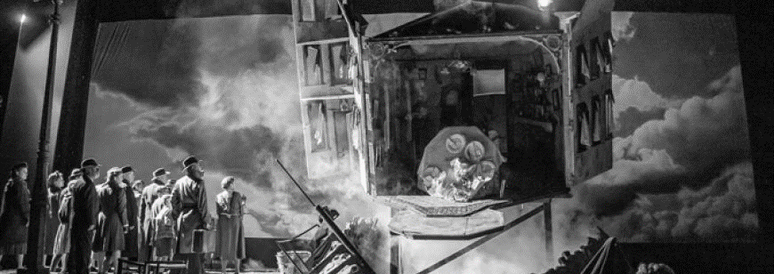

You won’t have access to a copy of the text in the exam and this isn’t a problem at all. You know the play well and you can instinctively recall the most memorable lines. For example: ‘unsinkable’, ‘absolutely furious’, ‘fairy prince’, ‘millions and millions’, and so on. However, there are some less recognisable quotations that are just as useful to know. And once again, our job is to consider their significance.

Quotations
- ‘You’re just the kind of son-in-law I always wanted’ (A1 | 163)
- ‘You seem to be a nice well-behaved family’ (A1 | 167)
- ‘We can keep it from him’ (A1 | 182)
- ‘It’s a favourite haunt of women of the town’ (A2 | 189)
- ‘You and I aren’t the same people who sat down to dinner here’ (A2 | 194)
- ‘She was claiming elaborate fine feelings and scruples’ (A2 | 199)
- ‘I hate these fat old tarts round the town’ (A3 | 204)
- ‘You’re not the kind of father a chap could go to when he’s in trouble’ (A3 | 205)
- ‘In the morning they’ll be as amused as we are’ (A3 | 220)

