High Five: Macbeth

- Evil deeds take place at night

Lady Macbeth’s scheming; the murder of Duncan; Macbeth’s second visit to the Witches.

- Stormy weather signifies a disruption in the natural social order

Storms accompany the prophecies; Duncan is murdered amidst a storm; the apparitions appear to thunder.

- We learn a lot through who and how Macbeth chooses to kill

On the battlefield (heroic); whilst Duncan sleeps (cowardly); pays murders to kill Banquo and Lady Macduff (despicable).

- Lady Macbeth is also vulnerable

Remembers her father (A2-S2); concerned at Macbeth’s increasingly tyranny (A3-S2); goes mad with guilt (A5-S1).

- Malcolm’s final words matter

He describes Macbeth as a ‘dead butcher’ and Lady Macbeth as a ‘fiend-like queen’ – fair?

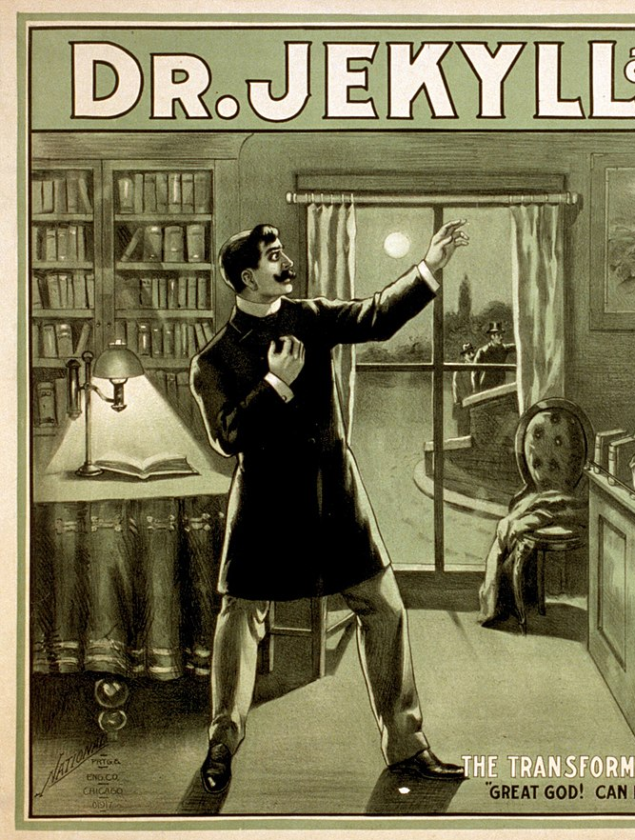
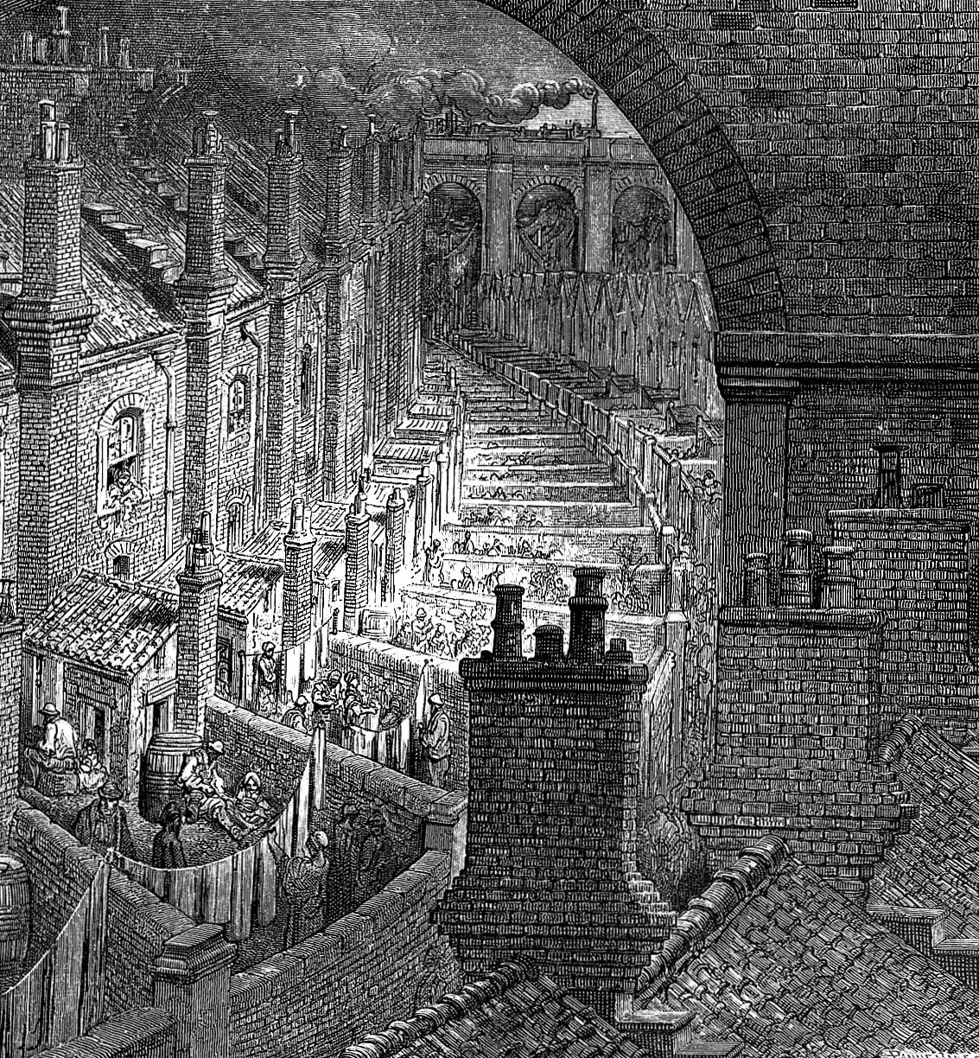
High Five: Jekyll and Hyde

- Hyde only appears under the cover of darkness

The trampling; the meeting with Utterson; the murder of Sir Danvers Carew; the meeting with Lanyon.

- Enfield’s appearance in chapter one hints at the double lives of respectable Victorian men

Enfield recounts how he was ‘coming home from some place at the end of the world’ very early in the morning.

- The doctor’s reaction to Hyde is extreme

The minor characters matter: the doctor turns ‘white with the desire to kill him.’

- The symbolism of Jekyll’s house is important

The front is well-maintained and the back is ‘sordidly’ neglected: respectable appearances mask dark secrets.

- Hyde hits a woman in the face

More violence: ‘Once a woman spoke to him, offering, I think, a box of lights. He smote her in the face’.

High Five: An Inspector Calls

- Sheila isn’t naive

She knows about Eric’s drinking; she knows Gerald wasn’t working all summer; she knows about Joe Meggarty.

- The lighting matters

‘Pink and intimate’ prior to the Inspector’s arrival; ‘brighter and harder’ afterwards.

- The stage directions matter

Compare the beginning of the play (‘gaily’, ‘positively’, ‘smiling’) with the middle (‘severely’, ‘bitterly’, ‘distressed’).

- Joe Meggarty is predatory and lecherous

His treatment of Eva is not dissimilar to Gerald and Eric’s treatment of her.

- Much of what the Birlings and Gerald say about Eva is positive

Birling concedes that she was a good worker; Sheila admits to being jealous of her; Eric highlights her morality.

