GCSE English Literature
Review Resources
Macbeth
The Strange Case of Dr Jekyll and Mr Hyde
An Inspector Calls
Power and Conflict Poetry
Term 1

Macbeth | Paper 1 | Section A

Notes

Review Questions
- Which monarch was on the throne when Macbeth was first performed?

- In which year is it generally thought the play was first performed?

- In which act and scenes does Macbeth ‘see’ a floating dagger?

- What does ‘hamartia’ mean?

- In which act and scene does Macbeth visit the witches for the second time?

- What title does Macduff hold?

- In which act and scene is Macduff’s wife killed?

- What is Lady Macbeth referring to when she describes ‘the golden round’?

- What is the name of Banquo’s son?

- Which character says, ‘Bleed, bleed, poor country!’?

- Which character says, ‘Out, dammed spot! Out I say!’?

- In which act and scene is Macbeth informed that his wife has died?

- Which character says, ‘Tyrant, show thy face!’?

- Which character kills Macbeth?

- Who is Malcolm referring to when he says, ‘dead butcher’?

Retrieval Practice
- Macbeth is powerful and violent

- Macbeth is loyal

- Macbeth is easily manipulated

- Macbeth has doubts about killing Duncan

- Macbeth is a tyrannical king

- Lady Macbeth is ambitious

- Lady Macbeth is persuasive

- Lady Macbeth is ruthless

- Macduff is loyal

- Macduff is patriotic

Vocabulary List
Flaw | Loyalty | Regret | Flaw
Ambition | Deceit | Guilt | Ambition
Power | Manipulation | Instability | Power
Violence | Doubt | Tyranny | Violence

Overview of Macbeth
- Macbeth begins the play as ‘brave’ and ends as a ‘dead butcher’.
- He believes that Duncan is a good king and has been ‘so clear in his great office’.
- Macbeth’s ‘vaulting ambition’ leads him to kill Duncan.
- Lady Macbeth accuses him of being ‘green and pale’ and calls him a ‘coward’ when he expresses doubts.
- He worries that Duncan’s blood will never wash clean from his hands and that he will ‘sleep no more’.
- In the aftermath of the murder, Lady Macbeth accuses Macbeth of being ‘infirm of purpose!’
- With Duncan ‘in his grave’, Macbeth hires murderers to kill Banquo and Fleance.
- Macbeth’s mental fragility is demonstrated when he accuses Banquo’s ghost of shaking ‘thy gory locks’ at him.
- With the feast disrupted, Lady Macbeth once again accuses him of being ‘unmann’d’.
- At the end of the play, isolated and deluded, Macbeth vows that he will ‘not be afraid of death and bane’.

Overview of Lady Macbeth
- Lady Macbeth is ambitious and intelligent, but at the end of the play she is described as a ‘fiend-like queen’.
- She believes her husband is equally ambitious, but also ‘too full o’ the milk of human kindness’.
- Lady Macbeth evokes the power of evil spirtis to ‘unsex’ her and fill her ‘top-full of direst cruelty!’
- She is the architect of the plan to murder Duncan; she tells Macbeth to ‘leave all the rest to me’.
- In the aftermath of the murder, Lady Macbeth is decisive; she orders Macbeth to ‘give me the daggers’.
- She scolds Macbeth for his weakness by saying that it is ‘a foolish thought to say a sorry sight’.
- When Macbeth sees the ghost of Banquo, Lady Macbeth calmly asks the ‘worthy’ thanes to ‘sit’.
- Towards the end of the play, Lady Macbeth sleepwalks and ‘rubs her hands’.
- She sees spots of blood on her hands and says that ‘all the perfumes of Arabia will not sweeten this little hand’.
- The doctor eventually reports to Macbeth that Lady Macbeth is ‘troubled with thick coming fancies’.

Overview of Macduff
- Macduff arrives to wake the Duncan the morning after the murder takes place ‘to call timely on him’.
- Macduff dutifuly describes Duncan as ‘royal’, his ‘master’ and his ‘king’.
- Upon discovering Duncan’s dead body, he loudly exclaims ‘O horror! horror! horror!’ in anguished confusion.
- Maduff’s loss of control contrasts to Macbeth’s hyperbole; Macbeth eulogises Duncan’s ‘golden blood’.
- Macbeth notes Macduff’s absence at the feast, remarking that he ‘denies his person at our great bidding’.
- The witches warn Macbeth to ‘beware Macduff’, but he is confident that ‘none of woman born shall harm’ him.
- Macbeth hires murderers to kill Macduff’s wife and family; the first murderer calls Macduff a ‘traitor’.
- Before being slaughtered, Macduff’s son calls the first murderer a ‘liar’ and ‘shag-hair’d villain!’
- In England, Macduff bemoans Macbeth’s ‘great tyranny’ and calls him a ‘hell-kite’ for slaughtering his family.
- In the final stages of the play, Macduff demands that Macbeth ‘show thy face!’ before killing him.

Specimen Question
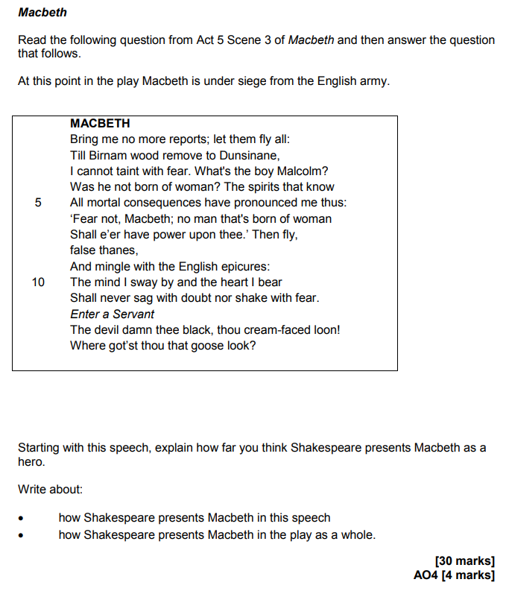

Source: AQA SAMS2 Booklet
Exemplar (25 Marks)
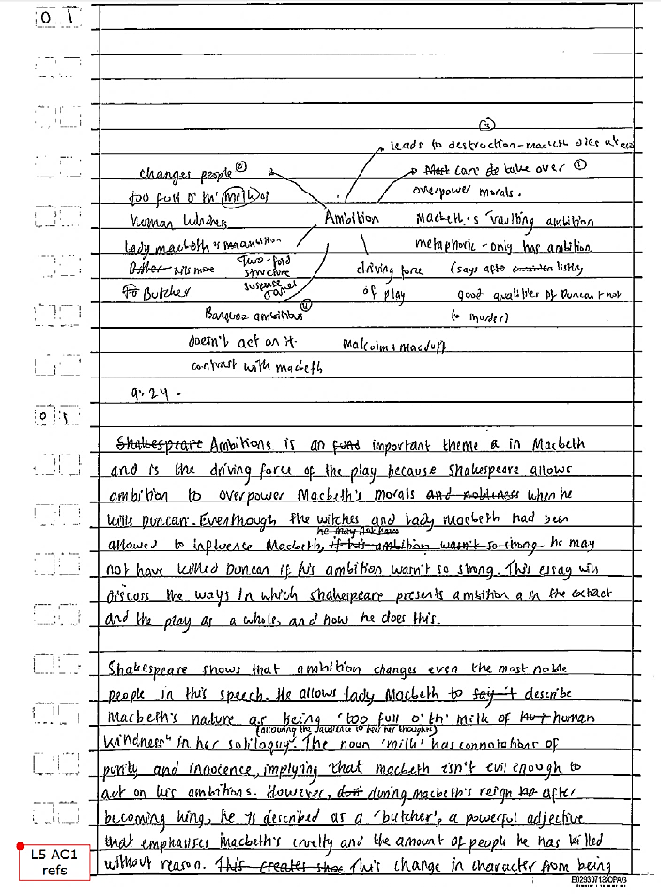

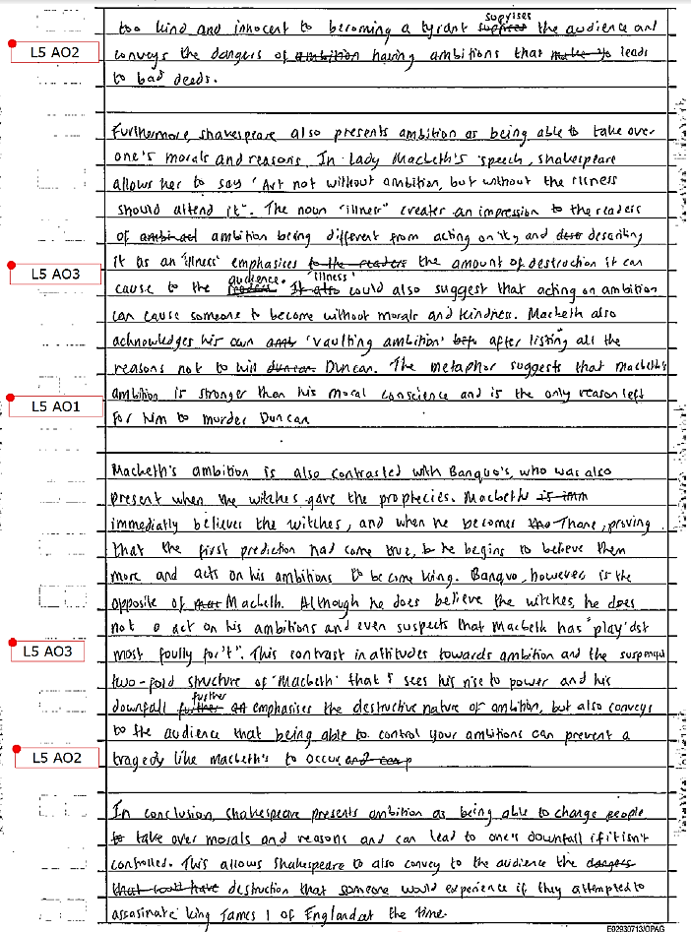

Source: AQA Reaching grade 8/9 Resource Booklet, 2018
Jekyll and Hyde | Paper 1 | Section B

Notes

Review Questions
- Which chapter is called ‘Search for Mr Hyde’?

- Which character has ‘an evil face, smoothed by hypocrisy’?

- Who witnesses the murder of Sir Danvers Carew?

- In which chapter is Jekyll described as ‘looking deadly sick’?

- What does Poole use to break down the door to Jekyll’s laboratory?

- What is ‘Coutts’ a reference to?

- What is Lanyon’s first name?

- What is a ‘sawbones’?

- Which character is described as a ‘hearty, healthy, dapper, red-faced gentleman’?

- What is the study of physiognomy?

- Which character is described in chapter 1 as ‘a man of rugged countenance’?

- Which character narrates the final chapter of the novel?

- Which character says, ‘The moment I choose, I can be rid of Mr Hyde’?

- Which character writes in an ‘odd, upright hand’?

- In which month does ‘the last night’ take place?

Retrieval Practice
- Jekyll is handsome

- Jekyll has a respectable group of friends

- Jekyll is deceitful

- Utterson is rational

- Utterson is loyal

- Hyde is remorseless

- Hyde is violent

- Hyde is grotesque

- Lanyon is healthy

- Lanyon dies of shock

Vocabulary List
Duality | Reputation | Danger | Duality
Respectability | Anxiety | Temptation | Respectability
Constraint | Civilisation | Pleasure | Constraint
Repression | Violence | Horror | Repression

Overview of Henry Jekyll
- Henry Jekyll is described as ‘the very pink of the proprieties’ in chapter one.
- However, he is described as ‘too fanciful’ by Lanyon, who flushes ‘suddenly purple’ at the mention of his name.
- By the end of chapter two, Utterson believes that ‘poor Harry Jekyll’ is in ‘deep waters!’
- We first see Jekyll in chapter three, where he is described as a ‘large, well-made, smooth-faced man of fifty’.
- After the Carew murder, with reference to Hyde, a ‘feverish’ Jekyll swears he will ‘never set eyes on him again’.
- Utterson reluctantly leaves Jekyll, believing that he has forged ‘for a murderer!’
- After Hyde disappears, Jekyll becomes more sociable; however, he swiftly becomes ‘confined to the house’.
- This confinement continues and Jekyll is seen at the window ‘taking the air with an infinite sadness’.
- In chapter nine, Lanyon’s letter reveals that the ‘creature’ Hyde is able to transform back into Jekyll.
- Jekyll’s full statement reveals that he found a drug that ‘potently controlled and shook the fortress of identity.’

Overview of Edward Hyde
- Hyde is described as a ‘damned Juggernaut’ by Enfield after he witnesses him trample ‘calmly’ over a child.
- Enfield remarks that Hyde ‘must be deformed somewhere’ and that he ‘gives a strong feeling of deformity’.
- When Utterson encounters Hyde, he feels ‘disgust, loathing and fear’.
- Hyde brutally murders ‘innocent’ Sir Danvers Carew by beating him to death and ‘carrying on like a madman’.
- Hyde’s Soho residence, despite being in ‘blackguardly’ surroundings, is ‘furnished with luxury and good taste’.
- When Hyde’s dead body is discovered by Poole and Utterson, it is ‘sorely contorted and still twitching’.
- Hyde appears to be dressed in Jekyll clothes, which are ‘far too large for him’.
- In Lanyon’s narrative, he recounts his meeting Hyde late at night; he describes Hyde as ‘abnormal’.
- Hyde is impatient to get the chemicals from Lanyon and places his hand on Lanyon’s arm to ‘shake’ him.
- In his final statement, Jekyll concedes that, as Hyde, ‘a spirit of hell awoke and raged in me’.

Overview of Gabriel Utterson
- Utterson is described in chapter one as ‘cold, scanty and embarrassed in discourse’.
- However, something ‘eminently human beaconed from his eye’.
- Utterson has a nightmare in about Hyde’s connection to Jekyll; he worries about the ‘startling clauses of the will.’
- Jekyll does not take his concerns seriously; Utterson leaves after heaving an ‘irrepressible sigh’.
- After Carew is murdered, Utterson worries that Jekyll is covering for Hyde and his blood runs ‘cold in his veins’.
- Lanyon confides in Utterson that he has ‘had a shock’ and wishes to ‘see or hear no more of Dr Jekyll’.
- After seeing Jekyll confined like a ‘disconsolate prisoner’, Utterson is so shocked that he turns ‘pale’.
- Utterson is certain that Jekyll is suffering from ‘one of those maladies that both torture and deform the sufferer’.
- After discovering Hyde’s dead body, Utterson believes that Jekyll might have ‘fled’ from the cabinet.
- Utterson leaves Jekyll’s house, vowing to ‘read these documents in quiet’.

Specimen Question
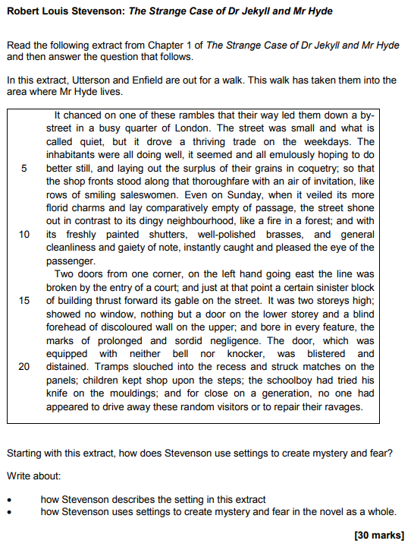

Source: AQA SAMS2 Booklet
Exemplar (Level 5)
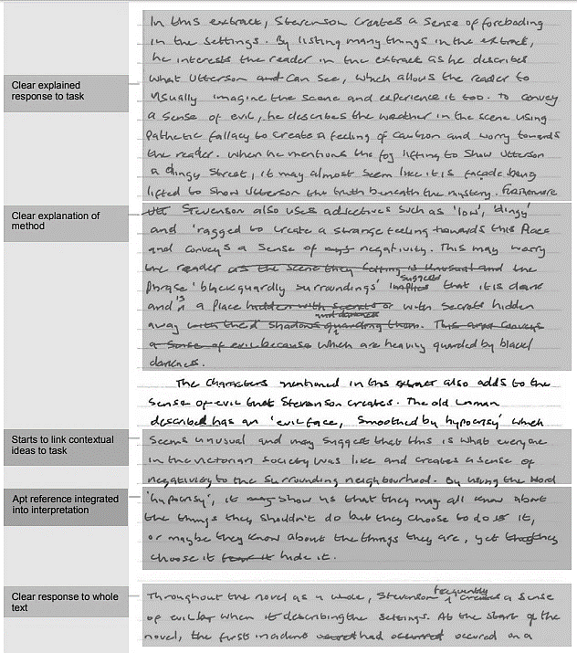

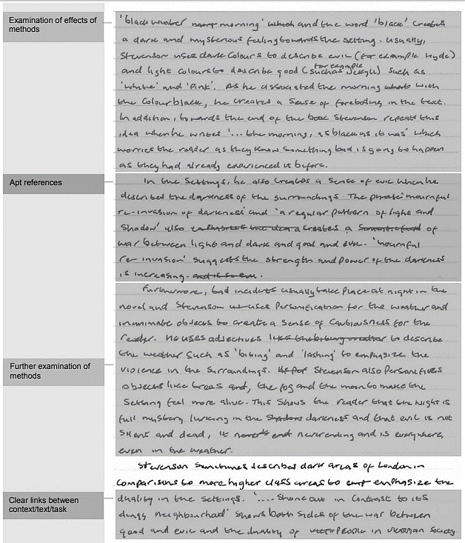

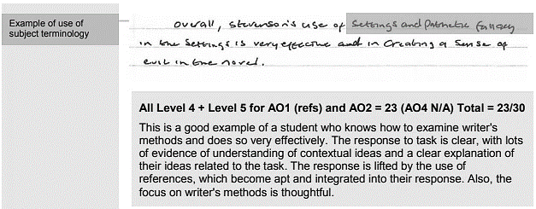

Source: AQA Marked Example Resource Booklet, 2017
An Inspector Calls | Paper 2 | Section A

Notes

Review Questions
- Which character is described as a ‘handsome chap’?

- What is the name of the parlour maid?

- Who became the prime minister in 1945?

- In which year was the play first performed?

- Which character says, ‘Yes, you’ve piled it on a bit tonight, Father’?

- Which character is interrogated first by the inspector?

- What is the name of the bar where Eric and Gerald meet Eva?

- Which character says, ‘What’s all this about?’

- Which character says, ‘So I’m really responsible?’

- In which year did World War 1 begin?

- Which character says, ‘All right. I knew her. Let’s leave it at that’?

- Which character says, ‘I’m glad I amuse you’?

- In which month does Gerald admit to meeting Daisy Renton?

- What is the name of the local alderman who ‘wedged’ Daisy into a corner?

- How much money did Eric steal from his father?

Retrieval Practice
- Birling is arrogant

- Birling is unremorseful

- Mrs Birling is aristocratic

- Mrs Birling is naive

- Sheila is easily pleased

- Sheila is assertive

- Eric is drunk

- Eric is defiant

- Gerald is agreeable

- Eva is vulnerable

Vocabulary List
Responsibility | Capitalism | Vulnerability | Responsibility
Power | Socialism | Equality | Power
Wealth | Owner | Class | Wealth
Status | Worker | Division | Status

Overview of Act 1
- The Birling family live in a ‘fairly large suburban house’ and, at rise of curtain, they are ‘pleased with themselves’.
- Birling remarks awkwardly that ‘it’s a pity Sir George and – er – Lady Croft can’t be with us’.
- Gerland presents Sheila with an engagement ring and she exlaims, ‘Oh – it’s wonderful!’
- Birling makes predictions about the future; he says, ‘we’re in for a time of steadily increasing prosperity’.
- Birling is unrepentant about his role in the suicide of Eva Smith, remarking that ‘it’s a free country’.
- Eric disagrees by saying that ‘it isn’t if you can’t go and work somewhere else’.
- Eva does manage to find another job because ‘Milwards suddenly found themselves short-handed’.
- Sheila feels guilty about using her influence to get Eva sacked; she says that ‘if I could help her now, I would – ’.
- The Inspector reveals that Eva changed her name to Daisy Renton, which prompts Gerald to ask ‘[startled] what?’
- Gerald asks Sheila not to tell the Inspector about his relationship with Daisy; he says, ‘we can keep it from him’.

Overview of Act 2
- Gerald tries to deter Sheila from staying to witness the questions and answers that are ‘bound to be unpleasant’.
- Mrs Birling notes Eric’s absence and remarks that he ‘seems to be in an excitable silly mood’.
- Gerald conceeds to the Inspector that he met the ‘young and pretty‘ Daisy in the disreputable Palace Bar.
- Gerald says that he ‘broke it off’ with her before he went away for ‘several weeks’ on business.
- Daisy kept a diary, in which she wrote that ‘she felt there’d never be anything as good again for her’.
- Obviously upset, Gerald excuses himself and leaves; however, he says, ‘I’m coming back’.
- Mrs Birling claims that she ‘did nothing I’m ashamed of or that won’t bear investigation’.
- She refused Eva charity money, stating that it is the father’s ‘responsibility’ to support her.
- Mrs Birling defiantly says, ‘I blame the young man who was the father of the child she was going to have’.
- When it is implied that Eric is the father, Mrs Birling becomes agitated and says, ‘I won’t believe it’.

Overview of Act 3
- Eric says bitterly to his mother that ‘you haven’t made it any easier for me’.
- Eric admits that he was ‘a bit squiffy’ when he met Eva and ‘was in that state when a chap easily turns nasty’.
- He saw Eva again; he ‘liked’ her, but ‘wasn’t in love with her or anything’.
- Eric tells the Inspector that Eva ‘didn’t want me to marry her’.
- Eric admits to taking money from his father; Birling reacts angrily and says that Eric has been ‘spoilt’.
- As the Inspector prepares to leave, he highlights to the Birlings and Gerald that each of them ‘helped to kill’ Eva.
- He asks them to remember that ‘there are millions and millions and millions of Eva Smiths and John Smiths’.
- The Inspector leaves and Eric says that he is ‘ashamed’ of his father.
- Birling believes that he and the rest of the family were ‘bluffed’; he later concludes that the Inspector was a ‘fake!’
- The play ends with Birling reporting that ‘a police inspector is on his way here – to ask some – questions’.

Specimen Questions
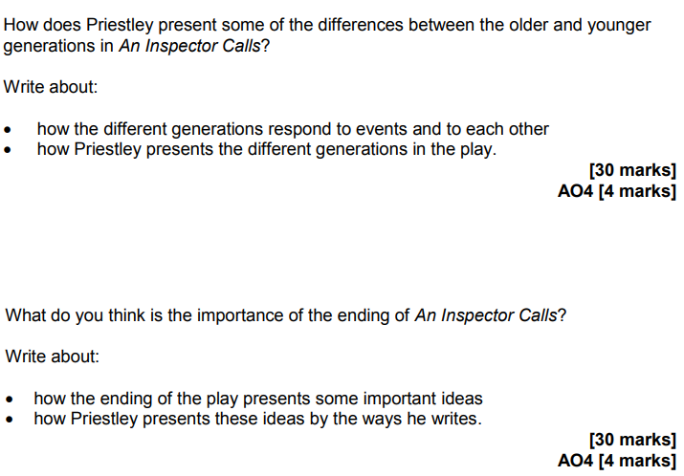

Source: AQA SAMS2 Booklet
Exemplar (28 Marks)
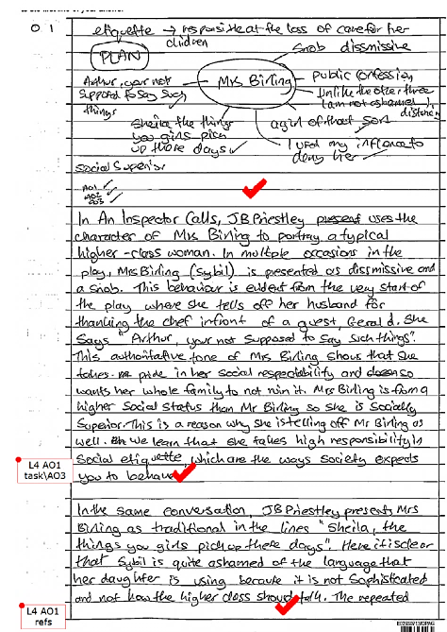

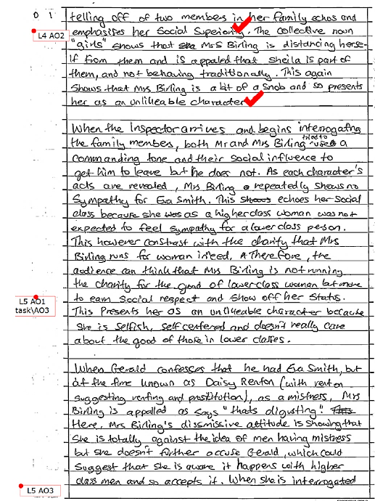

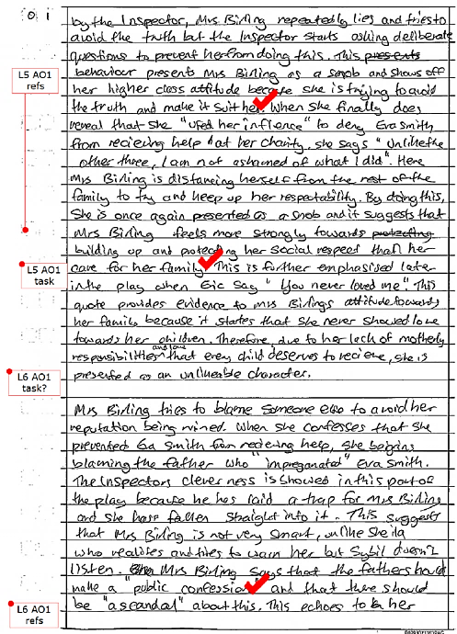

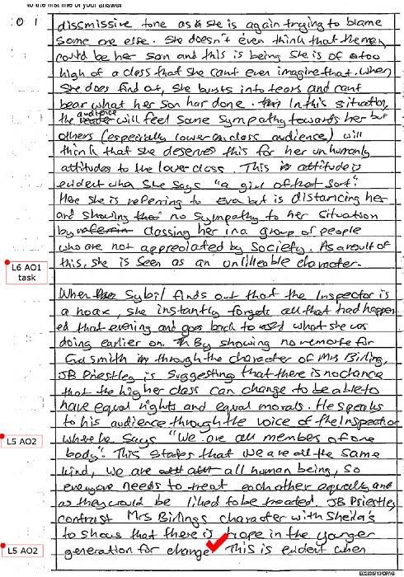
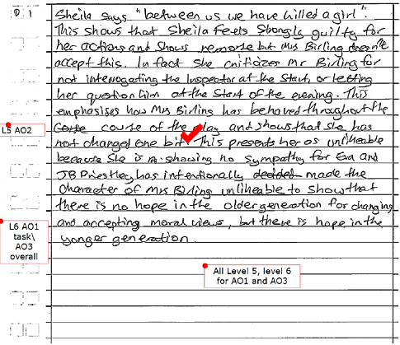

Source: AQA Reaching grade 8/9 Resource Booklet, 2018
Power and Conflict Poetry | Paper 2 | Section B

Notes

Review Questions
- What other name is Ozymandias typically known by?

- ‘Marks of weakness…’ How does the line finish?

- ‘There hung a darkness…’ How does the line finish?

- ‘A heart – how shall I say? – too…’ How does the line finish?

- In which war did the Light Brigade fight?

- In which country was Seamus Heaney born?

- What is a bayonet?

- What is a looter?

- What does Armistice Sunday commemorate?

- Who is the speaker in ‘Remains’?

- ‘Sellotape bandaged…’ How does the line finish?

- Which holy book is referenced in ‘Tissue’?

- What is an émigree?

- What is a tyrant?

- Which nationality is the pilot in ‘Kamikaze’?

Retrieval Practice
- ‘Ozymandias’ is a poem that highlights the transient nature of power
]
- ‘London’ is a poem that exposes political tensions in eighteenth century

- The cavalrymen of the Light Brigade were brave

- ‘Exposure’ is about the brutal weather conditions

- Hughes writes about the confusion of frontline combat

- Armitage explores the lasting impact of PTSD

- ‘Poppies’ is written from the perspective of a mother

- Duffy uses religious imagery in ‘War Photographer’

- Dharker uses striking images of light in ‘Tissue’

- Kamikaze pilots were meant to commit suicide

Vocabulary List
Violence | Endurance | Sacrifice | Violence
Brutality | Resentment | Struggle | Brutality
Tension | Anger | Confusion | Tension
Trauma | Bravery | Despair | Trauma

Overview
- Ozymandias: Written in 1818 shortly after the British Museum acquired a large section of a statue of Ramses II.

- London: Published in 1794 amidst the violent and unpredictable backdrop of the French Revolution.

- Prelude: The extract in the anthology presents the natural world as powerful, dramatic, beautiful and menacing.

- Last Duchess: The speaker is loosely based on the Duke of Ferrara.

- Light Brigade: The Crimean War was fought between 1853-6; over 150 of 600 cavalrymen were killed.

- Exposure: The poem records the horrendous conditions that British soldiers experienced on the front line.

- Storm: The poem presents the struggle between the people on an island and the hostile weather conditions.

- Bayonet Charge: Hughes writes from the perspective of a soldier charging across no-man’s land.

- Remains: Armitage writes from the perspective of a solider suffering from PTSD.

- Poppies: Weir writes from the perspective of a mother whose son has gone to war.

- Photographer: Duffy based the poem on accounts from Don McCullin.

- Tissue: A poem that explores the conflicts and tensions of the modern world.

- Émigree: Rumens writes from the perspective of a person who has left their home country.

- History: Agard challenges historical grand narratives.

- Kamikaze: Garland based her poem on the testimony of the daughter of a kamikaze pilot.

Specimen Question
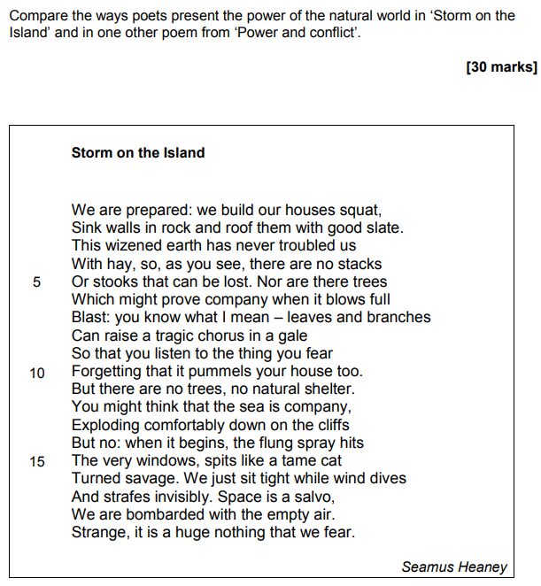

Source: AQA SAMS2 Booklet
Exemplar (26 Marks)
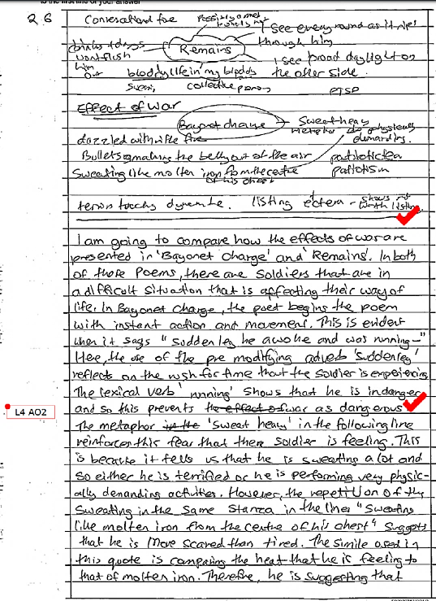

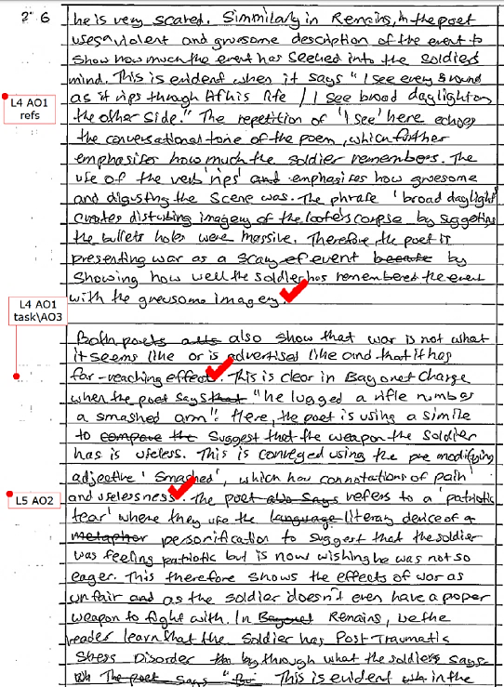

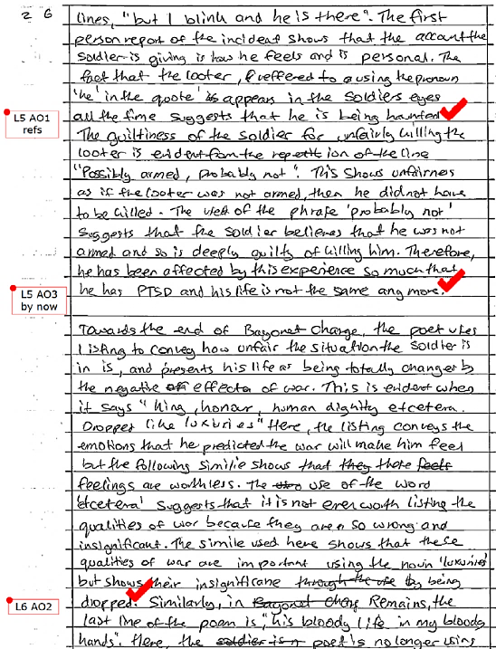

Source: AQA Reaching grade 8/9 Resource Booklet, 2018

