GCSE English Language

Paper 1

Explorations in creative reading and writing

Study pack

Answer the questions below.

If you get stuck, think harder. And if you’re still stuck, look in your book.

- How much time do you get to complete the whole paper?

- How much time do you get to complete section A?

- How much time do you get to complete section B?

- Is the section A text fiction or non-fiction?

- What does section B require you to do?

- How many marks are available for the whole paper?

- How many marks are available for question 3?

- How many marks are available for question 4?

- How many marks are available for question 5?

- How many of the marks for question 5 are awarded for technical accuracy?

- What are your required to do for question 1?

- What are you required to do for question 2?

- What are you required to do for question 4?

- List three ‘language’ terms?

- List three ‘structure’ terms?

Extracts from Elizabeth Berridge obituary

The novelist Elizabeth Berridge, who has died aged 89, was a writer of rare distinction who deserved more recognition than she ever received. She was born in south London, of English/Welsh ancestry. Her father was a land agent, administering large London and country estates, and she may have inherited something of his eye for property, for her descriptions of houses and localities, especially of the growth and development of the southern suburbs where she grew up and lived for large parts of her life, are memorable for their sharpness and accuracy.

Although [Berridge] was, on the surface, a conventional master of conservative suburban fiction, her work concealed a deep subversiveness. The reader continually finds his expectations railroaded on to a completely different track. She was, par excellence, the celebrator of family life. There is, as she said herself, no substitute for the family: ‘It is society's first teething ring, man's proving ground. When repudiated, it still leaves its strengthening mark. When it does the rejecting, the outcast is damaged. Within its confines, devils and angels rage together, emotions creep underfoot like wet rot, or flourish like Russian ivy. It is the world in microcosm, the nursery of tyrants, the no man's land of suffering, a place and a time, a rehearsal for silent parlour murder.

Berridge was an expert at charting the small cruelties that husband and wife, parent and child, can inflict on each other in the domestic arena, and at describing the intrinsic dignity and extrinsic humiliations of old age. On the other hand, she freely admitted to a preoccupation with aunts, and this is manifest in most of her finely crafted fiction, where aunts of all varieties – mainly elderly – proliferate on the page, realistically, if lovingly, described. Readers of Across the Common will not soon forget Aunt Seraphina, expertly stuffing her bag with cuttings from the flowerbeds of Regent’s Park under the nose of the keeper for the benefit of her garden at home.

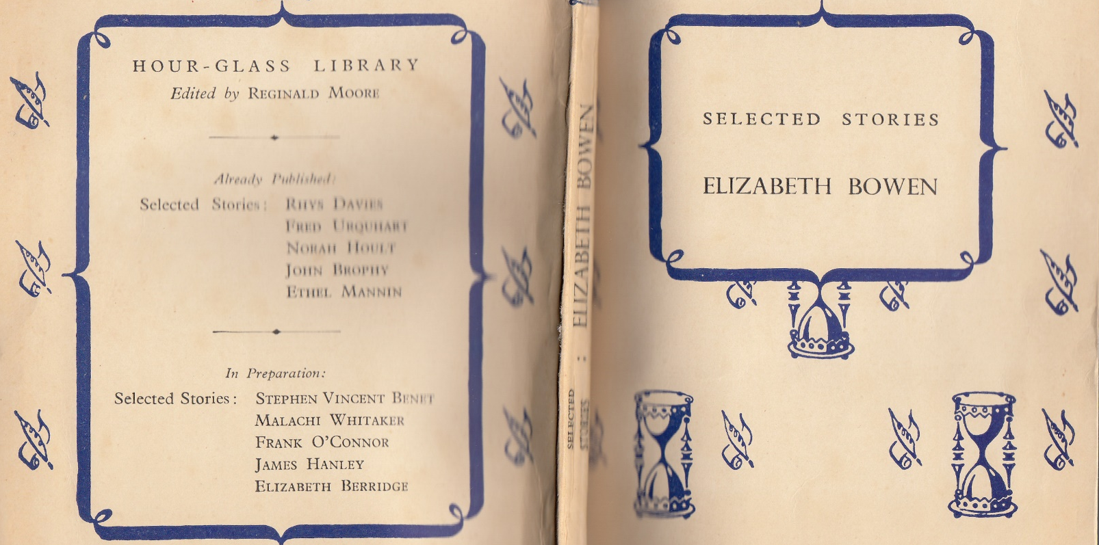

Source: https://www.theguardian.com/books/2009/dec/16/elizabeth-berridge-obituary
Lullaby, by Elizabeth Berridge

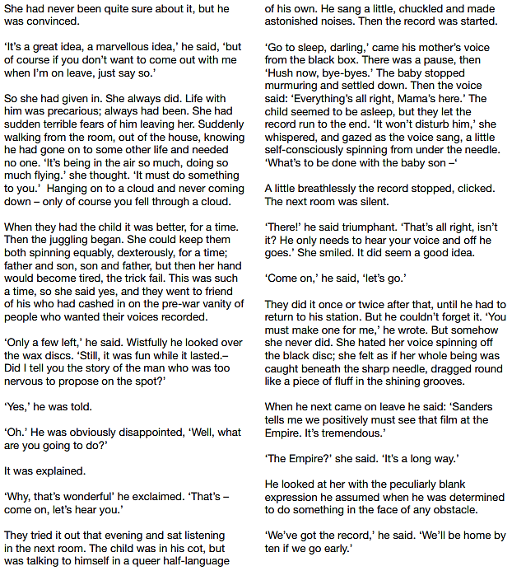

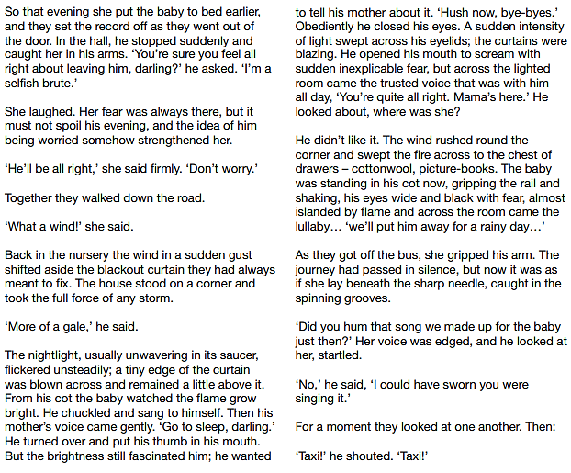

Source: AQA GCSE English Language reading resource booklet

0 | 1 Read again the third paragraph of the source.

List four things about the (unnamed) wife from this part of the source

[4 marks]

- Don’t write lengthy, unfocused answers

- Don’t make inferences on the passage

- Do write short, succinct answers

- Do select short, relevant quotations

0 | 2 Look in detail at this extract, from paragraph four of the source:

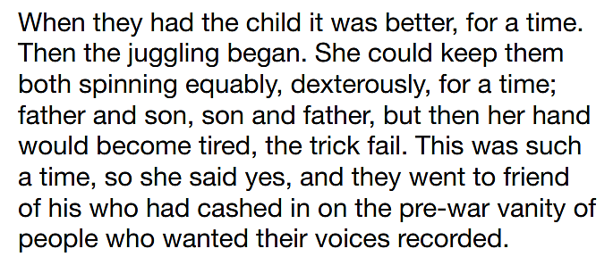

How does the writer use language here to convey the wife’s views on family life?

You could include the writer’s choice of:

- words and phrases

- language features and techniques

- sentence forms.

[8 marks]

- Don’t simply list technical terms

- Don’t feel obligated to write about ‘complex’ language features

- Don’t make unnecessary points about sentence lengths (e.g. the long sentences reflect amount of work)

- Do focus on why the writer has used certain words, short phrases and language devices

0 | 3 You now need to think about the whole of the source.

This text is a complete short story.

How has the writer structured the text to interest you as a reader?

You could write about:

- what the writer focuses your attention on at the beginning of the source

- how and why the writer changes this focus as the source develops

- any other structural features that interest you

[8 marks]

- Don’t retell the sequence of events

- Don’t write about the writer’s use of language

- Don’t use obscurely complex technical terms

- Do explain why events happen at certain points

- Do note a structural feature at a certain point and then comment on how it is developed

0 | 4 Focus this part of your answer on the second page of the source to the end.

A student said, ‘This part of the story, where the two parents decide to go to the cinema, shows how neglectful and selfish they are, and the fire is ultimately their fault.’

To what extent do you agree?

In your response, you could:

- consider your own impressions of what the actions of the parents

- evaluate how the writer conveys the actions of the parents

- support your response with references to the text.

[20 marks]

- Don’t write about details outside the stated lines

- Don’t feel that it is a necessity to construct artificial counter-arguments

- Don’t include unrelated or superficial information about historical context

- Do remember that the best answers are ‘detailed’ and ‘perceptive’

- Do adopt a method-based approach (e.g. the writer used the word/phrase to show…)

- Do explicitly refer back to the question

0 | 5 A magazine has asked for contributions for their creative writing section.

Either

Write a description of an evening at the cinema as suggested by the picture below:

or

Write a story about a time when you made a bad decision.
.
(24 marks for content and organisation

16 marks for technical accuracy)

[40 marks]

- Don’t use contrived ‘wow’ words and remember that an ‘advanced’ words do not always add clarity

- Don’t use plots based on films or computer games

- Don’t write about gory or unpleasant incidents

- Do plan your response (but don’t take too long)

- Do spell key words correctly

- Do use correct homophones, apostrophes and speech punctuation

