|  |
| --- |
| * Carefully re-read the demarcated lines * Neatly shade the circles * Check your answers |
| * Don’t rush |
| ⌚ 5 x minutes |

|  |
| --- |
| * Make a list of differences * Use the key words of the question in your answer * Use the phrases: ‘*This is important because…*’ **and** ‘*We learn that…*’ **and** ‘*This shows…*’ |
| * Don’t just retell what happens in each source |
| ⌚ 10 x minutes  📝 2 x paragraphs |

*In Source A the children’s experience of eating sweets at the cinema is enjoyable as they ‘ate steadily or raced up and down’. They seem to be able to eat and move as much as they like so there is a sense of freedom about their experience as they do not appear to be supervised. This is very different to the factory girls whose experience is controlled so that they complete their work. In Source B, the girls ‘sitting silently’ have no freedom because they are monitored so closely…*

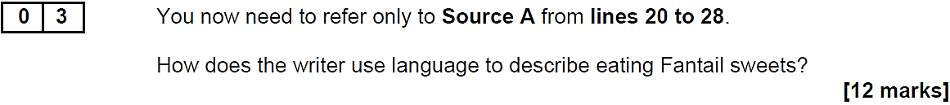

|  |
| --- |
| * Highlight and annotate three bits from the passage * Use the key words of the question in your answer * Use the phrases: ‘*This is important because…*’ **and** ‘*We learn that…*’ **and** ‘*This shows…*’ * Fully develop your points: ‘*Not only… but also…*’ **or** ‘*Furthermore…*’ |
| * Don’t go beyond the demarcated lines |
| ⌚ 15 x minutes  📝 3 x paragraphs |

*The writer uses the exaggeration of ‘strangled crying’ to create an image of how much physical effort is needed to eat the Fantail. The adjective ‘strangled’ suggests that eating it involves suffering rather than the usual enjoyment as the sweet is so sticky and chewy that the effort of chewing it is like being choked, but the children keep going…*

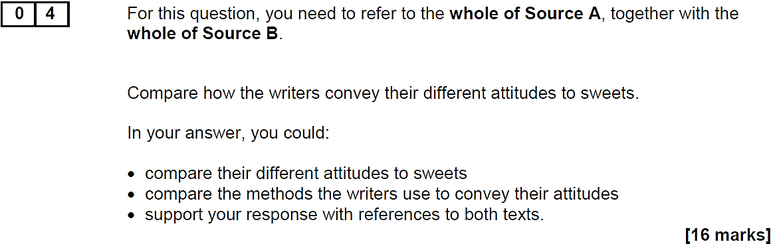

|  |
| --- |
| * Make a list of differences * Use the key words of the question in your answer * Use the phrases: ‘*This is important because…*’ **and** ‘*We learn that…*’ **and** ‘*This shows…*’ * Fully develop your points: ‘*Not only… but also…*’ **and** ‘*Furthermore…*’ |
| * Don’t forget to analyse language |
| ⌚ 20 x minutes  📝 4 x paragraphs |

*The writer of Source A is nostalgic as he recalls the sweets of his childhood cinema trips. Sweets are the most important part of the cinema experience because most of his account is about them and not what he watched. He shows this by describing all the sweets in great detail, building up to what he regards as the ‘star lolly’ of the Jaffa. By using the adjective ‘star’ he makes clear that it is the main attraction of the sweet-eating experience, the biggest name in the show. On the other hand, the writer in Source B does not share this nostalgic attitude to past sweets as in the past they were potentially life-threatening. He describes how these sweets ‘contained the most virulent poison’. His choice of the adjective ‘virulent’ suggests how severe, even deadly, the effects of this poison may have been on children. He clearly disapproves of this old manufacturing process that resulted in children’s deaths and hopes that sweets can now be enjoyed safely…*

|  |
| --- |
| * Form a clear viewpoint on the statement * Create a plan * Explicitly refer to the statement in each of your paragraphs * Signpost your writing: ‘*Firstly… Secondly…*’ **and** ‘*Although… Despite…*’ **and** ‘Crucially…’ * Fully develop your points: ‘*Not only… but also…*’ **and** ‘*Furthermore…*’ * Pay attention to accuracy * Vary the structure of your sentences * Choose your vocabulary with precision |
| * Don’t forget to proof-read your work at the end |
| ⌚ 45 x minutes  📝 2 x pages |