|  |
| --- |
| * Carefully re-read the demarcated lines * Neatly shade the circles * Check your answers |
| * Don’t rush |
| ⌚ 5 x minutes |

|  |
| --- |
| * Make a list of differences * Use the key words of the question in your answer * Use the phrases: ‘*This is important because…*’ **and** ‘*We learn that…*’ **and** ‘*This shows…*’ |
| * Don’t just retell what happens in each source |
| ⌚ 10 x minutes  📝 2 x paragraphs |

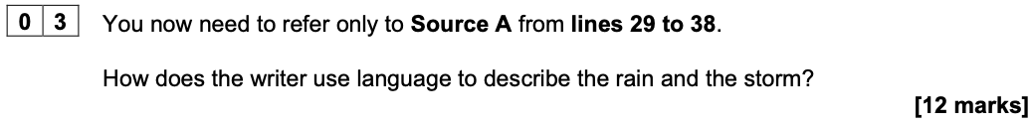

|  |
| --- |
| * Highlight and annotate three bits from the passage * Use the key words of the question in your answer * Zoom-in on individual words as well as images * Use the phrases: ‘*This word was chosen because…*’ **and** ‘*The image is significant because…*’ * Also use the phrases: ‘*This is important because…*’ **and** ‘*We learn that…*’ **and** ‘*This shows…*’ * Fully develop your points: ‘*Not only… but also…*’ **or** ‘*Furthermore…*’ |
| * Don’t just retell what happens in the passage |
| * Don’t go beyond the demarcated lines |
|  |
| ⌚ 15 x minutes  📝 3 x paragraphs |

|  |
| --- |
| * Make a list of differences * Use the key words of the question in your answer * Use the phrases: ‘*This is important because…*’ **and** ‘*We learn that…*’ **and** ‘*This shows…*’ * Also use the phrases: ‘*This is word was chosen because…*’ **and** ‘*The image is significant because…*’ * Fully develop your points: ‘*Not only… but also…*’ **and** ‘*Furthermore…*’ |
| * Don’t forget to analyse language |
| ⌚ 20 x minutes  📝 3 x paragraphs |

|  |
| --- |
| * Form a clear viewpoint on the statement * Create a plan * Explicitly refer to the statement in each of your paragraphs * Signpost your writing: ‘*Firstly… Secondly…*’ **and** ‘*Although… Despite…*’ **and** ‘Crucially…’ * Fully develop your points: ‘*Not only… but also…*’ **and** ‘*Furthermore…*’ * Pay attention to accuracy * Vary the structure of your sentences * Choose your vocabulary with precision |
| * Don’t forget to proof-read your work at the end |
| ⌚ 45 x minutes  📝 2 x pages |