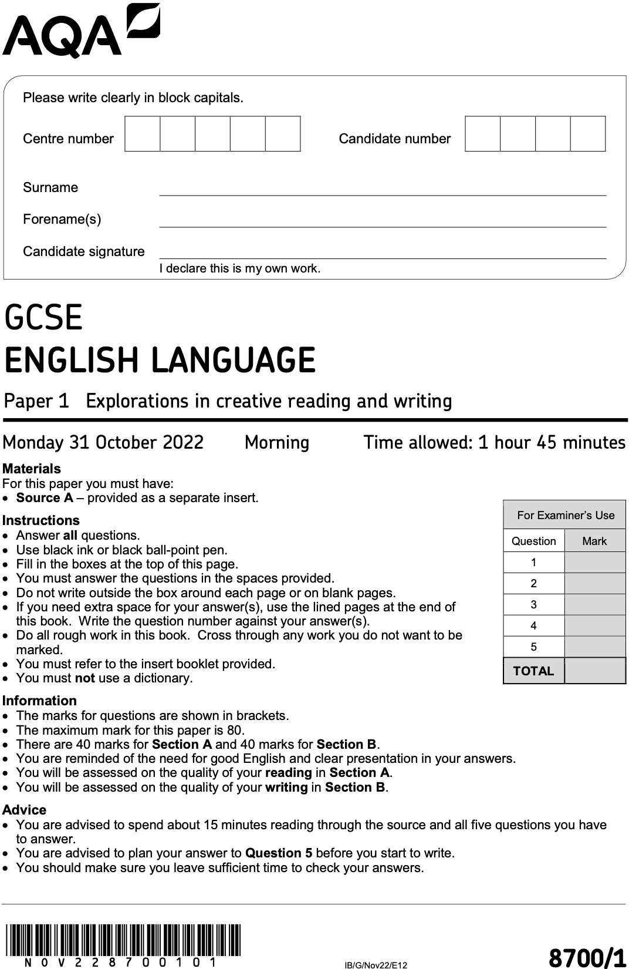
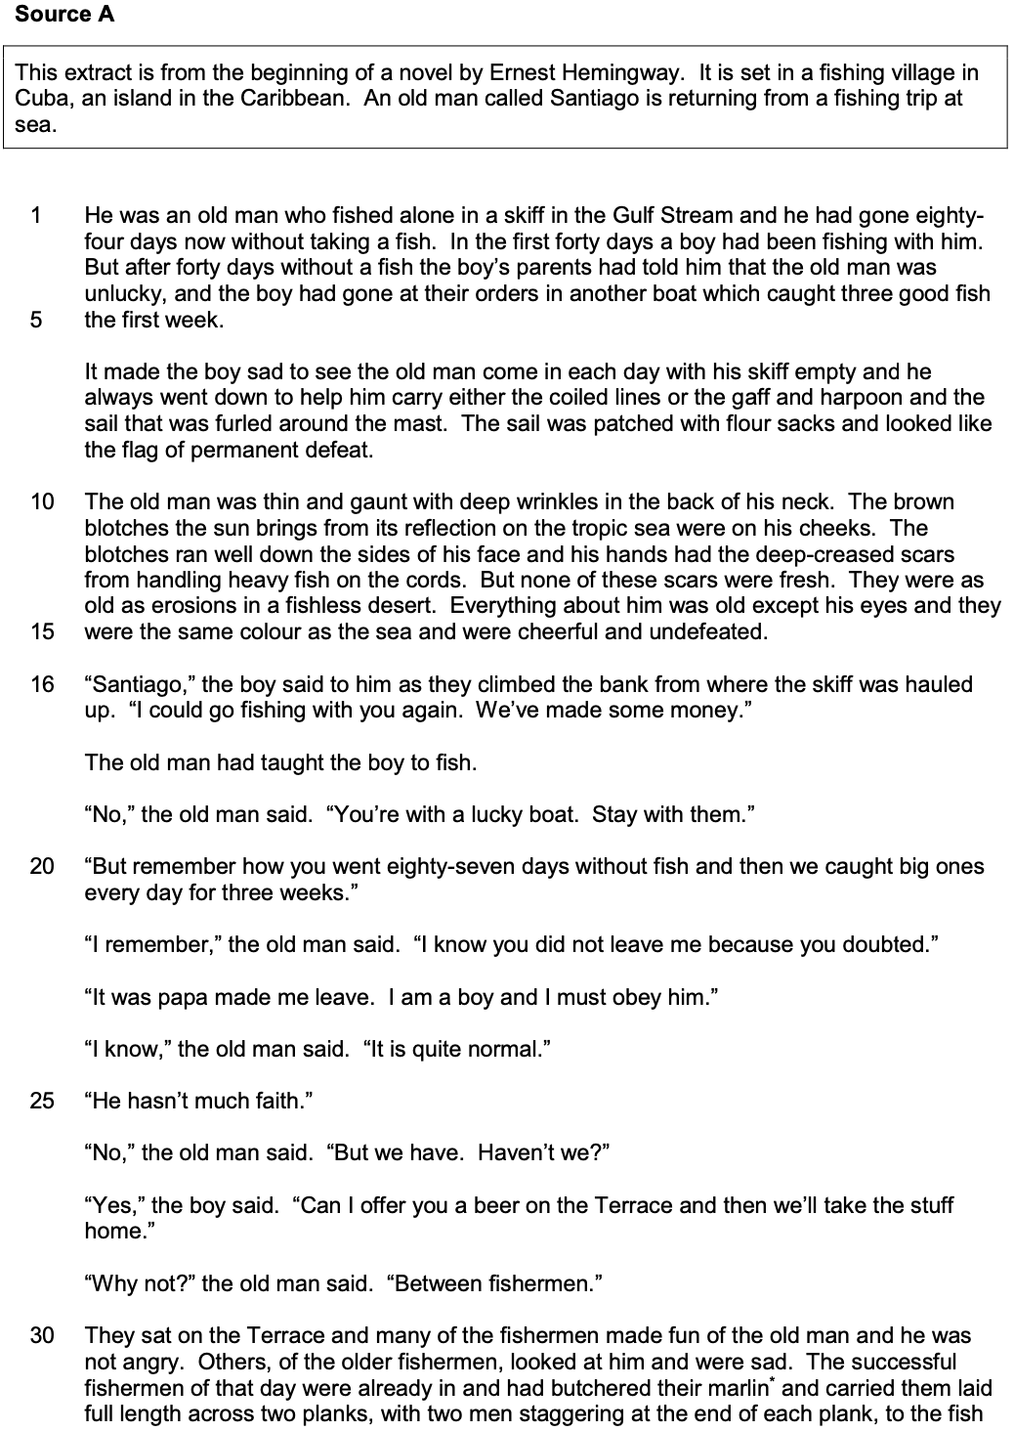

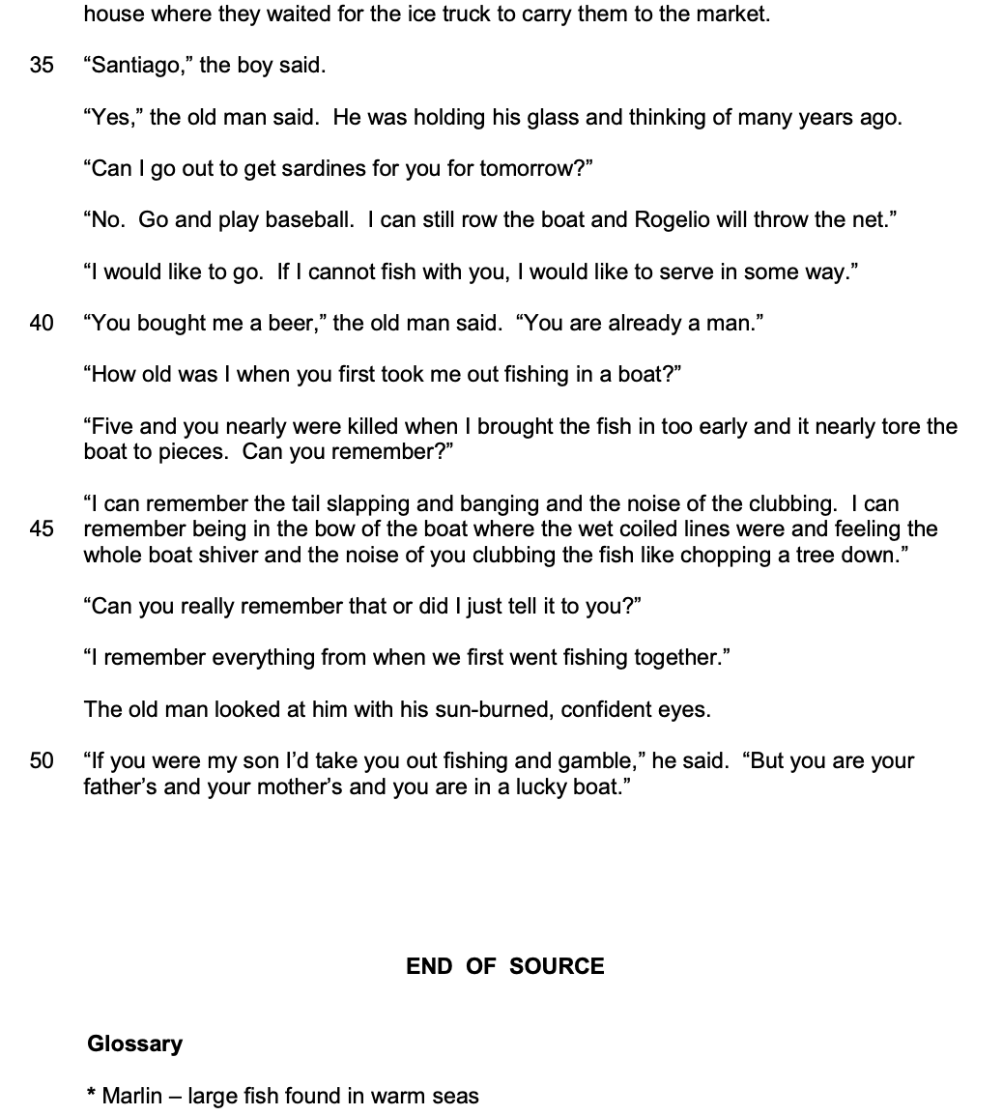

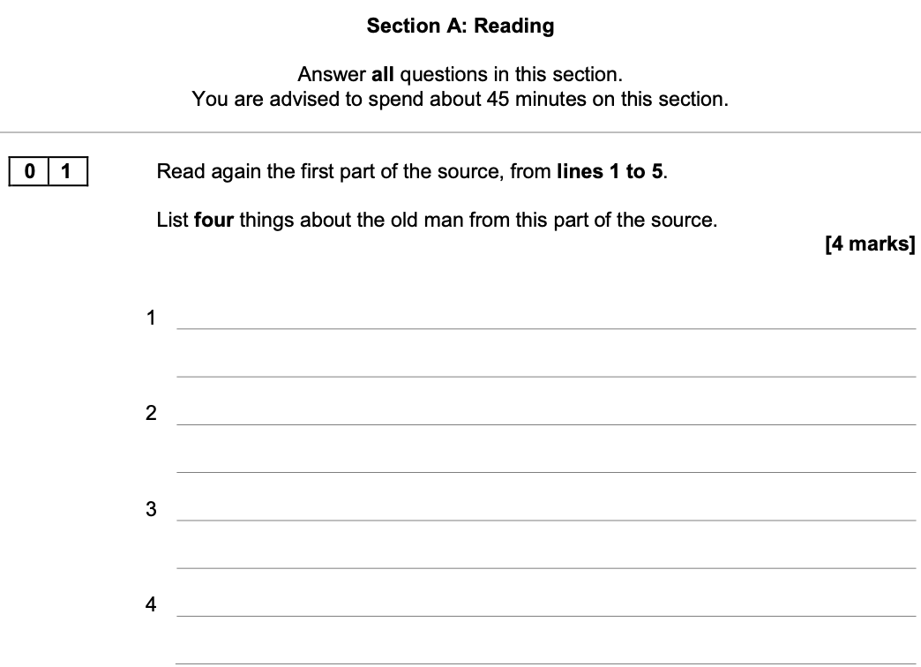

- Carefully re-read the demarcated lines
- Write a simple statement for each ‘thing’
- Check your answers

- Don’t rush
- Don’t write about anything that is not explicitly stated in the demarcated lines

5 x minutes

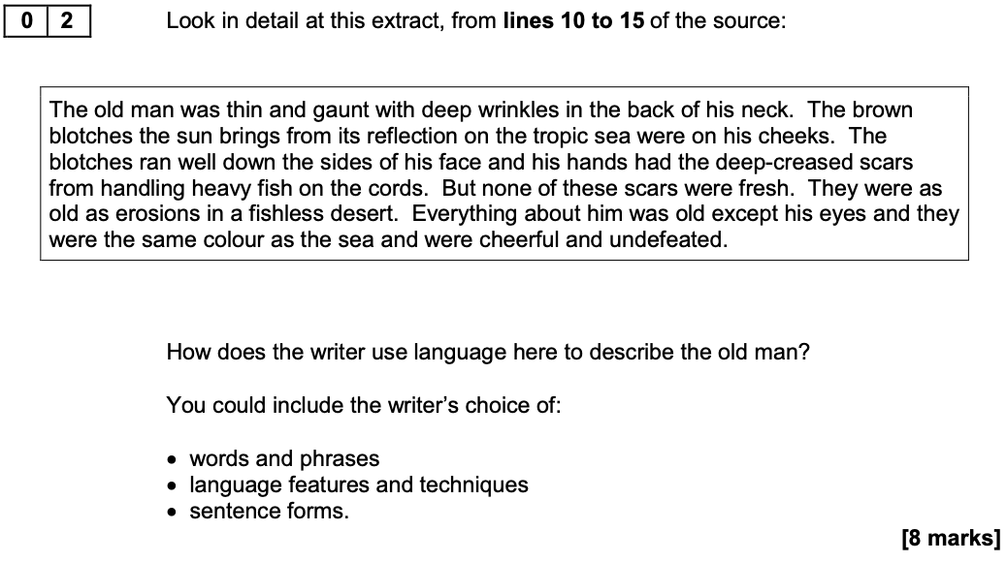

- Highlight and annotate two bits from the passage
- Use the key words of the question in your answer
- Zoom-in on individual words as well as images
- Use the phrases: ‘This word was chosen because…’ and ‘The image is significant because…’
- Also use the phrases: ‘This is important because…’ and ‘We learn that…’ and ‘This shows…’

- Don’t just retell what happens in the passage
- Don’t write about anything that’s not included in the box
10 x minutes
2 x paragraphs

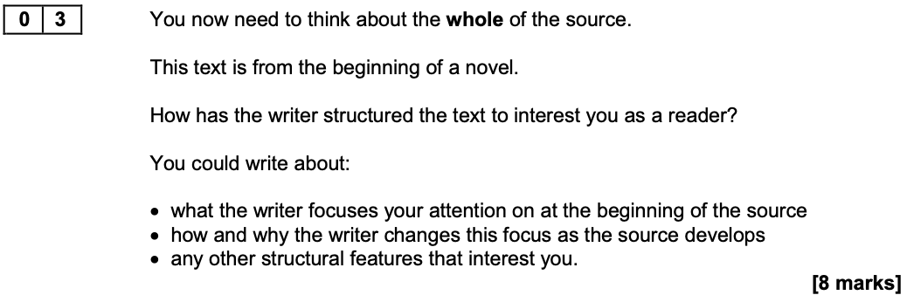

- Divide your response into three parts: beginning, middle and end
- Use the words: ‘focus’ and ‘perspective’ and ‘shift’ and ‘zoom-in’ and ‘zoom-out’
- Use the phrases: ‘At the beginning of the text, the focus is on…’ and ‘As the text progresses…’
- Also use the phrases: ‘This is important because…’ and ‘This interests me because…’

- Don’t analyse language
10 x minutes
2 x paragraphs

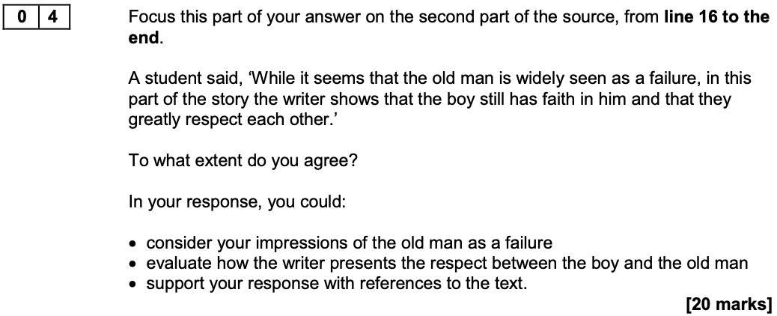

- Agree with the statement
- Fully explain why you agree with the student for each point that you make
- Use the key words of the question in your answer
- Use the phrases: ‘This supports my view because…’ and ‘This is an important point because…’
- Also use the phrases: ‘This is word was chosen because…’ and ‘The image is significant because…’
- Fully develop your points: ‘Not only… but also…’ and ‘A further point to consider is…’

- Don’t just retell what happens in the passage
- Don’t write about anything that’s not included in the box
20 x minutes
3 x paragraphs

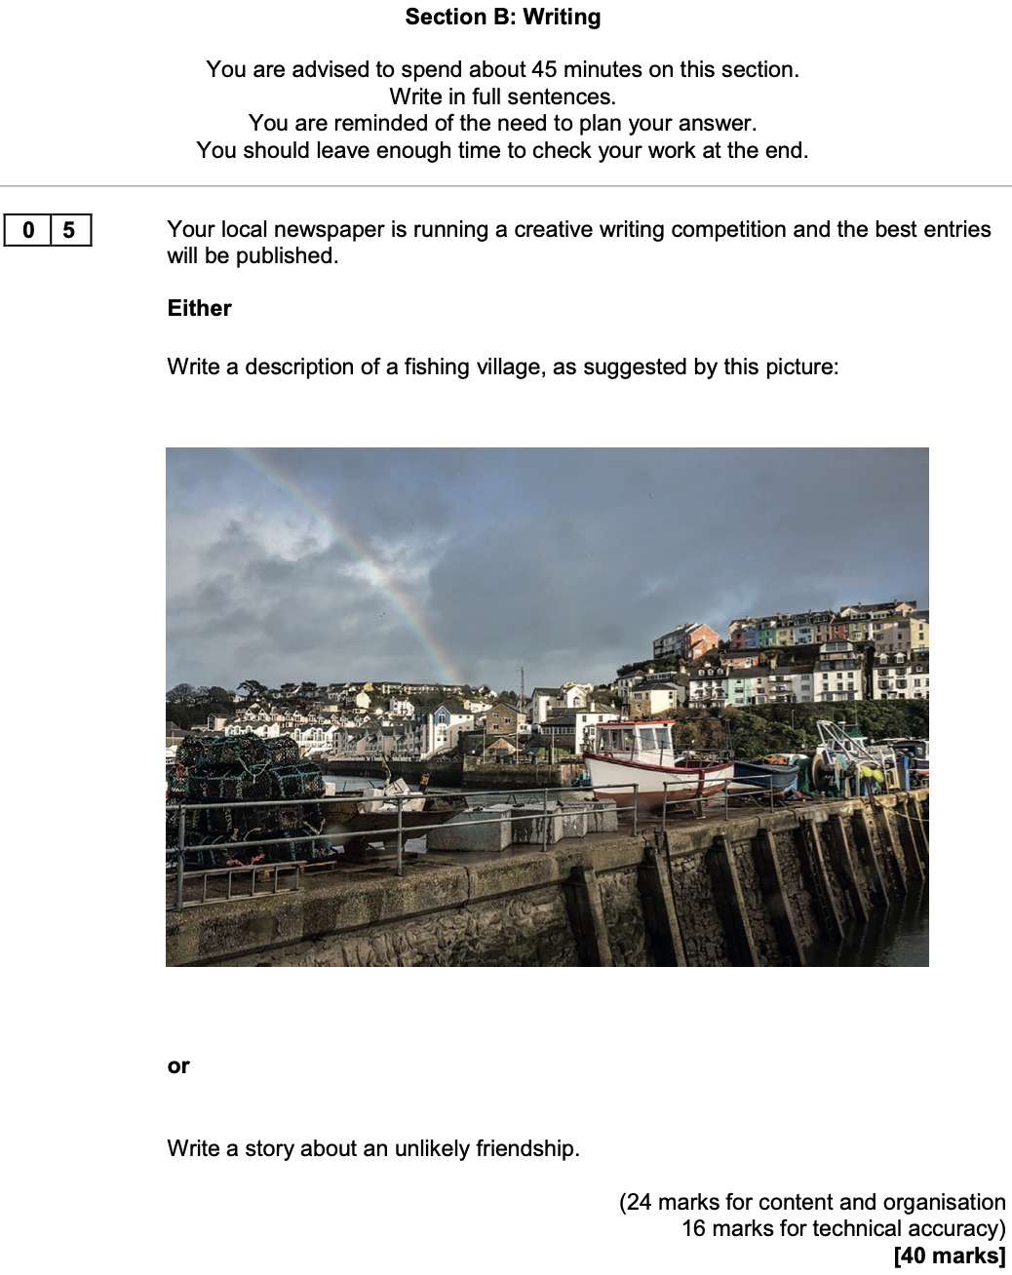

- Create a plan
- Zoom-in on a small bit of the image if you choose the first task and then develop your story from there
- Consider using a flashback that will ‘frame’ the story to come
- Carefully craft your writing and include: a very short sentence and a rhetorical question and ellipsis
- Pay attention to accuracy

- Don’t do both tasks

45 x minutes
2 x pages

